Supplementary information
Carbon-dependent net-zero emission energy systems without reliance on fossil fuels and bioenergy

Supplementary Tables
Supplementary Table 1 Scenario framework
Scenario name | Scenario classification | Specification
1.5C-CCU | Default | - CCS and bioenergy are limited to 4 Gt-CO₂ yr⁻¹ and 100 EJ yr⁻¹.  - Constraints on CDR to 1 Gt-CO₂ yr⁻¹.  - Limitation on non-hydrocarbon-based technology to 50% of new technology installation.
1.5C-DEC | Default | CCS and bioenergy are limited to 4 Gt-CO₂ yr⁻¹ and 100 EJ yr⁻¹.
1.5C-CDR | Default | Model default assumptions
1.5C-CCU-AdvTech | Sensitivity | Same with 1.5C-CCU, but optimistic assumptions on key technology cost as illustrated in Supplementary Fig. 11.
1.5C-DEC-AdvTech | Sensitivity | Same with 1.5C-DEC, but optimistic assumptions on key technology cost.
1.5C-CDR-AdvTech | Sensitivity | Same with 1.5C-CDR, but optimistic assumptions on key technology cost.
1.5C-CCU-ConvTech | Sensitivity | Same with 1.5C-CCU, but pessimistic assumptions on key technology cost.
1.5C-DEC- ConvTech | Sensitivity | Same with 1.5C-DEC, but pessimistic assumptions on key technology cost.
1.5C-CDR- ConvTech | Sensitivity | Same with 1.5C-CDR, but pessimistic assumptions on key technology cost.
1.5C-CCU-LimElec+ | Sensitivity | Same with 1.5C-CCU, but limitation on non-hydrocarbon-based technology is 10% of new installation.
1.5C-CCU-LimElec- | Sensitivity | Same with 1.5C-CCU, but limitation on non-hydrocarbon-based technology is 75% of new installation.
WB2C-CCU | Sensitivity | Same with 1.5C-CCU, but emission trajectory is equivalent to the 2 C goal, based on 1000 Gt-CO₂ budget case^{1,2}.
WB2 C-DEC | Sensitivity | Same with 1.5C-DEC, but emission trajectory is equivalent to the 2 C goal, based on 1000 Gt-CO₂ budget case^{1,2}.
WB2C-CDR | Sensitivity | Same with 1.5C-CDR, but emission trajectory is equivalent to the 2 C goal, based on 1000 Gt-CO₂ budget case^{1,2}.

Supplementary Table 2 Summary of key indicators in 2050
 | Unit | 1.5C-CCU | 1.5C-DEC | 1.5C-CDR
Synfuels share in final energy | % | 30.0 | 4.5 | 0.1
in industry | % | 21.8 | 3.3 | 0.2
in buildings | % | 12.6 | 0 | 0
in transport | % | 58.2 | 10.3 | 0.1
Electricity share in final energy | % | 38.1 | 56.3 | 51.3
in industry | % | 37.5 | 45.5 | 39.0
in buildings | % | 56.0 | 83.4 | 82.0
in transport | % | 20.6 | 48.2 | 41.8
Hydrocarbon share in final energy | % | 53.9 | 29.2 | 41.0
in industry | % | 43.1 | 31.6 | 41.3
in buildings | % | 43.0 | 16.6 | 17.9
in transport | % | 66.5 | 31.7 | 44.9
Fossil primary supply | EJ yr⁻¹ | 62.1 | 72.1 | 139.8
Biomass primary supply | EJ yr⁻¹ | 100.0 | 100.0 | 184.7
Hydrogen production | EJ yr⁻¹ | 245.0 | 94.1 | 32.7
Non-biomass renewable supply | EJ yr⁻¹ | 651.9 | 440.1 | 297.2
Carbon capture by DAC | Gt CO₂ yr⁻¹ | 10.1 | 1.0 | 0
CCS | Gt CO₂ yr⁻¹ | 3.4 | 4.0 | 8.7
Cumulative energy system cost per GDP | % | 2.1 | 1.3 | 1.2
Carbon prices | US$2010 t CO₂⁻¹ | 1,114 | 802.9 | 414

Supplementary Table 3 Technological parameter assumptions for synfuel production in the default technology cases.
 | Synthetic liquid fuel |  |  | Synthetic methane |  |  | Methane to hydrogen
 | 2020 | 2030 | 2050 | 2020 | 2030 | 2050 | Methane to hydrogen
Capital cost (US$ kW⁻¹) | 890 | 760 | 565 | 845 | 735 | 565 | 910
O&M cost (US$ kW⁻¹) | 36 | 30 | 23 | 34 | 29 | 23 | 33
Conversion efficiency | 73% |  |  | 77% |  |  | 76%
Lifetime (yr) | 15 |  |  | 15 |  |  | 15
O&M, operation and maintenance

Supplementary Figures

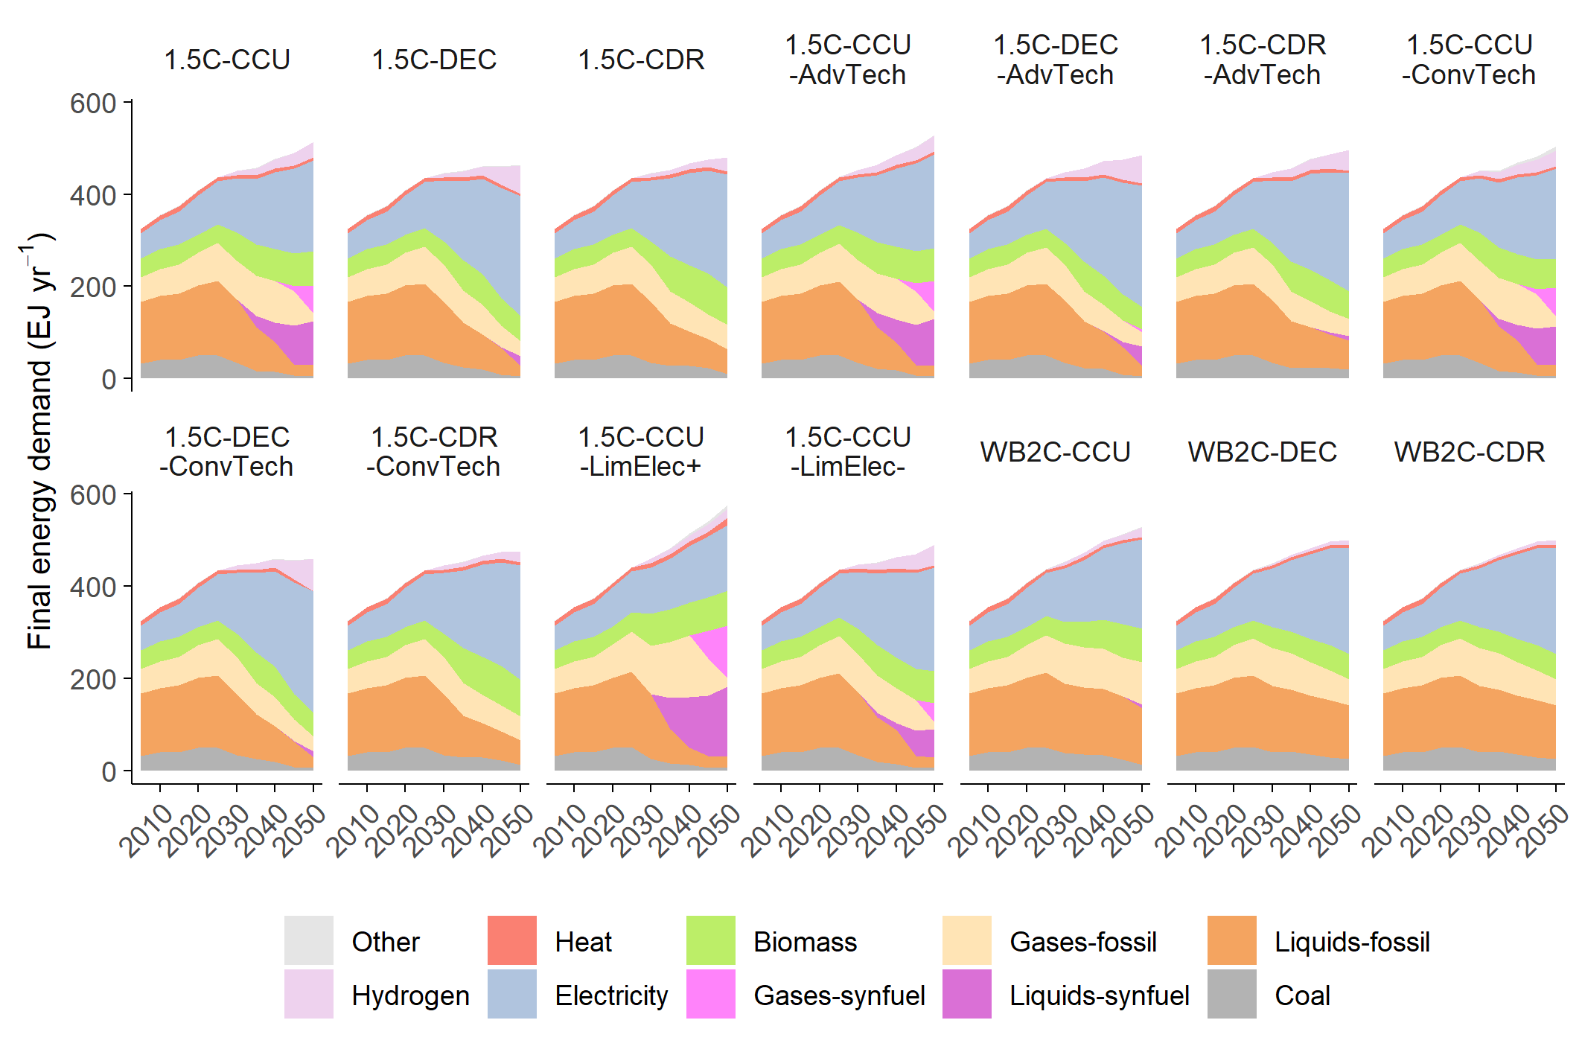
Supplementary Fig. 1 Final energy demand in all scenarios, including sensitivity scenarios.

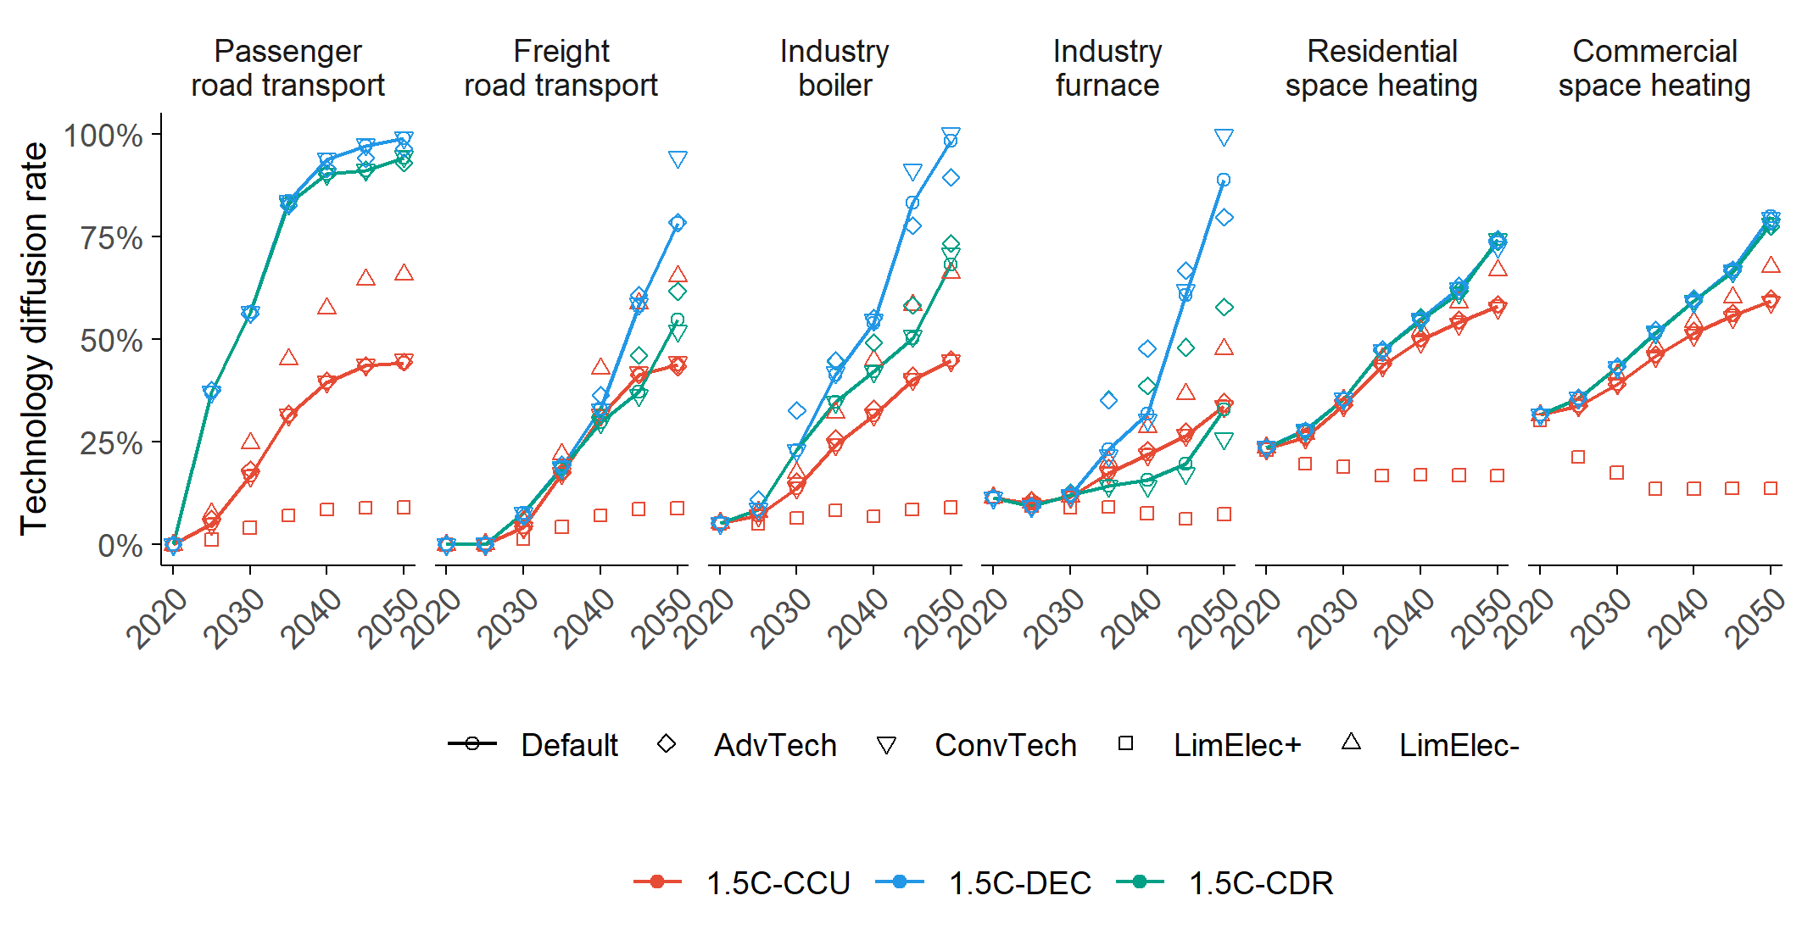
Supplementary Fig. 2 Technology diffusion rates of various technologies in the sensitivity cases.

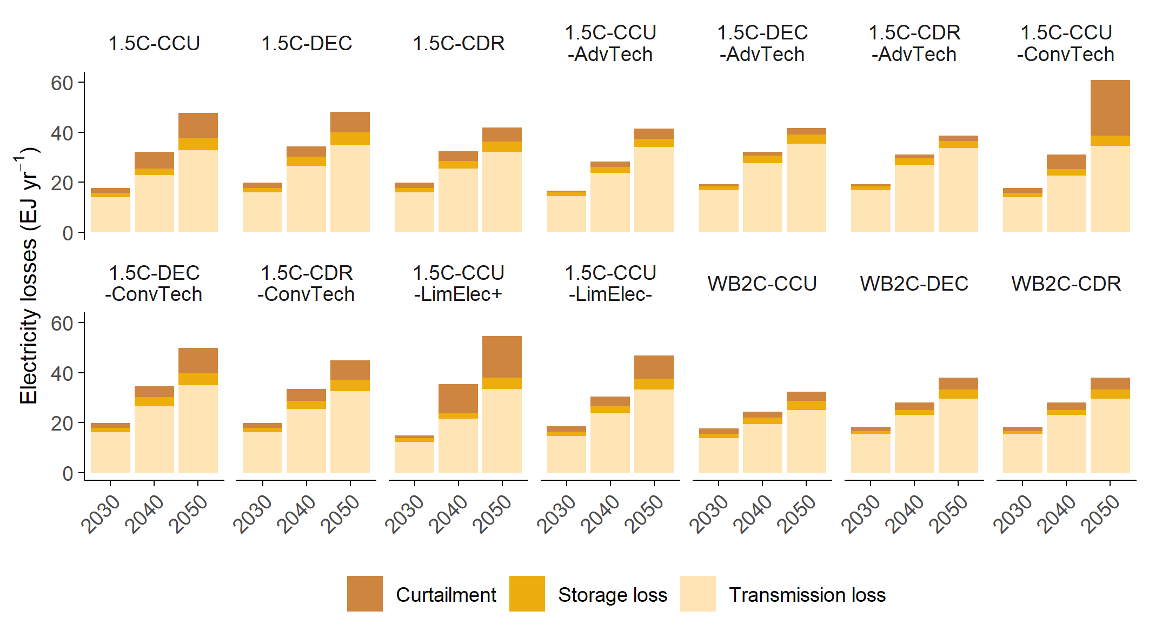
Supplementary Fig. 3 Electricity losses associated with variable renewable energy integration and transmission.

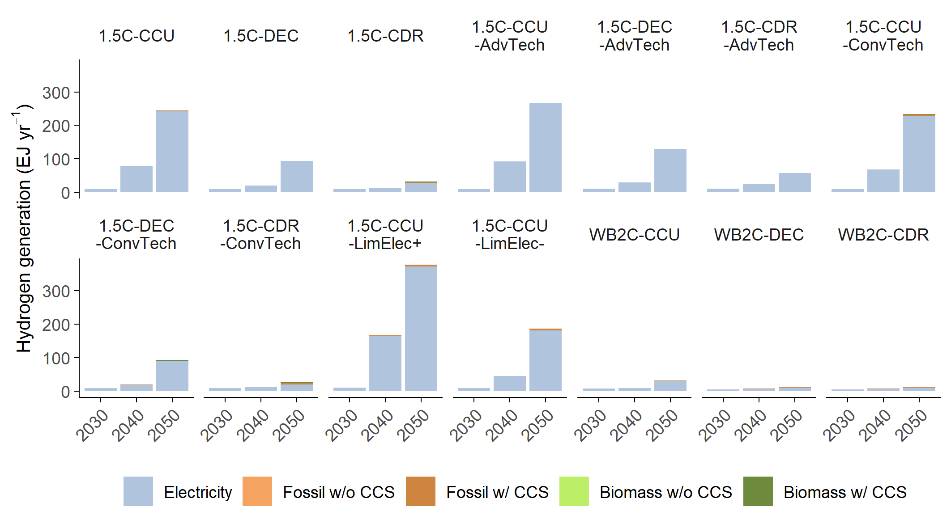
Supplementary Fig. 4 Hydrogen production in all scenarios, including sensitivity scenarios.

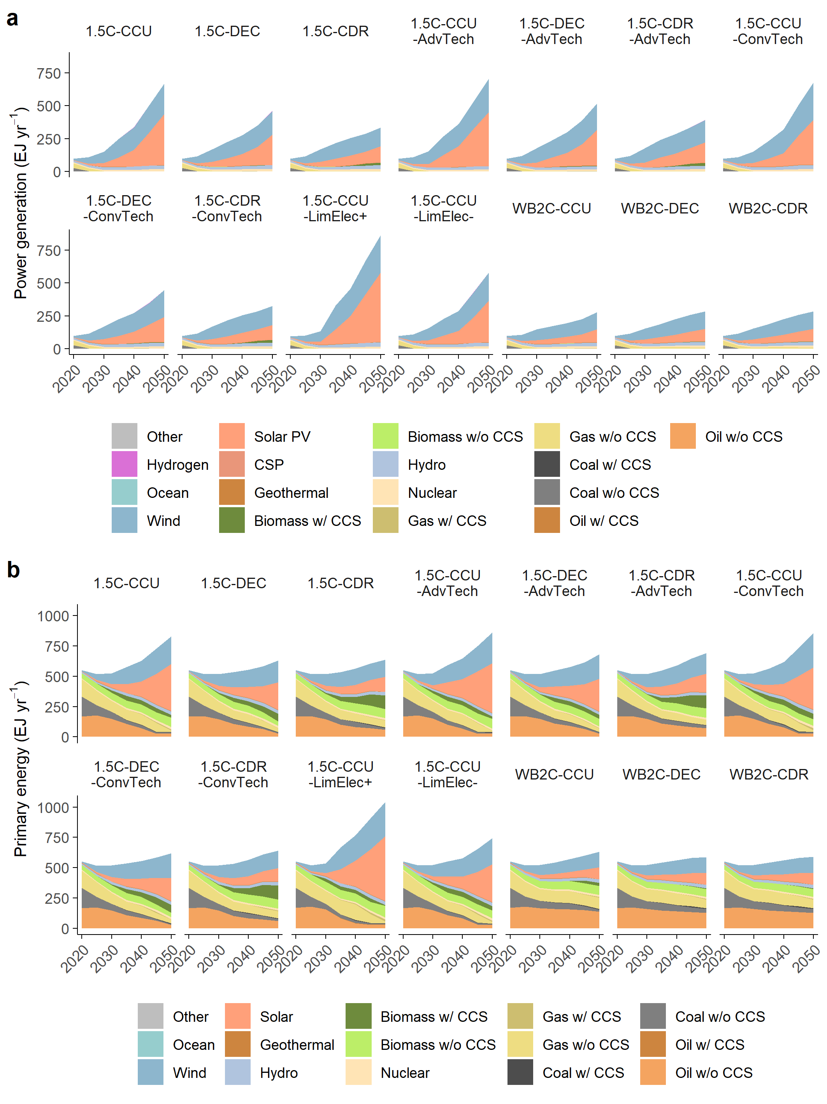
Supplementary Fig. 5 a, Primary energy supply in all scenarios, including sensitivity scenarios. b, Power generation in all scenarios, including sensitivity scenarios. Here, generated electricity includes electricity used for hydrogen production through electrolysis.

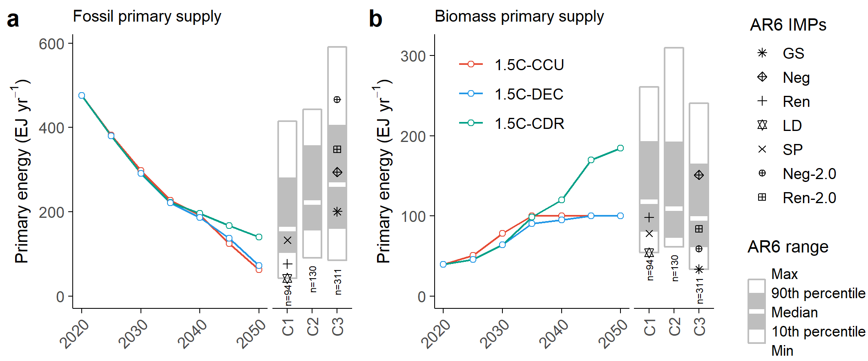
Supplementary Fig. 6 Primary energy supply from (a) fossil fuels and (b) biomass. Right box plots represent AR6 scenarios.

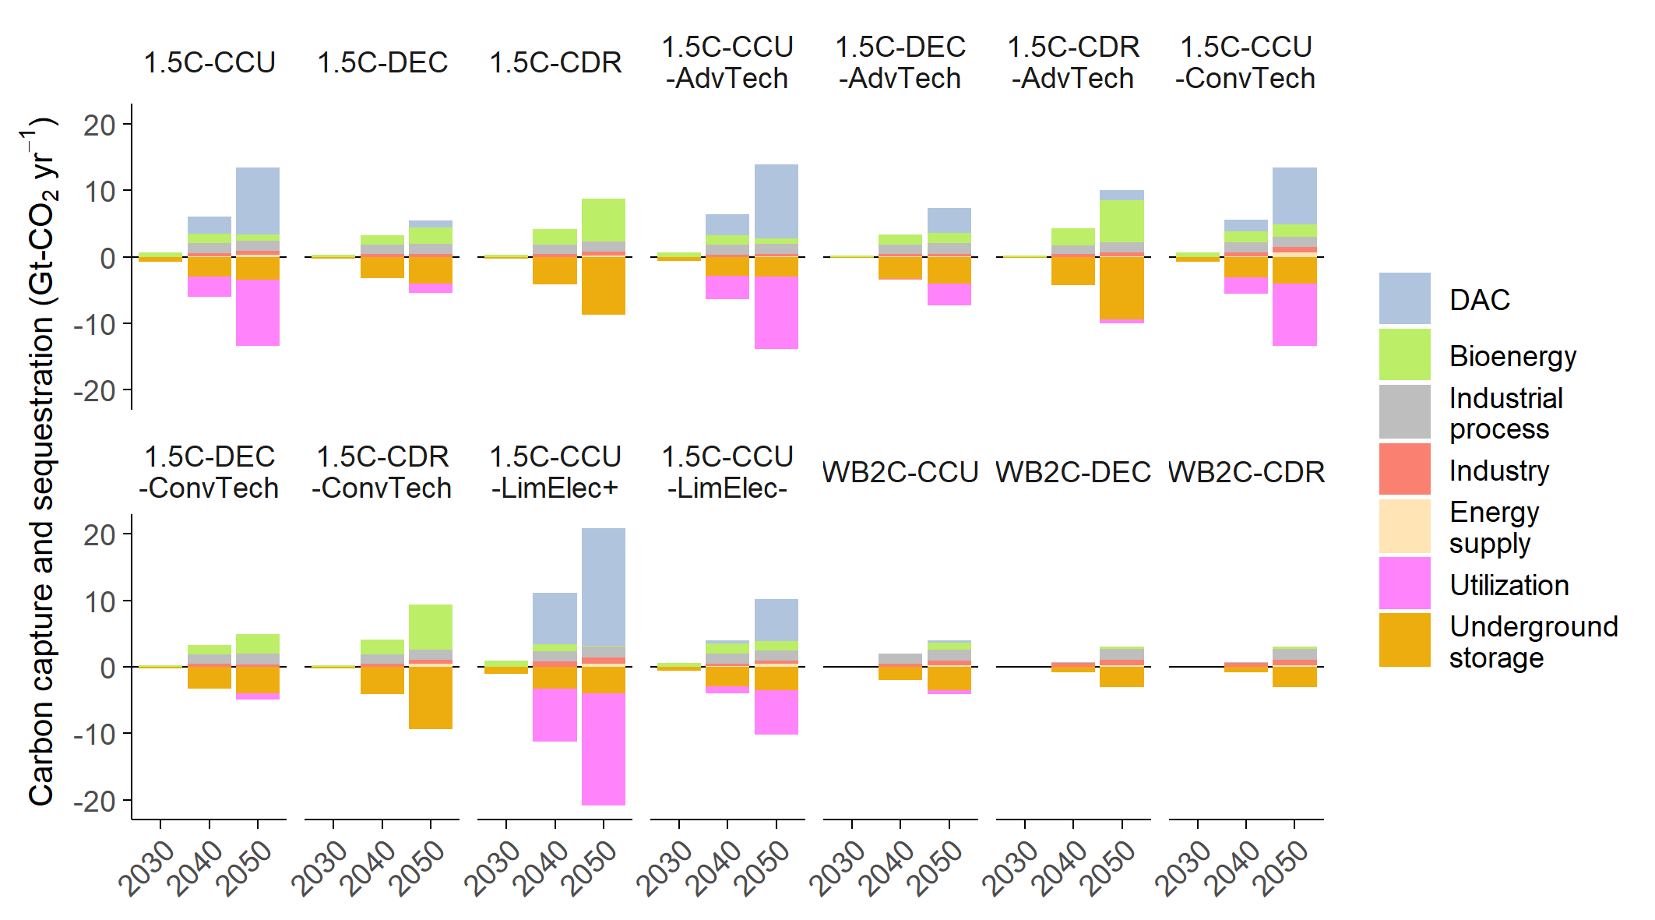
Supplementary Fig. 7 Carbon capture, sequestration, and utilization in energy and industrial processes, including DAC, across all scenarios. CO₂ storage and utilization are shown as negative numbers.

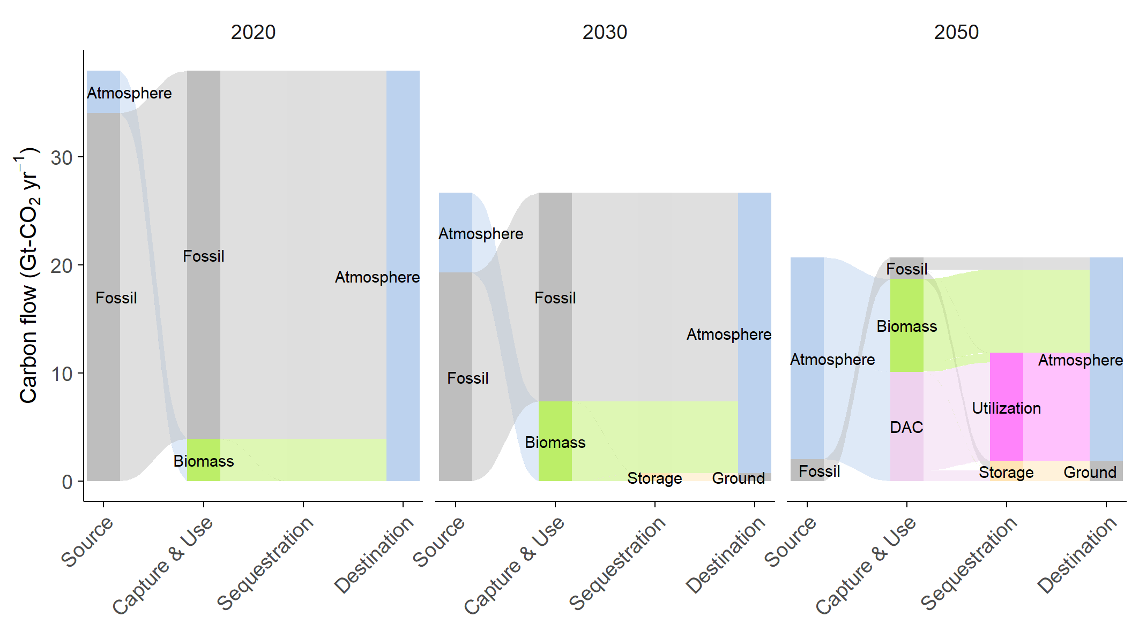
Supplementary Fig. 8 Carbon flow diagram for the 1.5C-CCU scenario in 2020, 2030, and 2050.

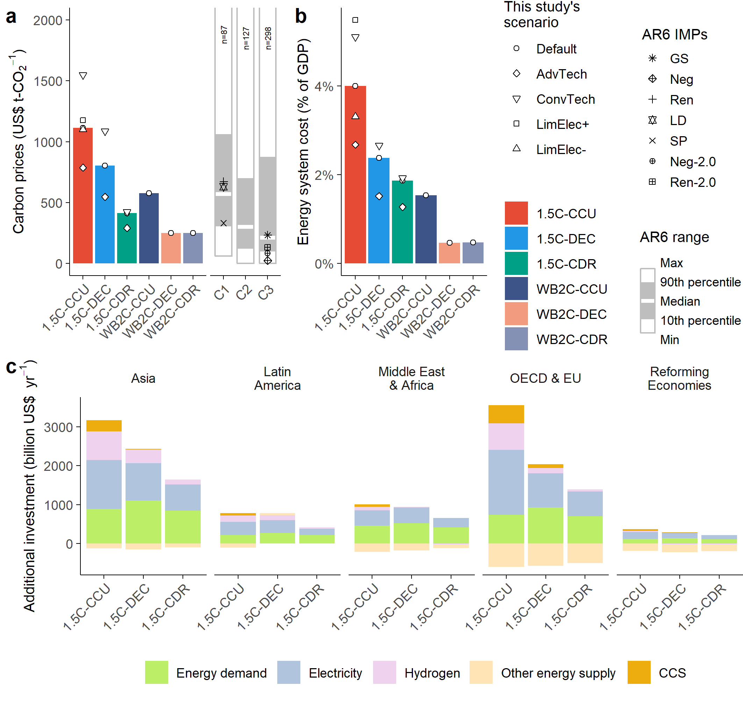
Supplementary Fig. 9 a, Carbon prices and b, Annual energy system cost relative to GDP in 2050. For carbon prices, the range between 0 and 2000 US$ t-CO₂⁻¹ is shown. c, Annual mean additional energy investment over 2041–2050 according to region, relative to the no-policy scenario. CCS includes investment in DAC.

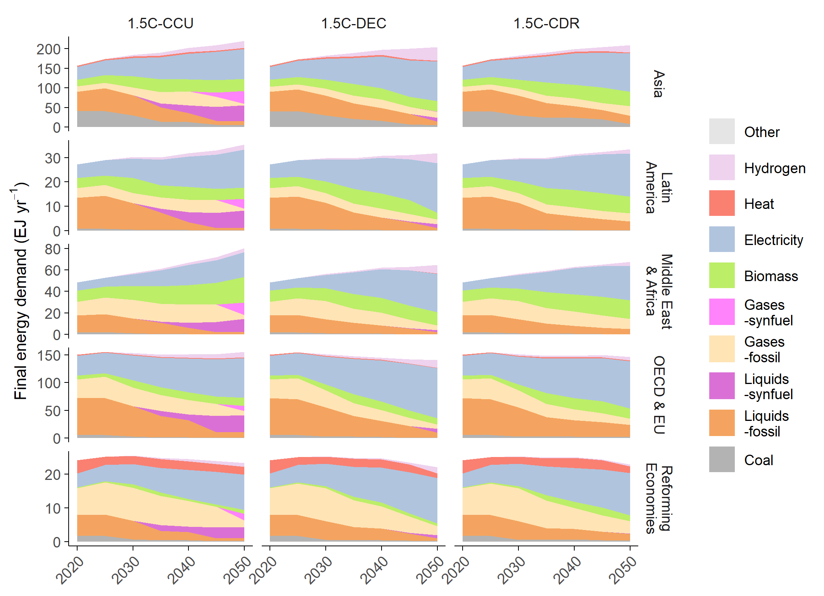
Supplementary Fig. 10 Final energy demand across 5 global regions.

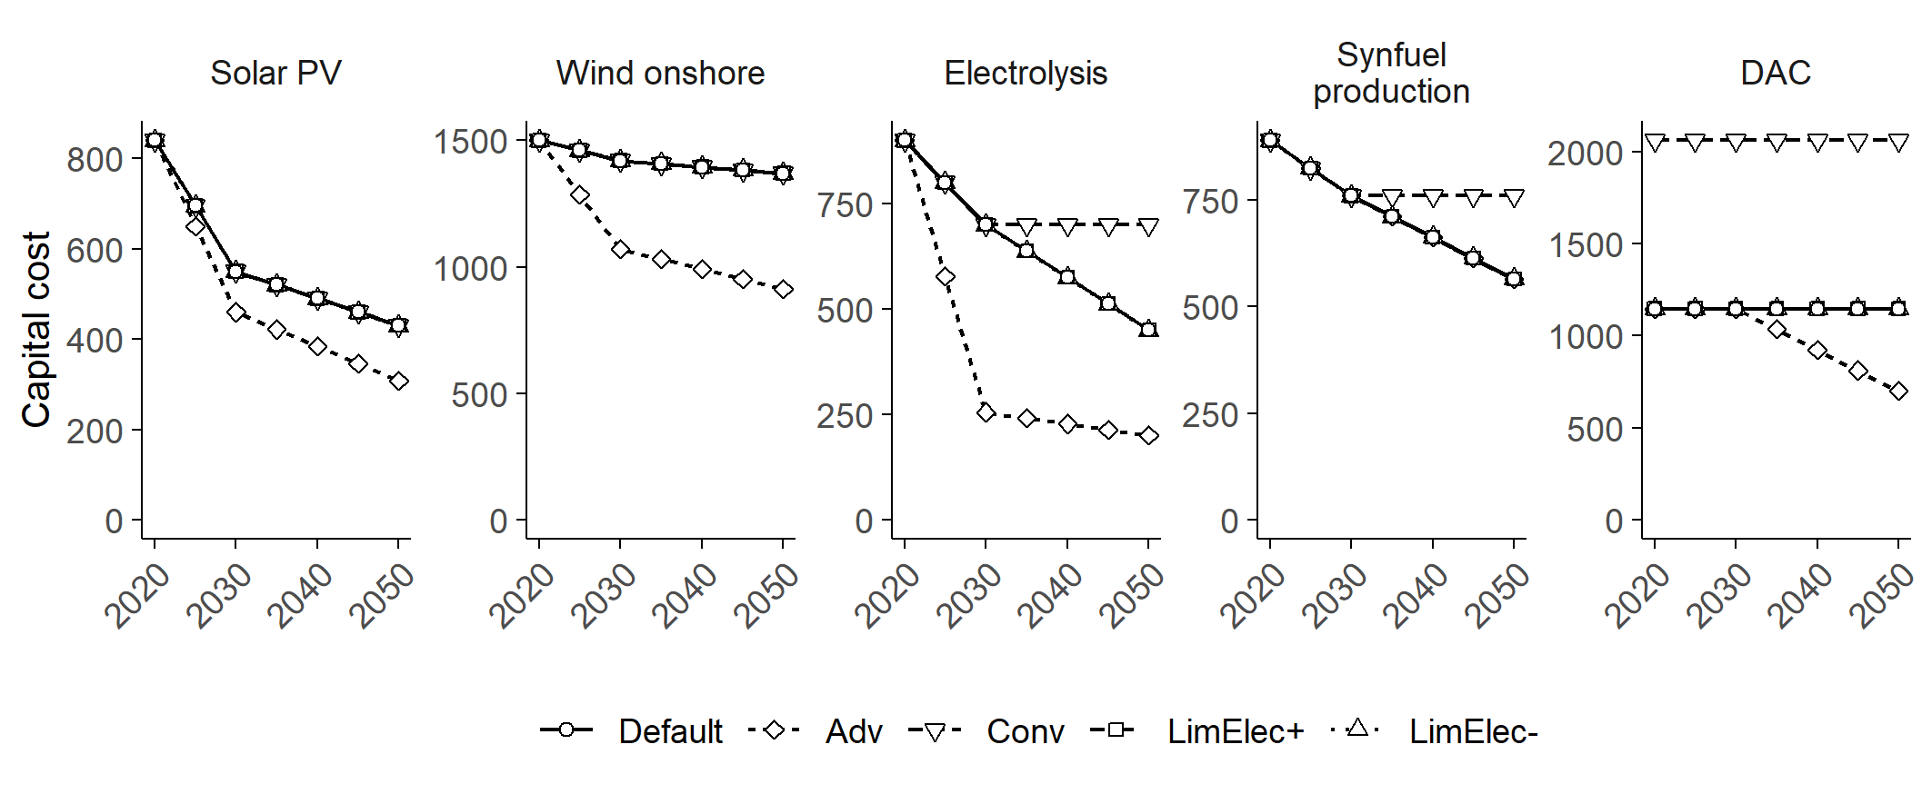
Supplementary Fig. 11 Capital cost assumptions for energy technologies associated with synfuel production in the sensitivity cases. Cost unit is US$ t-CO₂⁻¹ for DAC and US$ kW⁻¹ for all others. Cost assumptions for Europe are shown.

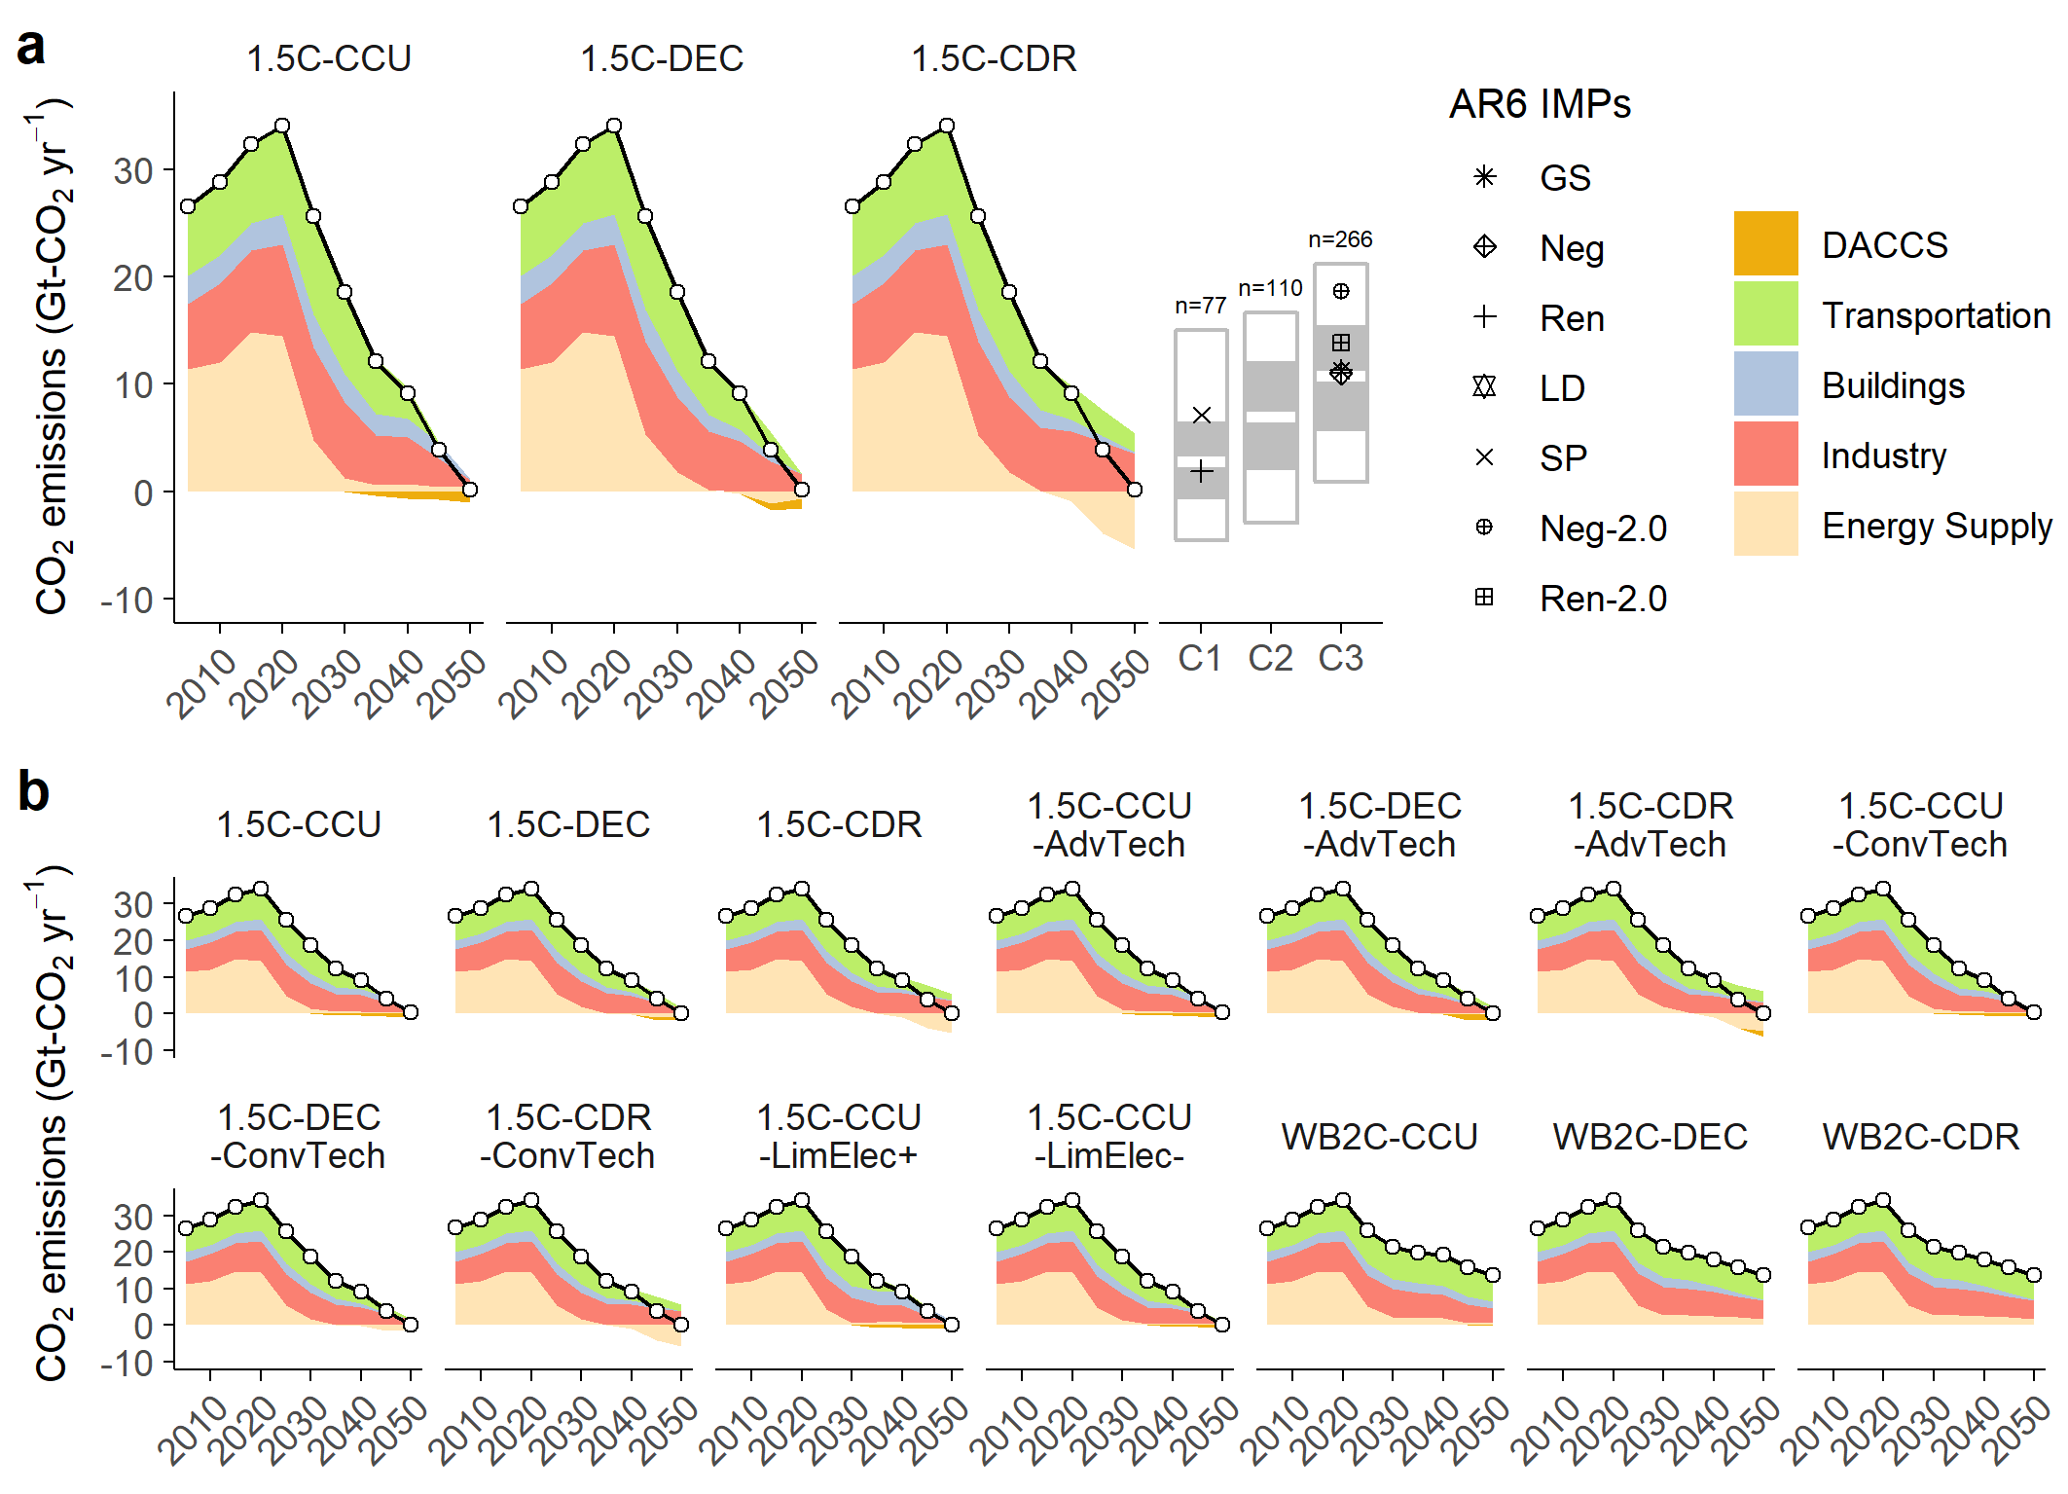
Supplementary Fig. 12 a, CO₂ emission from energy sectors, including negative emissions from DACCS. Box plots indicate ranges of CO₂ emissions from various energy sectors based on the AR6 scenario in 2050. b, CO₂ emissions from energy sectors across all scenarios, including sensitivity cases.

References
1 Riahi, K. et al. Cost and attainability of meeting stringent climate targets without overshoot. Nature Climate Change 11, 1063-1069, doi:10.1038/s41558-021-01215-2 (2021).
2 Hasegawa, T. et al. Land-based implications of early climate actions without global net-negative emissions. Nature Sustainability, 1052–1059 (2021), doi:10.1038/s41893-021-00772-w (2021).

