Supplementary Information

High-temperature energy storage polymer composites via hybrid assembly engineering
Lili Li^{a,b}, Mengquan Jiangª, Pingan Yangª, Jian Wang^{c}, Lin Zhang^{d}, Fei Wen^{a,b*}, Gaofeng Wang^{a*}, Wenjun Liª, Wei Wuª, Zhonghui Shen^{c,*} and Shujun Zhang^{b*}
ª Engineering Research Center of Smart Microsensors and Microsystems, Ministry of Education, College of Electronics and Information, Hangzhou Dianzi University, Hangzhou 310018, China
^{b} Institute for Superconducting and Electronic Materials, Australian Institute of Innovative Materials, University of Wollongong, NSW 2500, Australia
^{c} State Key Laboratory of Advanced Technology for Materials Synthesis and Processing, Center of Smart Materials and Devices, Wuhan University of Technology, Wuhan 430070, China
^{d} Media Lab, Massachusetts Institute of Technology, Cambridge, MA 02139, USA

*Corresponding Author
Fei Wen, (wenfei@hdu.edu.cn)
Gaofeng Wang, (gaofeng@hdu.edu.cn)
Zhonghui Shen, (zhshen@whut.edu.cn)
Shujun Zhang, (shujun@uow.edu.au)

Section S1: Experimental
Materials:
Na_{0.5}Bi_{0.5}TiO₃-Sr_{0.7}Bi_{0.2}TiO₃ (NBT-SBT) were fabricated through a conventional solid-state reaction method with Bi₂O₃ (analysis purity 99.975%), Na₂CO₃ (99.5%), SrCO₃ (99%) and TiO₂ (99.8%) as starting materials^{1, 2}. First, the (Sr_{0.7}Bi_{0.2}) TiO₃ and (Na_{0.5}Bi_{0.5}) TiO₃ ceramic powder were calcined in air at 950 ºC for 3 hours by Bi₂O₃, SrCO₃, Na₂CO₃ and TiO₂, respectively, according to the nominal stoichiometric composition. Second, NBT-SBT was fabricated by (Sr_{0.7}Bi_{0.2}) TiO₃ and (Na_{0.5}Bi_{0.5}) TiO₃ sintered in alumina crucible at the temperature range of 1100-1200 ºC. BNNS is provided by Nanjing Xianfeng nanomaterials Co., Ltd. Poly(Acrylonitrile-Butadiene-Styrene) (ABS, Polylac®) is supplied by Zhenjiang Chi Mei chemical Co. Ltd., and N,N-Dimethylformamide (DMF, AR grade) is supplied by Tianjin Reagents Co. Ltd.
Preparation of single layer NBT-SBT/ABS (S layer) composites
NBT-SBT/ABS composites were fabricated by a simple matrix/filler mixing and solution casting method. Using 100 mL DMF as solvent to dissolve 5 g ABS by magnetic stirring for 8 hours. Then added the calculated weight of NBT-SBT to 15 ml ABS solution and stirred for an additional 8 hours. The weight percent of the NBT-SBT was chosen to be x wt.% (x = 0, 2, 4, 6, 8, and 10). The NBT-SBT/ABS suspension was subjected to sonication for 30 minutes. Following which, the well dispersed solution was cast onto a glass plate to evaporate the solvent at 70 ºC. The thickness of 12 µm was carefully controlled for all composite films. Finally, the composite films were annealed at 200 ºC for 2 hours, then quenched immediately in an ice water bath, dried at 70 ºC and stored in a desiccator for later characterization.
Preparation of single layer BNNS/ABS (B layer) composites
The 2D BNNS was prepared as follows ³: 4 g hexagonal (h)-BN powders were dispersed in 400 mL DMF under vigorous stirring. The mixture was then subjected to a tip-type sonication (175 W) for 40 h. The obtained mixture was centrifuged at 3,000 rpm for 40 min, and the supernatant was collected. Then the supernatant was centrifuged at 10,000 rpm for 20 min to collect the precipitates. After drying at 70 ºC overnight, about 50 mg BNNS was obtained. BNNS/ABS composites with weight percent of the BNNS at x wt.% (x = 0, 2, 4, 6, 8, and 10) were also prepared by the same method as NBT-SBT/ABS (S layer) composites, respectively.

References
1. Li, J., Li, F., Xu, Z. & Zhang, S. Multilayer Lead-Free Ceramic Capacitors with Ultrahigh Energy Density and Efficiency. Adv. Mater. 30, e1802155 (2018).
2. Yang, P. et al. Significantly enhanced energy storage performance of flexible composites using sodium bismuth titanate based lead-free fillers. J. Mater. Chem. C 8, 14910-14918 (2020).
3. Liu, F. et al. Poly(methyl methacrylate)/boron nitride nanocomposites with enhanced energy density as high temperature dielectrics. Compos. Sci. Technol. 142, 139-144 (2017).

Section 2 Characterization
The surface morphology of BNNS filler was observed by a transmission electron microscope (TEM) (JEM-2010, JEOL Ltd, Tokyo, Japan). The microstructure of the composites was observed by SEM (JSM-7001F, JEOL Ltd, Tokyo, Japan). The crystal structure of composites was investigated by X-ray diffraction (XRD) (XRD-6100, SHIMADZU, Japan) using Cu Kα radiation.
Dielectric Measurements:
The room temperature frequency dependent dielectric property of the polymer films was measured by an HP (Agilent-4990, USA) LCR meter over a frequency range of 10²–10⁷ Hz. The E_{b} was measured 20 times under a DC electric field at a ramping rate of 500 V/s and a limit current of 5 mA with an auto voltage withstanding tester (RK2674B) at different temperatures (Room temperature, 120 °C). The value of E_{b} was analyzed by the Weibull distribution function.
Ferroelectric Measurements:
The polarization–electric field loops (P-E loop) were measured by using a TF 2000 analyzer (axi ACCT, Aachen, Germany) with a triangular waveform at frequency of 10 Hz, from room temperature to high temperature (120 °C). The fatigue test of charge-discharge was performed up to 10⁶ cycles with pulse field amplitudes of 300 MV/m and frequency of 500 Hz.

Section 3 The property of NBT-SBT/ABS and BNNS/ABS composites of single layer.
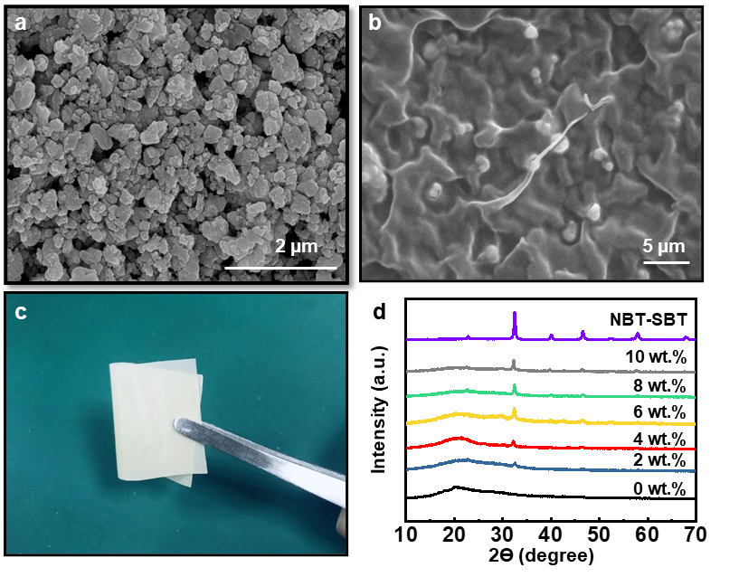
Supplementary Figure S1. Cross-section SEM images of (a) NBT-SBT particles and (b) 4 wt.% NBT-SBT/ABS composite film, (c) XRD of pure ABS, NBT-SBT and NBT-SBT/ABS composites, (d) Image of 4 wt.% NBT-SBT/ABS composite film.

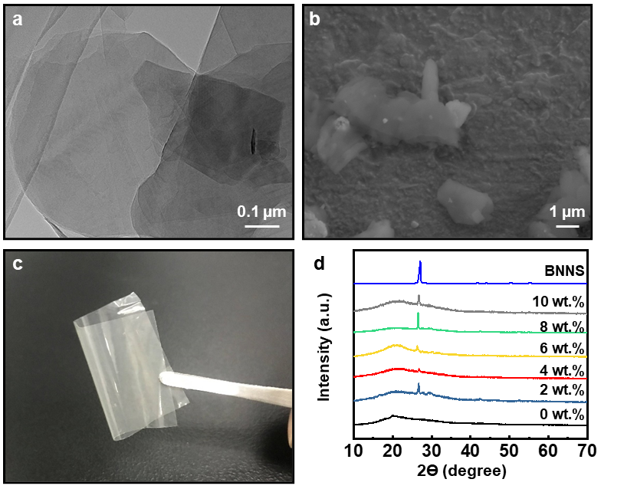
Supplementary Figure S2. (a) TEM image of BNNS, (b) Cross-section SEM images of 4 wt.% BNNS/ABS composite film, (c) XRD of pure ABS, BNNS and BNNS/ABS composites, (d) Image of 4 wt.% BNNS/ABS composite film.

The SEM images of NBT-SBT particles and 4 wt.% NBT-SBT/ABS composites are given in Figure S1 (a) and (b). The TEM images of BNNS and SEM images of 4 wt.% BNNS/ABS composites are given in Figure S2 (a) and (b). As illustrated in the figures, the average size of NBT-SBT particles is around 3 µm and the additive particles are uniformly distributed throughout the polymer matrix. Macroscopic digital pictures of NBT-SBT/ABS and BNNS/ABS composites are shown in Figure S1(c) and 2 (c), respectively. As can be seen, the color of the sample is uniform, and the BNNS/ABS sample, exhibits partial light transmission.
XRD images of NBT-SBT/ABS and BNNS/ABS composites are shown in Figure S1 (d) and S2 (d), respectively. As the additive particle content in the polymer matrix increases, the respective distinctive peaks become visible. As illustrated in Figure S1 (d), the XRD spectrum shows that the different components of NBT-SBT/ABS composites appear at 32.5º, 40.1º, 46.6º, 57.8º, and 67.9º, corresponding to the ceramic particle’s diffraction peak. As shown in Figure S2 (d), the pattern of the different components BNNS/ABS composites in 26.5º is attributed to BNNS particles.

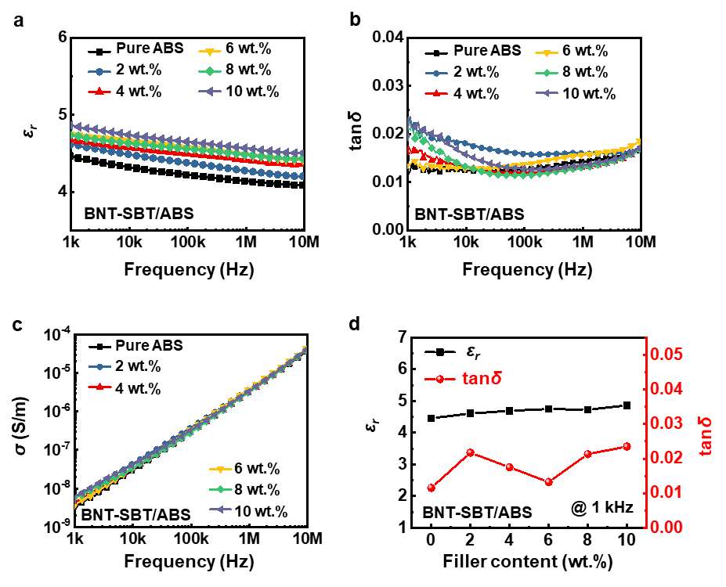
Supplementary Figure S3. Frequency dependent (a) dielectric permittivity, (b) dielectric loss and (c) AC electrical conductivity of pure ABS and NBT-SBT/ABS composites from 1 kHz to 1 MHz at room temperature, (d) dielectric permittivity, dielectric loss and AC electrical conductivity of NBT-SBT/ABS composite with NBT-SBT different content at 1kHz and room temperature.
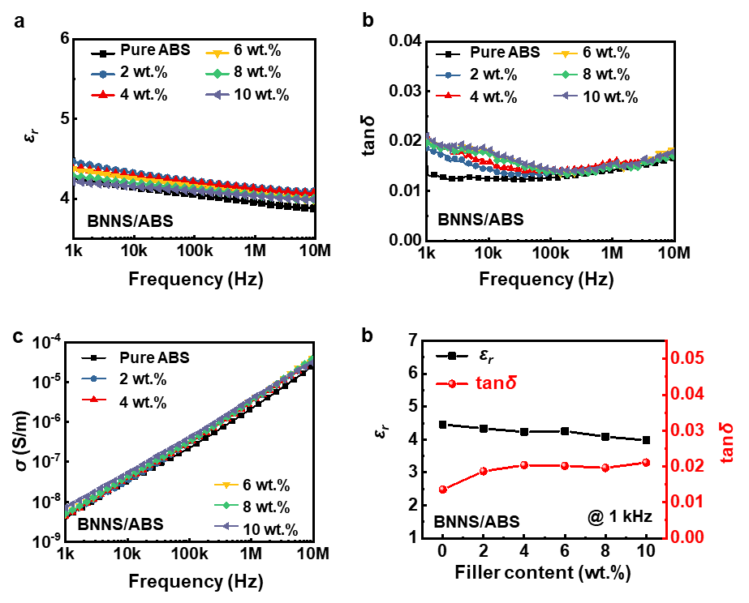
Supplementary Figure S4. Frequency dependent (a) dielectric permittivity, (b) dielectric loss and (c) AC electrical conductivity of pure ABS and BNNS/ABS composites from 1 kHz to 1 MHz at room temperature, (d) dielectric permittivity, dielectric loss and AC electrical conductivity of BNNS/ABS composites with BNNS different content at 1kHz and room temperature.
Figures S3 and S4 show the dielectric characteristics of NBT-SBT/ABS and BNNS/ABS composites with different content of added particles. In Figure S3, as the amount of NBT-SBT ceramic particles added increases, the dielectric permittivity of the composite increases. The dielectric loss is lower than 0.03, and the AC conductivity is below 10⁻⁸ S/m. While in Figure S4, with the increase of the amount of BNNS particles, the dielectric permittivity of the composite has a slight downward trend, the dielectric loss is less than 0.02, and the AC conductivity is below 10⁻⁸ S/m. This indicates that NBT-SBT/ABS and BNNS/ABS composites have good dielectric and insulation properties.

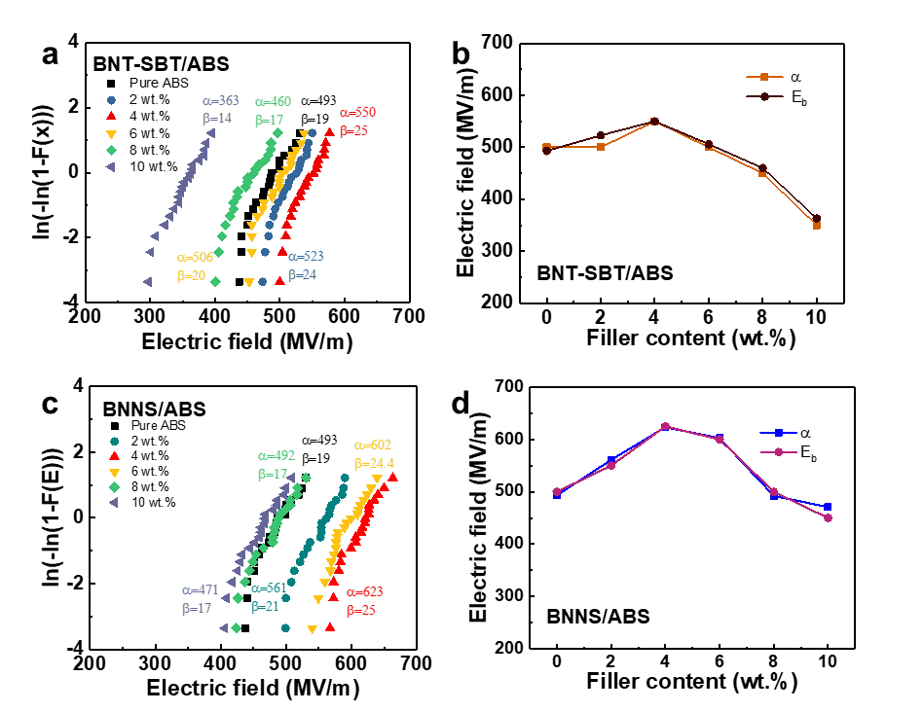
Supplementary Figure S5. The electric breakdown field of Weibull distribution at room temperature of (a) NBT-SBT/ABS composites and (c) BNNS/ABS composites; the α parameter of Weibull distribution and E_{b} of (b) NBT-SBT/ABS composites samples and (d) BNNS/ABS composites samples.
The breakdown electric field performance graphs of NBT-SBT/ABS and BNNS/ABS composites with different content of added particles are shown in Figure S5. Figure S5 (a) and (c) are Weibull distribution of ABS polymer, NBT-SBT/ABS and BNNS/ABS composites with different components. The breakdown field strength of ABS polymer is only 493 MV/m. What is interesting is that the breakdown strength of NBT-SBT/ABS and BNNS/ABS composites increases first and then decreases as the filler increases, which α was reached the maximum with the 4 wt.% composites. For example, the 4 wt.% NBT-SBT/ABS and BNNS/ABS composites reach 550 MV/m and 623 MV/m, respectively. Compared with the 493 MV/m of pure polymer, the breakdown strength is increased by about 11.6% and 26% respectively. It shows that the addition of filler effectively improves the breakdown field strength. When fillers are added, the breakdown field strength decreases, which suggests that the filler content is increased excessively, agglomerations and pores form in the composite, making it more prone to breakdown, which is consistent with prior research findings. The factor β is a parameter that describes the status of the breakdown field's distribution. In NBT-SBT/ABS and BNNS/ABS composites, when the mass fraction of the particles added 4 wt.%, β value reaches the maximum is about 24 and 25, respectively, indicating the distribution of breakdown field strength is relatively concentrated with the addition amount of 4 wt.%. This is interpreted that the best performance in dielectric energy storage of the ABS composite. Figure S5 (b) and (d) are the comparison of the breakdown field strength E_{b} (from the maximum applied external field in the P-E loop) and the α (Weibull breakdown electric field) of ABS polymer, NBT-SBT/ABS and BNNS/ABS composites with different components picture. As can be seen, the change trend of the breakdown field strength E_{b} and the value of α are same, showing that the experimental results are consistent over multiple testing. It is interesting that E_{b} of 4 wt.% composite is the highest as same as α . This is one of the reasons we chose to prepare three-layer composites with two 4 wt.% NBT-SBT/ABS and BNNS/ABS.

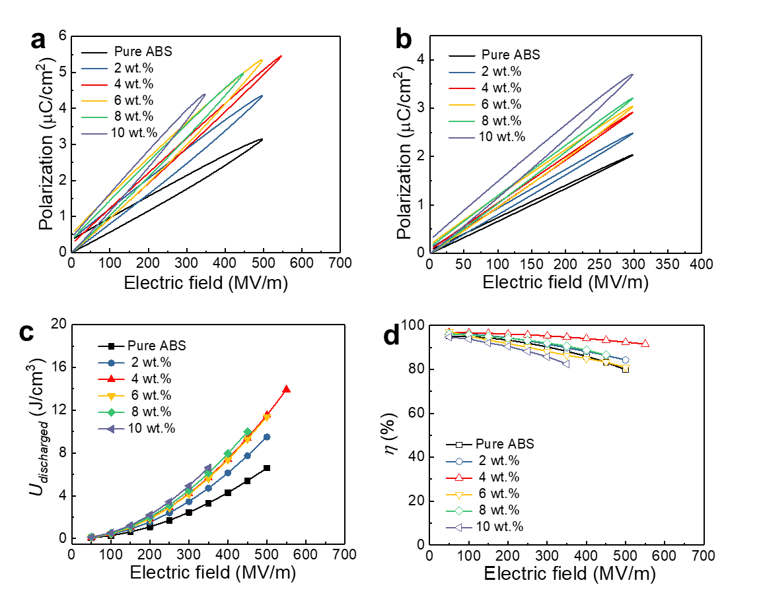
Supplementary Figure S6 (a) The unipolar P-E loops at E_{b} and (b) The unipolar P-E loops at 500 MV/m, (c) U_{discharged} vs. E and (d) η vs. E of NBT-SBT/ABS composites samples at room temperature.

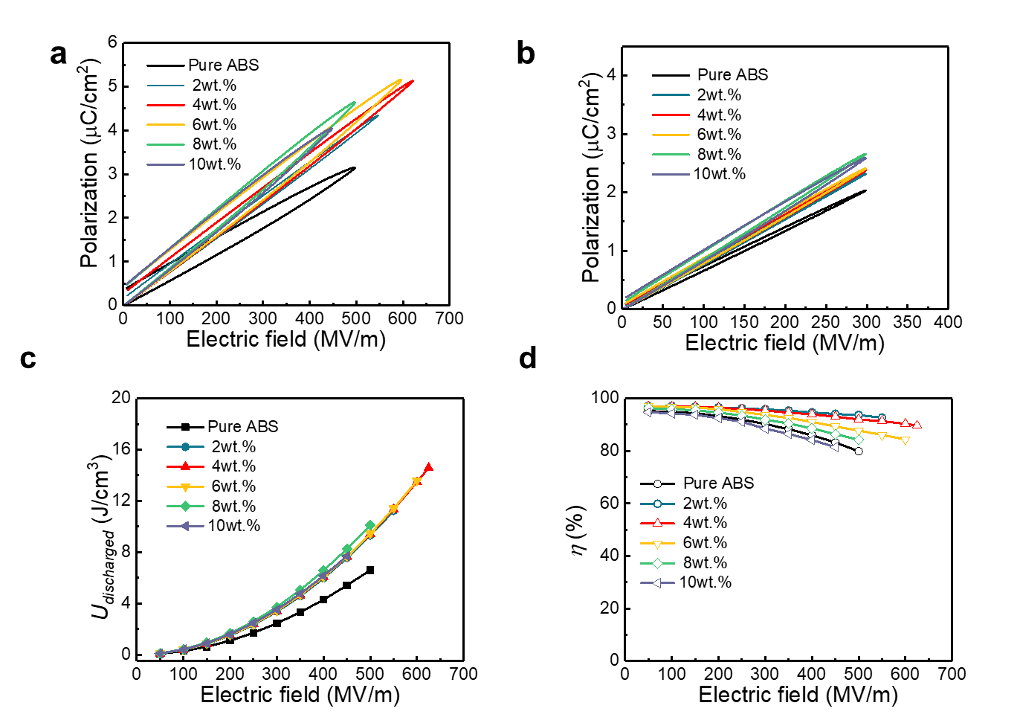
Supplementary Figure S7 (a) The unipolar P-E loops at E_{b} and (b) The unipolar P-E loops at 500MV/m, (c) U_{discharged} vs. E and (d) η vs. E of BNNS/ABS composites samples at room temperature.
The discharge energy density and efficiency are critical factors of electrostatic energy storage. Figure S6 and S7 are P-E loop and energy storage of NBT-SBT/ABS and BNNS/ABS composites at room temperature (RT), respectively. Figure S6 (a) and (b) show the P-E loops of ABS polymer and NBT-SBT/ABS composites with different components at the maximum field strength and 300 MV/m, respectively. P_{max} is extremely important for the energy storage performance of dielectric materials. Under the same residual polarization P_{r}, if the P_{max} is larger, the energy storage density and efficiency of the composite could be higher. As shown in Figure S6 (a), the P_{max} of 4 wt.% NBT-SBT/ABS composite is the highest under 550 MV/m. In addition, under the same field strength of 300 MV/m, the P_{max} increases with the addition of NBT-SBT ceramic particles, as shown in Figure S7 (b). As shown in Figure S7 (c), the discharge energy density curve of the composite is above the curve of the ABS polymer, indicating that the discharge energy density of the composite is better than that of pure polymer under the same field strength. The discharge energy density of 4 wt.% NBT-SBT/ABS has the best performance, reaching 13.4 J/cm³ at 550 MV/m, which is 180% of the energy density of pure (ABS 7.2 J/cm³@500 MV/m). The discharge efficiency decreases slightly with the increase of the breakdown field strength, as shown in Figure S7 (d). Among all the composites, 4 wt.% of the composites obtained excellent efficiency, which is 91% at 550 MV/m and much higher than that of other components. This is because the 4 wt.% composite not only obtains a higher P_{max}, but also maintains P_{r} at a low level, which is effectively improved the efficiency of composites. BNNS/ABS composites have comparable P-E loop and energy storage properties to NBT-SBT/ABS composites as shown in Figure S7. The discharge energy density and efficiency of 4 wt.% BNNS/ABS composites are the highest in the BNNS/ABS composites. The discharge energy density of 4 wt.% BNNS/ABS composites is 14.2 J/cm³ at 625 MV/m, which is double that of pure ABS. It is worth noting that the BNNS/ABS composite likewise achieved an efficiency of 88%. This is another reason that we chose two 4 wt.% NBT-SBT/ABS and BNNS/ABS to prepare three-layer composites.

Supplementary Figures

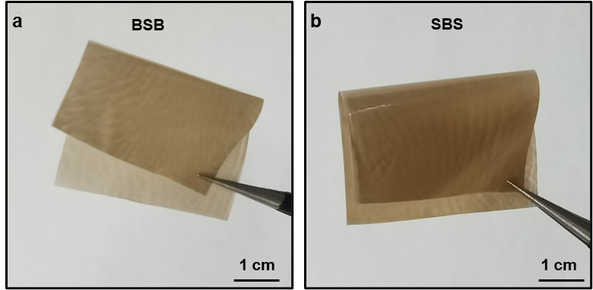
Supplementary Figure S8 The Macroscopic digital pictures of SBS and BSB samples.

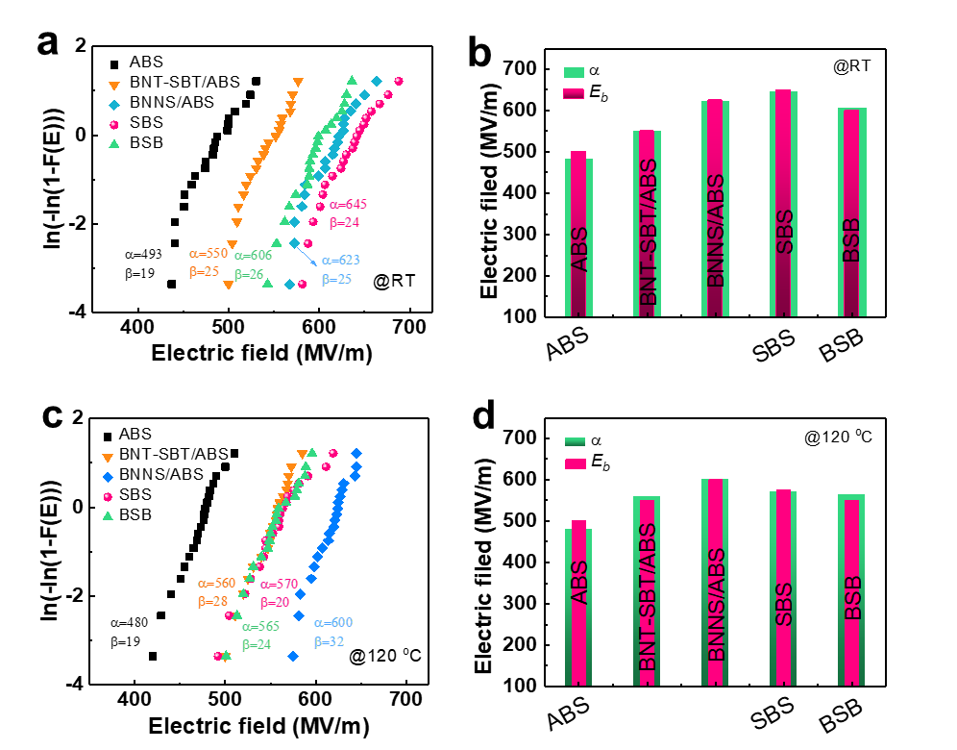
Supplementary Figure S9 The electric breakdown field of Weibull distribution of pure ABS, NBT-SBT/ABS, BNNS/ABS, SBS and BSB composites (a) at room temperature and (c) at evaluated temperature (120 ºC); the α parameter of Weibull distribution and E_{b} of pure ABS, NBT-SBT/ABS, BNNS/ABS, SBS and BSB composites (b) at room temperature and (d) at evaluated temperature (120 ºC).

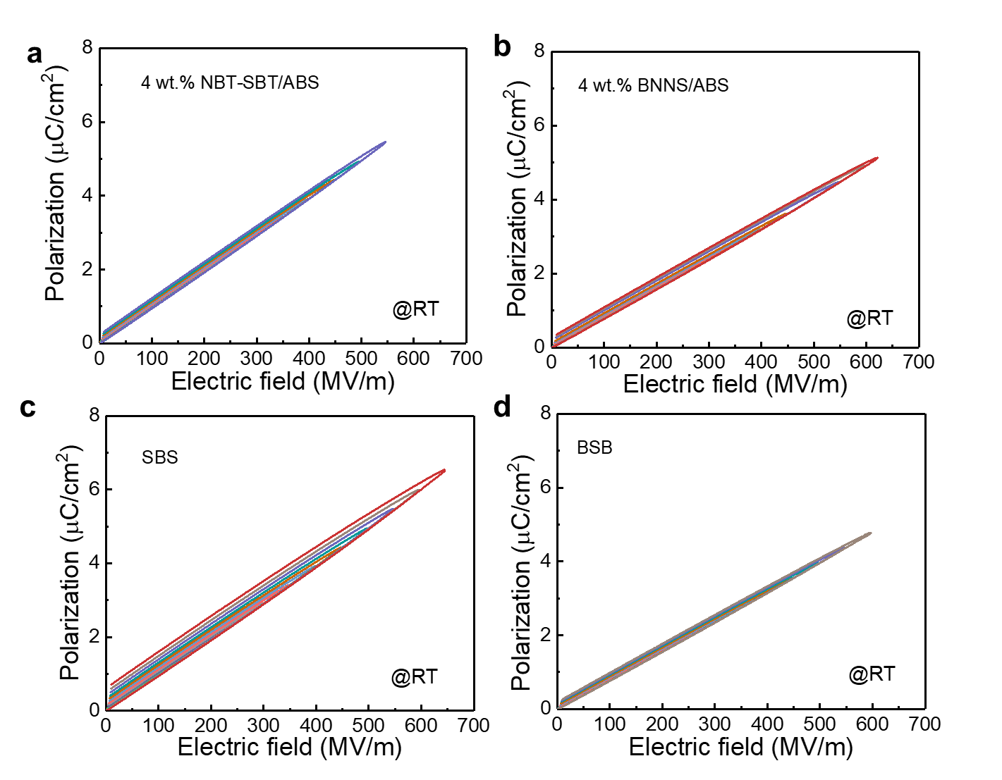

Supplementary Figure S10 The unipolar P-E loops of single-layer and tri-layer ABS composites at room temperature.

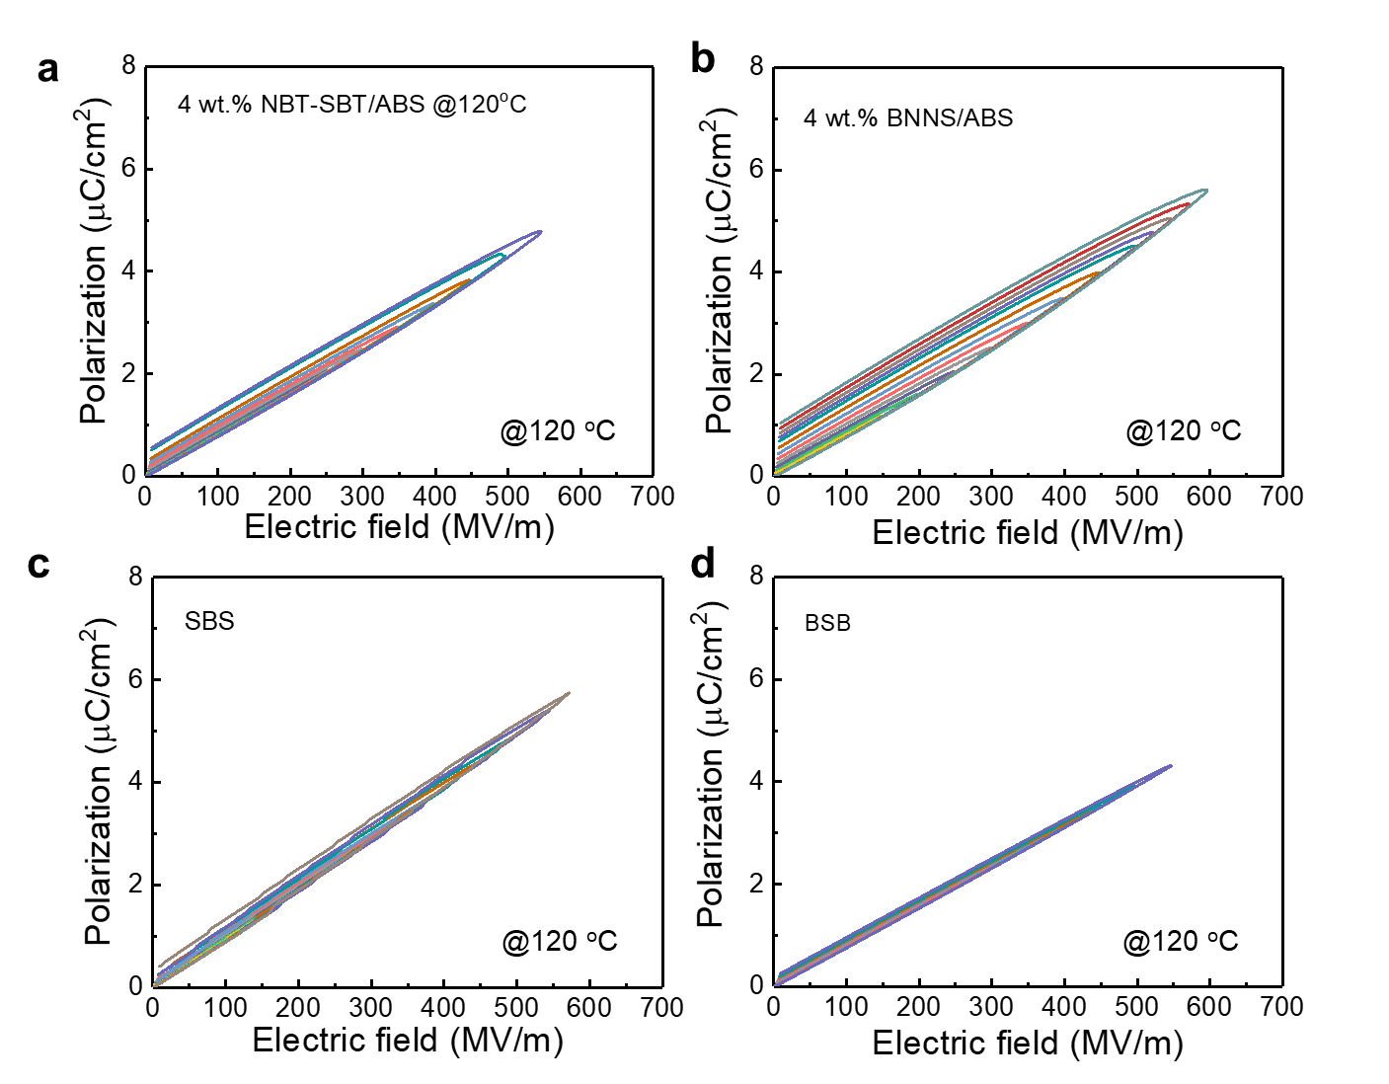
Supplementary Figure S11 The unipolar P-E loops at E_{b} single-layer and tri-layer ABS composites samples at evaluated temperature (120 ºC).

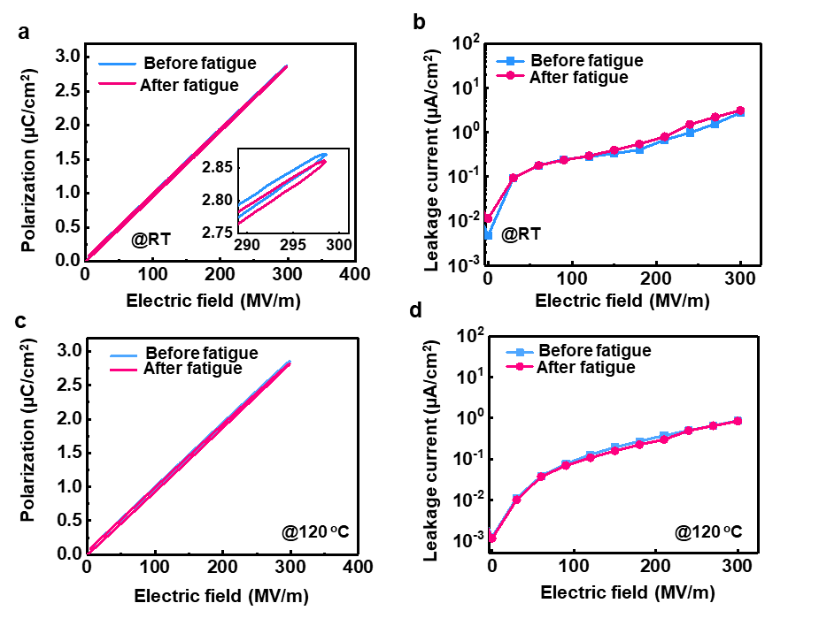
Supplementary Figure S12 (a) Unipolar P-E loops and (b) leakage current of trilayer SBS composite film at 300 MV/m before and after 10⁶ cycles at room temperature (@RT), (c) Unipolar P-E loops and (d) leakage current of trilayer SBS composite film at 300 MV/m before and after 10⁶ cycles at evaluated temperature (120 ºC).

Section 5
First, the heat transport process when operating at applied electric field is described by:
(1)
where ρ is the charge density, C_{p} is the constant-pressure heat capacity, and κ is the thermal conductivity, respectively. When solving Equation (1), the heat flux at material surface is assumed to be controlled by the convective heat transfer by:
(2)
where T_{ext} is the surrounding temperature and h is the convective heat transfer coefficient. In this simulation, the influence of temperature change on the electrical conductivity of materials is considered. The ABS polymer would exhibit higher electrical conductivity as the temperature increases according to the experimental results, while the electrical conductivity of NBT-SBT and BN remains unchanged due to their excellent high temperature stability.
Based on the stochastic model proposed by Niemeyer et al, we established an electrical breakdown model to study the effect of filler microstructure on the breakdown process. Here, we introduce a variable u(r,t) to characterize the propagation path of electric trees in composites, where u(r,t)=1 indicates that the material has breakdown, and u(r,t)=0 indicates that the material has not breakdown. We assumed that dielectric breakdown occurs only when the local electric field is larger than the intrinsic breakdown strength of the material. Thus, the variable u(r,t) is controlled by:
(3)
where E(r) is the local electric field and E_{b}(r) is the intrinsic breakdown strength. H(E(r)-E_{b}(r)) is the Heaviside unit step function with H(E(r)<E_{b}(r))=0 and H(E(r)<E_{b}(r))=1. The local electric field distribution in the composites can be calculated by solving the following current continuity equation:
(4)
(5)
(6)
(7)
where J is current density, ρ_{V} is the space charge density, ε₀ is vacuum dielectric constant, ε_{r} is relative dielectric constant, σ is the electrical conductivity, and φ is the electric potential, respectively.Here, the values of parameters used in this model are shown in Table S1.
Table S1 The parameters of different phases used in this model
 | ABS | NBT-SBT | BNNS
thermal conductivity (W/m⁻¹ K⁻¹) | 0.02 | 2 | 300
dielectric constant | 4.5 | 2000 | 3.5
electrical conductivity (S/m) | 1e-8 @419K  8e-9 @411K  5e-9 @408K  3e-9 @405K | 1e-6 | 1e-15
theoretical breakdown strength (kV/mm) | E_{b}=35ε^{-0.64}

