Bile salt hydrolase/aminoacyltransferase shapes the microbiome
Douglas V. Guzior^{1,2}, Maxwell Okros², Christian Martin H.², Madison Shivel^{2,3}, Bruin Armwald^{2,3}, Robert P. Hausinger^{1,2}, and Robert A. Quinn²
¹Department of Microbiology and Molecular Genetics, Michigan State University, East Lansing, MI, USA
²Department of Biochemistry and Molecular Biology, Michigan State University, East Lansing, MI, USA
³College of Osteopathic Medicine, Michigan State University, East Lansing, MI, USA

Supplementary Data
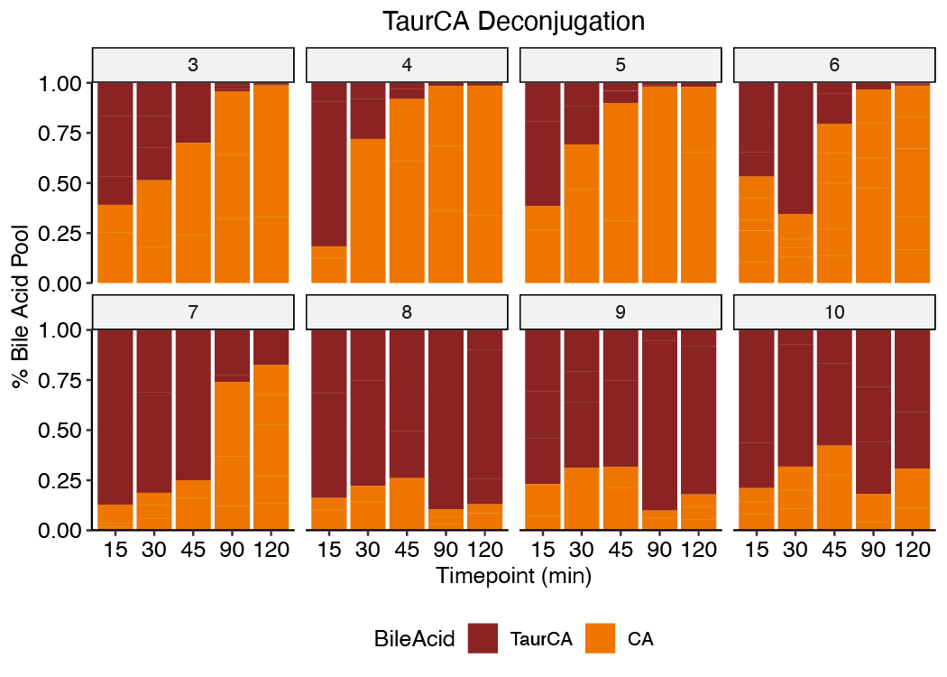
Figure S1. Proportion of TCA and CA in the bile acid pool when CpBSH/T was incubated with TCA for at different pH values across time. n =3 replicates.

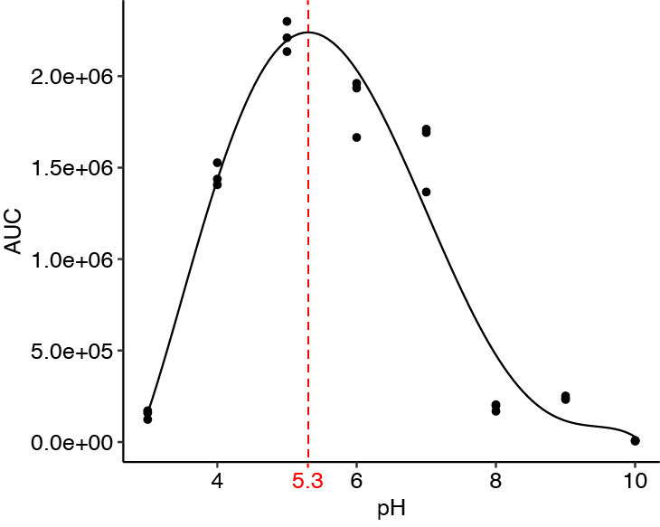
Figure S2. The pH dependence for bile acid conjugation by CpBSH/T. CpBSH/T was incubated with 2.5 mM TCA and 125 µM total concentration of equimolar amino acids. Total MCBA production was summed after 120 min incubation at various pH values. A 5-factor polynomial was used to fit the data (Table S1) and the red dashed line indicates the pH 5.3 optimum following derivation. n=3 replicates.
Figure S3. Nonmetric data scaling of amino acid use in BA conjugation. Bray-Curtis distances were calculated between strains capable of MCBA production for the averaged summed abundance of each amino acid conjugated to CA, based on GNPS-annotation of MCBAs. Color represents cluster assigned based on cluster analysis and dot size represents the logarithm of the average summed MCBA abundance. n = 3.

Supplementary Tables
Amino Acid | TCA | CA | GlyCA
Ala | 1.88E+04 (1.22E+02) | 1.54E+04 (5.90E+02) | 7.59E+03 (3.77E+02)
Arg | 2.95E+05 (7.18E+03) | 2.68E+05 (9.36E+03) | 1.72E+05 (3.18E+03)
Asn | 1.75E+05 (5.76E+03) | 0.00E+00 (0.00E+00) | 0.00E+00 (0.00E+00)
Cys | 7.22E+04 (9.33E+01) | 0.00E+00 (0.00E+00) | 0.00E+00 (0.00E+00)
Gln | 0.00E+00 (0.00E+00) | 1.38E+05 (1.44E+03) | 6.90E+04 (3.22E+03)
Glu | 5.04E+04 (1.59E+02) | 0.00E+00 (0.00E+00) | 0.00E+00 (0.00E+00)
Gly | 5.81E+04 (2.70E+03) | 6.90E+03 (2.74E+03) | N/A
His | 7.42E+05 (3.08E+04) | 5.63E+05 (1.88E+04) | 4.14E+05 (5.33E+03)
Ile/Leu | 1.12E+05 (5.52E+03) | 1.29E+05 (1.04E+03) | 7.17E+04 (1.61E+03)
Lys | 1.41E+05 (4.59E+03) | 9.13E+04 (3.59E+03) | 6.85E+04 (1.82E+03)
Met | 0.00E+00 (0.00E+00) | 1.16E+05 (2.76E+02) | 6.40E+04 (2.59E+03)
Phe | 1.29E+05 (4.83E+03) | 0.00E+00 (0.00E+00) | 0.00E+00 (0.00E+00)
Ser | 6.60E+04 (1.08E+03) | 0.00E+00 (0.00E+00) | 0.00E+00 (0.00E+00)
Thr | 8.54E+04 (2.66E+03) | 7.32E+04 (3.22E+03) | 3.95E+04 (1.42E+03)
Trp | 1.36E+05 (4.85E+03) | 4.84E+04 (6.61E+03) | 3.20E+04 (1.27E+03)
Tyr | 1.34E+05 (4.02E+03) | 1.07E+05 (2.01E+03) | 5.44E+04 (9.38E+02)
Val | 0.00E+00 (0.00E+00) | 5.48E+04 (1.41E+03) | 3.33E+04 (3.73E+02)
Table S1. Relative abundances of MCBAs produced by CpBSH/T when provided different BA substrates at pH 5 after 120 minute incubation. Data presented as mean with sem.

 | Dependent variable:
 | y
 | -1 | poly(2) | poly(3) | poly(4) | poly(5)
Constant | 2.002e+06*** | 9.630e+05*** | 9.630e+05*** | 9.630e+05*** | 9.630e+05***
 | -4.90E+05 | -1.06E+05 | -4.75E+04 | -4.79E+04 | -4.48E+04
x | -1.599e+05** | -1.795e+06*** | -1.795e+06*** | -1.795e+06*** | -1.795e+06***
 | -7.11E+04 | -5.19E+05 | -2.33E+05 | -2.35E+05 | -2.20E+05
x2 |  | -2.891e+06*** | -2.891e+06*** | -2.891e+06*** | -2.891e+06***
 |  | -5.19E+05 | -2.33E+05 | -2.35E+05 | -2.20E+05
x3 |  |  | 2.136e+06*** | 2.136e+06*** | 2.136e+06***
 |  |  | -2.33E+05 | -2.35E+05 | -2.20E+05
x4 |  |  |  | 1.96E+05 | 1.96E+05
 |  |  |  | -2.35E+05 | -2.20E+05
x5 |  |  |  |  | -4.231e+05*
 |  |  |  |  | -2.20E+05
Observations | 24 | 24 | 24 | 24 | 24
R² | 0.187 | 0.672 | 0.937 | 0.939 | 0.95
Adjusted R² | 0.15 | 0.641 | 0.928 | 0.926 | 0.936
Residual Std. Error | 7.98E+05 | 5.19E+05 | 2.33E+05 | 2.35E+05 | 2.20E+05
Residual Std. Error | (df = 22) | (df = 21) | (df = 20) | (df = 19) | (df = 18)
F Statistic | 5.061** | 21.526*** | 99.244*** | 73.479*** | 67.932***
F Statistic | (df = 1; 22) | (df = 2; 21) | (df = 3; 20) | (df = 4; 19) | (df = 5; 18)
Table S2. Goodness of fit outputs for curve fitting to determine CpBSH/T pH optimum. Values in parenthesis represent standard error. Based on the adjusted R2 values, the pH optimum was calculated using the 5-factor polynomial (bolded) by first taking the derivative and then solving for y = 0 between pH 3 and 10. *p<0.1; **p<0.05; ***p<0.01.

 | Phe-CA | Ser-CA | TCA | Vehicle | class.error
Phe-CA | 4 | 0 | 0 | 0 | 0
Ser-CA | 0 | 5 | 0 | 0 | 0
TCA | 0 | 0 | 5 | 0 | 0
Vehicle | 0 | 2 | 0 | 2 | 0.5
Table S5. Cecum random forest confusion matrix and error rate. The overall out-of-bag error rate for the model was 11.11%.
 | Phe-CA | Ser-CA | TCA | Vehicle | class.error
Phe-CA | 29 | 1 | 0 | 0 | 0.03333333
Ser-CA | 0 | 29 | 0 | 1 | 0.03333333
TCA | 0 | 0 | 30 | 0 | 0
Vehicle | 3 | 0 | 0 | 27 | 0.1
Table S7. Fecal random forest classification confusion matrix and error rate. The overall out-of-bag error rate for the model was 4.17%.

