Supplementary Information

A pragmatic approach for assessing risk of arsenic in water-soil-plant continuum in an arsenic endemic area (Nadia) of West Bengal, India
Rahul Mishra^{1,2}, Siba Prasad Datta^{1*}, Debasis Golui^{1,3}, Mahesh Chand Meena¹, Bramha Swaroop Dwivedi⁴, Kali Kingkar Bandyopadhyay¹, Arti Bhatia¹, Mohammad Mahmudur Rahman⁵, Arkaprava Roy¹, and Punyavrat S. Pandey⁶
¹ ICAR-Indian Agricultural Research Institute, New Delhi, India
² ICAR- Indian Institute of Soil Science, Bhopal, India
³ Department of Civil, Construction and Environmental Engineering, North Dakota State
University, Fargo, USA
⁴ ICAR- National Bureau of Soil Survey & Land Use Planning, Nagpur, India
⁵ Global Centre for Environmental Remediation (GCER), College of Engineering, Science and Environment, The University of Newcastle, Callaghan, NSW, 2308, Australia.
⁶ Education Division, Indian Council of Agricultural Research, New Delhi 110 012, India

*Corresponding author at: ICAR-Indian Agricultural Research Institute, New Delhi, India
E-mail address: profssac2017@gmail.com, Mobile No. +91 8376836507

A pragmatic approach for assessing risk of arsenic in water-soil-plant continuum in arsenic endemic area (Nadia) of West Bengal, India

Section A1. Sampling information
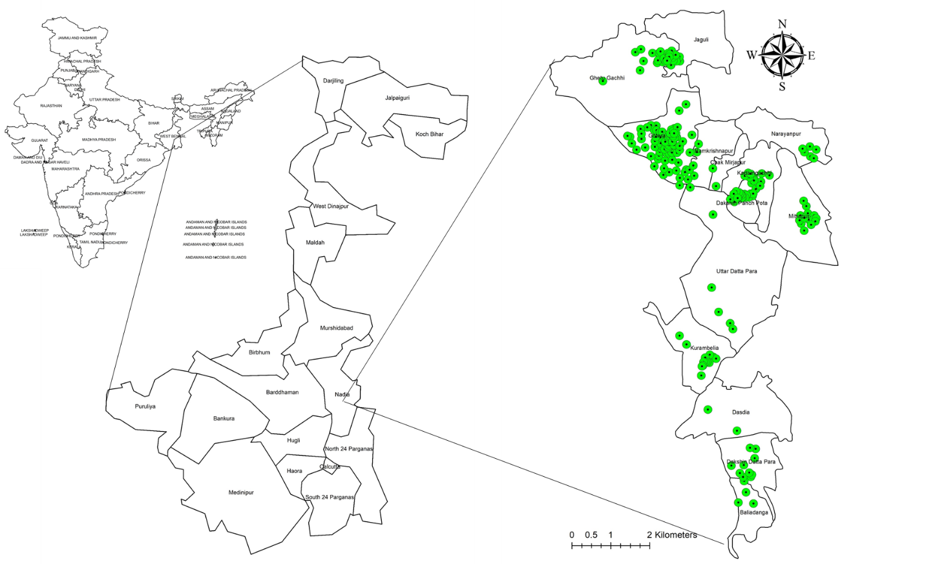
Figure S1: Map showing the origin of samples
Section A2. Analysis of water samples
pH and electrical conductivity (EC)
The pH of water samples was determined directly using combined electrode (glass and calomel electrodes) by digital pH meter (Jackson, 1973). The electrical conductivity (EC) was determined in the same sample with the help of Conductivity Bridge and expressed in dS m⁻¹ at 25 °C (Jackson, 1973).
Phosphorus
Phosphorus content in the filtered aliquot was determined by ascorbic acid method (Watanabe and Olsen 1965).
Potassium and Sodium
Potassium and Sodium content in the aliquot was measured directly by flame photometer (Jackson, 1973).
Calcium and Magnesium
Calcium and Magnesium content in the aliquot was measured directly by Atomic absorption spectrometer (AAS, Z-Xpress 8000, Spectrum).
Sulphur: Sulphur in the aliquot was determined by turbidimetric method (Chesnin and Yien 1950).
Metals and metalloids
Content of Zn, Cu, Fe, Mn and As in the filtered water samples were determined directly with the help of ICP-MS (Nexlon 300 ×, Perkin Elmer, USA) after acidifying the sample with HNO₃ (2% HNO₃). The instrument was calibrated with ICP multi-element standard solution (Merck KGaA, Germany).
Section A3. Determination of soil properties
Soil pH and electrical conductivity (EC)
The pH of soil was determined in 1:2.5 (soil: water) suspension using combined electrode (glass and calomel electrodes) by digital pH meter. The electrical conductivity (EC) was determined in the supernatant liquid of the same extracts with the help of Conductivity Bridge and expressed in dS m⁻¹ at 25 °C (Jackson, 1973).
Soil organic carbon
For determination of oxidizable organic carbon, soil samples were sieved and pass through 0.2 mm sieve. Organic carbon content in soil was determined by wet oxidation method using K₂Cr₂O₇ as outlined by Walkley and Black (1934).
Arsenic content in soil samples
For extractable As, 2.5 g of processed soil was extracted with 50 mL solution of 0.5 M NaHCO₃ (pH 8.5) for thirty minutes in a 150 mL conical flask (Olsen, 1954). After filtration with Whatman No.42-filter paper, concentration of As in the filtrate was measured by AAS (Z-Xpress 8000, Spectrum, Germany), coupled with hydride generator unit (AAS-HG). For determination of extractable As, 10 mL of aliquot was taken in a 50 mL volumetric flask. Then 5 mL of concentrated (30%) suprapure-HCl (Merck KGaA, Germany) was added to create an acidic environment in the sample. Then 5 mL of 5% KI (v/v) and 5 mL of 5% ascorbic acid (v/v) were added for further reduction of As present in the sample. Before analysis through AAS-HG, sample was incubated for about 45 minutes, after that volume was made up to 50 mL with Milli-Q water. Instrument was calibrated with range of standard solutions (0, 10, 20, 40 and 50 µg L⁻¹; ICP multi-element standard solution (Merck KGaA, Germany). During analysis, 0.2% NaBH₄ and 10% HCl (suprapure) were injected separately from two containers through flow analyzer for further reduction of As present in the sample.
Section A4. Analysis of plant samples
Digestion of plant samples
Brown rice grain and straw samples were digested with concentrated (65%) suprapure nitric acid (Merck KGaA, Germany) in a microwave digester (Multiwave ECO, Anton Paar). For this purpose, 0.5 g processed plant sample was taken into PTFE-TFM vessel, to which 7 mL suprapure-HNO₃ was added. The operational programs were set as follows: a ramp time of 25 min was used to reach a temperature of 180-190 ºC and a hold time of another 25 min was used to maintain the temperature at 180-190 ºC (Golui et al., 2017). After completion of digestion, the vessels were cooled to room temperature, vented and opened. Milli-Q water was added to the vessel and it was shaken thoroughly with its mouth closed to ensure the complete transfer of content. The content was filtered through Whatman No. 42 filter paper and the volume was made up to 50 mL in a volumetric flask using Milli-Q water.
Determination of As in plant samples
Total As in digest was determined with ICP-MS (PerkinElmer NexION 300). Instrument was calibrated with ICP multi-element standard solution (Merck KGaA, Germany). Similar procedure without plant sample was carried out for preparing blank.

Section A5
Table S1. Descriptive statistics of physicochemical properties of soils and plant As content in Nadia
Parameters | pH | EC  (dS m⁻¹) | WBC (%) | Extractable As (mg kg⁻¹) | Grain As (mg kg⁻¹) | Straw As (mg kg⁻¹) | HQ (grain)
Mean | 7.56 | 0.37 | 1.06 | 1.45 | 0.43 | 3.48 | 0.58
Minimum | 5.38 | 0.23 | 0.60 | 0.48 | 0.20 | 0.88 | 0.27
Maximum | 8.05 | 0.68 | 1.67 | 3.57 | 0.61 | 11.1 | 0.83
Median | 7.65 | 0.36 | 1.07 | 1.39 | 0.44 | 3.13 | 0.60
Mode | 7.69 | 0.40 | 1.07 | 1.02 | 0.57 | 2.43 | 0.77
SE | 0.02 | 0.01 | 0.02 | 0.04 | 0.01 | 0.10 | 0.01
SD | 0.34 | 0.08 | 0.23 | 0.58 | 0.11 | 1.46 | 0.15
Variance | 0.12 | 0.01 | 0.05 | 0.33 | 0.01 | 2.12 | 0.02
Kurtosis | 10.40 | 1.32 | 0.02 | 0.99 | -0.95 | 4.96 | -0.95
Skewness | -2.57 | 0.96 | 0.25 | 0.90 | -0.32 | 1.70 | -0.32
SE = Standard Error, SD =Standard Deviation

Section A6
Table S2. Principal component analysis of different water quality parameters
 | PC1 | PC2 | PC3 | PC4 | PC5 | PC6
As | -0.68 | -0.02 | -0.25 | -0.05 | -0.20 | 0.12
pH | -0.49 | 0.73 | -0.14 | 0.05 | 0.19 | 0.26
EC | 0.76 | 0.17 | 0.13 | -0.04 | -0.21 | 0.27
Fe | -0.76 | -0.32 | -0.11 | -0.02 | 0.03 | -0.13
Mn | -0.65 | -0.19 | -0.23 | -0.23 | 0.06 | 0.40
Zn | -0.41 | 0.41 | 0.54 | 0.05 | 0.27 | -0.30
Cu | 0.02 | 0.18 | 0.78 | -0.36 | 0.28 | 0.08
Na | 0.78 | 0.10 | -0.26 | 0.06 | -0.30 | 0.00
K | -0.19 | -0.19 | 0.50 | 0.52 | -0.22 | 0.53
Ca | 0.47 | -0.32 | -0.13 | 0.31 | 0.68 | 0.10
Mg | 0.70 | 0.27 | 0.27 | -0.31 | 0.05 | 0.35
CO₃²⁻ | -0.11 | 0.40 | 0.01 | 0.74 | 0.06 | -0.01
HCO₃⁻ | -0.63 | 0.63 | 0.18 | -0.06 | -0.28 | -0.02
SO₄²⁻ | 0.06 | -0.44 | 0.71 | 0.15 | -0.30 | -0.29
PO₄³⁻ | -0.53 | -0.63 | 0.26 | -0.07 | 0.06 | 0.27
Eigenvalue | 4.49 | 2.26 | 2.07 | 1.23 | 1.04 | 1.01
Variability (%) | 29.95 | 15.0 | 13.8 | 8.22 | 6.96 | 6.71
Cumulative (%) | 29.95 | 44.99 | 58.76 | 66.98 | 73.94 | 80.64

Section A7

Figure S1. Comparison between observed and predicted hazard quotient based on solubility and free ion activity model

References
Chesnin, L., Yien, C.H., 1951. Turbidimetric determination of available sulfates. Soil Sci. Soc. Am. J. 15(C),149-151.
Golui, D., Datta, S.P., Meena, M.C., Shukla, A.K. 2017. Determination of arsenic in water, soil, plant and biomarker. Manual on Advance Techniques for Analysis of Nutrients and Pollutant Elements in Soil, Plant and Human, Eds. S.P. Datta, M.C. Meena, B.S. Dwivedi and A.K. Shukla. Westville Publishing House, New Delhi (ISBN 978-93-83491-87-2).
Jackson, M.L., 1973. Soil Chemical Analysis. Prentice Hall of India Private Limited, New Delhi.
Olsen, S.R., Cole, C.V., Watanabe, F.S., Dean, L.A., 1954. Estimation of available phosphorus in soil by extraction with sodium bicarbonate. U.S. Department of Agricultural Repot. Circular no. 93.
Walkley, A., Black, I.A., 1934. An examination of the Degtjareff method for determining Soil Organic matter, and a proposed modification of the Chromic Acid Titration Method. Soil Sci. 37, 29–38.
Watanabe, F.S., Olsen, S.R., 1965. Test of an ascorbic acid method for determining phosphorus in water and NaHCO₃ extracts from soil. Soil Sci. Soc. Am. J. 29(6), 677-678.

