An integrated strain-level analytic pipeline utilizing longitudinal metagenomic data
Boyan Zhou¹, Chan Wang¹, Gregory Putzel², Jiyuan Hu¹, Menghan Liu³, Fen Wu⁴, Yu Chen⁴, Alejandro Pironti², Huilin Li¹*

1 Division of Biostatistics, Department of Population Health, New York University School of Medicine, New York, New York 10016, USA
2 Department of Microbiology, New York University School of Medicine, New York, New York 10016, USA
3 Department of Biological Sciences, Columbia University in the City of New York, New York, New York 10027, USA
4 Division of Epidemiology, Department of Population Health, New York University School of Medicine, New York, New York 10016, USA

Correspondence: Huilin.Li@nyulangone.org

Supporting Information
Contents
The full list of 44 screened species in the real data analysis of TEDDY dataset 3
Supplemental Figures 4
Supplemental Figure S1. Recall and precision of StrainPhlAn, MIDAS, and LongStrain in Bacteroides fragilis with average depth of 5$×$, 10$×$, and 20$×$ under different scenarios 4
Supplemental Figure S2. Recall and precision of StrainPhlAn, MIDAS, and LongStrain in Bifidobacterium adolescentis under stable and transitional scenarios. 5
Supplemental Figure S3. Recall and precision of StrainPhlAn, MIDAS, and LongStrain in Staphylococcus aureus under stable and transitional scenarios. 5
Supplemental Figure S4. Recall and precision of StrainPhlAn, MIDAS, and LongStrain in Enterococcus faecalis under stable and transitional scenarios. 6
Supplemental Figure S5. Recall and precision of StrainPhlAn, MIDAS, and LongStrain in Listeria monocytogenes under stable and transitional scenarios. 6
Supplemental Figure S6. Comparison of the report rate (proportion of reported species in the 20 species) of ConStrains and LongStrain under stable and transitional scenarios. 7
Supplemental Figure S7. Recall and precision of StrainPhlAn, MIDAS, and LongStrain in Helicobacter pylori under different scenarios. 7
Supplemental Figure S8. Number of samples that have a dominant strain in 26 species. 8
Supplemental Figure S9. Number of subjects with/without a strain transition in 26 species. 8
Supplemental Figure S10. The scatter plots of time of the first transition and early life events (antibiotic treatment and weaning). 9
Supplemental Figure S11. Distribution of variant similarities in Akkermansia muciniphila. 10
Supplemental Figure S12. Distribution of variant similarities in Bacteroides uniformis. 11
Supplemental Figure S13. Distribution of variant similarities in Bifidobacterium longum. 12
Supplemental Figure S14. Phylogenetic tree of six species: 13
Supplemental Tables 14
Supplemental Table S1. Strains of species in Gut20 with numbers of true variants relative to reference genomes from MIDAS 14
Supplemental Table S2. The accuracy of the estimated proportion of the primary strain by ConStrains and LongStrain in single-species simulation under the transitional scenario 15
Supplemental Table S3. The accuracy of the estimated proportion of the primary strain by ConStrains and LongStrain in single-species simulation under the stable scenario 16
Supplemental Table S4. Association test of the log2-ratio (primary strain proportion/ secondary strain proportion) and the birth mode (caesarian or vaginal) by the linear mixed model 17

The full list of 44 screened species in the real data analysis of TEDDY dataset
Bifidobacterium bifidum, Bifidobacterium breve, Bifidobacterium catenulatum, Bifidobacterium longum, Bifidobacterium pseudocatenulatum, Bifidobacterium dentium, Bifidobacterium adolescentis, Bacteroides caccae, Bacteroides fragilis, Bacteroides sp. A1C1, Bacteroides thetaiotaomicron, Bacteroides uniformis, Bacteroides vulgatus, Staphylococcus aureus, Streptococcus mitis, Streptococcus oralis, Streptococcus parasanguinis, Streptococcus pneumoniae,
Streptococcus pseudopneumoniae, Streptococcus sp. 116-D4, Streptococcus thermophilus, Staphylococcus epidermidis, Lactobacillus rhamnosus, Lactococcus lactis, Enterococcus avium, Enterococcus faecalis, Enterococcus faecium, Enterococcus casseliflavus, Eggerthella lenta, Roseburia hominis, Rothia mucilaginosa, Clostridium butyricum, Clostridium perfringens, Anaerostipes hadrus, Anaerostipes rhamnosivorans, Roseburia intestinalis, Lachnospiraceae bacterium GAM79, Faecalibacterium prausnitzii, Flavonifractor plautii, Ruthenibacterium lactatiformans, Veillonella parvula, Escherichia coli, Akkermansia muciniphila, Helicobacter pylori.

Supplemental Figures
Supplemental Figure S1. Recall and precision of StrainPhlAn, MIDAS, and LongStrain in Bacteroides fragilis with average depth of 5$×$, 10$×$, and 20$×$ under different scenarios.

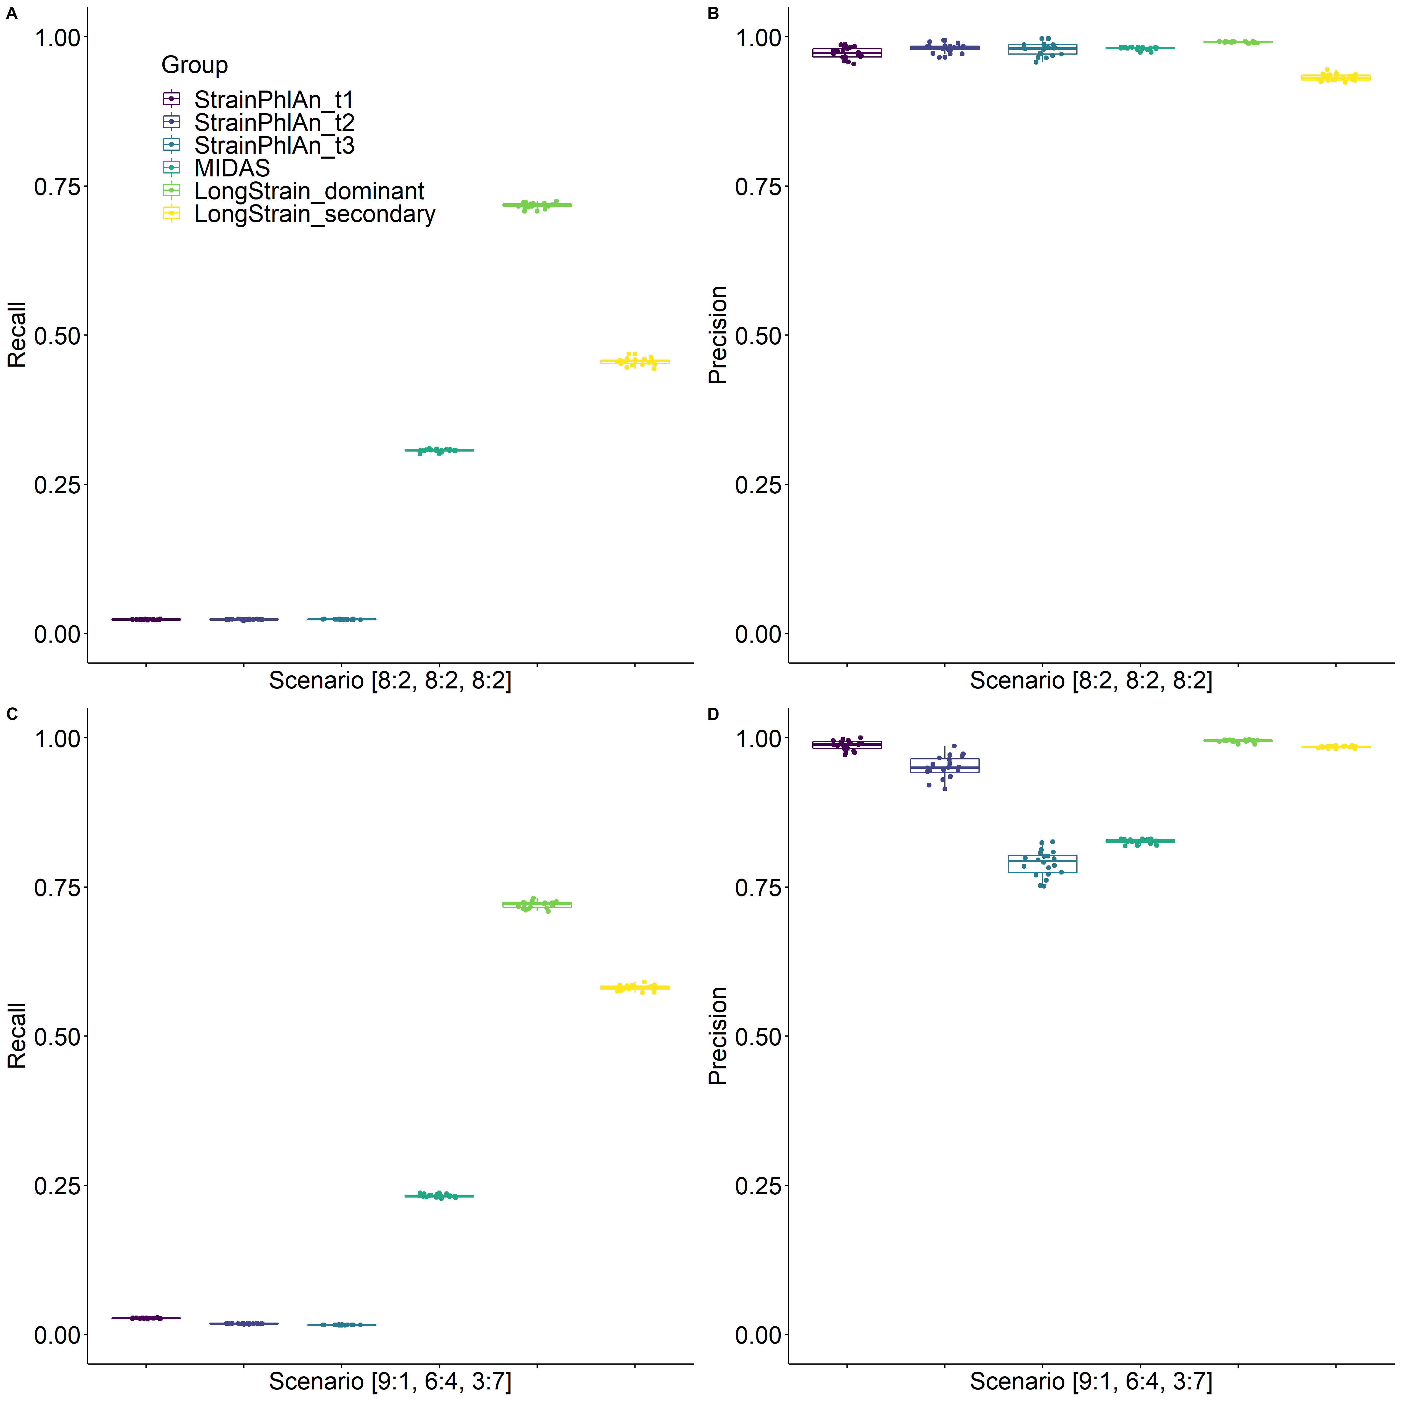
Supplemental Figure S2. Recall and precision of StrainPhlAn, MIDAS, and LongStrain in Bifidobacterium adolescentis under stable and transitional scenarios.
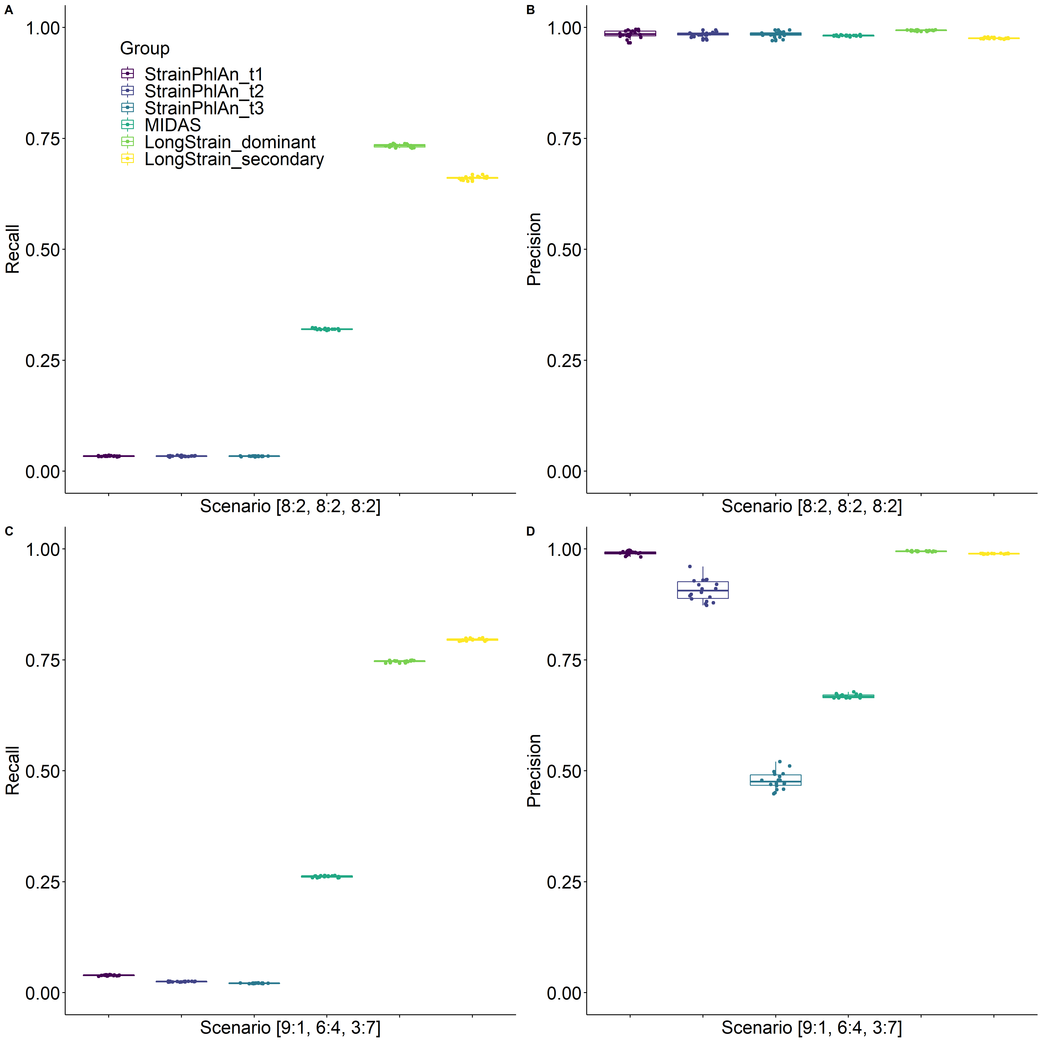

Supplemental Figure S3. Recall and precision of StrainPhlAn, MIDAS, and LongStrain in Staphylococcus aureus under stable and transitional scenarios.

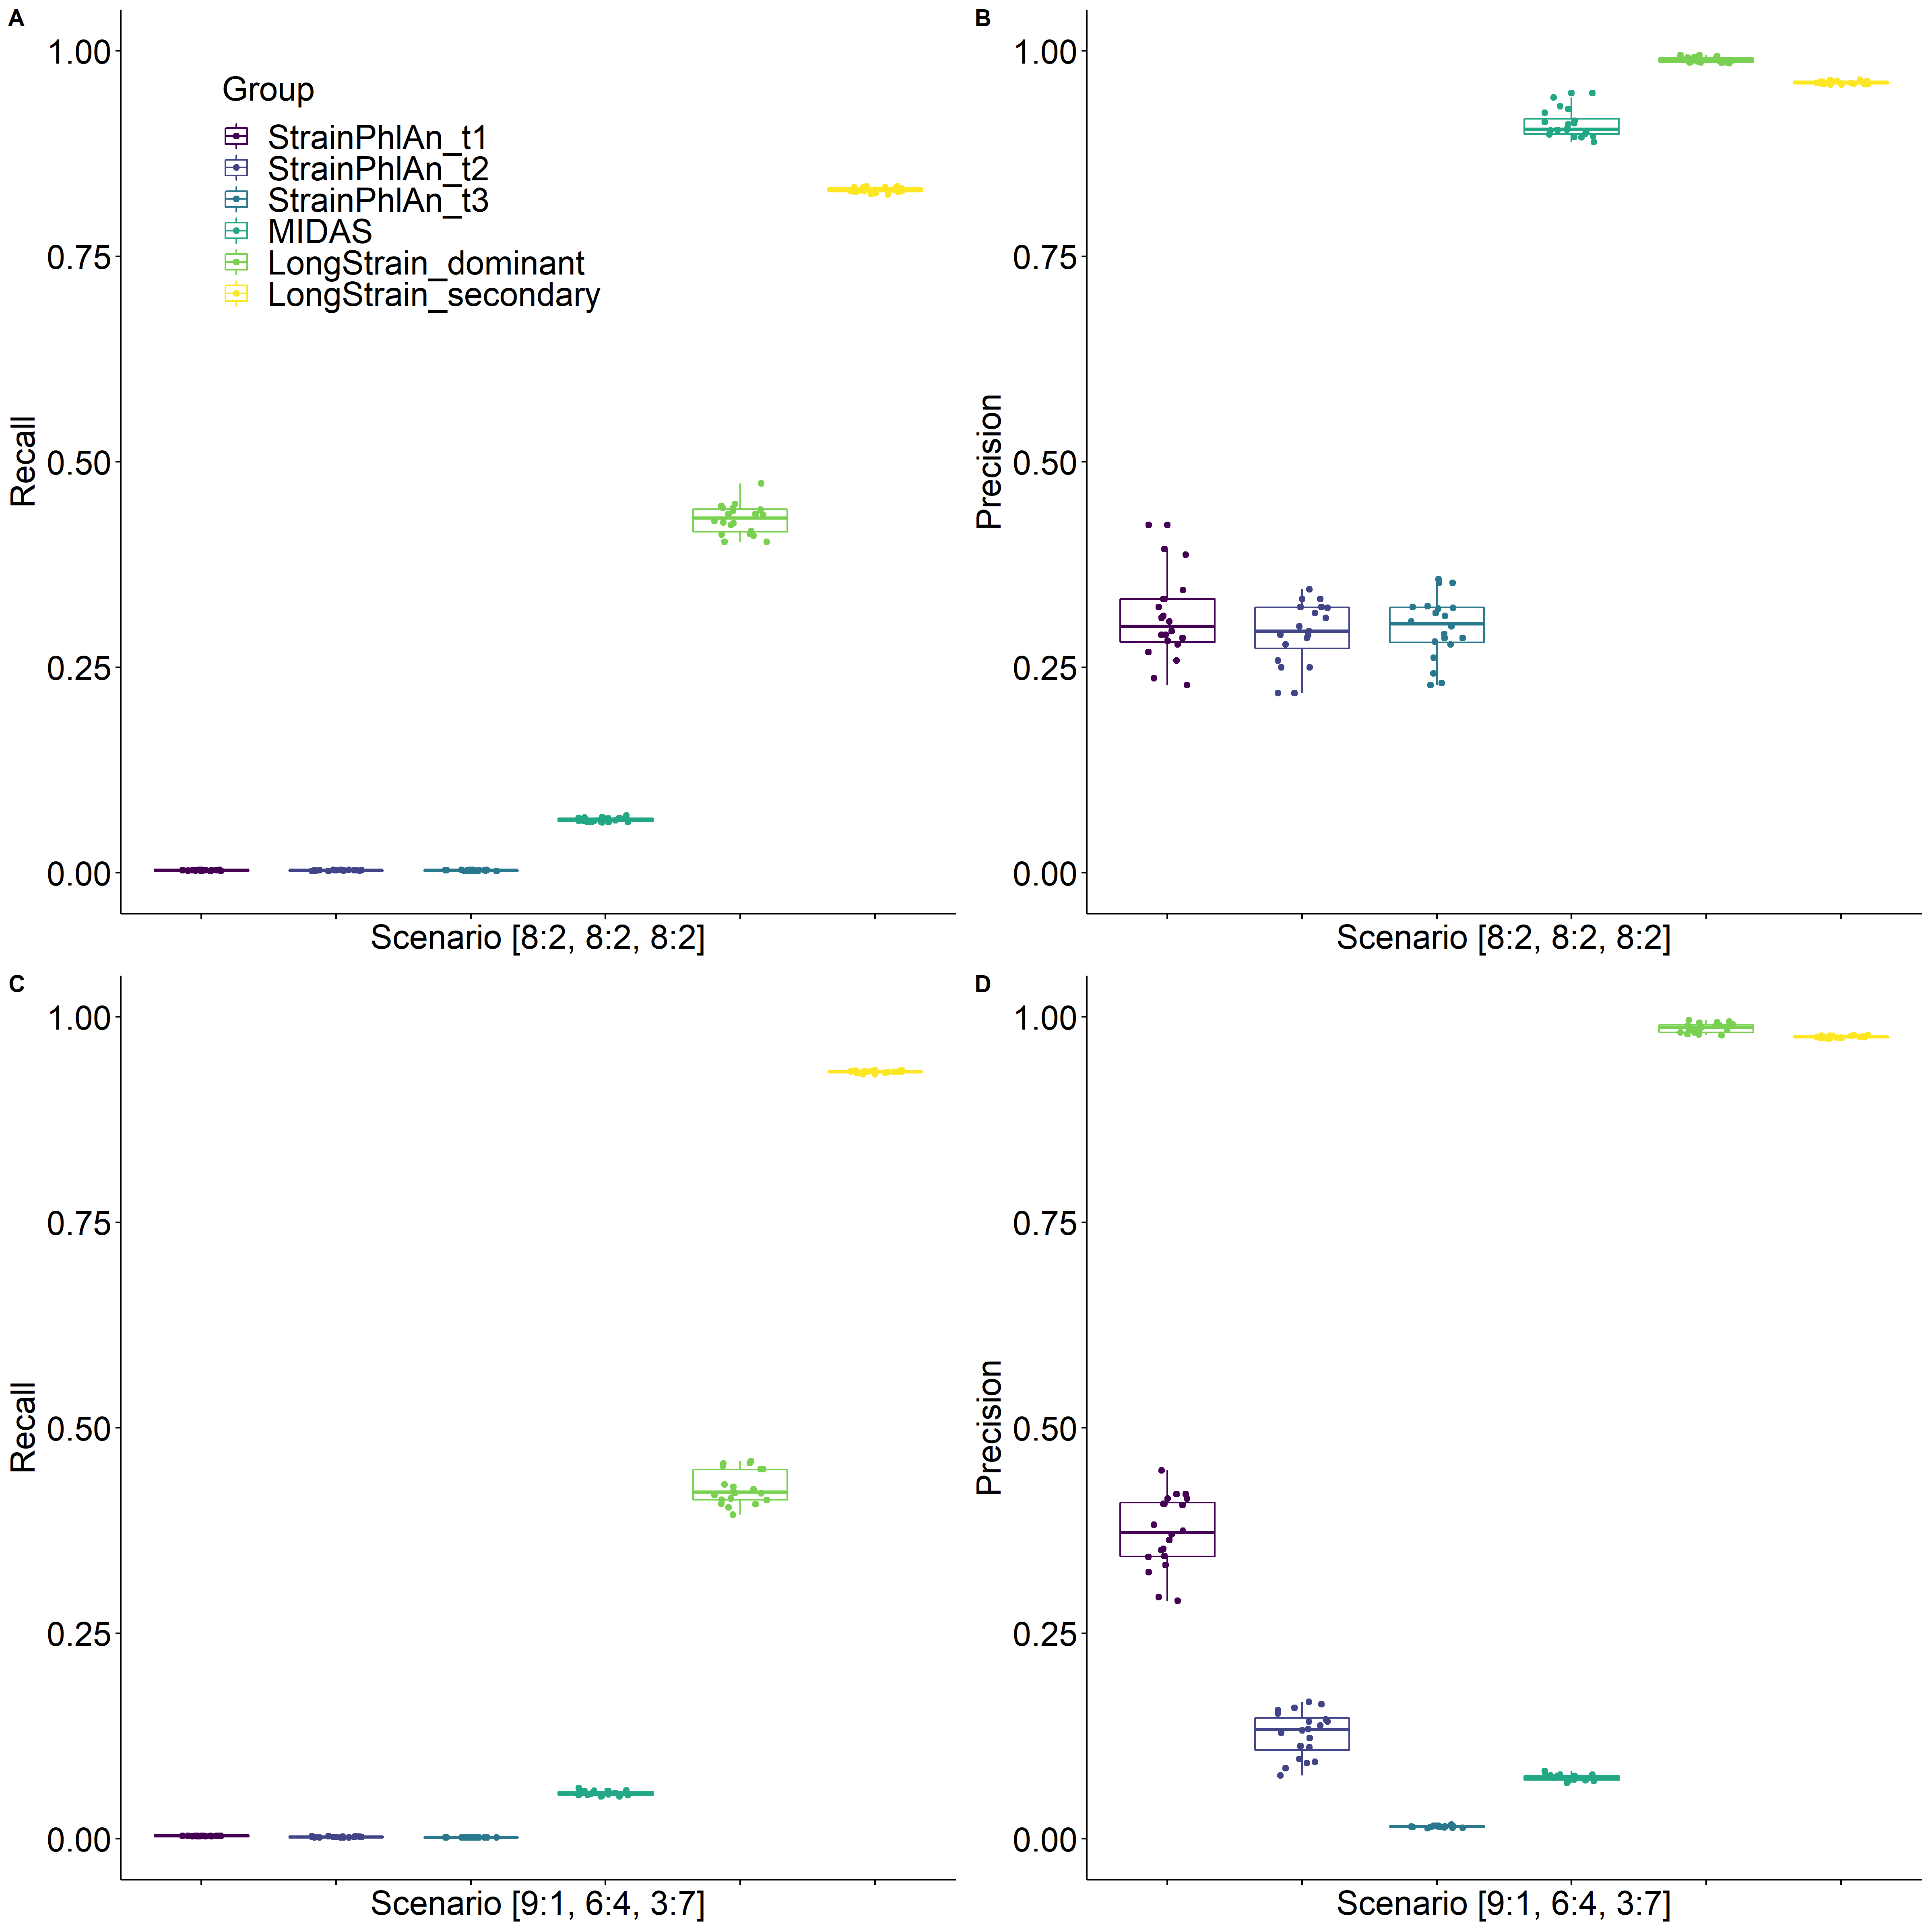
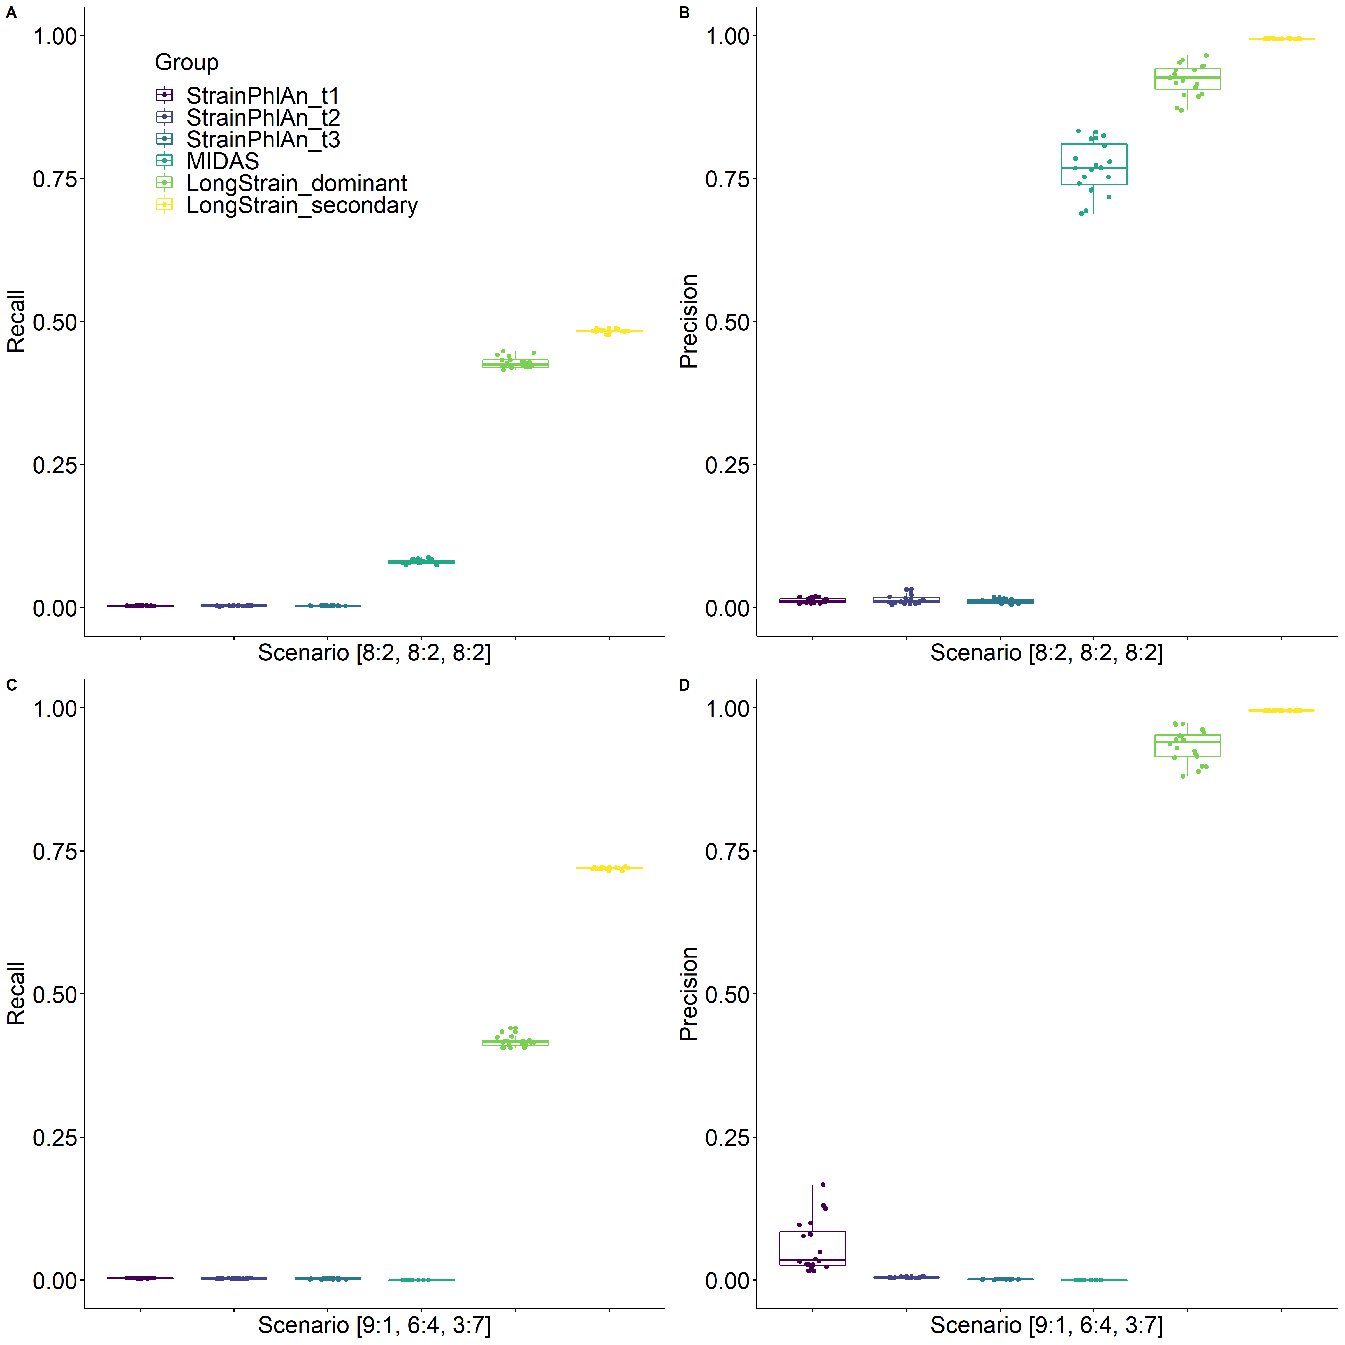
Supplemental Figure S4. Recall and precision of StrainPhlAn, MIDAS, and LongStrain in Enterococcus faecalis under stable and transitional scenarios.

Supplemental Figure S5. Recall and precision of StrainPhlAn, MIDAS, and LongStrain in Listeria monocytogenes under stable and transitional scenarios.

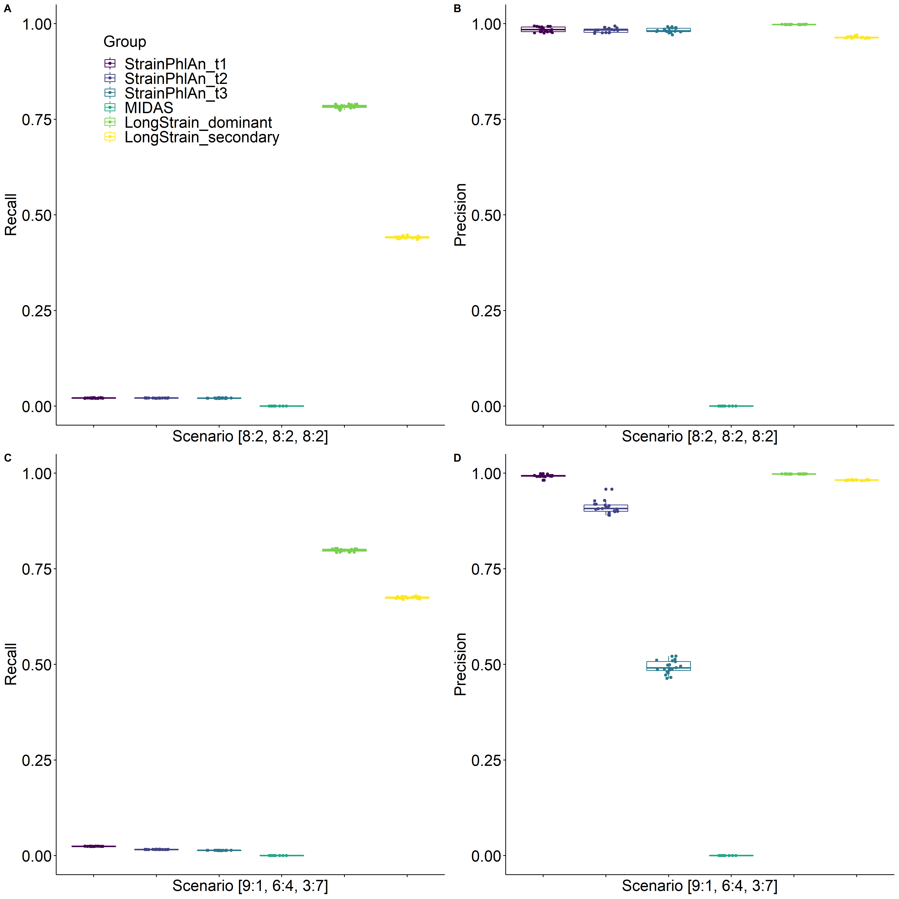
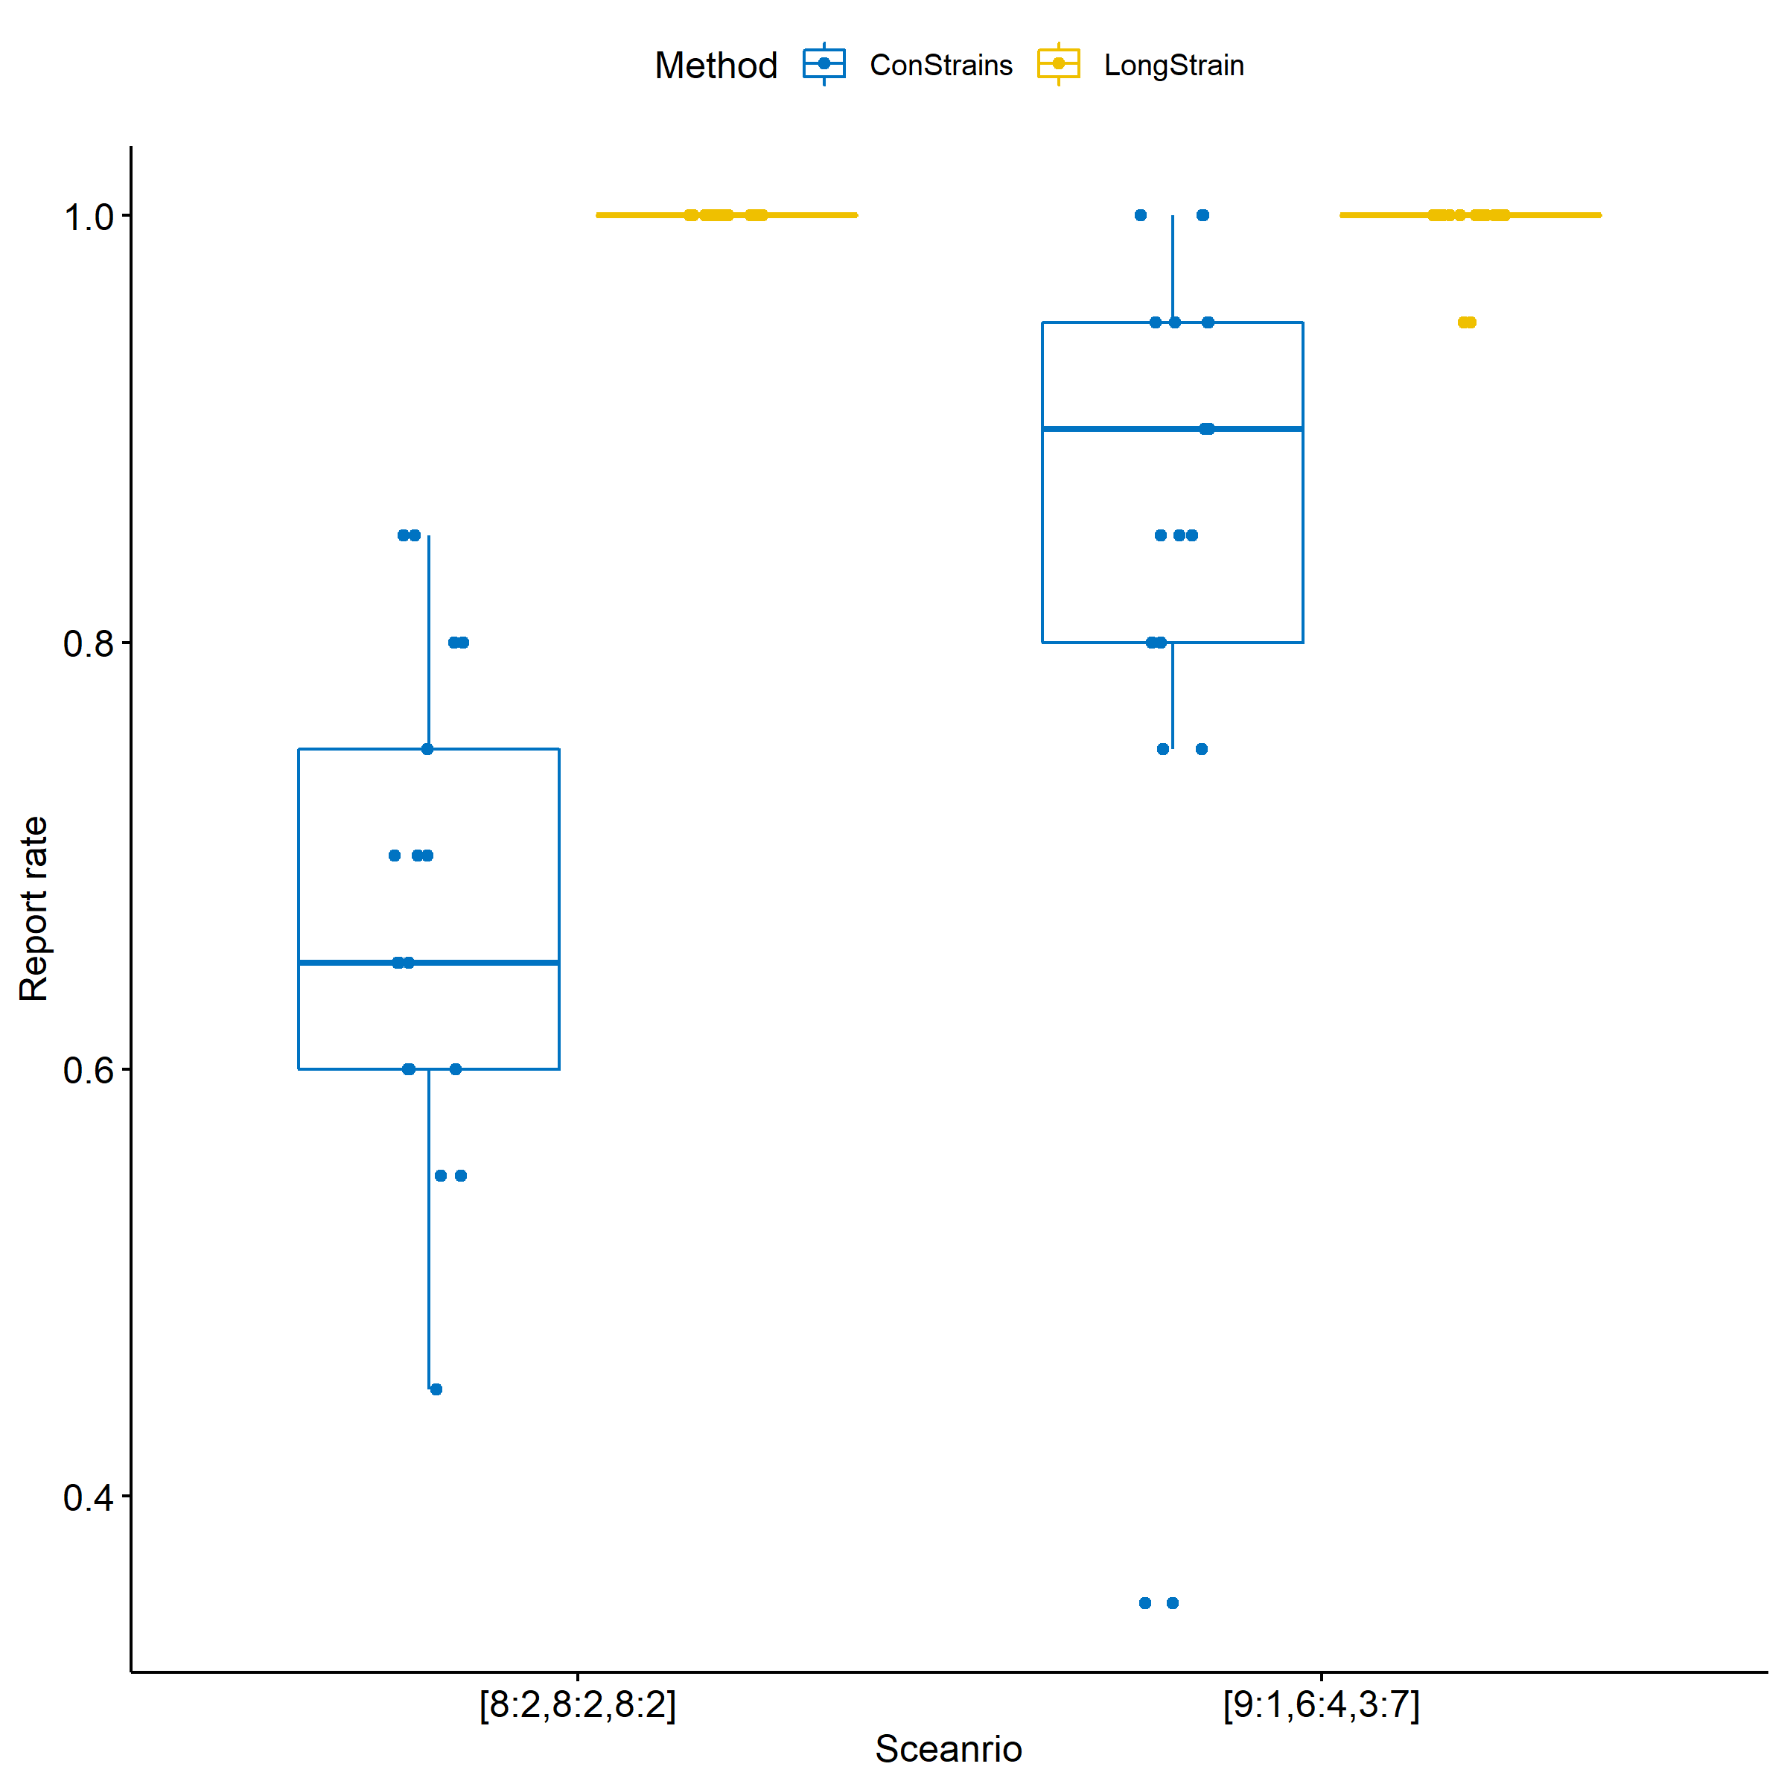
Supplemental Figure S6. Comparison of the report rate (proportion of reported species in the 20 species) of ConStrains and LongStrain under stable and transitional scenarios.

Supplemental Figure S7. Recall and precision of StrainPhlAn, MIDAS, and LongStrain in Helicobacter pylori under different scenarios.

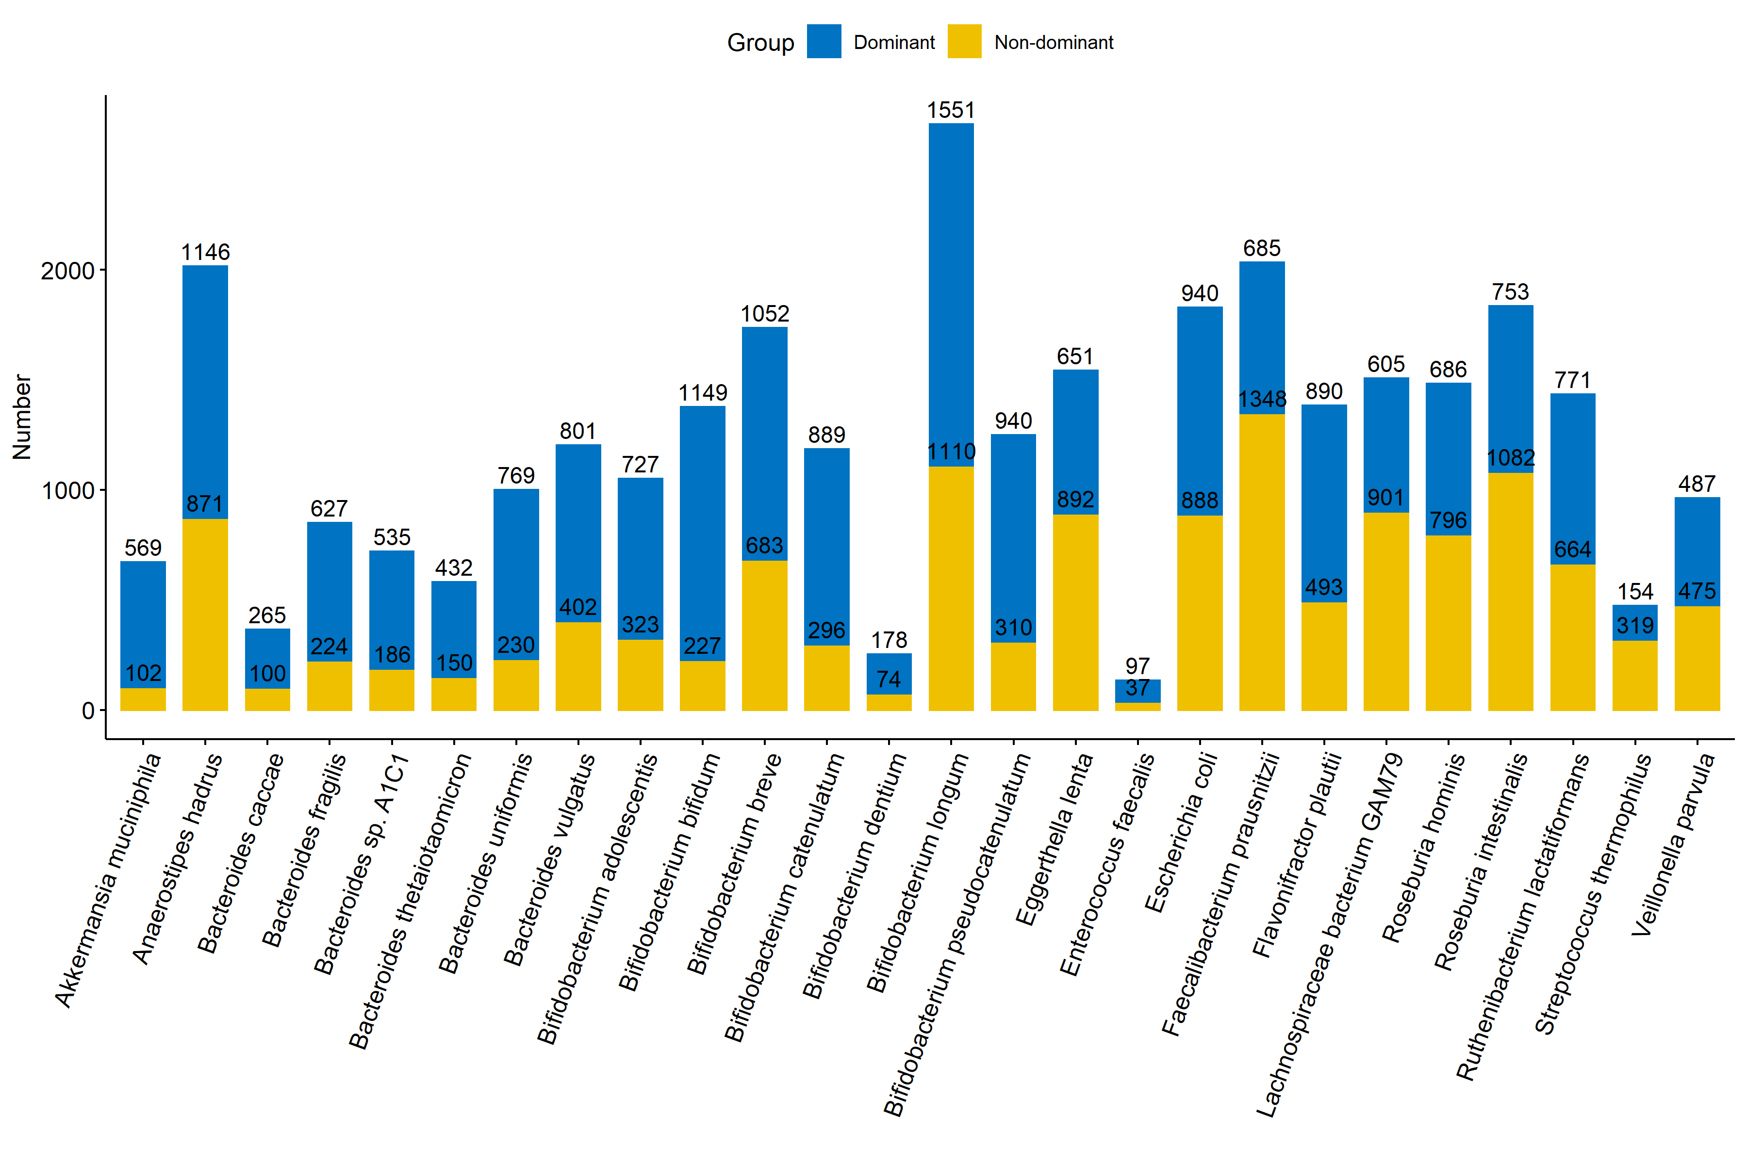
Supplemental Figure S8. Number of samples that have a dominant strain in 26 species. We define p as the proportion of a strain within its species at one time. The dominated strain is defined as the strain with p>80% at a certain time point. Blue: samples with a dominant strain; yellow: samples without a dominant strain.
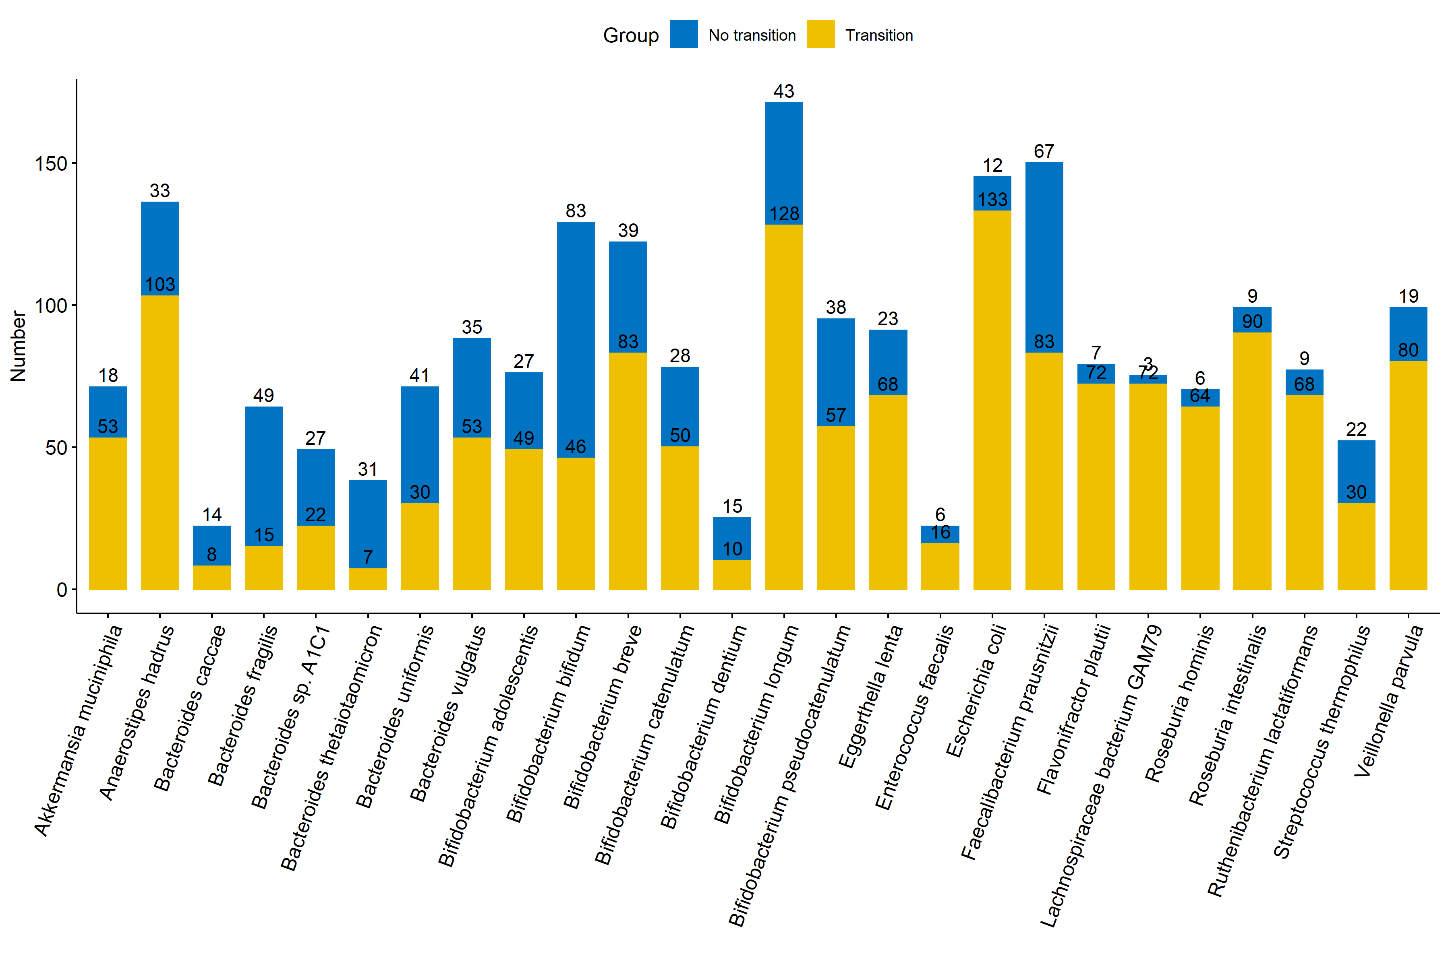
Supplemental Figure S9. Number of subjects with/without a strain transition in 26 species. We define the major strain as the strain with proportion >50% within its species in one sample. We summarized whether a strain transition happened in all subjects with sufficient read counts. Blue: subjects without a strain transition; yellow: subjects with at least one strain transition.

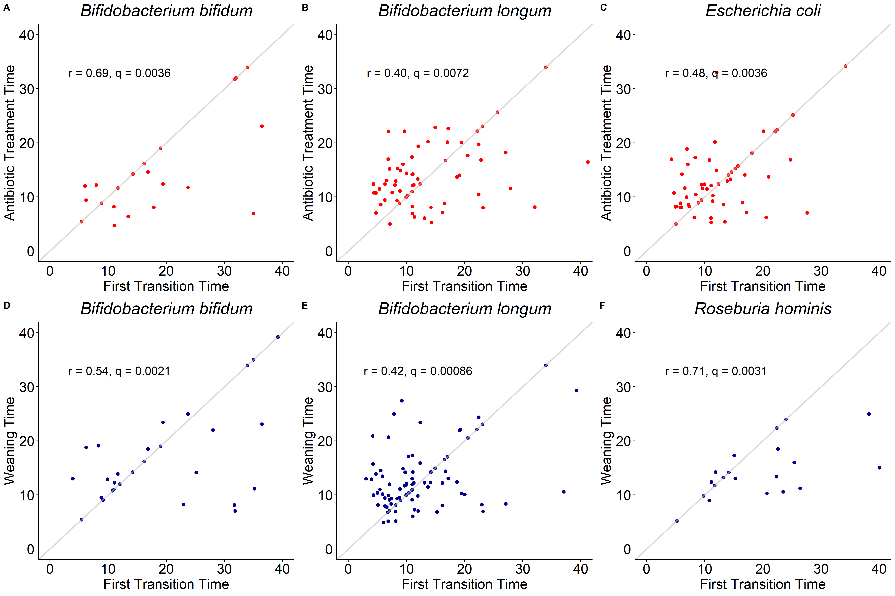
Supplemental Figure S10. The scatter plots of time of the first transition and early life events (antibiotic treatment and weaning). A. Time of antibiotic treatment in Bifidobacterium bifidum; B. time of antibiotic treatment in Bifidobacterium longum; C. time of antibiotic treatment in Escherichia coli; D. time of weaning in Bifidobacterium bifidum; E. time of weaning in Bifidobacterium longum; F. time of weaning in Roseburia hominis.

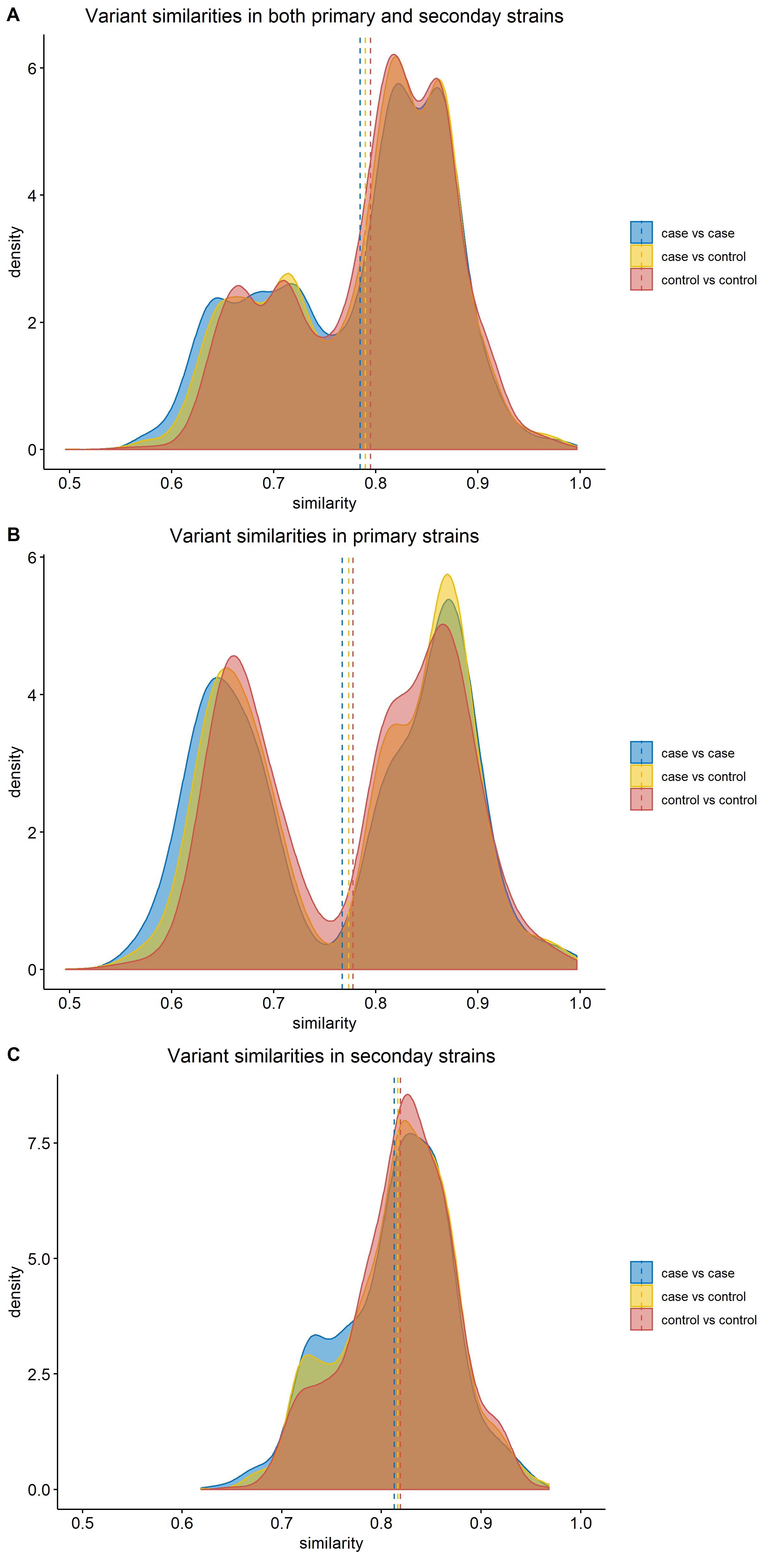
Supplemental Figure S11. Distribution of variant similarities in Akkermansia muciniphila. (A) Variant similarities of “case vs case”, “case vs control”, and “control vs control” in both primary and secondary strains; (B) variant similarities of “case vs case”, “case vs control”, and “control vs control” in primary strains; (C) variant similarities of “case vs case”, “case vs control”, and “control vs control” in secondary strains.

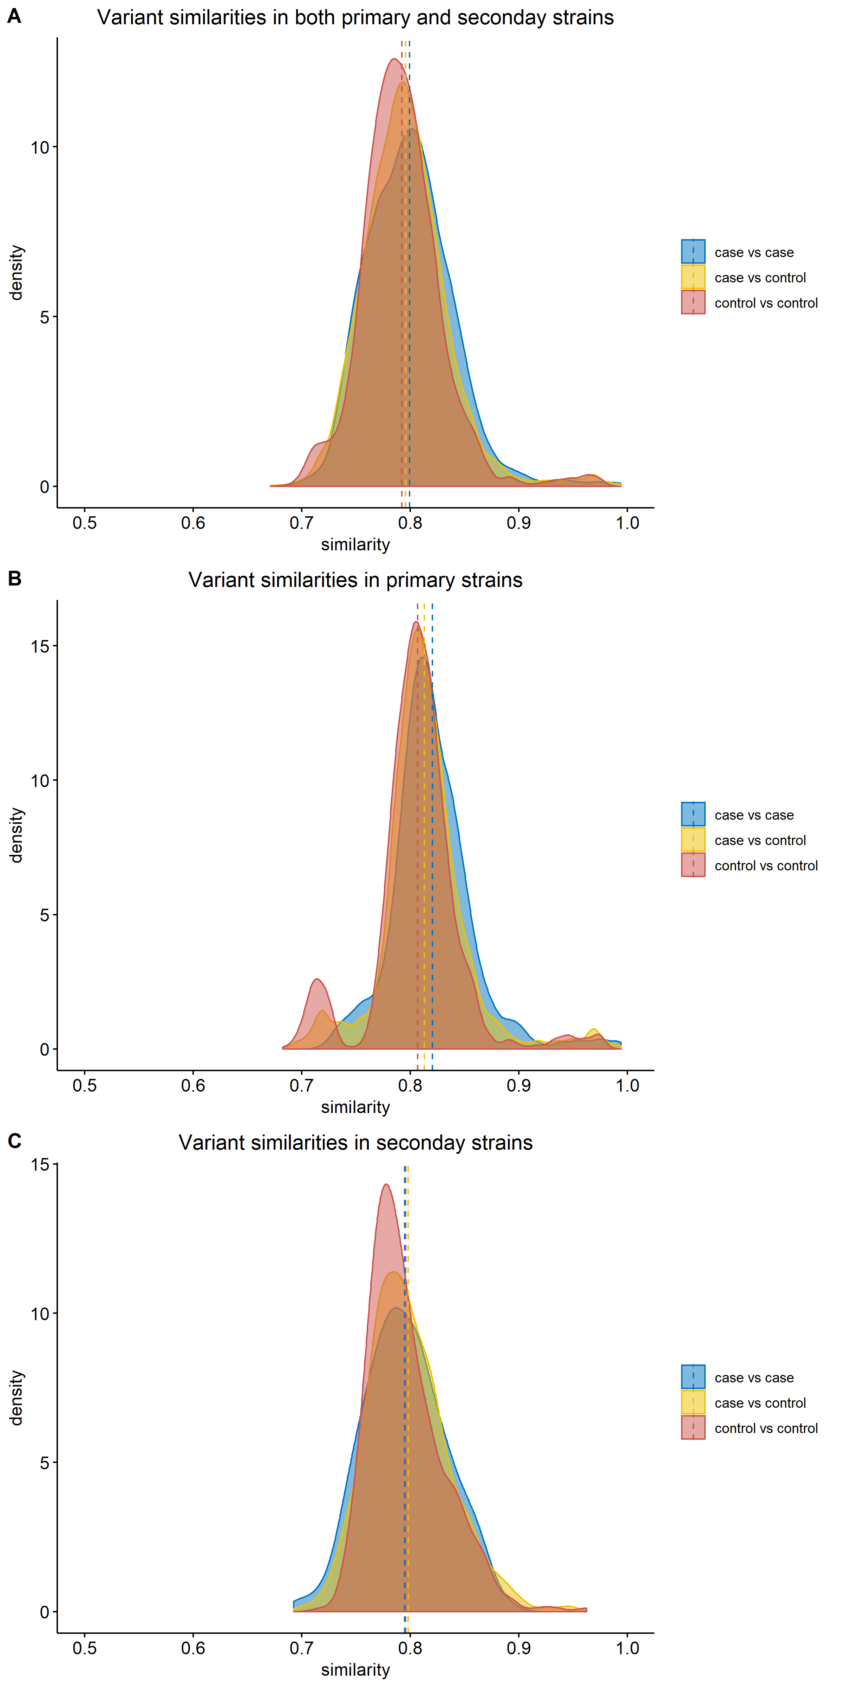

Supplemental Figure S12. Distribution of variant similarities in Bacteroides uniformis. (A) Variant similarities of “case vs case”, “case vs control”, and “control vs control” in both primary and secondary strains; (B) variant similarities of “case vs case”, “case vs control”, and “control vs control” in primary strains; (C) variant similarities of “case vs case”, “case vs control”, and “control vs control” in secondary strains.

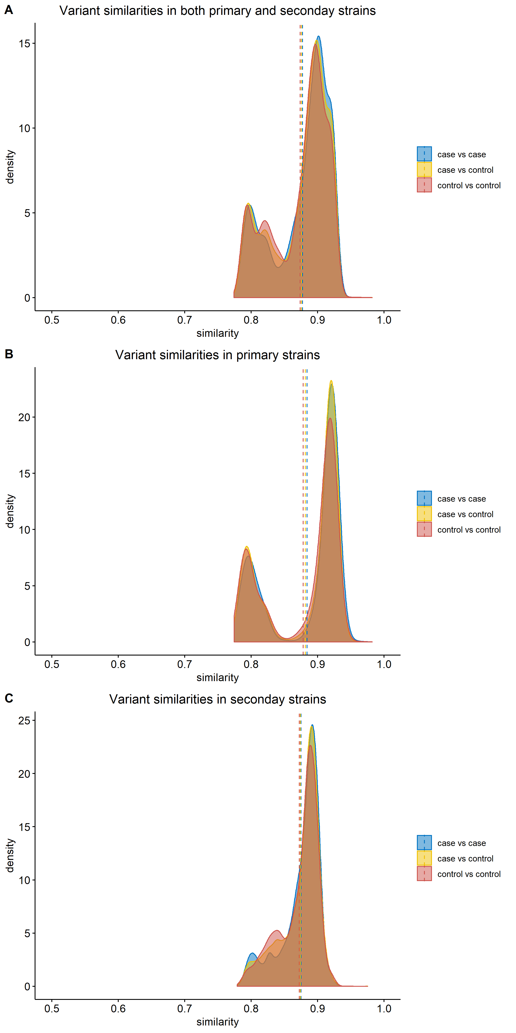
Supplemental Figure S13. Distribution of variant similarities in Bifidobacterium longum. (A) Variant similarities of “case vs case”, “case vs control”, and “control vs control” in both primary and secondary strains; (B) variant similarities of “case vs case”, “case vs control”, and “control vs control” in primary strains; (C) variant similarities of “case vs case”, “case vs control”, and “control vs control” in secondary strains.

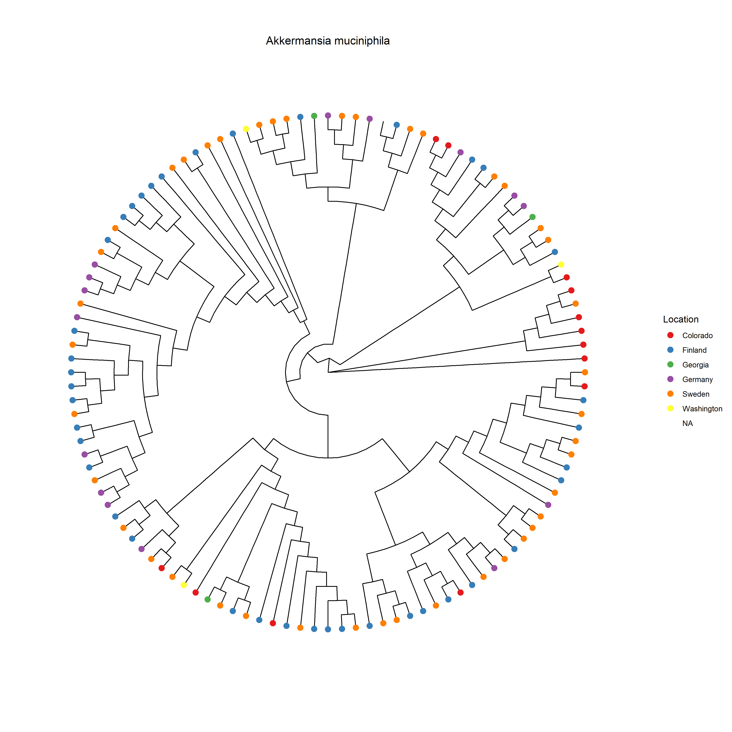
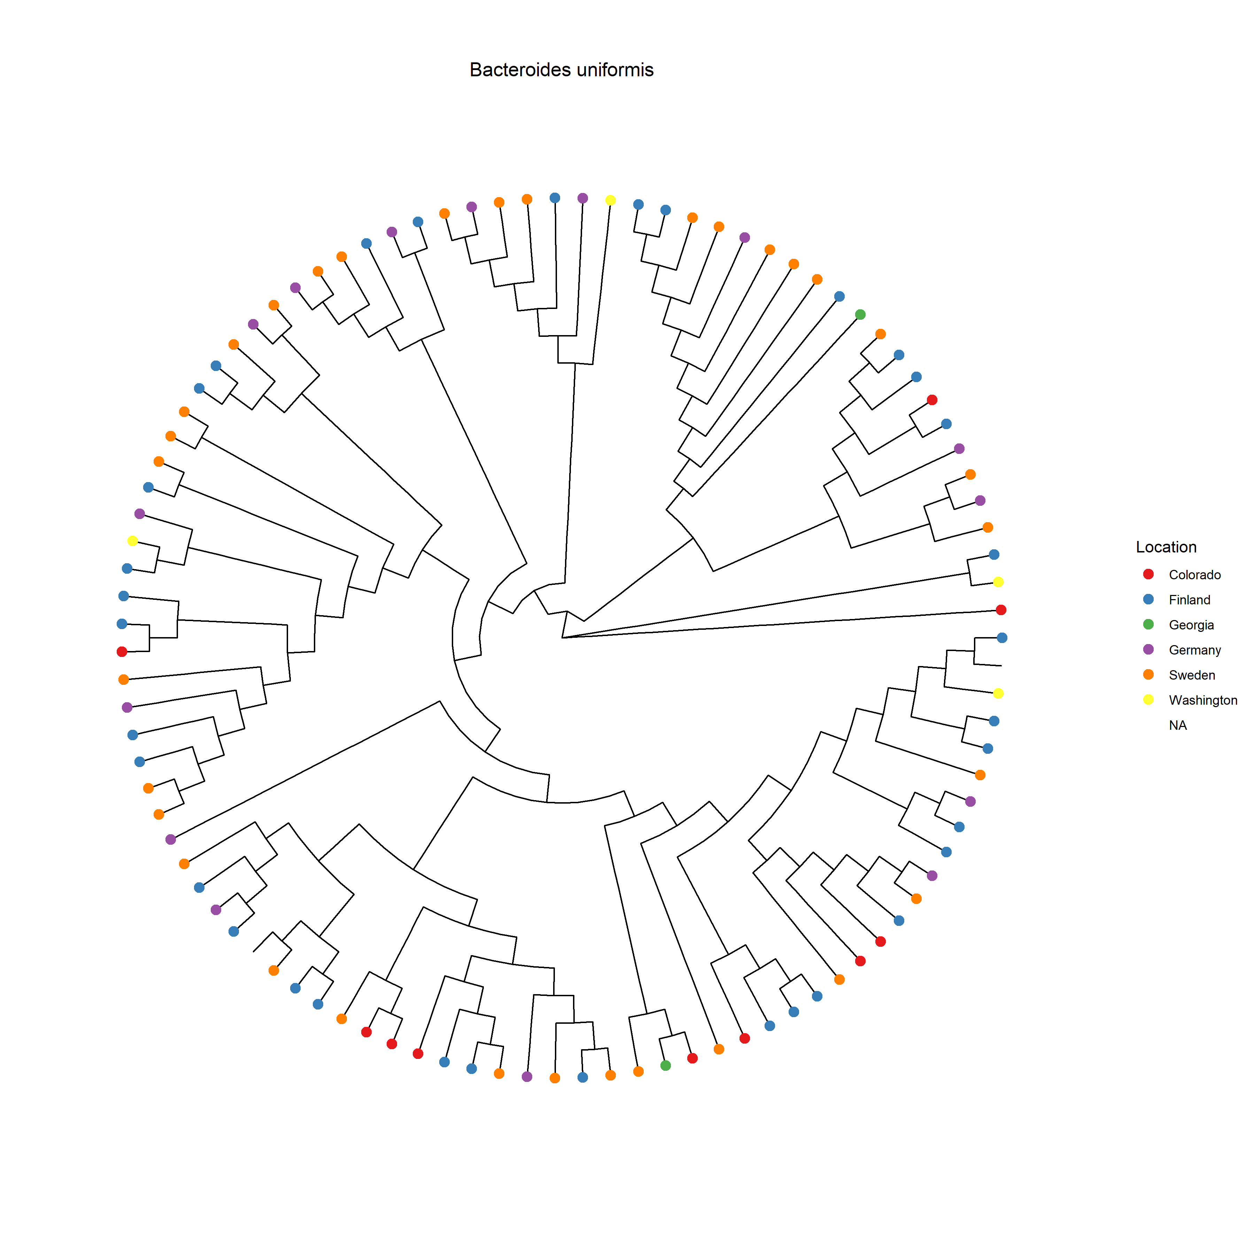
Supplemental Figure S14. Phylogenetic tree of six species: Akkermansia muciniphila, Bifidobacterium bifidum, Bacteroides uniformis, Bacteroides vulgatus, Eggerthella lenta, Faecalibacterium prausnitzii.

Supplemental Tables

Supplemental Table S1. Strains of species in Gut20 with numbers of true variants relative to reference genomes from MIDAS
Species | Dominated strain | variant number | Non-dominated strain | variant number
Bacteroides fragilis | YCH46 | 30138 | 638R | 26051
Neisseria meningitidis | Z2491 | 39648 | FAM18 | 10288
Staphylococcus epidermidis | ATCC_12228 | 8991 | RP62A | 14489
Staphylococcus aureus | NCTC_8325 | 20791 | RF122 | 37553
Bacillus cereus | ATCC_10987 | 139763 | E33L | 88191
Lactobacillus gasseri | GCF_902386655.1 | 17076 | 4M13 | 16999
Enterococcus faecalis | V583 | 3484 | OG1RF | 19791
Bifidobacterium breve | ACS-071-V-Sch8b | 16118 | 12L | 15447
Rhodobacter sphaeroides | KD131;KCTC_12085 | 81545 | MBTLJ-8 | 899
Deinococcus radiodurans | R1 | 1036 | BNK-50 | 525
Clostridium beijerinckii | NRRL B-598 | 87411 | BAS | 98189
Streptococcus agalactiae | 2603V/R | 8900 | NEM316 | 11099
Listeria monocytogenes | 4b F2365 | 799 | EGD-e | 87687
Bifidobacterium longum | NCC2705 | 15588 | DJO10A | 16441
Acinetobacter baumannii | AB0057 | 56119 | ACICU | 12476
Helicobacter pylori | 51 | 39283 | J99 | 56243
Bifidobacterium adolescentis | BB23 | 16369 | 22L | 16942
Escherichia coli | BL21(DE3) | 45782 | CFT073 | 86055
Pseudomonas aeruginosa | PAO1 | 28758 | UCBPP-PA14 | 58448
Streptococcus mutans | NN2025 | 13412 | UA159 | 1112

Species | ConStrains |  |  | LongStrain
Species | N* | MAE | RMSE | N | MAE | RMSE
A. baumannii | 17 | 0.037 | 0.038 | 20 | 0.083 | 0.083
B. cereus | 0 | - | - | 0 | - | -
B. fragilis | 15 | 0.044 | 0.053 | 20 | 0.0029 | 0.0030
B. adolescentis | 19 | 0.044 | 0.047 | 20 | 0.0038 | 0.0039
B. breve | 19 | 0.044 | 0.049 | 20 | 0.0033 | 0.0033
B. longum | 16 | 0.059 | 0.073 | 20 | 0.0042 | 0.0044
C. beijerinckii | 0 | - | - | 0 | - | -
D. radiodurans | 7 | 0.23 | 0.23 | 20 | 0.080 | 0.081
E. faecalis | 20 | 0.049 | 0.059 | 20 | 0.0092 | 0.0092
E. coli | 19 | 0.037 | 0.039 | 20 | 0.23 | 0.23
H. pylori | 16 | 0.048 | 0.051 | 20 | 0.076 | 0.076
L. gasseri | 0 | - | - | 0 | - | -
L. monocytogenes | 20 | 0.053 | 0.062 | 20 | 0.059 | 0.059
N. meningitidis | 20 | 0.047 | 0.054 | 20 | 0.038 | 0.038
P. aeruginosa | 17 | 0.047 | 0.060 | 20 | 0.056 | 0.056
R. sphaeroides | 17 | 0.058 | 0.072 | 20 | 0.022 | 0.022
S. aureus | 15 | 0.051 | 0.062 | 19 | 0.010 | 0.010
S. epidermidis | 19 | 0.056 | 0.074 | 20 | 0.012 | 0.012
S. agalactiae | 18 | 0.056 | 0.069 | 20 | 0.16 | 0.16
S. mutans | 18 | 0.033 | 0.036 | 20 | 0.012 | 0.012

Supplemental Table S2. The accuracy of the estimated proportion of the primary strain by ConStrains and LongStrain in single-species simulation under the transitional scenario
*: N is the number of successful reports in 20 repetitions of the simulation. Values in bold highlight the better performing method for a given species.

Supplemental Table S3. The accuracy of the estimated proportion of the primary strain by ConStrains and LongStrain in single-species simulation under the stable scenario
Species | ConStrains |  |  | LongStrain
Species | N* | MAE | RMSE | N | MAE | RMSE
A. baumannii | 17 | 0.027 | 0.030 | 20 | 0.0098 | 0.0099
B. cereus | 0 | - | - | 0 | - | -
B. fragilis | 9 | 0.0407 | 0.051 | 20 | 0.011 | 0.011
B. adolescentis | 11 | 0.022 | 0.026 | 20 | 0.012 | 0.012
B. breve | 16 | 0.014 | 0.016 | 20 | 0.012 | 0.012
B. longum | 14 | 0.027 | 0.041 | 20 | 0.012 | 0.012
C. beijerinckii | 0 | - | - | 0 | - | -
D. radiodurans | 12 | 0.055 | 0.058 | 20 | 0.0064 | 0.0067
E. faecalis | 13 | 0.024 | 0.047 | 20 | 0.0064 | 0.0065
E. coli | 12 | 0.023 | 0.036 | 20 | 0.058 | 0.058
H. pylori | 11 | 0.016 | 0.016 | 20 | 0.029 | 0.029
L. gasseri | 0 | - | - | 0 | - | -
L. monocytogenes | 17 | 0.017 | 0.034 | 20 | 0.022 | 0.022
N. meningitidis | 14 | 0.028 | 0.050 | 20 | 0.046 | 0.046
P. aeruginosa | 14 | 0.0046 | 0.0050 | 20 | 0.037 | 0.037
R. sphaeroides | 13 | 0.020 | 0.031 | 20 | 0.027 | 0.027
S. aureus | 12 | 0.015 | 0.028 | 20 | 0.0050 | 0.0051
S. epidermidis | 15 | 0.011 | 0.011 | 20 | 0.0043 | 0.0044
S. agalactiae | 13 | 0.018 | 0.033 | 20 | 0.043 | 0.043
S. mutans | 16 | 0.013 | 0.014 | 20 | 0.021 | 0.021
*: N is the number of successful reports in 20 repetitions of the simulation. Values in bold highlight the better performing method for a given species.

Supplemental Table S4. Association test of the log2-ratio (primary strain proportion/ secondary strain proportion) and the birth mode (caesarian or vaginal) by the linear mixed model
Species | Month | p-value FDR | BirthMode-Vaginal | p-value FDR | Gender-Male | p-value FDR | Interaction-Month-BirthMode | p-value FDR
Akkermansia muciniphila | 0.218099 | 0.117597 | 8.115809 | 0.014688 | -0.25837 | 0.960762 | -0.45919 | 0.019681
Anaerostipes hadrus | -0.07583 | 0.117597 | -1.45104 | 0.333477 | -0.18694 | 0.933131 | 0.089497 | 0.130442
Bacteroides caccae | -0.13064 | 0.760105 | -4.15278 | 0.620057 | 0.432207 | 0.925338 | 0.254275 | 0.406928
Bacteroides fragilis | 0.133718 | 0.055902 | 1.473342 | 0.388051 | -0.4426 | 0.757659 | -0.14297 | 0.067735
Bacteroides sp. A1C1 | -0.00061 | 0.993257 | -0.7143 | 0.86315 | -0.49733 | 0.925338 | -0.08744 | 0.462563
Bacteroides thetaiotaomicron | 0.205937 | 0.00506 | 3.930116 | 0.015161 | -0.77379 | 0.369791 | -0.20369 | 0.019681
Bacteroides uniformis | -0.00268 | 0.993257 | -1.6643 | 0.620057 | -0.3704 | 0.925338 | 0.031322 | 0.867946
Bacteroides vulgatus | 0.027204 | 0.854146 | 0.02092 | 0.984408 | 0.100716 | 0.960762 | -0.09528 | 0.210947
Bifidobacterium adolescentis | -0.07387 | 0.524917 | -1.33927 | 0.647148 | -0.25639 | 0.941162 | 0.170396 | 0.07128
Bifidobacterium bifidum | -0.00852 | 0.993257 | -0.33777 | 0.86315 | 0.078204 | 0.960762 | 0.013127 | 0.874599
Bifidobacterium breve | -0.17011 | 8.63E-06 | -2.37154 | 0.000993 | 0.401911 | 0.694704 | 0.235589 | 5.79E-08
Bifidobacterium catenulatum | 0.168333 | 0.03257 | 2.840976 | 0.206627 | -0.02918 | 0.967586 | -0.16119 | 0.07128
Bifidobacterium dentium | -0.01508 | 0.993257 | -0.67016 | 0.897126 | -0.05799 | 0.967586 | 0.076817 | 0.817795
Bifidobacterium longum | -0.07316 | 0.038009 | 0.356732 | 0.756883 | -0.16717 | 0.925338 | -0.07297 | 0.07128
Bifidobacterium pseudocatenulatum | 0.000444 | 0.993257 | 0.784888 | 0.756883 | -0.14715 | 0.960762 | 0.009951 | 0.874599
Eggerthella enta | -0.11553 | 0.003729 | 0.771237 | 0.658904 | -1.07928 | 0.369791 | -0.0398 | 0.480143
Enterococcus faecalis | 0.317545 | 0.727881 | -3.10844 | 0.647148 | -0.60215 | 0.925338 | 0.124345 | 0.874599
Escherichia coli | -0.08493 | 0.066405 | 0.185967 | 0.897126 | -0.56877 | 0.369791 | -0.05202 | 0.41979
Faecalibacterium prausnitzii | 0.020557 | 0.727881 | 0.762205 | 0.453186 | -0.54935 | 0.363644 | -0.07973 | 0.034136
Flavonifractor plautii | 0.069626 | 0.393844 | -0.03313 | 0.984408 | -0.81294 | 0.407739 | -0.04302 | 0.746763
Lachnospiraceae bacterium GAM79 | 0.022803 | 0.855774 | -0.68084 | 0.785211 | -0.05275 | 0.967586 | 0.00934 | 0.874599
Roseburia hominis | -0.0315 | 0.760105 | -2.14825 | 0.294221 | 0.371293 | 0.925338 | 0.097505 | 0.210947
Roseburia intestinalis | 0.014513 | 0.921798 | 2.34299 | 0.046731 | -0.80962 | 0.369791 | -0.13534 | 0.034136
Ruthenibacterium lactatiformans | -0.00422 | 0.993257 | 0.824045 | 0.756883 | -1.60816 | 0.343527 | -0.06804 | 0.41979
Streptococcus thermophilus | 0.094386 | 0.122189 | -0.21545 | 0.903611 | 0.253395 | 0.925338 | 0.037905 | 0.767442
Veillonella parvula | -0.18104 | 0.03257 | 0.190067 | 0.903611 | -0.60435 | 0.407739 | 0.012966 | 0.874599
*The linear mixed model: $\log_{2}{Ratio} \sim β_{0}+β_{1}Month+β_{2}BirthModel+β_{3}Month:BirthModel+β_{4}Gender+\left(1|ID\right)$

