Supplementary Information

Synthesis of core/shell nanocrystals with ordered intermetallic single-atom alloy layers for nitrate electroreduction to ammonia

Qiang Gao^{1,†}, Bingqing Yao^{2,†}, Hemanth Somarajan Pillai^{1,†}, Wenjie Zang², Xue Han¹, Yuanqi Liu¹, Shen-Wei Yu³, Zihao Yan¹, Bokki Min¹, Sen Zhang³, Hua Zhou⁴, Lu Ma⁵, Hongliang Xin^{1,} , Qian He^{2,}, & Huiyuan Zhu^{1,}

¹Department of Chemical Engineering, Virginia Polytechnic Institute and State University, 635 Prices Fork Rd., Blacksburg, Virginia 24061, USA.
²Department of Materials Science and Engineering, National University of Singapore, 9 Engineering Drive 1, 117575, Singapore.
³Department of Chemistry, University of Virginia, Charlottesville, Virginia 22904, USA.
⁴X-ray Science Division, Advanced Photon Source, Argonne National Laboratory, Lemont, Illinois 60439, USA
⁵National Synchrotron Light Source II (NSLS-II), Brookhaven National Laboratory, Upton, NY 11973, USA

Supplementary Figure 1 | Characterizations of Cu nanocubes. a, b, TEM images of Cu nanocubes.

Supplementary Figure 2 | Characterizations of the core/shell Cu/CuAu ordered SAA nanocubes. a, an atomic-resolution HAADF image. b, and c, are the corresponding line profiles of line 1 and line 2 in (a), respectively.

As shown in the corresponding line profile, the intensity profiles show d-spacings of ~2.0 Å and ~3.69 Å from line 1 and line 2, which can be assigned to (-110) and (001) plane of the ordered intermetallic CuAu structure along [110] direction.

Supplementary Figure 3 | Characterizations of the core/shell Cu/CuAu ordered SAA nanocubes. a, an atomic-resolution HAADF image, and b, the corresponding FFT image of the o Cu/CuAu ordered SAA nanocubes. c-e, the corresponding FFT images of regions 1-3 in (a), showing the crystal structure along the Cu[001], CuAu [001] and CuAu[110] directions, respectively.

The corresponding FFT patterns in different regions display the crystal structure along Cu [001], CuAu [001], and CuAu [110] directions, respectively, indicating the epitaxial growth of ordered intermetallic CuAu over the Cu cube.

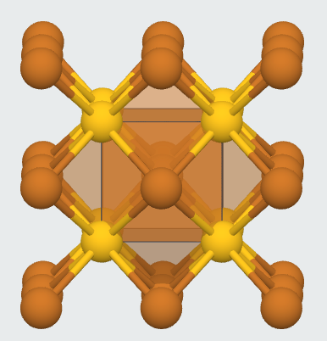
Supplementary Figure 4 | Illustration of the ordered intermetallic structure of CuAu. Illustration of a tetragonal P4/mmm ordered intermetallic structure of CuAu. Brown and yellow balls correspond to Cu and Au atoms, respectively.

Supplementary Figure 5 | Characterizations of the core/shell Cu/CuAu SAA nanocubes. a, an atomic-resolution HAADF-STEM image, and b, c, the corresponding unit cell mapping of Cu/CuAu SAA nanocubes.

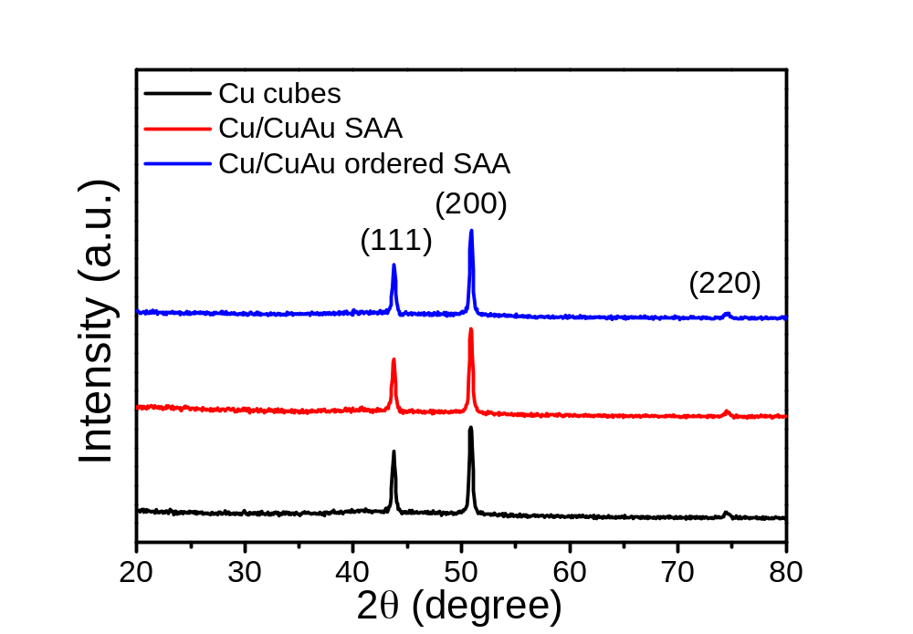
Supplementary Figure 6 | XRD characterization. XRD patterns of as-synthesized Cu/CuAu SAA, Cu/CuAu ordered SAA nanocubes, and Cu nanocubes.

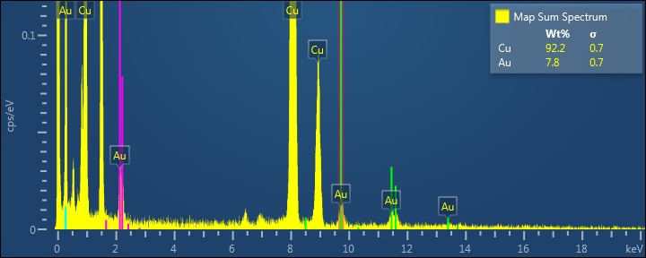
Supplementary Figure 7 | EDX characterization. EDX spectrum of the Cu/CuAu ordered SAA nanocubes.

Supplementary Figure 8 | EXAFS spectra. a, R space and b, inverse FT fitting curves of the Au L-edge for Cu/CuAu SAA nanocubes.

Supplementary Figure 9 | EXAFS spectra. a, R space and b, inverse FT fitting curves of the Au L-edge for Cu/CuAu ordered SAA nanocubes.

Supplementary Figure 10 | Characterizations of the core/shell ordered SAA. HAADF-STEM images of a, Cu/CuPd ordered SAA and b, Cu/Cu₃Pt ordered SAA. Blue, yellow, and grey balls represent Cu, Pd, and Pt atoms, respectively.

Supplementary Figure 11 | TEM image of carbon-supported catalysts. TEM image of carbon-supported Cu/CuAu ordered SAA nanocubes.

Supplementary Figure 12 | Characterizations of Au nanocubes. a, b, TEM images of pure Au nanocubes.

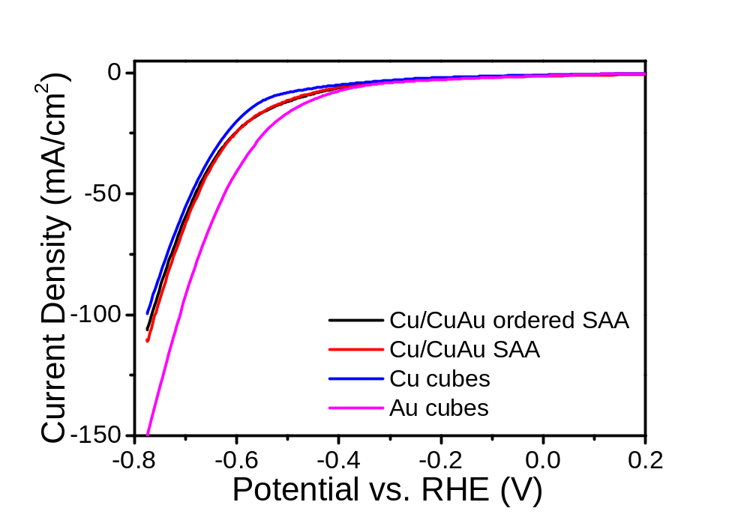
Supplementary Figure 13 | Electrocatalytic HER performance. LSV curves of Cu/CuAu SAA nanocubes, Cu/CuAu ordered SAA nanocubes, Cu nanocubes, and Au nanocubes normalized to the geometric area. The polarization curves were obtained by sweeping the potential from -0.6 to -1.8 V vs. Ag/AgCl with a sweep rate of 20 mV s⁻¹ in 1 M KOH.

Supplementary Figure 14 | Capacitance measurement. Cyclic voltammograms in the region of -0.1-0 V vs. Ag/AgCl for different studied samples: a, Cu/CuAu ordered SAA nanocubes, b, Cu/CuAu SAA nanocubes, c, Cu nanocubes, and d, Au nanocubes.

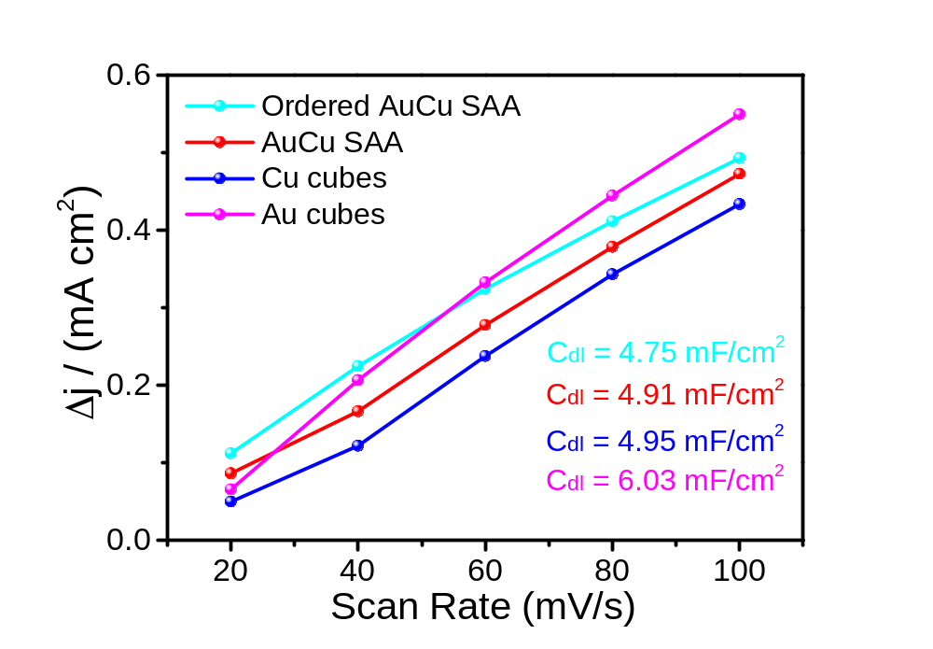
Supplementary Figure 15 | Capacitance measurement. Plots showing the extraction of the C_{dl} for different catalysts.

Supplementary Figure 16 | Electrocatalytic NO₃RR performance. a, linear scan voltammetry curves of Cu/CuAu ordered SAA nanocubes, Cu/CuAu SAA nanocubes, Cu nanocubes, and Au nanocubes normalized to ECSA. b, partial NH₃ current densities normalized to ECSA.

Supplementary Figure 17 | Electrocatalytic NO₃RR performance. CA measurements of catalysts at different potentials for 1 h in 1 M KOH + 1 M KNO₃ solution normalized to the geometric area. a, Cu/CuAu SAA nanocubes, b, Cu/CuAu ordered SAA nanocubes, c, Cu nanocubes, and d, Au nanocubes.

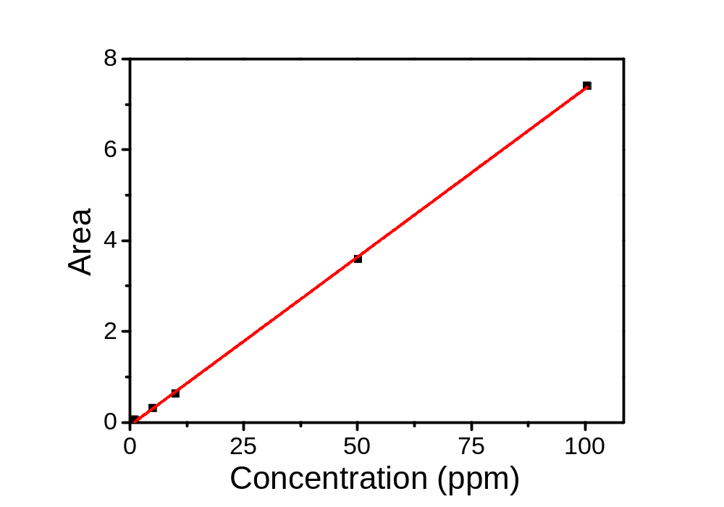
Supplementary Figure 18 | Ion chromatography measurements of the concentrations of NO₂⁻. Calibration curve of NO₂⁻ with different concentrations. Electrolytes after catalysis were diluted to ensure the NO₂⁻ concentrations in the test solutions were in the linear range of the calibration curve.

Supplementary Figure 19 | UV-vis measurements of the concentrations of ammonium with Nessler’s reagents. a, the ultraviolet-visible absorption spectra of different solutions with different ammonium concentrations. b, calibration curve colorimetric NH₃ assay using Nessler reagent. Electrolytes after catalysis were diluted to ensure the ammonia concentrations in the test solutions were in the linear range of the calibration curve.

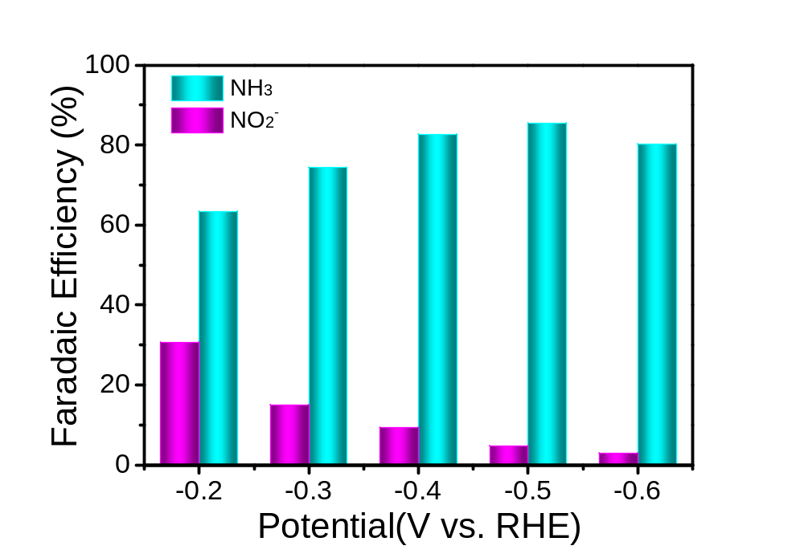
Supplementary Figure 20 | Electrocatalytic NO₃RR performance. FE of NH₃ and NO₂⁻ for NO₃RR on Cu/CuAu ordered SAA nanocubes at different potentials.

Supplementary Table 1 | Comparison of the catalytic parameter of different NO₃RR electrocatalysts.
Catalyst | Electrolyte | NH₃ FE(%) | NH₃ yield rate (mol/g_{cat}*h) | Ref.
Cu/CuAu ordered SAA | 1 M KOH + 1 M KNO₃ | 85.5 | 8.47 | This work
Cu/CuAu SAA | 1 M KOH + 1 M KNO₃ | 84.8 | 6.24 | This work
CuPd nanocubes | 1 M KOH + 1 M KNO₃ | 92.5 | 6.25 | Ref. ¹
Fe single atom/C | 0.5 M KNO₃ + 0.1 M K₂SO₄ | 75 | 1.18 | Ref. ²
Oxygen-doped-Ru | 1 M KOH + 1 M KNO₃ | 96 | 5.56 | Ref. ³
Cu₅₀Ni₅₀ alloys | 1 M KOH + 0.1 M KNO₃ | 99 | N/A | Ref. ⁴
Pd₄Cu₄@N-pC | N/A | <20 | N/A | Ref. ⁵
Cu/Cu₂O | 200 ppm NO₃⁻-N + 0.5 M Na₂SO₄ | 95.8 | 0.2449 mmol ^{h-1}  cm⁻² | Ref. ⁶
TiO_{2-x} nanotubes | 50 ppm NO₃⁻-N + 0.5 M Na₂SO₄ | 85 | N/A | Ref. ⁷
Co₃O₄₋TiO₂/Ti | 50 ppm NO₃⁻-N + 0.1 M Na₂SO₄ | 89 | N/A | Ref. ⁸

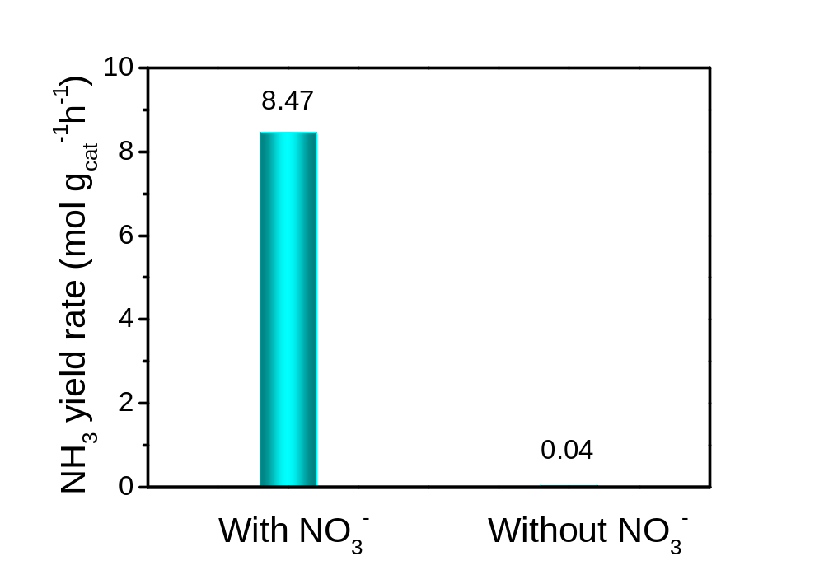
Supplementary Figure 21 | Electrocatalytic NO₃RR performance of Cu/CuAu ordered SAA nanocubes. The yield rate of NH₃ with or without nitrate at -0.6 V vs. RHE.

Supplementary Figure 22 | ATR-SEIRAS results. ATR-SEIRAS spectra of Cu/CuAu ordered SAA nanocubes during CV cycling between 0 V and -1.8 V vs. Ag/AgCl at 5 mV/s in 0.1 M KOH + 1 M KNO₃.

Supplementary Figure 23 | Electrocatalytic NO₃RR performance. a, LSV curves of Cu/CuAu ordered SAA nanocubes in 1 M KOH + 1 M KNO₃ solution and 1 M KOH + 0.1 M KNO₃ solution. b, CA measurements of Cu/CuAu ordered SAA nanocubes at different potentials in 1 M KOH + 0.1 M KNO₃ solution normalized to the geometric area. c, FE of NH₃ and d, NH₃ yield rate at different potentials in 1 M KOH + 1 M KNO₃ solution and 1 M KOH + 0.1 M KNO₃ solution.

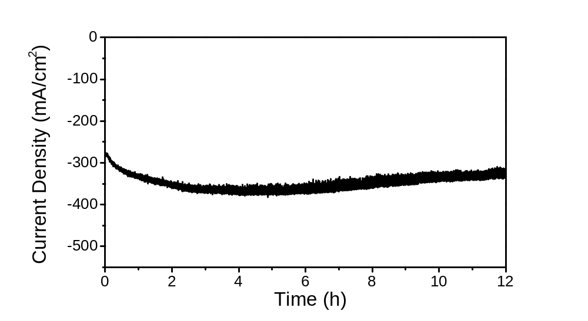
Supplementary Figure 24 | Stability test. Stability test by running the CA measurement on Cu/CuAu ordered SAA nanocubes at -0.5 V vs. RHE for 12 h.

Supplementary Table 2 | Free formation energies of reaction intermediates at 0 V vs. RHE for strained Cu/CuAu(100), Cu/CuAu SAA and Cu(100). The free formation energies (in eV) are calculated using a grand canonical DFT scheme at U = 0 V and with respect to NO₃ ⁻(aq), OH⁻ (aq) and H₂O(l) at standard conditions.

Catalyst | (-2.5 %) Cu/CuAu(100)  Ordered SAA | Cu/CuAu SAA | Cu(100)
*NO₃ | 0.10 | 0.43 | 0.32
*NO₂ | -1.56 | -1.21 | -1.32
*NO | -2.27 | -2.14 | -2.19
*NHO | -2.73 | -2.11 | -2.20
*NH₂O | -2.68 | -2.18 | -2.28
*NH₂OH | -2.42 | -2.21 | -2.25
*NH₂ | -4.76 | -4.27 | -4.37

References

1 Gao, Q. et al. Breaking adsorption-energy scaling limitations of electrocatalytic nitrate reduction on intermetallic CuPd nanocubes by machine-learned insights. Nat. Commun. 13, 2338, (2022).
2 Wu, Z.-Y. et al. Electrochemical ammonia synthesis via nitrate reduction on Fe single atom catalyst. Nat. Commun. 12, 2870, (2021).
3 Li, J. et al. Efficient Ammonia Electrosynthesis from Nitrate on Strained Ruthenium Nanoclusters. J. Am. Chem. Soc. 142, 7036-7046, (2020).
4 Wang, Y. et al. Enhanced nitrate-to-ammonia activity on copper-nickel alloys via tuning of intermediate adsorption. J. Am. Chem. Soc. 142, 5702-5708, (2020).
5 Chen, M. et al. Achieving high-performance nitrate electrocatalysis with PdCu nanoparticles confined in nitrogen-doped carbon coralline. Nanoscale 10, 19023-19030, (2018).
6 Wang, Y., Zhou, W., Jia, R., Yu, Y. & Zhang, B. Unveiling the Activity Origin of a Copper-based Electrocatalyst for Selective Nitrate Reduction to Ammonia. Angew. Chem., Int. Ed. 59, 5350-5354, (2020).
7 Jia, R. et al. Boosting Selective Nitrate Electroreduction to Ammonium by Constructing Oxygen Vacancies in TiO2. Acs Catal. 10, 3533-3540, (2020).
8 Gao, J. et al. Non-precious Co3O4-TiO2/Ti cathode based electrocatalytic nitrate reduction: Preparation, performance and mechanism. Appl. Catal. B: Environ. 254, 391-402, (2019).

