Supporting Information
Combined Surface Light Scattering and Pendant-Drop Experiments for the Determination of Viscosity and
Surface Tension of High-Viscosity Fluids
Demonstrated for Ionic Liquids
Ziwen Zhai,ª Julius H. Jander,ª Alexander Bergen,^{b}
Junwei Cui,ª Karsten Meyer,^{b} Thomas M. Koller*^{,a}
ª Institute of Advanced Optical Technologies − Thermophysical Properties (AOT-TP), Department of Chemical and Biological Engineering (CBI) and Erlangen Graduate School in Advanced Optical Technologies (SAOT), Friedrich-Alexander-Universität
Erlangen-Nürnberg (FAU), Paul-Gordan-Straße 8, 91052 Erlangen, Germany
^{b} Chair of Inorganic and General Chemistry, Department of Chemistry and Pharmacy, Friedrich-Alexander-Universität Erlangen-Nürnberg (FAU), Egerlandstraße 1,
91058 Erlangen, Germany

_____________________
*Author to whom correspondence should be addressed: email: thomas.m.koller@fau.de, ORCID number 0000-0003-4917-3079.
S1. Material Information and Characterization
The commercially available compounds were purchased and purified as stated below in Table S1. At the Chair of Inorganic and General Chemistry of the FAU, the IL 1,3-bis(2-(2-methoxyethoxy)ethyl)imidazolium iodide ([(mPEG₂)₂Im]I) was synthesized and purified according to a literature procedure [1], additionally dried for 72 h at 30 Pa, and stored under an Ar atmosphere prior to use. Its purity was confirmed by nuclear magnetic resonance (NMR) spectroscopy and elemental analysis, as discussed below. Table S1 provides details to the used chemicals including their purity in terms of mass fraction w, mole fraction x, or volume fraction ϕ as well as the water contents for the degassed IL and TOTM samples. Here, the water contents given in mass fractions w_{H2O} were determined before and after the combined SLS-PD experiments by Karl–Fischer (KF) coulometric titration (Metrohm, model 899) with an estimated relative expanded (k = 2) uncertainty of less than 20%.
Table S1. Specifications of used chemicals
substance | source | purity | purification method | color | 10⁶ w_{H2O} before exp. | 10⁶ w_{H2O}  after exp.
n-dodecane  (n-C₁₂H₂₆) | Merck KGaA | w = 0.997^{b} | filtration and evacuation | colorless | - | -
water (H₂O) | self-made | ρ_{e} = 18 MΩ·cm^{c} | none | colorless | - | -
toluene (C₇H₈) | Merck KGaA | w > 0.999^{b} | filtration | colorless | - | -
tris(2-ethylhexyl) trimellitate (TOTM) | Sigma-Aldrich | w = 0.995^{b} | filtration and evacuation | colorless | 19 | 121
1-methyl-3-octylimidazolium-hexafluorophosphate ([OMIM][PF₆]) | Iolitec | w > 0.99^{b} | evacuation | weak yellowish | 15 | 1457e
1,3-bis(2-(2-methoxyethoxy)ethyl) imidazolium iodide ([(mPEG₂)₂Im]I) | self-madeª | N/Aª | literature methodª | yellow to brown | 2635^{d} | 3625^{d}
argon (Ar) | Linde AG | ϕ ≥ 0.99999^{b} | none | colorless | - | -
ª Synthesized and purified according to literature [1]
^{b} Purity as specified by the supplier
^{c} Specific electric resistance measured at 298 K
^{d} Value probably falsified and overestimated by the excess of iodine as the anion of the IL for KF coulometric titration
^{e} Value probably falsified and overestimated by water contamination for KF coulometric titration
In connection with [OMIM][PF₆], the relatively large water content after the experiments with 1457 ppm seems to be falsified by water contamination, e.g., through an overly long contact with air after opening the sample cell. Thus, it is considered that the value of 15 ppm obtained directly before the measurement is more realistic for the situation during the measurement. For [(mPEG₂)₂Im]I, both measured water contents are anticipated to be strongly overestimated. The water content in KF coulometric titration is determined via current measurement by the stochiometric consumption of iodine (I₂) to generate iodide (I⁻) in the presence of H₂O. Since [(mPEG₂)₂Im]I contains already an excessively large amount of I⁻, this seems to influence the chemical equilibria significantly and, therefore, also the quantitative result of the titration, as has also been observed for iodide-containing ILs [2].
¹H nuclear magnetic resonance (NMR) spectra on [(mPEG₂)₂Im]I were recorded on a JEOL JNM ECX 400 MHz instrument, operating at a respective frequency of 400.18 MHz, with a probe temperature of 296 K. Chemical shifts δ are reported relative to the ¹H resonances of the solvent in ppm [3]. NMR multiplicities are abbreviated as follows: s = singlet, d = duplet, t = triplet, m = multiplet, br = broad signal. The summary of the NMR is listed in the following: ¹H NMR (400 MHz, chloroform-d) δ (ppm) = 9.98 (s, 1 H, Im-H), 7.57 (d, ⁴J_{HH} = 1.37 Hz, 2 H, Im-H), 4.57 (t, ³J_{HH} = 4.70 Hz, 4 H, NCH₂), 3.93 (t, ³J_{HH} = 4.70 Hz, 4 H, NCH₂CH₂), 3.70–3.66 (m, 4 H, PEG-CH₂), 3.56‒3.51 (m, 4 H, PEG-CH₂), 3.37 (s, 6 H, OCH₃). The corresponding 1H NMR spectrum of [(mPEG₂)₂Im]I is illustrated in Fig. S1. As can be seen, the spectrum does not reveal any pronounced water signal (δ at 1.56 ppm in chloroform-d). Also considering this fact, it seems that the determined water contents of the [(mPEG₂)₂Im]I sample given in Table S1 are not very accurate and probably overestimated.
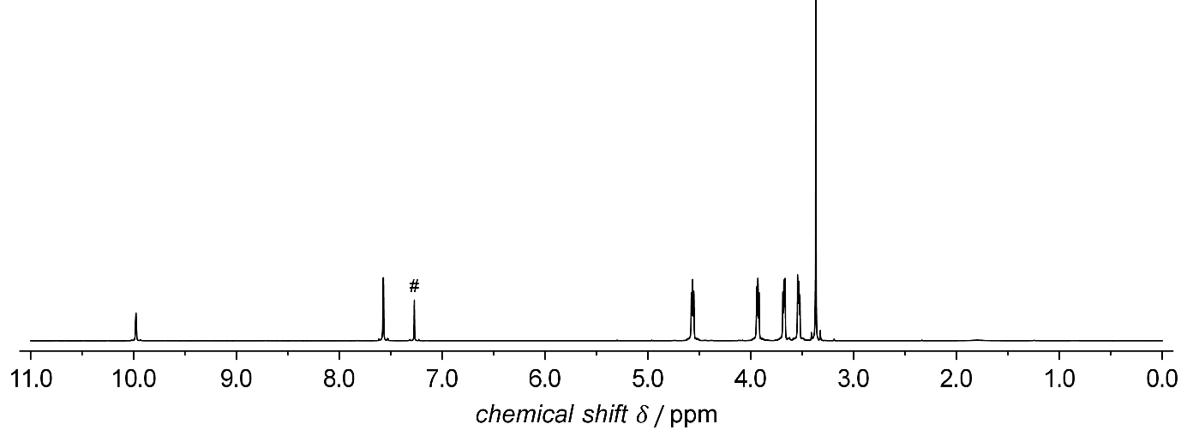
Fig. S1 ¹H NMR spectrum of [(mPEG₂)₂Im]I measured in chloroform-d at a frequency of 400 MHz at about 296 K. The solvent residual signal of chloroform-d is marked with a hash (#).
Elemental analyses (EA) for [(mPEG₂)₂Im]I were obtained using Euro EA 3000 (Euro Vector) and EA 1108 (Carlo-Erba) elemental analyzers. The following EA for C₁₃H₂₅IN₂O₄ were found; calc. (exp.): C, 39.01% (38.80%); H, 6.30% (6.53%); N, 7.00% (6.75%).
S2. Viscosity Measurements by Capillary Viscometry (CV)
With the CV technique, the liquid kinematic viscosity ν_{L} of [OMIM][PF₆] was measured from (313 to 353) K in steps of 10 K at a pressure of 0.1 MPa under an Ar atmosphere. An Ubbelohde viscometer (capillary number IIc manufactured by SI Analytics) was used because it covers the relevant viscosity range between (30 and 300) mm²·s⁻¹. ν_{L} is determined by measuring the flow time t of the degassed IL sample through the capillary, in combination with the use of the calibration constants K = 0.3092 mm²·s⁻². The latter value specified by the supplier features a relative expanded uncertainty (k = 2) of 0.65%. Surface-tension effects on CV measurements [4,5] can be neglected since the used capillary constant is associated with fluids having σ values between (20 and 30) mN·m⁻¹, which corresponds well to the values for [OMIM][PF₆]. The measurement equipment and procedure are identical to those described in Ref. [6]. In close vicinity of the capillary that is immersed into a thermostatic oil bath, the temperature was measured with a calibrated Pt-100 resistance probe with an expanded uncertainty (k = 2) of 0.04 K and showed a stability better than ±0.01 K. For each T, five measurements were carried out, resulting in five individual flow times. η_{L} was calculated by the product of ν_{L} determined in this work and the liquid density ρ_{L} adopted from the literature and given in section S3. From error propagation calculations that consider the uncertainties of K, ρ_{L}, and t, the expanded (k = 2) uncertainty of the measured data for η_{L} of [OMIM][PF₆] is between (0.69 and 0.72)%.

S3. Input Data for the Evaluation of the SLS, PD, and CV Measurements
To solve the Young-Laplace equation and the dispersion equation for hydrodynamic surface fluctuations in the evaluation of the PD and SLS measurements, respectively, data for the liquid density ρ_{L} and gas density ρ_{G} are required. As a further input parameter for the dispersion relation, the viscosity of the gas phase η_{G} needs to be known. In the case of CV measurements, ρ_{L} serves for the conversion of directly measured liquid kinematic viscosities ν_{L} to liquid dynamic viscosities η_{L} used for the discussion and data comparison.
ρ_{L} of [(mPEG₂)₂Im]I is calculated from the T-dependent correlation specified in the work of Seidl et al. [1]. It is based on measurements with a vibrating tube-densimeter (DMA 5000, Anton Paar) at atmospheric pressure between (283.15 and 363.15) K with a relative expanded (k = 2) of 0.02%. This uncertainty was also considered for the density at 373 K, to which the correlation was extrapolated for the state investigated additionally in the combined SLS-PD measurements. For [OMIM][PF₆], the authors applied the T-dependent correlation for ρ_{L} provided by Safarov et al. [7]. This correlation considers the density data obtained at atmospheric pressure from (278 to 373) K by using three different types of vibrating tube-densimeters (SVM 3000, DMA 5000, and DSA 5000 M from Anton Paar) with a stated relative expanded (k = 2) uncertainty of 0.23%. For the calculation of the gas-phase properties ρ_{G} and η_{G}, it can reliably be assumed that only the inert gas argon (Ar) is present, considering the negligible vapor pressure of the IL up to 373 K. For the studied T and p at about 0.1 MPa, the corresponding values for pure Ar were employed from REFPROP [8] which recommends the use of the equation of state from Tegeler et al. [9] for the density and the reference correlation from Lemmon and Jacobsen [10] for η_{G}.

S4. Surface Tension Results for Reference Fluids by PD Measurements
The measurement results for σ of the reference fluids water, toluene, and n-dodecane from sole PD measurements in the new sample cell are shown as a function of temperature in the upper part of Fig. S1. In its lower part, the relative deviation of the measured data from the corresponding reference correlation implemented in REFPROP [8] is illustrated.
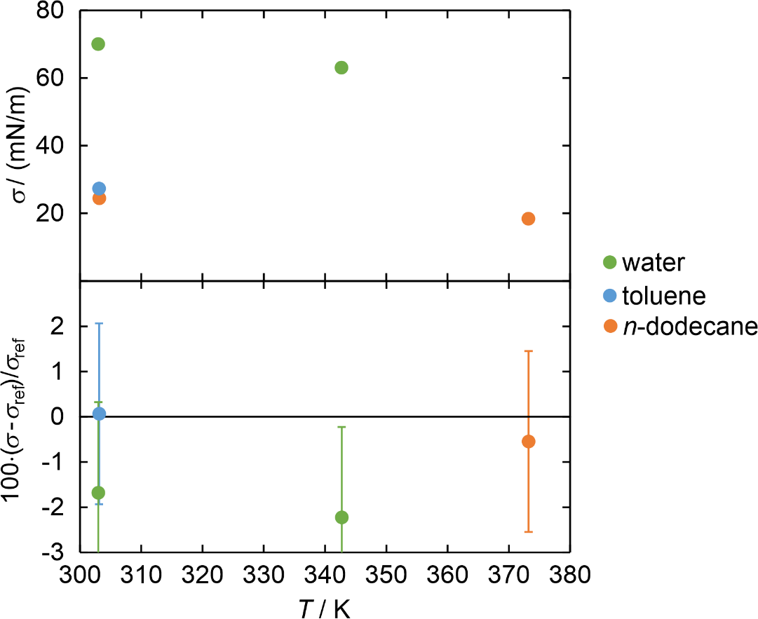
Fig. S2 Surface tension σ of the reference fluids water, toluene, and n-dodecane obtained by the PD method as a function of temperature T (upper part) and their relative deviations from reference correlations σ_{ref} for water [11], toluene [12], and n-dodecane [12] (lower part)

S5. Viscosity Results for [OMIM][PF₆] from CV Measurements
The measurements results for the viscosity of [OMIM][PF₆] from CV are listed in Table S2.
Table S2. Experimental results for η_{L} including relative expanded (k = 2) uncertainties for [OMIM][PF₆] at about 0.1 MPa based on CV measurements
T / K | η_{L} / (mPa∙s) | 100∙Δη_{L}/η_{L}
313.14 | 265.4 | 0.72
323.14 | 153.0 | 0.72
333.15 | 94.68 | 0.69
343.14 | 61.91 | 0.71
353.15 | 42.54 | 0.70

REFERENCES
- V. Seidl, M. Bosch, U. Paap, M. Livraghi, Z. Zhai, C. R. Wick, T. M. Koller, P. Wasserscheid, F. Maier, A.-S. Smith, J. Bachmann, H.-P. Steinrück, and K. Meyer, J. Ionic Liq. 2, 100041 (2022).
- L. V. N. R. Ganapatibhotla, J. Zheng, D. Roy, and S. Krishnan, Chem. Mater. 22, 6347 (2010).
- G. R. Fulmer, A. J. M. Miller, N. H. Sherden, H. E. Gottlieb, A. Nudelman, B. M. Stoltz, J. E. Bercaw, and K. I. Goldberg, Organometallics 29, 2176 (2010).
- F. J. P. Caetano, J. M. N. A. Fareleira, A. C. Fernandes, C. M. B. P. Oliveira, A. P. Serro, I. M. Simões de Almeida, and W. A. Wakeham, Fluid Phase Equilib. 245, 1 (2006).
- J. C. F. Diogo, H. M. N. T. Avelino, F. J. P. Caetano, J. M. N. A. Fareleira, and W. A. Wakeham, Fluid Phase Equilib. 418, 192 (2016).
- J. Cui, M. Kerscher, J. Jander, T. Rüde, P. S. Schulz, P. Wasserscheid, M. H. Rausch, T. M. Koller, and A. P. Fröba, accepted for publication in J. Chem. Eng. Data (2022), doi.org/10.1021/acs.jced.2c00519.
- J. Safarov, C. Bussemer, A. Aliyev, C. Lafuente, E. Hassel, and I. Abdulagatov, J. Chem. Thermodyn. 124, 49 (2018).
- E. W. Lemmon, M. L. Huber, and M. O. McLinden, NIST Standard Reference Database 23: Reference Fluid Thermodynamic and Transport Properties (REFPROP), Version 10.0; National Institute of Standards and Technology, Standard Reference Data Program, 2018.
- C. Tegeler, R. Span, W. J. Wagner, J. Phys. Chem. Ref. Data, 28, 779 (1999).
- E. W. Lemmon and R. T. Jacobsen, Int. J. Thermophys. 25, 21 (2004).
- “Revised Release on Surface Tension of Ordinary Water Substance,” International Association for the Properties of Water and Steam, IAPWS R1-76 (2014), http://www.iapws.org/relguide/Surf-H2O.html
- A. Mulero, I. Cachadiña, and M. I. Parra, J. Phys. Chem. Ref. Data 41, 043105 (2012).

