Structural dynamics in the evolution of SARS-CoV-2 spike glycoprotein

Supplementary information

Valeria Calvaresi¹*, Antoni G. Wrobel²*, Joanna Toporowska¹, Dietmar Hammerschmid¹, Katie J. Doores³, Richard T. Bradshaw¹, Ricardo B. Parsons¹, Donald J. Benton², Chloë Roustan², Eamonn Reading¹. Michael H. Malim³, Steven J. Gamblin², Argyris Politis^{1,4,5}*

*Lead corresponding author: argyris.politis@manchester.ac.uk

Co-corresponding authors:
valeria.clavaresi@kcl.ac.uk
antoni.wrobel@crick.ac.uk

¹ Department of Chemistry, King’s College London, SE1 1DB, London, UK

² Structural Biology of Disease Processes Laboratory, The Francis Crick Institute, NW1 1AT, London, UK.
³ Department of Infectious Diseases, School of Immunology and Microbial Sciences, King's College London, SE1 9RT, London, UK.

⁴ Faculty of Biology, Medicine and Health, School of Biological Sciences, The University of Manchester, M13 9PT, Manchester, UK
⁵ Manchester Institute of Biotechnology, University of Manchester, M1 7DN, Manchester, UK.

Fig. S1. Mutations in spike genome of SARS-CoV-2 variants analysed.
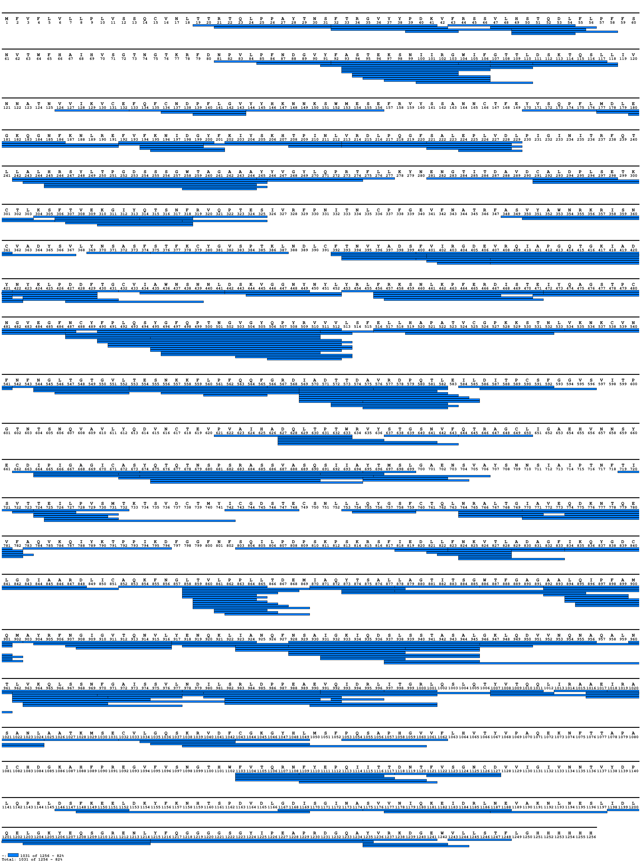
Fig. S2. Coverage map of peptides whose HDX was followed for comparing Wuhan and G614 spikes. The signal peptide (residues 1-13) is indicated but not present in the protein analyzed. The figure was generated with MS Tools¹.

Fig. S3. Difference plot illustrating the difference in HDX between Wuhan and G614 spikes (light blue line: 4 s on ice, orange line: 20 s on ice, grey line: 15 s at 23 °C, yellow line: 1 min at 23 °C, green line: 10 min at 23 °C, violet line: 100 min at 23 °C, dark blue line: 360 min at 28 °C). Residues comprising a region with significant differences in HDX are indicated. The peptides are arranged according to their peptide centre residue. A dotted grey line indicates the 98% CI as a threshold for significance. The top bar shows spike subdomains. The black dot indicates the position of D614G substitution.

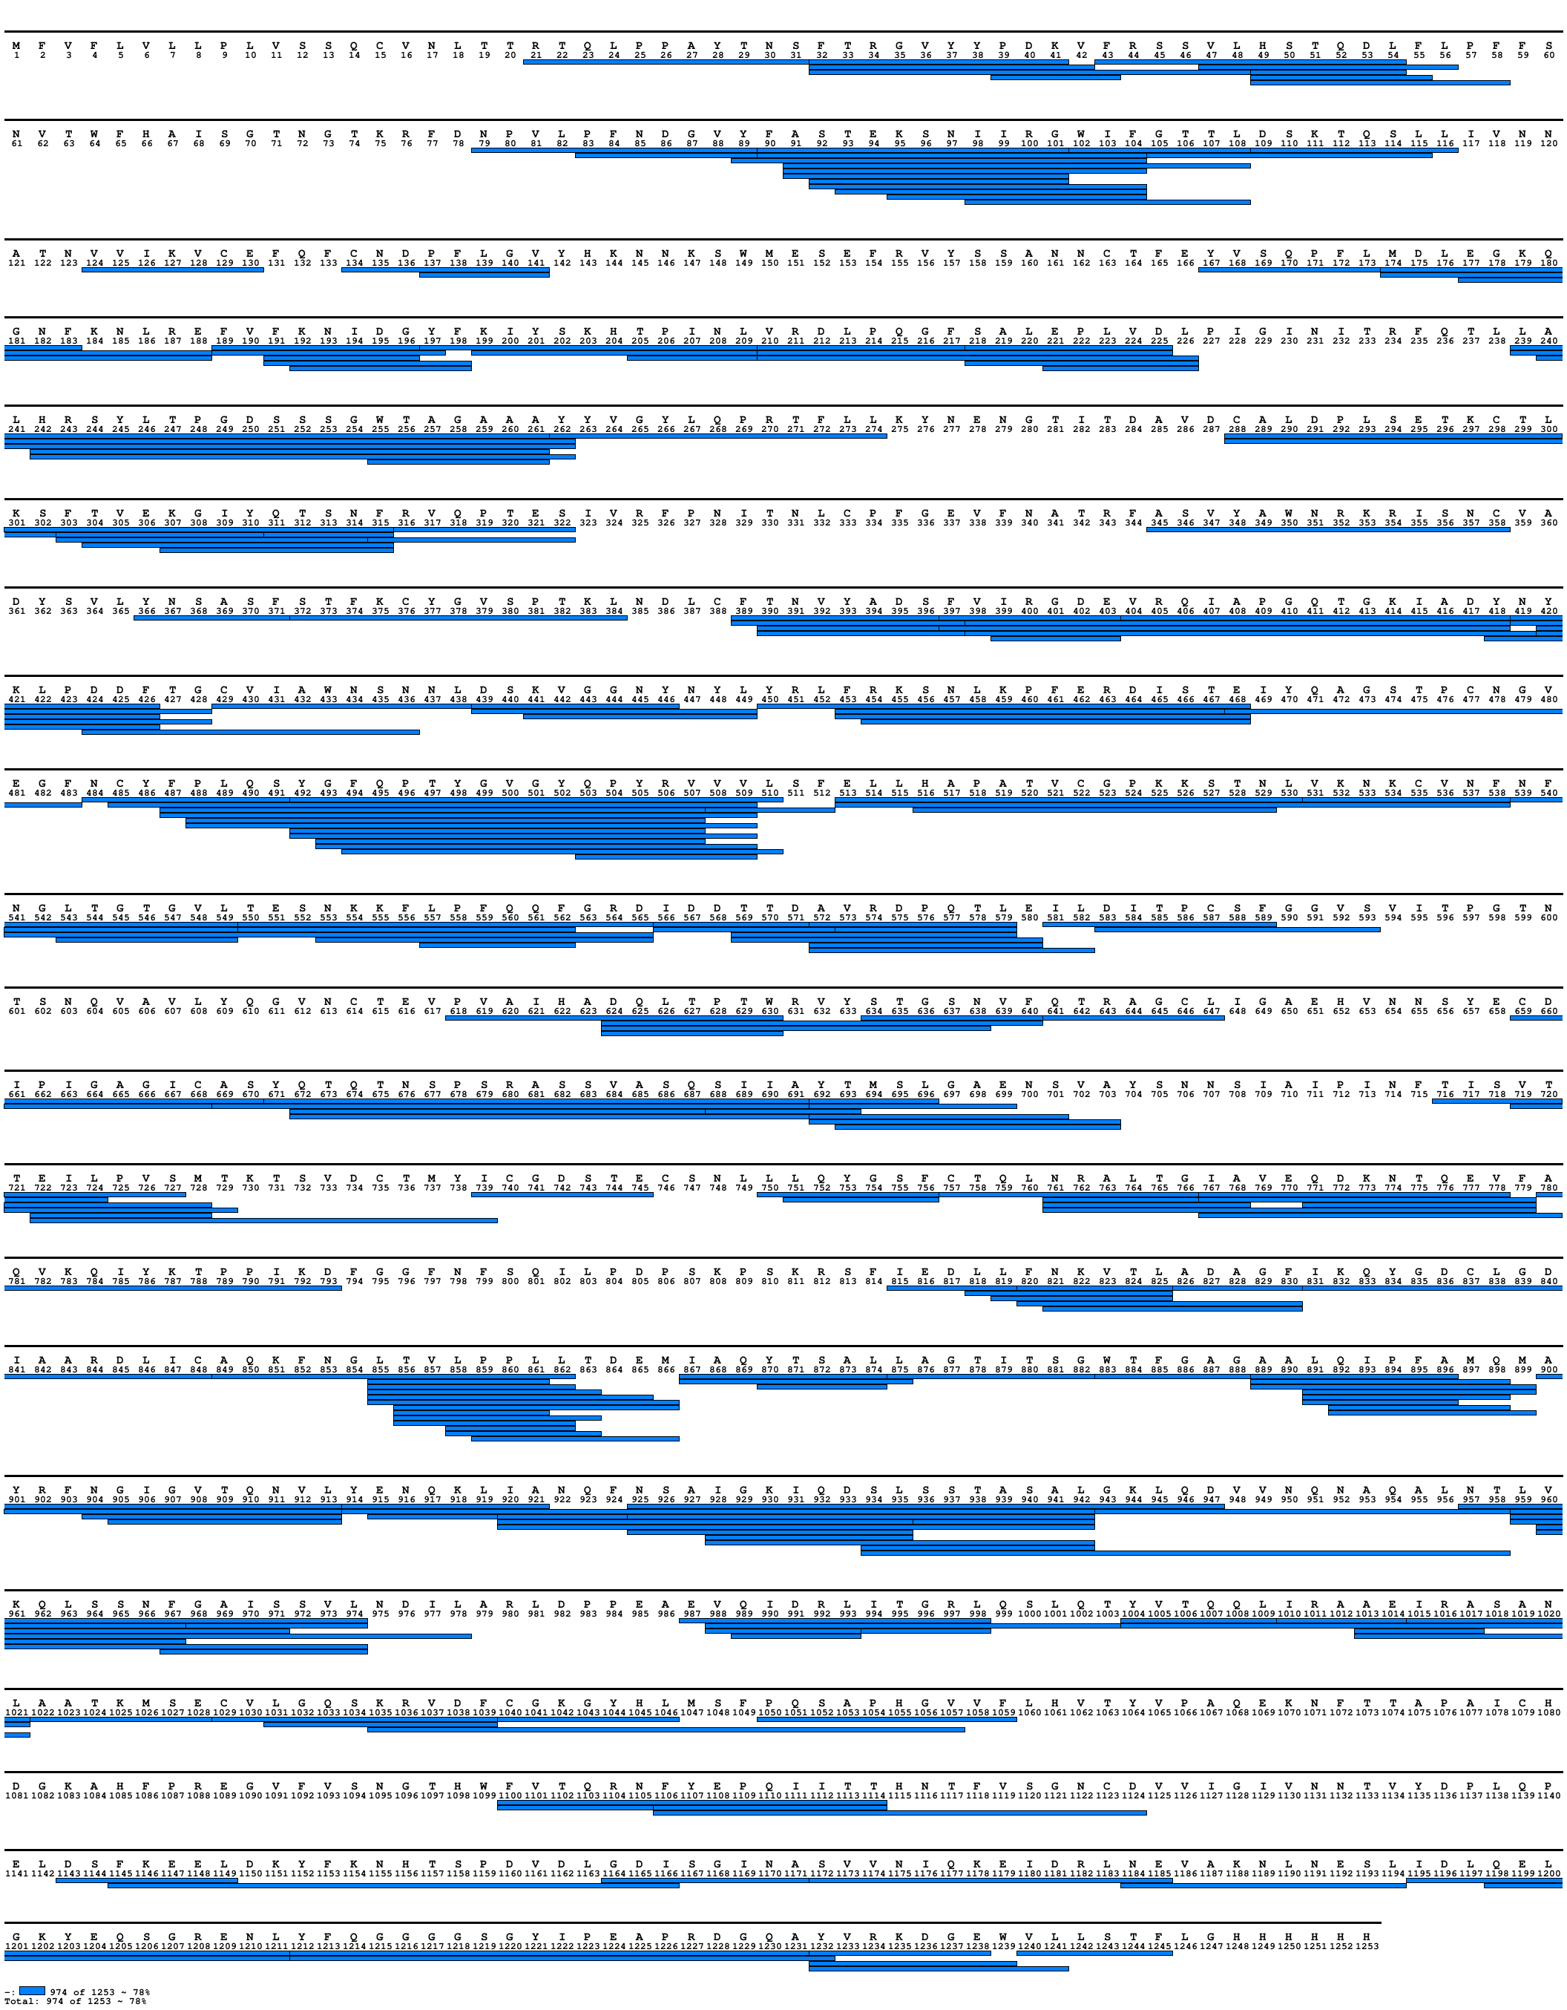
Fig. S4. Coverage map of peptides whose HDX was followed in alpha spike (apo state). The signal peptide (residues 1-13) is indicated but not present in the protein analyzed. The figure was generated with MS Tools.

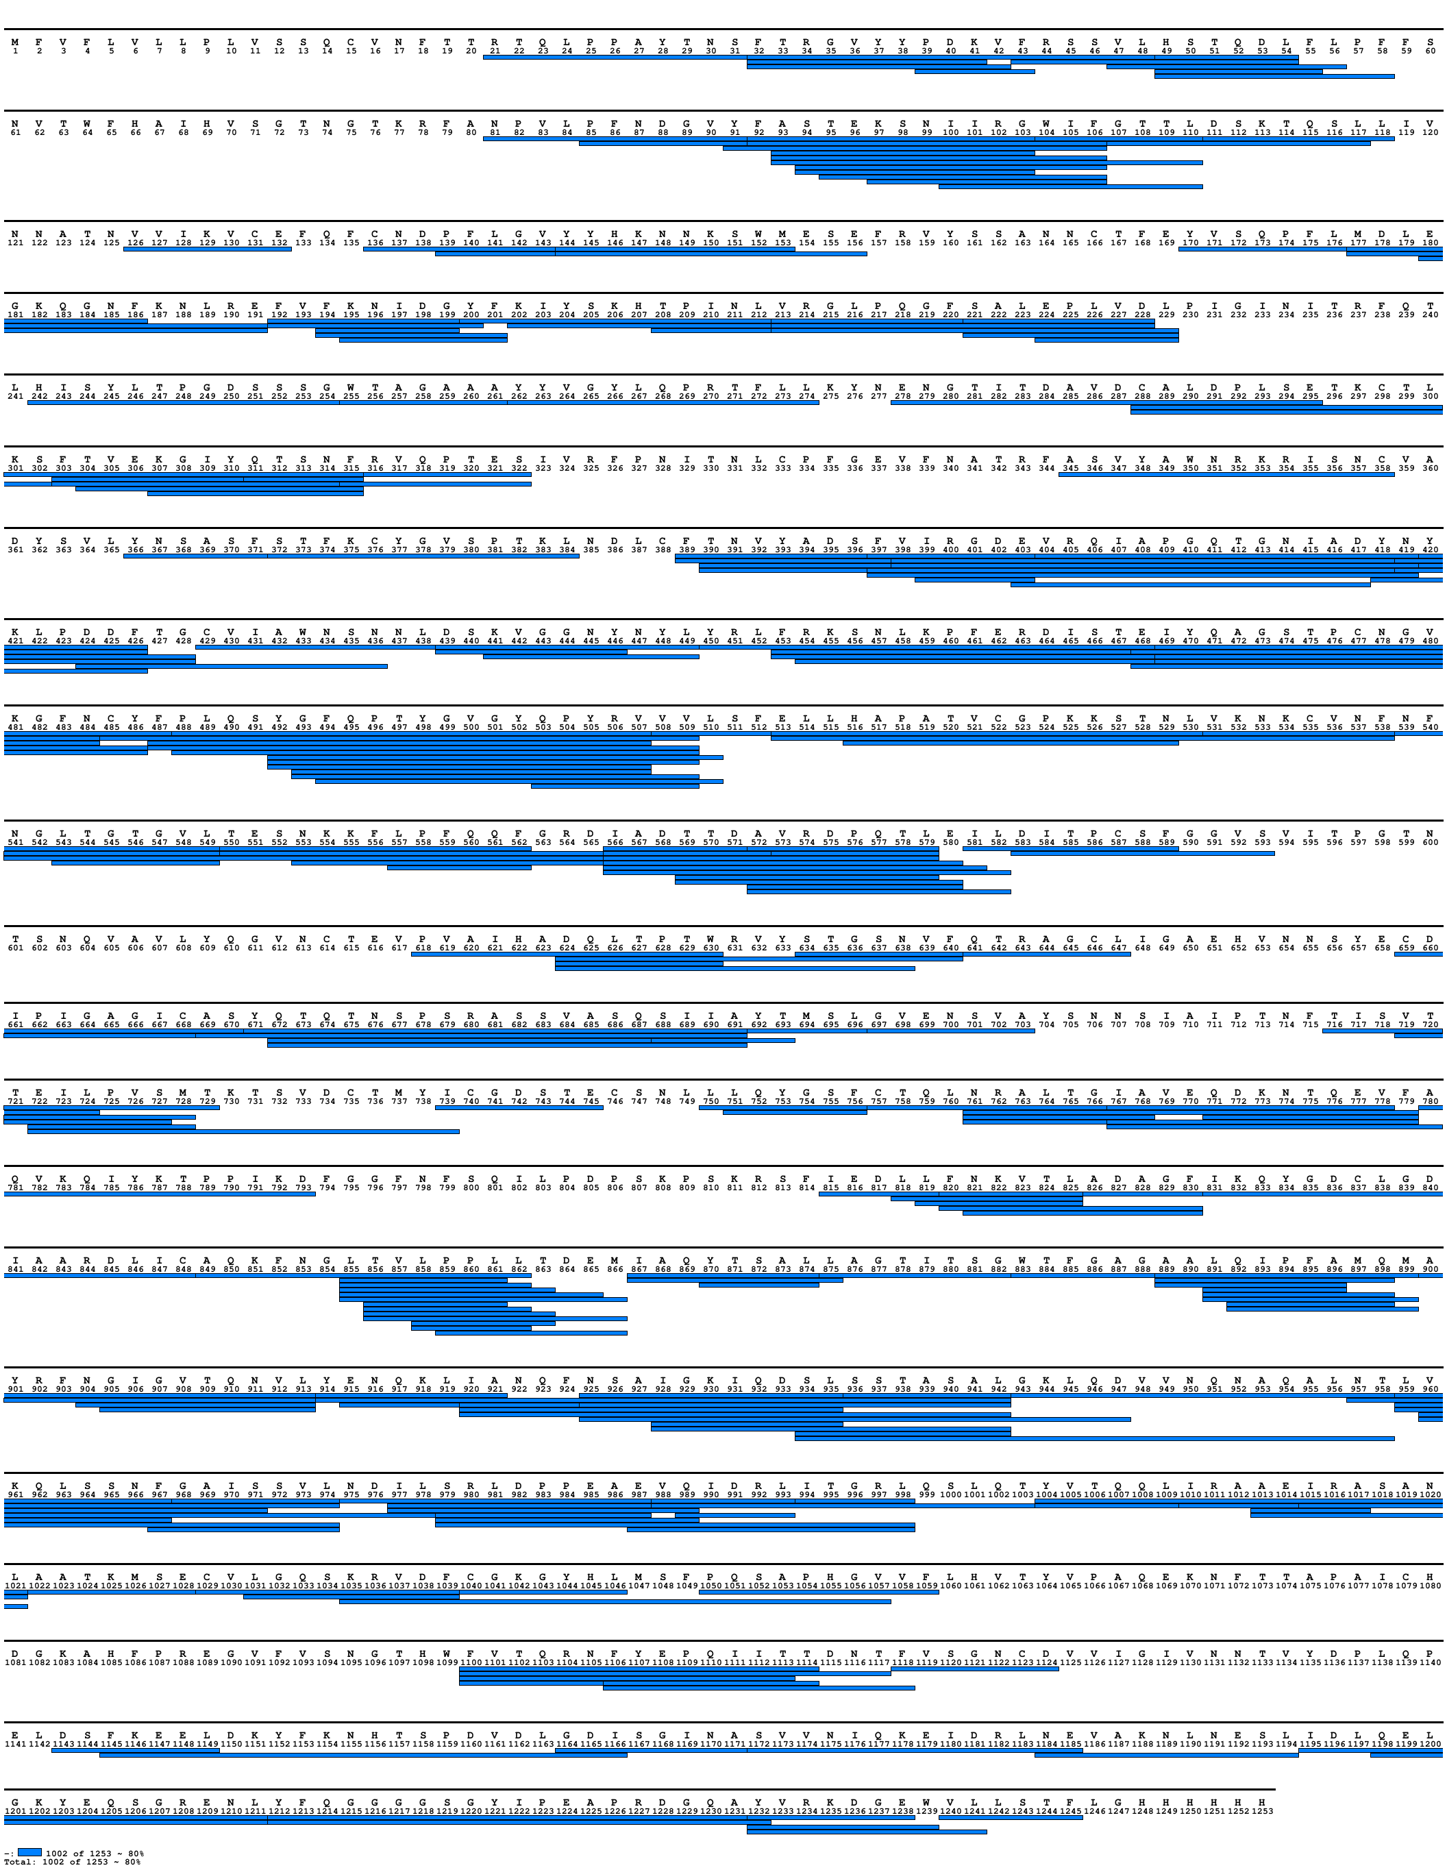
Fig. S5. Coverage map of peptides whose HDX was followed in beta spike (apo state). The signal peptide (residues 1-13) is indicated but not present in the protein analyzed. The figure was generated with MS Tools.

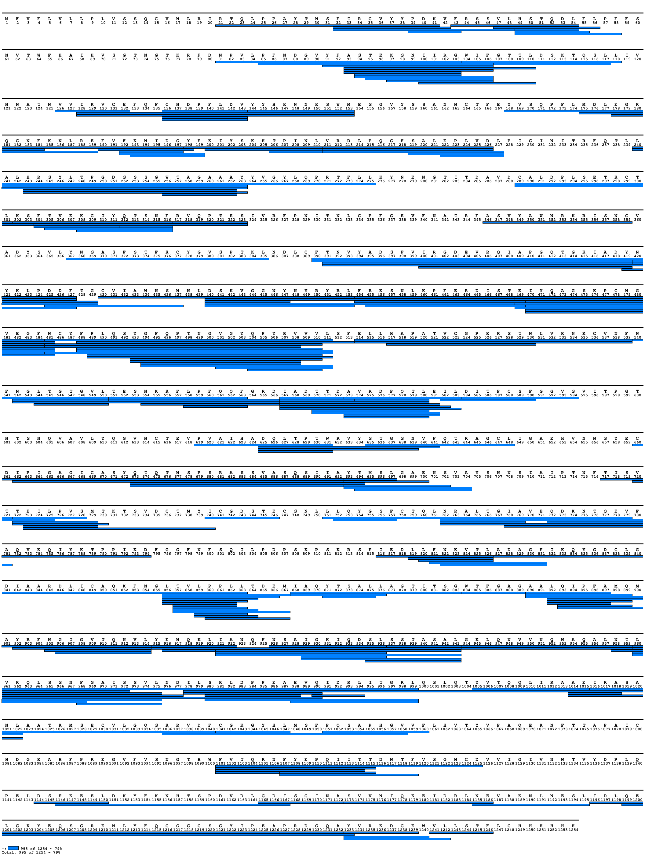
Fig. S6. Coverage map of peptides whose HDX was followed in delta spike (apo state). The signal peptide (residues 1-13) is indicated but not present in the protein analyzed. The figure was generated with MS Tools.

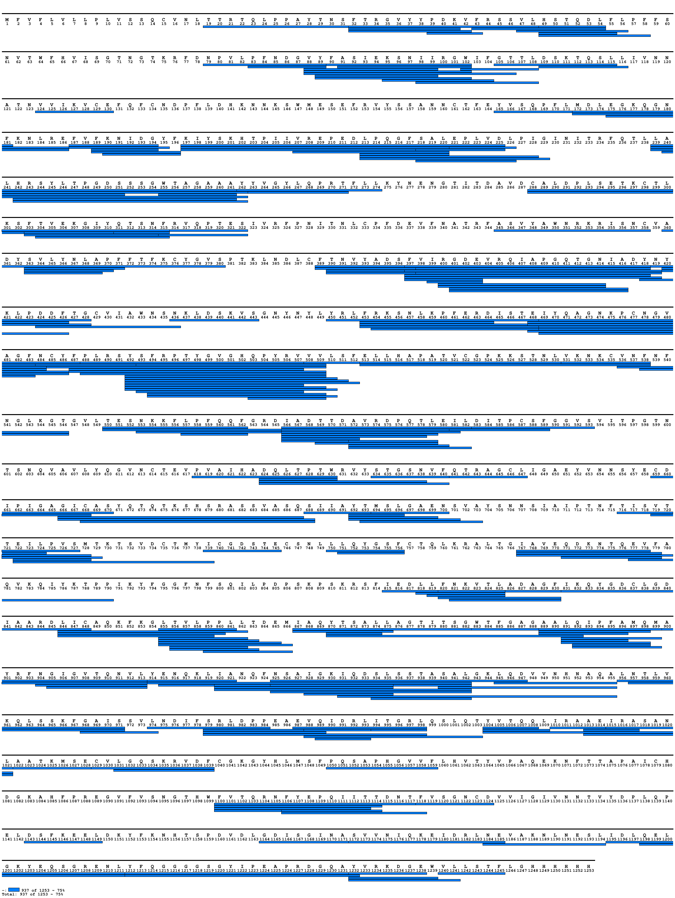
Fig. S7. Coverage map of peptides whose HDX was followed in omicron spike (apo state). The signal peptide (residues 1-13) is indicated but not present in the protein analyzed. The figure was generated with MS Tools.

Fig S8. Difference plot illustrating the difference in HDX between alpha and G614 spikes (light blue line: 4 s on ice, orange line: 20 s on ice, grey line: 15 s at 23 °C, yellow line: 1 min at 23 °C, green line: 10 min at 23 °C, violet line: 100 min at 23 °C, dark blue line: 360 min at 28 °C). Residues comprising a region with significant differences in HDX are indicated according to residue numbering of G614 spike. The peptides are arranged according to their peptide centre residue. A dotted grey line indicates the 98% CI as a threshold for significance. The top bar shows spike subdomains. The black dot indicates the position of D614G substitution, whereas the red dots indicate the position of the other residue changes.

Fig S9. Difference plot illustrating the difference in HDX between beta and G614 spikes (light blue line: 4 s on ice, orange line: 20 s on ice, grey line: 15 s at 23 °C, yellow line: 1 min at 23 °C, green line: 10 min at 23 °C, violet line: 100 min at 23 °C, dark blue line: 360 min at 28 °C). Residues comprising a region with significant differences in HDX are indicated according to residue numbering of G614 spike. The peptides are arranged according to their peptide centre residue. A dotted grey line indicates the 98% CI as a threshold for significance. The top bar shows spike subdomains. The black dot indicates the position of D614G substitution, whereas the red dots indicate the position of the other residue changes.
Fig S10. Difference plot illustrating the difference in HDX between delta and G614 spikes (light blue line: 4 s on ice, orange line: 20 s on ice, green line: 10 min at 23 °C, dark blue line: 360 min at 28 °C). Residues comprising a region with significant differences in HDX are indicated according to residue numbering of G614 spike. The peptides are arranged according to their peptide centre residue. A dotted grey line indicates the 98% CI as a threshold for significance. The top bar shows spike subdomains. The black dot indicates the position of D614G substitution, whereas the red dots indicate the position of the other residue changes.

Fig S11. Difference plot illustrating the difference in HDX between omicron and G614 spikes (light blue line: 4 s on ice, orange line: 20 s on ice, grey line: 15 s at 23 °C, yellow line: 1 min at 23 °C, green line: 10 min at 23 °C, violet line: 100 min at 23 °C, dark blue line: 360 min at 28 °C). Residues comprising a region with significant differences in HDX are indicated according to residue numbering of G614 spike. The peptides are arranged according to their peptide centre residue. A dotted grey line indicates the 98% CI as a threshold for significance. The top bar shows spike subdomains. The black dot indicates the position of D614G substitution, whereas the red dots indicate the position of the other residue changes.

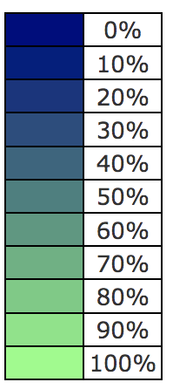
Fig. S12. Conformational dynamics of Wuhan, G614, alpha, beta, delta and omicron spikes. Selected peptide segments are coloured on the structure of G614 spike with one protomer erected (PDB: 7bnn) in blue-to-green scale according to the percentage of deuterium uptake at selected time points (and an average of them) relative to the uptake of the maximally labelled control. Red squares frame protein regions displaying common effects in spike variants (in the protomer where they are better visible and at the time point when they more clearly manifest). Figures were generated with MS Tools and Jmol.
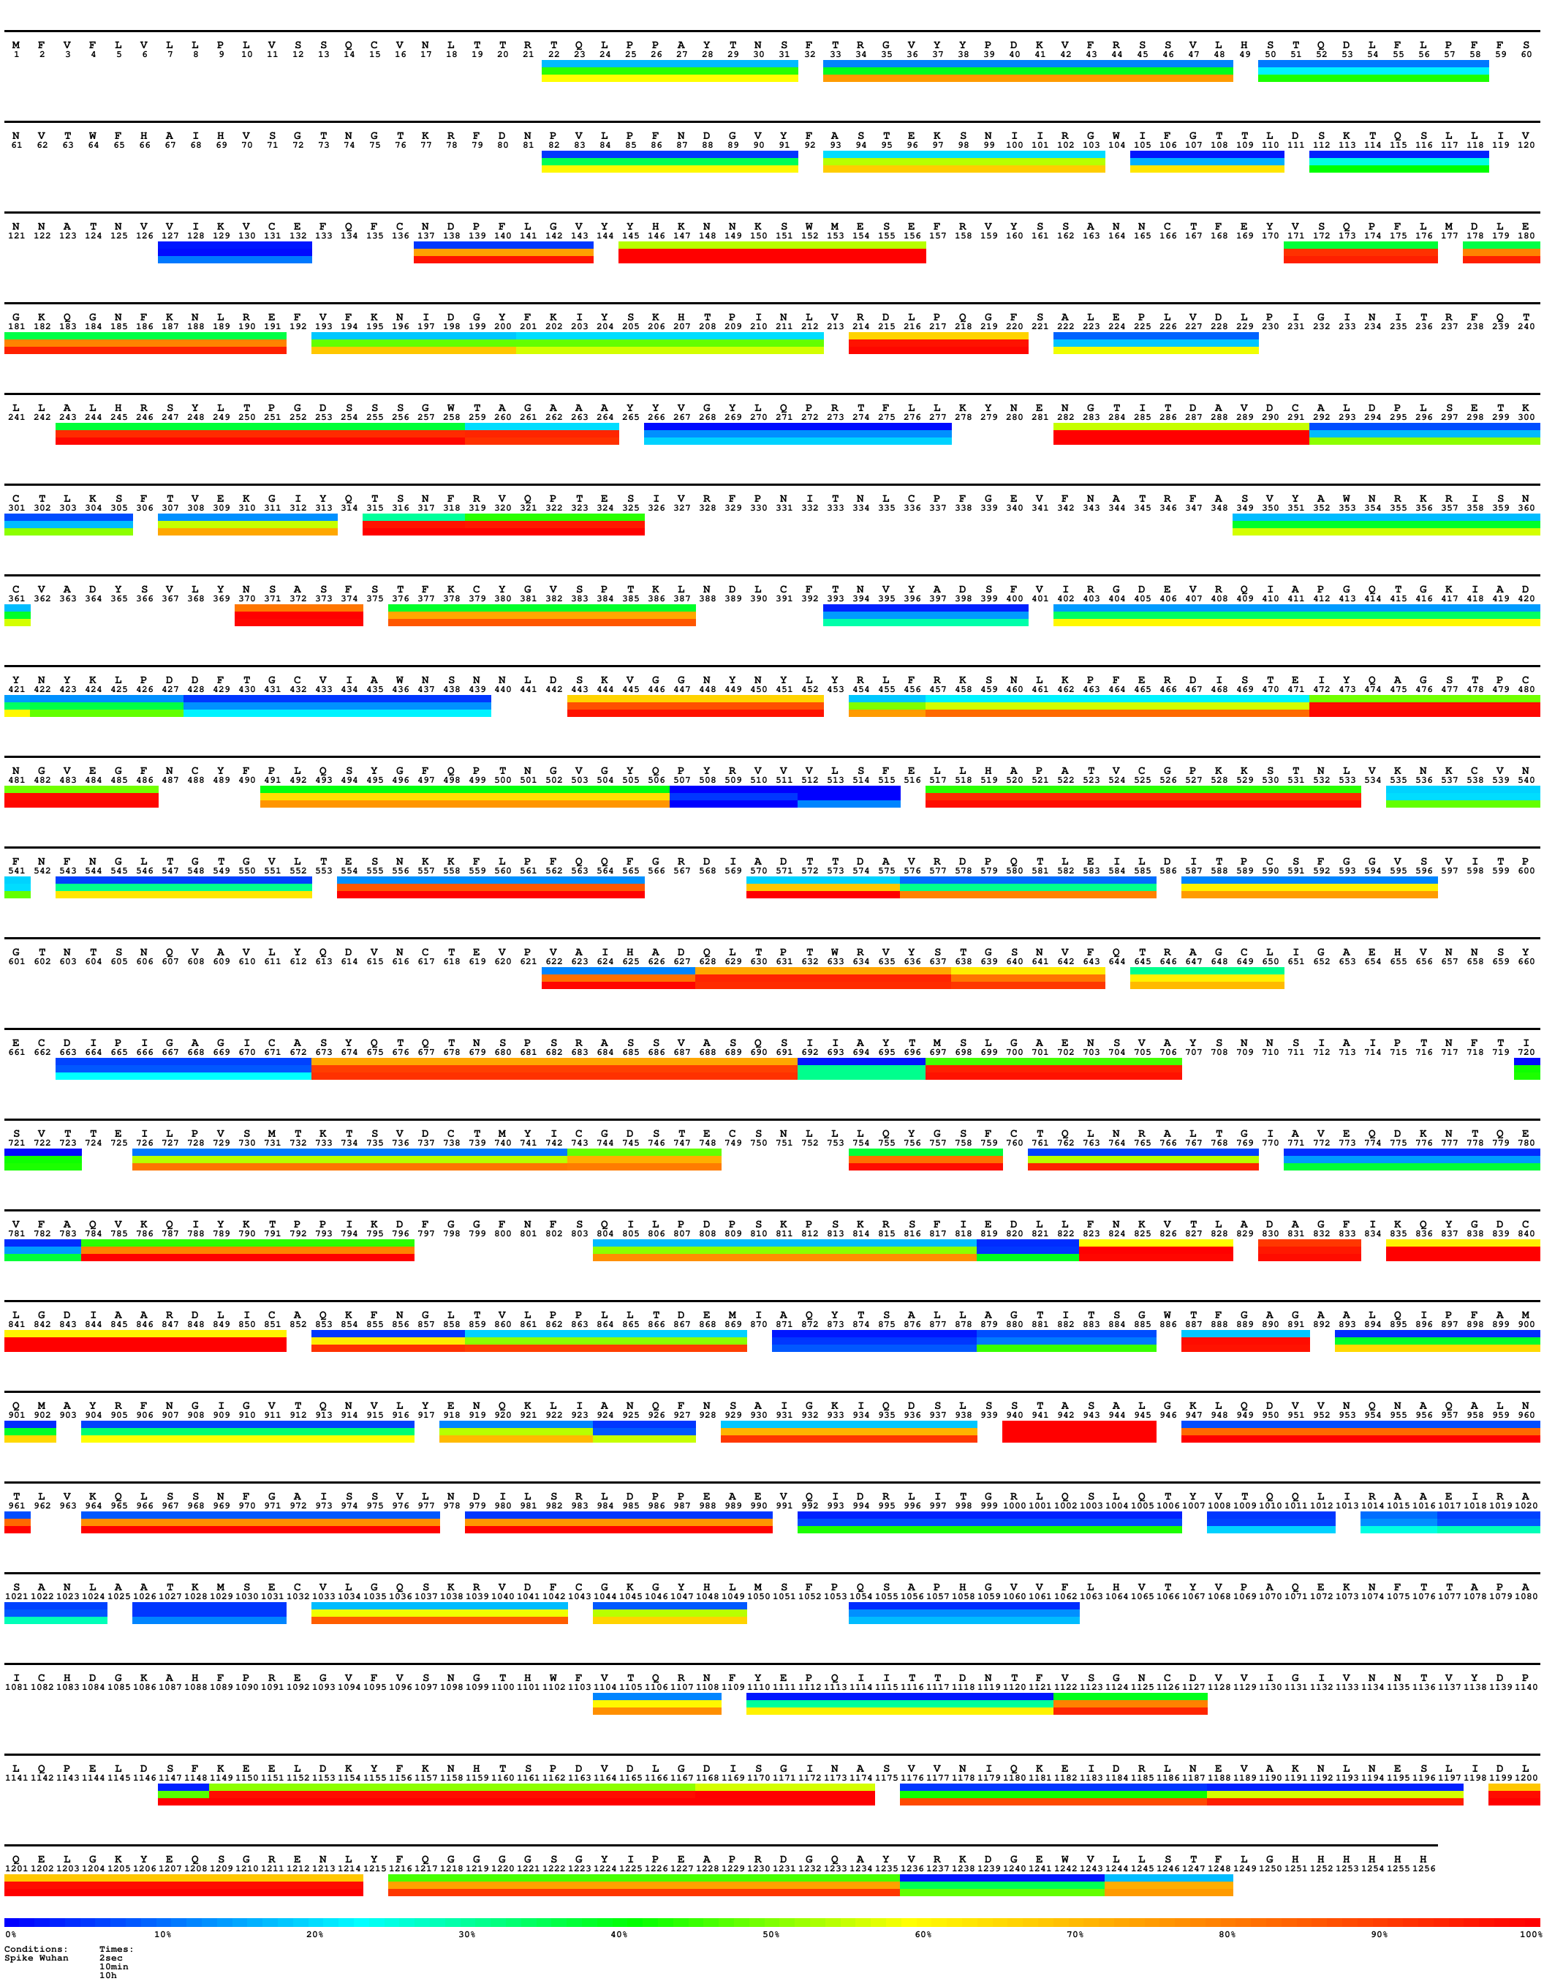
Fig. S13. Heatmap of Wuhan spike for time points 20 s on ice (~2 s at 23 °C), 10 min at 23 °C and 360 min at 28 °C (~10 h at 23 °C). Selected peptide segments are coloured according to the percentage of deuterium uptake relative to the maximally labelled control. Peptide segments manifesting HDX in the NTD of spike variants are framed in black. The figure was generated with MS Tools.
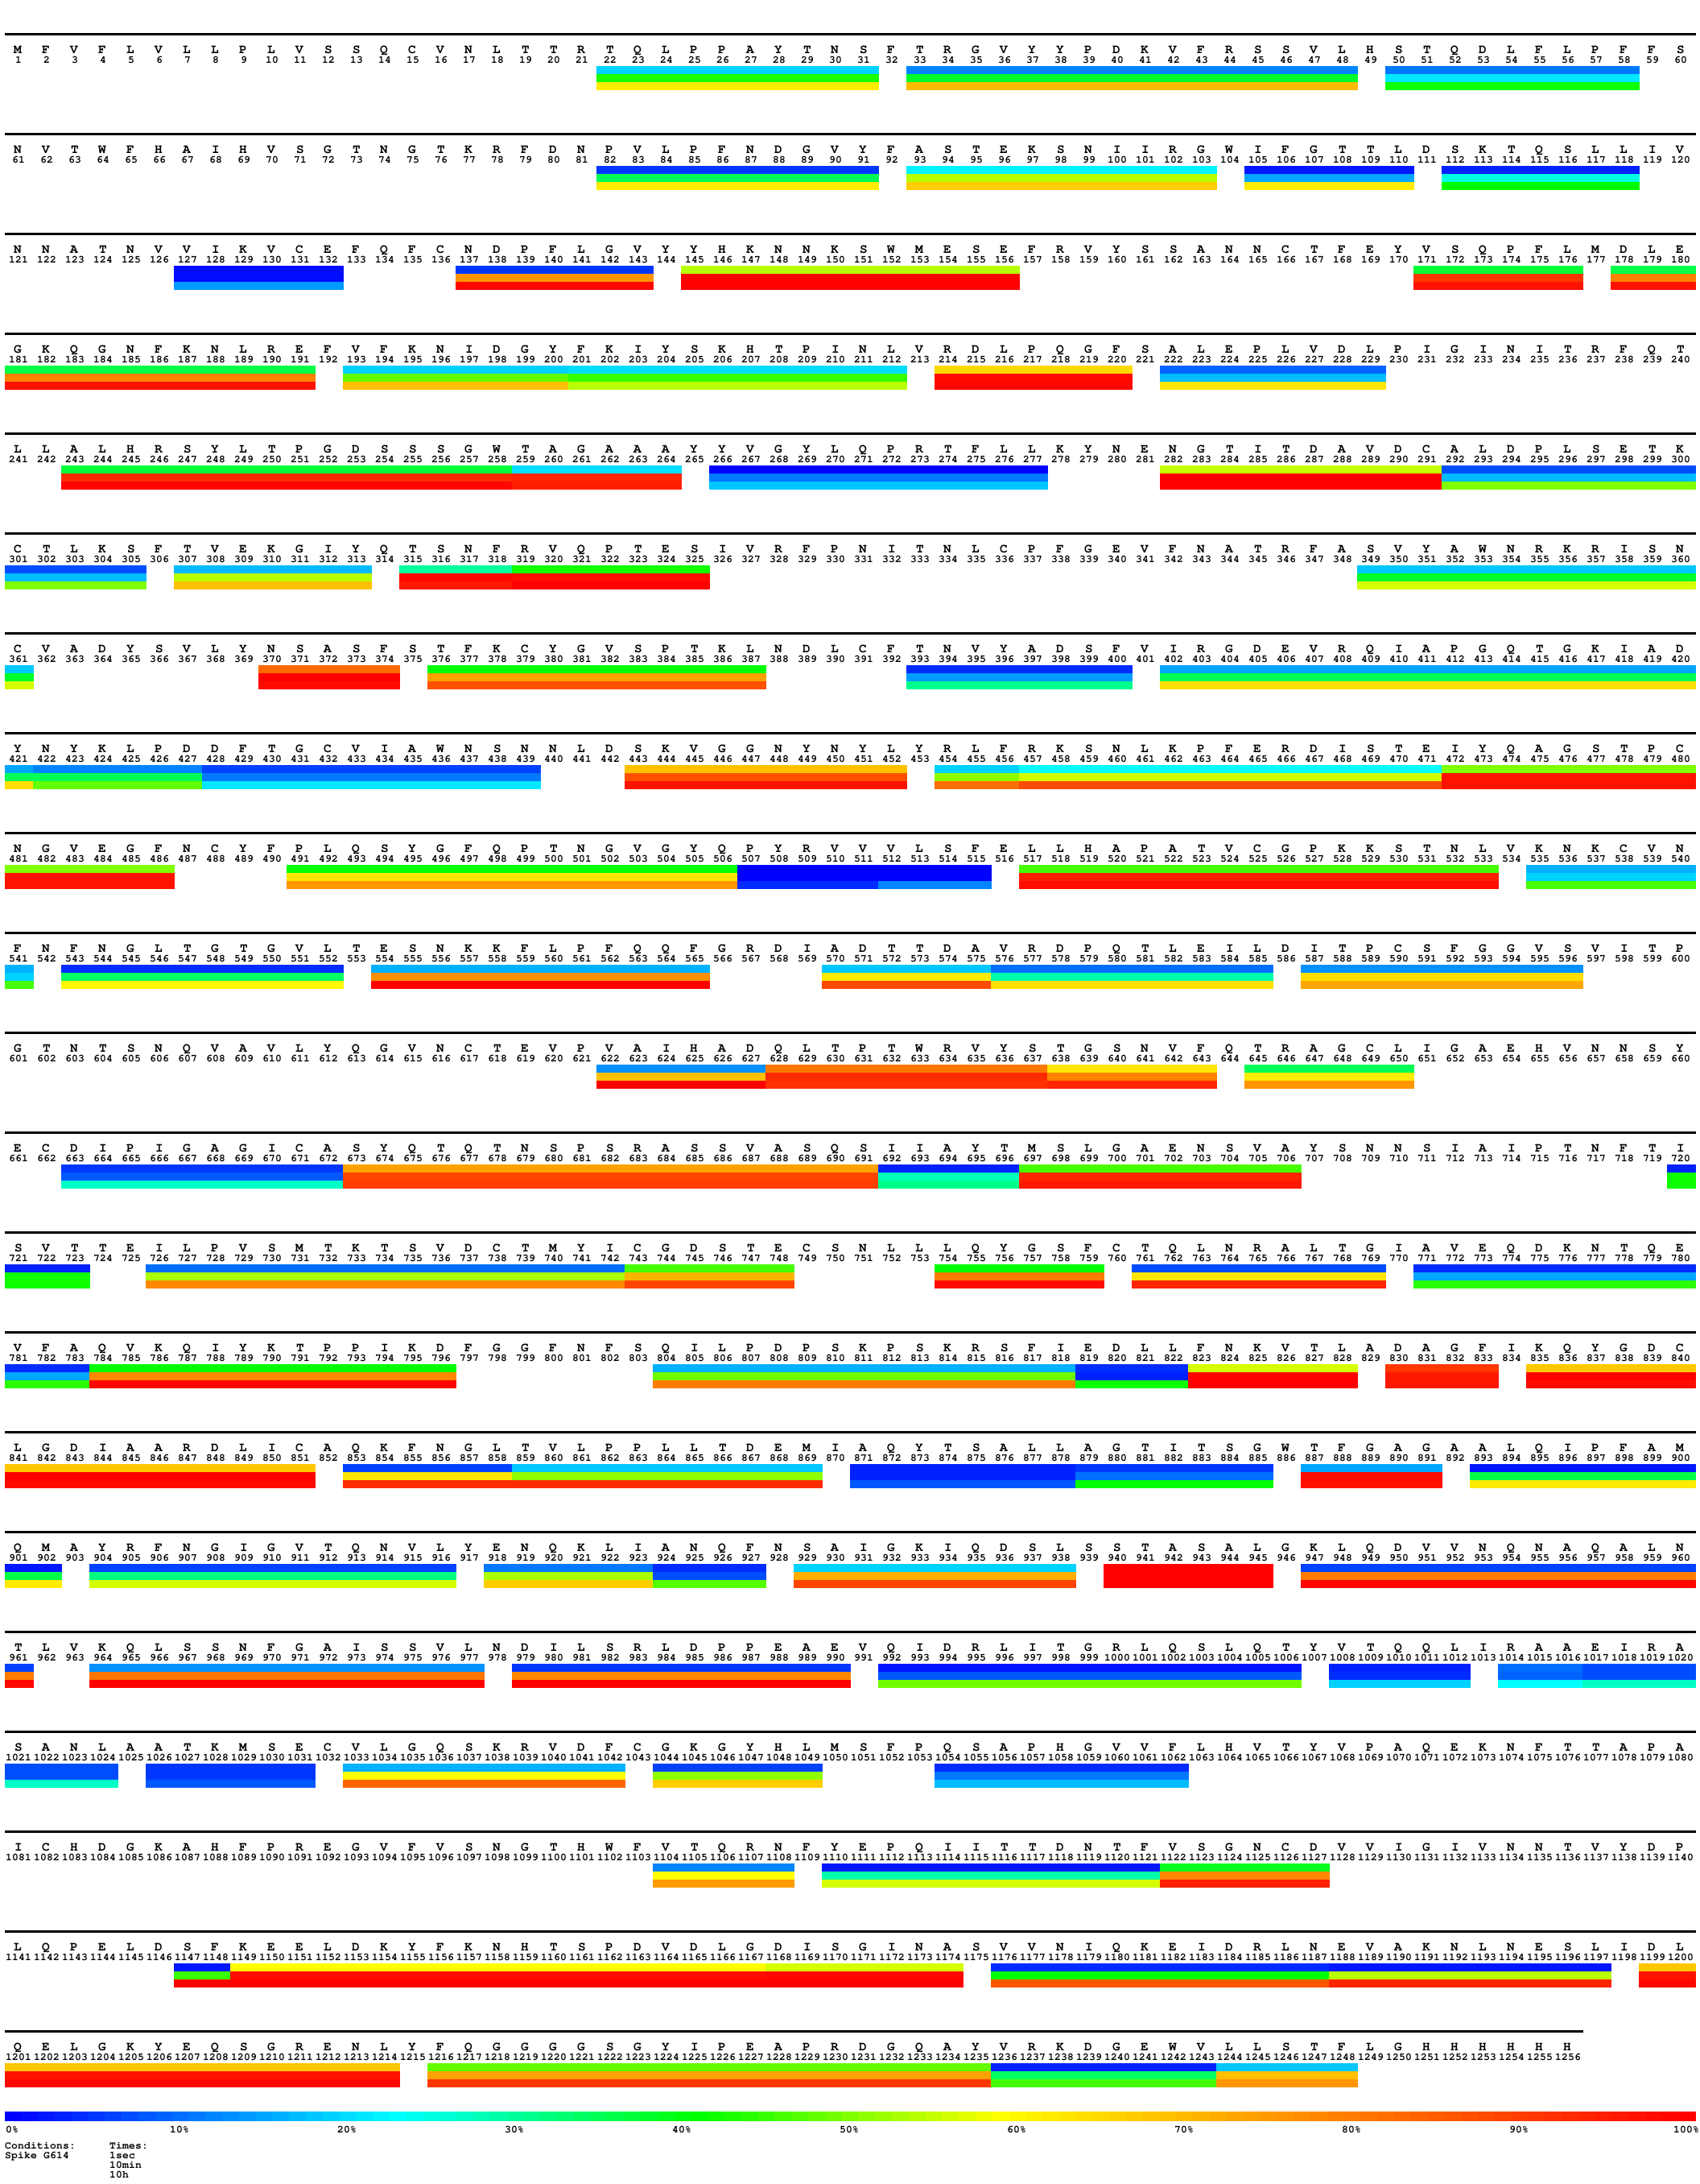
Fig. S14. Heatmap of G614 spike for time points 20 s on ice (~2 s at 23 °C), 10 min at 23 °C and 360 min at 28 °C (~10 h at 23 °C). Peptide segments are coloured according to the percentage of deuterium uptake relative to the maximally labelled control. Selected peptide segments manifesting increased HDX in the NTD of spike variants are framed in black. The figure was generated with MS Tools.
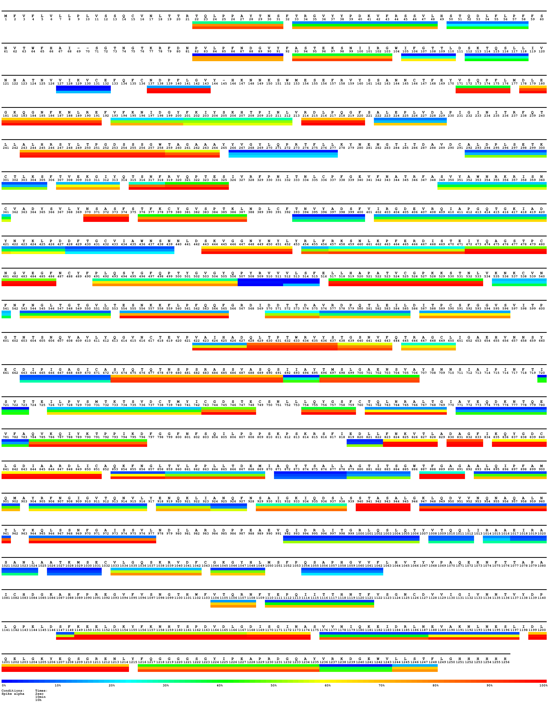
Fig. S15. Heatmap of alpha spike for time points 20 s on ice (~2 s at 23 °C), 10 min at 23 °C and 360 min at 28 °C (~10 h at 23 °C). Selected peptide segments are coloured according to the % of uptake relative to the maximally labelled control. Sequence was adapted to the residue numbering of G614 spike. Peptide segments manifesting increased HDX in the NTD of spike variants are framed in black. The figure was generated with MS Tools.
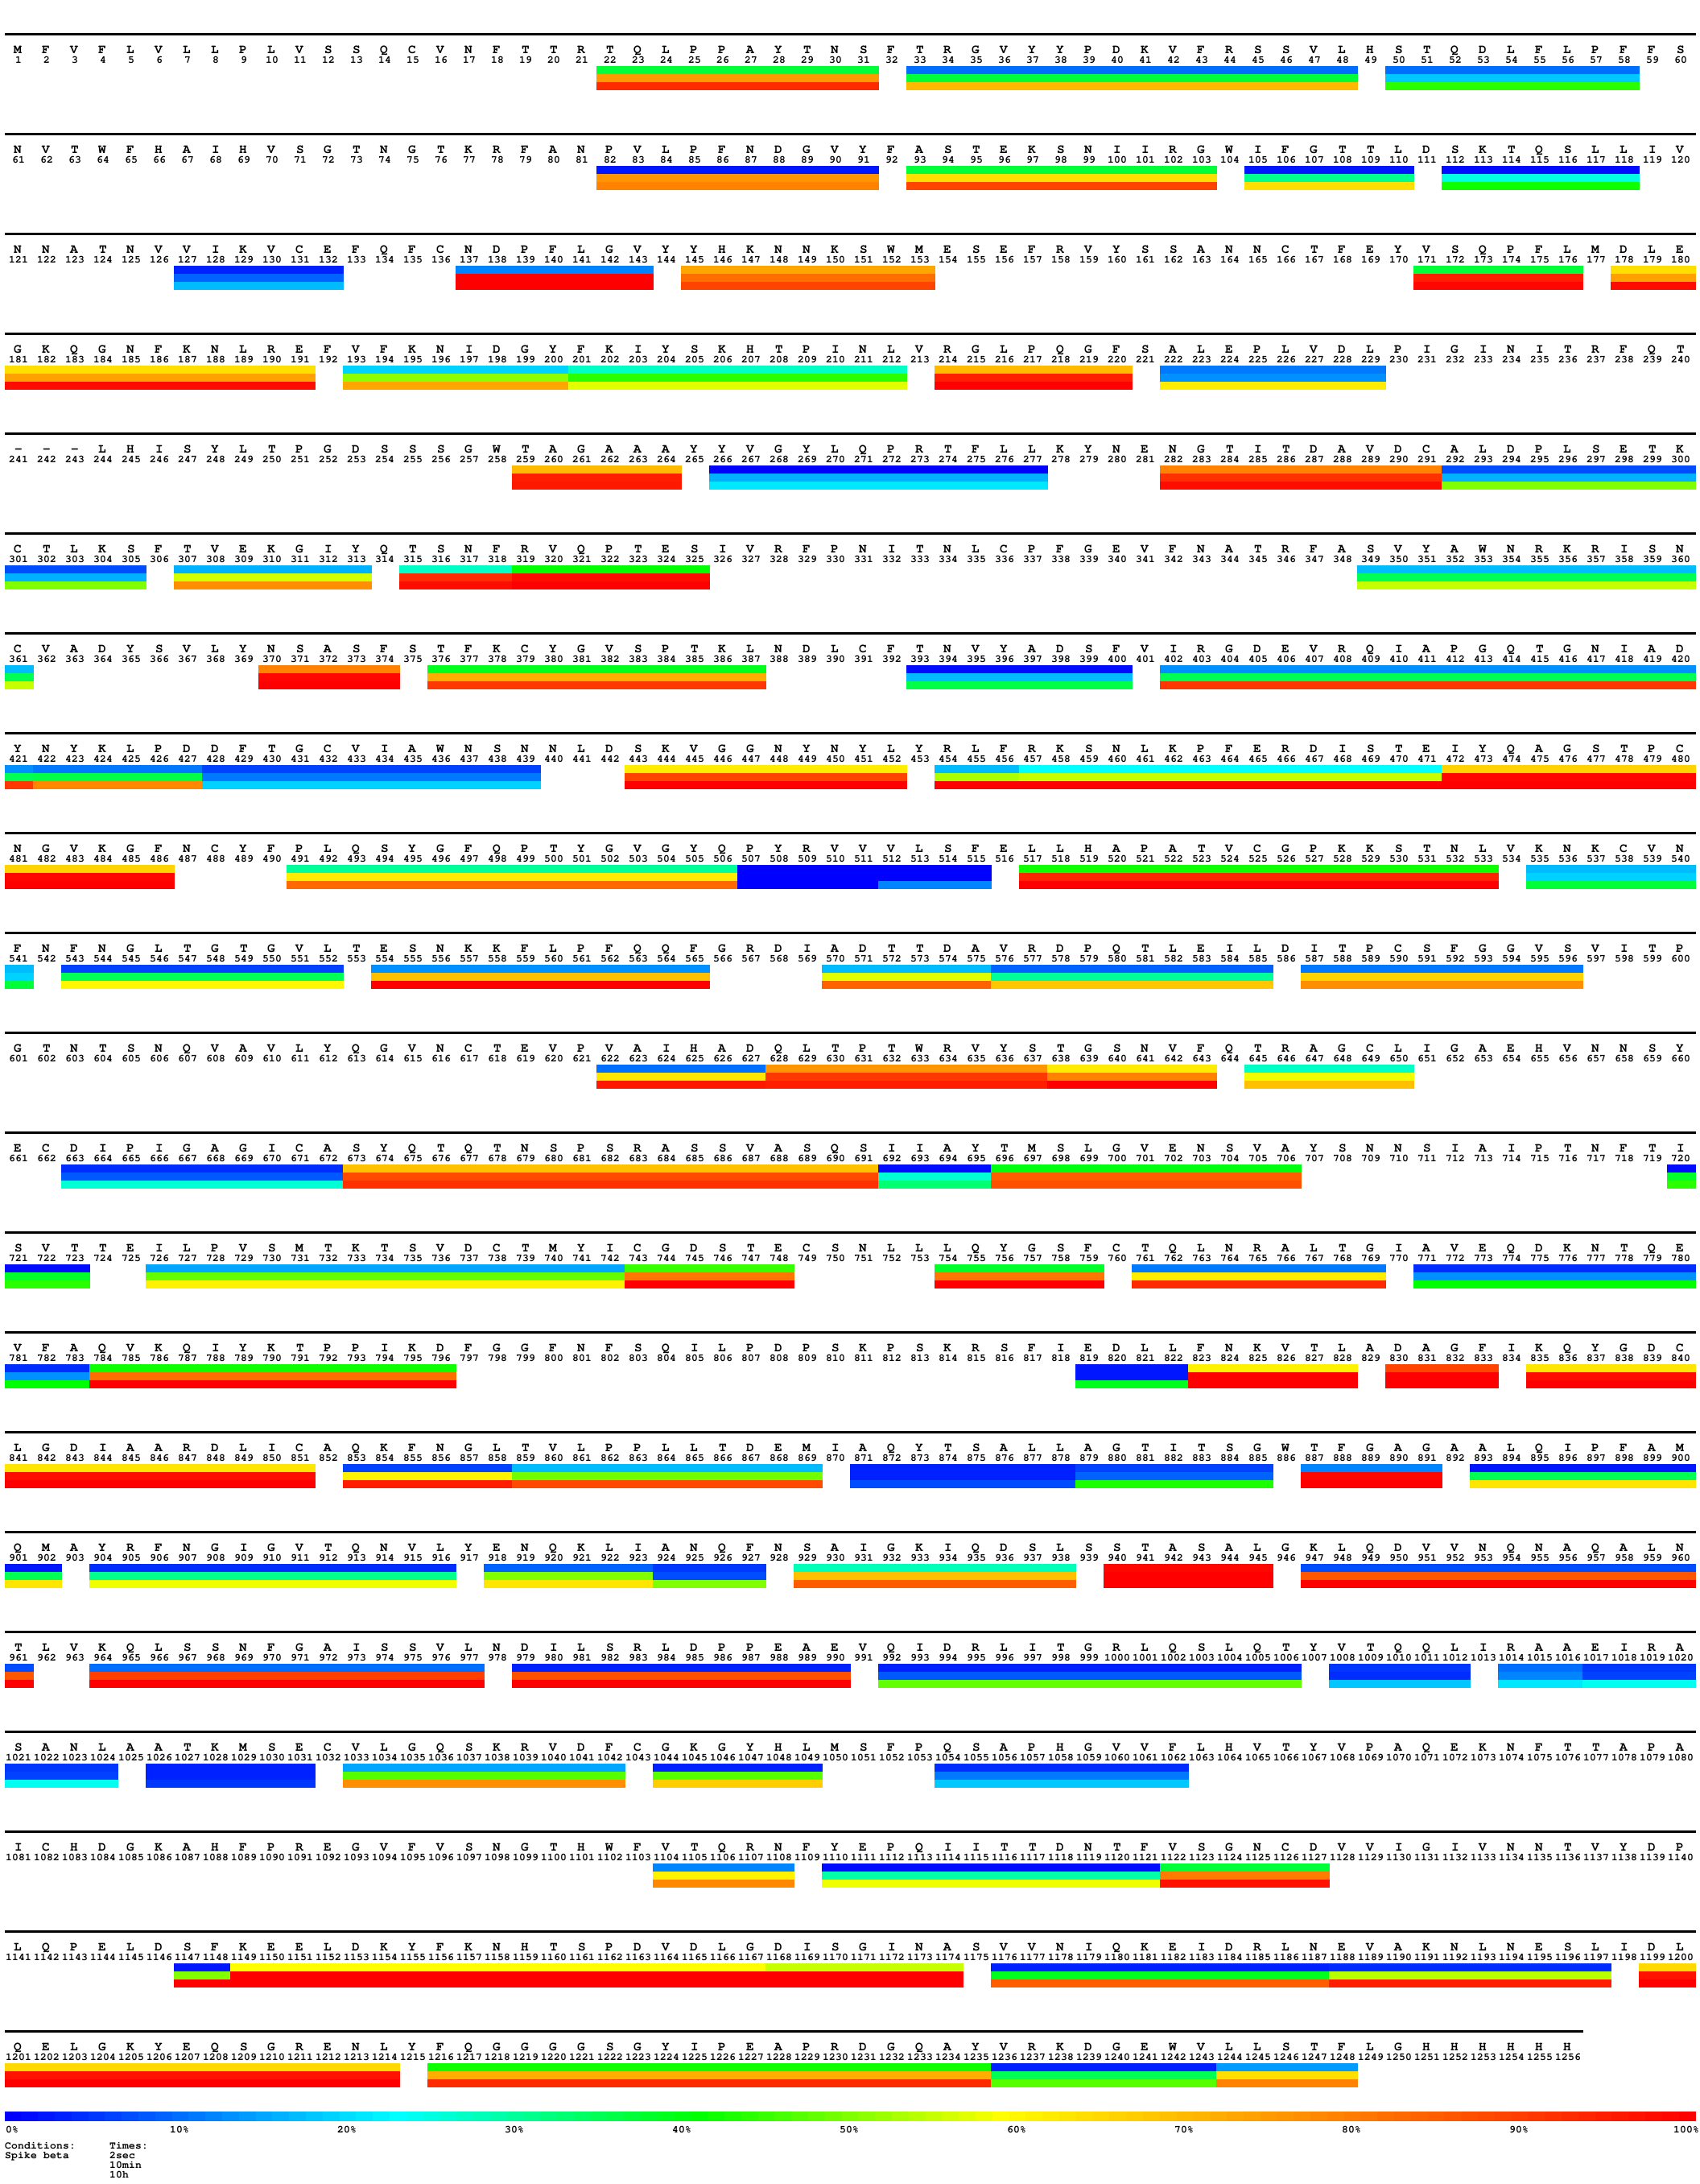
Fig. S16. Heatmap of beta spike for time points 20 s on ice (~2 s at 23 °C), 10 min at 23 °C and 360 min at 28 °C (~10 h at 23 °C). Selected peptide segments are coloured according to the % of uptake relative to the maximally labelled control. Sequence was adapted to the residue numbering of G614 spike. Peptide segments manifesting increased HDX in the NTD of spike variants are framed in black. The figure was generated with MS Tools.
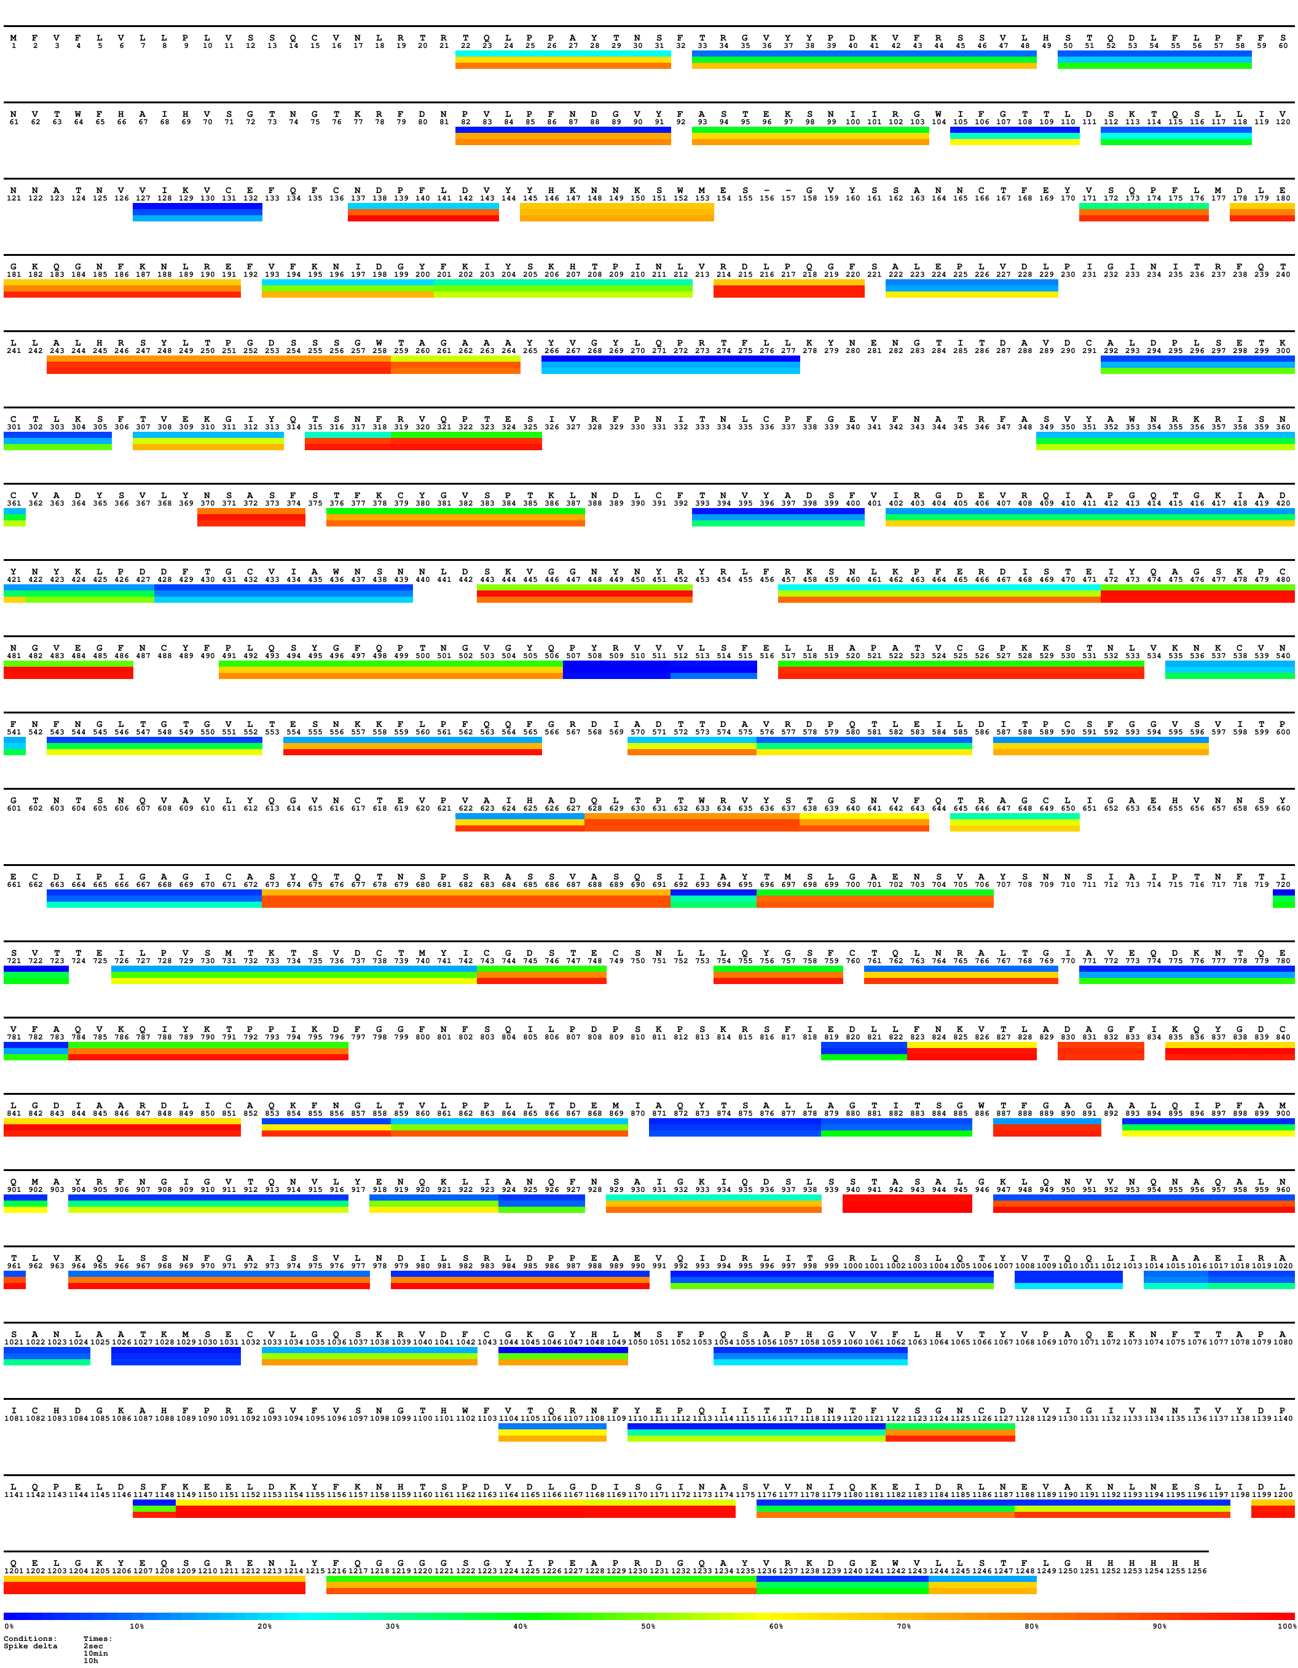
Fig. S17. Heatmap of delta spike for time points 20 s on ice (~2 s at 23 °C), 10 min at 23 °C and 360 min at 28 °C (~10 h at 23 °C). Selected peptide segments are coloured according to the % of uptake relative to the maximally labelled control. Sequence was adapted to the residue numbering of G614 spike. Peptide segments manifesting increased HDX in the NTD of spike variants are framed in black. The figure was generated with MS Tools.
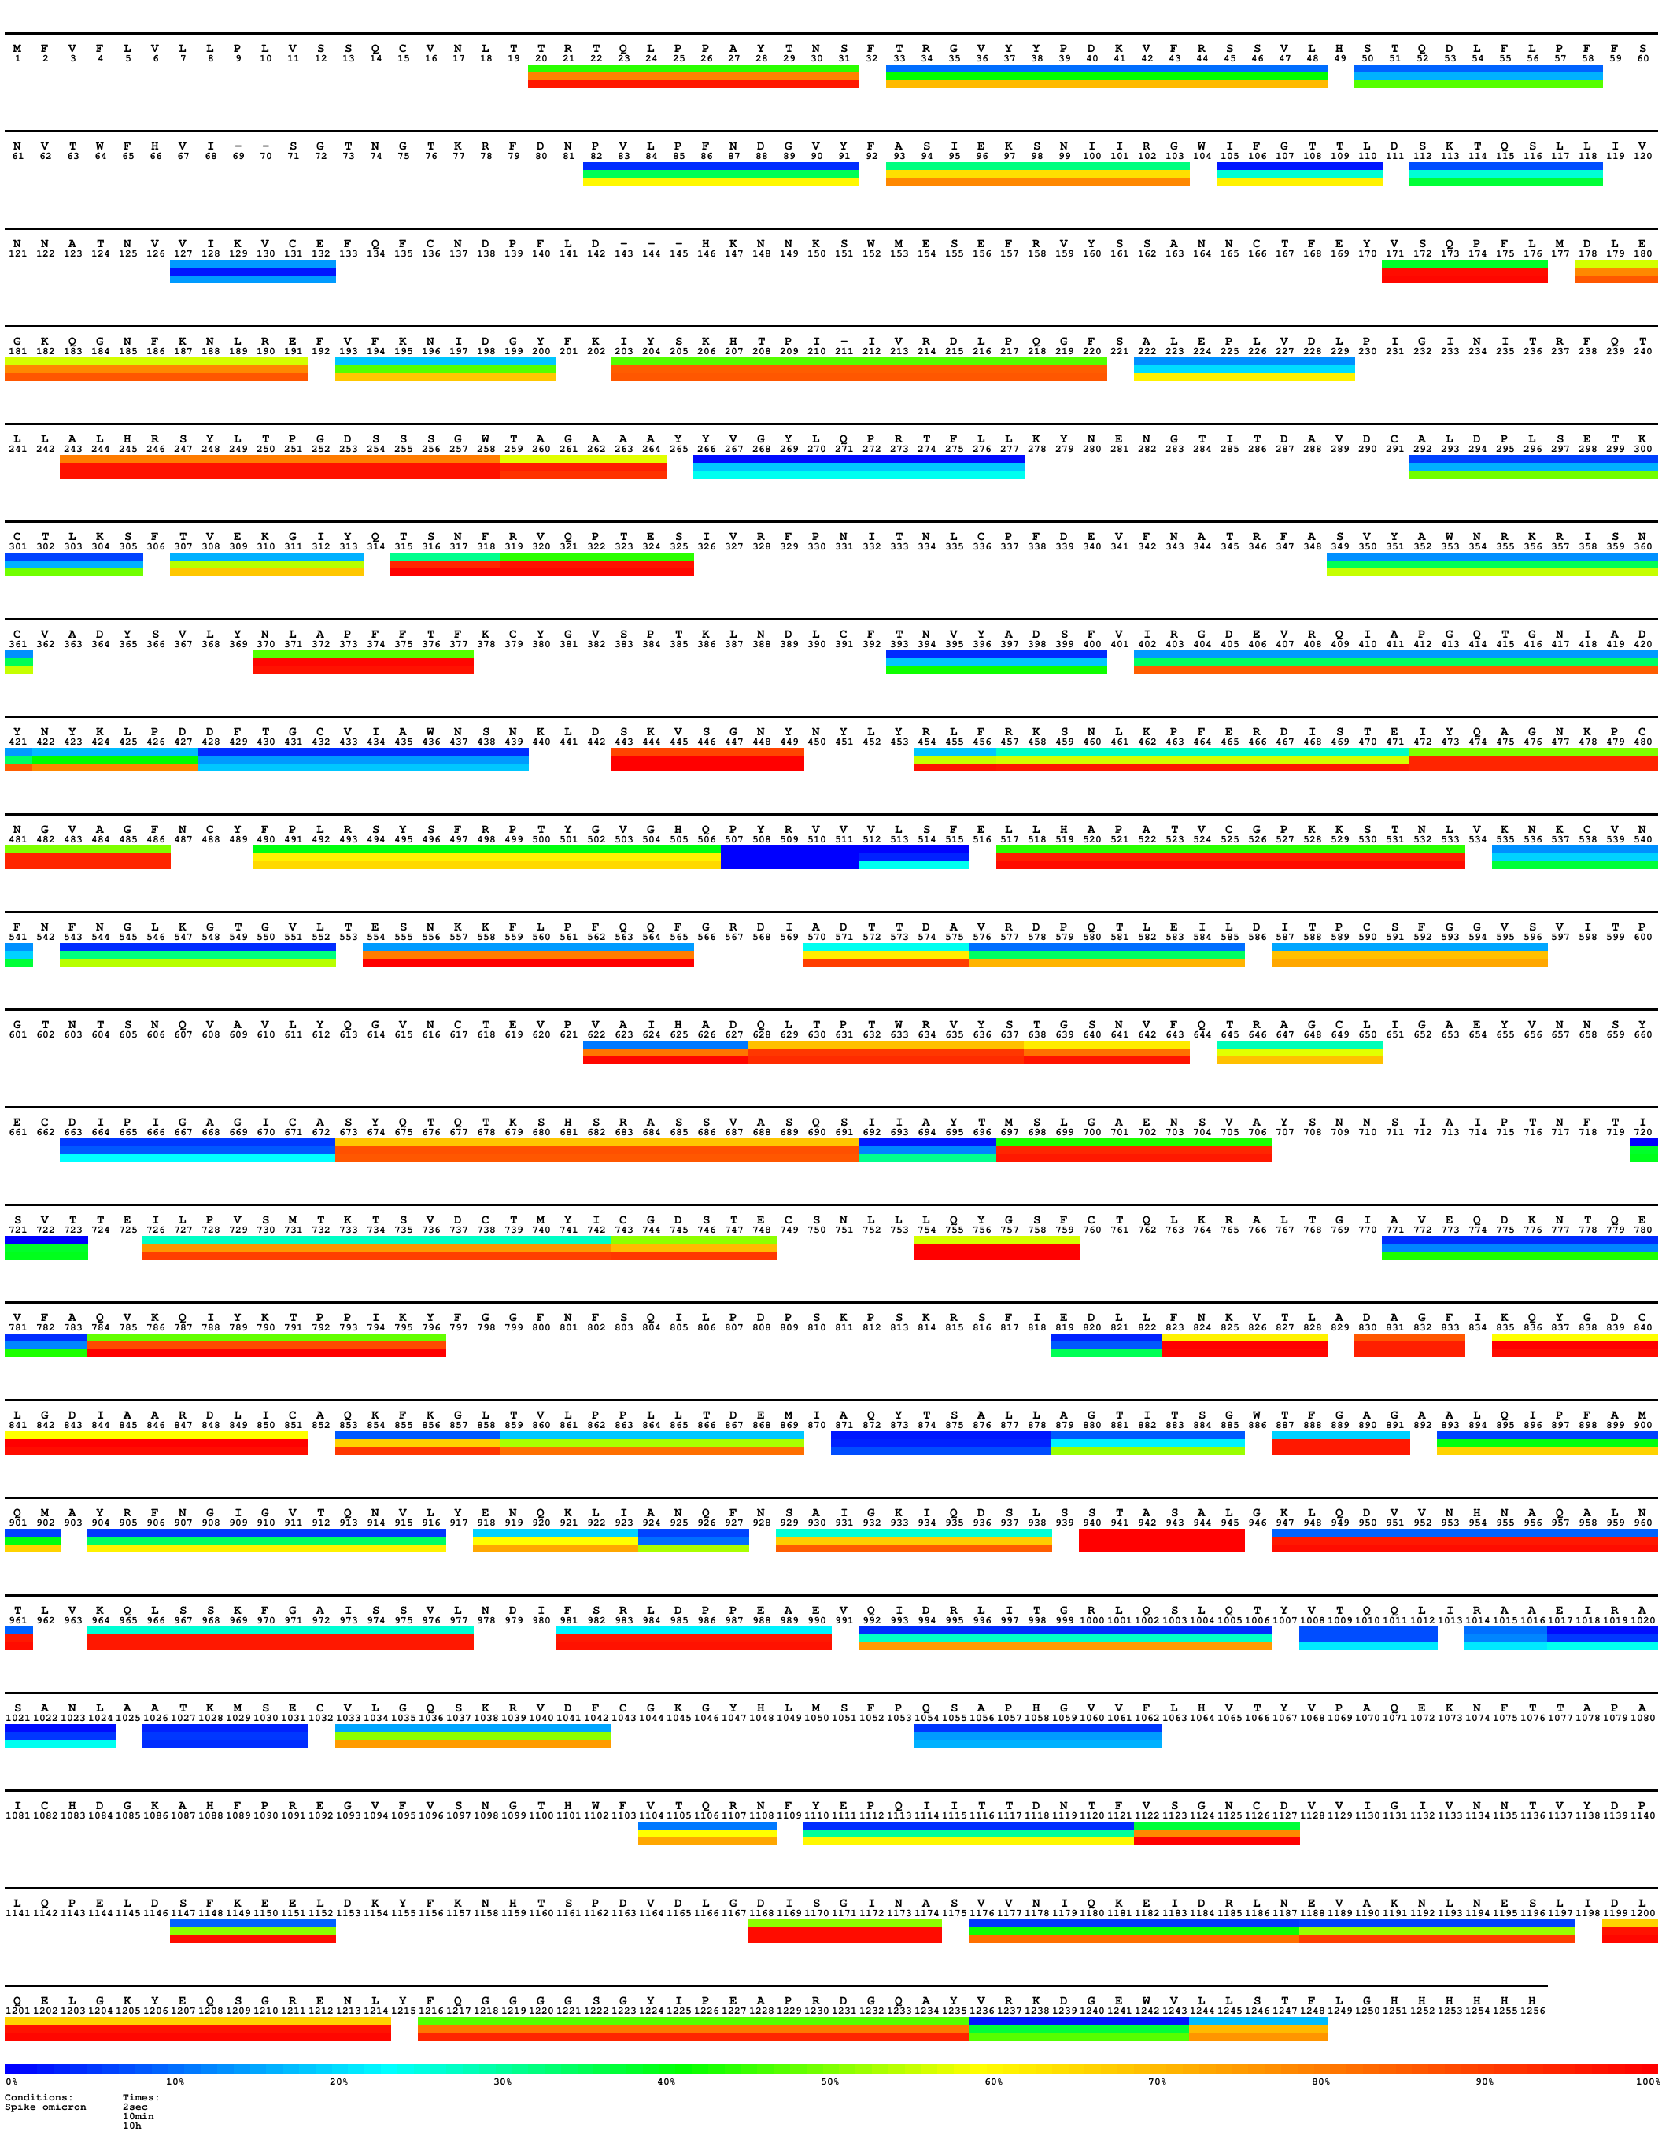
EPE
Fig. S18. Heatmap of omicron spike for time points 20 s on ice (~2 s at 23 °C), 10 min at 23 °C and 360 min at 28 °C (~10 h at 23 °C). Selected peptide segments are coloured according to the % of uptake relative to the maximally labelled control. Sequence was adapted to the residue numbering of G614 spike. Peptide segments manifesting increased HDX in the NTD of spike variants are framed in black. Figure was generated with MS Tools.
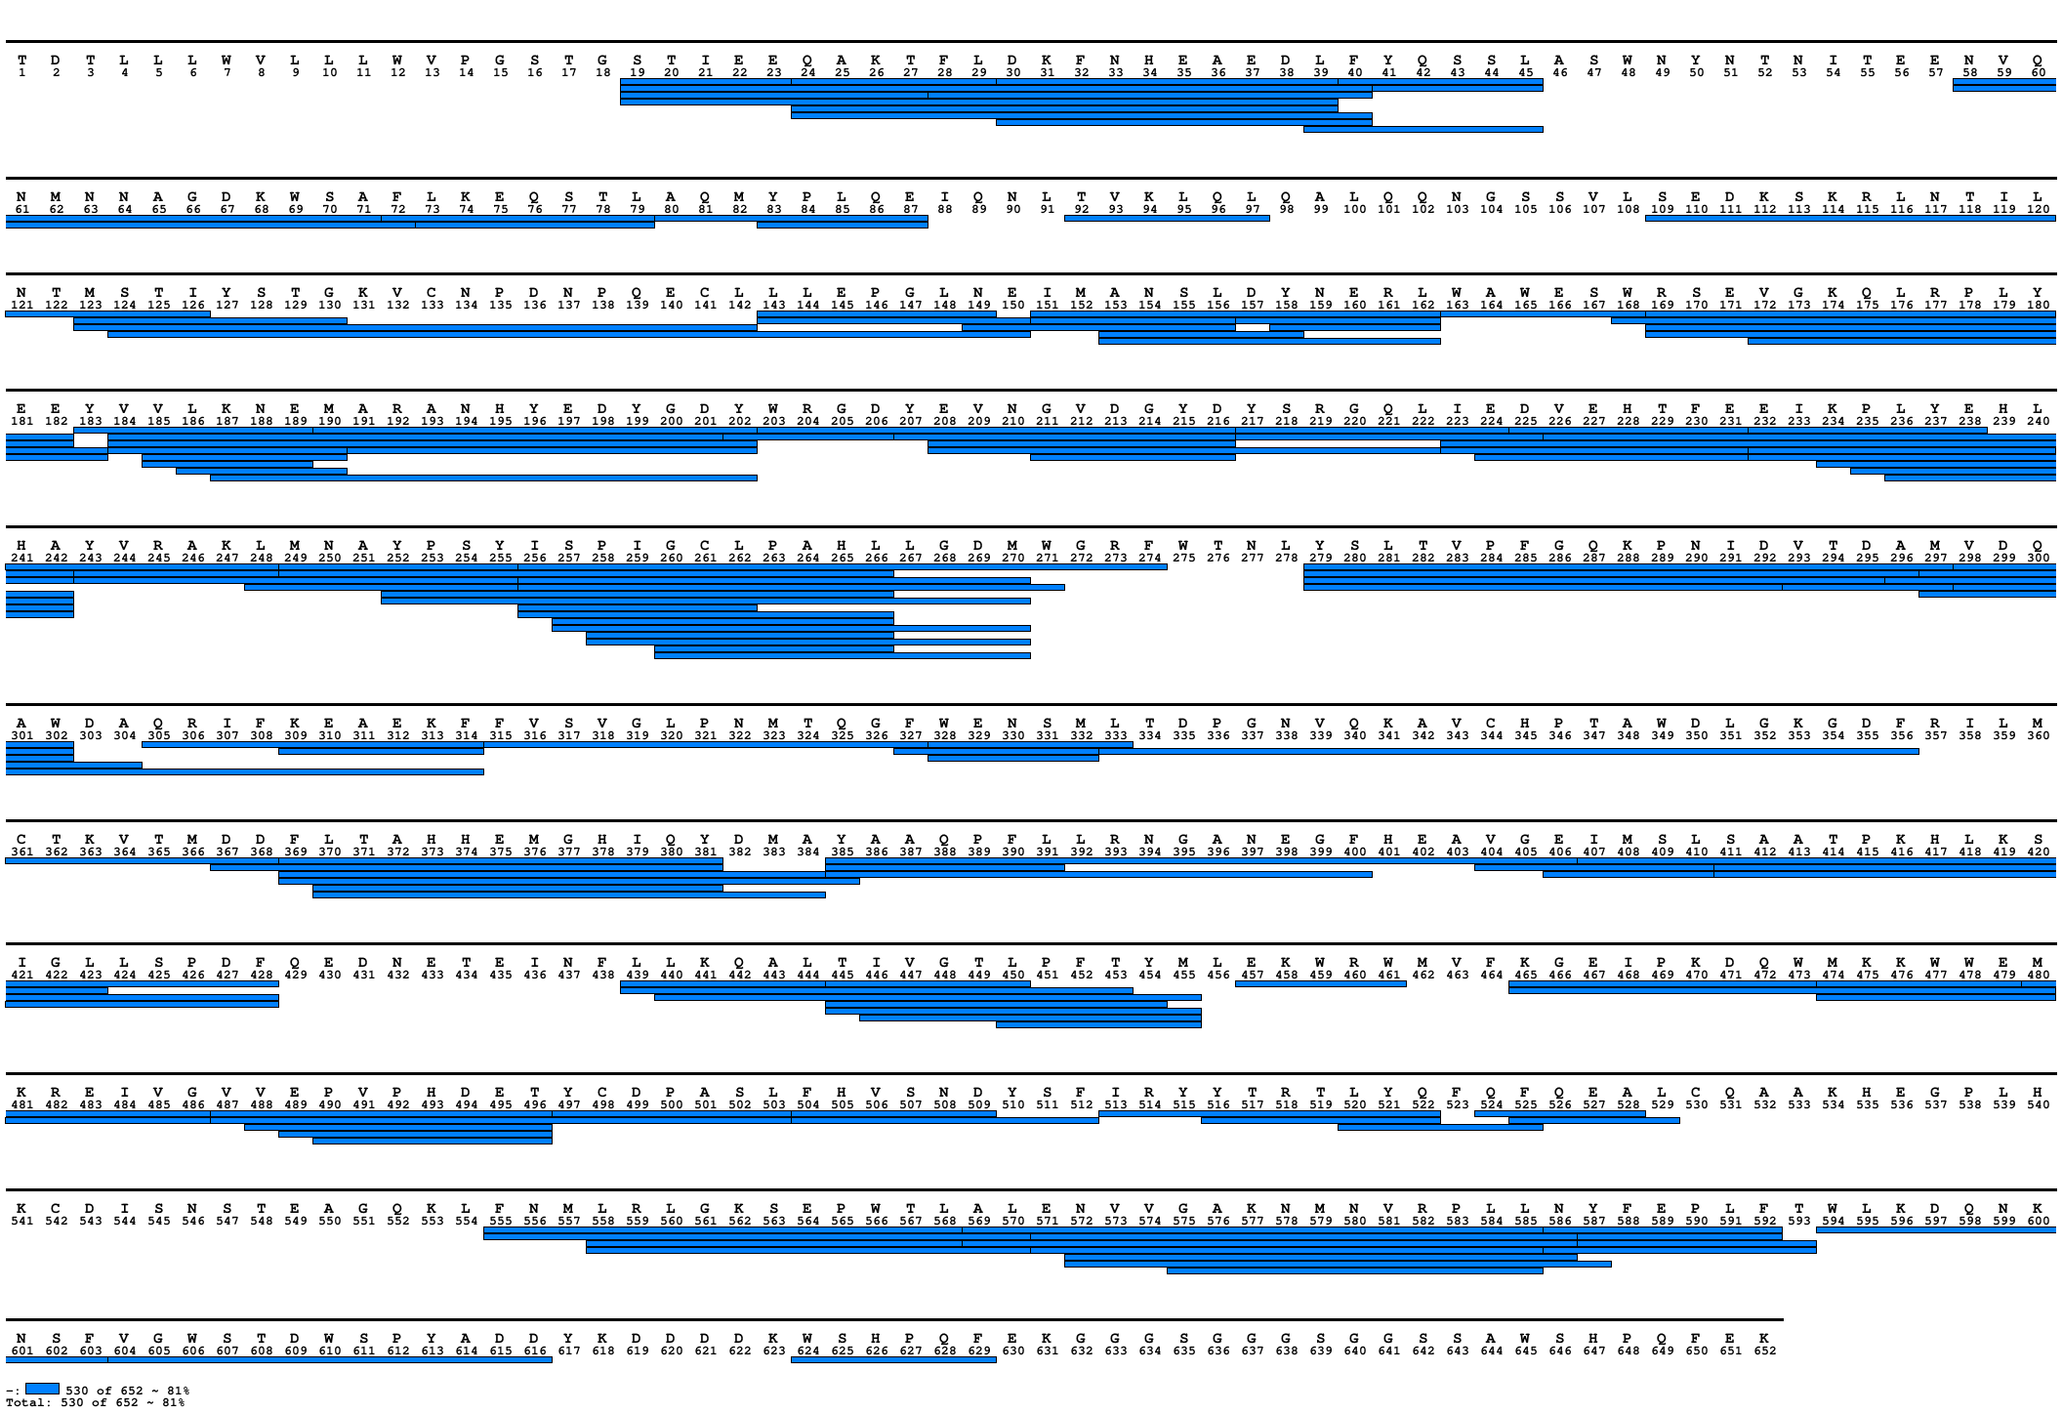
Fig. S19. Coverage map of peptides whose HDX was followed for ACE2 in apo state and in complex with spikes. The signal peptide (residues 1-18) is indicated but not present in the protein analyzed. The figure was generated with MS Tools.

Fig S20. Difference plot illustrating the difference in HDX between ACE2 in complex with Wuhan spike and ACE2 alone (light blue line: 4 s on ice, orange line: 20 s on ice, grey line: 15 s at 23 °C, yellow line: 1 min at 23 °C, green line: 10 min at 23 °C, violet line: 100 min at 23 °C, dark blue line: 360 min at 28 °C). Peptide segments of interest are highlighted. The peptides are arranged according to their peptide centre residue. A dotted grey line indicates the 98% CI as a threshold for significance and a dotted black line the 99% CI as a threshold for significance.

Fig S21. Difference plot illustrating the difference in HDX between ACE2 in complex with G614 spike and ACE2 alone (light blue line: 4 s on ice, orange line: 20 s on ice, grey line: 15 s at 23 °C, yellow line: 1 min at 23 °C, green line: 10 min at 23 °C, violet line: 100 min at 23 °C, dark blue line: 360 min at 28 °C). Peptide segments of interest are highlighted. The peptides are arranged according to their peptide centre residue. A dotted grey line indicates the 98% CI as a threshold for significance and a dotted black line the 99% CI as a threshold for significance.

Fig S22. Difference plot illustrating the difference in HDX between ACE2 in complex with alpha spike and ACE2 alone (light blue line: 4 s on ice, orange line: 20 s on ice, grey line: 15 s at 23 °C, yellow line: 1 min at 23 °C, green line: 10 min at 23 °C, violet line: 100 min at 23 °C, dark blue line: 360 min at 28 °C). Peptide segments of interest are highlighted. The peptides are arranged according to their peptide centre residue. A dotted grey line indicates the 98% CI as a threshold for significance and a dotted black line the 99% CI as a threshold for significance.

Fig S23. Difference plot illustrating the difference in HDX between ACE2 in complex with beta spike and ACE2 alone (light blue line: 4 s on ice, orange line: 20 s on ice, grey line: 15 s at 23 °C, yellow line: 1 min at 23 °C, green line: 10 min at 23 °C, violet line: 100 min at 23 °C, dark blue line: 360 min at 28 °C). Peptide segments of interest are highlighted. The peptides are arranged according to their peptide centre residue. A dotted grey line indicates the 98% CI as a threshold for significance and a dotted black line the 99% CI as a threshold for significance.

Fig S24. Difference plot illustrating the difference in HDX between ACE2 in complex with delta spike and ACE2 alone (orange line indicates: 20 s on ice, green line: 10 min at 23 °C, dark blue line: 360 min at 28 °C). Peptide segments of interest are highlighted. The peptides are arranged according to their peptide centre residue. A dotted grey line indicates the 98% CI as a threshold for significance and a dotted black line the 99% CI as a threshold for significance.

Fig S25. Difference plot illustrating the difference in HDX between ACE2 in complex with omicron spike and ACE2 alone (light blue line: 4 s on ice, orange line: 20 s on ice, grey line: 15 s at 23 °C, yellow line: 1 min at 23 °C, green line: 10 min at 23 °C, violet line: 100 min at 23 °C, dark blue line: 360 min at 28 °C). Peptide segments of interest are highlighted. The peptides are arranged according to their peptide centre residue. A dotted grey line indicates the 98% CI as a threshold for significance and a dotted black line the 99% CI as a threshold for significance.

Fig. S26. ACE2 receptor affinity and avidity of spikes. Plot illustrating cumulative differences in HDX (ΔHDX) between ACE2 and ACE2 in complex with spikes for selected peptides of interests through all time points (delta spike has been excluded as not all time points were sampled). Extended plot of fig. 3 in the main text.

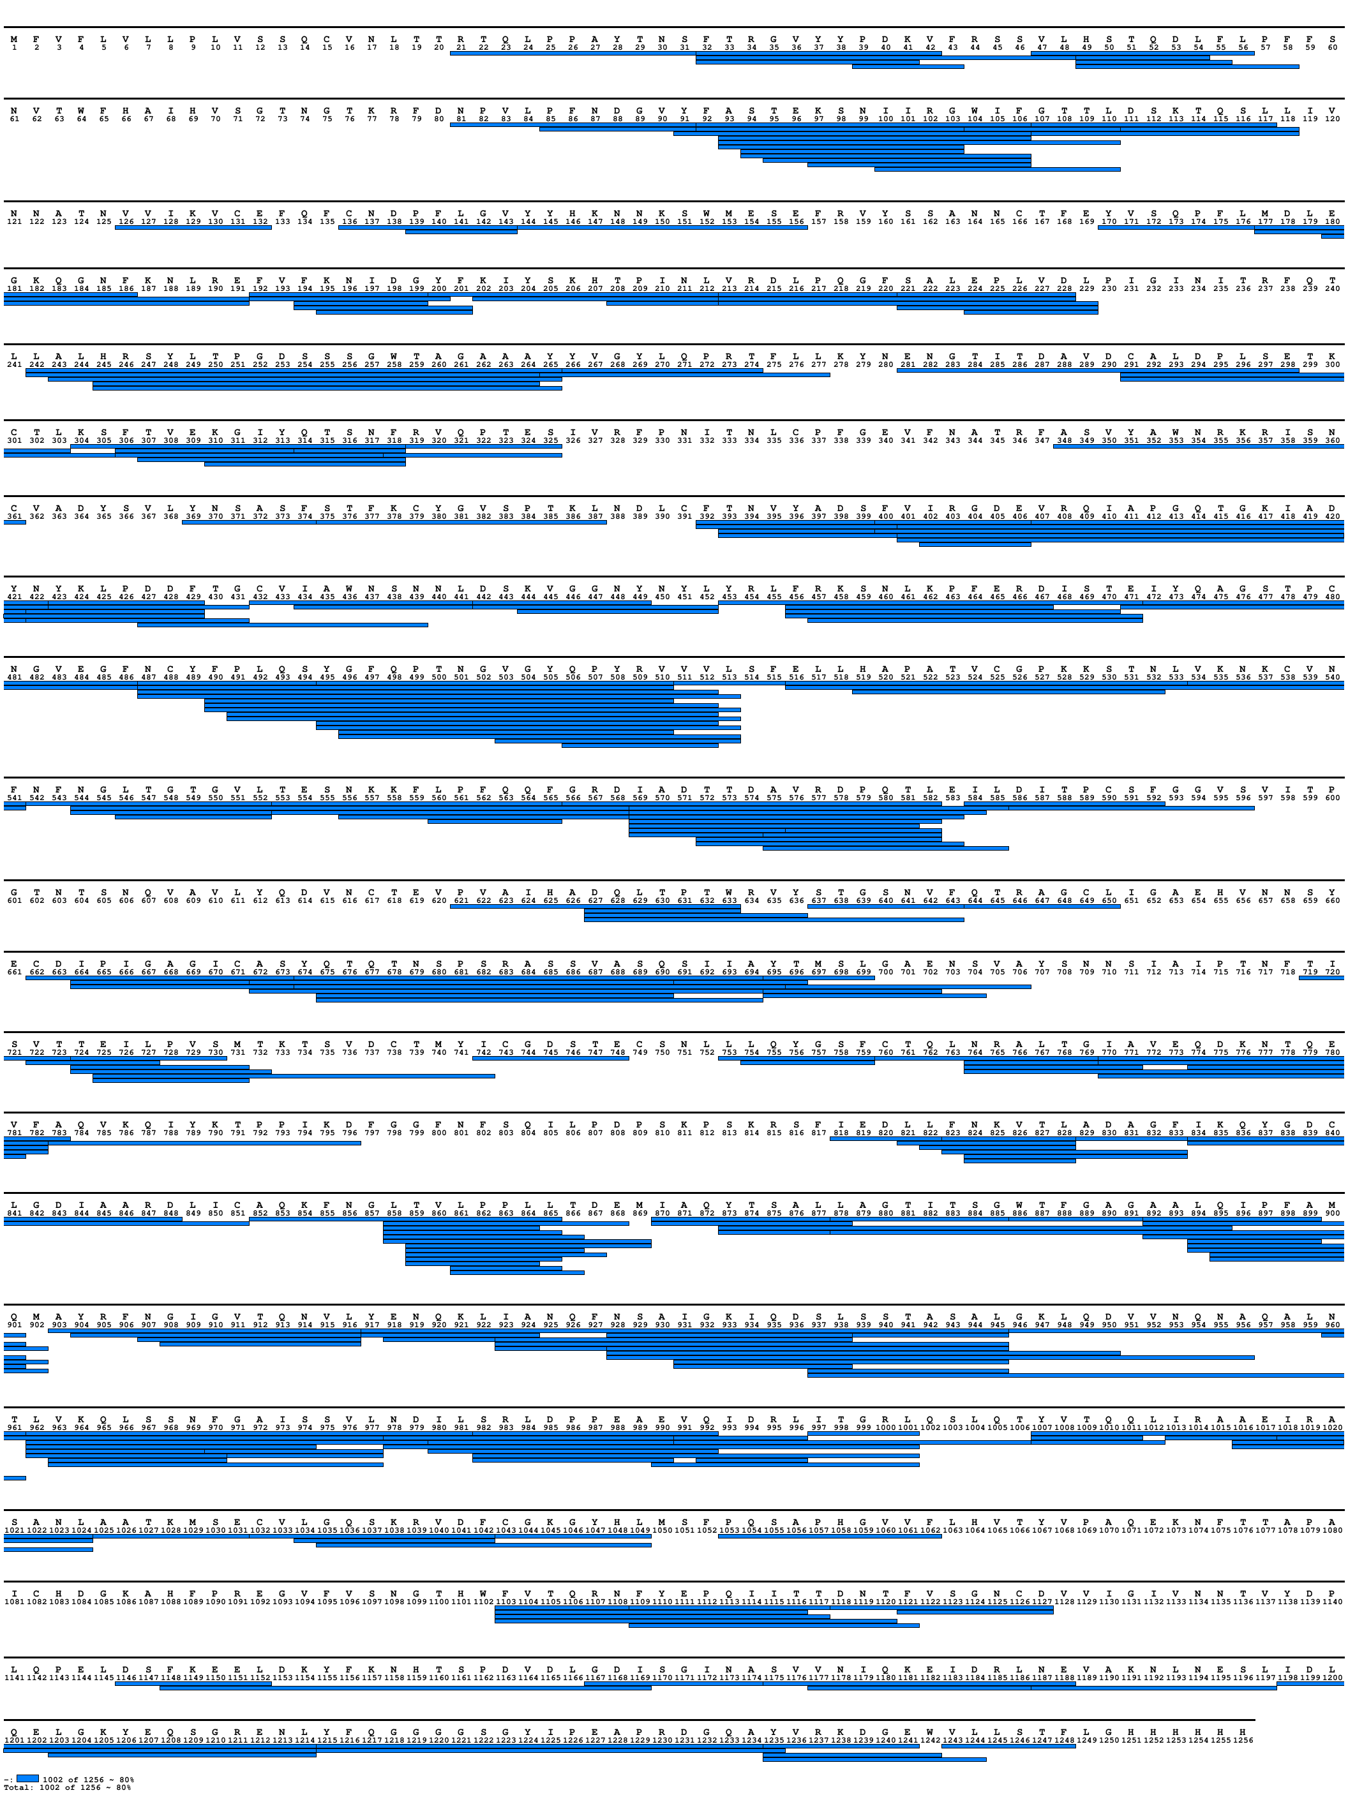
Fig. S27. Coverage map of peptides whose HDX was followed for studying Wuhan/G614 spike-ACE2 complexes. The signal peptide (residues 1-13) is indicated but not present in the protein analyzed. The figure was generated with MS Tools.
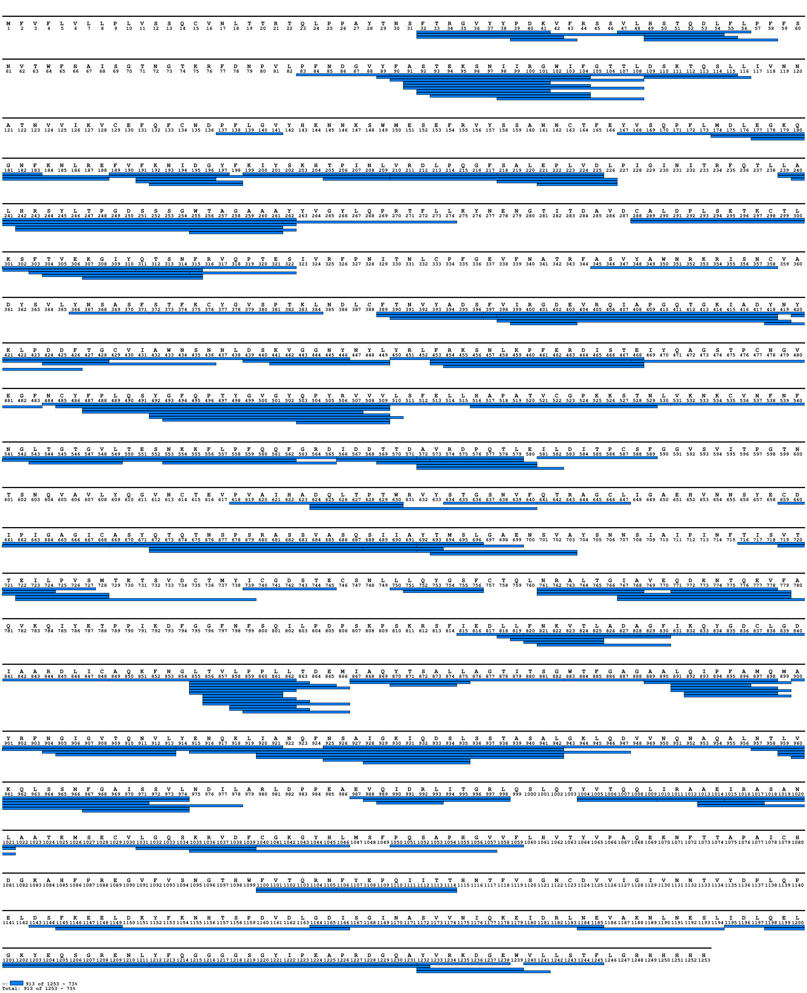
Fig. S28. Coverage map of peptides whose HDX was followed for studying alpha spike-ACE2 complex. The signal peptide (residues 1-13) is indicated but not present in the protein analyzed. The figure was generated with MS Tools.

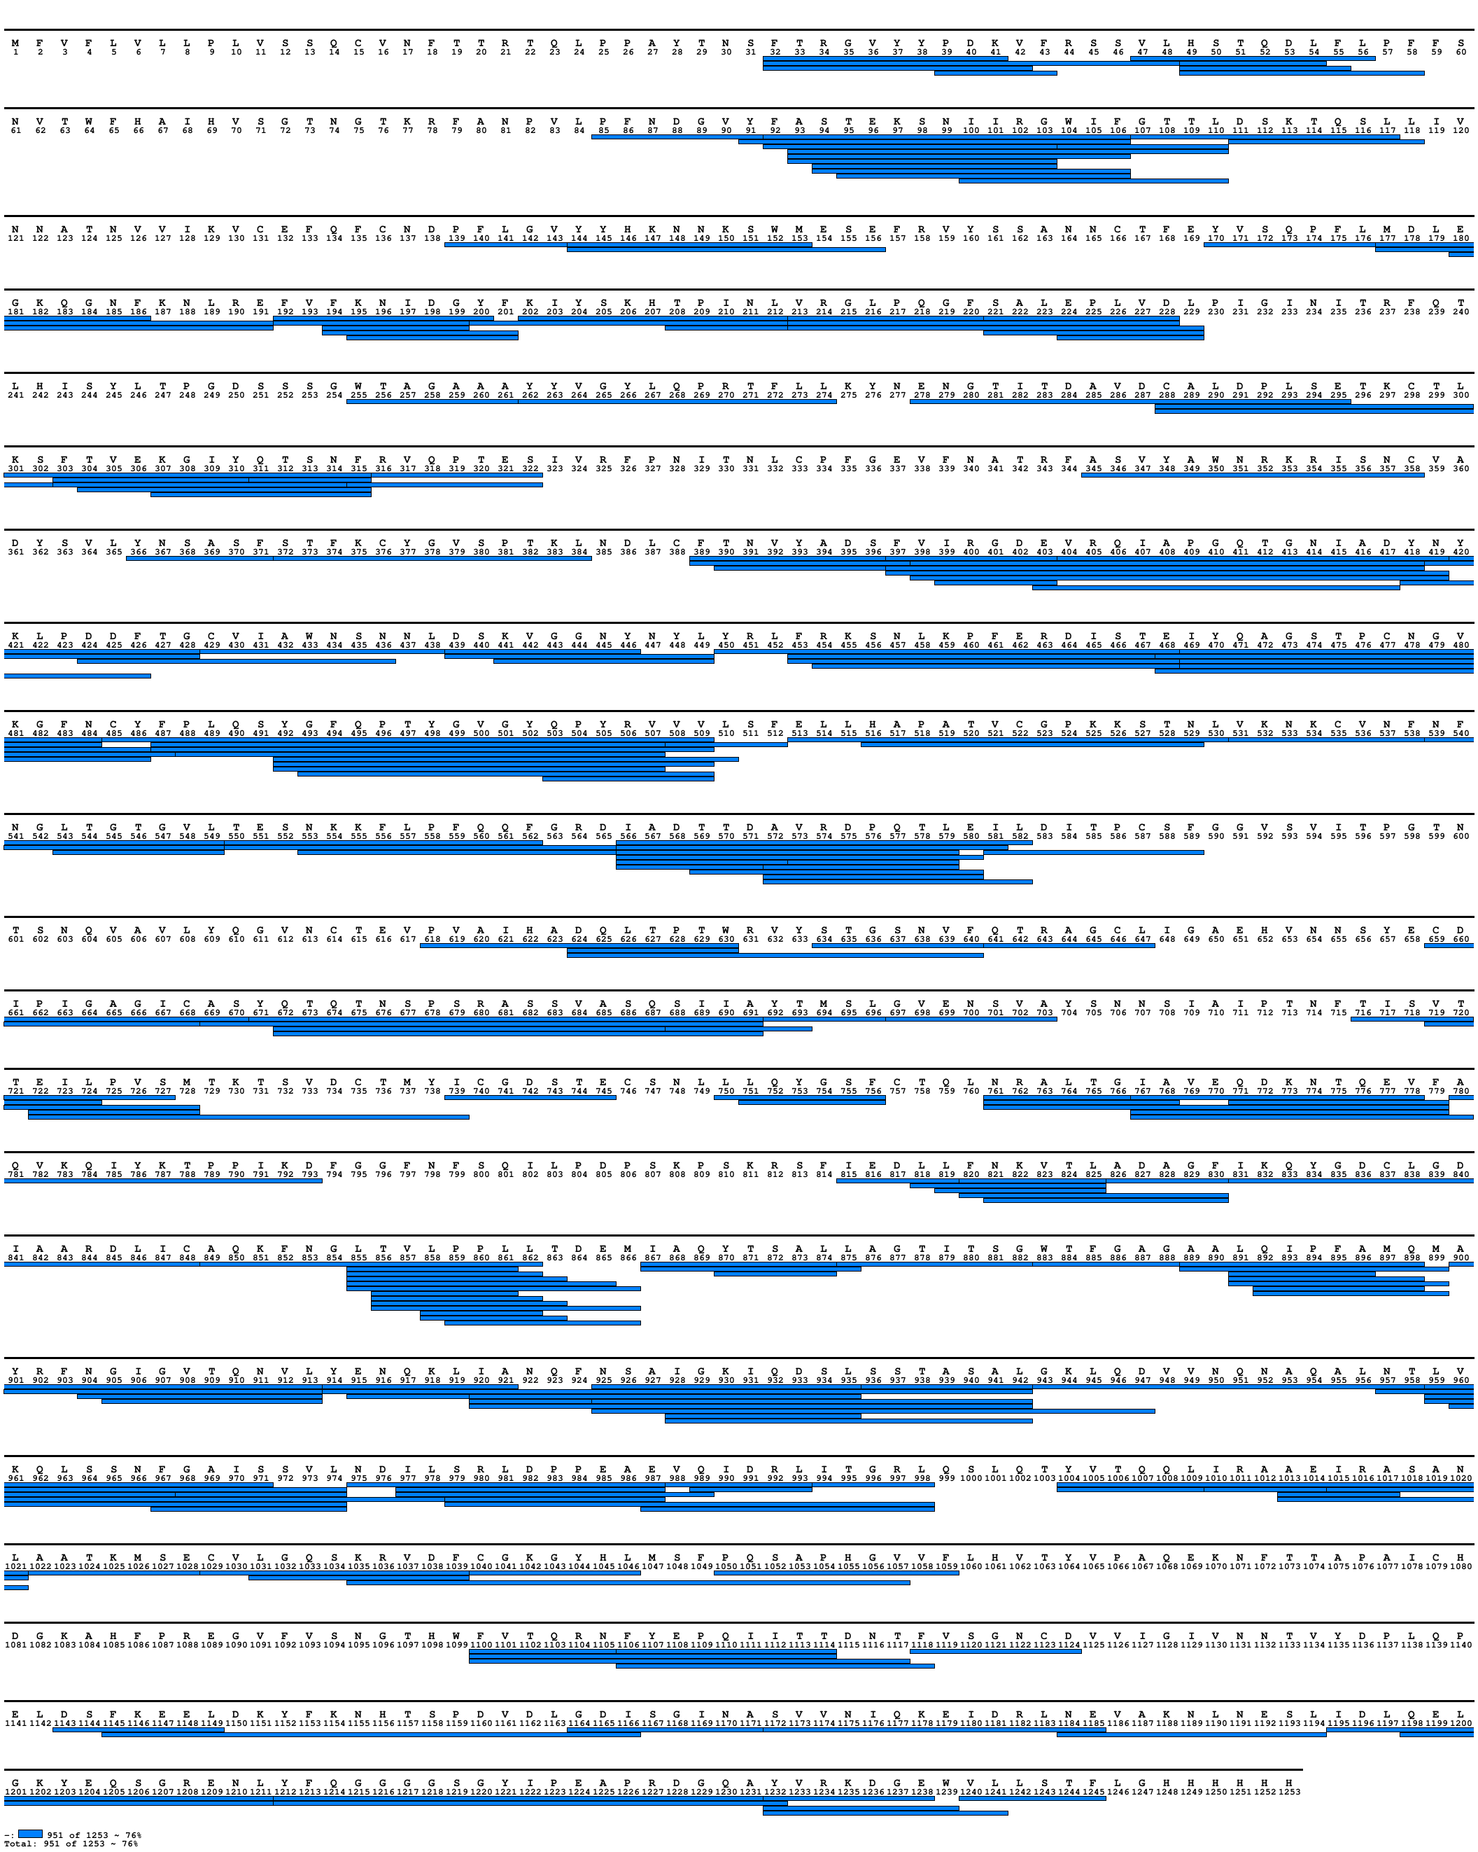
Fig. S29. Coverage map of peptides whose HDX was followed for studying beta spike-ACE2 complex. The signal peptide (residues 1-13) is indicated but not present in the protein analyzed. The figure was generated with MS Tools.

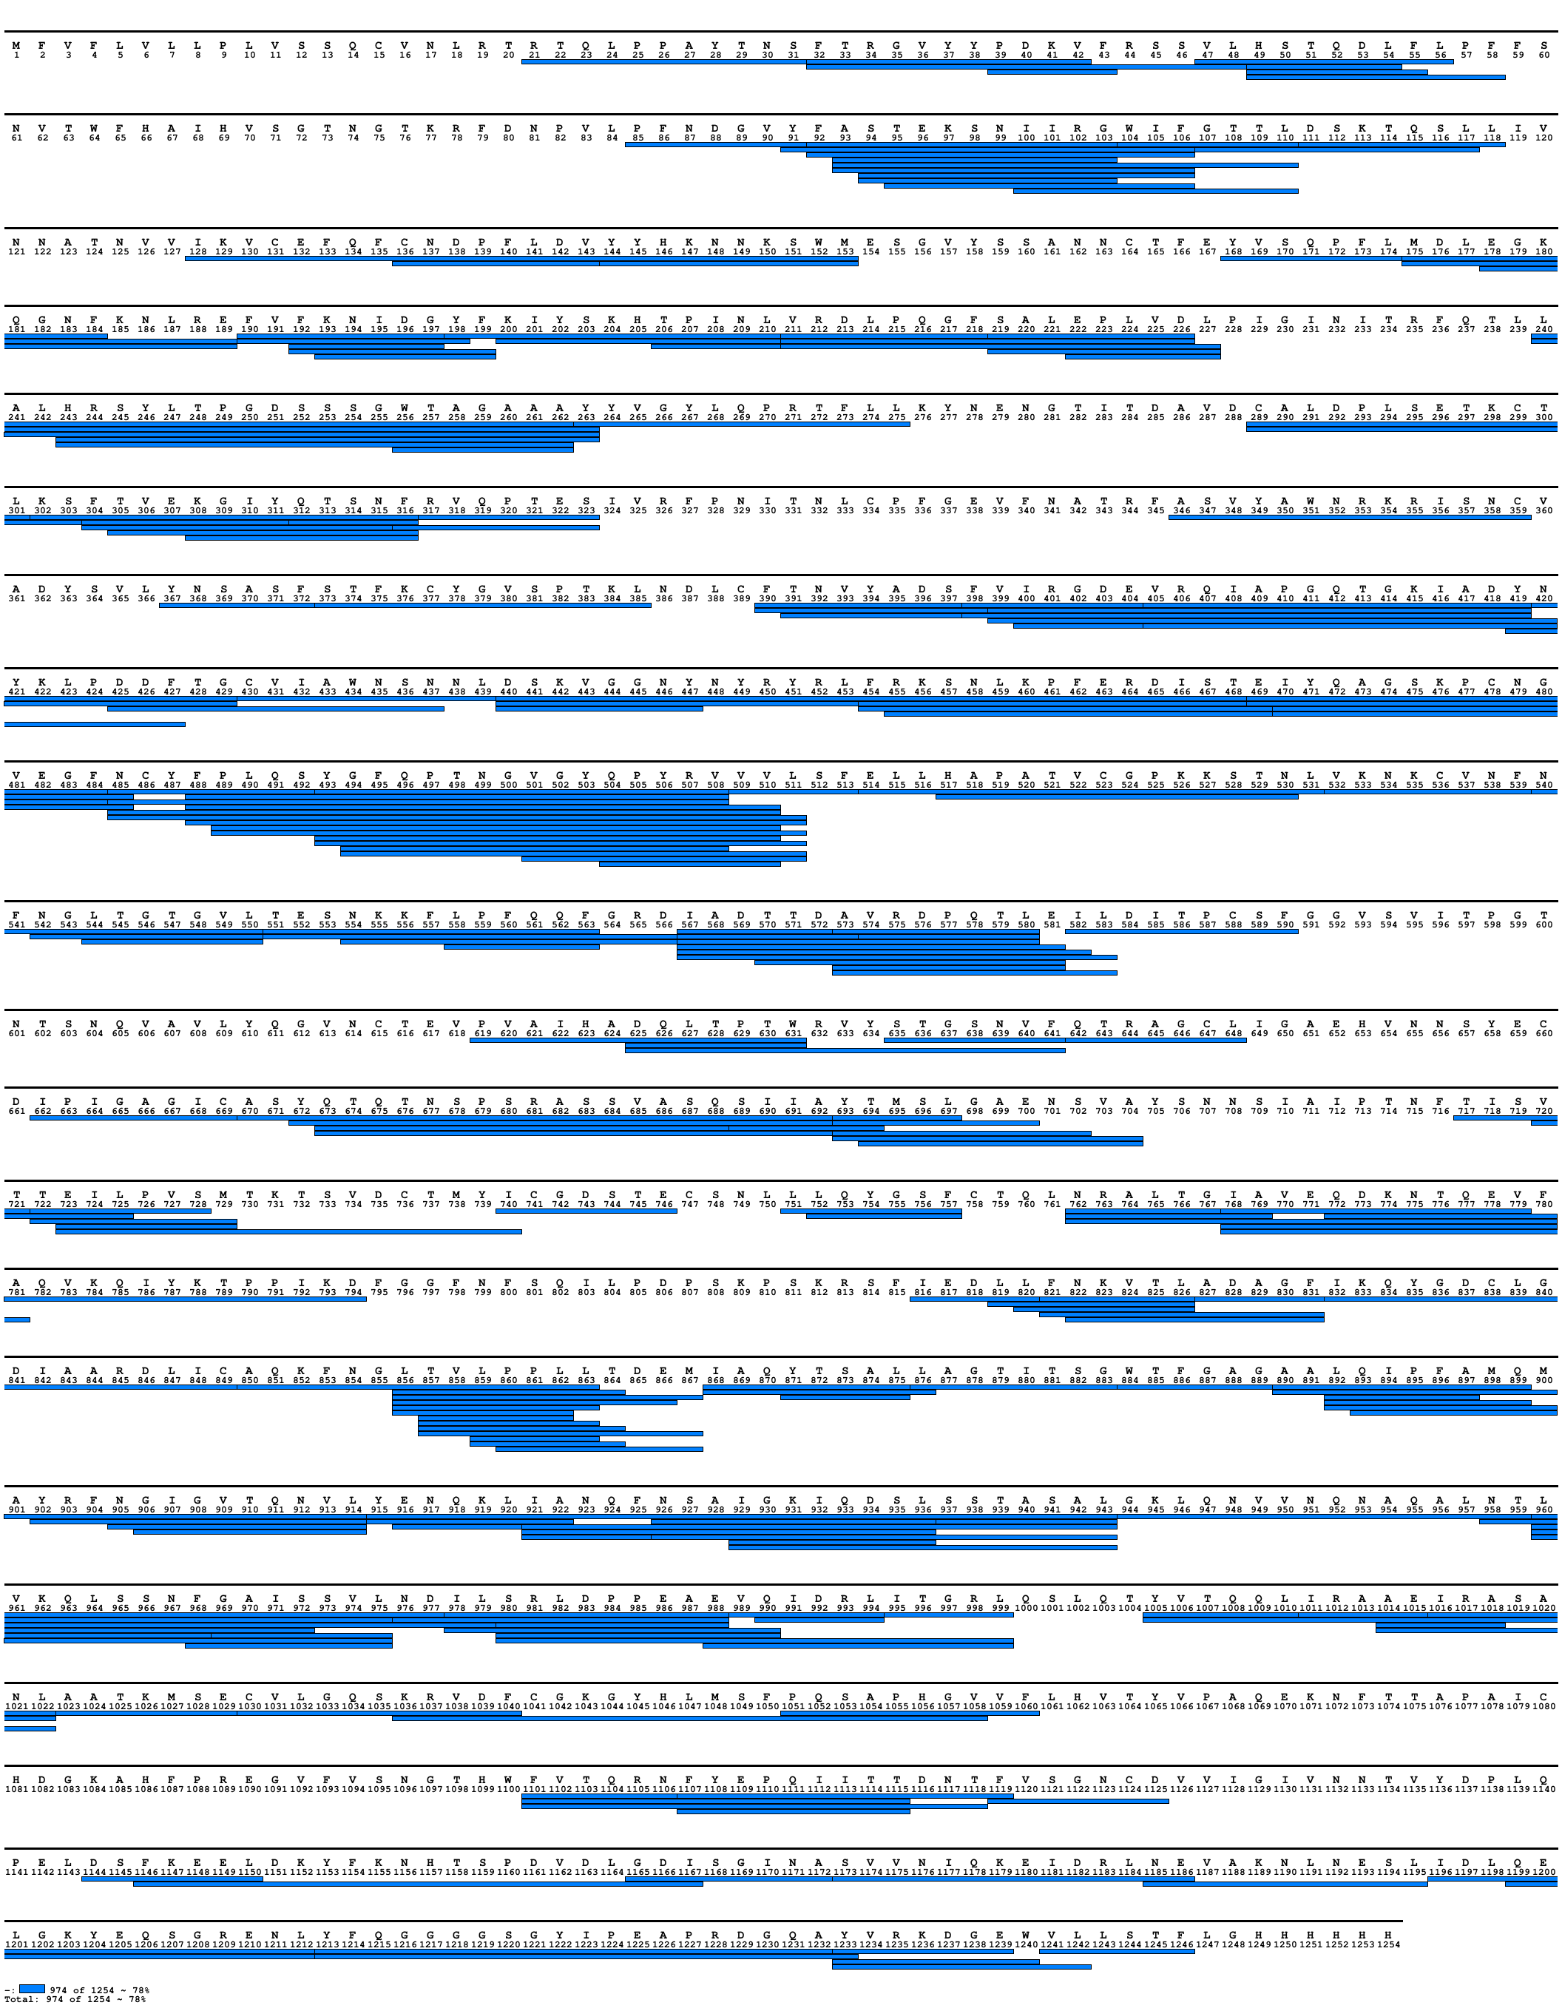
Fig. S30. Coverage map of peptides whose HDX was followed for studying delta spike-ACE2 complex. The signal peptide (residues 1-13) is indicated but not present in the protein analyzed. The figure was generated with MS Tools.

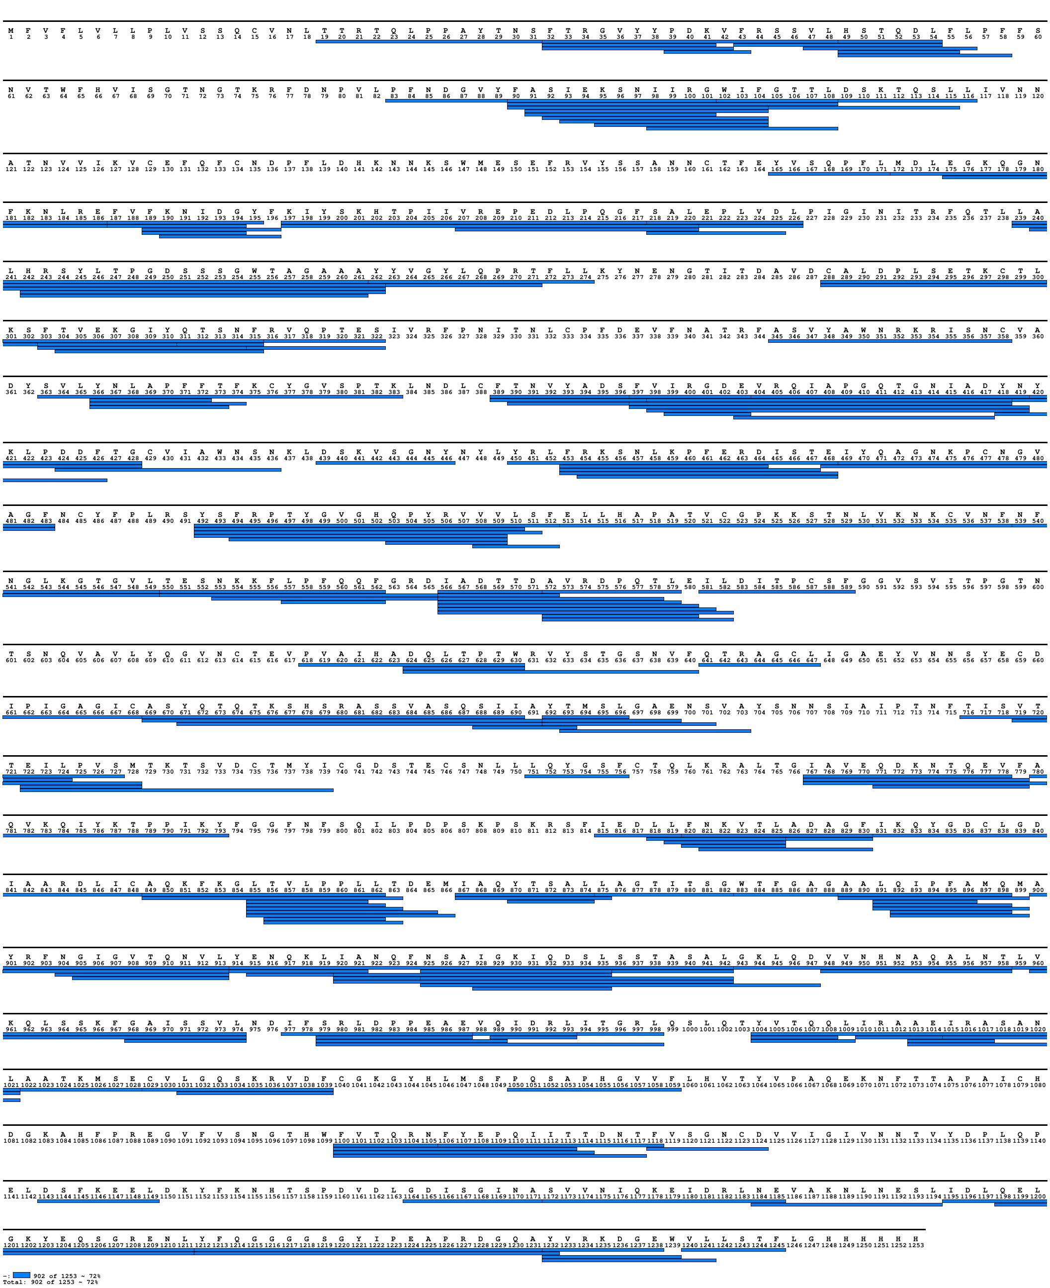
Fig. S31. Coverage map of peptides whose HDX was followed for studying omicron spike-ACE2 complex. The signal peptide (residues 1-13) is indicated but not present in the protein analyzed. The figure was generated with MS Tools.

Fig S32. Difference plot illustrating the difference in HDX between Wuhan spike in complex with ACE2 and Wuhan spike alone (light blue line: 4 s on ice, orange line: 20 s on ice, grey line: 15 s at 23 °C, yellow line: 1 min at 23 °C, green line: 10 min at 23 °C, violet line: 100 min at 23 °C, dark blue line: 360 min at 28 °C). Residues comprising a region with significant differences in HDX are indicated. The peptides are arranged according to their peptide centre residue. A dotted grey line indicates the 98% CI as a threshold for significance. The top bar shows spike subdomains.

Fig S33. Difference plot illustrating the difference in HDX between G614 spike in complex with ACE2 and G614 spike alone (light blue line: 4 s on ice, orange line: 20 s on ice, grey line: 15 s at 23 °C, yellow line: 1 min at 23 °C, green line: 10 min at 23 °C, violet line: 100 min at 23 °C, dark blue line: 360 min at 28 °C). Residues comprising a region with significant differences in HDX are indicated. The peptides are arranged according to their peptide centre residue. A dotted grey line indicates the 98% CI as a threshold for significance. The top bar shows spike subdomains. The black dot indicates the position of D614G substitution.

Fig S34. Difference plot illustrating the difference in HDX between alpha spike in complex with ACE2 and alpha spike alone (light blue line: 4 s on ice, orange line: 20 s on ice, grey line: 15 s at 23 °C, yellow line: 1 min at 23 °C, green line: 10 min at 23 °C, violet line: 100 min at 23 °C, dark blue line: 360 min at 28 °C). Residues comprising a region with significant differences in HDX are indicated (in black with residue numbers of alpha spike and in grey with residue numbers of G614 spike). The peptides are arranged according to their peptide centre residue. A dotted grey line indicates the 98% CI as a threshold for significance. The top bar shows spike subdomains. The black dot indicates the position of D614G substitution, whereas the red dots indicate the position of the other residue changes.

Fig S35. Difference plot illustrating the difference in HDX between beta spike in complex with ACE2 and beta spike alone (light blue line: 4 s on ice, orange line: 20 s on ice, grey line: 15 s at 23 °C, yellow line: 1 min at 23 °C, green line: 10 min at 23 °C, violet line: 100 min at 23 °C, dark blue line: 360 min at 28 °C). Residues comprising a region with significant differences in HDX are indicated (in black with residue numbers of beta spike and in grey with residue numbers of G614 spike). The peptides are arranged according to their peptide centre residue. A dotted grey line indicates the 98% CI as a threshold for significance. The top bar shows spike subdomains. The black dot indicates the position of D614G substitution, whereas the red dots indicate the position of the other residue changes.

Fig S36. Difference plot illustrating the difference in HDX between delta spike in complex with ACE2 and delta spike alone (orange line: 20 s on ice, green line: 10 min at 23 °C, dark blue line: 360 min at 28 °C). Residues comprising a region with significant differences in HDX are indicated (in black with residue numbers of delta spike and in grey with residue numbers of G614 spike). The peptides are arranged according to their peptide centre residue. A dotted grey line indicates the 98% CI as a threshold for significance. The top bar shows spike subdomains. The black dot indicates the position of D614G substitution, whereas the red dots indicate the position of the other residue changes.

Fig S37. Difference plot illustrating the difference in HDX between omicron spike in complex with ACE2 and omicron spike alone (light blue line: 4 s on ice, orange line: 20 s on ice, grey line: 15 s at 23 °C, yellow line: 1 min at 23 °C, green line: 10 min at 23 °C, violet line: 100 min at 23 °C, dark blue line: 360 min at 28 °C). Residues comprising a region with significant differences in HDX are indicated (in black with residue numbers of omicron spike and in grey with residue numbers of G614 spike). The peptides are arranged according to their peptide centre residue. A dotted grey line indicates the 98% CI as a threshold for significance. The top bar shows spike subdomains. The black dot indicates the position of D614G substitution, whereas the red dots indicate the position of the other residue changes.

Fig. S38. EX1 kinetics in the receptor binding motif (RBM) of spikes in complex with ACE2. From top to bottom: peptide YGFQPTNGVGYQPYRVVVL (495-513) of Wuhan spike; peptide YGFQPTNGVGYQPYRVVVL (495-513) of G614 spike; peptide YGFQPTNGVGYQPYRVVVL (493-511) of delta spike; peptide YGFQPTYGVGYQPYRVVVL (492-510) of alpha spike; peptide YGFQPTYGVGYQPYRVVVL (492-510) of beta spike; peptide YSFRPTYGVGHQPYRVVV (492-509) of omicron spike. From left to right: bubble plots representing the level of deuteration and the relative intensity of the low- and high-mass envelope (binomial fit 1 and binomial fit 2, respectively) for bimodal isotopic distributions and the level of deuteration of the unimodal envelope (unimodal fit), set at 100% intensity, in the ACE2 bound state; peak width of the isotopic distribution (calculated at 50% of Baseline Peak Intensity -BPI) and number of exchangble amides (#NHs), in the bound state; deuterium level of the low-mass envelopes (binomial 1), high-mass envelopes (binomial 2) and unimodal distributions (centroid) in ACE2-bound spike; deuterium level of spikes in apo state (unimodal distributions – centroid). Spectral analysis was conducted with HX-Express2² and graphs were authomatically generated upon fitting the isotopic envelopes shown in fig. S39. Bimodal fit was applied to peptide spectra at time points showing clear features of bimodality and/or enhanced peak width.

a
b
Fig. S39. EX1 kinetics in the receptor binding motif (RBM) of spikes in complex with ACE2. Mass spectra of the representative peptides of the RBM (listed in fig. S38) deconvoluted with bimodal or unimodal fittings with HX-Express 2. A) Mass spectra of peptide of Wuhan, G614 and delta spikes. B) Mass spectra of peptide of alpha, beta and omicron spikes. The horizontal orange lines indicate the distribution width at 50% BPI; the red dots mark the envelope peaks; the vertical green lines indicate the centroid mass; the dark blue lines fit the unimodal envelope distributions deconvoluted with binomial fitting; the green lines fit the low-mass envelope distributions deconvoluted with bimodal fitting; the light blue lines fit the high-mass envelope distributions deconvoluted with bimodal fitting.

References

1. Kavan, D. & Man, P. MSTools - Web based application for visualization and presentation of HXMS data. Int. J. Mass Spectrom. 302, 53–58 (2011).
2. Miklos Guttman, David D. Weis, John R. Engen, and K. K. L. Analysis of Overlapped and Noisy Hydrogen/Deuterium Exchange Mass Spectra. J. Am. Soc. Mass Spectrom. 24, 1–12 (2013).
3. Masson, G. R. et al. Recommendations for performing, interpreting and reporting hydrogen deuterium exchange mass spectrometry (HDX-MS) experiments. Nat. Methods 16, 595–602 (2019).

Supplementary tables
HDX summary tables, as per community-based recommendations³

