Angiotensin II type 1a receptor deficiency alleviates muscle atrophy after denervation

Short Title: Angiotensin II type 1a receptor and muscle atrophy

Suguru Takayama¹, Kazuho Inoue², Yuji Ogura³, Seiko Hoshino², Takeshi Sugaya¹,
Keiichi Ohata¹, Hitoshi Kotake¹, Daisuke Ichikawa¹, Minoru Watanabe⁴, Kenjiro Kimura⁵, Yugo Shibagaki¹, and Atsuko Kamijo-Ikemori^{1,2,4,＊}
¹Division of Nephrology and Hypertension, Department of Internal Medicine, St. Marianna University School of Medicine, Kanagawa, Japan.
²Department of Anatomy, St. Marianna University School of Medicine, Kanagawa, Japan.
³Department of Physiology, St. Marianna University School of Medicine, Kanagawa, Japan.
⁴Institute for Animal Experimentation, St. Marianna University Graduate School of Medicine, Kanagawa, Japan.
⁵JCHO Tokyo Takanawa Hospital, Tokyo, Japan.
*Corresponding author

Correspondence should be addressed to: Atsuko Kamijo-Ikemori, M.D., Ph.D.,
Division of Nephrology and Hypertension, Department of Internal Medicine,
Department of Anatomy, and Experimental Animals Institution, St. Marianna University School of Medicine, 2-16-1 Sugao, Miyamae-Ku, Kawasaki 216-8511, Japan.
Tel: +81-44-977-8111 ext. 3630; Fax: +81-44-976-7083
E-mail: a2kamijo@marianna-u.ac.jp

Additional Figures

Supplementary Figure S1.
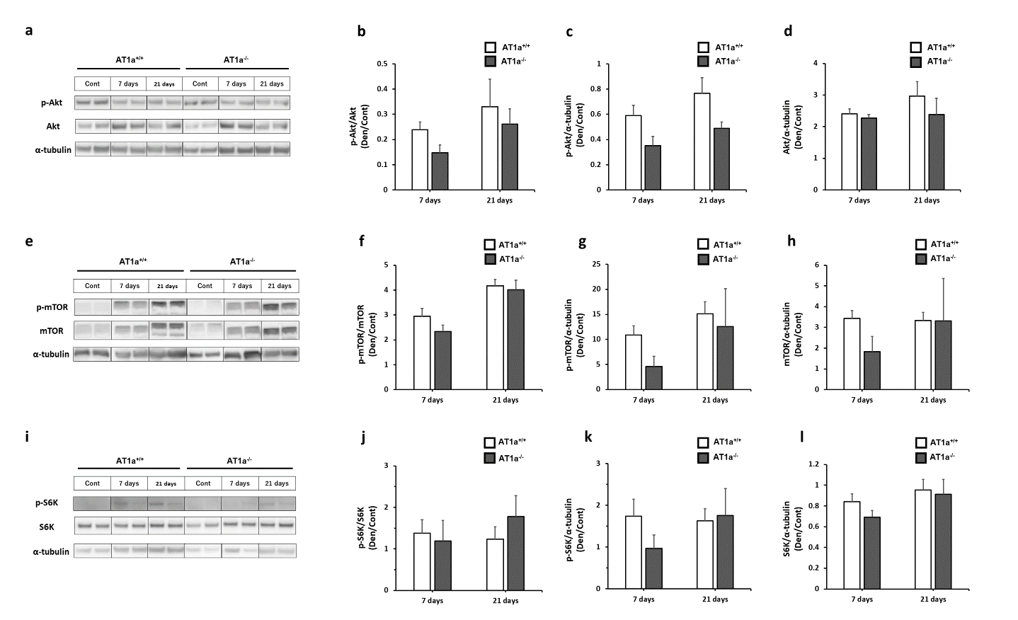
AT1a receptor loss did not activate muscular protein synthesis in denervated gastrocnemius muscles
To evaluate activation of muscular protein synthesis, activations of Akt (Fig. S1a-d), mTOR (Fig. S1e-h), and S6K (Fig. S1i-l) were evaluated by western blot analysis in the gastrocnemius muscle. Protein expression levels in each sample were normalized to α-tubulin expression levels and shown as the fold increase or decrease in protein expression in the Den groups compared with the Cont groups. The ratios of phosphorylated Akt, mTOR, and S6K to total each protein were not significantly different between the AT1a^{+/+} and AT1a^{−/−} mice.

Western blot analysis
Protein samples extracted from frozen gastrocnemius muscle (15 μg) were separated by sodium dodecyl sulfate-polyacrylamide gel electrophoresis using NuPAGE 4%–12% Bis-Tris gels and the XCell SureLock Mini-Cell system (Thermo Fisher Scientific, Rockford, IL, USA) as described previously. After blocking, the membranes were incubated overnight at 4°C with primary antibodies against Akt (rabbit monoclonal; #9272; 1:1000; Cell Signaling Technology), phospho-Akt (Ser 473) (rabbit monoclonal; #9271; 1:1000; Cell Signaling Technology, Inc.), mTOR(rabbit monoclonal; #2983; 1:1000; Cell Signaling Technology), phospho-mTOR (Ser2448) (rabbit monoclonal; #5536; 1:1000; Cell Signaling Technology), S6K(rabbit monoclonal; #2708; 1:1000; Cell Signaling Technology), phospho-p70S6 kinase (S6K; rabbit monoclonal; #9234; 1:1000; Cell Signaling Technology). We also used a rabbit monoclonal antibody to α-tubulin (ab176560; 1:4000, Abcam) to detect α-tubulin on the same membranes. After incubation with horseradish peroxidase-conjugated anti-rabbit antibody (ab97051; Abcam), protein bands were detected by chemiluminescence using the ECL Prime western blotting detection reagent (GE Healthcare, Little Chalfont, UK). Images were acquired on a charge-coupled device camera system (ImageQuant LAS 4000; GE Healthcare). The ratio of phosphorylated to total proteins was calculated using ImageJ software (NIH, Frederick, MD, USA). The expression levels of all proteins were quantified using ImageJ software (National Institutes of Health, Bethesda, MD, USA). Entire images of western blot analysis are shown in a Supplementary Information file (Supplementary Fig. S4–S6).

Entire images of western blot analysis

Supplementary Figure S2.
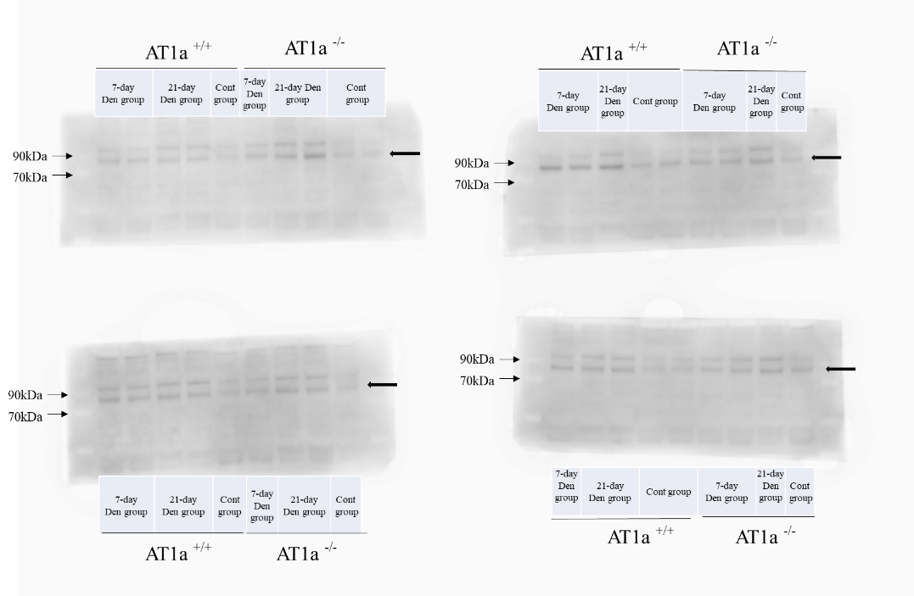
a. Phospho-FoxO1

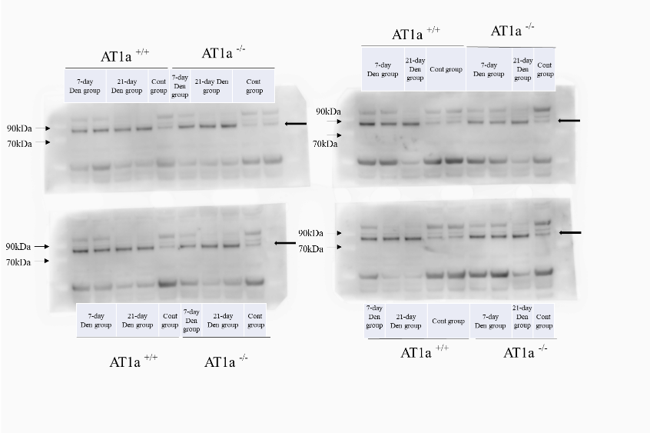
b. FoxO1

c. α-tubulin
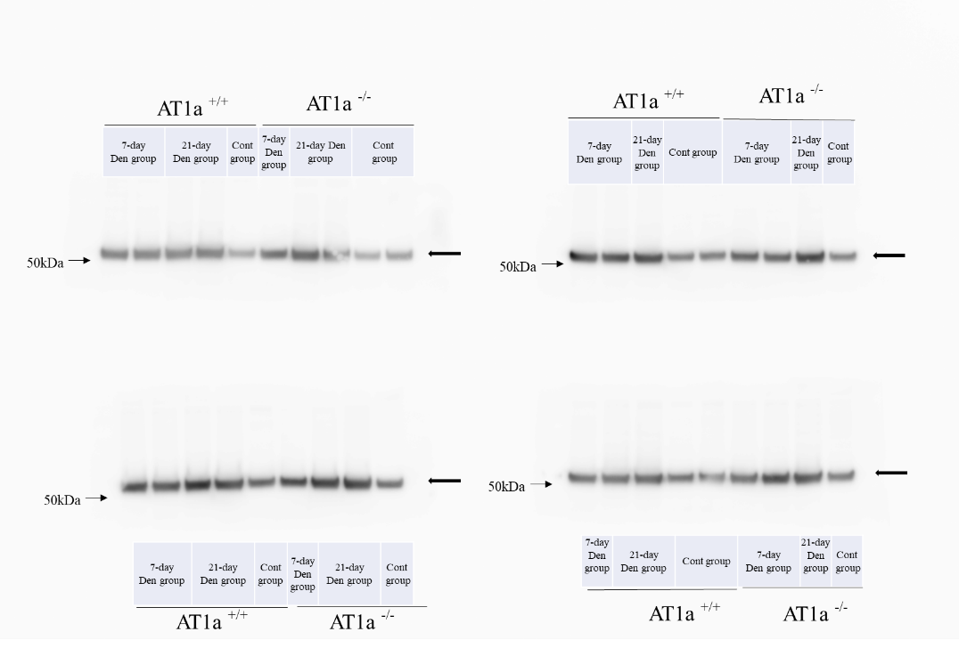

Western blot analysis of phospho-FoxO1 (a), FoxO1 (b), and α-tubulin (c) in the Den and Cont groups at 7 and 21days postdenervation. Black arrows represent the targeted protein.

Supplementary Figure S3.
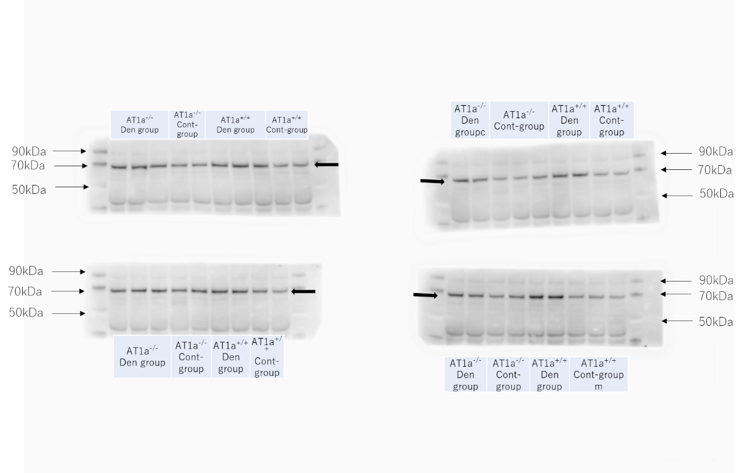
a. Phospho-NF-κB

b. NF-κB
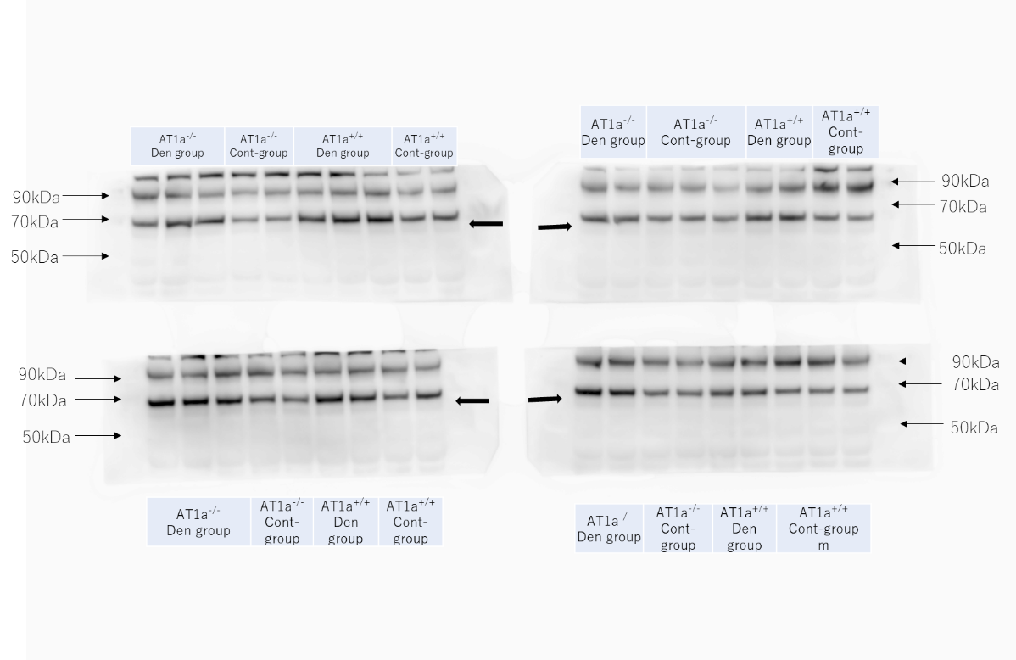

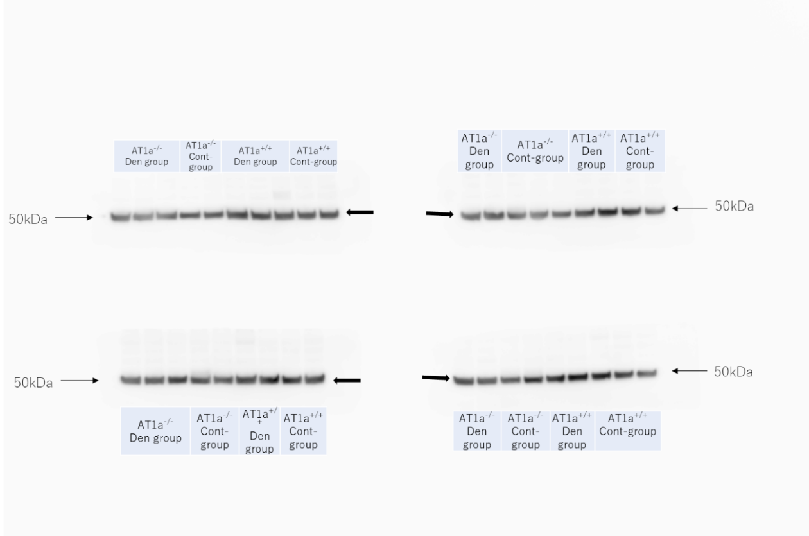
c. α-tubulin

Western blot analysis of phospho-NF-κB (a), NF-κB (b), and α-tubulin (c) in the Den and Cont groups at 3 days postdenervation. Black arrows represent the targeted protein.

Supplementary Figure S4.
a. Phospho-Akt
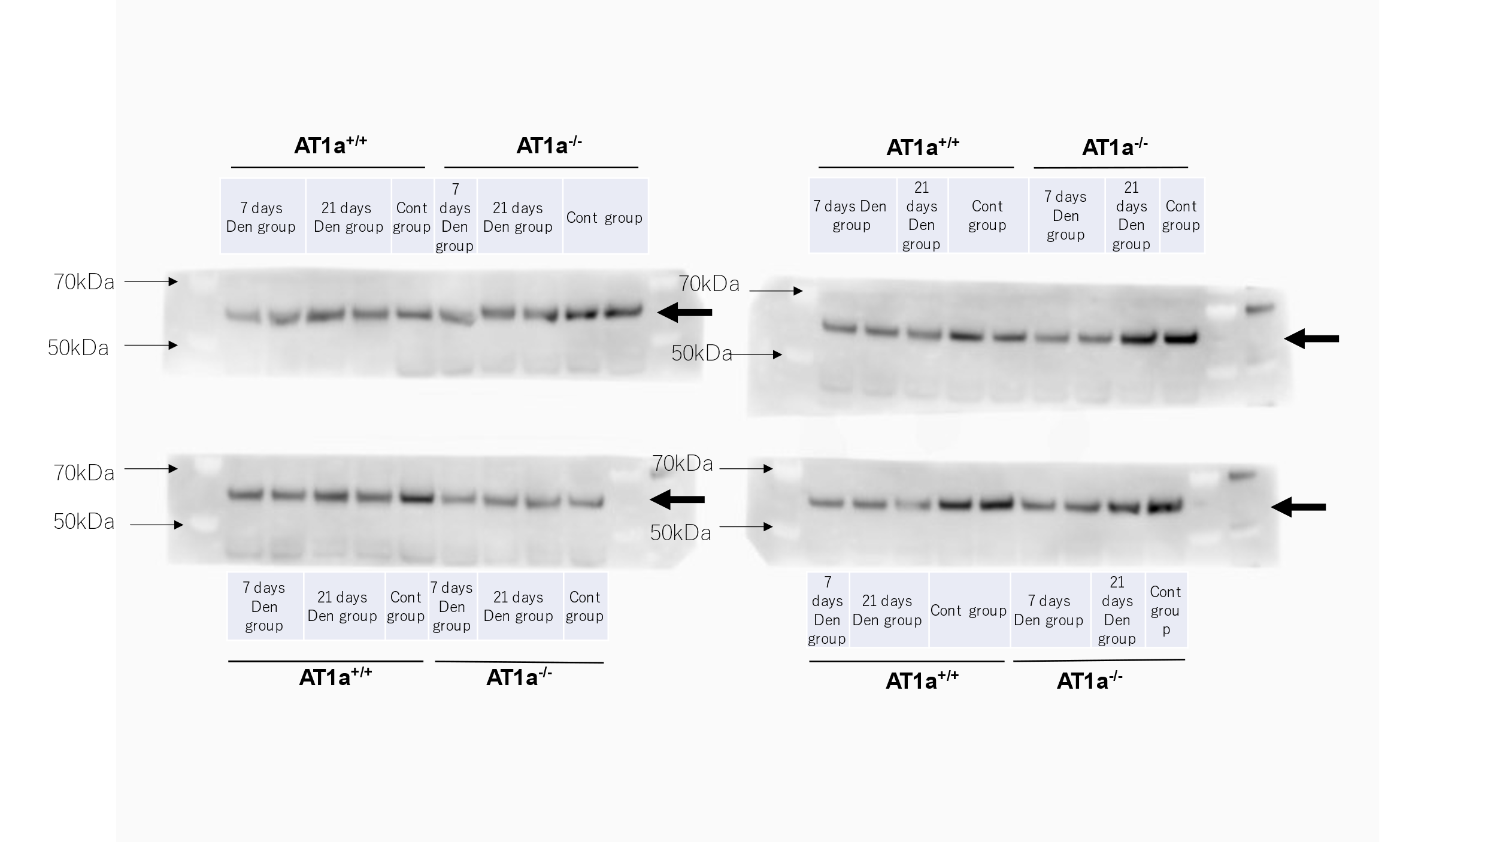

b. Akt
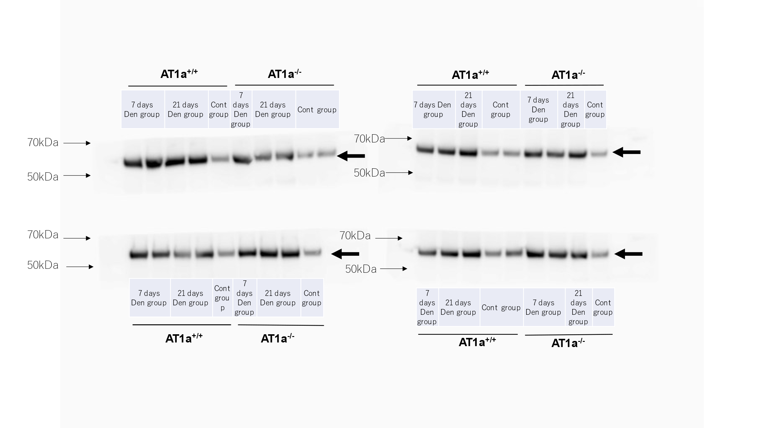

c. α-tubulin
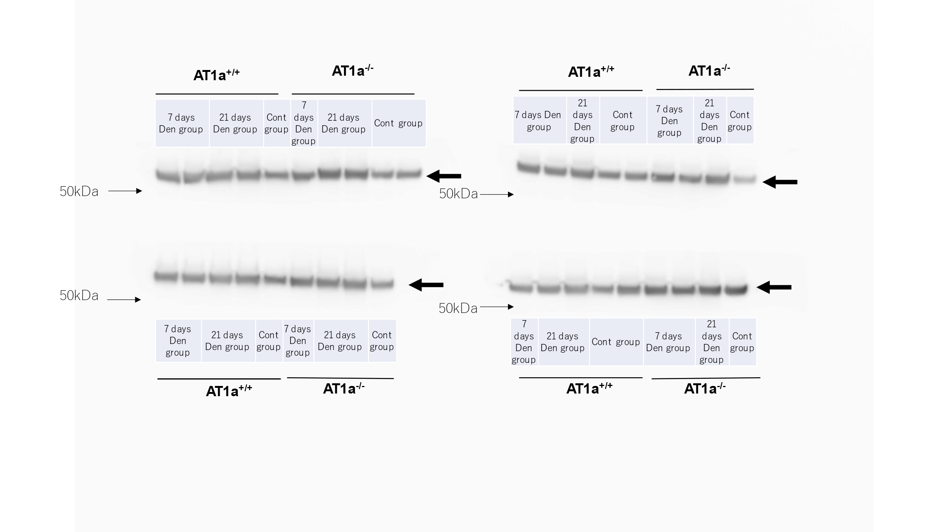
Western blot analysis of phospho-Akt (a), Akt (b), and α-tubulin (c) in the Den and Cont groups at 7 and 21days postdenervation. Black arrows represent the targeted protein.

Supplementary Figure S5.
a. Phospho-mTOR
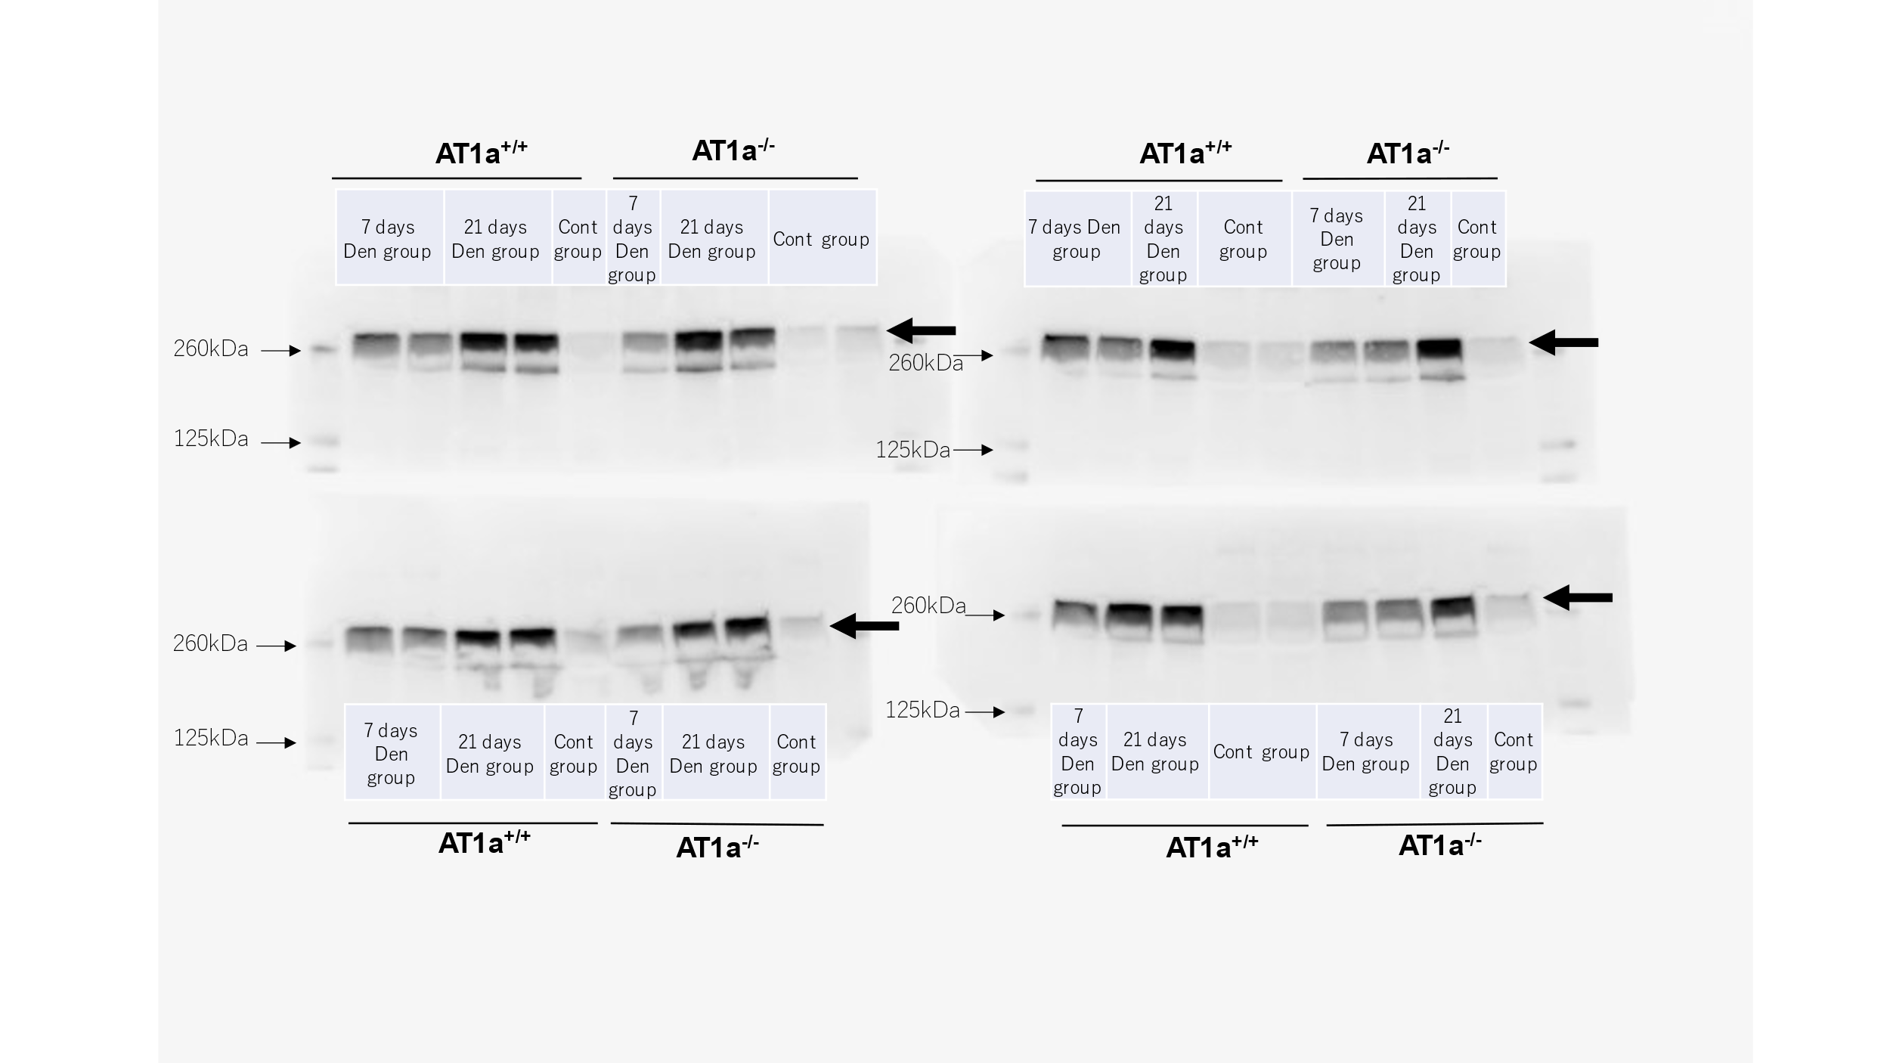

b. mTOR
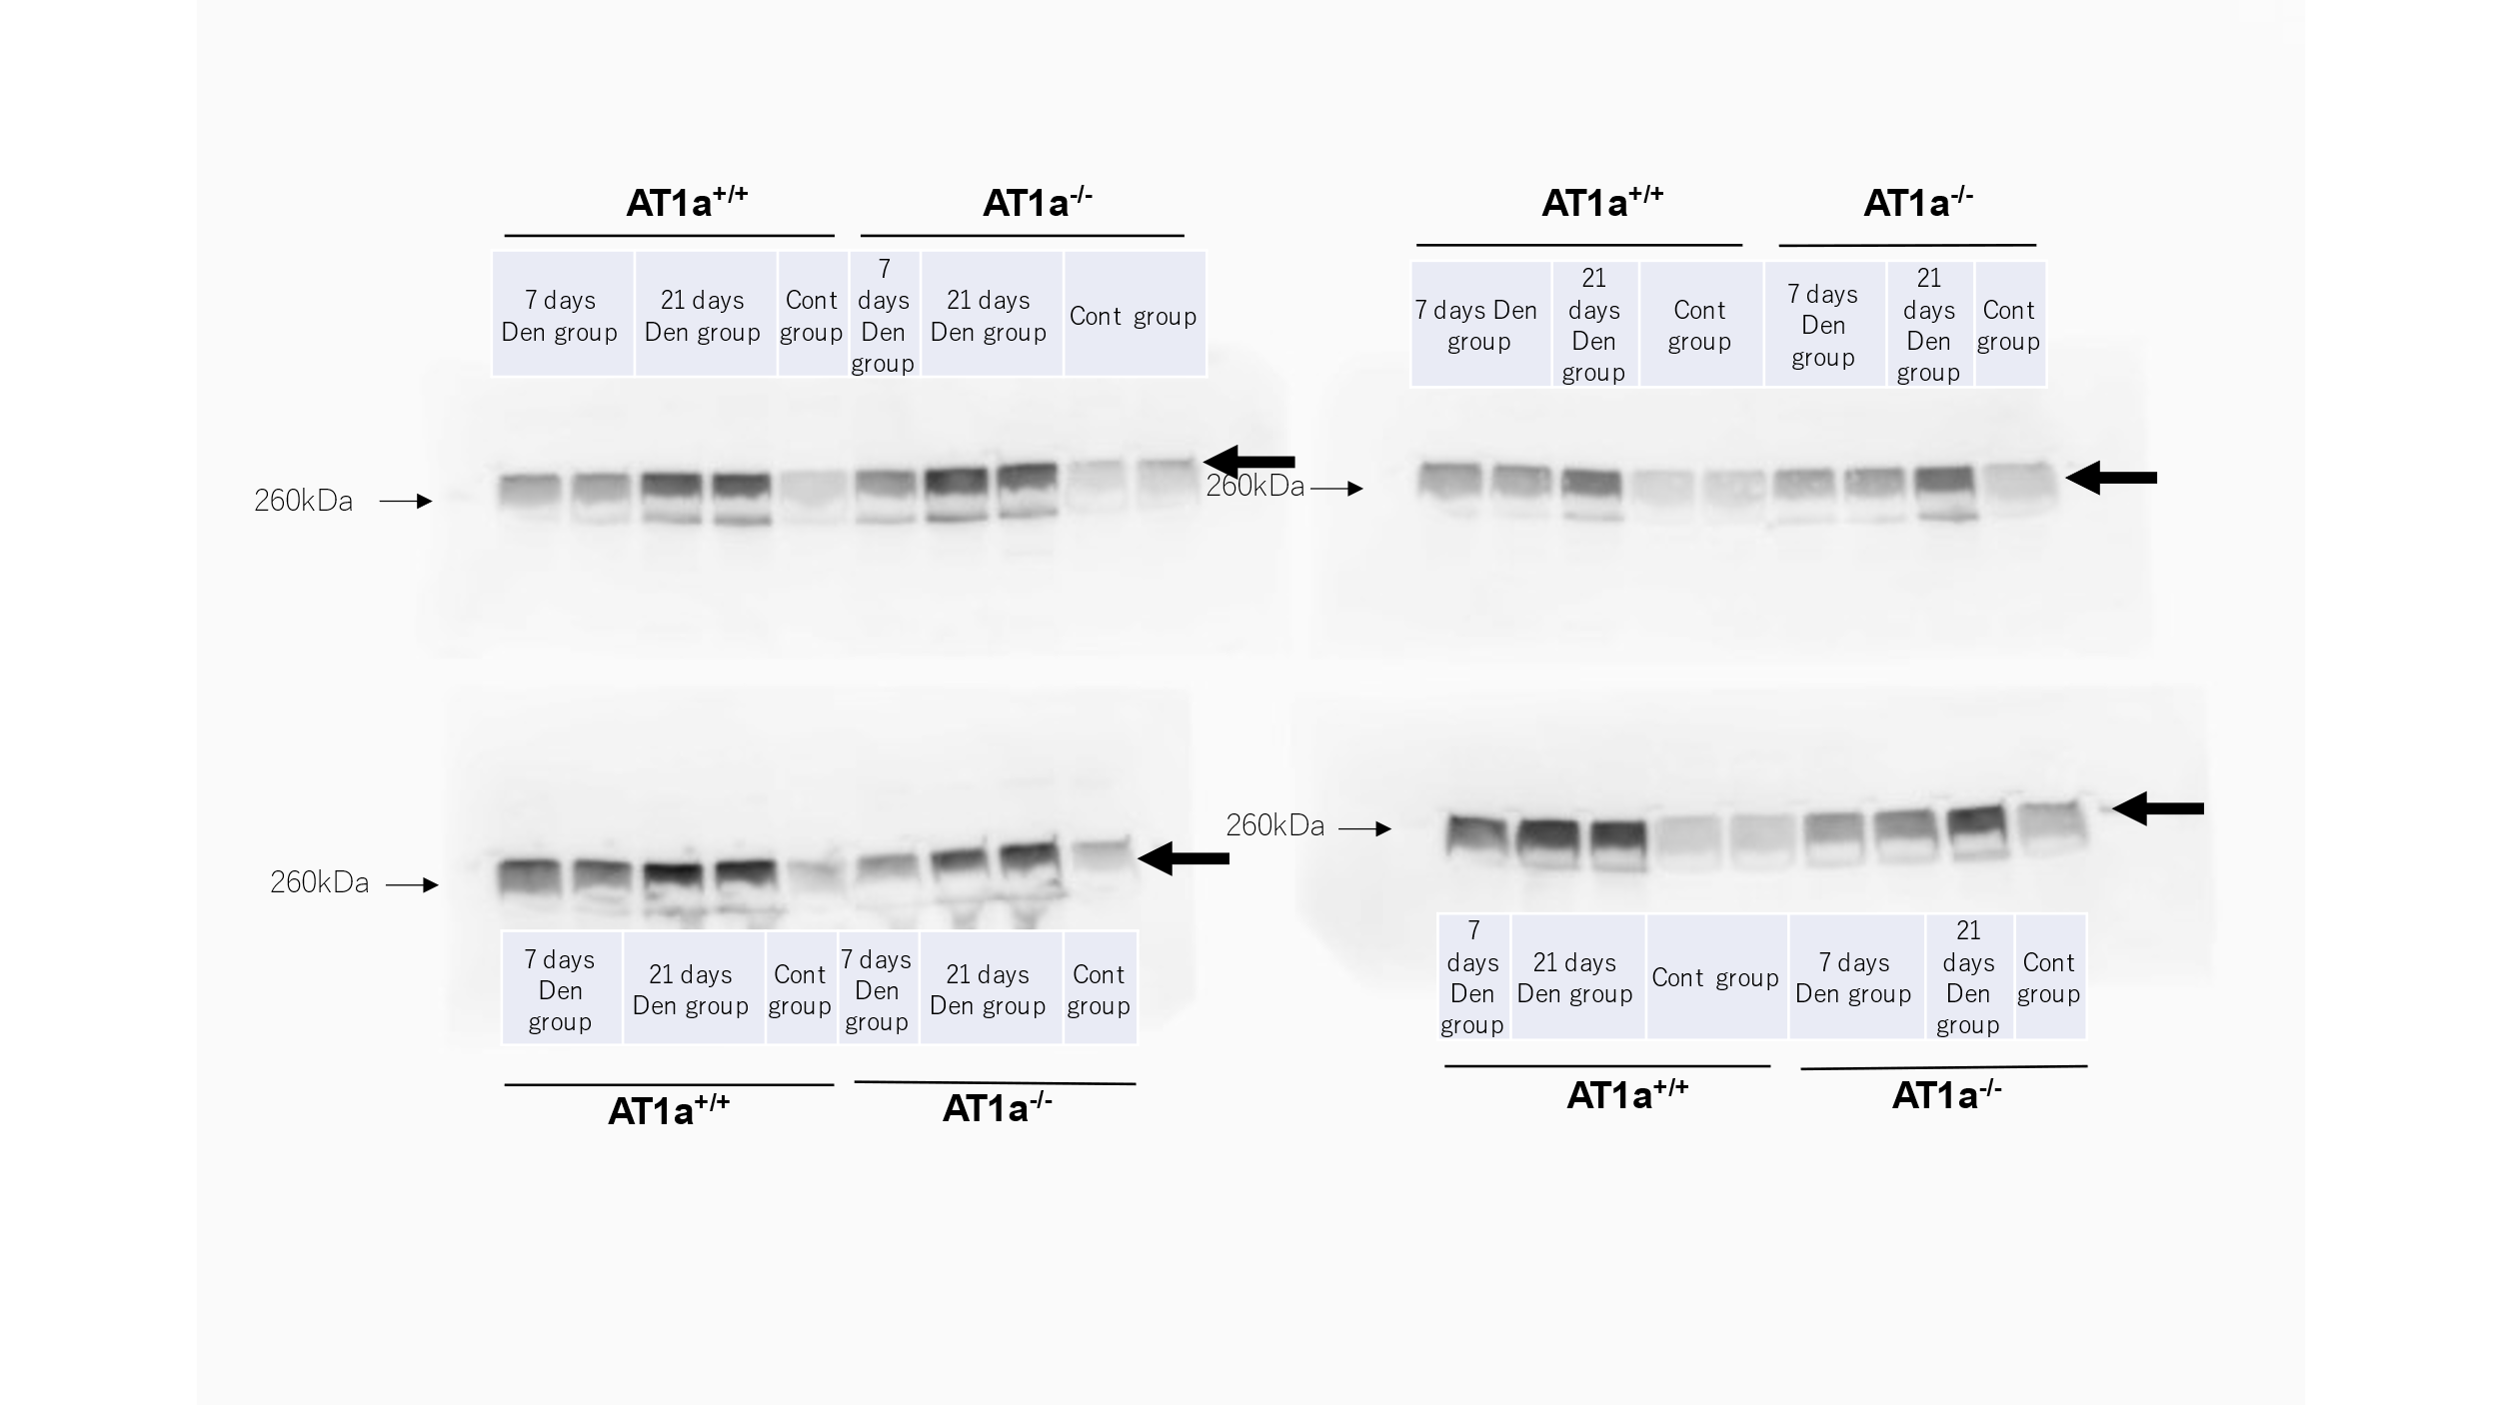

c. α-tubulin
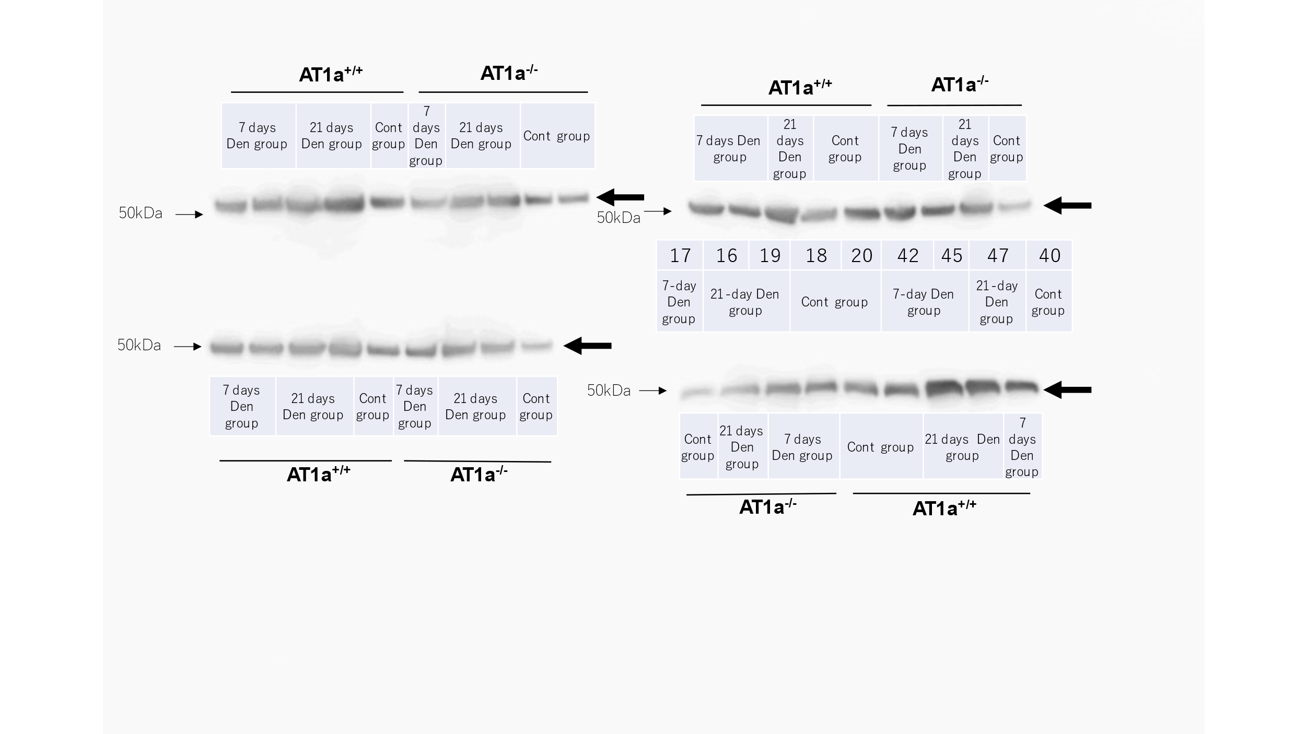
Western blot analysis of phospho-mTOR (a), mTOR (b), and α-tubulin (c) in the Den and Cont groups at 7 and 21 days postdenervation. Black arrows represent the targeted protein.

Supplementary Figure S6.
a. Phospho-S6K
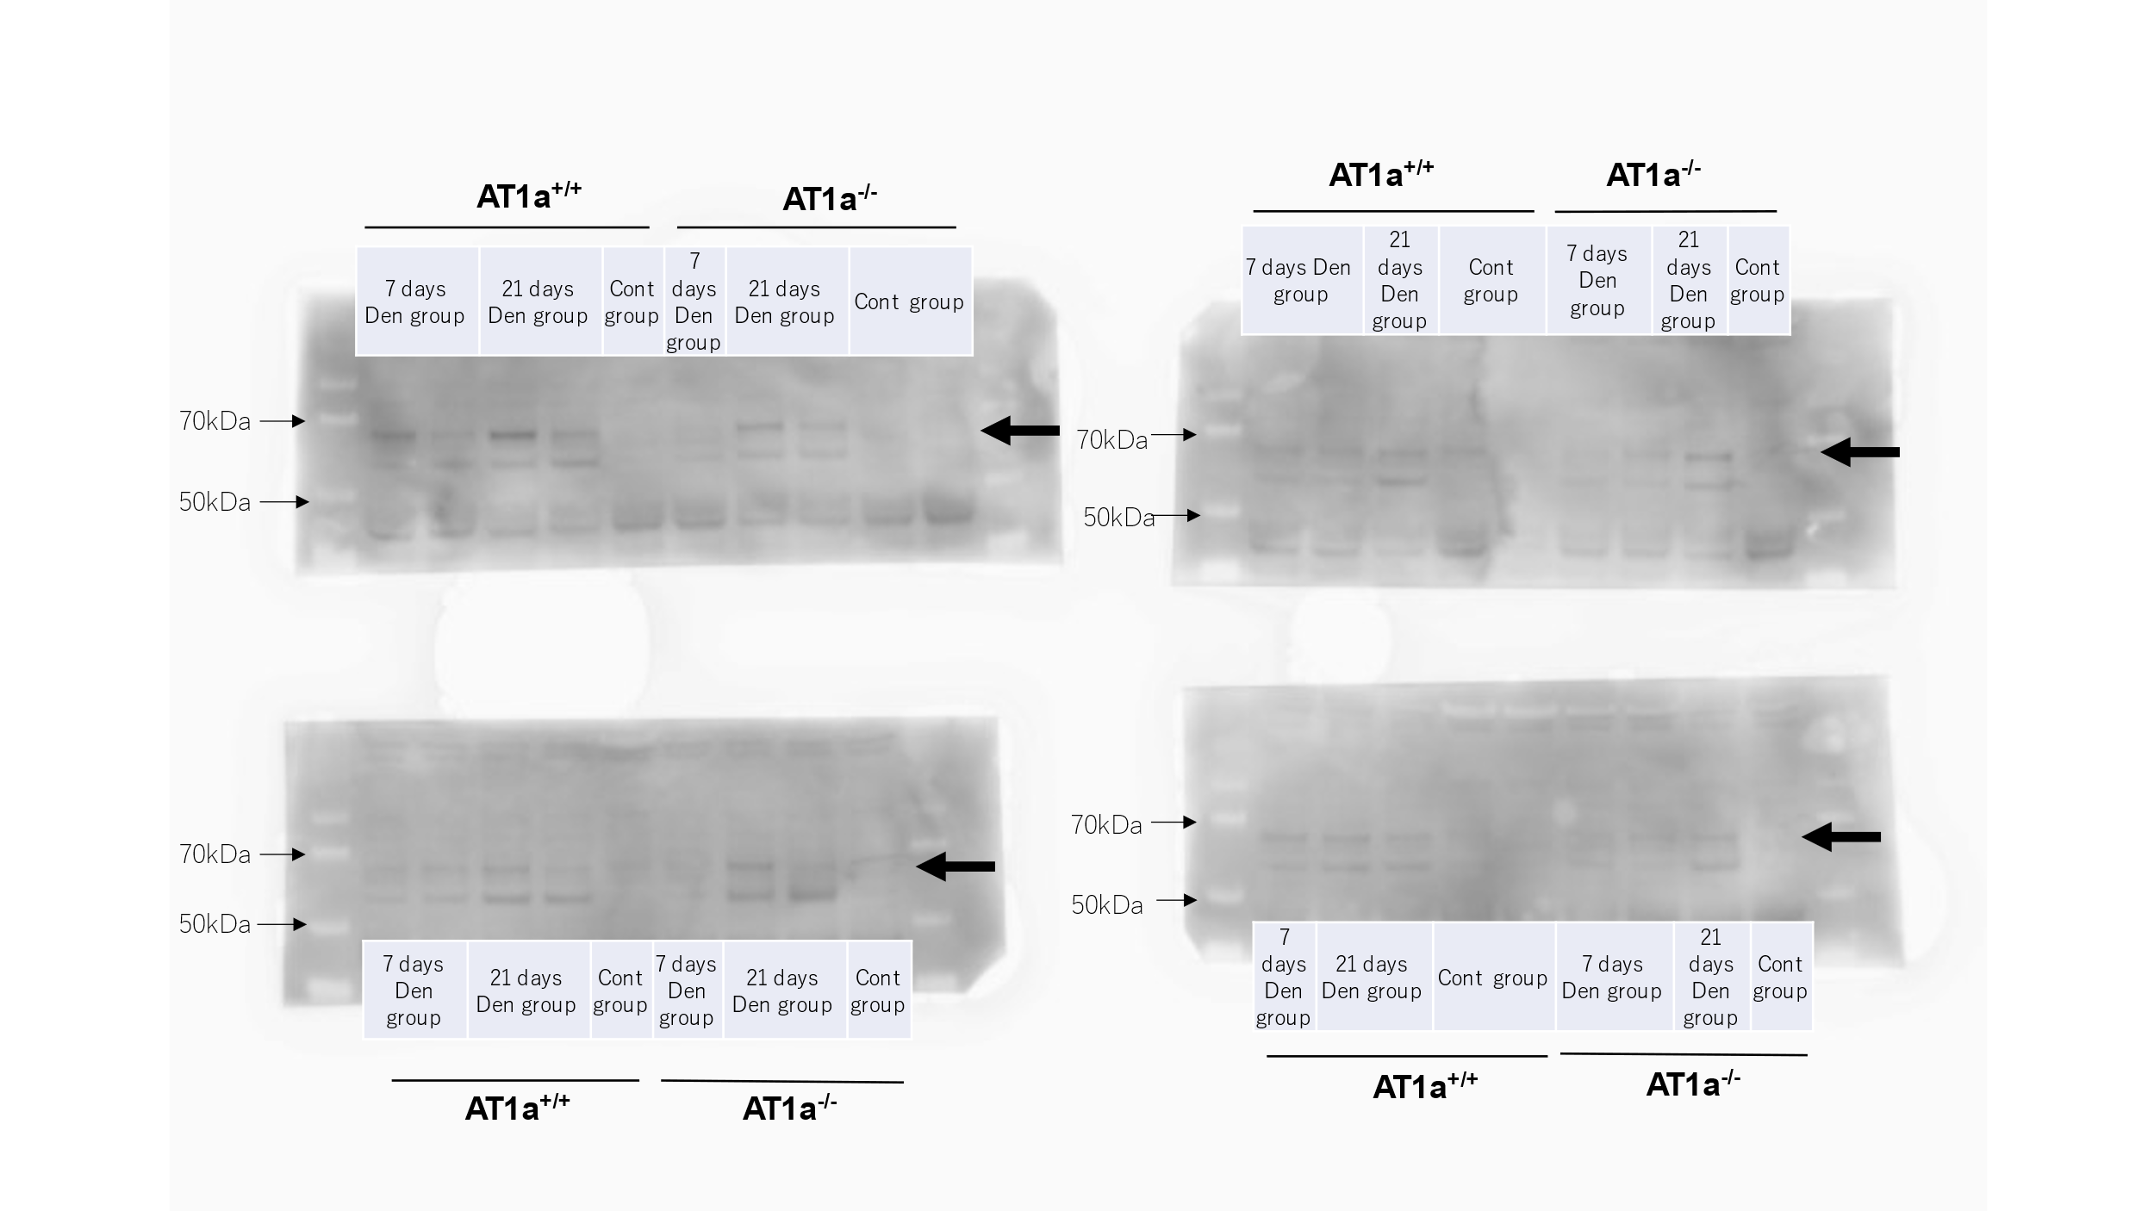

b. S6K
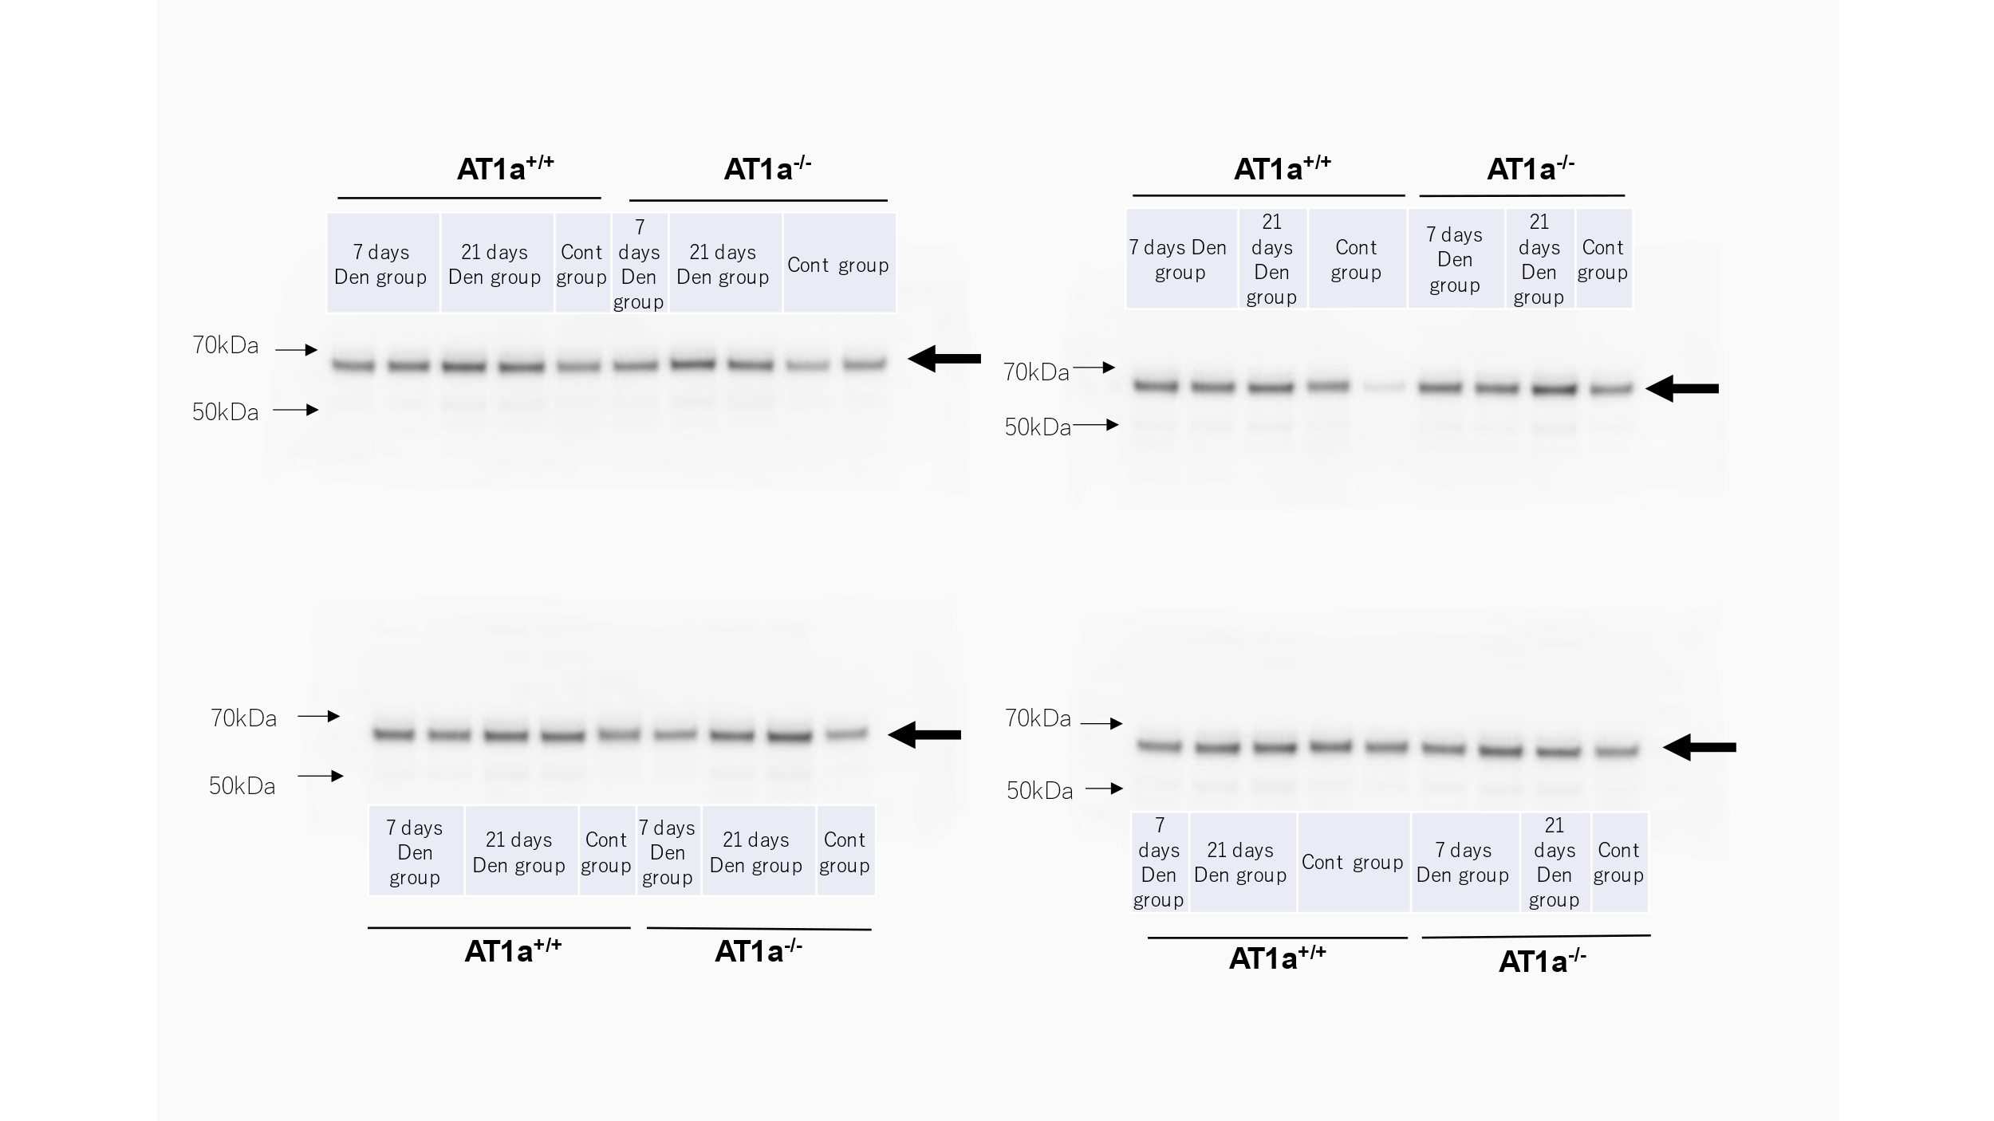

c. α-tubulin
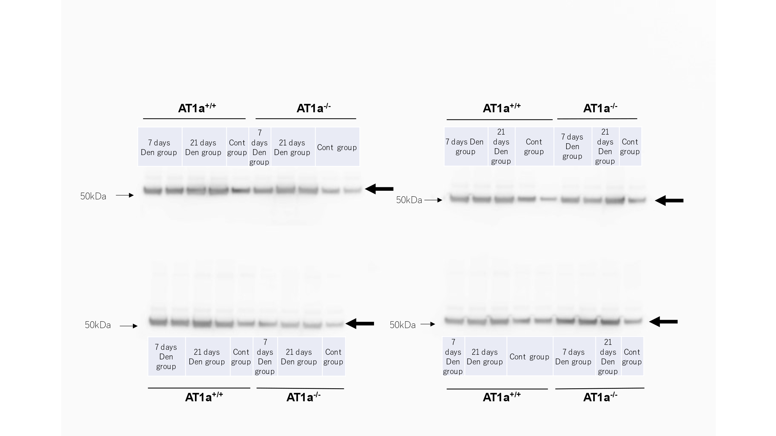
Western blot analysis of phospho-S6K (a), S6K (b), and α-tubulin (c) in the Den and Cont groups at 7 and 21 days postdenervation. Black arrows represent the targeted protein.

