Additional File 2 Brief Review Checklist

Abrami PC, Borokhovski E, Bernard RM, Wade CA, Tamim R, Persson T, et al. Issues in conducting and disseminating brief reviews of evidence. Evidence & policy: a journal of research, debate and practice. 2010;6(3):371-89.
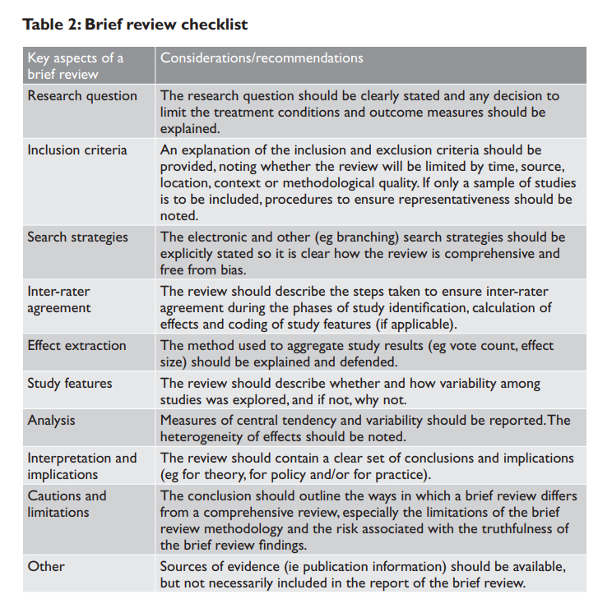
✓

✓
✓
✓
✓

n/a
n/a
✓
✓
✓

✓
✓

