Appendix: Standard Curves
- Total polyphenol content Assay standard Curve
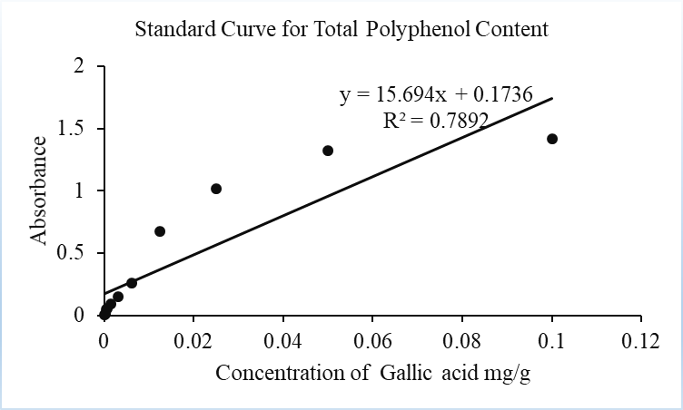

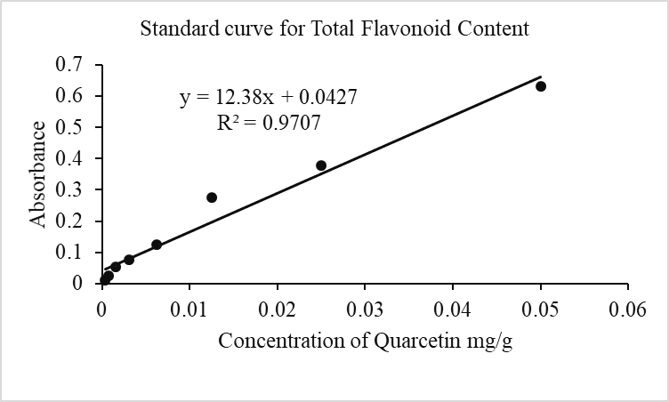
- Total Flavonoid Content Assay standard curve

- Ferric reducing antioxidant power assay standard curve
