Table 1 Compounds identified in the defensive secretion of Gonyleptes curticornis and G. horridus
Compounds | Retention time  (min) | IR | Characteristic ions (m/z, abundance) | Species | Relative abundance
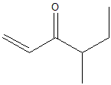  4-methyl-1-hexen-3-one (1) | 8.72 | 831.2 | 112 M⁺(15); 97(12); 84(35); 83(12); 69(12); 58(28); 56(23); 55(100); 41(29) | G. curticornis | 65.5 %
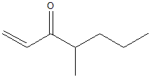  4-methyl-1-heptan-3-one (2) | 12.47  12.07 | 980.4 | 126 M⁺ (1); 111(4); 97(21); 83(12); 70(89); 55(100); 43(23); 40(36) | G. horridus  G. curticornis | 10.2 %  12.1 %
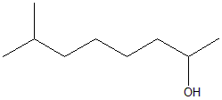  7-methyl-2-octanol (3) | 14.11 | 1040 | 144 M⁺ (4); 129(2); 116(6); 87(17); 58(58); 45(100) | G. horridus | 12,9 %
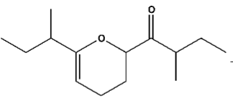  1-(6-(1-methyl-propyl) 3,4-dihydro-2H-pyran-2-yl)2-methyl-butanone (4) | 26.21  28.22 | 1456 | 224 M⁺ (30), 139(100); 121(21); 95(31); 81(22); 69(41); 57(68); 41(42) | G. horridus  G. curticornis | 27.3 %  18.2 %
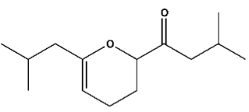  1-(6-isopropyl-3,4-dihydro-2H-pyran-2-yl)isobutanone (5) | 26.26  28.21 | 1458 | 224 M⁺ (29); 139(100); 121(21); 95(31); 83(13); 81(22); 69(39); 57(66); 41(40); | G. horridus  G. curticornis | 37.2 %  38.3 %

Table 2 Defensive secretion of two harvestmen (Arachnida, Opiliones). Chemical shifts obtained from the ¹H NMR spectrum for 4-methyl-1-hexen-3-one (1) and 4-methyl-1-hepten-3-one (2)
G. curticornis |  | G. horridus
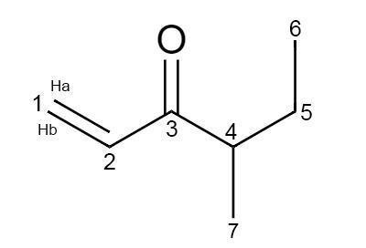  (1) |  | 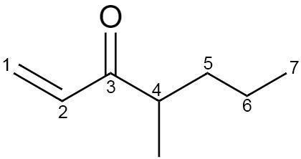  (2)
Position | δH (J in Hz) | Position | δH (J in Hz)
1a | 6.25; dd (17.5; 1.4) | 1a | 6.25; dd (18; 1.2)
1b | 5.86; dd (10.0; 1.4) | 1b | 5.85; dd (10,5; 1.4)
2 | 6.49; dd (17.5; 10.5) | 2 | 6.47; dd (18; 10.8)
4 | 2.89; m | 4 | 2.83; m
5 | 1.59; m | 5a | 1.59; m
- | - | 5b | 1.59; m
6 | 0.79; t (7.5) | 6a | 1.34; m
- | - | 6b | 1.34; m
7 | 1.0; d (6.9) | 7 | 0.79; t (7.8)
- | - | 8 | 0.98; d (6.8)

Table 4. Modified chemical character matrix from Caetano and Machado (2013) of the K92 clade (Arachnida, Opiliones) mapped in Figure 3
