“Resistome prevalence and diversity in Escherichia coli isolates of global wastewaters”

Pavithra Anantharaman Sudhakari and Bhaskar Chandra Mohan Ramisetty*
Laboratory of Molecular Biology and Evolution, 312@ASK1, School of Chemical and Biotechnology, SASTRA Deemed University, Thanjavur, India
*Corresponding author
Bhaskar Chandra Mohan Ramisetty
Laboratory of Molecular Biology and Evolution, 312@ASK1, School of Chemical and Biotechnology, SASTRA Deemed University, Thanjavur, India
Mobile: 08122609945
E-mail ID: ramisettybcm@biotech.sastra.edu; bcmr25@gmail.com

Supplementary Table S1. Summary of genomics of E. coli strains sequenced in this study.
Isolate name | Phylogroup | Serotype | Sequence type | Resistance by patching | No. of CDS | Resistance predicted by ResFinder |  | Biofilm-related proteins | Virulence gene
 |  |  |  |  |  | ARGs | Point mutation | Biofilm-related proteins | Virulence gene
PPO19  (https://www.ncbi.nlm.nih.gov/biosample/28772516) | A | O81:H45 | ST500, ST823, ST437 | Chloramphenicol, ciprofloxacin, kanamycin, tet | 4,981 | Aminoglycoside (aadA1, aadA2b, and aph(3’)-Ia), phenicol (cmlA1), quinolone (qnrA1), sulfonamide (sul3), tetracycline (tet(A)), and disinfectant (qacL) | Nalidixic acid and ciprofloxacin (gyrA p.S83L, parC p.S80I) | Biofilm PGA synthesis protein PgaD, Cyclic-di-GMP-binding biofilm dispersal mediator protein, Toxin-antitoxin biofilm protein TabA, Biofilm regulator BssS | Tellurium ion resistance protein
PPR76 (https://www.ncbi.nlm.nih.gov/biosample/28772517) | B2 | O25:H4 | ST43 | Ciprofloxacin, gentamicin, kanamycin | 4,808 | Disinfectant (sitABCD) | Nalidixic acid and ciprofloxacin (gyrA p.D87N, parC p.E84V, parE p.I529L, gyrA p.S83L, parC p.S80I) | Biofilm PGA synthesis protein PgaD, Cyclic-di-GMP-binding biofilm dispersal mediator protein, Toxin-antitoxin biofilm protein TabA, Biofilm regulator BssS | Tellurium ion resistance protein, Glutamate decarboxylase, Nnon-ribosomal peptide synthetase, Siderophore receptor, Iron transport protein, Outer membrane hemin receptor, Outer membrane protease, Increased serum survival, Fimbrial protein, Uropathogenic specific protein
PPR154 (https://www.ncbi.nlm.nih.gov/biosample/28772518) | D | O1:H15 | ST8 | Chloramphenicol, Ciprofloxacin, gentamicin, kanamycin, tetracycline | 5,413 | Fluoroquinolone and aminoglycoside (aac(6')-Ib-cr), rifampicin, beta-lactam (blaCMY-42 and blaOXA-1), phenicol (catB3), macrolide (mph(A)), sulfonamide (sul1), tetracyclineracycline (tetracycline(B)), and disinfectant (sitABCD) | Nalidixic acid and ciprofloxacin (gyrA p.D87N, gyrA p.S83L, parC p.S80I) | Biofilm PGA synthesis protein PgaD, Cyclic-di-GMP-binding biofilm dispersal mediator protein, Toxin-antitoxin biofilm protein TabA | Tellurium ion resistance protein, Glutamate decarboxylase, Nnon-ribosomal peptide synthetase, Siderophore receptor, Iron transport protein, Outer membrane hemin receptor, Capsule polysaccharide export protein, Polysialic acid transport protein, Major pilin, Adherence protein, Aerobactin synthetase, Ferric aerobactin receptor, Secreted autotransporter toxin, Heat-resistant agglutinin, Salmonella HilA homolog, Enteroaggregative immunoglobulin repeat protein, Afimbrial adhesion, Transcriptional regulator, Outer membrane usher protein, Diffuse adherence fibrillar adhesin gene
PPR228 (https://www.ncbi.nlm.nih.gov/biosample/28772519) | B1 | O174:H28 | ST19 | Chloramphenicol, ciprofloxacin, gentamicin, kanamycin, tetracycline | 4,762 | Aminoglycoside (aac(6')-Ib3, aac(6)-Id, and aac(3'')-Ib), fluoroquinolone (aac(6')-Ib-cr), beta-lactam (blaTEM-1B), phenicol (catA1 and catB3), trimethoprim (drfA1), sulfonamide (sul1 and sul2), tetracyclineracycline (tetracycline(B)), and disinfectant (qacE) | Nalidixic acid and ciprofloxacin (gyrA p.D87N, gyrA p.S83L, parC p.E84K, parE p.L416F) | Biofilm growth-associated repressor, Biofilm PGA synthesis protein PgaD, Cyclic-di-GMP-binding biofilm dispersal mediator protein, Toxin-antitoxin biofilm protein TabA, Biofilm regulator BssS | Tellurium ion resistance protein, Glutamate decarboxylase, Heat-resistant agglutinin, Increased serum survival
PPO79 (https://www.ncbi.nlm.nih.gov/biosample/29927164) | A | O62:H12 | ST446 | - | 4,878 | - | - | Biofilm PGA synthesis protein PgaD, Cyclic-di-GMP-binding biofilm dispersal mediator protein, Toxin-antitoxin biofilm protein TabA, Biofilm regulator BssS | -
PPO117 (https://www.ncbi.nlm.nih.gov/biosample/29927165) | A | O13/O135:H53 | ST230 |  | 5,043 | - | - | Biofilm PGA synthesis protein PgaD, Cyclic-di-GMP-binding biofilm dispersal mediator protein, Toxin-antitoxin biofilm protein TabA, Biofilm regulator BssS | Tellurium ion resistance protein, Glutamate decarboxylase, Colicin, Outer membrane protein
PPR75 (https://www.ncbi.nlm.nih.gov/biosample/29927166) | A | O128:H34 | ST1113, ST513, ST338, ST442, ST718, ST450 | - | 5,216 | - | Nalidixic acid and ciprofloxacin (gyrA p.S83L) | Biofilm growth-associated repressor, Biofilm PGA synthesis protein PgaD, Cyclic-di-GMP-binding biofilm dispersal mediator protein, Toxin-antitoxin biofilm protein TabA, Biofilm regulator BssS | Tellurium ion resistance protein, Glutamate decarboxylase, Colicin, Long polar fimbriae
PPR93 (https://www.ncbi.nlm.nih.gov/biosample/29927167) | B2 | O6:H1 | ST4 | - | 4,994 | beta-lactam (blaTEM-1B), disinfectant (sitABCD) | Nalidixic acid and ciprofloxacin (gyrA p.S83L) | Biofilm PGA synthesis protein PgaD, Toxin-antitoxin biofilm protein TabA, Biofilm regulator BssS | Tellurium ion resistance protein, Glutamate decarboxylase, Outer membrane protease, Colicin, Increased serum survival, Nnon-ribosomal peptide synthetase, Siderophore receptor, Iron transport protein, Outer membrane hemin receptor, Capsule polysaccharide export protein, Polysialic acid transport protein, microcin, Fimbrial protein, Uropathogenic specific protein, Major pilin , Adherence protein, Enterobactin siderophore receptor protein, ABC transporter protein MchF, Aerobactin synthetase, Ferric aerobactin receptor, Vacuolating autotransporter toxin, S fimbrial/F1C minor subunit, Secreted autotransporter toxin, Hybrid non-ribosomal megasynthase, Tir domain-containing protein, Serine protease autotransporters (SPATE), MchC protein, F1C adhesion

Supplementary Table S2. ARGs on global wastewater E. coli.
Antibiotics | No. of resistance genes
Aminoglycoside | 934
Beta-lactam | 589
Disinfectant | 481
Sulfonamide | 390
Trimethoprim | 271
Tetracycline | 259
Phenicol | 167
Macrolide | 188
Quinolone | 123
Fluoroquinolone and aminoglycoside | 70
Colistin | 38

Supplementary Table S3: Plasmids of eight sequenced local isolates.
Plasmid name | Type | ARGs and resistance mutations | Virulence genes
pPPO19 | IncX1 (21,349bp) | Aminoglycoside (aph(3’)-Ia), quinolone (qnrS13), tetracycline (tet(A)), and trimethoprim (dfrA14)  Resistance mutation: nalidixic acid and ciprofloxacin | -
pPPR76 | IncX4 (31,189 bp)  IncFIA (30,781bp)  IncFIB (AP001918) (14,036 bp)  Col156 (10,524 bp) | - | Plasmid-encoded enterotoxin and outer membrane protein complement resistance
pPPR154 | IncI2(Delta) (59,493 bp)  IncX4 (32,764 bp)  IncFII(pCRY) (21,880 bp)  Col(BS512) (2,229 bp) | Trimethoprim (dfrA17) | Outer membrane protein complement resistance
pPPO79 | IncR (29,623 bp), Col440I (4,782 bp), ColpVC (1,990 bp) | - | -
pPPO117 | Col440I (4,990) | - | Glutamate decarboxylase
pPPR75 | IncR (11,434 bp), Col156 (6,202 bp), Col(pHAD28) (2,044 bp) | - | Endonuclease colicin E2
pPPR93 | ColRNAI (28,345 bp) | - | Colicin E1

Supplementary Figures

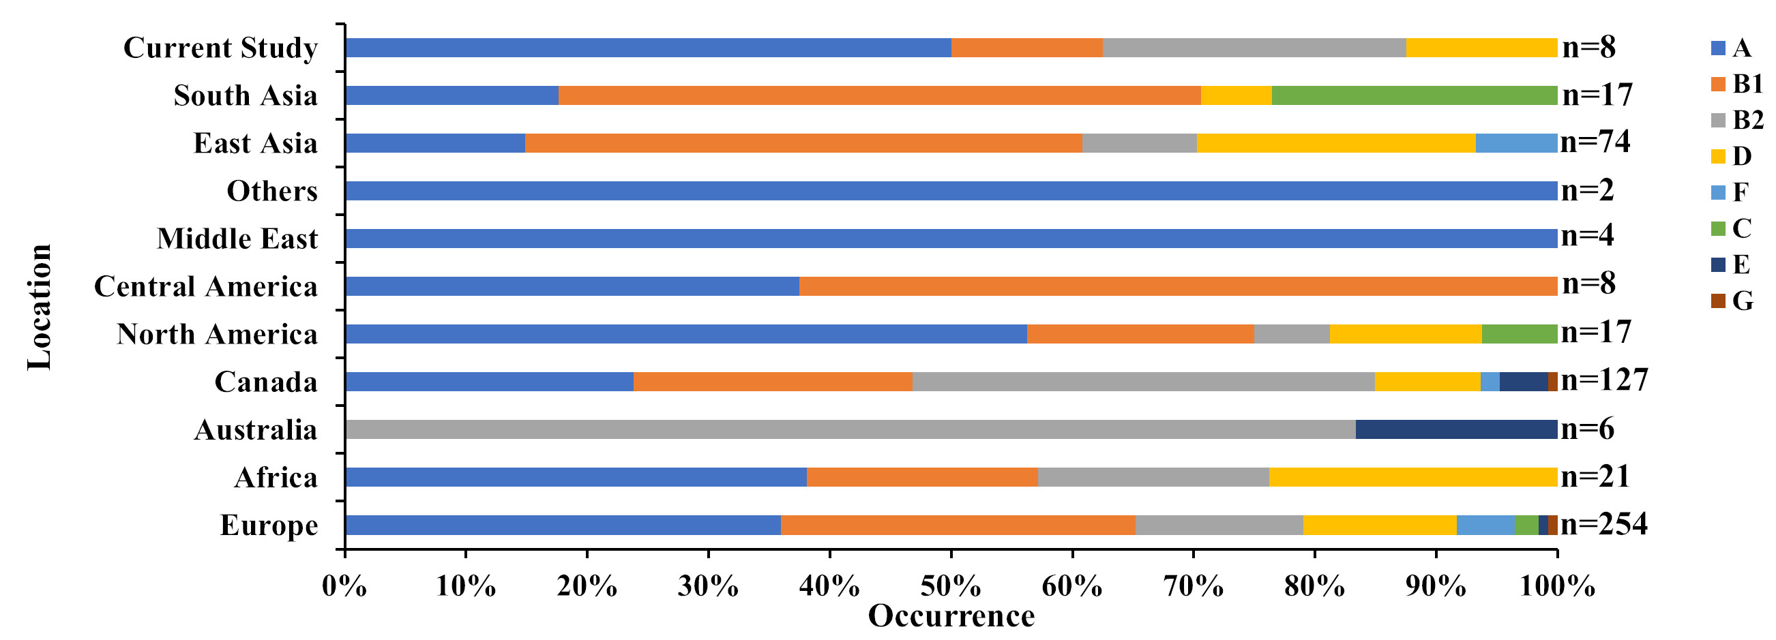
Supplementary Figure S1: Phylogroups of global wastewater isolates. ClermonTyping was performed on all the isolates, and the diversity of phylogroups within each location is presented as a stacked bar plot. Phylogroups A (161 isolates) and B1 (158 isolates) were predominantly represented by global wastewater E. coli. Of the nine phylogroups, phylogroup G is least represented among the wastewater E. coli. East Asian isolates belonged majorly to phylogroup B1 (34 isolates). Phylogroup D is rarely represented among the South Asian E. coli. The current study isolates belonged to phylogroup A (PPO19, PPO79, PPO117, and PPR75), B2 (PPR76 and PPR93), B1 (PPR75), and D (PPR154).

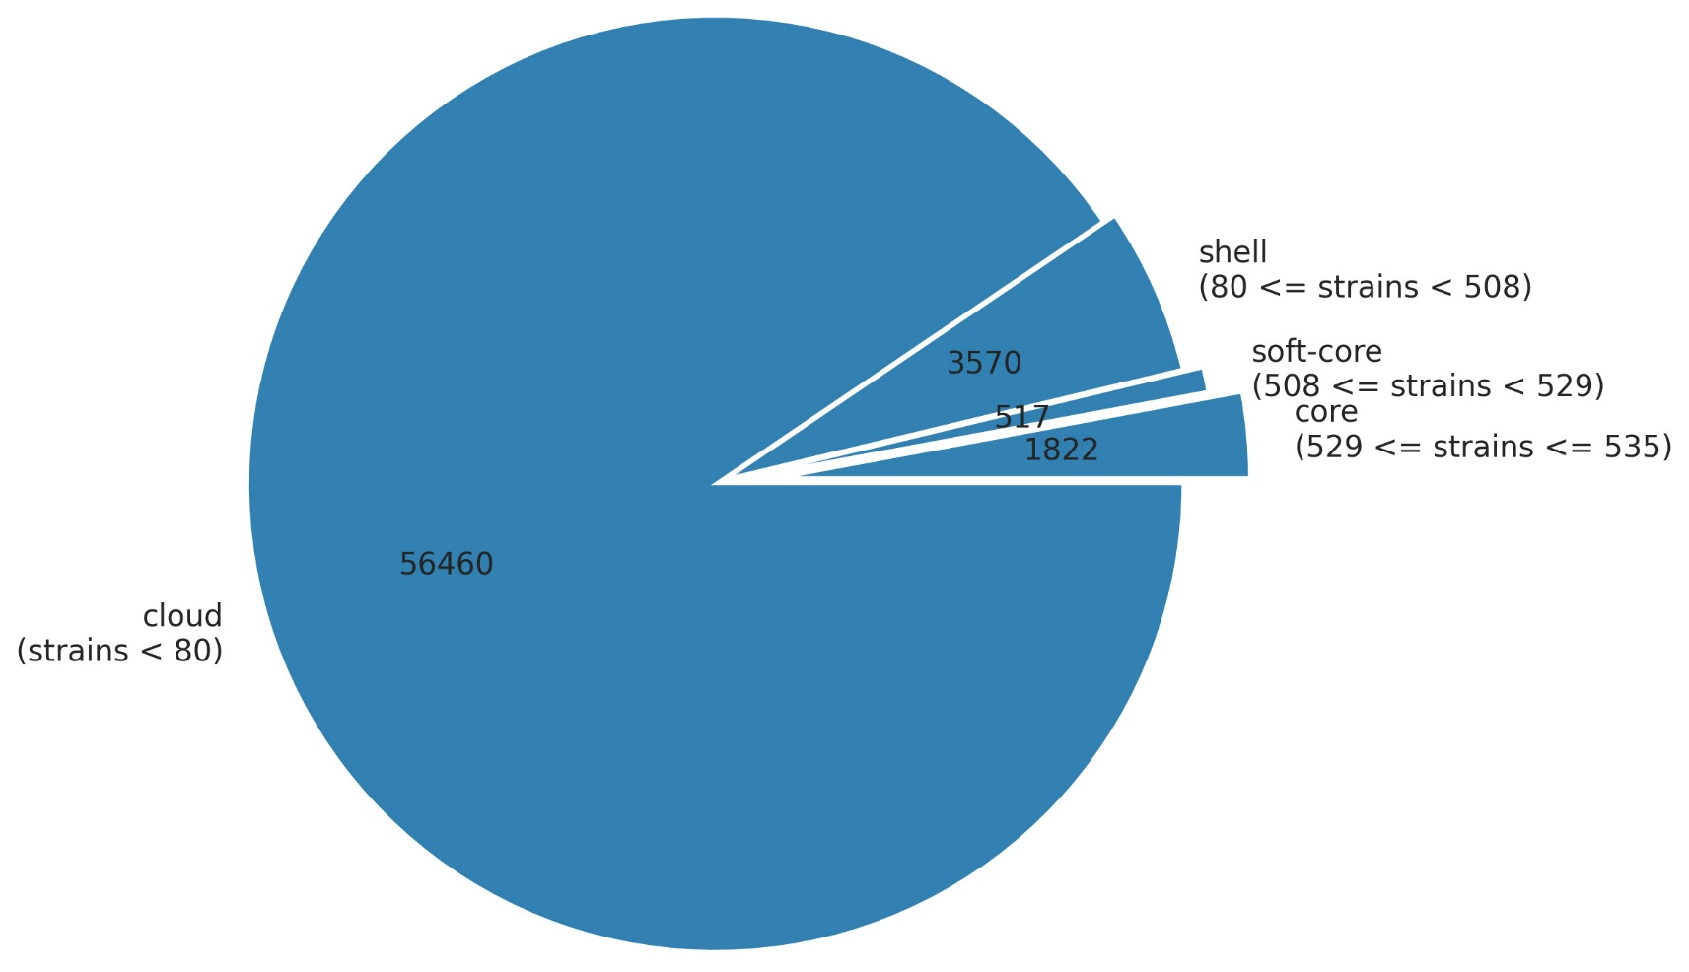
Supplementary Figure S2 The overall core- and shell-genome of global wastewater E. coli. The Roary tool was used to calculate the core- and pan-genome with default threshold values. The paralogs were removed by setting the parameter “paralog split” to true.

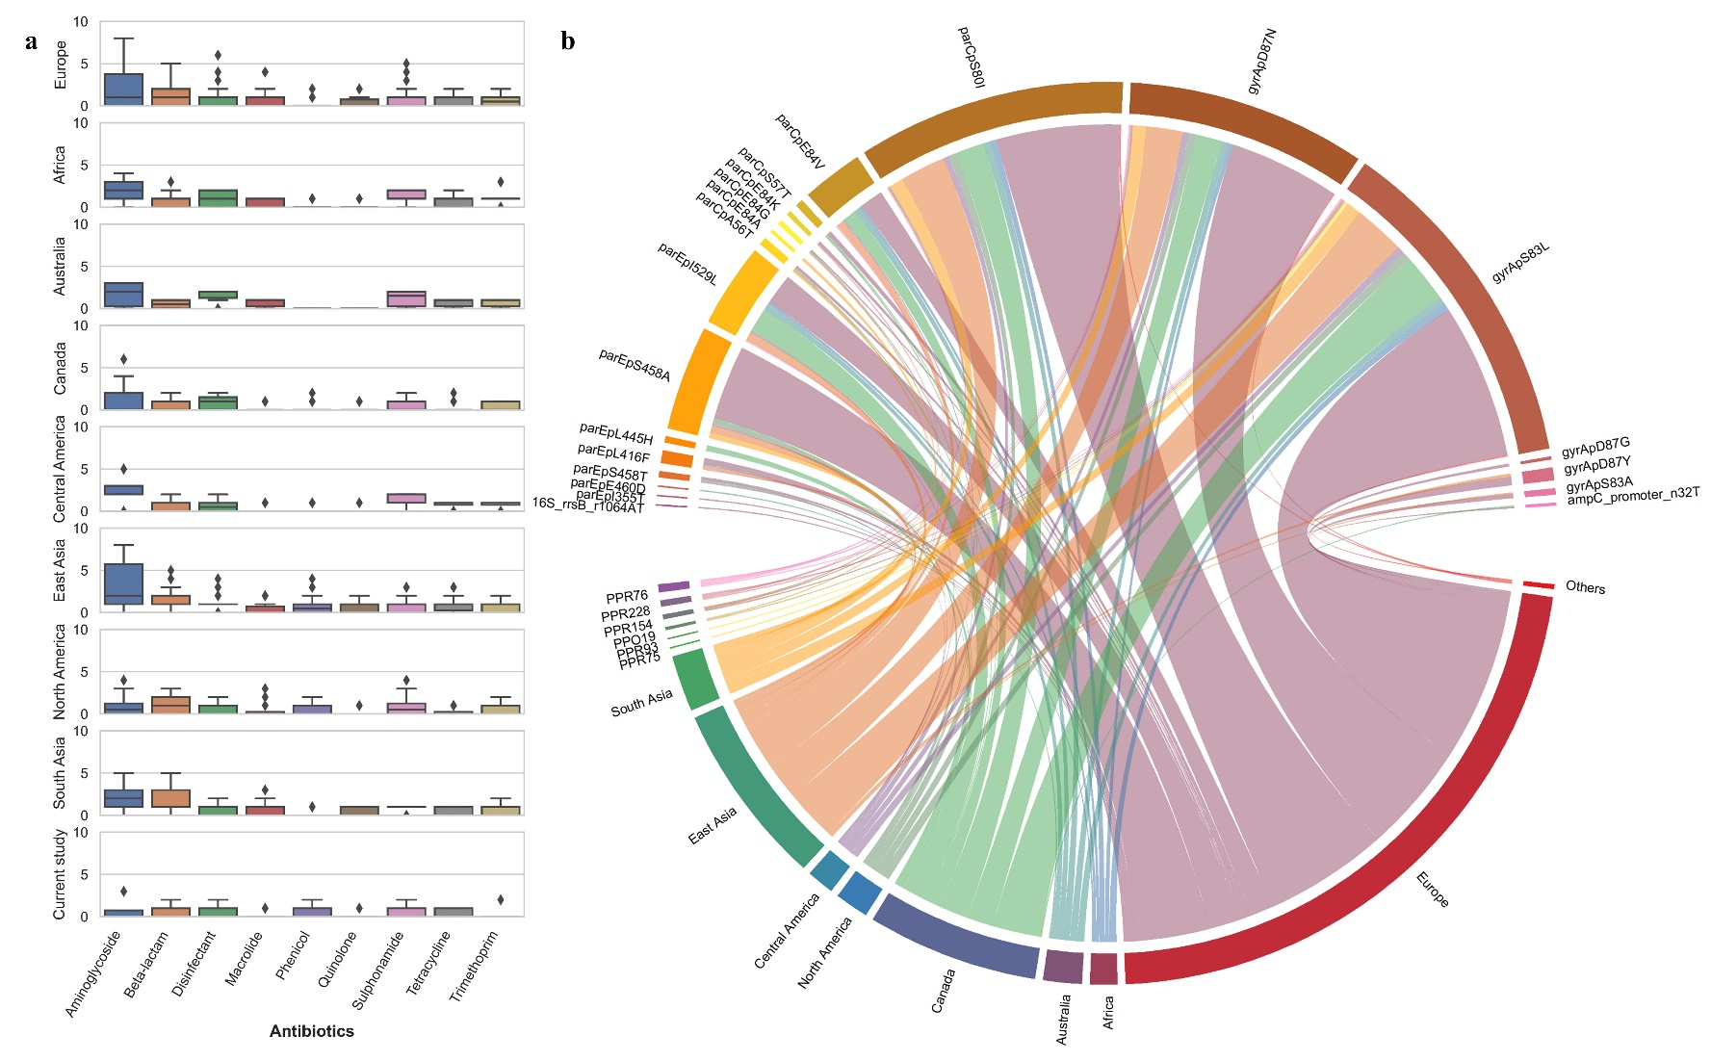
Supplementary Figure S3: Resistome of geography-specific wastewater E. coli. (a) The occurrence of ARGs encoded against nine highly prevalent antibiotics on the genomes of wastewater E. coli across the globe is plotted as boxplots with outliers. In accordance with the phenotypic resistance profile, antibiotic susceptible isolates (PPO79, PPO117, and PPR75) sequenced in this study did not encode any ARGs. Resistance to disinfectants was invariably prevalent across all the regions. Except for bleomycin and colistin, resistance to all other antibiotic classes was detected in the resistome of the East Asian isolate. (b) Resistance mutations conferring resistance to specific antibiotics. The gyr (S83L, D87N) and par (S80I) mutations conferring resistance to nalidixic acid and ciprofloxacin were observed in global wastewater E. coli. Of the eight local isolates, PPR93 and PPR75 have the least number of resistance mutations (gyrA p.S83L), and PPR228 with the highest number of mutations (two gyrA, two parC and one parE).

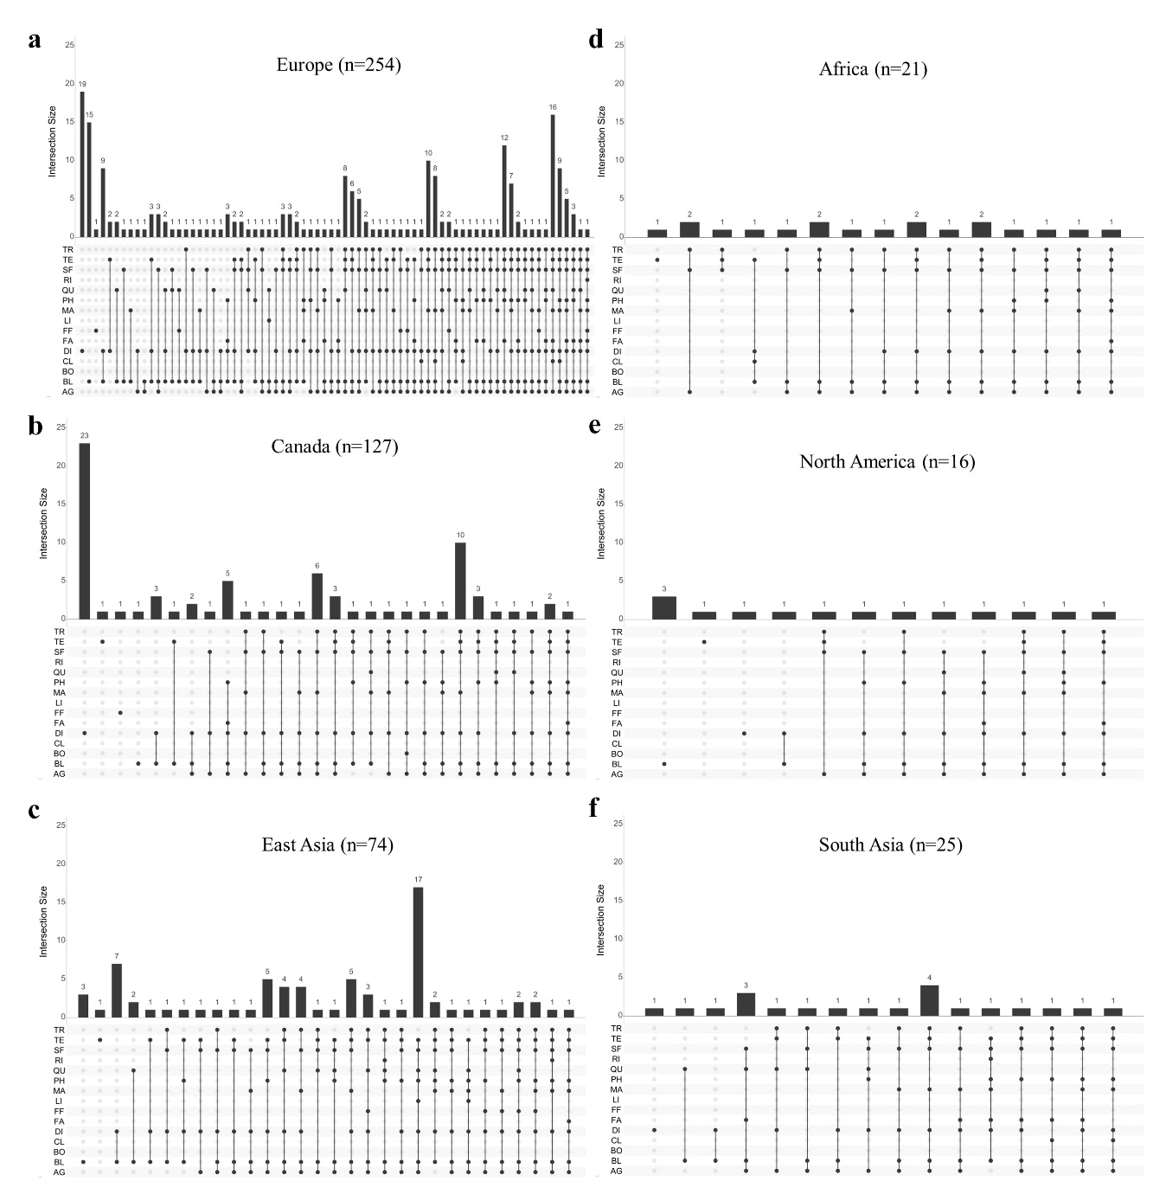
Supplementary Figure S4: Combination of resistances in geographic-specific wastewater isolates. The combinations of resistances encoded on the genomes of global wastewater E. coli are presented as an intersection plot using the UpSetR library in R. The dots connected by lines represent the occurrence of resistance among the global isolates. The prevalence of the combination of specific resistances is shown as intersection size (above the column). The sample size in each location is given as “n.” AG-Aminoglycoside, BL-Beta-lactam, BO-Bleomycin, CL-Colistin, DI-Disinfectant, FA-Fluoroquinolone and aminoglycoside, FF-Fosfomycin, LI-Lincosamide, MA-Macrolide, PH-Phenicol, QU-Quinolone, RI-Rifampicin, SF-Sulfonamide, TE-Tetracycline, TR-Trimethoprim.

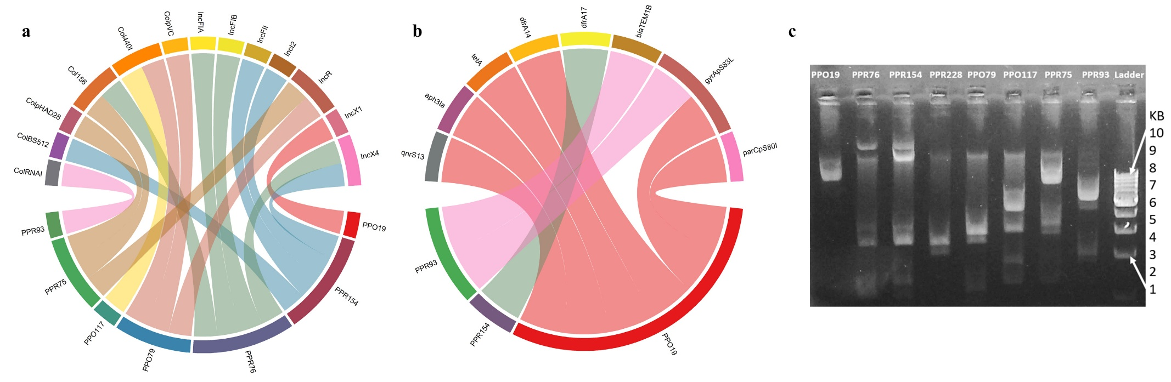
Supplementary Figure S5: Plasmidomics of local wastewater E. coli. (a) Plasmid types of the eight sequenced local isolates. Colicin-like replicons, ranging from 4 to 50 kb (supplementary table S3), were typed prevalently in local isolates except in PPO19 (IncX1). The plasmid contig of PPR93 was typed as ColRNAI (28,345 bp) but with reduced sequence identity (~88%), contrary to that of others in which the sequence identity was around 98%. (b) ARGs and resistance mutations on the plasmids of local isolates (pPPO19, pPPO154, and pPPR93). The resistance against aminoglycoside, beta-lactam, tetracycline, and trimethoprim was observed on the plasmids of local. (c) Agarose gel image of plasmids extracted from eight local isolates using QIAGEN Miniprep kit (Cat. No. 27104).

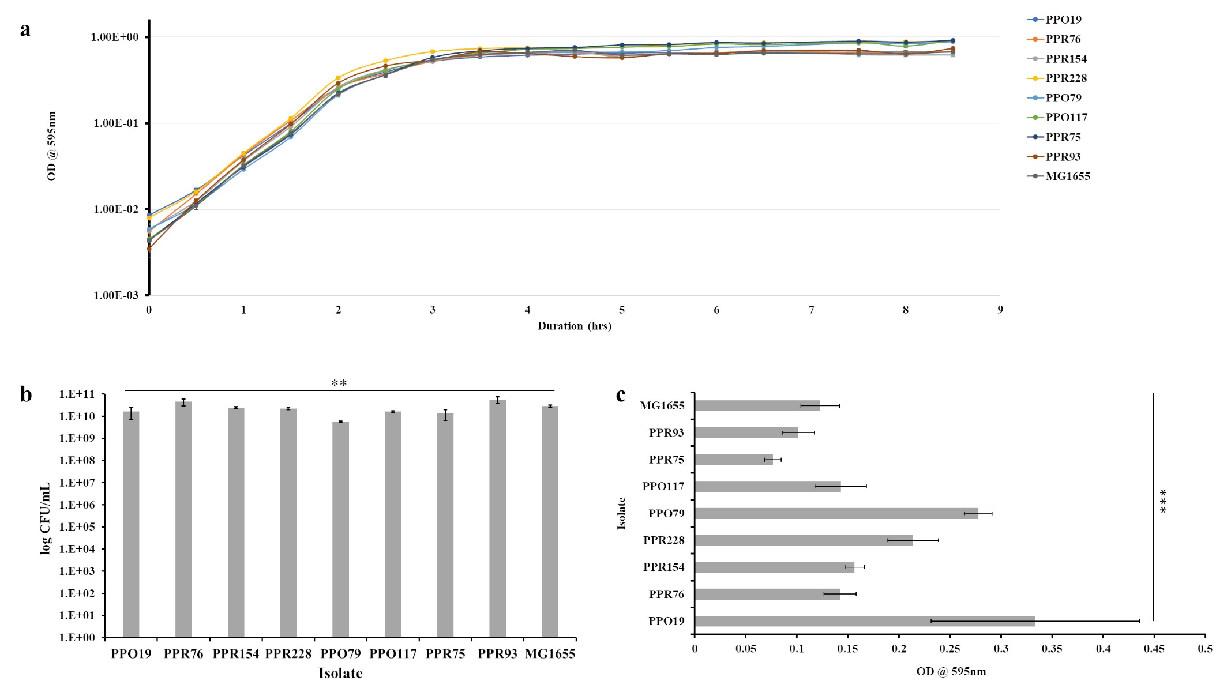
Supplementary Figure S6: Comparison of growth rates and colony-forming units of the wastewater local isolates. (a) Growth curve (OD/hour) and (b) Colony-forming units (CFU/mL) in 24-hours culture. Compared to the lab strain K-12 MG1655, we did not find any significant difference in the growth rates and maximal CFU among the local isolates, indicating no fitness loss in the conditions tested; (c) Biofilm assay. PPO19 showed a three-fold higher biofilm-forming capacity, followed by PPO79 and PPR228 (two-fold). Experiments were done in biological and technical replicates, and the average was plotted as a graph with error as the standard error mean (SEM). Statistical analysis (one-way ANOVA) was performed, and the p-value < 0.05 showed a significant difference in CFU/mL between the strains. (** indicates p-value <0.01 and *** indicates p-value < 0.001).

