Supplementary Information
Mangrove plant species | Acanthus ebracteatus, Acanthus volubilis, Acrostichum aureum, Acrostichum danaeifolium, Acrostichum speciosum, Aegialitis annulata, Aegialitis rotundifolia, Aegiceras corniculatum, Aegiceras floridum, Aglaia cucullata, Avicennia alba, Avicennia bicolor, Avicennia germinans, Avicennia integra, Avicennia marina, Avicennia officinalis, Avicennia schaueriana, Brownlowia argentata, Brownlowia tersa, Bruguiera cylindrica, Bruguiera exaristata, Bruguiera gymnorrhiza, Bruguiera hainesii, Bruguiera parviflora, Bruguiera sexangula, Camptostemon philippinense, Camptostemon schultzii, Ceriops australis, Ceriops decandra, Ceriops tagal, Ceriops zippeliana, Conocarpus erectus, Dolichandrone spathacea, Excoecaria agallocha, Excoecaria indica, Heritiera fomes, Heritiera globosa, Heritiera littoralis, Kandelia candel, Kandelia obovata, Laguncularia racemosa, Lumnitzera littorea, Lumnitzera racemosa, Mora oleifera, Nypa fruticans, Osbornia octodonta, Pelliciera rhizophorae, Pemphis acidula, Phoenix paludosa, Rhizophora apiculata, Rhizophora mangle, Rhizophora mucronata, Rhizophora racemosa, Rhizophora samoensis, Rhizophora stylosa, Scyphiphora hydrophylacea, Sonneratia alba, Sonneratia apetala, Sonneratia caseolaris, Sonneratia griffithii, Sonneratia lanceolata, Sonneratia ovata, Tabebuia palustris, Xylocarpus granatum, Xylocarpus moluccensis
Marine provinces | Agulhas, Andaman, Bay of Bengal, Central Polynesia, East Central Australian Shelf, Eastern Coral Triangle, Galapagos, Gulf of Guinea, Hawaii, Java Transitional, North Brazil Shelf, Northeast Australian Shelf, Northern New Zealand, Northwest Australian Shelf, Red Sea and Gulf of Aden, Sahul Shelf, Somali/Arabian, South China Sea, South Kuroshio, Southeast Australian Shelf, Southern New Zealand, Southwest Australian Shelf, Sunda Shelf, Tropical East Pacific, Tropical Northwestern Atlantic, Tropical Northwestern Pacific, Tropical Southwestern Atlantic, Tropical Southwestern Pacific, Warm Temperate Northeast Pacific, Warm Temperate Northwest Atlantic, Warm Temperate Northwest Pacific, Warm Temperate Southwestern Atlantic, West African Transition, West and South Indian Shelf, West Central Australian Shelf, Western Coral Triangle, Western Indian Ocean
Biophysical typology | Delta, Estuary, Lagoon, Open Coast, Terrigenous, Carbonate

Supplementary Table 1 – List of the biodiversity data used.
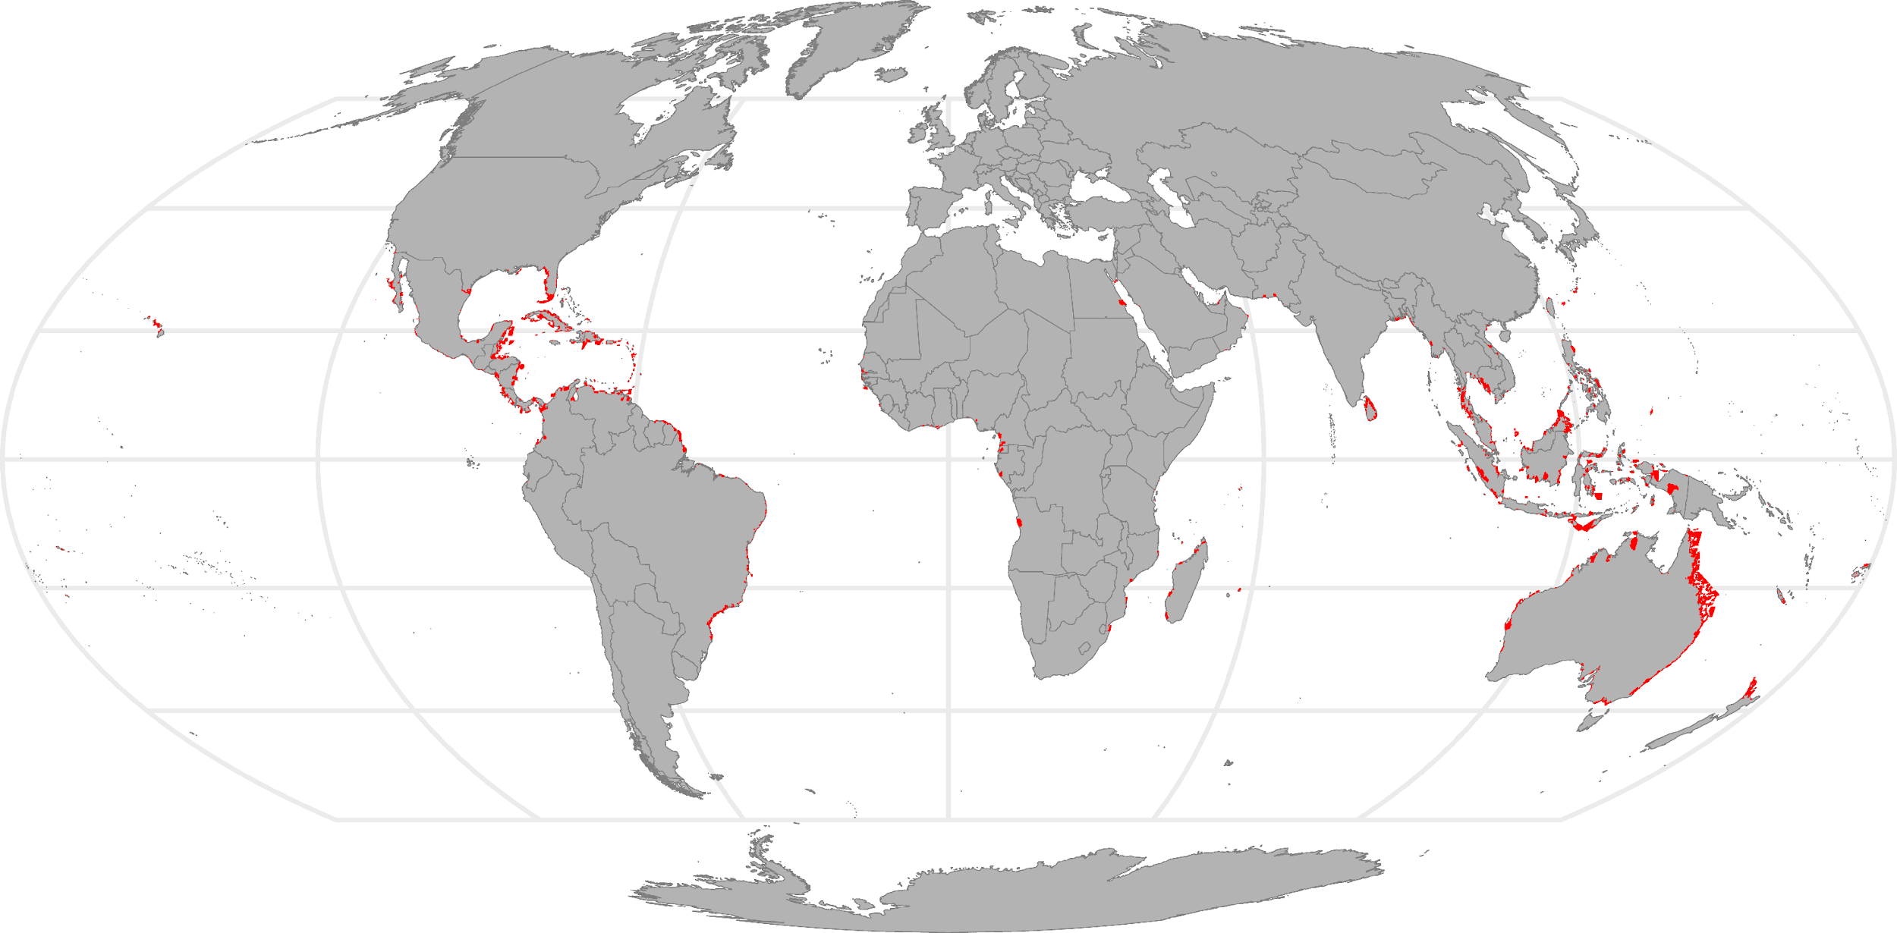
Supplementary Fig. 1 – Protected areas (IUCN categories I-IV) that intersect global mangrove distribution (red colour).
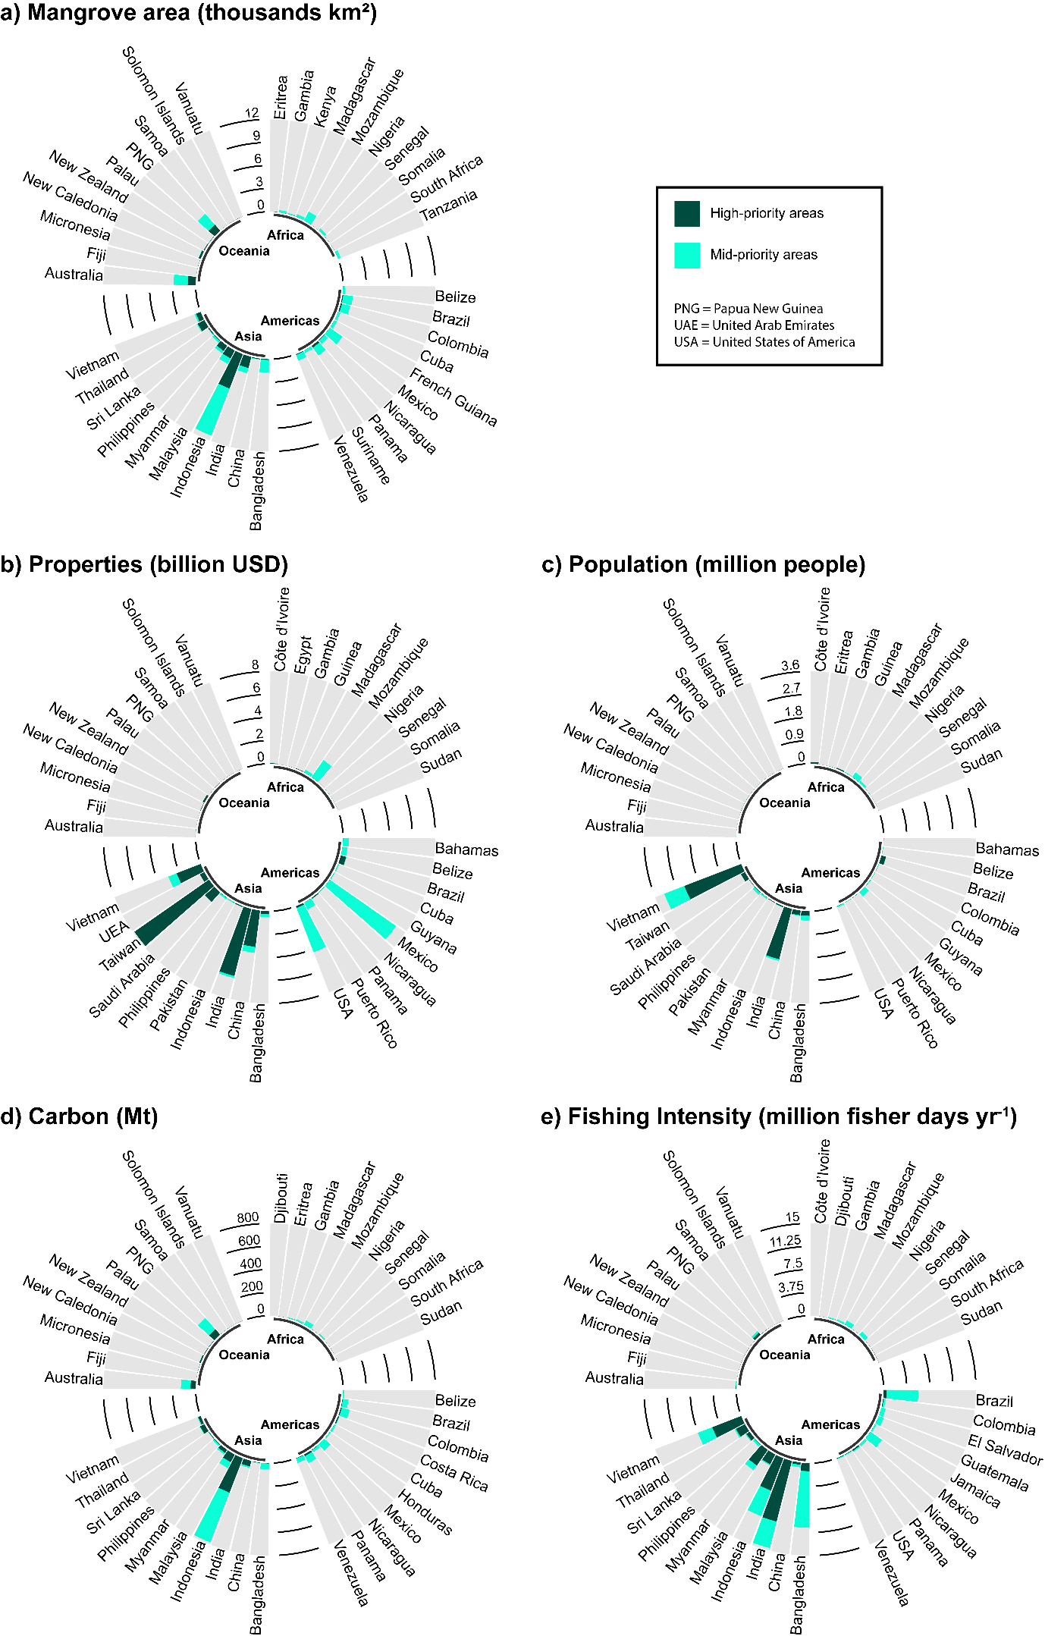
Supplementary Fig. 2 – Cumulative mangrove area and cumulative ecosystem services, by continent and country, for an optimised prioritisation for protection of biodiversity and ecosystem services. a) Mangrove area and b-e) ecosystem services provided by the high-priority areas for protection (dark shade) and the mid-priority areas (light shade) resulting from a prioritisation that maximises protection of biodiversity and ecosystem services. Only the top-10 countries per continent a) by mangrove area and b-e) by amount of ecosystem services provided are shown.

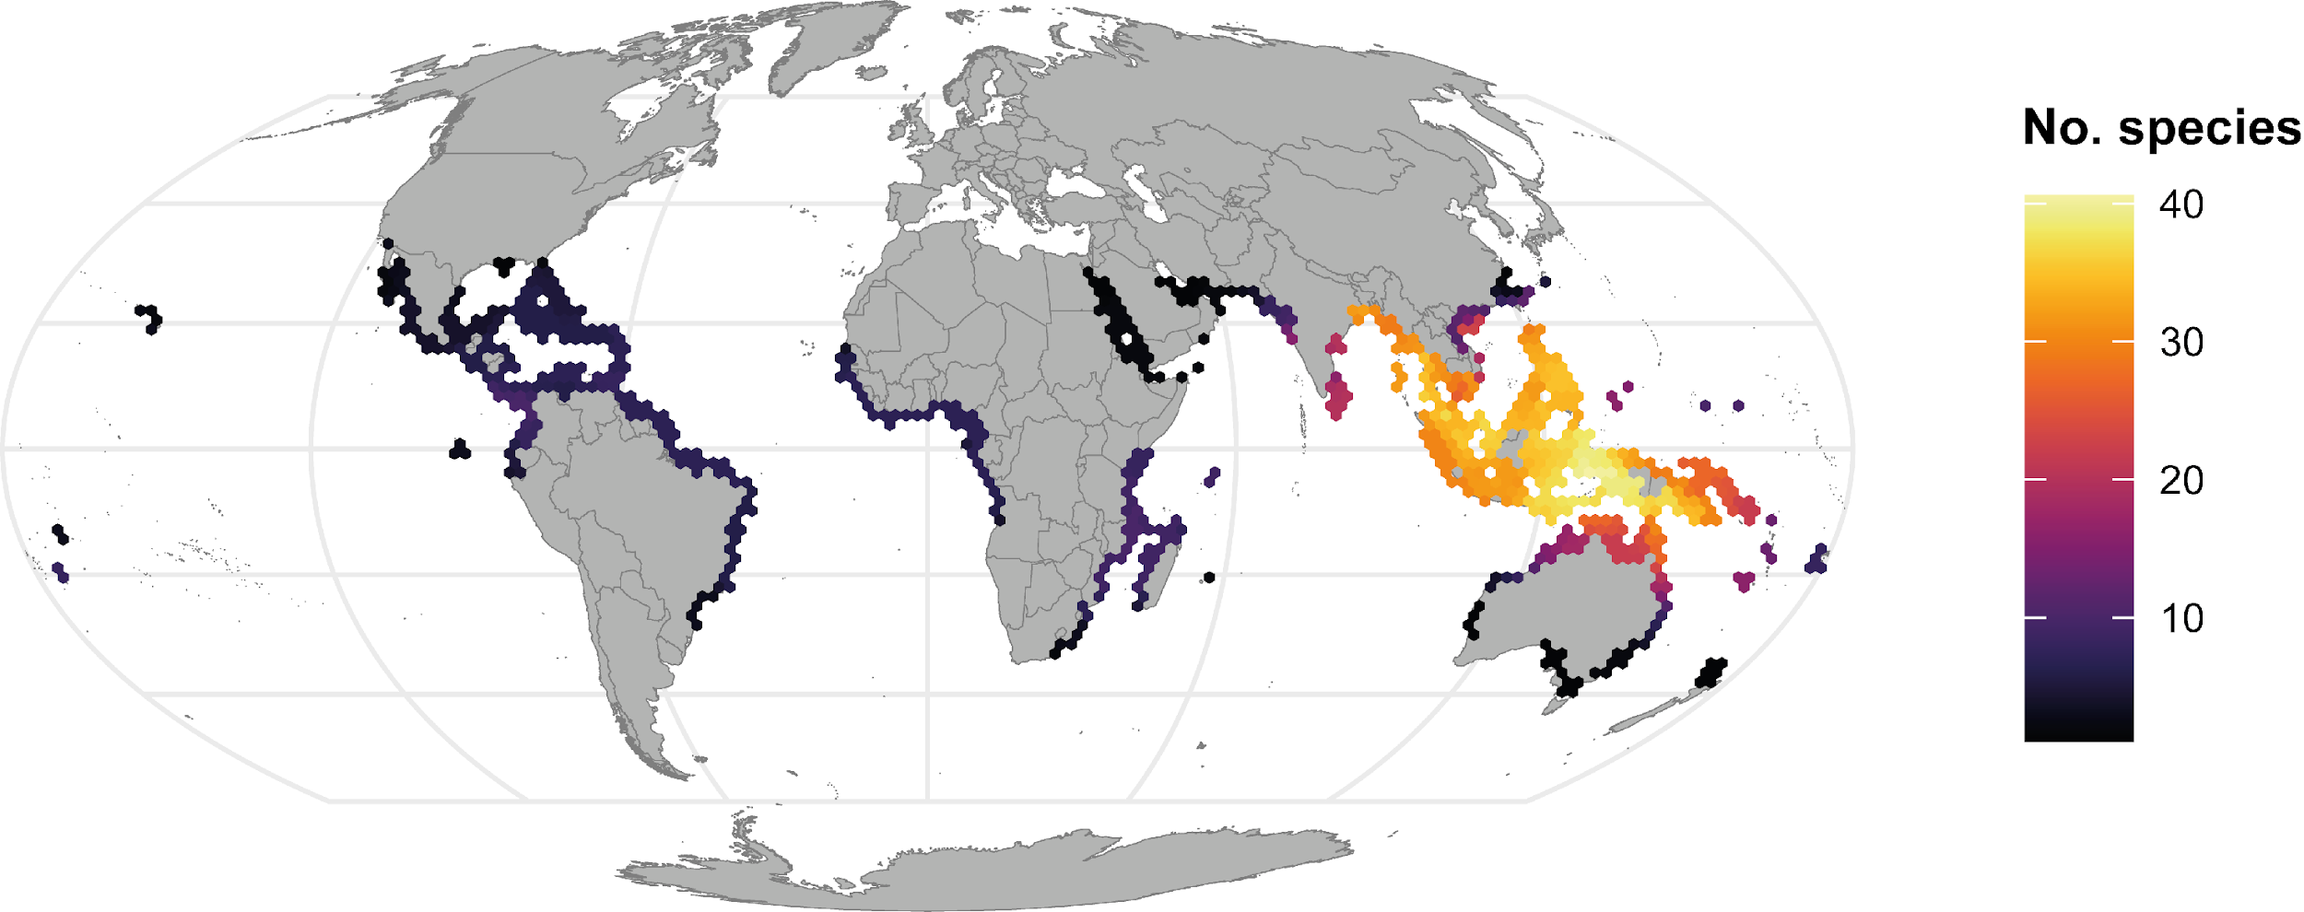

Supplementary Fig. 3 – Distribution of species richness. Global distribution of total mangrove species considered in the analysis. Data are aggregated at a 40,000 km² scale for visualisation.
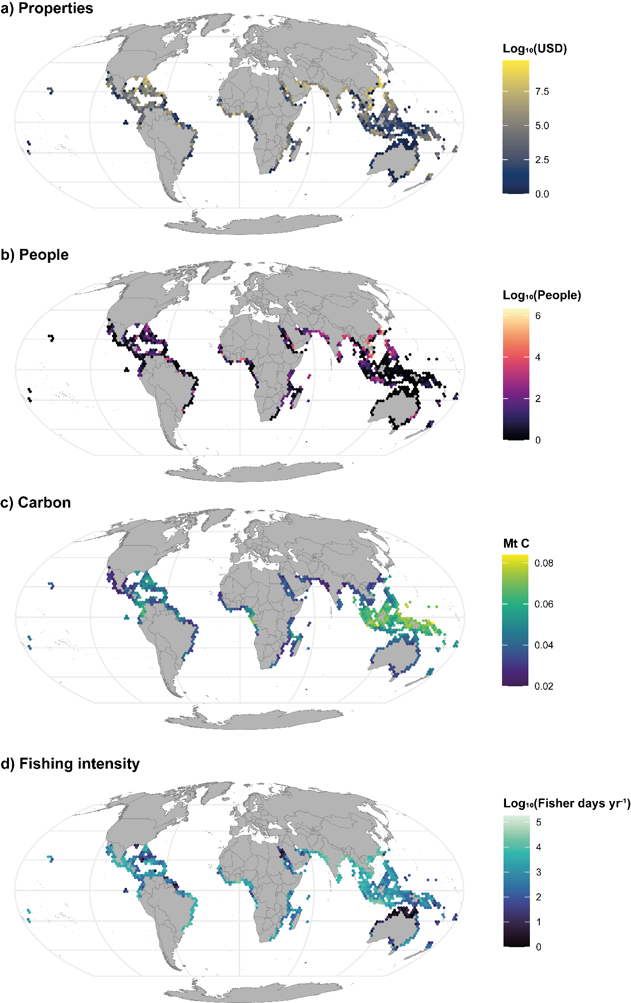
Supplementary Fig. 4 – Distribution of ecosystem services. Global distribution of: a) value of properties and b) number of people protected by mangroves; c) carbon stored by mangroves; and d) fishing intensity in mangroves. Data are aggregated at a 40,000 km² scale for visualisation.
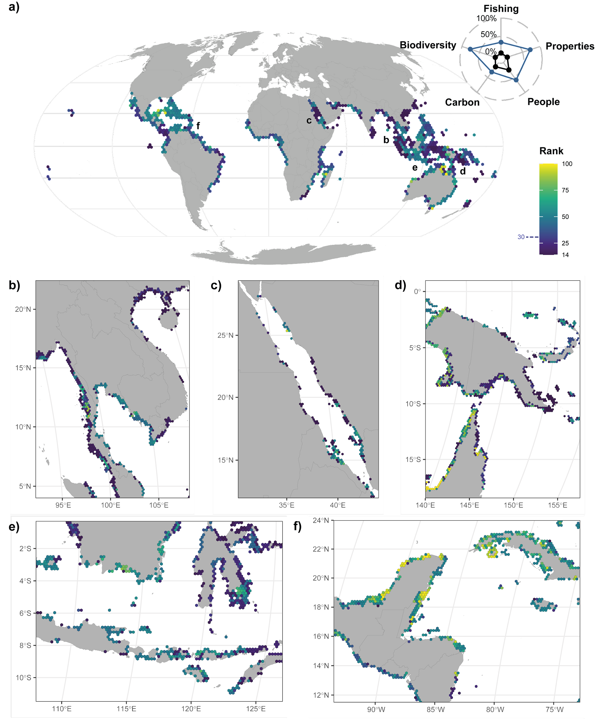
Supplementary Fig. 5 – Global mangrove priority areas for protection expanding the current protected area system. a) Priority map, with hexagonal bins aggregated at a scale of 40,000 km² for visualisation, shows the median value of the rank of the planning units in the selection (the lower the rank, the more important the planning unit is in terms of protecting biodiversity and delivering ecosystem services). Planning units currently protected are not included in the maps. The radar plot shows the percentage of ecosystem services protected and the percentage of conservation targets reached in the currently protected areas (in black), and in priority areas to expand protection to 30% of the global mangrove area (same colour scale of the map). Insets maps (planning units at the analysis scale of 400 km²) show results for: b) Southeast Asia; c) The Red Sea; d) West Papua, Papua New Guinea, Northern Australia; e) Indonesia; and f) Latin America and The Caribbean.
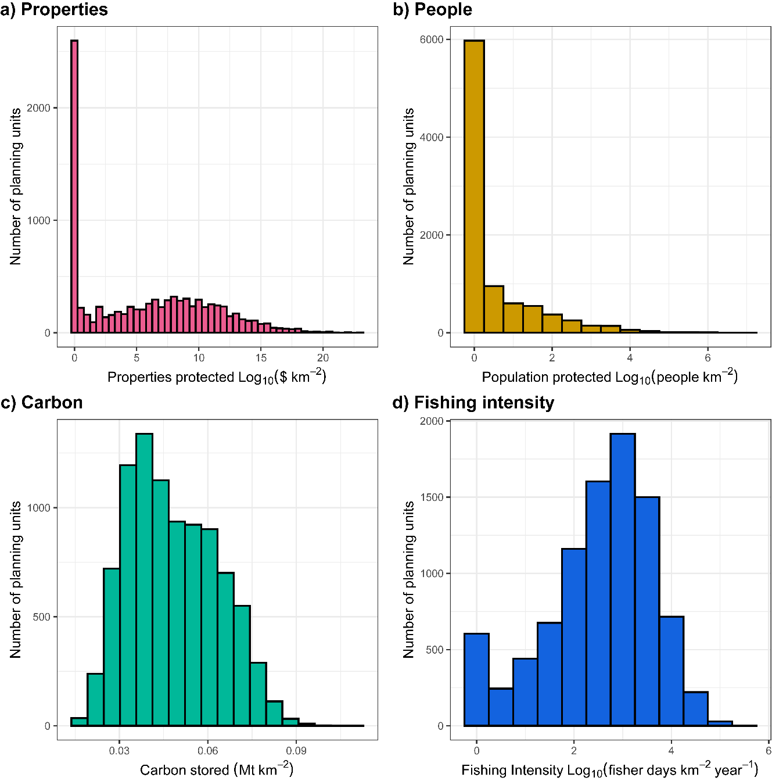
Supplementary Fig. 6 – Histograms of the ecosystem services provided by mangroves in each planning unit. Histograms for the mean value of a) properties protected, b) population protected, c) carbon stored and d) fishing intensity.

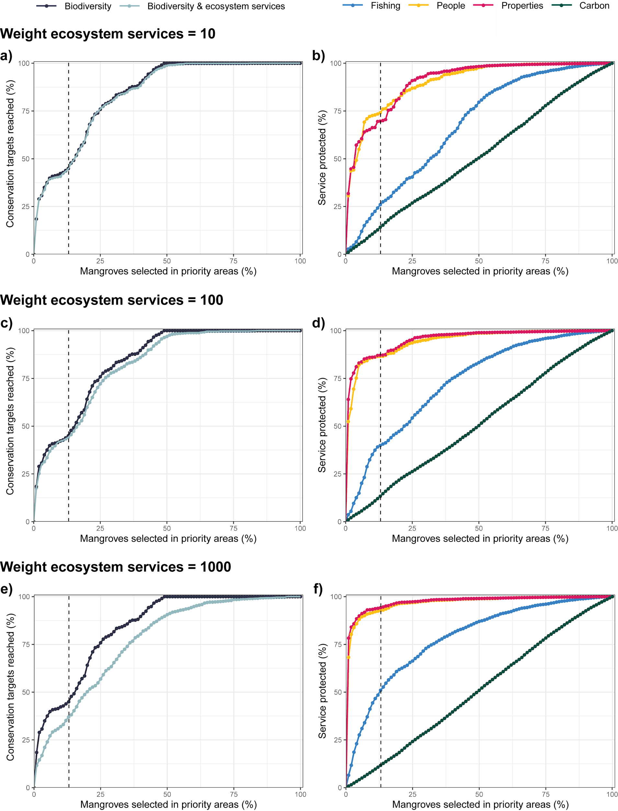
Supplementary Fig. 7 – Variation in species conservation targets reached and ecosystem services conserved when changing ecosystem services weights, in a series of prioritisation based on incremental area budgets (i.e., increasing the area of mangroves protected). a, c, e) Conservation targets reached (%) in a spatial prioritisation optimised for biodiversity alone, or on biodiversity and ecosystem services, and b, d, f) increase in the percentage of the total of each ecosystem service protected for a spatial prioritisation optimised focusing on biodiversity and ecosystem services. Prioritisations were run varying the ecosystem services weights: a, b) 10; c, d) 100 and e, f) 1,000. The percentage of mangrove area currently protected is indicated by a dashed vertical line.

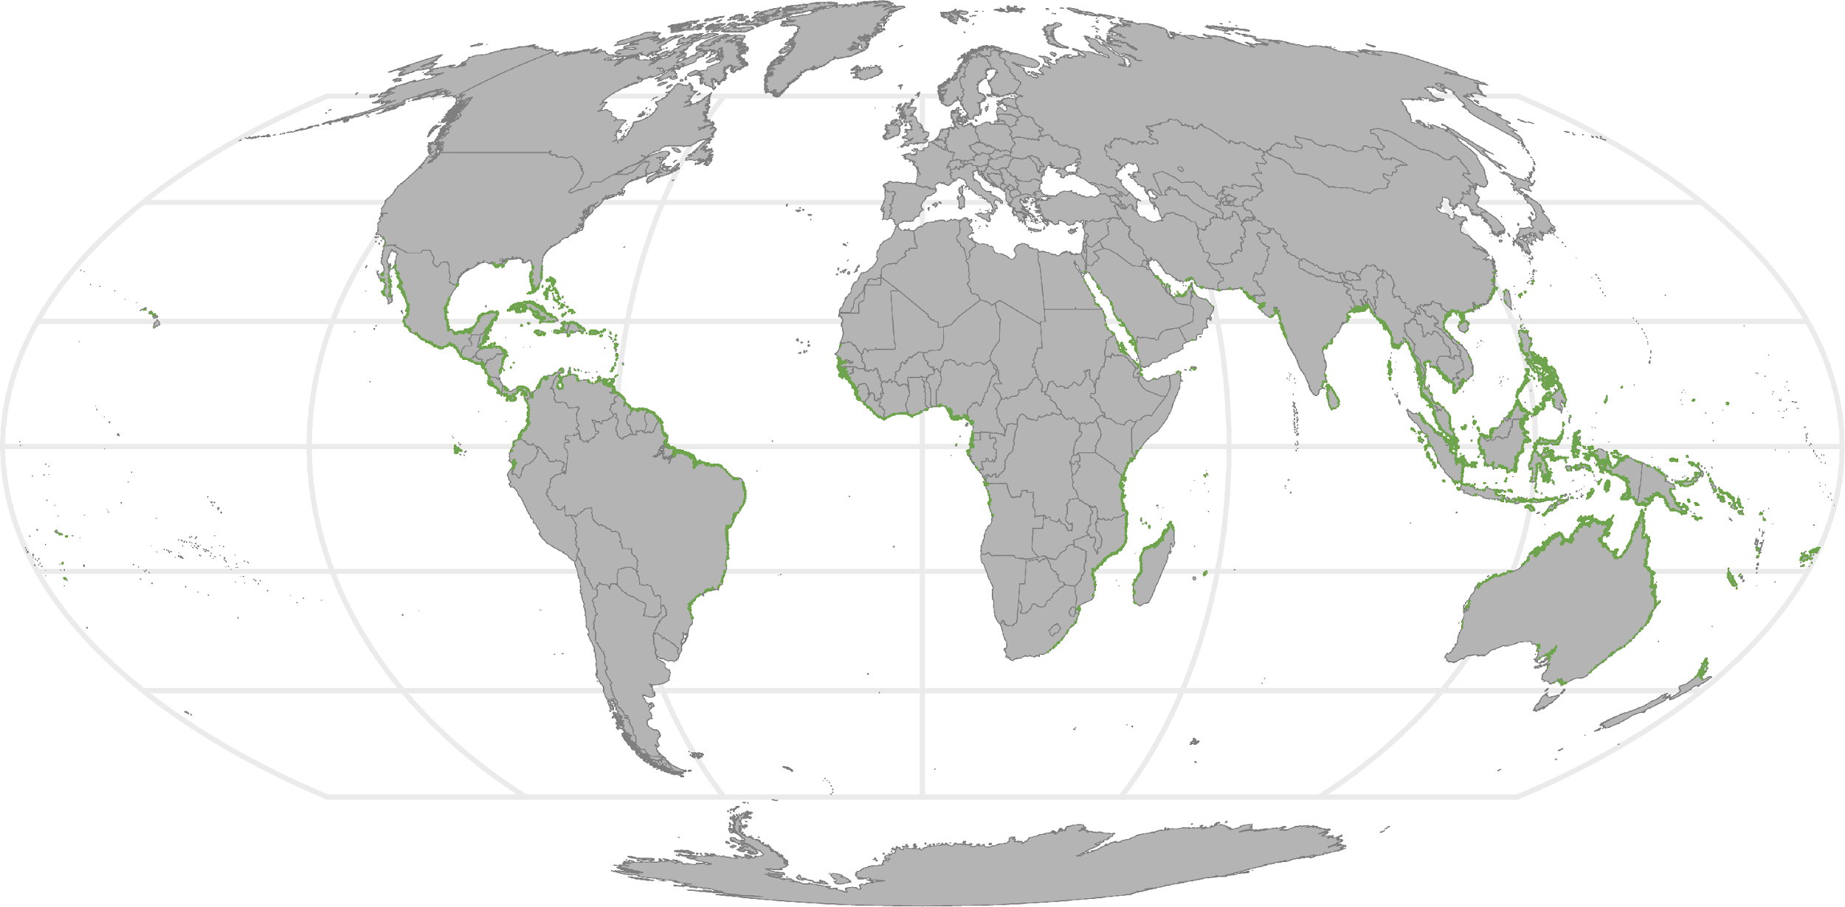
Supplementary Fig. 8 – Distribution of mangroves aggregated at 400 km² scale (green colour).

High-resolution figures of the global maps are available at: https://github.com/AlviDab/SpatialPrioritisation_MangrovesEcosystemBenefits/blob/50a0e437ea27499d3660e2997f96ff2fbf8a937f/Figures
Pending acceptance, these figures will be archived in a Zenodo digital repository.

