Title: Diaphragm function in patients with interstitial lung disease (ILD): a pilot study.

Supplementary material

Nicol Bernardinello¹, Elisabetta Cocconcelli¹, Annalisa Boscolo², Gioele Castelli¹, Nicolò Sella², Chiara Giraudo³, Elisabetta Zanatta⁴, Federico Rea⁵, Marina Saetta¹, Paolo Navalesi^{2,3}, Paolo Spagnolo¹ and Elisabetta Balestro¹*

¹Respiratory Disease Unit, Department of Cardiac, Thoracic, Vascular Sciences, and Public Health, University of Padova and Padova City Hospital, Padova, Italy.
²Institute of Anaesthesia and Intensive Care, Padua University Hospital, Italy
³ Department of Medicine (DIMED), University of Padua, Italy
⁴ Rheumatology Division, Department of Medicine (DIMED), University of Padua, Padua, Italy
⁵ Thoracic Surgery and Lung Transplant Unit, Department of Cardiac, Thoracic, Vascular Sciences, and Public Health, University of Padua, Padua, Italy

*Corresponding author: Dr. Elisabetta Balestro (MD, PhD)
Tel: +39 049 8213702; fax: +39 049 8213110;
Email: elisabetta.balestro@aopd.veneto.it

Figure S1: two examples of diaphragmatic displacement in a patient with systemic sclerosis (A) and a patient with IPF (B).
B
A

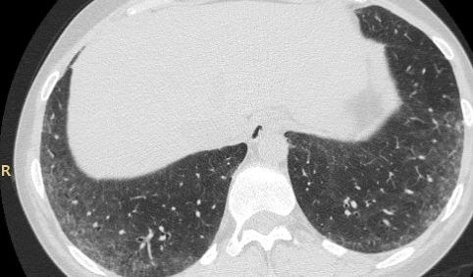 | 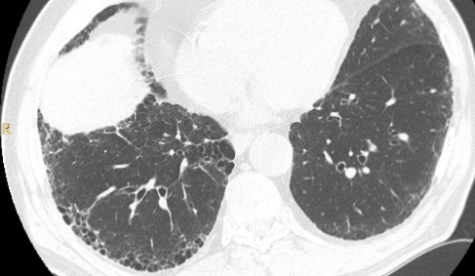
 | 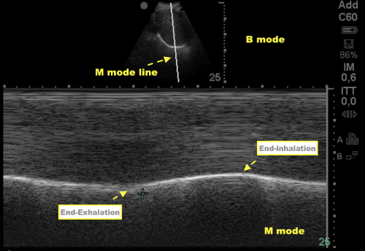
TLC: 99%  DLCO: 87%  MIP: 75 cmH2O | TLC: 74%  DLCO: 52%  MIP: 89 cmH2O
TLC: total lung capacity, DLCO: diffusion lung carbon monoxide, MIP: maximum inspiratory pressure.

Figure S2: comparison between Ti, Te and DD measurements in right and left diaphragm of 61 patients.

Ti: inspiratory thickness, Te: expiratory thickness, DD: diaphragmatic displacement.

Table S1: demographics, functional and clinical characteristics of patients with CTD-ILD and IPF divided based on radiological patterns.
 | UIP (45) | Alternative diagnosis (25) | Indeterminate (12) | p
Age (years) | 74 (39 – 83) | 61 (28 – 78) | 59 (46 – 71) | <0.0001
BMI (kg/m²) | 27 (22 – 37) | 27 (17 – 41) | 26 (20 – 35) | 0.92
Male – n° (%) | 33 (73%) | 6 (24%) | 1 (8%) | <0.0001
Former Smokers – n° (%) | 26 (58%) | 6 (24%) | 5 (42%) | 0.02
Diagnosis
- IPF – n° (%) | 40 (89%) | 0 (0%) | 1 (8%) | <0.0001
- CTD-ILD – n° (%) | 5 (11%) | 25 (100%) | 11 (92%)
DD dx (cm) | 1.8 (0.9 – 2.8) | 1.3 (0.6 – 2.1) | 1.5 (1.1 – 2.5) | 0.002
Ti dx (cm) | 0.17 (0.11 – 0.34) | 0.18 (0.08 – 0.27) | 0.16 (0.11 – 0.29) | 0.26
Te dx (cm) | 0.13 (0.07 – 0.27) | 0.11 (0.06 – 0.20) | 0.12 (0.06 – 0.21) | 0.69
Tf (%) | 44 (14 – 80) | 33 (10 – 83) | 31 (17 – 74) | 0.20
MIP (cmH₂O) | 76 (37 – 134) | 57 (18 – 99) | 55 (14 – 101) | 0.002
MEP (cmH₂O) | 86 (27 – 128) | 75 (30 – 124) | 81 (22 – 103) | 0.34
FVC (L) | 2.6 (1.2 – 4.1) | 2.5 (1.1– 4.7) | 2.2 (1.1 – 3.8) | 0.19
FVC (%) | 84 (47 – 152) | 89 (49 – 142) | 87 (43 – 140) | 0.72
FEV1 (L) | 2.2 (1.2 – 3.7) | 2.2 (0.5 – 3.7) | 1.9 (0.9 – 3.1) | 0.19
FEV1 (%) | 90 (56 – 169) | 90 (26 – 152) | 84 (50 – 140) | 0.55
TLC (L) | 3.9 (1.8 – 5.9) | 3.9 (2.2 – 7.5) | 3.2 (1.9 – 5.1) | 0.12
TLC (%) | 63 (38 – 112) | 78 (51 – 111) | 67 (42 – 99) | 0.03
DLCO (%) | 54 (23 – 100) | 75 (34 – 115) | 57 (27 – 81) | 0.003
mMRC ≥ 2 – n° (%) | 19 (42%) | 11 (44%) | 6 (50%) | 0.73
Oxygen on effort – n° (%) | 11 (24%) | 1 (4%) | 0 (0%) | 0.02
CTD-ILD: connective tissue disease-associated interstitial lung disease, IPF: idiopathic pulmonary fibrosis, BMI: body mass index, mMRC: Modified British Medical Research Council Questionnaire, TF: thickening fraction, Ti: inspiratory thickening, Te: expiratory thickening, DD: diaphragmatic displacement, FVC: forced vital capacity, DLCO: diffusion lung carbon monoxide, TLC: total lung capacity, FEV1: forced expiratory volume in 1 second, MEP: maximum expiratory pressure, MIP: maximum inspiratory pressure.

Table S2: different diagnosis in CTD-ILD group (n=41).
Type of diagnosis | n° - (%)
Polymyositis/dermatomyositis | 12 (29%)
SSc | 10 (24%)
Mixed connective tissue disease | 6 (14%)
Antisynthetase syndrome | 5 (12%)
AR | 5 (12%)
IPAF | 1 (3%)
Sjogren’s syndrome | 1 (3%)
LES | 1 (3%)
SSc: systemic sclerosis, AR: rheumatoid arthritis, IPAF: interstitial pneumoniae with autoimmune features, LES: systemic lupus erythematosus.

Table S3: Inter-observer reliability of ultrasonographic measurements of diaphragm function.
 | Median | Range | ICC
Ti (cm) | 0.21 | 0.09 – 0.35 | 0.97
Te (cm) | 0.15 | 0.07 – 0.27 | 0.96
DD (cm) | 1.88 | 0.69 – 2.8 | 0.79
Ti: inspiratory thickening, Te: expiratory thickening, DD: diaphragmatic displacement, ICC: Intra-class correlation coefficient.

