All data generated or analysed during this study are included in this published article [and its supplementary information files.
Supplementary Fig S1-S17 is the data generated by tooth displacement after 3d finite element modeling, as the color changes from blue to red, the tooth displacement increases. The data in the figure show the displacement changes of different parts of teeth under the action of the self-made four-curvature.

Supplementary Fig S1: 1a group displacement data

Supplementary Fig S2: 1b group displacement data

Supplementary Fig S3: 1c group displacement data

Supplementary Fig S4: 1d group displacement data

Supplementary Fig S5: 1d group displacement data

2 group
Supplementary Fig S6: 2a group displacement data

Supplementary Fig S7: 2b group displacement data

Supplementary Fig S8: 2c group displacement data

Supplementary Fig S9: 2d group displacement data

3 group:
Supplementary Fig S10: 3a group displacement data

Supplementary Fig S11: 3b group displacement data

Supplementary Fig S12: 3c group displacement data

Supplementary Fig S13: 3d group displacement data

4 group: Incisor displacement
Supplementary Fig S14: 4a group displacement data

Supplementary Fig S15: 4b group displacement data

Supplementary Fig S16: 4c group displacement data

Supplementary Fig S17: 4d group displacement data

Supplementary Fig S18-S33 is the data generated by tooth displacement after 3d finite element modeling, as the color changes from blue to red, the tooth periodontal stress increases. The data in the figure show the periodontal stress changes of different parts of teeth under the action of the self-made four-curvature. Finally, whether the periodontal membrane stress exceeds the maximum stress is compared with the data 2.6 × 10-2MPa.
Supplementary Fig S18: 1a group periodontal stress data

Supplementary Fig S19: 1b group periodontal stress data

Supplementary Fig S20: 1c group periodontal stress data

Supplementary Fig S21: 1d group periodontal stress data

2 group: periodontal stress
Supplementary Fig S22: 2a group periodontal stress data

Supplementary Fig S23: 2b group periodontal stress data

Supplementary Fig S24: 2c group periodontal stress data
Supplementary Fig S25: 2d group periodontal stress data

3 group: periodontal stress
Supplementary Fig S26: 3a group periodontal stress data

Supplementary Fig S27: 3b group periodontal stress data

Supplementary Fig S28: 3c group periodontal stress data

Supplementary Fig S29: 3d group periodontal stress data

4 group: periodontal stress
Supplementary Fig S30: 4a group periodontal stress data

Supplementary Fig S31: 4b group periodontal stress data

Supplementary Fig S32: 4c group periodontal stress data

Supplementary Fig S33: 4d group periodontal stress data

Application of clinical cases

Supplementary Fig S34: Intraoral photos and radiographs
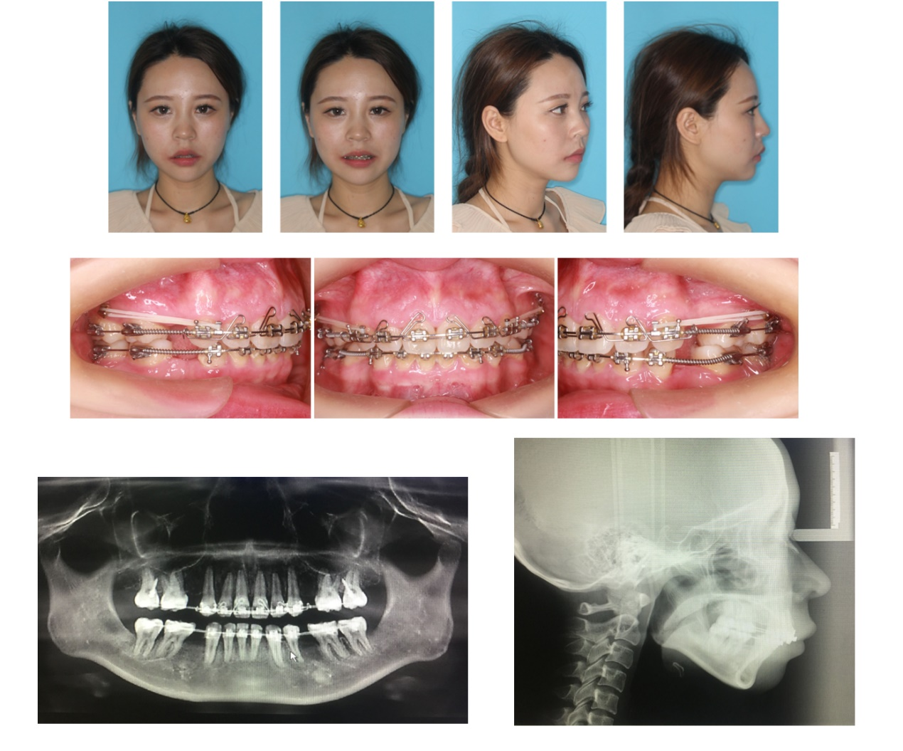

Supplementary Fig S35: self-made four-curvature Intraoral photos and radiographs

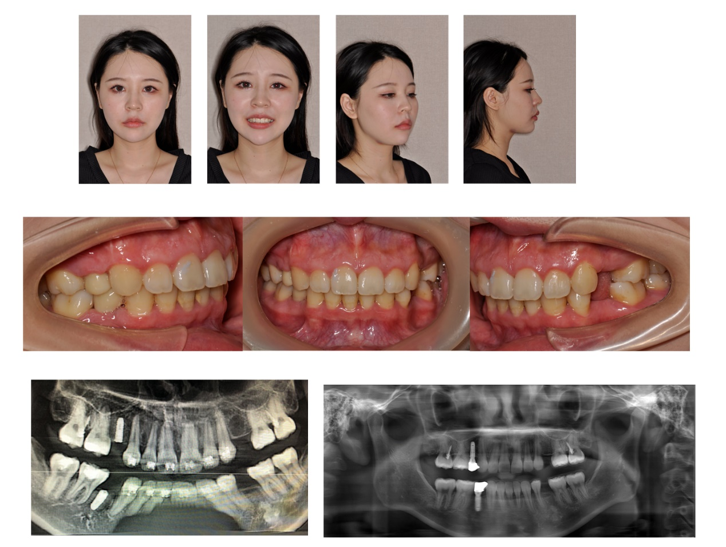
Supplementary Fig S36: end of the treatment Intraoral photos and radiographs

Supplementary Fig S37: Comparison of panoramic X-ray radiographs before, during and after treatment

