Supplementary Materials for MTL4MHC2: MHC class II binding prediction using multi-task learning from small training data.

Kazuhiro Ikkyu^{1,2}, Itoshi Nikaido*^{1,2, 3}

^{s1}Degree Programs in Systems and Information Engineering, Graduate School of Science and Technology, Doctoral Program in Life Science Innovation (Bioinformatics), University of Tsukuba, 1-1-1 Tennodai, Tsukuba, Ibaraki, 305-8577 Japan,
² Laboratory for Bioinformatics Research, RIKEN Center for Biosystems Dynamics Research, 2-1 Hirosawa Wako, Saitama, 351-0198, Japan,
³ Department of Functional Genome Informatics, Division of Medical Genomics, Medical Research Institute, Tokyo Medical and Dental University (TMDU), Bunkyo, 113-8510, Japan
*To whom correspondence should be addressed

Table of Contents
Method
Figure S1. The training history of Bi-LSTM model 6 in the parameter turning step.
Figure S2. The training history of Bi-LSTM model 11 in the parameter turning step.
Figure S3. The training history of multi-head Bi-LSTM model 5 in the parameter turning step.
Figure S4. The training history of multi-head Bi-LSTM model 16 in the parameter turning step.
Figure S5. The training history of multi-task Bi-LSTM model 1 in the parameter turning step.
Figure S6. The training history of multi-task Bi-LSTM Model 3 in the parameter turning step.
Figure S7. The training history of multi-task Bi-LSTM Model 5 in the parameter turning step.
Figure S8. The training history of Bi-LSTM model 6 in evaluation model training.
Figure S10. The training history of multi-head Bi-LSTM model 5 in evaluation model training.
Figure S11. The training history of multi-head Bi-LSTM model 16 in evaluation model training.
Figure S12. The training history of multi-task Bi-LSTM model 1 in evaluation model training.
Figure S13. The training history of multi-task Bi-LSTM Model 3 in evaluation model training.
Figure S14. The training history of multi-task Bi-LSTM Model 5 in evaluation model training.
Table S1. 5-fold cross validation results of parameter turning using grid search (average ± standard deviation).
Table S2. The accuracy score obtained using the evaluation dataset for each HLA class II subtype.
Table S3. The recall score obtained using the evaluation dataset for each HLA class II subtype.
Table S4. The precision score obtained using the evaluation dataset for each HLA class II subtype.
Table S5. The AUC-ROC score obtained using the evaluation dataset for each HLA class II subtype.
Table S6. The F1-score obtained using the evaluation dataset for each HLA class II subtype.

Method
Bi-LSTM (MHCAttnNet model and tuned Bi-LSTM model)
We attempted to replicate the work on MHCAttnNet by using their source code. However, we could not reproduce MHCAttnNet. Additionally, the model data of MHCAttnNet are not publicly available. Therefore, we reimplemented the same Bi-LSTM model, which is based on MHCAttnNet, from scratch.
The Bi-LSTM model, which is used in various existing neoepitope prediction models, was created from the MHC class II and cancer antigen peptide datasets (Fig. 3A). This model was designed based on the MHCAttnNet model [5]. The LSTM model architecture is the same as that of MTL4MHC2.

Multi-head attention
Multi-head attention was defined as the following function (Q, K, V are input data and
W0 is the weight used to revert the feature vector back to the original dimension.).
$$Multi\text{-}head(Q, K, V) = concat({LT}_{i})W_{0}$$
The multi-head is converted to different values of the same shape for each layer by the following regularization (I is the input, F is the regularization factor, and W is the weight of each layer).
$$LT = \left\|WWT-I\right\|F_{2}$$
In this research, Bi-LSTM recurrent kernels were converted by regularization.

Model evaluation
Candidate models were evaluated using five split test datasets and another IEDB dataset, which was sorted by HLA species. The evaluation metrics were the accuracy, recall, precision, AUC-ROC, and F1-score.

Evaluation function
Each prediction model was evaluated using the following metrics, in which TP, TN, FP, and FN indicate true positives, true negatives, false positives, and false negatives, respectively. The area under the receiver operating characteristic curve (AUC-ROC) is the area under the curve plotted when the TP rate is plotted against FP rate. The AUC-ROC was calculated using the roc_auc_score function in Scikit-learn.
$$Accuracy \text{= }\frac{TP+TN}{TP+FP+FN+TN}$$
$$Recall= \frac{TP}{TP+FN}$$
$$Precision= \frac{TP}{TP+FP}$$
$$F1\text{-}score= \frac{2 ×Precision ×Recall}{Precision+Recall}$$

Calculation environment
Our deep learning models were implemented using GPGPU (NVIDIA TITAN X).
The execution script, Dockerfile, and our experimental data are available in our Git-hub repository (https://github.com/rikenbit/MTL4MHC2).

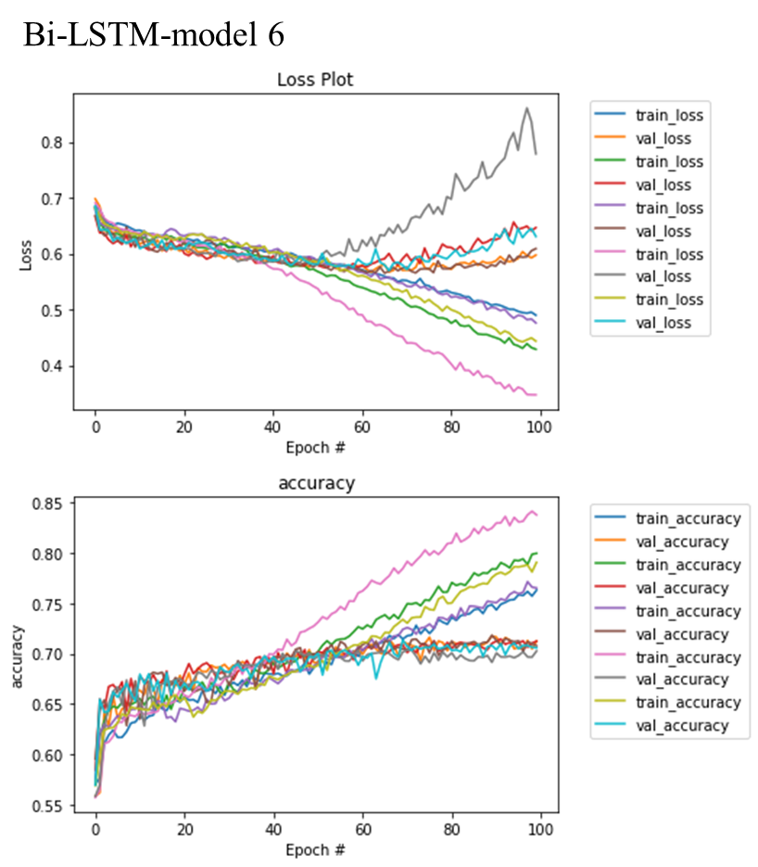
Figure S1. The training history of Bi-LSTM model 6 in the parameter turning step.

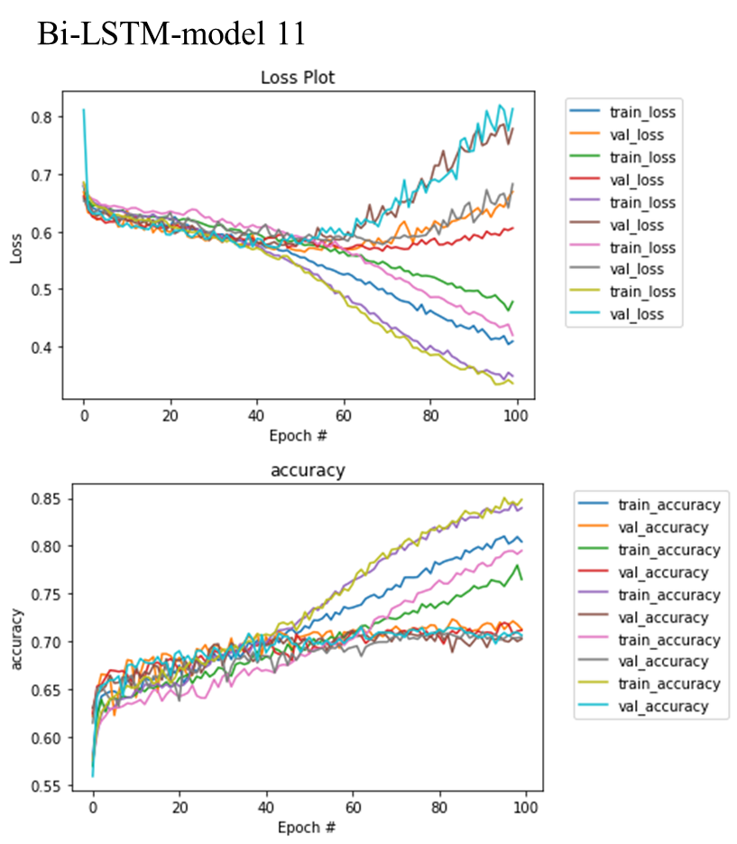
Figure S2. The training history of Bi-LSTM model 11 in the parameter turning step.

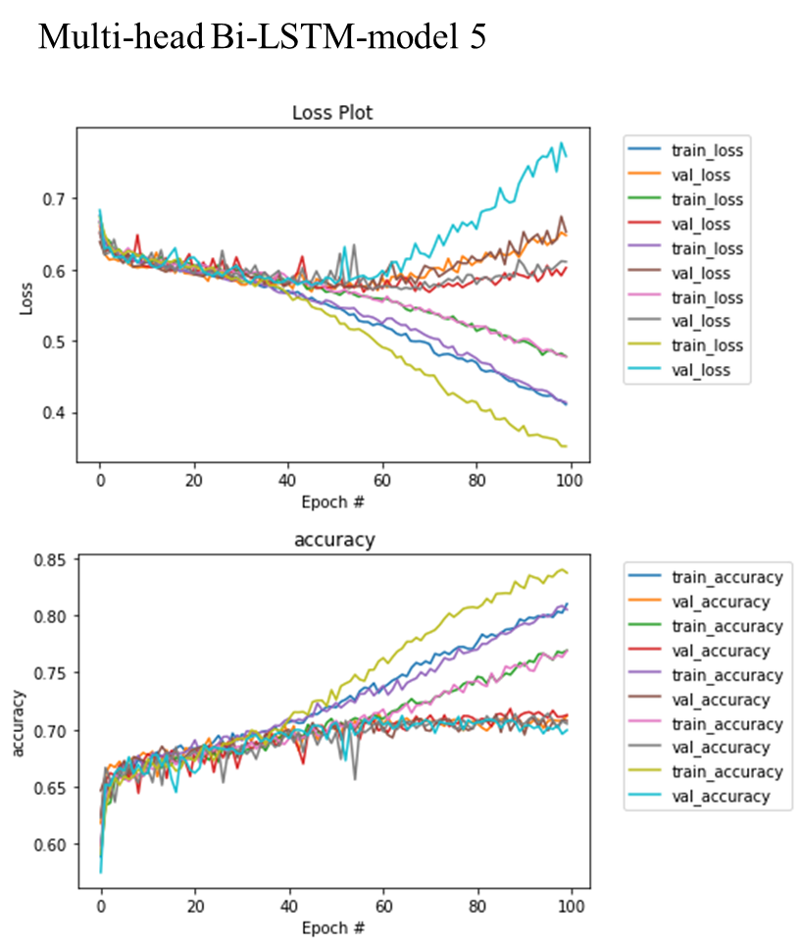
Figure S3. The training history of multi-head Bi-LSTM model 5 in the parameter turning step.

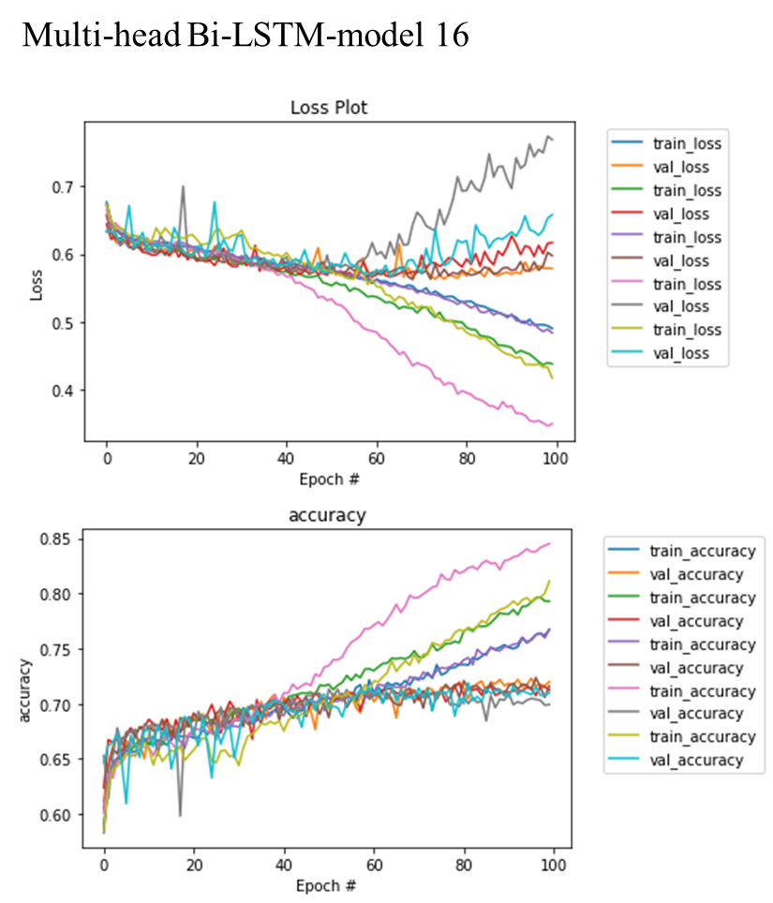
Figure S4. The training history of multi-head Bi-LSTM model 16 in the parameter turning step.

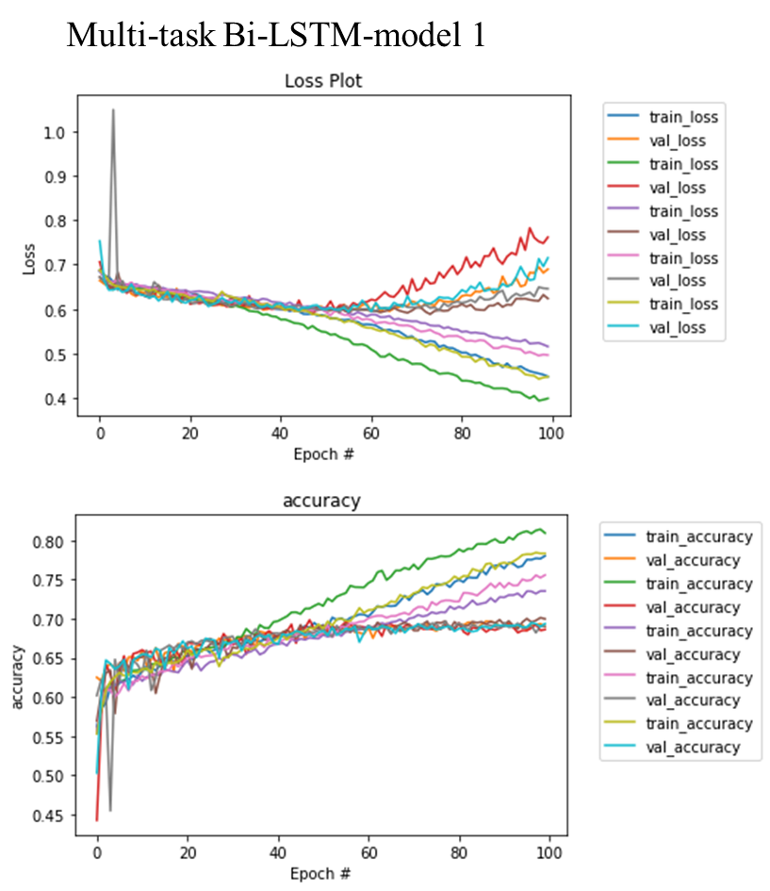
Figure S5. The training history of multi-task Bi-LSTM model 1 in the parameter turning step.
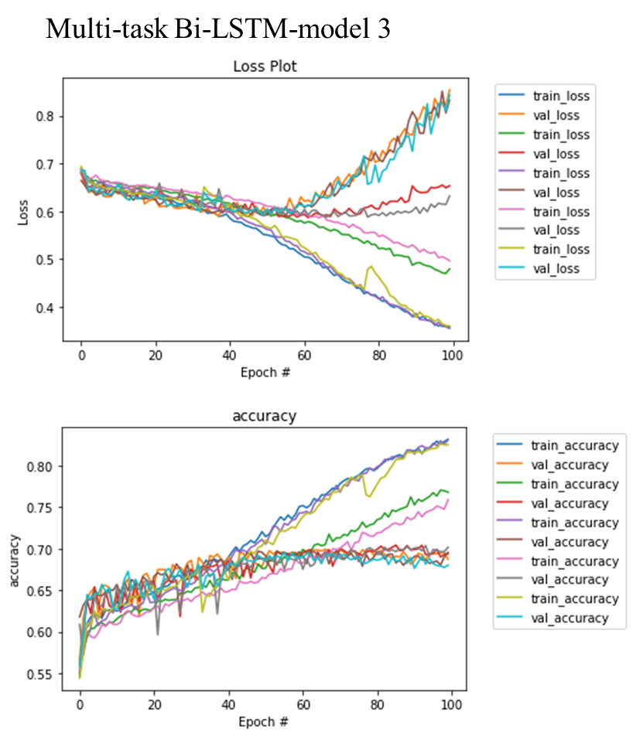
Figure S6. The training history of multi-task Bi-LSTM Model 3 in the parameter turning step.
Figure S7. The training history of multi-task Bi-LSTM Model 5 in the parameter turning step.

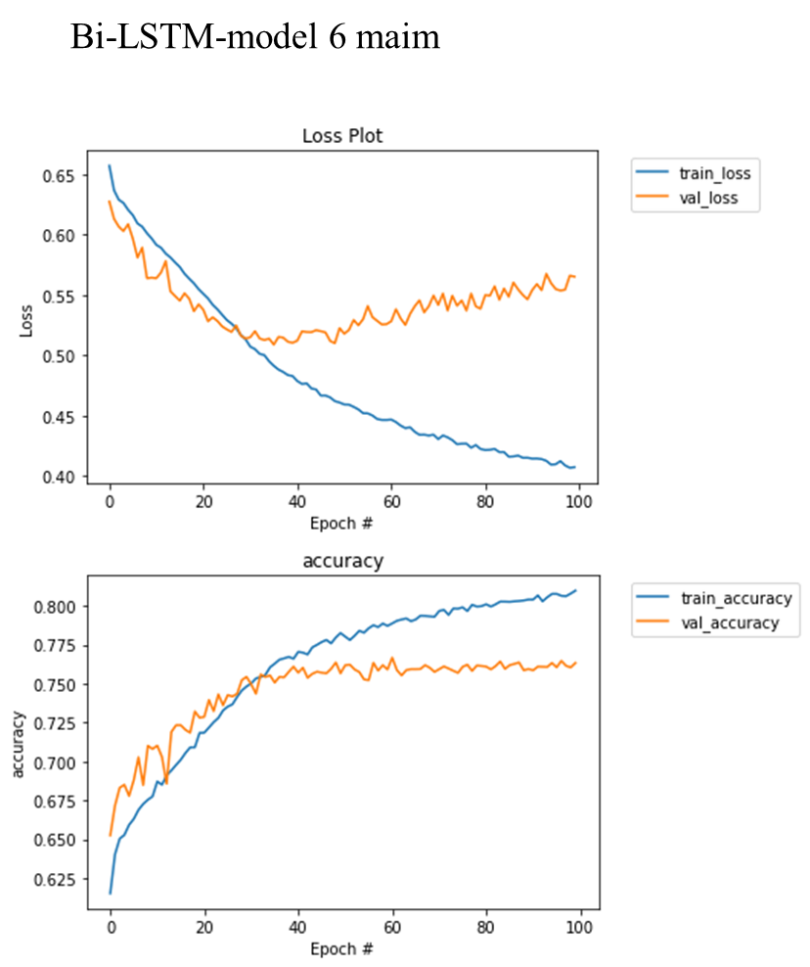
Figure S8. The training history of Bi-LSTM model 6 in evaluation model training.

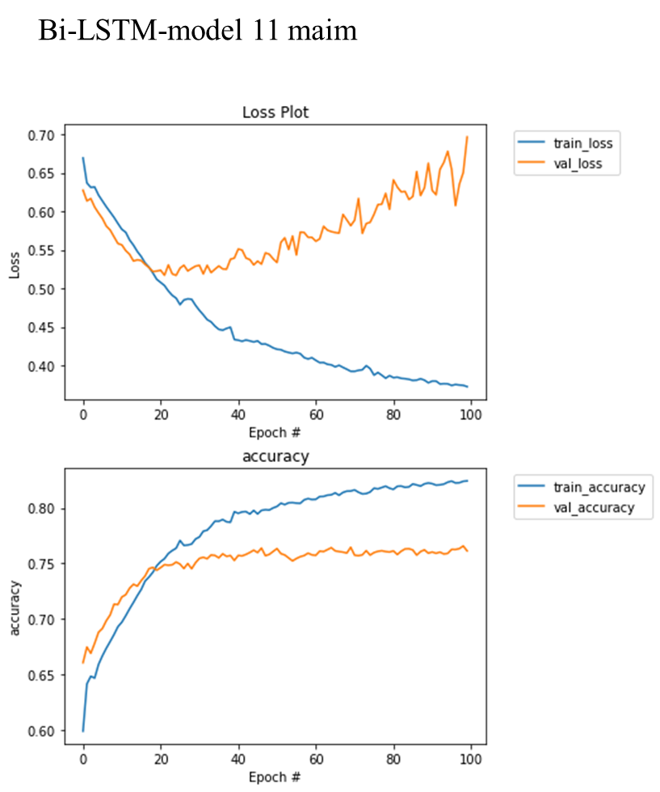
Figure S9. The training history of Bi-LSTM model 11 in evaluation model training.

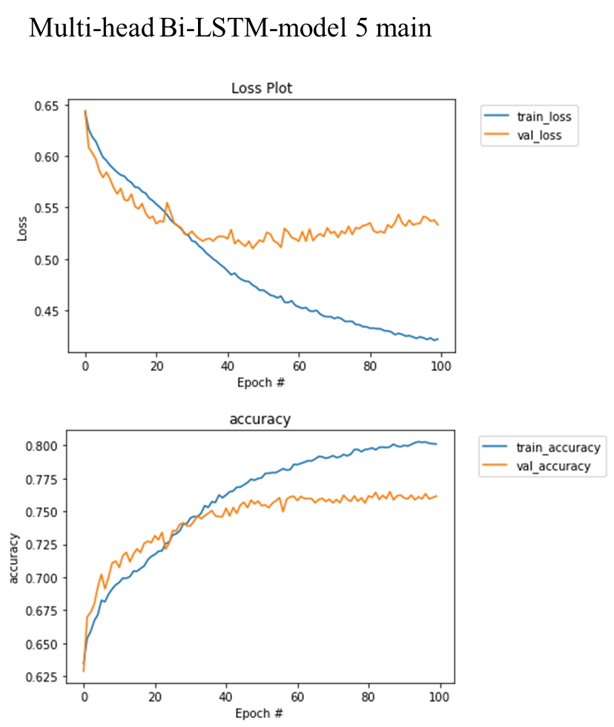
Figure S10. The training history of multihead Bi-LSTM model 5 in evaluation model training.
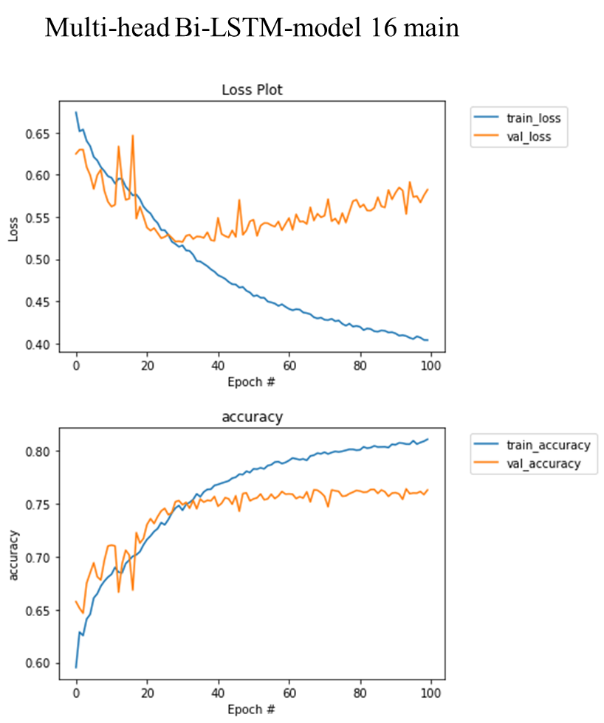
Figure S11. The training history of multi-head Bi-LSTM model 16 in evaluation model training.

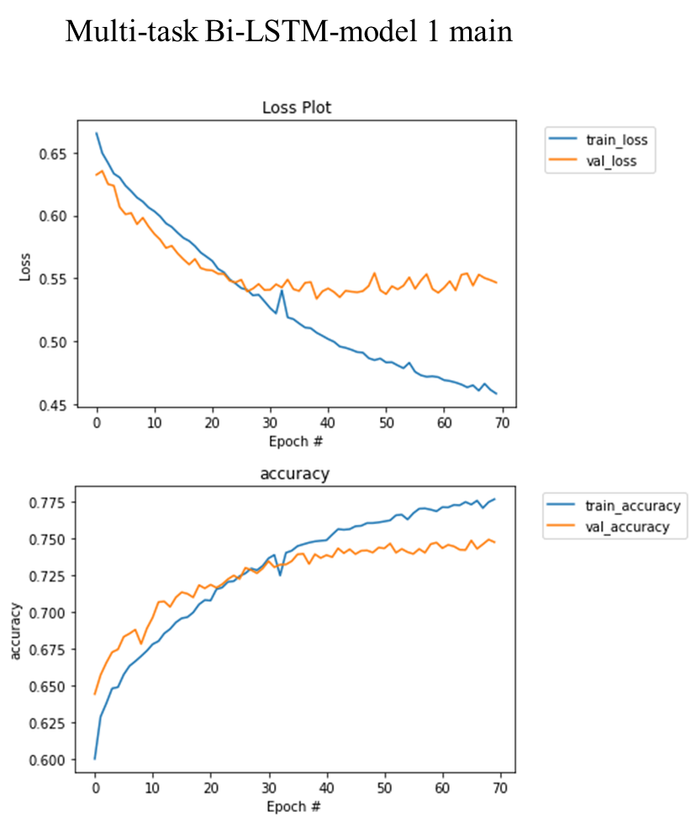
Figure S12. The training history of multi-task Bi-LSTM model 1 in evaluation model training.

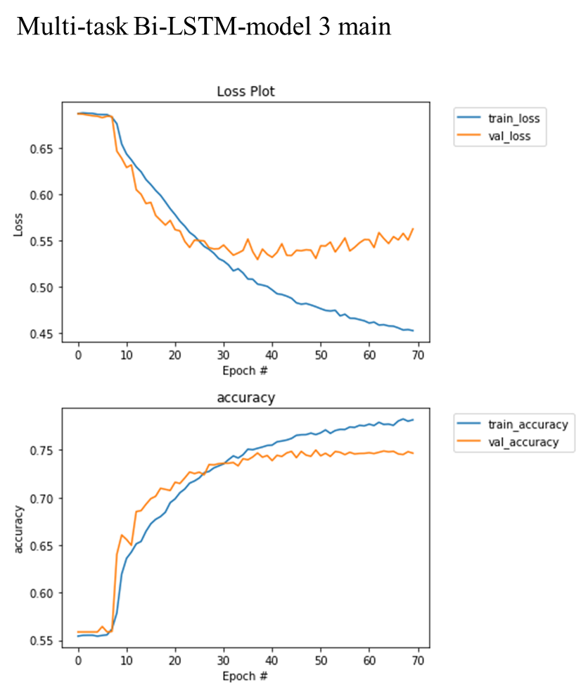
Figure S13. The training history of multi-task Bi-LSTM Model 3 in evaluation model training.

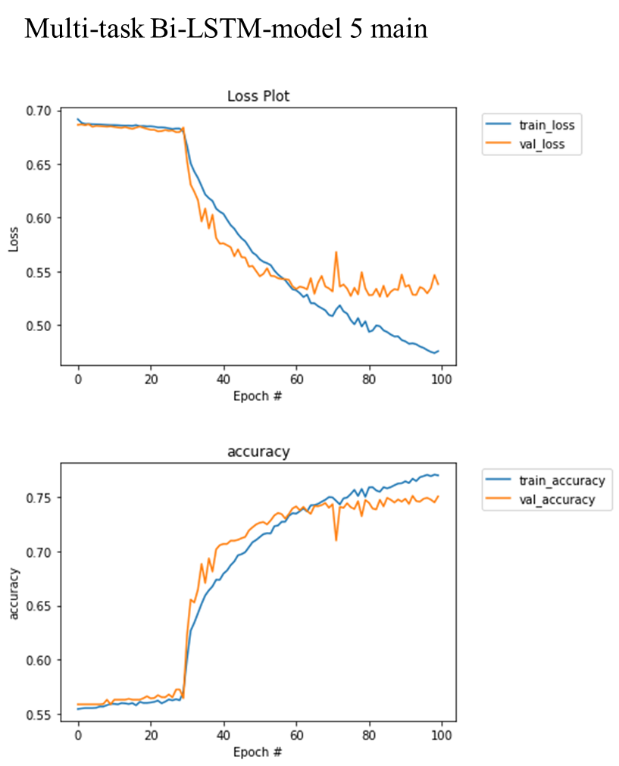
Figure S14. The training history of multi-task Bi-LSTM Model 5 in evaluation model training.

Table S1. 5-fold cross validation results of parameter turning using grid search (average ± standard deviation).

Table S2. The accuracy score obtained using the evaluation dataset for each HLA class II subtype.

Table S3. The recall score obtained using the evaluation dataset for each HLA class II subtype.

Table S4. The precision score obtained using the evaluation dataset for each HLA class II subtype.

Table S5. The AUC-ROC score obtained using the evaluation dataset for each HLA class II subtype.

Table S6. The F1-score obtained using the evaluation dataset for each HLA class II subtype.

