Figure S1 The abundance and diversity of microbial communities of different groups was estimated by alpha diversity analysis including richness (observed OTUs), Shannon, Invited Simpson, and Chao1

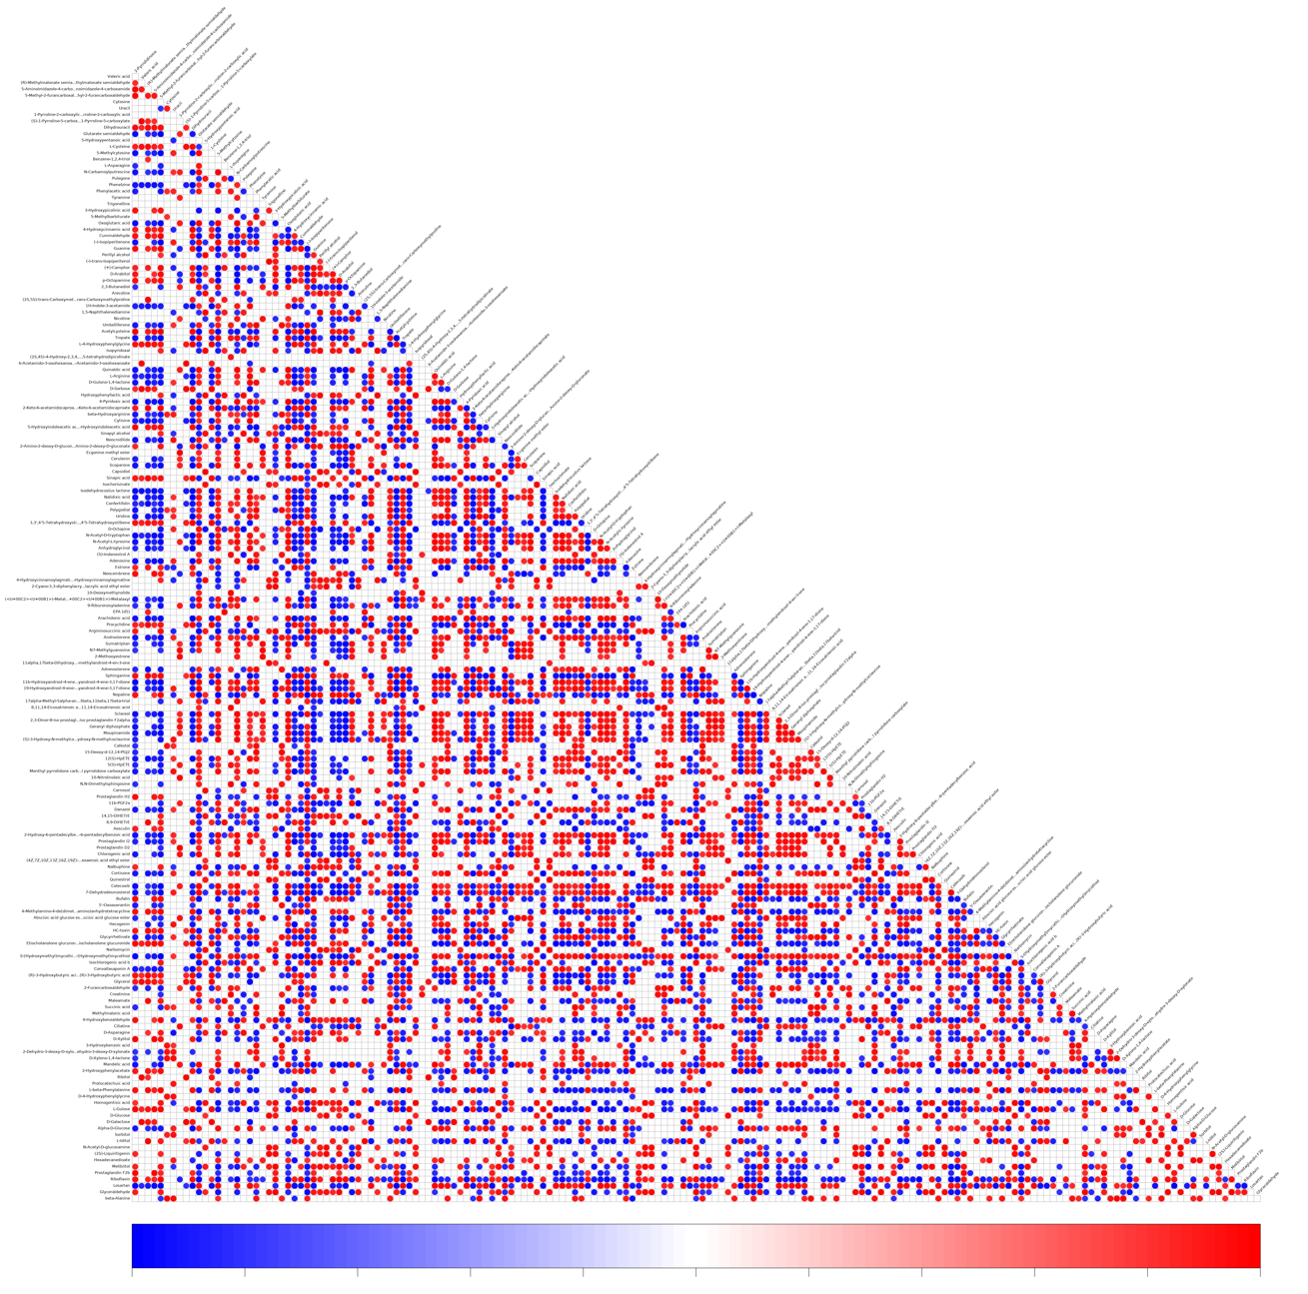
Figure S2 Correlation analysis of differential metabolites

