Supporting Information
Chemometrics integrated with in silico pharmacology to reveal antioxidative and anti-inflammatory markers of dandelion for its quality control

Feng-Jie Liu^{1*}, Jiao Yang¹, Xu-Yan Chen, Ting Yu, Hui Ni, Liang Feng, Ping Li, Hui-Jun Li*

State Key Laboratory of Natural Medicines, China Pharmaceutical University, No. 24 Tongjia Lane, Nanjing 210009, China

* Corresponding authors:
E-mail addresses: liufj_cpu@126.com (Feng-Jie Liu); cpuli@163.com (Huijun Li).
¹ The authors contributed equally to this work.

Contents
Table S1 The identification of phenolic components in TH.
Table S2 Antioxidant capacity of candidate markers
Table S3 The in silico pharmacokinetic parameters of candidate markers.
Table S4 Methodology investigation for the quantitation of four markers.
Fig. S1 Representative UV absorbance profile (a), and base peak chromatogram (b).
Fig. S2 PLSR models. The summary of fit (a-c) and permutation tests (d-f) for antioxidative activity by DPPH and FRAP, and anti-inflammatory activity, respectively.
Fig. S3 The toxicity of luteolin (a), apigenin (b), kaempferol (c) and luteolin-7-O-β-d-glucoside (d) on RAW264.7 cells.
Fig. S4 Chromatograms of Taraxacum extracts with different extraction solvents. 1 caffeic acid, 2 cichoric acid, 3 p-coumaric acid, 4 luteolin, 5 kaemferol, 6 apigenin, 7 eupalitin.

Table S1 The identification of phenolic components in TH.
No. | Rt/min | m/z | Ion type | Formula | MS/MS fragments | Identification
1 | 10.945 | 311.0324 | [M-H]⁻ | C₁₃H₁₂O₉ | 179.0320/149.0069/135.0426/133.0221 | caftaric acid
2 | 13.089 | 137.0220 | [M-H]⁻ | C₇H₆O₃ | 119.0122/108.0208/92.0255 | p-hydroxybenzoic acid
3 | 16.306 | 353.0817 | [M-H]⁻ | C₁₆H₁₈O₉ | 191.0534/179.0331 | 5-O-caffeoylquinic acid
4 | 16.34 | 353.0533 | [M-H]⁻ | C₁₆H₁₈O₉ | 191.0526/173.0424/85.0285 | chlorogenic acid
5 | 19.523 | 179.0318 | [M-H]⁻ | C₉H₈O₄ | 135.0429/89.0397 | caffeic acid
6 | 22.231 | 595.1248 | [M-H]⁻ | C₂₆H₂₈O₁₆ | 463.0833/301.0301 | quercetin O-(pentosyl)-glucoside
7 | 25.153 | 473.0703 | [M-H]⁻ | C₂₂H₁₈O₁₂ | 311.0371/149.0070/219.0256/293.0270/179.0320 | cichoric acid
8 | 25.957 | 163.0376 | [M-H]⁻ | C₉H₈O₃ | 119.05 | p-coumaric acid
9 | 29.04 | 609.1395 | [M-H]⁻ | C₂₇H₃₀O₁₆ | 285.0374/327.0466 | luteolin-7-O-β-d-gentiobioside
10 | 29.358 | 611.1574 | [M+H]⁺ | C₂₇H₃₀O₁₆ | 497.0992/449.1050/365.1020/287.0537 | luteolin-6, 8-di-C-glucosides
11 | 31.453 | 515.1125 | [M-H]⁻ | C₂₅H₂₄O₁₂ | 353.0836/191.0530/161.0865 | isochlorogenic acid A
12 | 32.66 | 447.0865 | [M-H]⁻ | C₂₁H₂₀O₁₁ | 285.0358 | luteolin-7-O-β- d -glucoside
13 | 33.648 | 463.0848 | [M-H]⁻ | C₂₁H₂₀O₁₂ | 301.0297/273.0413/178.9958/151.0014 | quercetin-3-O-glucoside
14 | 36.011 | 515.1178 | [M-H]⁻ | C₂₅H₂₄O₁₂ | 353.0820/191.0613 | isochlorogenic acid C
15 | 38.44 | 639.3069 | [M-H]⁻ | C₂₈H₃₂O₁₇ | 519.2529/477.2481/373.2224/145.0272/119.0503 | isorhamnetin-3,7-di-O-β-d-glucoside
16 | 38.741 | 477.1060 | [M-H]⁻ | C₂₂H₂₂O₁₂ | 314.04 | isorhamnetin-3-O-β-d-glucoside
17 | 40.568 | 301.0308 | [M-H]⁻ | C₁₅H₁₀O₇ | 178.9958/151.0014/121.0280 | quercetin
18 | 41.389 | 285.0364 | [M-H]⁻ | C₁₅H₁₀O₆ | 151.0012/133.0278 | luteolin
19 | 42.086 | 285.0411 | [M-H]⁻ | C₁₅H₁₀O₆ | 151.0000/133.0270/65.0038 | kaempferol
20 | 42.445 | 269.0408 | [M-H]⁻ | C₁₅H₁₀O₅ | 225.0492/117.0324/151.0008/65.0032 | apigenin
21 | 42.638 | 329.0632 | [M-H]⁻ | C₁₇H₁₄O₇ | 314.04 | eupalitin
22 | 42.723 | 299.0530 | [M-H]⁻ | C₁₆H₁₂O₆ | 284.0286/256.0343 | diosmetin

Table S2 Antioxidant capacity of candidate markers
Compound | IC₅₀ DPPH  (μM） | DPPH  (mmol Trolox/g) | FRAP  (mmol FeSO₄/g)
luteolin | 13.15±0.52 | 6.46±1.49 | 11.01±2.99
cichoric acid | 14.77±2.50 | 3.93±0.49 | 9.39±0.87
caffeic acid | 19.63±0.60 | 8.25±0.78 | 18.70±3.96
5-O-caffeoylquinic acid | 36.76±0.85 | 2.54±0.64 | 4.66±1.20
caftaric acid | 26.53±0.40 | 3.94±0.30 | 10.46±1.27

Table S3 The in silico pharmacokinetic parameters of candidate markers.
No. | GA | Drug-likeness
No. | GA | Lipinski | Ghose | Veber | Egan | Muegge
5 | √ | √ | √ | √ | √ | ×
8 | √ | √ | √ | √ | √ | ×
18 | √ | √ | √ | √ | √ | √
19 | √ | √ | √ | √ | √ | √
20 | √ | √ | √ | √ | √ | √
21 | √ | √ | √ | √ | √ | √
1 | × | √ | × | × | × | ×
3 | × | √ | × | × | × | ×
7 | × | × | √ | × | × | ×
9 | × | × | × | × | × | ×
13 | × | × | √ | × | × | ×
17 | × | × | √ | × | × | ×

Table S4 Methodology investigation for the quantitation of four markers.
Compound | Regression equition | r² | Test range (μg/mL) | Repeatability (RSD, %) | Recovery
 |  |  |  |  | mean | (RSD, %)
cichoric acid | y=39764x-226680 | 0.9994 | 0.44-677 | 1.15 | 100.83 | 2.38
caffeic acid | y=61367x+38743 | 0.9997 | 0.11-166 | 1.95 | 99.68 | 1.05
luteolin | y=42424x+1807.2 | 1 | 0.15-118 | 1.90 | 98.45 | 1.55

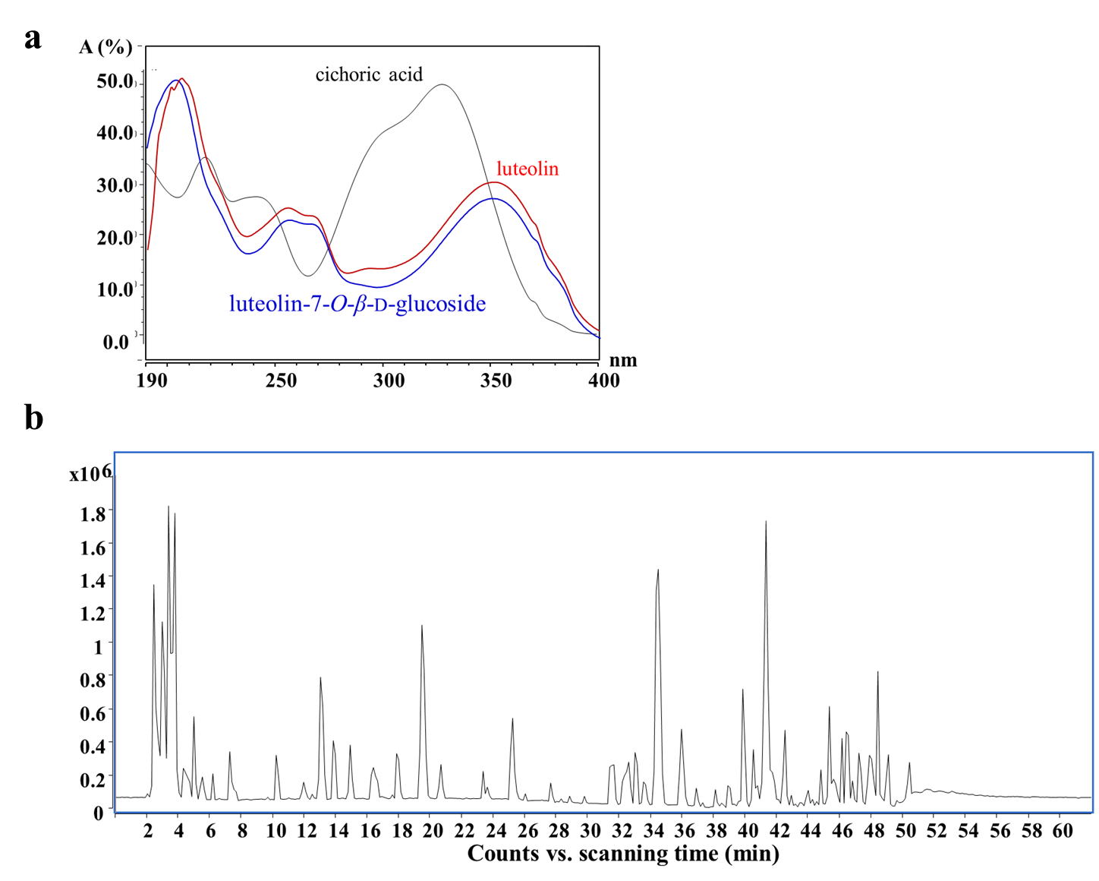
Fig. S1 Representative UV absorbance profile (a), and base peak chromatogram (b).

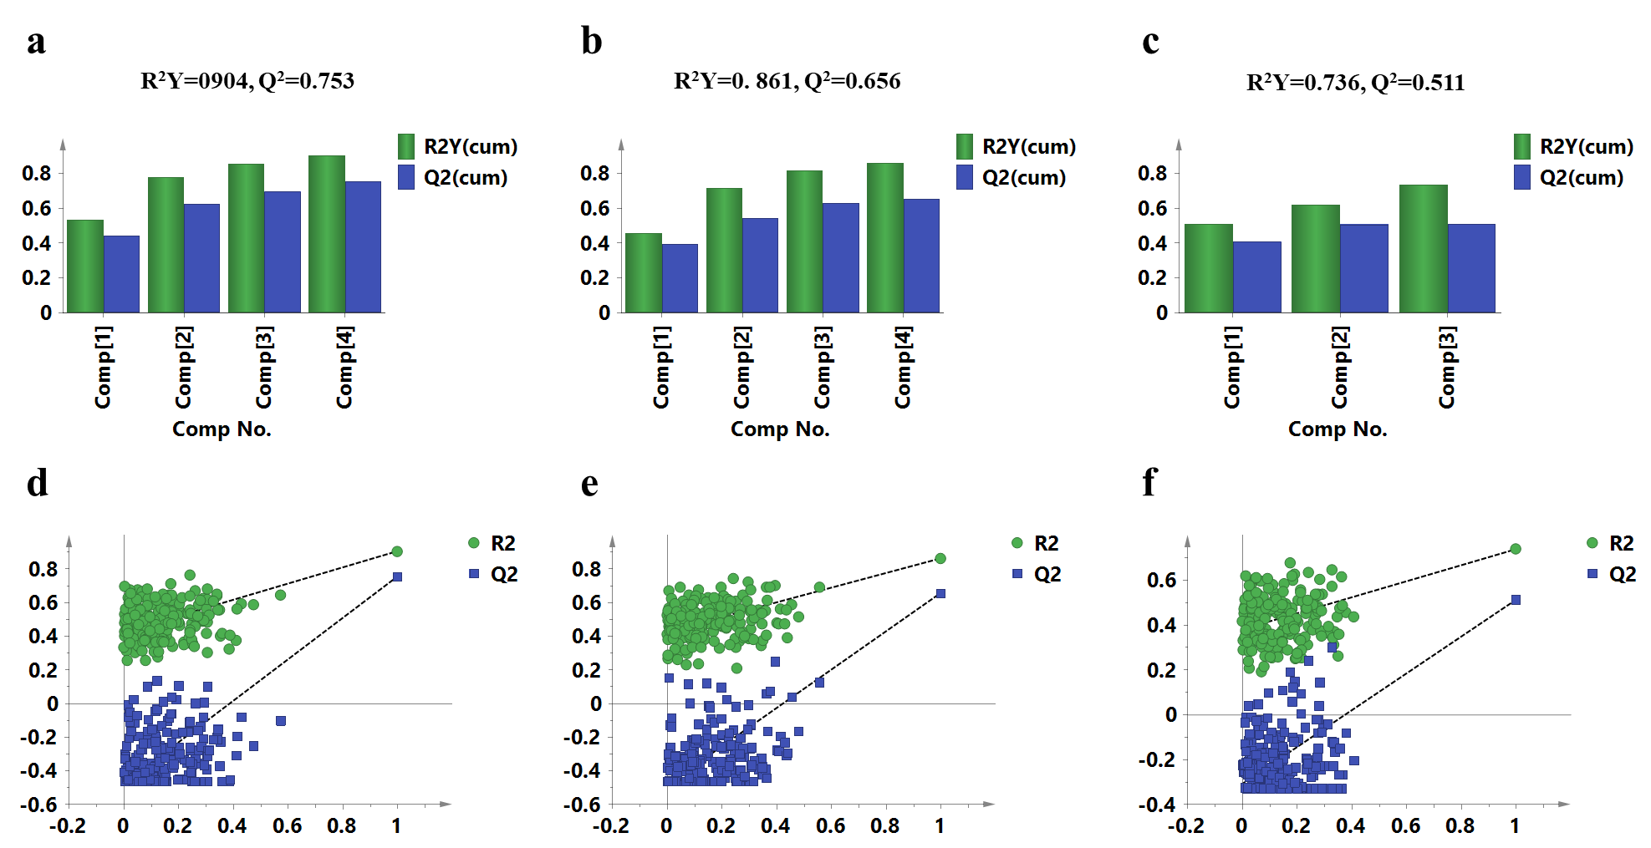
Fig. S2 PLSR models. The summary of fit (a-c) and permutation tests (d-f) for antioxidative activity by DPPH and FRAP, and anti-inflammatory activity, respectively.
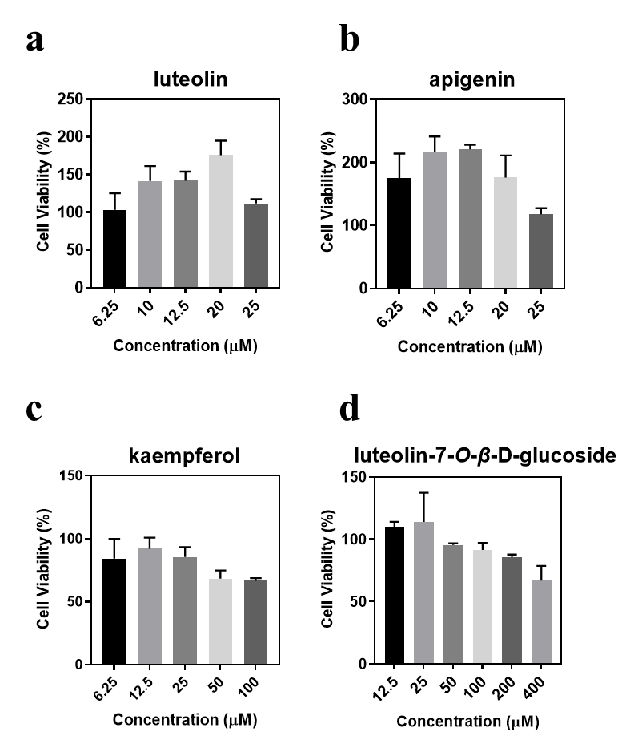
Fig. S3 The toxicity of luteolin (a), apigenin (b), kaempferol (c) and luteolin-7-O-β-d-glucoside (d) on RAW264.7 cells.

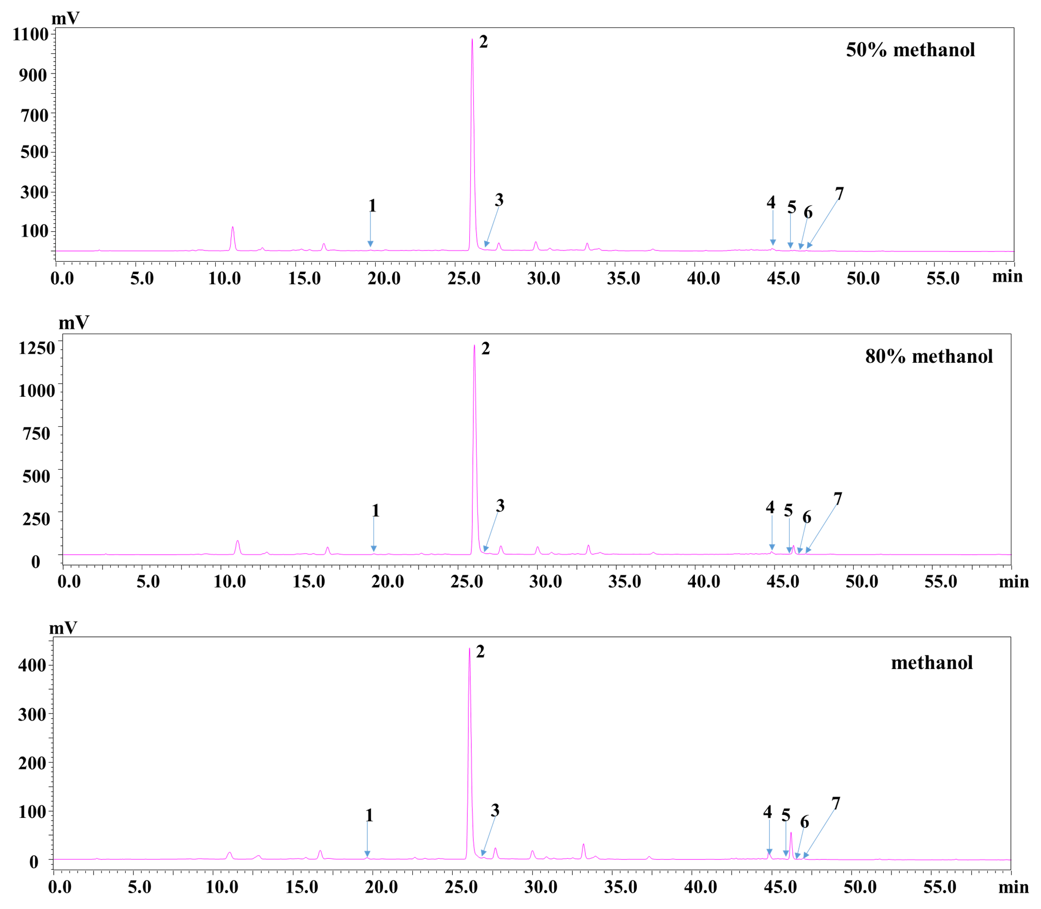
Fig. S4 Chromatograms of TH samples extracted by different solvents. 1 caffeic acid, 2 cichoric acid, 3 p-coumaric acid, 4 luteolin, 5 kaemferol, 6 apigenin, 7 eupalitin.

