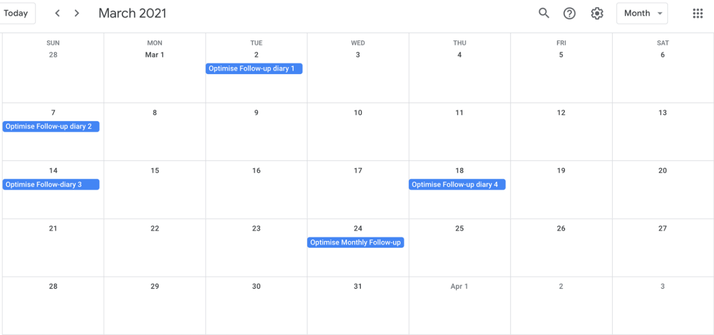
Supplementary Figure 2: Sample of a typical monthly survey invitation of a participant after completing baseline, all surveys are opened for 7 days.

