Supplementary Information

Tripodal Pd metallenes mediated by Nb₂C MXenes for boosting alkynes semihydrogenation

Zhongzhe Wei^{1, 3}, Zijiang Zhao^{1, 3}, Chenglong Qiu¹, Songtao Huang¹, Zihao Yao^{1,} *, Mingxuan Wang¹, Yi Chen¹, Yue Lin², Xing Zhong¹, Xiaonian Li^{1,} *, Jianguo Wang^{1,} *

¹ Institute of Industrial Catalysis, College of Chemical Engineering, Zhejiang University of Technology, Hangzhou 310032, P. R. China.
² Hefei National Laboratory for Physical Sciences at the Microscale, University of Science and Technology of China, Hefei, P. R. China.
³ These authors contributed equally: Zhongzhe Wei, Zijiang Zhao.
* email: yaozihao@zjut.edu.cn; xnli@zjut.edu.cn; jgw@zjut.edu.cn.

Supplementary Methods
Synthesis of Cl-Nb₂C. Initially, 100 mL as-prepared Nb₂C solution (1.85 mg/mL) was added into 250 mL round bottom flask. Then, 20 mL HCl (36%) was added to the Nb₂C solution under magnetic stirring for 2 h at room temperature. Further, the precipitate was filtered and washed with double distilled water. Finally, the obtained solid precipitate was dried in a vacuum oven at 60 °C overnight.
Synthesis of Br-Nb₂C. Initially, 100 mL as-prepared Nb₂C solution (1.85 mg/mL) was added into 250 mL round bottom flask. Then, 20 mL HBr (48%) was added to the Nb₂C solution under magnetic stirring for 2 h at room temperature. Further, the precipitate was filtered and washed with double distilled water. Finally, the obtained solid precipitate was dried in a vacuum oven at 60 °C overnight.
Synthesis of O-Nb₂C. Initially, 100 mL as-prepared Nb₂C solution (1.85 mg/mL) was added into 250 mL round bottom flask. Then, 20 mL H₂O₂ (30%) was added to the Nb₂C solution under magnetic stirring for 1 h at room temperature. Further, the precipitate was filtered and washed with double distilled water. Finally, the obtained solid precipitate was dried in a vacuum oven at 60 °C overnight.
Synthesis of Pd/Cl-Nb₂C, Pd/Br-Nb₂C and Pd/O-Nb₂C. Firstly, 150 mg as-prepared Cl-Nb₂C, Br-Nb₂C and O-Nb₂C powder was added into 100 mL round bottom flask. Then, 50 mL deionized water was added to the Cl-Nb₂C, Br-Nb₂C and O-Nb₂C powder under magnetic stirring for 30 min at room temperature. Further, 1.25 mL of PdCl₂ (1 mg/mL) was added to the Cl-Nb₂C, Br-Nb₂C and O-Nb₂C solution under magnetic stirring for 4 h at 35 °C, respectively. The precipitate was filtered and washed with double distilled water. Finally, the obtained solid precipitate was dried in a vacuum oven at 60 °C overnight.

Computational Details
1. Parametrization Method for the Interatomic Potential. To fit the force field parameters, DFT calculations with periodic boundary conditions were performed using the VASP code. And the fitting data was based on structures and interaction energies of Pd₄ cluster supported on MXenes (Br₂Nb₂C, Cl₂Nb₂C, O₂Nb₂C and Nb₂C) with a 3 × 3 × 1 unit cell. The interaction energy is defined as
$E_{int}=E_{{Pd}_{4}/sub}-E_{{Pd}_{4}}-E_{sub}$ (1)
where $E_{{Pd}_{4}/sub}$, $E_{{Pd}_{4}}$ and $E_{sub}$ is total energy of 4-atom Pd cluster on substrate, 4-atom Pd cluster and substrate, respectively.
First, the four-atom Pd cluster supported on substrates were optimized by DFT calculations. Then the DFT-optimized cluster placed on the surface of substrate at a distance R without structure reoptimization, where R was varied between 1 and 6.0 Å at intervals of 0.1 Å. And a total of 36 structures were selected for each system to fit the force field parameters.
During the fitting process, the interaction energy is the sum of all the Pd-M interactions, where M indicates each atom in the substrate with a distance smaller than 8 Å from the Pd atoms. To obtain accurate parameters effectively, we employed Levenberg-Marquardt (LM) method^{1,2} to solve the Morse potential function, and the function of convergence criterion for fitting was defined as
$e=\sum_{R}{{(E_{fit}-E_{DFT})}^{2}}$ (2)
where R represents the distance between the four-atom Pd cluster and the surface of substrate. $E_{fit}$ and $E_{DFT}$ are the interaction energies obtained by fitting results and DFT calculations, respectively.

2. MD simulations. All MD simulations were performed using the large-scale atomic/molecular massively parallel simulator (LAMMPS) software³. Pd₅₆₁ nanoparticles with the structure of cuboctahedron was selected as supported metal models. Nb₂C and its derivative (Cl₂Nb₂C, Br₂Nb₂C and O₂Nb₂C) were selected as the substrates, whose structures were optimized by DFT calculations.
In MD simulation, the embedded-atom method (EAM) was adopted to model metal−metal interactions^{4,5}. And the Morse potential was employed for describing the interaction between the Pd atom and substrate, which was obtained by fitting results of the DFT calculations.
The MD simulation was performed in a NVT ensemble with a time step of 2.5 fs. The equilibrium structure of supported nanoparticle was obtained by annealing process. First, the initial structure was optimized at 300 K for 50 ps. Then, the nanoparticle was heated to the melting point and equilibrated at 1400 K for 50 ps. Finally, the nanoparticle was cooled to 300 K. In MD simulation, the substrate layers were fixed, and the periodic boundary conditions were applied parallel to the substrates (x and y directions), while a non-periodic boundary condition was applied perpendicular to the substrates (z direction).
- DFT Computational Methods. To study CHCR hydrogenation, two types of periodic surfaces were selected in our simulation, namely, Pd(111) and Two layers Pd(111)/Nb₂C. The p(4x4) unit cell was utilized for Pd(111) and Two layers Pd(111)/Nb₂C. Both models were built with a 15 Å vacuum region to avoid the neighboring slab interactions. The thickness of the surfaces was verified to be sufficient. All DFT calculations were performed with generalized gradient approximation (GGA) of the Perdew-Burke-Ernzerhof (PBE)⁶ functional using the VASP simulation package^{7,8}. The approach of project-augmented-wave (PAW) was exploited to describe the interaction between core-electron and valence electron^{9,10}. A plane-wave basis set was expanded with the kinetic cutoff energy of 400 eV on valence electronic states. The Brillouin zone samplings of k-point values were tested using CHCR chemisorption energy, and a k-point sampling of 3x3x1 was adopted with the convergence value less than 0.1 eV. The effect of vdW interaction is significant for the reaction mechanism in our previous study¹¹⁻¹⁵. Therefore, the DFT-D3 method¹⁶⁻¹⁹ of Grimme et al. was utilized to calculate all the energetics and structures of the intermediates and transition states. The energetics and structures were calculated using the conjugate-gradient algorithm until the Hellman Feynman forces on each atom less than 0.01 eV/Å. The transition states (TSs) were searched using the method called a constrained optimization scheme²⁰⁻²³. The transition states were confirmed by two rules: (i) all forces on atoms have been optimized to be less than 0.01 eV/Å; (ii) the total energy is a maximum along the reaction coordinate but a minimum with respect to all other degrees of freedom. All the optimized initial states, transition states and final states were verified by frequency analysis using a finite displacement method to the mass-weighted Hessian matrix²⁴.

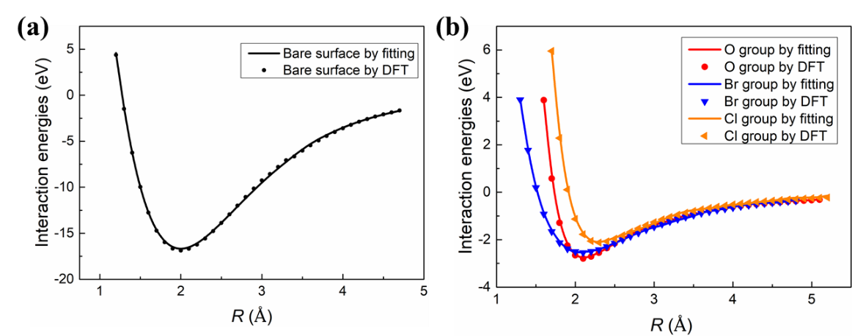
Supplementary Fig. 1 | Interaction energies for the DFT calculations and the fitted Morse potential curve with the structures of (a) Pd₄/Nb₂C, (b) Pd₄/O₂Nb₂C, Pd₄/Br₂Nb₂C and Pd₄/Cl₂Nb₂C.

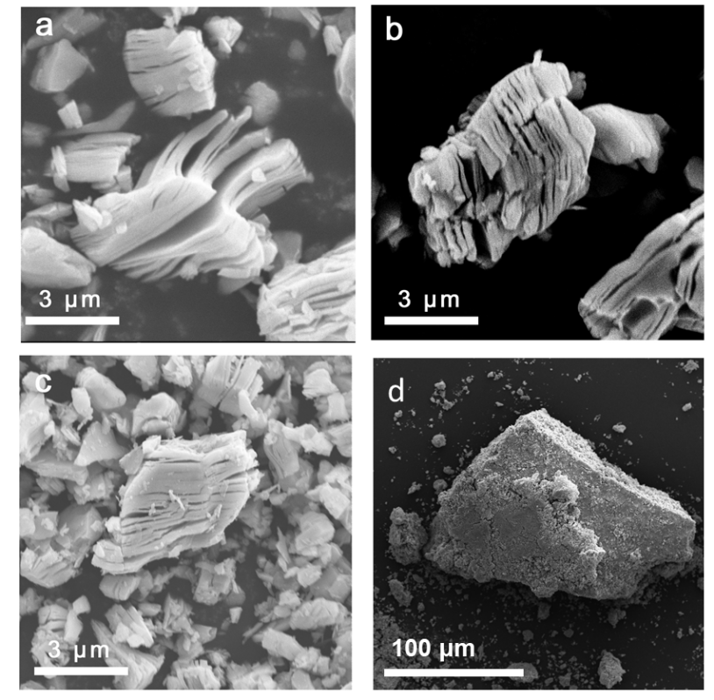
Supplementary Fig. 2 | SEM images of (a) Pd/Nb₂C, (b) Pd/Cl-Nb₂C, (c) Pd/Br-Nb₂C, (d) Pd/O-Nb₂C, respectively.

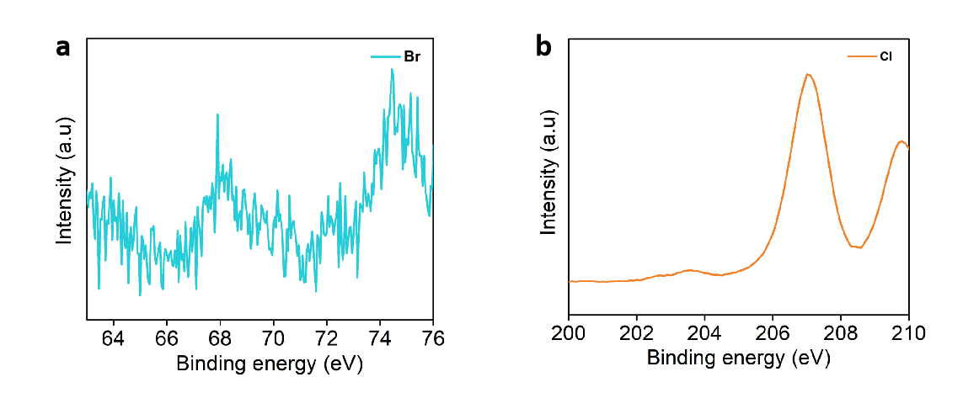
Supplementary Fig. 3 | High resolution XPS spectrum of Pd/Br-Nb₂C and Pd/Cl-Nb₂C. (a) Br 2p; (b) Cl 3d.

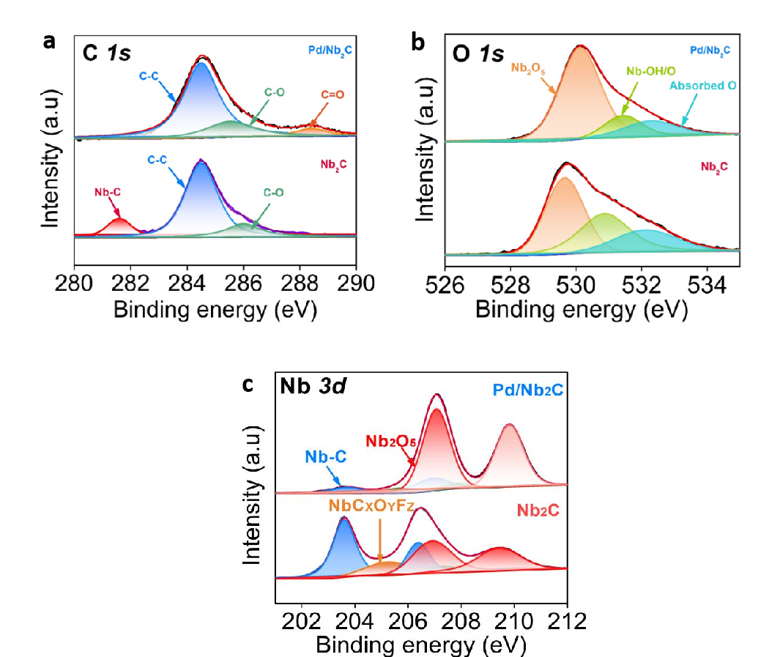
Supplementary Fig. 4 | High resolution XPS spectra of Pd/Nb₂C and Nb₂C. (a) C 1s; (b) O 1s; (c) Nb 3d.

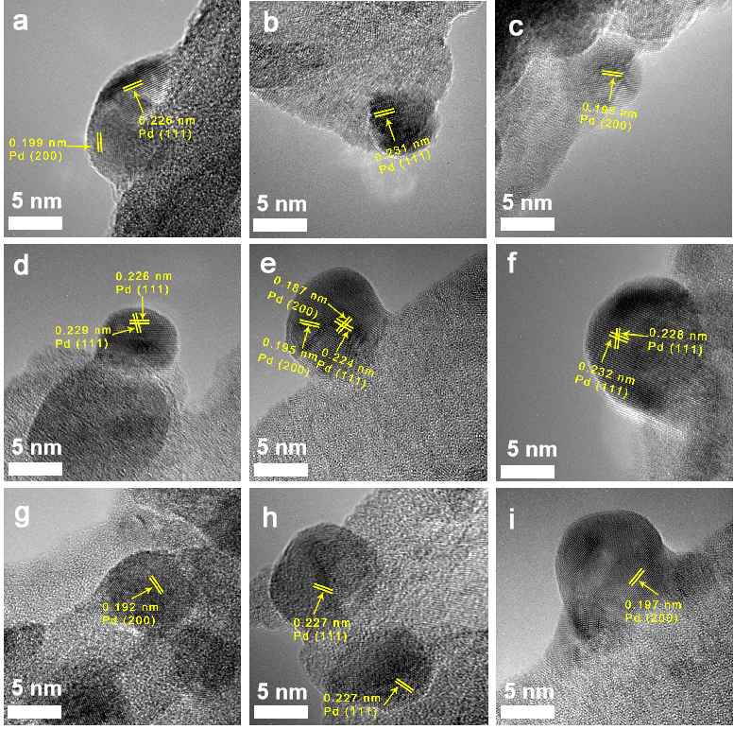
Supplementary Fig. 5 | HRTEM images of Pd/Cl-Nb₂C.

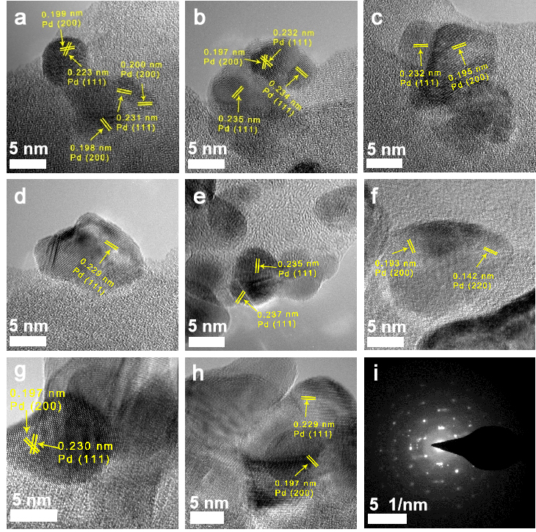
Supplementary Fig. 6 | HRTEM images and selected area electron diffraction (SAED) pattern of Pd/Br-Nb₂C.

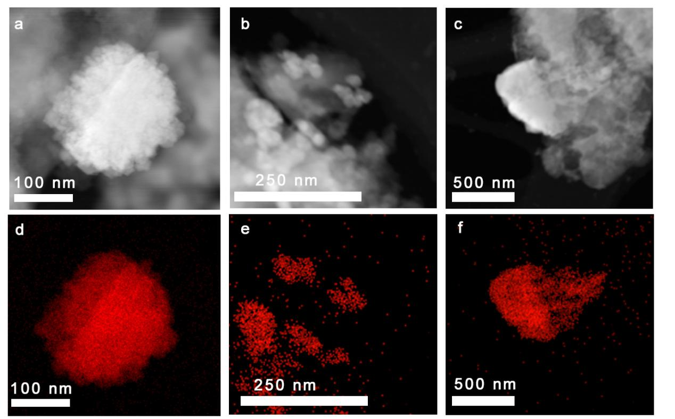
Supplementary Fig. 7 | TEM images and elemental mapping of Pd/O-Nb₂C.

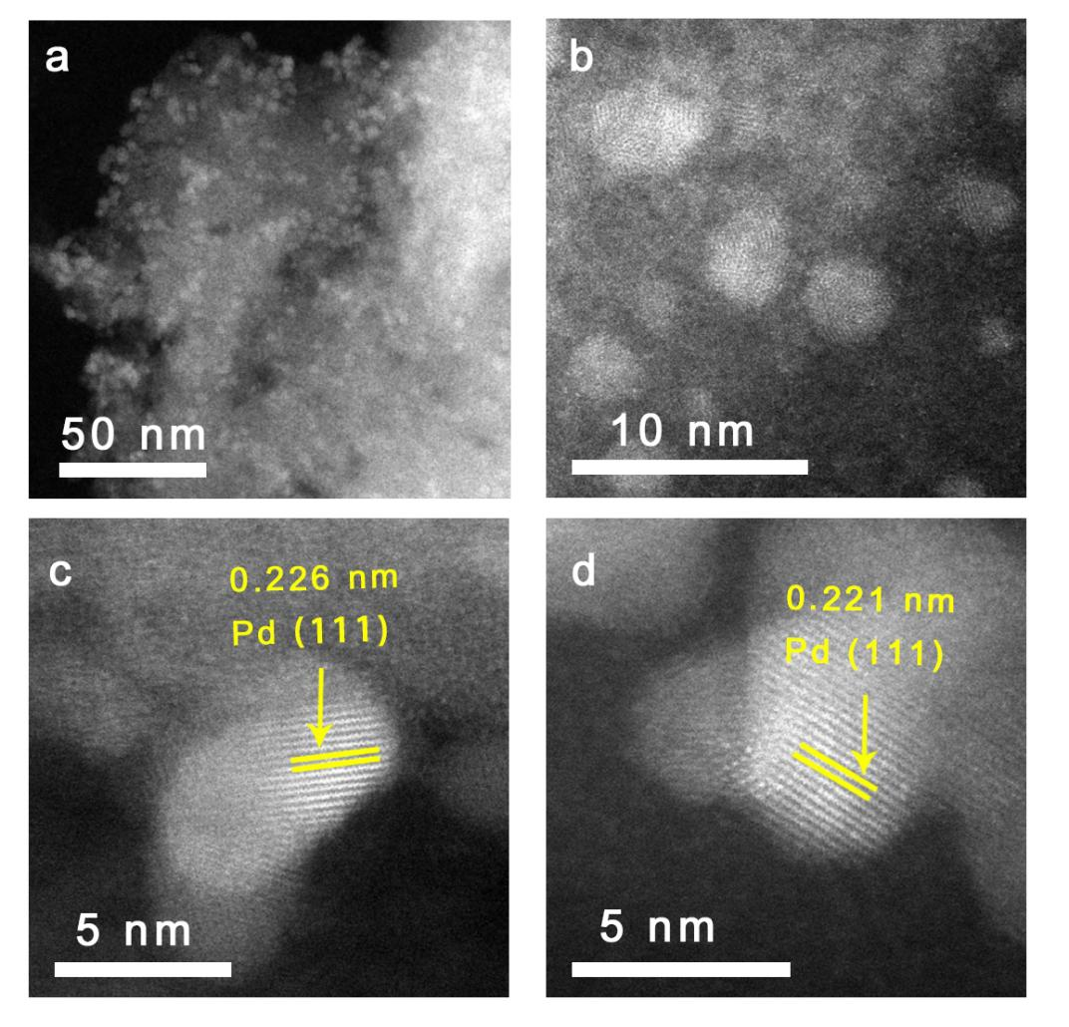
Supplementary Fig. 8 | HRTEM images of Pd/Nb₂C.

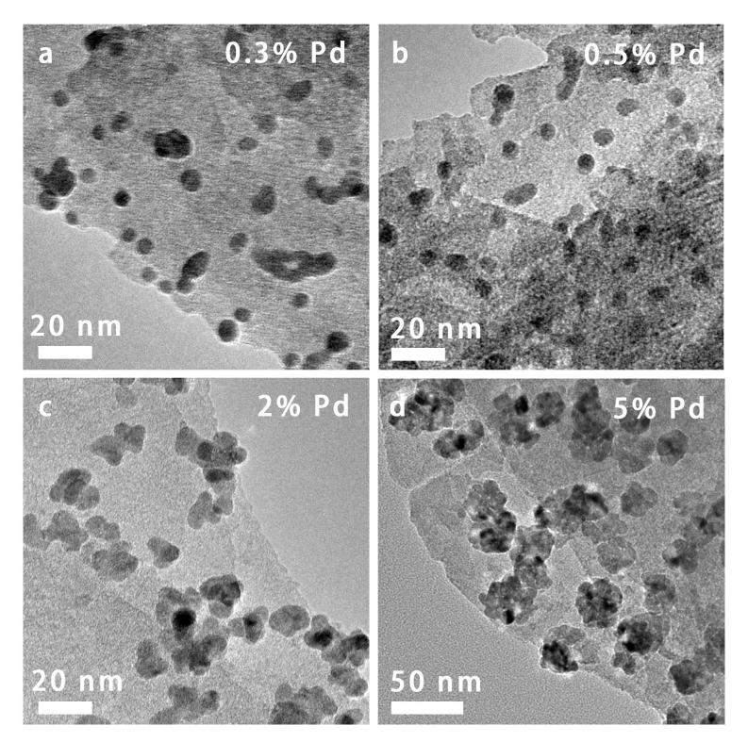
Supplementary Fig. 9 | TEM images of Pd/Nb₂C samples with different Pd loadings. (a) 0.3% Pd/Nb₂C; (b) 0.5% Pd/Nb₂C; (c) 2% Pd/Nb₂C; (d) 5% Pd/Nb₂C.

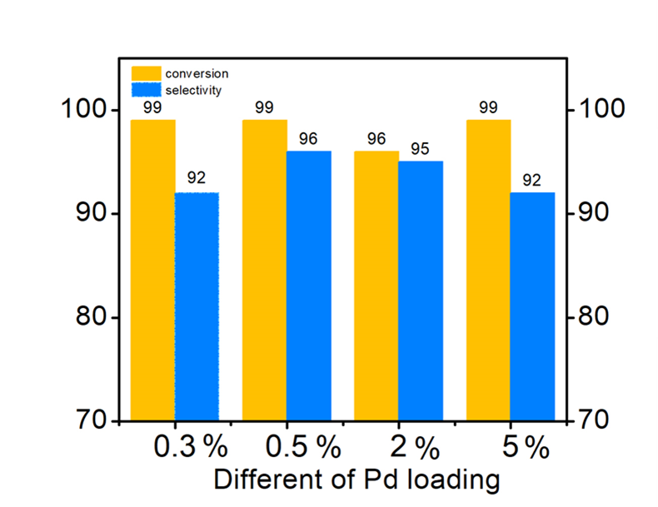
Supplementary Fig. 10 | Performance of Pd/Nb₂C with different Pd loadings. Experimental results revealed that excessive Pd loading would decrease the selectivity of styrene.

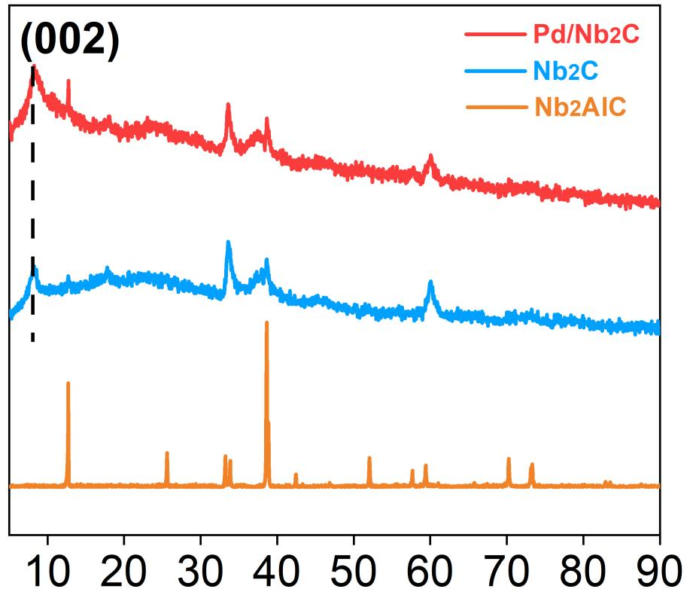
Supplementary Fig. 11 | XRD patterns of the Pd/Nb₂C, Nb₂C and Nb₂AlC.

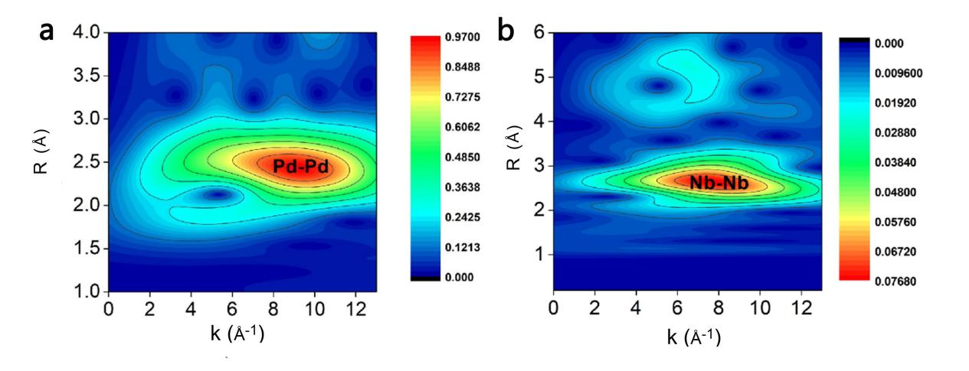Supplementary Fig. 12 | WT-EXAFS plots of Pd in the Pd foil and WT-EXAFS plots of Nb in the Nb foil. (a) Pd; (b) Nb.

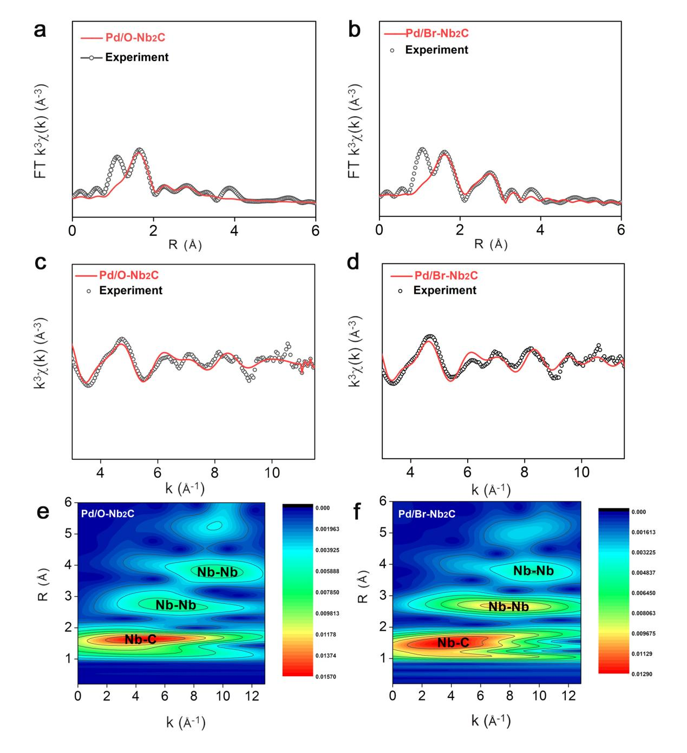
Supplementary Fig. 13 | Fourier transform spectra of Nb K-edge EXAFS for Pd/O-Nb₂C and Pd/Br-Nb₂C. (a, c, e) XAFS analysis of Pd/O-Nb₂C, (a) R-spaced FT-EXAFS of Nb K-edge; (c) k-space; (e) WT-EXAFS plots of Nb. (b, d, f) XAFS analysis of Pd/Br-Nb₂C, (b) R-spaced FT-EXAFS of Nb K-edge; (d) k-space; (f) WT-EXAFS plots of Nb.
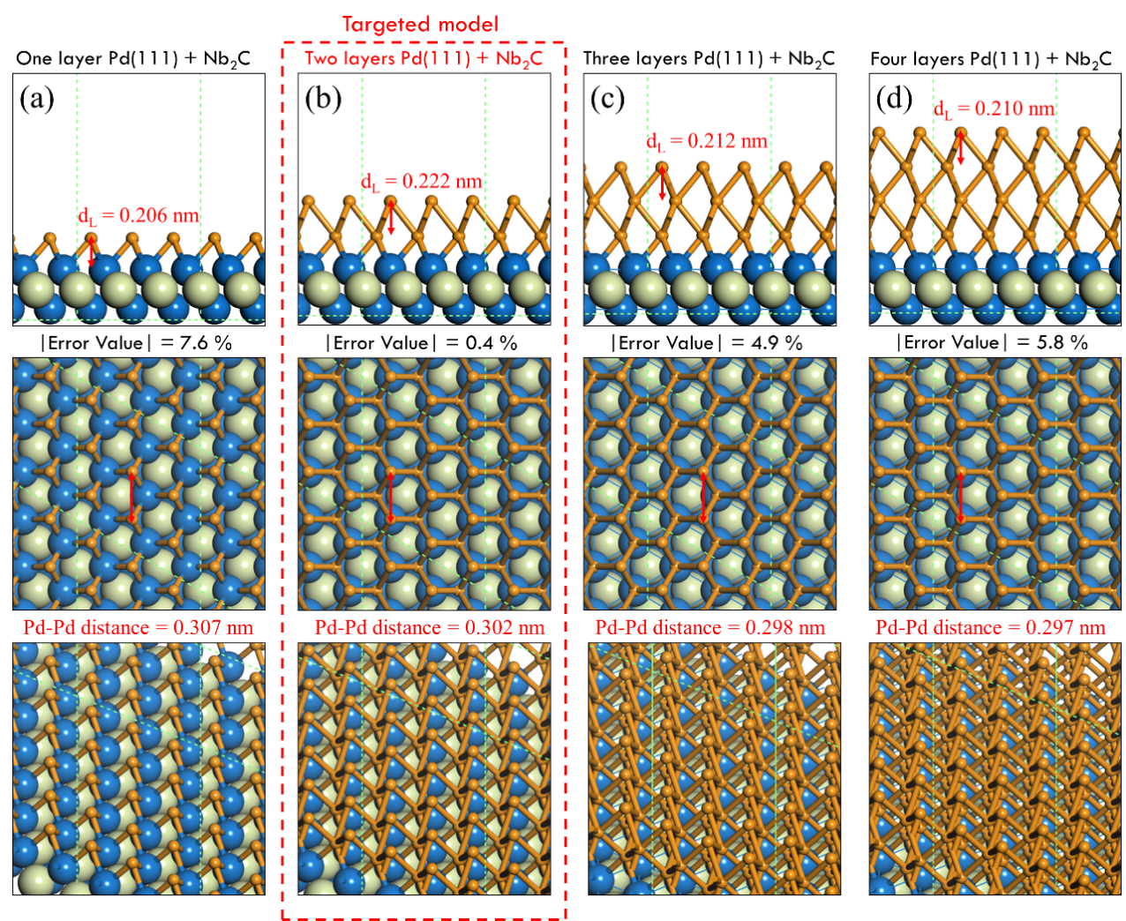
Supplementary Fig. 14 | The side view (up), top view (middle) and oblique view (bottom) of the simulated surfaces. (a) One layer Pd(111)+Nb₂C; (b) Two layers Pd(111)+Nb₂C; (c) Three layers Pd(111)+Nb₂C; (d) Four layers Pd(111)+Nb₂C. The d_{L} represents simulated lattice space. $\left|Error value\right|=\left|\frac{experiment value-d_{L}}{experiment value}\right|$, $experiment value=0.223 nm$.

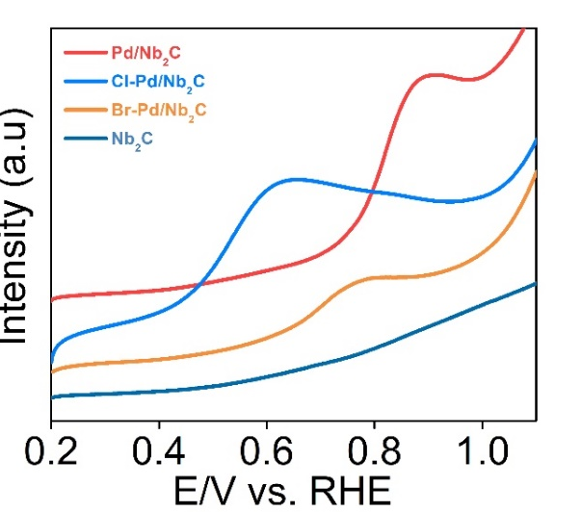
Supplementary Fig. 15 | CO stripping voltammetry curves of Nb₂C, Pd/Nb₂C, Pd/Cl-Nb₂C, and Pd/Br-Nb₂C.

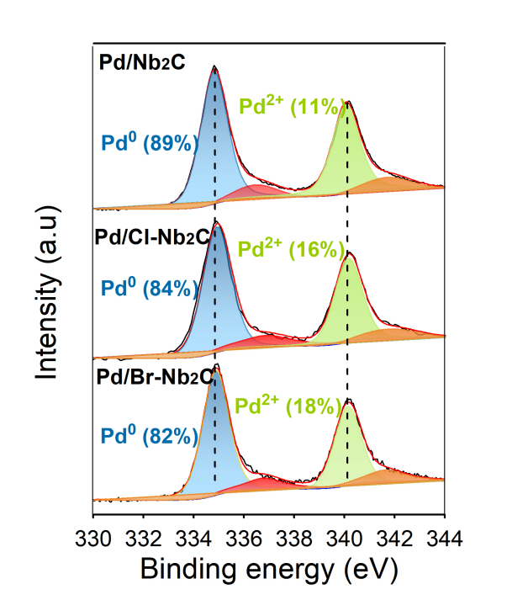
Supplementary Fig. 16 | Pd 3d XPS spectra of Pd/Nb₂C, Pd/Cl-Nb₂C, and Pd/Br-Nb₂C.

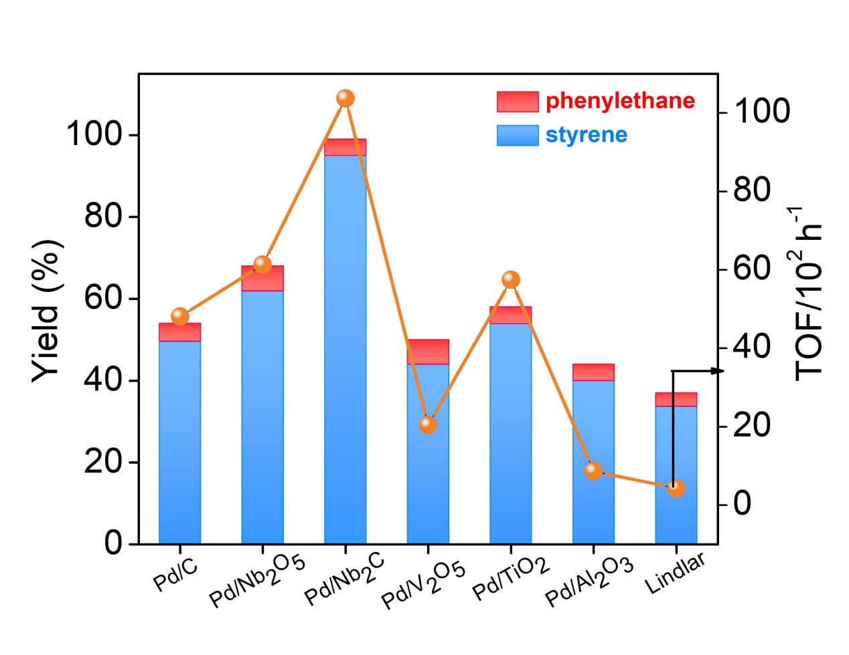
Supplementary Fig. 17 | TOF values and the yields of products for various supported Pd catalysts. Conditions: 2 mmol of phenylacetylene, 10 mg of catalyst (0.5% Pd), 5 mL of CH₃CH₂OH, 298 K, 0.1 MPa of H₂, 40 min.

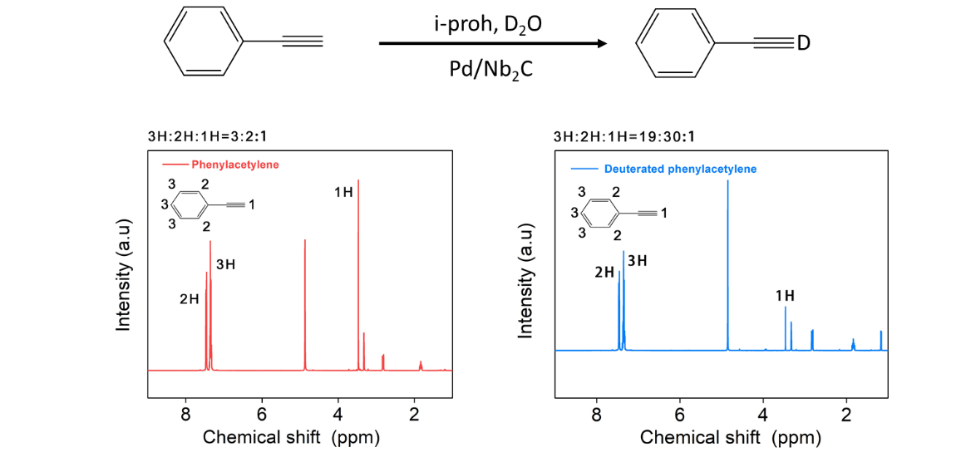
Supplementary Fig. 18 | NMR data for deuterated phenylacetylene catalyzed by Pd/Nb₂C. NMR data for the products of deuterated phenylacetylene carried out by using Pd/Nb₂C in i-proh as the solvent, and D₂O as deuterium source. (Red) Phenylacetylene, the peaks around 3.47 ppm were corresponding to H atoms on carbon-carbon triple bond. (Blue) Deuterated phenylacetylene, the peaks around 3.46 ppm decreased in the intensity compared to Red. These results also confirmed the existence of hydrogen proton in the reaction mechanism for Pd/Nb₂C.

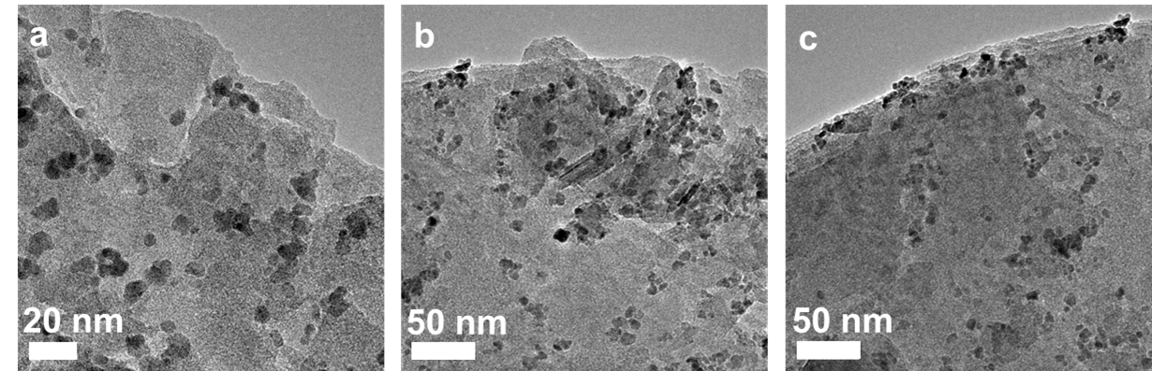
Supplementary Fig. 19 | TEM images of the used Pd/Nb₂C.

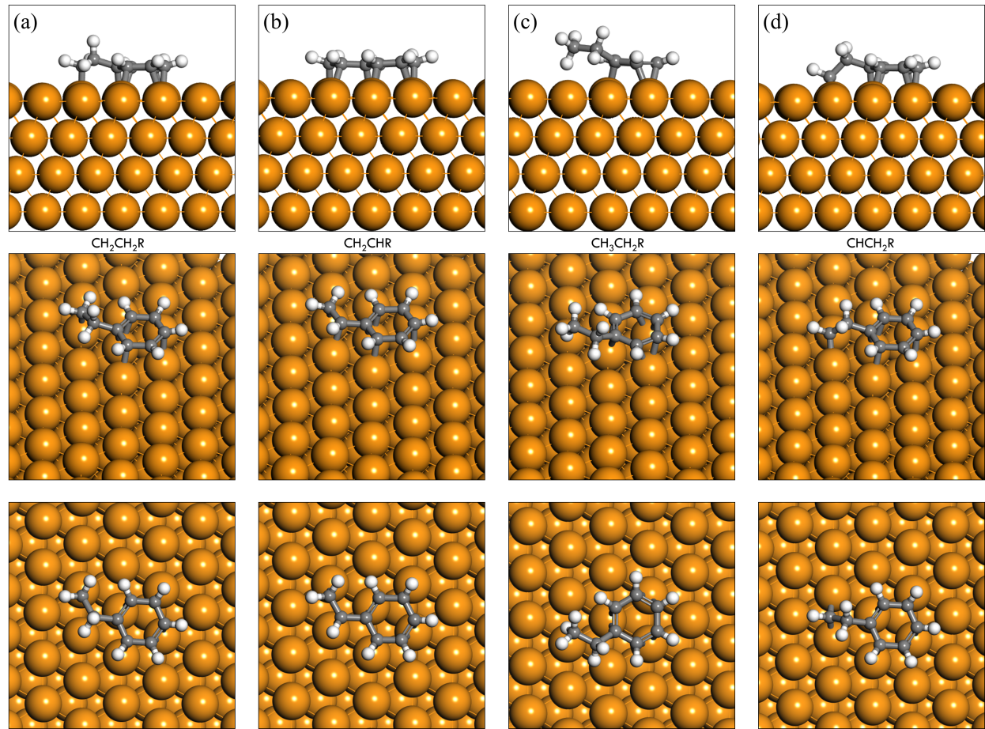
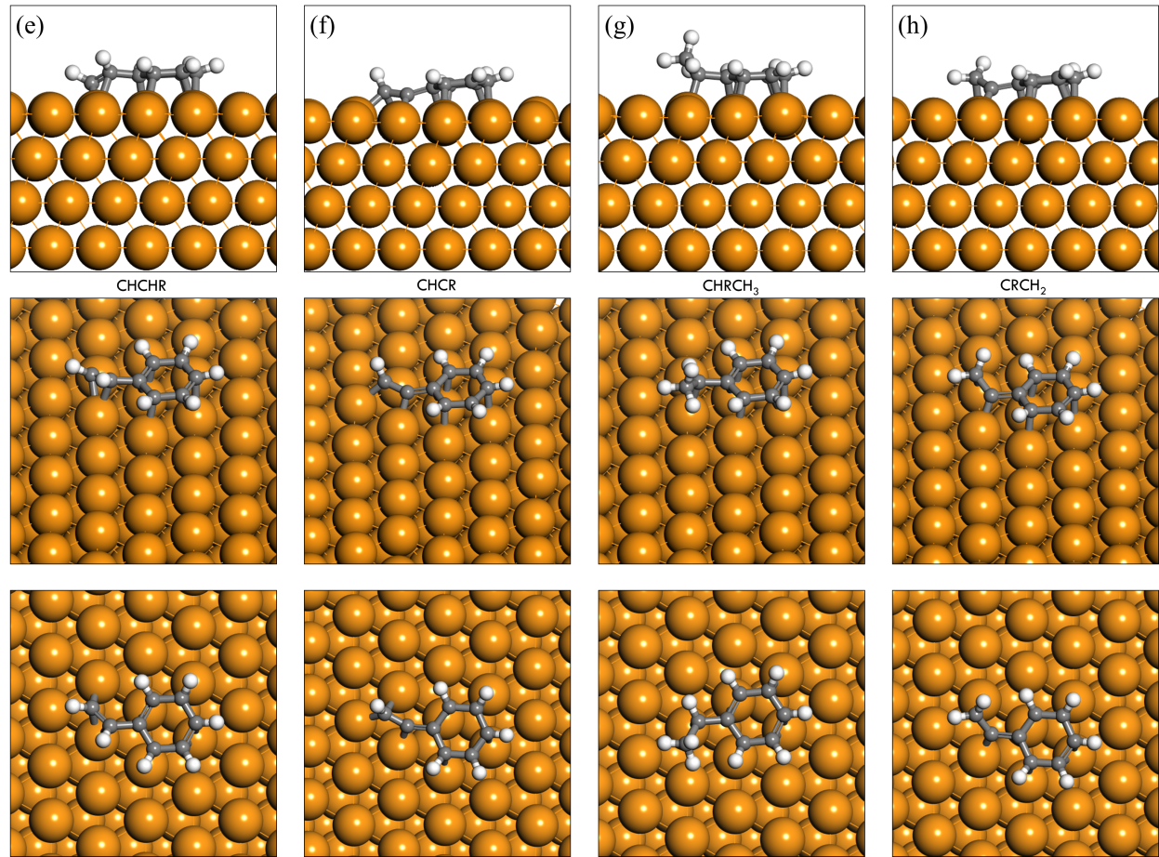

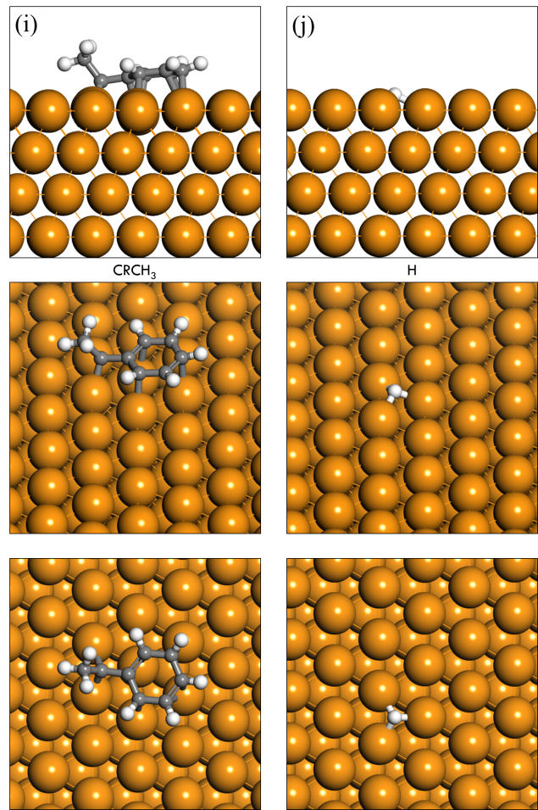
Supplementary Fig. 20 | Side and top views of all the optimized geometries of intermediates on Pd(111). (a) CH₂CH₂R; (b) CH₂CHR; (c) CH₃CH₂R; (d) CHCH₂R; (e) CHCHR; (f) CHCR; (g) CHRCH₃; (h) CRCH₂; (i) CRCH₃; (j) H.

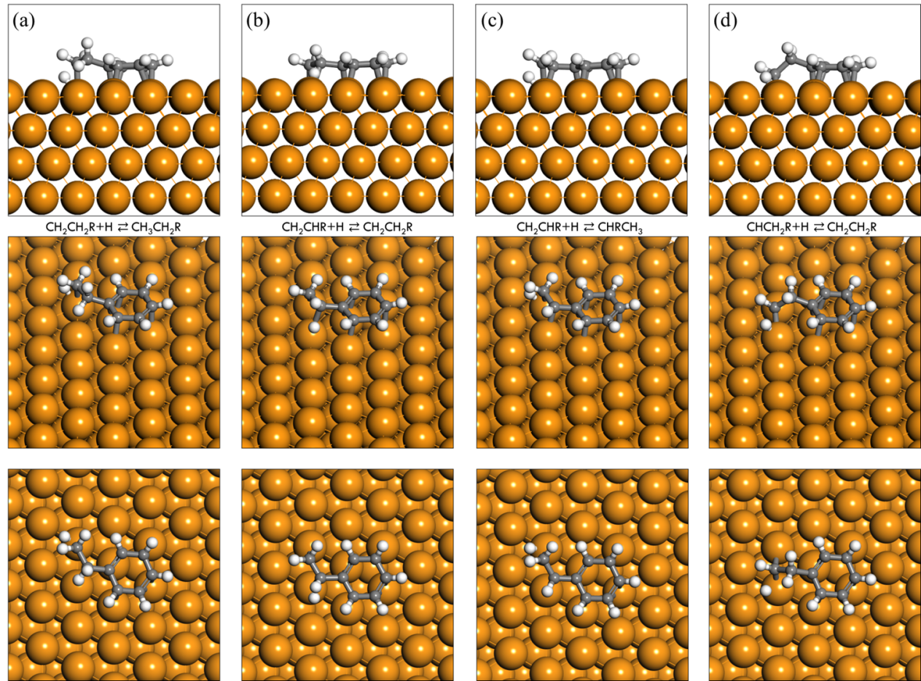
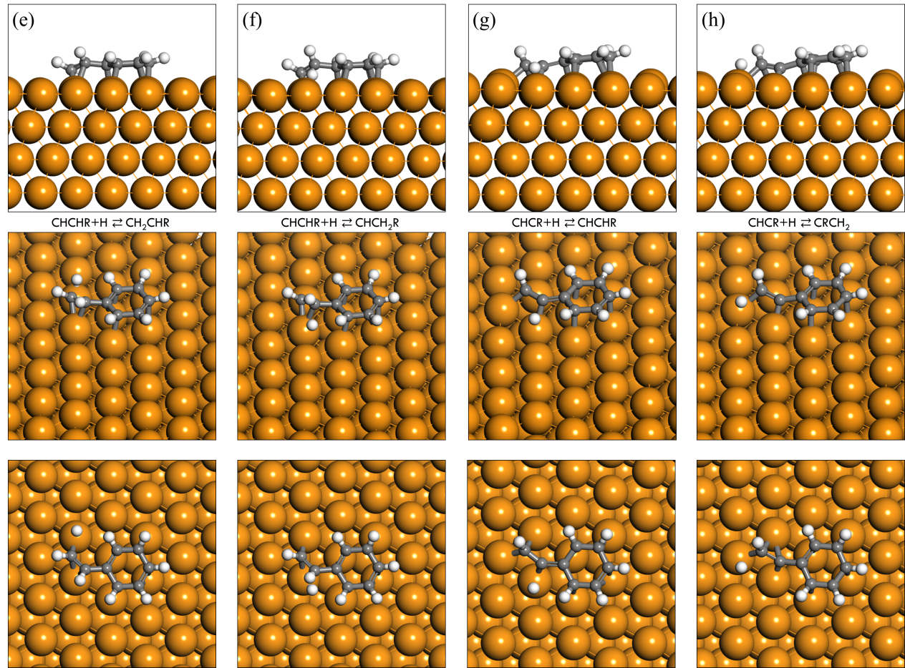

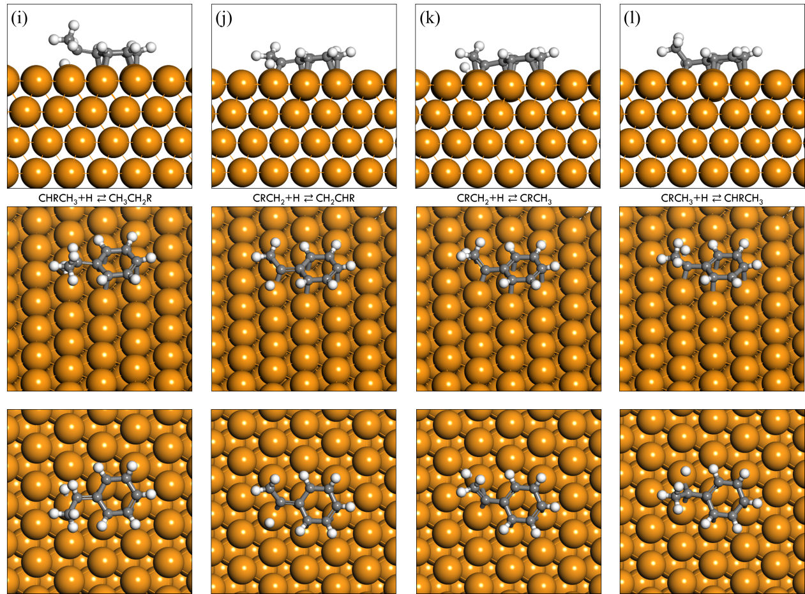
Supplementary Fig. 21 | Side and top views of calculated transition state geometries on Pd(111). (a) CH₂CH₂R+H ⇄ CH₃CH₂R; (b) CH₂CHR+H ⇄ CH₂CH₂R; (c) CH₂CHR+H ⇄ CHRCH₃; (d) CHCH₂R+H ⇄ CH₂CH₂R; (e) CHCHR+H ⇄ CH₂CHR; (f) CHCHR+H ⇄ CHCH₂R; (g) CHCR+H ⇄ CHCHR; (h) CHCR+H ⇄ CRCH₂; (i) CHRCH₃+H ⇄ CH₃CH₂R; (j) CRCH₂+H ⇄ CH₂CHR; (k) CRCH₂+H ⇄ CRCH₃; (l) CRCH₃+H ⇄ CHRCH₃.

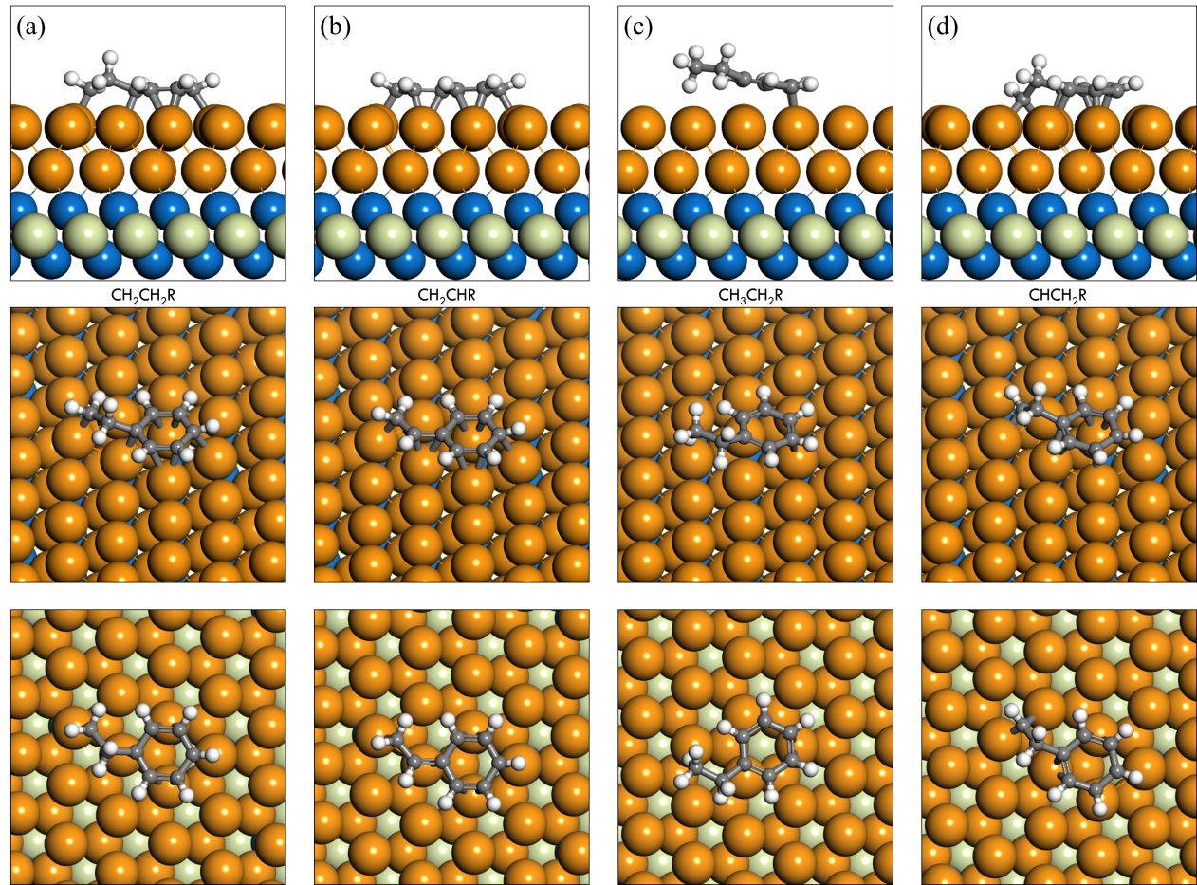
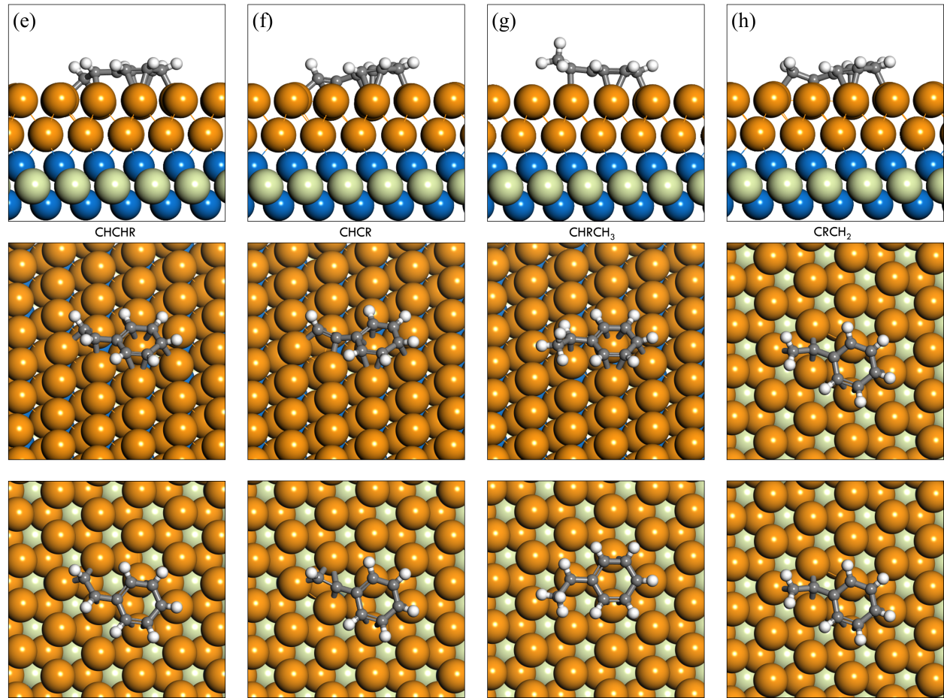

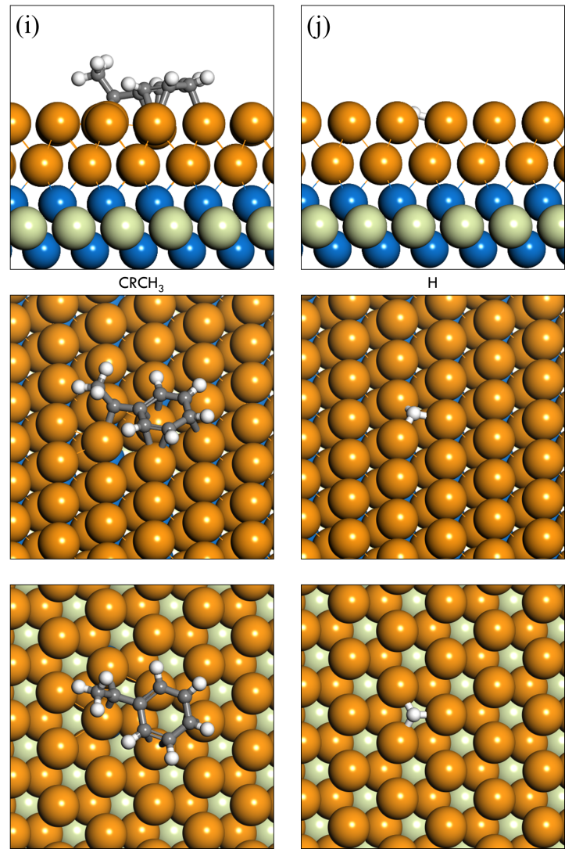

Supplementary Fig. 22 | Side, oblique and top views of all the optimized geometries of intermediates on Two layers Pd(111)+Nb₂C. (a) CH₂CH₂R; (b) CH₂CHR; (c) CH₃CH₂R; (d) CHCH₂R; (e) CHCHR; (f) CHCR; (g) CHRCH₃; (h) CRCH₂; (i) CRCH₃; (j) H.

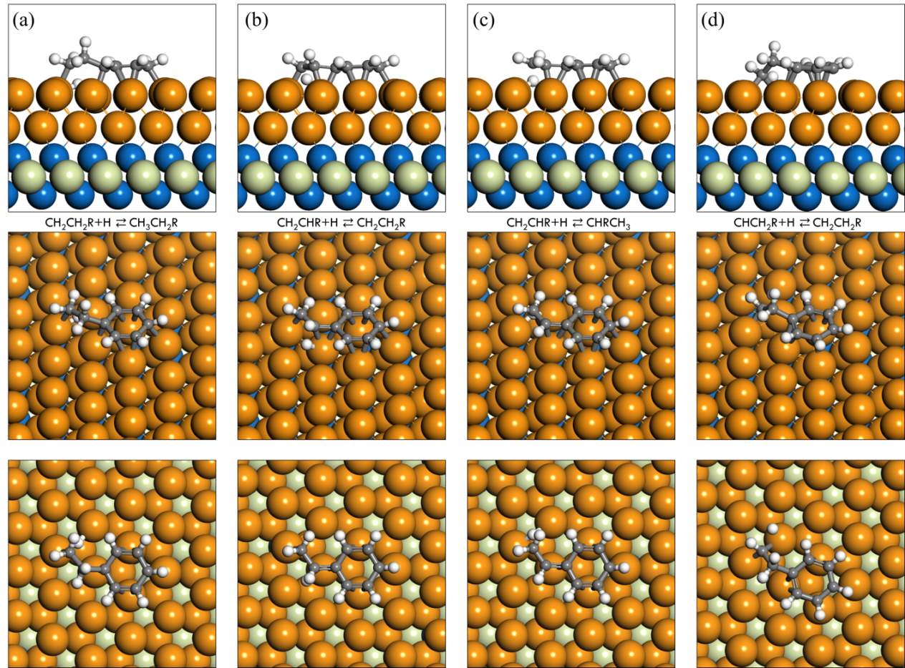
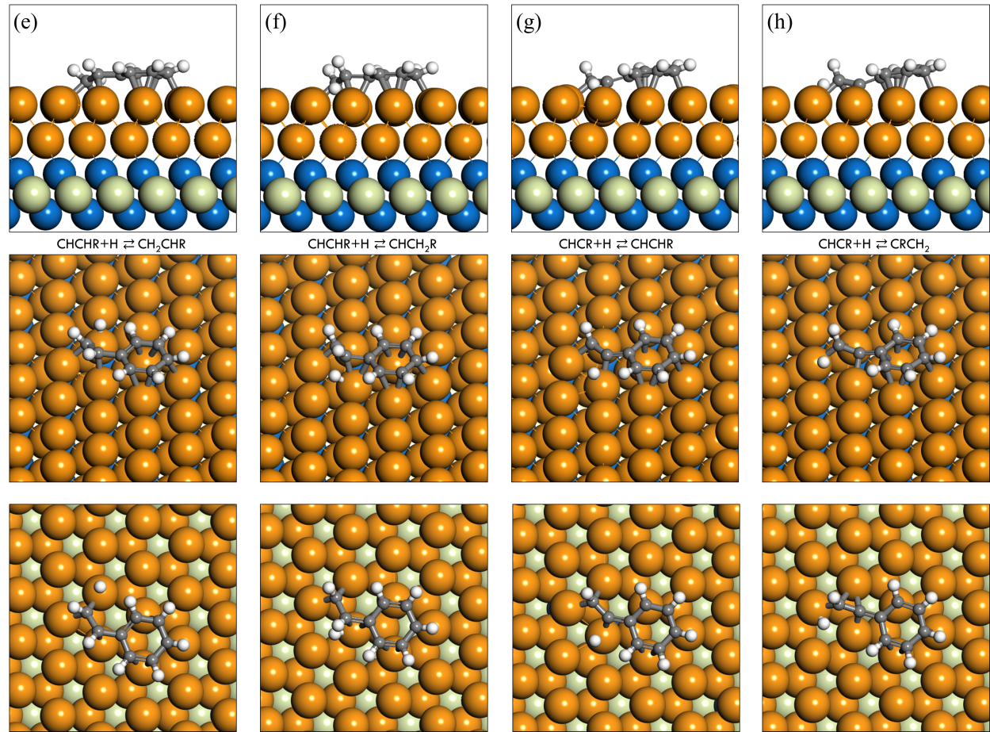

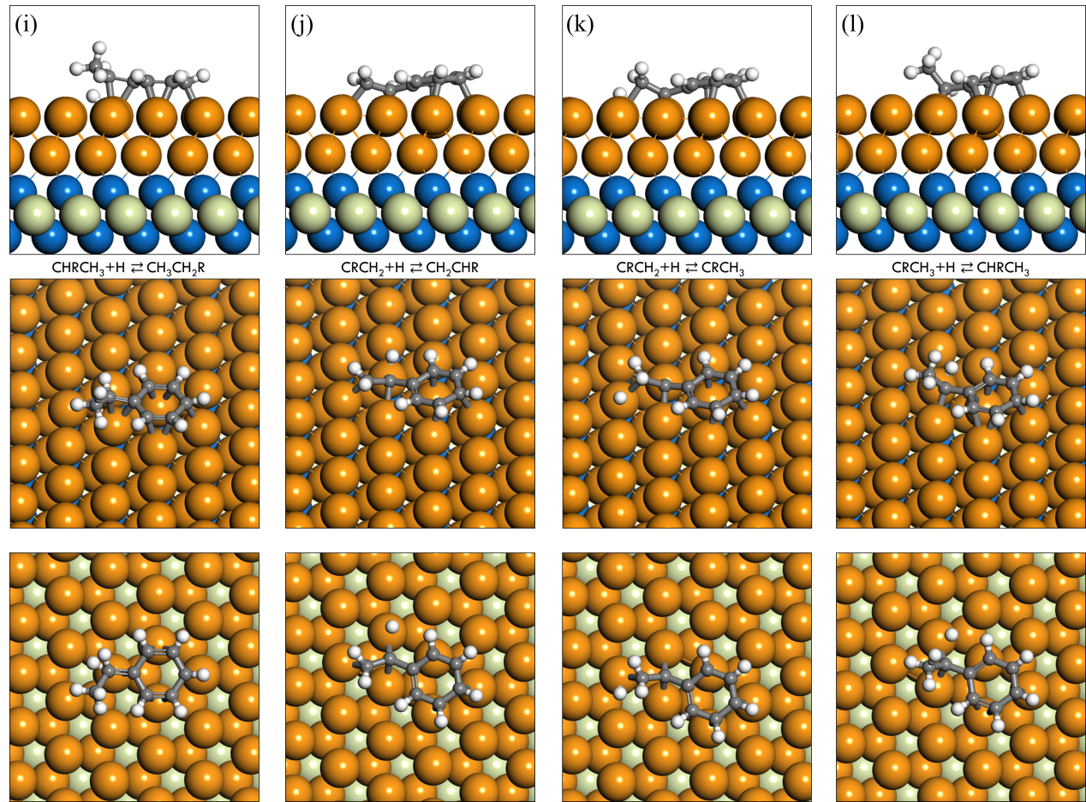

Supplementary Fig. 23 | Side and top views of calculated transition state geometries on Two layers Pd(111)+Nb₂C. (a) CH₂CH₂R+H ⇄ CH₃CH₂R; (b) CH₂CHR+H ⇄ CH₂CH₂R; (c) CH₂CHR+H ⇄ CHRCH₃; (d) CHCH₂R+H ⇄ CH₂CH₂R; (e) CHCHR+H ⇄ CH₂CHR; (f) CHCHR+H ⇄ CHCH₂R; (g) CHCR+H ⇄ CHCHR; (h) CHCR+H ⇄ CRCH₂; (i) CHRCH₃+H ⇄ CH₃CH₂R; (j) CRCH₂+H ⇄ CH₂CHR; (k) CRCH₂+H ⇄ CRCH₃; (l) CRCH₃+H ⇄ CHRCH₃.

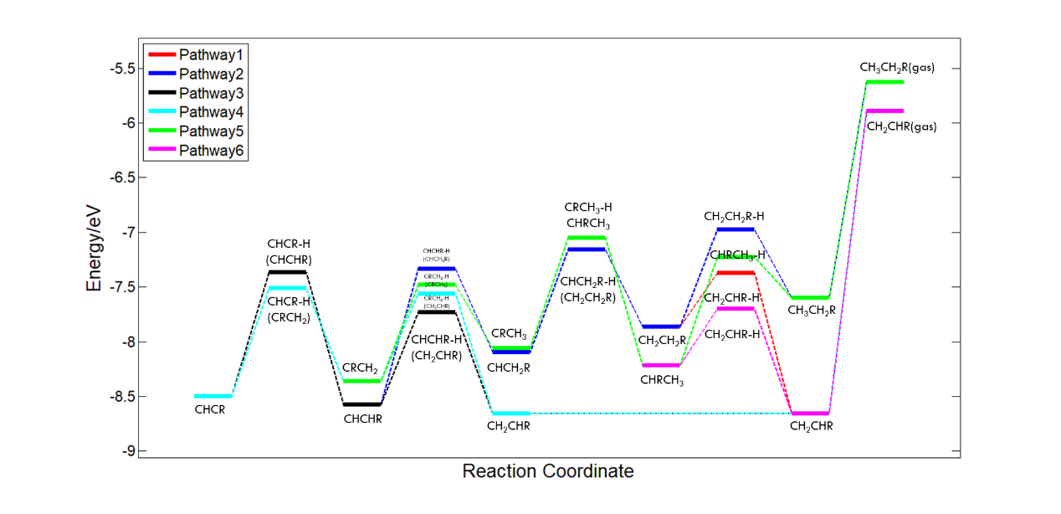
Supplementary Fig. 24 | Energy profiles of CHCR hydrogenation on Pd(111). The IS (Initial State) is chosen as CHCR_{ad} + 4H_{ad}.

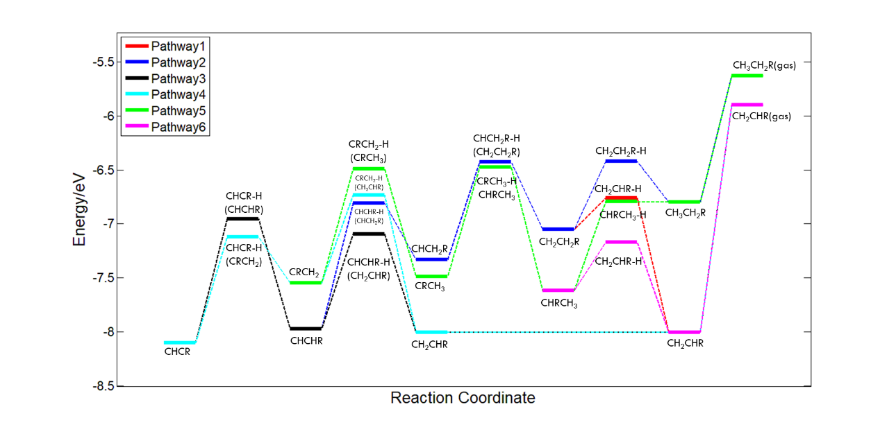
Supplementary Fig. 25 | Energy profiles of CHCR hydrogenation on Two layers Pd(111)+Nb₂C. The IS (Initial State) is chosen as CHCR_{ad} + 4H_{ad}.

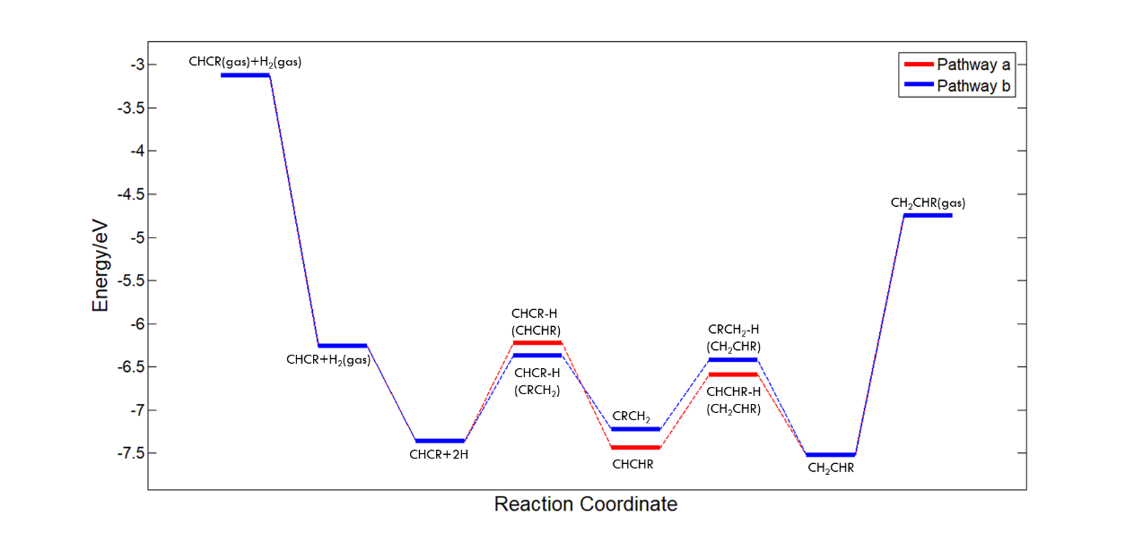
Supplementary Fig. 26 | Energy profiles of reaction pathway a and reaction pathway b on Pd(111).

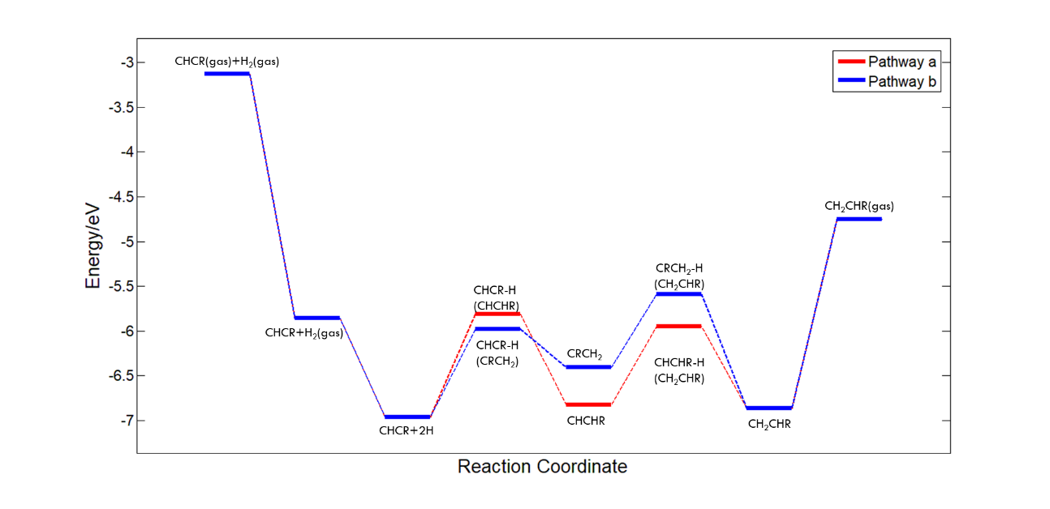
Supplementary Fig. 27 | Energy profiles of reaction pathway a and reaction pathway b on Two layers Pd(111)+Nb₂C.

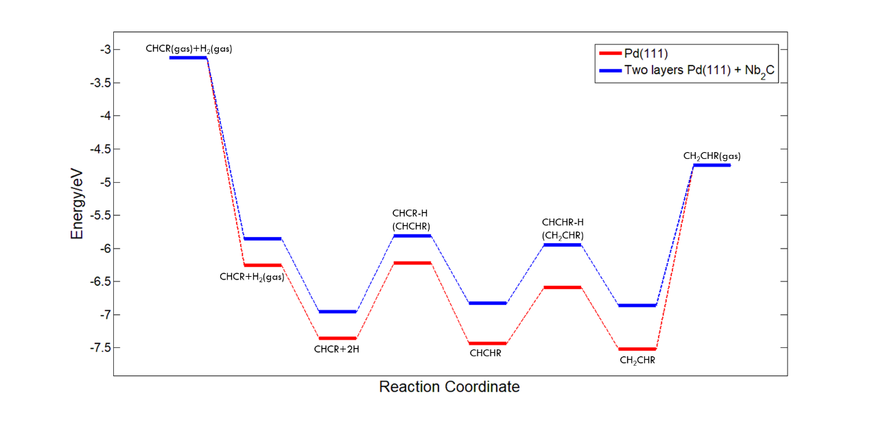
Supplementary Fig. 28 | Energy profiles of major reaction pathway (pathway a) on Pd(111) and Two layers Pd(111)+Nb₂C.

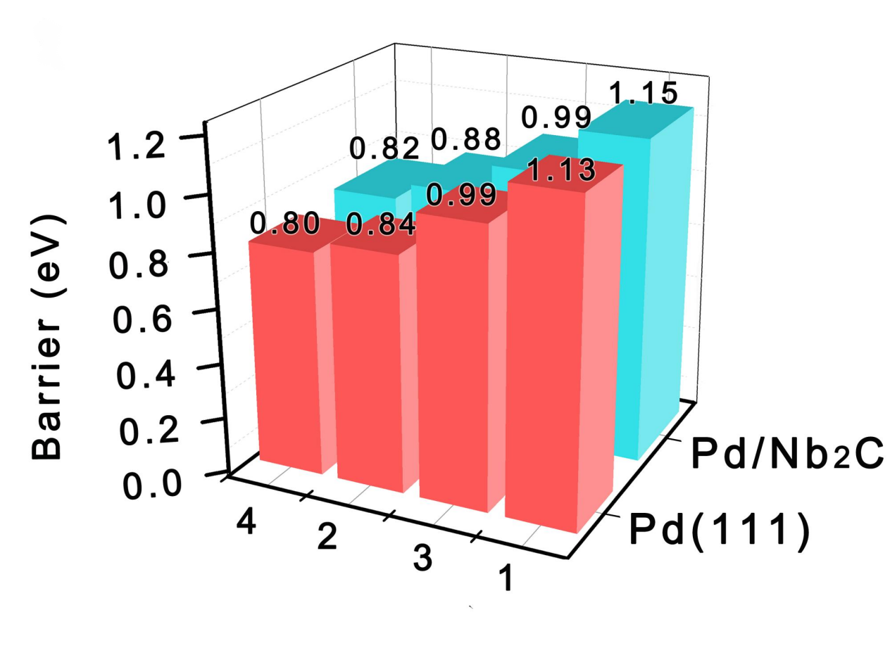
Supplementary Fig. 29 | The barriers of significant hydrogenation pathways on Pd(111) and Pd/Nb₂C respectively. Pathway 1 is CHCR+H ⇄ CHCHR; Pathway 2 is CHCHR+H ⇄ CH₂CHR; Pathway 3 is CHCR+H ⇄ CRCH₂; Pathway 4 is CRCH₂+H ⇄ CH₂CHR.

Supplementary Table 1. Morse Force Field Parameters for Pd/Nb₂C, Pd/O₂Nb₂C, Pd/Br₂Nb₂C and Pd/Cl₂Nb₂C.
 |  | D (eV) | α (1/Å) | r₀ (Å)
Bare surface | Pd-Nb | 1.807 | 1.566 | 2.30
Bare surface | Pd-C | 0.047 | 0.960 | 5.30
O group | Pd-O | 2.913 | 2.642 | 1.40
O group | Pd-Nb | 0.0187 | 0.520 | 4.80
O group | Pd-C | 0.008 | 2.191 | 5.60
Br group | Pd-Br | 0.500 | 2.097 | 2.10
Br group | Pd-Nb | 0.0211 | 0.196 | 4.70
Br group | Pb-C | 0.00247 | 1.417 | 7.00
Cl group | Pd-Cl | 2.102 | 2.514 | 1.60
Cl group | Pd-Nb | 0.0220 | 0.450 | 4.90
Cl group | Pd-C | 0.00163 | 2.138 | 6.70

Supplementary Table 2. Structural Parameters of a series of Pd/Nb₂C Extracted from the EXAFS Fitting of Pd K-edge.
Catalyst | Path | CNª | R^{b}(Å) | σ²× 10² (Å² )^{c} | ΔE₀ (eV)
Pd/Nb₂C | Pd-O | 2.1 | 2.00 | 0.001 | 1.632± 0.764
Pd/Nb₂C | Pd-Pd | 3 | 2.74 | 0.017 | 1.632± 0.764
Pd/Br-Nb₂C | Pd-Pd | 11.1±1.0 | 2.75±0.01 | 0.64±0.5 | -0.1±0.8
Pd/O-Nb₂C | Pd-Pd | 10.4±0.7 | 2.76±0.01 | 0.78±0.4 | 1.3±0.
ªCN is the coordination number; ^{b}R is interatomic distance; ^{c}σ² is Debye-Waller factor (a measure of thermal and static disorder in absorber-scatter distances); S₀² was obtained from Nb metal and fixed as 0.80; ΔE₀ shift in absorption edge energy, Data ranges 3.000 ≤ k ≤ 12.651 Å⁻¹, 1.25 ≤ R ≤ 2.70 Å. The number of variable parameters is 3, out of a total of 8.8125 independent data points, R factor for these fits are 1.79%, 0.4%, 0.6%.

Supplementary Table 3. Structural Parameters of a series of Pd/Nb₂C Extracted from the EXAFS Fitting of Nb K-edge.
Catalyst | Path | CNª | R^{b}(Å) | σ²× 10⁻² (Å² )^{c} | ΔE₀ (eV)
Pd/Nb₂C | Nb-C | 2.1 | 2.11 | 1.1 | 13.3
Pd/Nb₂C | Nb-Pd | 1.8 | 2.72 | 1.1 | 13.3
Pd/Nb₂C | Nb-C-Nb | 0.5 | 3.11 | 0.6 | 13.3
Pd/O-Nb₂C | Nb-C | 2.1 | 2.11 | 0.8 | 12.8
Pd/O-Nb₂C | Nb-C-Nb | 2.7 | 2.74 | 1.8 | 12.8
Pd/O-Nb₂C | Nb-Nb | 0.2 | 3.17 | 0.3 | 12.8
Pd/Br-Nb₂C | Nb-C | 2.1 | 2.12 | 1.1 | 10.9
Pd/Br-Nb₂C | Nb-C-Nb | 4.4 | 2.79 | 2.3 | 10.9
Pd/Br-Nb₂C | Nb-Nb | 0.5 | 3.16 | 0.3 | 10.9
ªCN is the coordination number; ^{b}R is interatomic distance; ^{c}σ² is Debye-Waller factor (a measure of thermal and static disorder in absorber-scatter distances); S₀² was obtained from Nb metal and fixed as 0.80; ΔE₀ shift in absorption edge energy, Data ranges 3.000 ≤ k ≤ 11 Å⁻¹, 1.3 ≤ R ≤ 3.1 Å. The number of variable parameters is 3, R factor for these fits are 0.6%, 0.9%, 1.9%.

Supplementary Table 4. Full elementary steps for CHCR hydrogenation.
Elementary Reaction Steps
(r1) H₂+*+*→H*+H*
(r2) CHCR+*→CHCR*
(r3) CHCR*+H*→CHCHR*+*
(r4) CHCR*+H*→CRCH₂*+*
(r5) CHCHR*+H*→CH₂CHR*+*
(r6) CRCH₂*+H*→CH₂CHR*+*
(r7) CH₂CHR*→CH₂CHR+*
(r8) CHCHR*+H*→CHCH₂R*+*
(r9) CRCH₂*+H*→CRCH₃*+*
(r10) CH₂CHR*+H*→CH₂CH₂R*+*
(r11) CH₂CHR*+H*→CHRCH₃*+*
(r12) CH₂CH₂R*+H*→CH₃CH₂R*+*
(r13) CHRCH₃*+H*→CH₃CH₂R*+*
(r14) CH₃CH₂R*→CH₃CH₂R+*
(r15) CHCH₂R*+H*→CH₂CH₂R*+*
(r16) CRCH₃*+H*→CHRCH₃*+*

Supplementary Table 5. Reaction energetics of each elementary step for solving the kinetic modelling on Pd(111)
Pd(111) | Ea | ΔH
H₂+*+*→H*+H* | 0.00 | -1.10
CHCR+*→CHCR* | 0.00 | -3.13
CHCR*+H*→CHCHR*+* | 1.13 | -0.08
CHCR*+H*→CRCH₂*+* | 0.99 | 0.13
CHCHR*+H*→CH₂CHR*+* | 0.84 | -0.08
CRCH₂*+H*→CH₂CHR*+* | 0.80 | -0.29
CH₂CHR*→CH₂CHR+* | 2.77 | 2.77
CHCHR*+H*→CHCH₂R*+* | 1.24 | 0.48
CRCH₂*+H*→CRCH₃*+* | 0.88 | 0.31
CH₂CHR*+H*→CH₂CH₂R*+* | 1.29 | 0.79
CH₂CHR*+H*→CHRCH₃*+* | 0.96 | 0.44
CH₂CH₂R*+H*→CH₃CH₂R*+* | 0.89 | 0.27
CHRCH₃*+H*→CH₃CH₂R*+* | 0.99 | 0.62
CH₃CH₂R*→CH₃CH₂R+* | 1.97 | 1.97
CHCH₂R*+H*→CH₂CH₂R*+* | 0.94 | 0.23
CRCH₃*+H*→CHRCH₃*+* | 1.01 | -0.16

Supplementary Table 6. Reaction energetics of each elementary step for solving the kinetic modelling on Pd(111)
Two layers Pd(111) + Nb₂C | Ea | ΔH
H₂+*+*→H*+H* | 0.00 | -1.11
CHCR+*→CHCR* | 0.00 | -2.73
CHCR*+H*→CHCHR*+* | 1.15 | 0.13
CHCR*+H*→CRCH₂*+* | 0.99 | 0.56
CHCHR*+H*→CH₂CHR*+* | 0.88 | -0.04
CRCH₂*+H*→CH₂CHR*+* | 0.82 | -0.46
CH₂CHR*→CH₂CHR+* | 2.11 | 2.11
CHCHR*+H*→CHCH₂R*+* | 1.16 | 0.64
CRCH₂*+H*→CRCH₃*+* | 1.06 | 0.06
CH₂CHR*+H*→CH₂CH₂R*+* | 1.25 | 0.96
CH₂CHR*+H*→CHRCH₃*+* | 0.84 | 0.39
CH₂CH₂R*+H*→CH₃CH₂R*+* | 0.63 | 0.25
CHRCH₃*+H*→CH₃CH₂R*+* | 0.83 | 0.82
CH₃CH₂R*→CH₃CH₂R+* | 1.17 | 1.17
CHCH₂R*+H*→CH₂CH₂R*+* | 0.90 | 0.28
CRCH₃*+H*→CHRCH₃*+* | 1.01 | -0.13

References
1. Marquardt, D. W. An Algorithm for Least-Squares Estimation of Nonlinear Parameters. J. Soc. Ind. Appl. Math. 11, 431-441 (1963).

2. Lagunas, F. A method for the solution of certain non-linear problems in least squares. Quar. Appl. Math. 2, 164-168 (1944).

3. Plimpton, S. Fast Parallel Algorithms for Short-Range Molecular Dynamics. J. Comput. Phys. 117, 1-19 (1995).

4. Daw, M. S., Baskes, M. I. Embedded-atom method: Derivation and application to impurities, surfaces, and other defects in metals. Phys. Rev. B 29, 6443-6453 (1984).

5. Foiles, S. M., Baskes, M. I., Daw, M. S. Embedded-atom-method functions for the fcc metals Cu, Ag, Au, Ni, Pd, Pt, and their alloys. Phys. Rev. B 33, 7983-7991 (1986).

6. Perdew, J. P., Burke, K., Ernzerhof, M. Generalized Gradient Approximation Made Simple. Phys. Rev. Lett. 77, 3865-3868 (1996).

7. Kresse, G., Furthmüller, J. Efficiency of ab-initio total energy calculations for metals and semiconductors using a plane-wave basis set. Comput. Mater. Sci. 6, 15-50 (1996).

8. Kresse, G., Hafner, J. Ab initio molecular-dynamics simulation of the liquid-metal--amorphous-semiconductor transition in germanium. Phys. Rev. B 49, 14251-14269 (1994).

9. Kresse, G., Joubert, D. From ultrasoft pseudopotentials to the projector augmented-wave method. Phys. Rev. B 59, 1758-1775 (1999).

10. Blöchl, P. E., Jepsen, O., Andersen, O. K. Improved tetrahedron method for Brillouin-zone integrations. Phys. Rev. B 49, 16223-16233 (1994).

11. Wei, Z. Z., et al. Optimizing Alkyne Hydrogenation Performance of Pd on Carbon in Situ Decorated with Oxygen-Deficient TiO2 by Integrating the Reaction and Diffusion. ACS Catal. 9, 10656-10667 (2019).

12. Yao, Z. H., Guo, C. X., Mao, Y., Hu, P. Quantitative Determination of C-C Coupling Mechanisms and Detailed Analyses on the Activity and Selectivity for Fischer-Tropsch Synthesis on Co(0001): Microkinetic Modeling with Coverage Effects. ACS Catal. 9, 5957-5973 (2019).

13. Yao, Z., Zhao, J., Bunting, R. J., Zhao, C., Hu, P., Wang, J. Quantitative Insights into the Reaction Mechanism for the Direct Synthesis of H2O2 over Transition Metals: Coverage-Dependent Microkinetic Modeling. ACS Catal. 11, 1202-1221 (2021).

14. Yao, Z., et al. A first-principles study of reaction mechanism over carbon decorated oxygen-deficient TiO2 supported Pd catalyst in direct synthesis of H2O2. Chin. J. Chem. Eng. 31, 126-134 (2021).

15. Xie, P., et al. Oxo dicopper anchored on carbon nitride for selective oxidation of methane. Nat. Commun. 13, 1375 (2022).

16. Klimeš, J., Bowler, D. R., Michaelides, A. Van der Waals density functionals applied to solids. Phys. Rev. B 83, (2011).

17. Grimme, S., Antony, J., Ehrlich, S., Krieg, H. A consistent and accurate ab initio parametrization of density functional dispersion correction (DFT-D) for the 94 elements H-Pu. J. Chem. Phys. 132, 154104 (2010).

18. Grimme, S., Ehrlich, S., Goerigk, L. Effect of the damping function in dispersion corrected density functional theory. J. Comput. Chem. 32, 1456-1465 (2011).

19. Schroder, H., Creon, A., Schwabe, T. Reformulation of the D3(Becke-Johnson) Dispersion Correction without Resorting to Higher than C(6) Dispersion Coefficients. J. Chem. Theory Comput. 11, 3163-3170 (2015).

20. Michaelides, A., Liu, Z. P., Zhang, C. J., Alavi, A., King, D. A., Hu, P. Identification of General Linear Relationships between Activation Energies and Enthalpy Changes for Dissociation Reactions at Surfaces. J. Am. Chem. Soc. 125, 3704-3705 (2003).

21. Liu, Z.-P., Hu, P. General Rules for Predicting Where a Catalytic Reaction Should Occur on Metal Surfaces: A Density Functional Theory Study of C−H and C−O Bond Breaking/Making on Flat, Stepped, and Kinked Metal Surfaces. J. Am. Chem. Soc. 125, 1958-1967 (2003).

22. Zhang, C., Hu, P., Alavi, A. A General Mechanism for CO Oxidation on Close-Packed Transition Metal Surfaces. J. Am. Chem. Soc. 121, 7931-7932 (1999).

23. Alavi, A., Hu, P., Deutsch, T., Silvestrelli, P. L., Hutter, J. CO Oxidation on Pt(111): An Ab Initio Density Functional Theory Study. Phys. Rev. Lett. 80, 3650-3653 (1998).

24. Cortright, R. D., Dumesic, J. A. Kinetics of heterogeneous catalytic reactions: Analysis of reaction schemes. Adv. Catal. 46, 161-264 (2001).

