Suppl. Table 1: Correlation of first three most important PCs with the original values of the morphometric traits
 | PC1 | PC2 | PC3
Males
LG | 0.94 | -0.30 | -0.14
HT | 0.61 | 0.39 | 0.12
HG | 0.78 | 0.36 | -0.23
PG | 0.44 | 0.86 | -0.09
HL | 0.74 | 0.10 | -0.005
HC | 0.51 | 0.06 | 0.63
DbH | 0.24 | 0.11 | 0.55
EL | 0.01 | 0.64 | 0.46
FL | 0.59 | -0.33 | 0.41
FW | 0.23 | 0.41 | 0.58
TL | 0.52 | 0.06 | 0.83
Females
LG | -0.55 | 0.83 | -0.06
HT | -0.65 | -0.15 | 0.25
HG | -0.91 | -0.18 | -0.11
PG | -0.85 | -0.48 | -0.06
HL | -0.65 | 0.17 | 0.006
HC | -0.53 | -0.28 | 0.40
DbH | -0.36 | -0.41 | 0.34
EL | -0.27 | -0.53 | 0.46
FL | -0.38 | 0.45 | 0.23
FW | -0.29 | -0.36 | 0.50
TL | -0.40 | 0.07 | 0.89

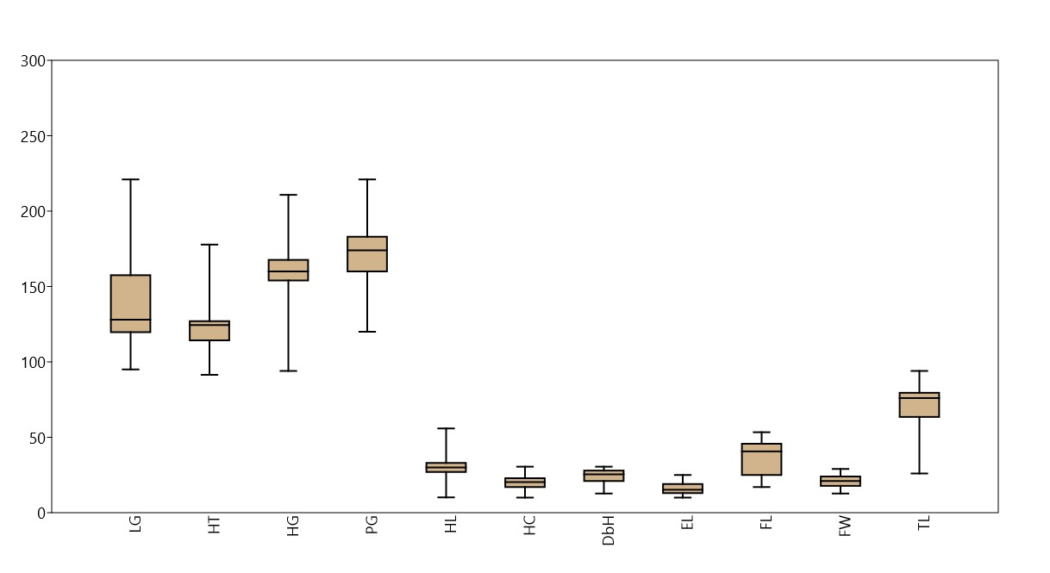
Suppl. figure 1(a): Boxplots for various morphometric traits in adult male Sikkimese Yaks
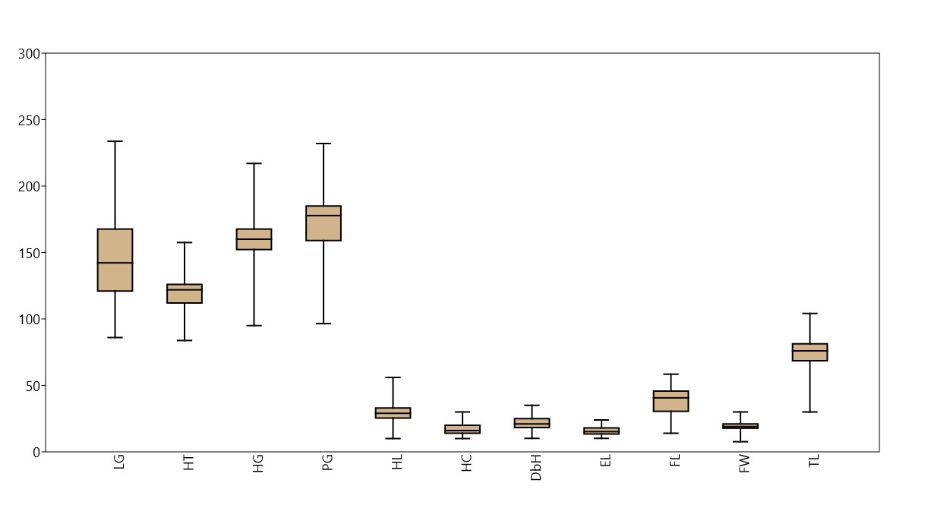
Suppl. figure 1(b): Boxplots for various morphometric traits in adult female Sikkimese Yaks

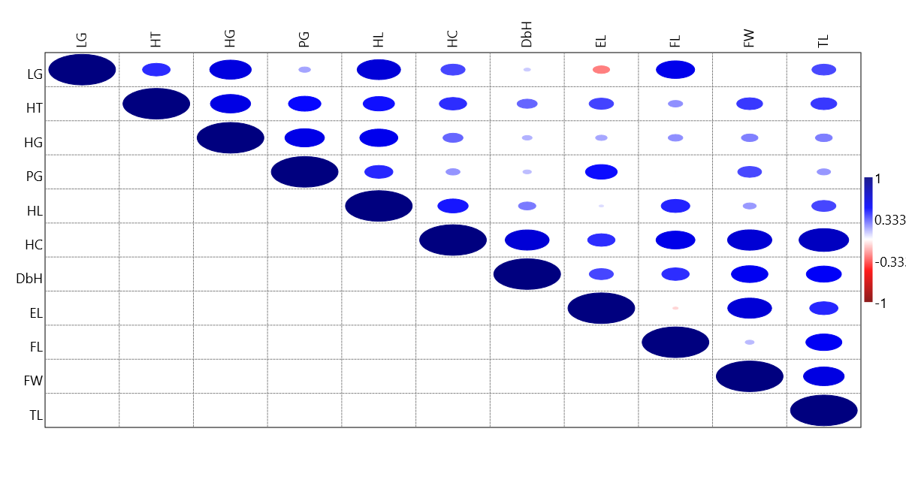
2(a)
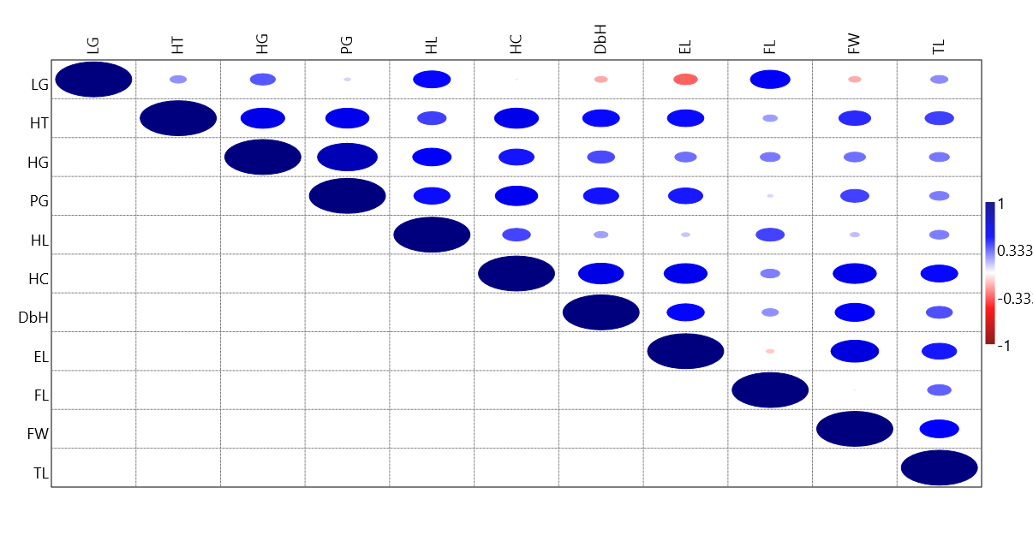
2(b)
Suppl. figure 2: Correlation matrix among various morphometric traits in adult Sikkimese yak 2(a) males, 2(b) females

