Supplementary materials
Supplementary Table 1. Regions of interest (Tzourio-Mazoyer et al.) included in the functional connectivity analysis
*IC (insular cortex) | *SFG (superior frontal gyrus)
*MidFG (middle frontal gyrus) | *PreCG (precentral gyrus)
*aSTG r (superior temporal gyrus, anterior division) | *pSTG (posterior temporal gyrus, anterior division)
*aMTG (middle temporal gyrus, anterior division) | *pMTG (middle temporal gyrus, posterior division)
*toMTG (middle temporal gyrus, temporooccipital part) | *aITG (inferior temporal gyrus, anterior division)
*pITG (inferior temporal gyrus, posterior division) | *toITG (inferior temporal gyrus, temporooccipital part)
*PostCG r (postcentral gyrus right) | *aSMG (supramarginal gyrus, anterior division)
*pSMG (supramarginal gyrus, posterior division) | *AG (angular gyrus)
*SMA (juxtapositional lobule cortex, formerly called supplementary motor area) | SubCalC (subcallosal cortex)
*PaCiG (paracingulate gyrus) | PC (cingulate gyrus, posterior division)
*aPaHC (parahippocampal gyrus, anterior division) | *pPaHC (parahippocampal gyrus, posterior division)
*aTFusC (temporal fusiform cortex, anterior division) | *pTFusC (temporal fusiform cortex, posterior division)
*FO (frontal operculum cortex) | *CO (central opercular cortex)
*PO (parietal operculum cortex) | *PP (planum polare)
*HG (Heschl’s gyrus) | *PT (planum temporale)
*Caudate  *Pallidum | *Putamen  *Thalamus
*Hippocampus | *Accumbens
*Amygdala
*Cereb1 (cerebellum Crus1) | *Cereb2 (cerebellum Crus2)
*Cereb3 (cerebellum 3) | *Cereb4 (cerebellum 4)
*Cereb4,5 (cerebellum 4,5) | *Cereb6 (cerebellum 6)
*Cereb7 (cerebellum 7) | *Cereb8 (cerebellum 8)
*Cereb9 (cerebellum 9) | *Cereb10 (cerebellum 10)
Ver1,2 (vermis 1,2) | Ver3 (vermis 3)
Ver4,5 (vermis 4,5) | Ver6 (vermis 6)
Ver7 (vermis 7) | Ver8 (vermis 8)
Ver9 (vermis 9) | Ver10 (vermis 10)
Note: ROIs labeled with “*” represent bilateral seeds.

Supplementary Table 2. Changes in functional connectivity after 36h-TSD
Connection |  |  | T (34) | p-unc | p-FDR
Cereb1 r | Cereb6 l |  | 3.66 | 0.001 | 0.009
Cereb1 r | aMTG r |  | –3.47 | 0.001 | 0.034
Cereb1 l | IC r |  | 3.07 | 0.004 | 0.047
Cereb1 l | Cereb6 l |  | 3.15 | 0.003 | 0.024
Cereb2 l | SFG r |  | 5.55 | 0.000 | 0.000
Cereb2 l | MidFG r |  | 2.96 | 0.006 | 0.041
Cereb2 l | PaCiG r |  | 3.04 | 0.004 | 0.023
Cereb2 r | SFG l |  | 3.92 | 0.000 | 0.020
Cereb2 r | PC |  | 3.64 | 0.001 | 0.006
Cereb45 r | aMTG l |  | 3.10 | 0.004 | 0.035
Cereb45 l | aMTG l |  | 2.97 | 0.005 | 0.040
Cereb45 l | PC |  | 3.65 | 0.001 | 0.006
Cereb6 r | SMA l |  | 2.93 | 0.006 | 0.042
Cereb6 r | Putamen r |  | 3.65 | 0.001 | 0.029
Cereb6 l | Putamen r |  | 4.30 | 0.000 | 0.007
Cereb6 l | Putamen l |  | 3.67 | 0.001 | 0.040
Cereb6 l | pSTG r |  | 3.85 | 0.001 | 0.049
Cereb6 l | SMA l | 5.47 |  | 0.000 | 0.000
Cereb6 l | SMA r | 4.68 |  | 0.000 | 0.004
Cereb6 l | HG l | 4.84 |  | 0.000 | 0.003
Cereb6 l | PT r | 3.66 |  | 0.001 | 0.017
Cereb6 l | PT l | 3.96 |  | 0.000 | 0.036
Cereb6 l | CO r | 3.59 |  | 0.001 | 0.033
Cereb6 l | PO r | 3.11 |  | 0.004 | 0.037
Cereb6 l | IC r | 3.06 |  | 0.004 | 0.047
Cereb7 r | MidFG l | 4.62 |  | 0.000 | 0.005
Cereb7 r | PaCiG l | 3.16 |  | 0.003 | 0.046
Cereb7 l | SFG r | 3.03 |  | 0.005 | 0.046
Cereb7 l | PaCiG r | 3.40 |  | 0.002 | 0.014
Cereb7 l | PC | 3.05 |  | 0.004 | 0.023
Cereb7 l | MidFG r | 5.45 |  | 0.000 | 0.000
Cereb7 l | AG r | 4.19 |  | 0.000 | 0.008
Cereb8 r | MidFG r | 2.94 |  | 0.006 | 0.041
Cereb8 l | MidFG r | 4.33 |  | 0.000 | 0.003
Cereb9 r | MidFG r | 3.47 |  | 0.001 | 0.027
Cereb9 l | MidFG r | 4.97 |  | 0.000 | 0.001
Ver3 | PostCG r | 3.64 |  | 0.001 | 0.029
Ver45 | PreCG l | 3.71 |  | 0.001 | 0.036
Ver45 | aMTG r | 3.20 |  | 0.003 | 0.042
AG r | Accumbens l | –3.15 |  | 0.003 | 0.042
IC r | Pallidum l | 3.83 |  | 0.001 | 0.023
IC r | Pallidum r | 3.28 |  | 0.002 | 0.033
PO l | Thalamus l | 4.78 |  | 0.000 | 0.003
CO l | Thalamus l | 4.28 |  | 0.000 | 0.007
PO r | Thalamus l | 4.50 |  | 0.000 | 0.007
PO r | Thalamus r | 3.41 |  | 0.002 | 0.024
Putamen r | PC | –4.35 |  | 0.000 | 0.007
Putamen l | PC | –3.74 |  | 0.001 | 0.040
SFG r | pMTG r | 4.12 |  | 0.000 | 0.006
SFG r | aMTG l | 3.22 |  | 0.003 | 0.035
AG r | PaCiG r | 4.08 |  | 0.000 | 0.008
AG r | SFG r | 5.41 |  | 0.000 | 0.000
aMTG l | PC | 6.62 |  | 0.000 | 0.000
aMTG r | PC | 5.70 |  | 0.000 | 0.000
pMTG l | PC | 5.02 |  | 0.000 | 0.002
pMTG r | PC | 4.71 |  | 0.000 | 0.004
pMTG r | PaCiG r | 4.03 |  | 0.000 | 0.006
aMTG l | PaCiG r | 4.07 |  | 0.000 | 0.006
aMTG l | PaCiG l | 3.55 |  | 0.001 | 0.022
aMTG l | SubCalC | 3.01 |  | 0.005 | 0.040
aMTG r | PaCiG r | 3.22 |  | 0.003 | 0.042
PostCG r | PostCG l | 5.41 |  | 0.000 | 0.000
PostCG r | PreCG l | 3.85 |  | 0.001 | 0.025
SMA l | PaCiG r | –5.75 |  | 0.000 | 0.000
SMA l | PaCiG l | –5.38 |  | 0.000 | 0.000
SMA r | PaCiG r | –4.43 |  | 0.000 | 0.004
SMA l | PC | –2.82 |  | 0.008 | 0.049
aSMG r | aMTG l | –4.83 |  | 0.000 | 0.002
aSMG r | aMTG r | –4.77 |  | 0.000 | 0.002
aSMG r | pMTG r | –4.13 |  | 0.000 | 0.007
aSMG r | pMTG l | –3.82 |  | 0.001 | 0.011
aSMG l | aMTG l | –4.10 |  | 0.000 | 0.020
aSMG l | aMTG r | –3.93 |  | 0.000 | 0.020
PO r | pITG r | –3.58 |  | 0.001 | 0.024
IC r | pITG r | –3.50 |  | 0.001 | 0.032
PO r | pITG l | –3.11 |  | 0.004 | 0.037
CO l | toITG r | 3.31 |  | 0.002 | 0.044
aSMG r | pITG r | –3.29 |  | 0.002 | 0.026
aSMG r | pITG l | –3.08 |  | 0.004 | 0.033
toMTG r | toITG l | –5.68 |  | 0.000 | 0.000
SMA l | SFG l | –4.74 |  | 0.000 | 0.001
SMA l | SFG r | –3.19 |  | 0.003 | 0.033
pMTG r | toITG r | –3.90 |  | 0.000 | 0.007
pMTG r | toITG l | –3.60 |  | 0.001 | 0.014
aMTG l | toITG l | –3.11 |  | 0.004 | 0.035
aMTG l | pSMG r | –3.36 |  | 0.002 | 0.031
aSMG r | PC | –3.81 |  | 0.001 | 0.011
aSMG r | PaCiG r | –3.35 |  | 0.002 | 0.024
aSMG r | AG r | –3.60 |  | 0.001 | 0.016
aSMG r | MidFG r | –3.10 |  | 0.004 | 0.033
aSMG r | SFG r | –3.11 |  | 0.004 | 0.033
MidFG l | aITG r | –3.93 |  | 0.000 | 0.019
SFG r | aITG l | 3.13 |  | 0.004 | 0.041
SMA r | pPaHC r | –4.38 |  | 0.000 | 0.004
SMA l | aPaHC l | –4.03 |  | 0.000 | 0.005
SMA l | aPaHC r | –2.93 |  | 0.006 | 0.042
FO l | aPaHC l | –3.66 |  | 0.001 | 0.048
FO l | pPaHC r | –3.61 |  | 0.001 | 0.048
aSTG l | aSTG r | –4.24 |  | 0.000 | 0.016
aSTG r | pMTG r | –4.05 |  | 0.000 | 0.014
pSMG r | PC | –3.98 |  | 0.000 | 0.034
toITG l | aITG r | –4.79 |  | 0.000 | 0.002
toITG r | aITG r | –3.96 |  | 0.000 | 0.021
toITG l | aITG l | –3.44 |  | 0.002 | 0.038
CO r | MidFG r | –4.44 |  | 0.000 | 0.009
PO r | MidFG r | –3.4 |  | 0.002 | 0.024
IC r | MidFG r | –3.31 |  | 0.002 | 0.033
CO r | AG r | –3.40 |  | 0.002 | 0.043
aITG r | PC | 3.64 |  | 0.001 | 0.017
FDR, false discovery rate.

Cover figure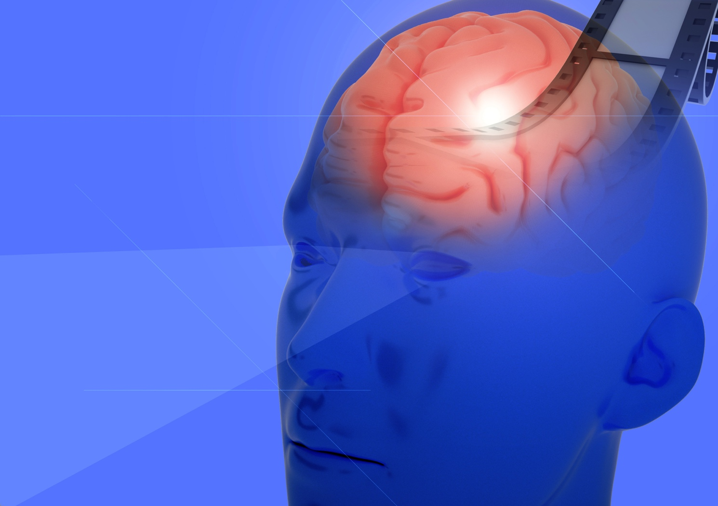

Workflow
