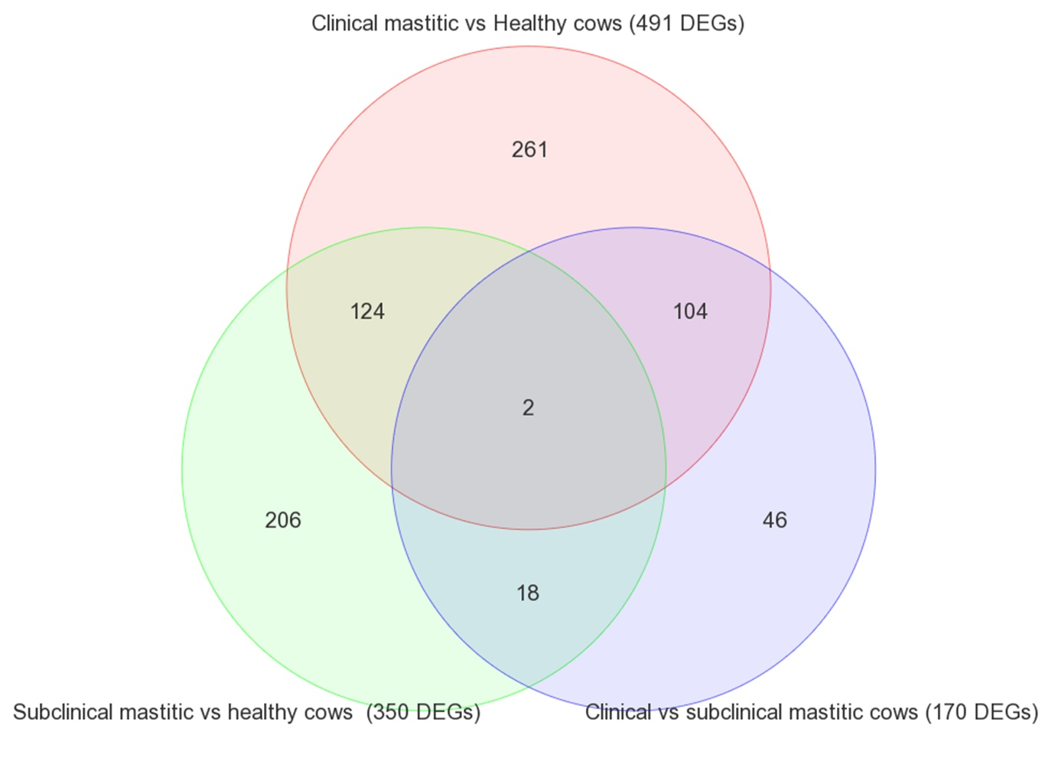
Supplementary file 3. Venn diagram for the comparison pairs between healthy cows (n = 144) and those with subclinical (n = 48) and clinical (n = 22) mastitis.

