(A)
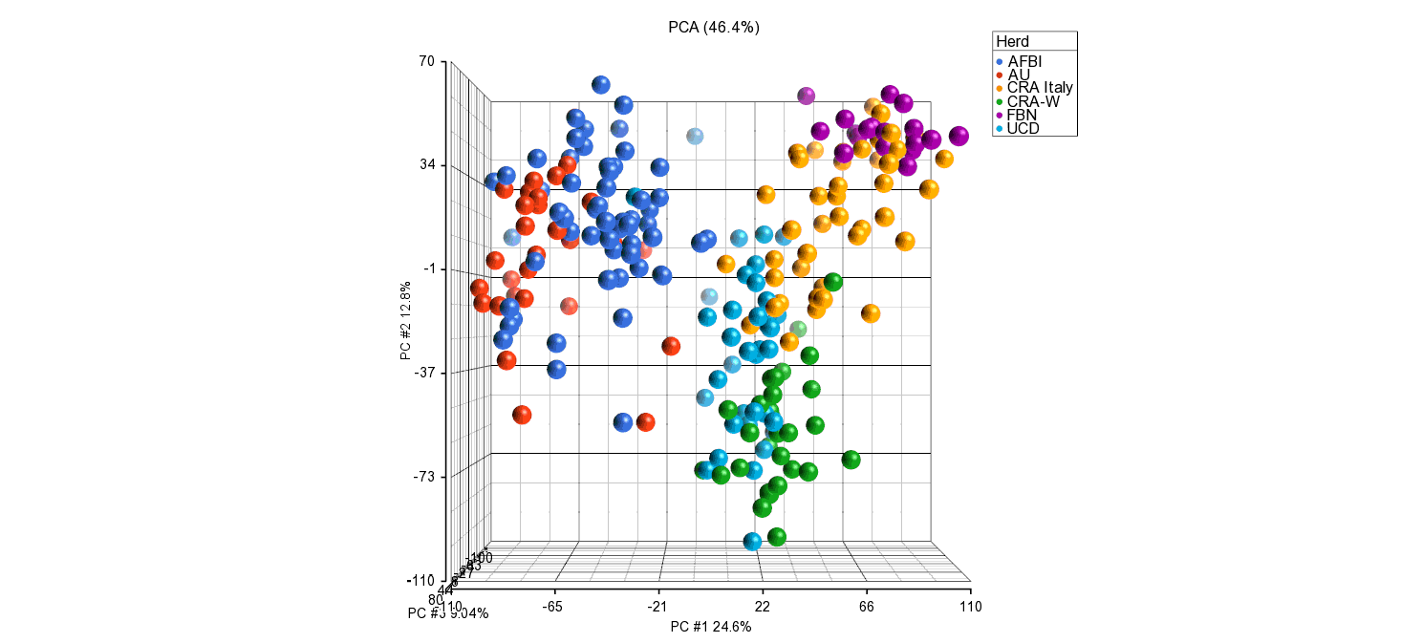

(B)
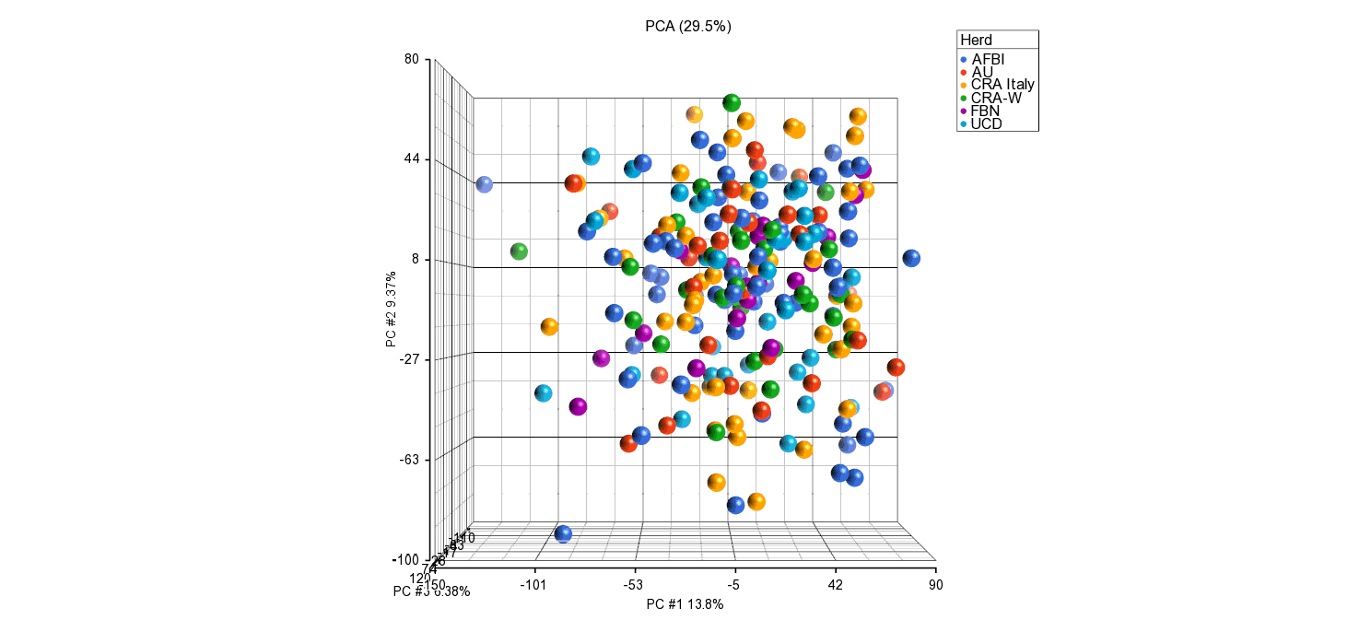
Supplementary file 2. Principal component analysis before (a) and (b) after removing herd effect.

