SUPPLEMENTARY DOCUMENTS

Table S1 The results of 18 common models before adjusting hyper-parameters
Number | Total AHI |  |  |  |  |  |  | Nocturnal supine position AHI
Number | Model | Accuracy | AUC | Recall | Precision | F1 |  | Model | Accuracy | AUC | Recall | Precision | F1
1 | RBFSVM | 0.64 | 0.68 | 0.79 | 0.64 | 0.70 |  | RBFSVM | 0.74 | 0.73 | 0.97 | 0.74 | 0.84
2 | CATBOOST | 0.67 | 0.72 | 0.77 | 0.68 | 0.72 |  | ET | 0.76 | 0.74 | 0.94 | 0.77 | 0.85
3 | ET | 0.67 | 0.75 | 0.77 | 0.68 | 0.72 |  | CATBOOST | 0.77 | 0.76 | 0.94 | 0.78 | 0.85
4 | LIGHTGBM | 0.66 | 0.71 | 0.76 | 0.67 | 0.71 |  | RF | 0.73 | 0.72 | 0.94 | 0.75 | 0.83
5 | LR | 0.66 | 0.70 | 0.74 | 0.67 | 0.70 |  | GBC | 0.76 | 0.75 | 0.89 | 0.78 | 0.83
6 | XGBOOST | 0.68 | 0.72 | 0.74 | 0.70 | 0.71 |  | LIGHTGBM | 0.75 | 0.74 | 0.89 | 0.79 | 0.83
7 | RF | 0.64 | 0.69 | 0.73 | 0.66 | 0.69 |  | XGBOOST | 0.76 | 0.74 | 0.88 | 0.79 | 0.84
8 | RIDGE | 0.65 | 0.00 | 0.73 | 0.67 | 0.70 |  | KNN | 0.66 | 0.59 | 0.84 | 0.72 | 0.77
9 | GBC | 0.65 | 0.70 | 0.73 | 0.67 | 0.70 |  | LR | 0.72 | 0.73 | 0.84 | 0.78 | 0.80
10 | LDA | 0.65 | 0.68 | 0.71 | 0.67 | 0.69 |  | ADA | 0.71 | 0.69 | 0.83 | 0.77 | 0.80
11 | ADA | 0.64 | 0.69 | 0.69 | 0.67 | 0.67 |  | MLP | 0.71 | 0.69 | 0.82 | 0.78 | 0.80
12 | MLP | 0.62 | 0.67 | 0.67 | 0.64 | 0.66 |  | RIDGE | 0.70 | 0.00 | 0.82 | 0.76 | 0.79
13 | KNN | 0.56 | 0.59 | 0.67 | 0.59 | 0.63 |  | LDA | 0.69 | 0.72 | 0.80 | 0.76 | 0.78
14 | GPC | 0.56 | 0.54 | 0.64 | 0.59 | 0.61 |  | SVM | 0.67 | 0.00 | 0.78 | 0.76 | 0.77
15 | SVM | 0.65 | 0.00 | 0.63 | 0.71 | 0.66 |  | GPC | 0.63 | 0.53 | 0.77 | 0.72 | 0.74
16 | DT | 0.57 | 0.57 | 0.58 | 0.62 | 0.60 |  | QDA | 0.62 | 0.54 | 0.75 | 0.62 | 0.65
17 | QDA | 0.51 | 0.60 | 0.31 | 0.64 | 0.39 |  | DT | 0.64 | 0.59 | 0.73 | 0.75 | 0.74
18 | NB | 0.54 | 0.66 | 0.29 | 0.70 | 0.39 |  | NB | 0.50 | 0.70 | 0.35 | 0.84 | 0.48
ADA: Ada Boost Classifier; CATBOOST: CatBoost Classifier; DT: Decision Tree Classifier; ET: Extra Trees Classifier; GBC: Gradient Boosting Classifier; GPC: Gaussian Process Classifier; KNN: K Neighbors Classifier; LDA: Linear Discriminant Analysis; LIGHTGBM: Light Gradient Boosting Machine; LR: Logistic Regression; MLP: MLP Classifier; NB: Naive Bayes; QDA: Quadratic Discriminant Analysis; RBFSVM: SVM - Radial Kernel; RF: Random Forest Classifier; RIDGE: Ridge Classifier; SVM: SVM - Linear Kernel; XGBOOST: Extreme Gradient Boosting.
AUC: area under the ROC curve; F1: F1 score = 2*recall*precision/(recall+precision); Precision: model’s positive predictive value (PPV) in machine learning; Recall: model’s sensitivity in machine learning.

Table S2 The validation results of external validation dataset among top-5 models
Number | Total AHI |  |  |  |  |  |  | Nocturnal supine position AHI
Number | Model | Accuracy | AUC | Recall | Precision | F1 |  | Model | Accuracy | AUC | Recall | Precision | F1
1 | LR | 0.70 | 0.68 | 0.75 | 0.75 | 0.75 |  | CATBOOST | 0.82 | 0.56 | 0.96 | 0.84 | 0.90
2 | CATBOOST | 0.64 | 0.62 | 0.70 | 0.70 | 0.70 |  | GBC | 0.82 | 0.63 | 0.93 | 0.86 | 0.89
3 | LIGHTGBM | 0.64 | 0.62 | 0.70 | 0.70 | 0.70 |  | RF | 0.76 | 0.59 | 0.85 | 0.85 | 0.85
4 | ET | 0.58 | 0.56 | 0.65 | 0.65 | 0.65 |  | RBFSVM | 0.73 | 0.57 | 0.81 | 0.85 | 0.83
5 | RBFSVM | 0.52 | 0.49 | 0.60 | 0.60 | 0.60 |  | ET | 0.70 | 0.49 | 0.81 | 0.81 | 0.81
CATBOOST: CatBoost Classifier; ET: Extra Trees Classifier; GBC: Gradient Boosting Classifier; LIGHTGBM: Light Gradient Boosting Machine; LR: Logistic Regression; RBFSVM: SVM - Radial Kernel; RF: Random Forest Classifier.
AUC: area under the ROC curve; F1: F1 score = 2*recall*precision/(recall+precision); Precision: model’s positive predictive value (PPV) in machine learning; Recall: model’s sensitivity in machine learning.
Figure S1 The technique and scenario of photography
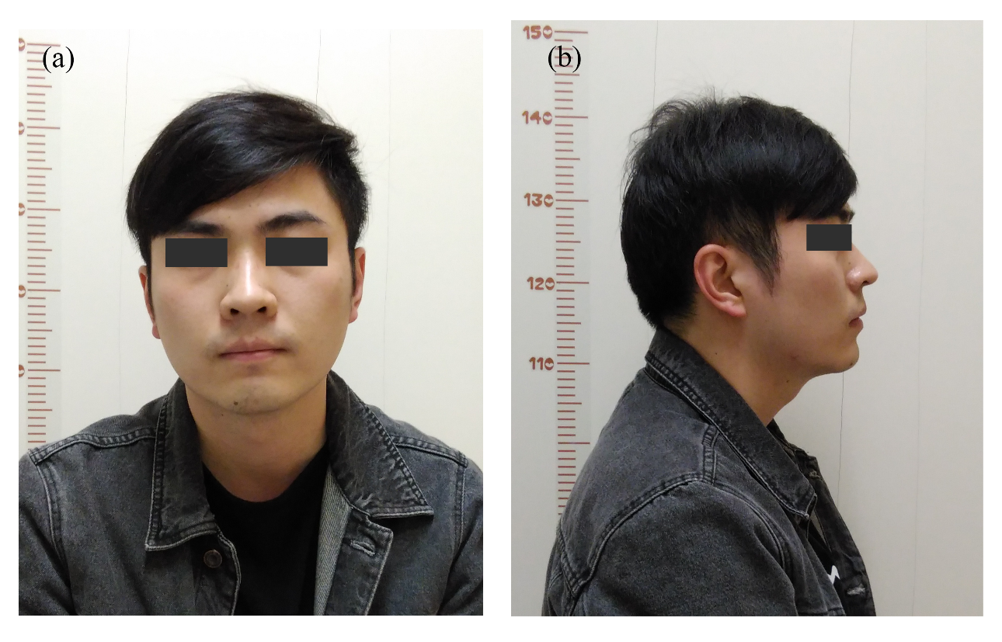(a) Frontal view needs to include eyes opening, clear eyebrows and ears; (b) Lateral view contains a clear outline with binoculus aligning. The patient had signed the consent for this study.

Figure S2 The distribution of 68 feature points and the anatomic characteristics
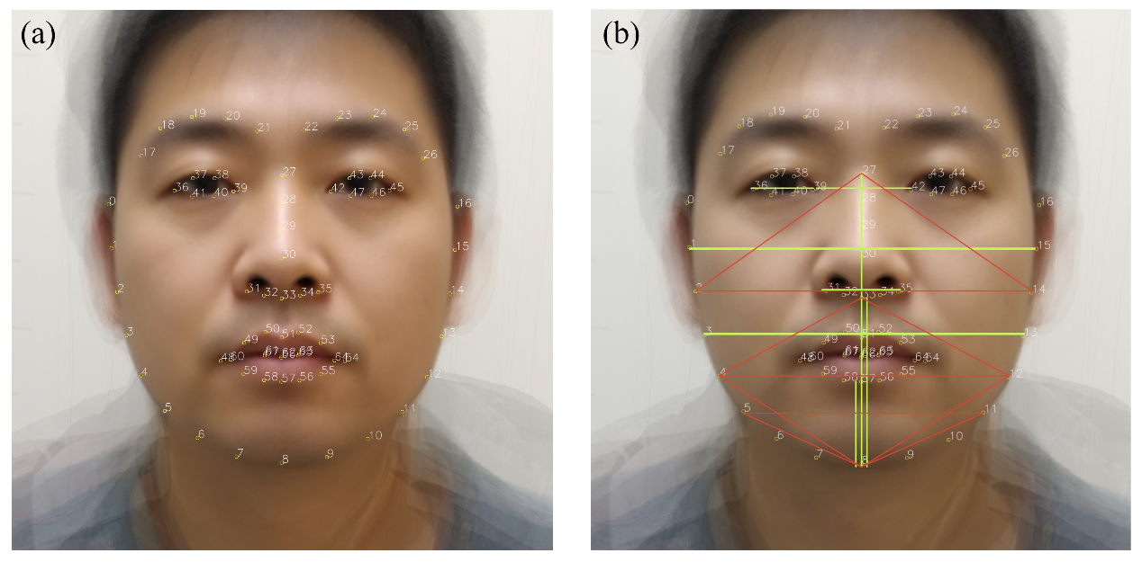
(a) The feature points depict the shape of face (0-26), nose (27-35), eyes (36-47) and mouth (48-68); (b) The green lines represent the distance variables and the area variables consist of red lines. The Average Face displayed in e-Figure 2 was generated by computer program to present the location of feature points.

Figure S3 The Average Face varied from genders
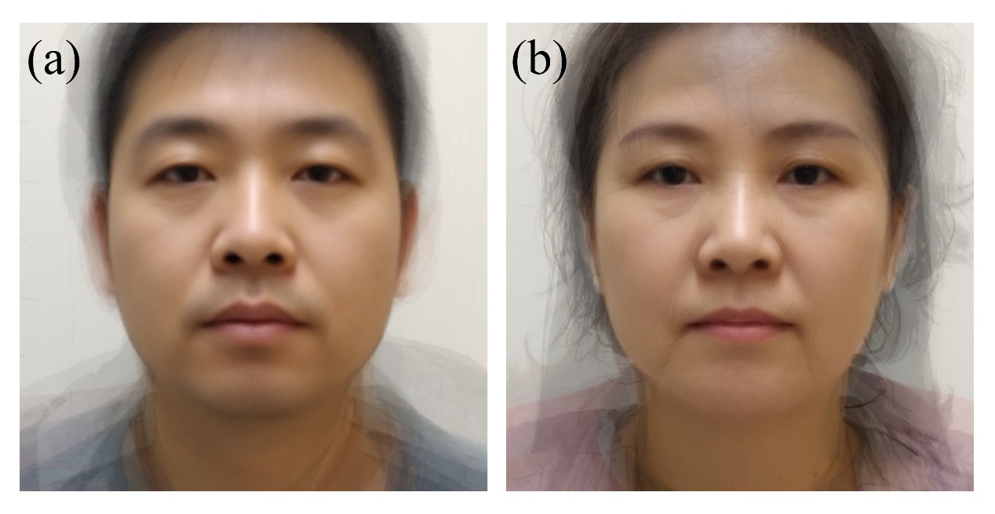
(a) The Average Face in male; (b) The Average Face in female. The Average Face displayed in e-Figure 3 was generated by computer program to show the gender differences.

Figure S4 ROC curve and predictive status of optimal model
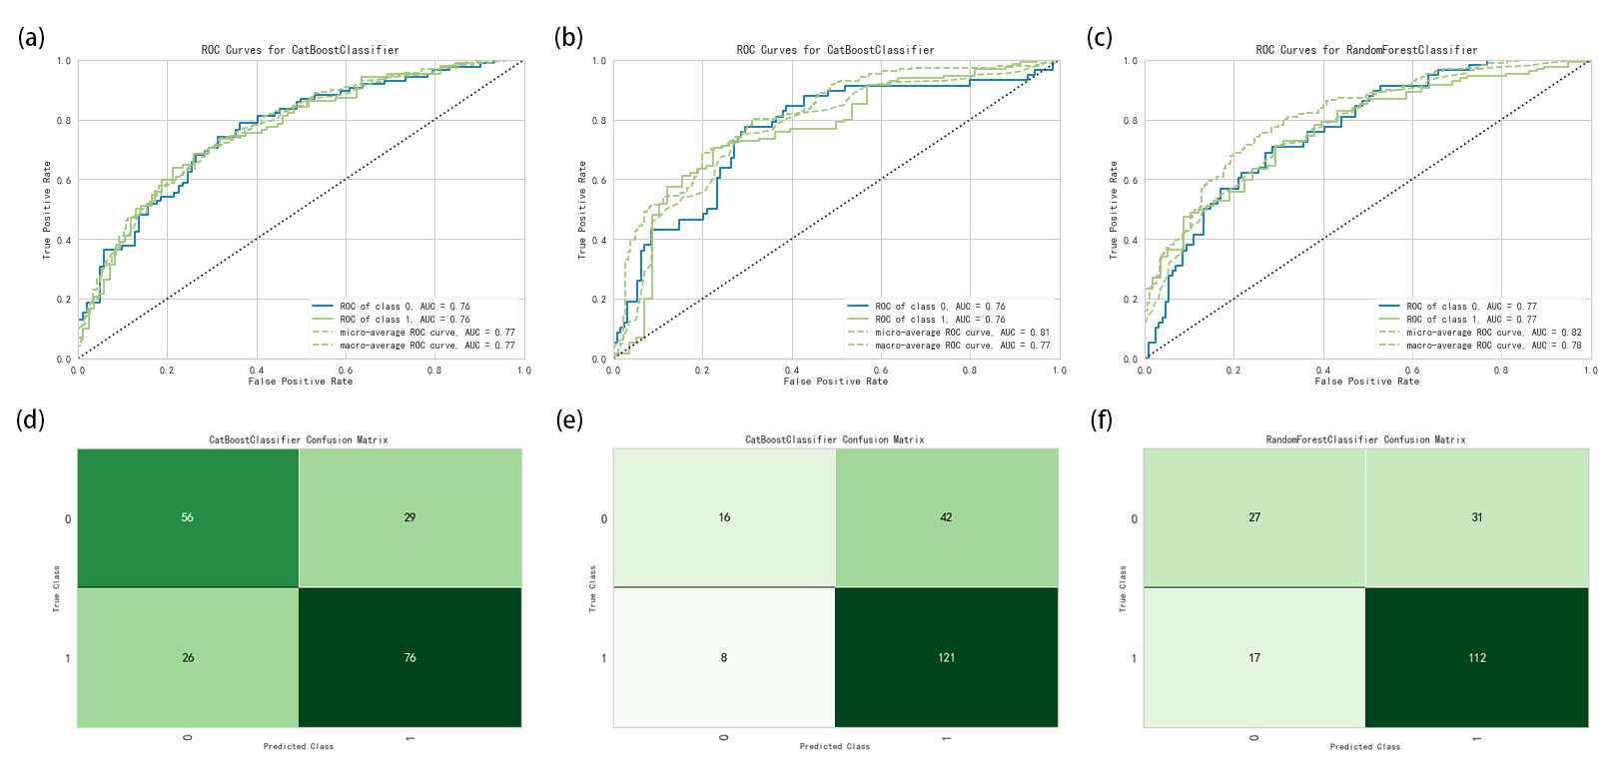
(a) The ROC curve of CATBOOST for classification of OSA (with best sensitivity and accuracy); (b) The ROC curve of CATBOOST for classification of supine sleep disorder (with best sensitivity); (c) The ROC curve of RF for classification of supine sleep disorder (with best accuracy); (d-f) The predictive status of each model after inputting test validation dataset.

Figure S5 The mobile application for OSA detection developed from this study


