Triclosan Loaded pH-sensitive Vehicles Spray Facilitate Infected Wound Healing by Eliminating Methicillin Resistant Staphylococcus Aureus in BiofilmAuthors
Changrong Wang^{1, a}, Jinghua Huang^{1, a}, Yifei Lin^{1, a}, Xiangjun Chenª, Wenting Liª, Shuna Zhengª, Yumin Zhang^{b,} *, Keke Li^{a,} *, Wei Hong^{a,} *, Jinjian Liu^{b,} *
ªSchool of Pharmacy, Shandong New Drug Loading & Release Technology and Preparation Engineering Laboratory, Binzhou Medical University, Guanhai Road 346,Yantai, 264003, China
^{b}Tianjin Key Laboratory of Radiation Medicine and Molecular Nuclear Medicine, Institute of Radiation Medicine, Chinese Academy of Medical Sciences and Peking Union Medical College, Tianjin 300192, China
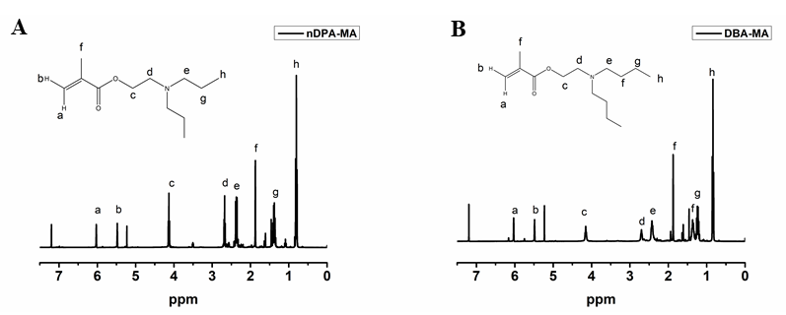
Figure S1. The ¹H NMR of nDPA-MA (A) and DBA-MA (B).
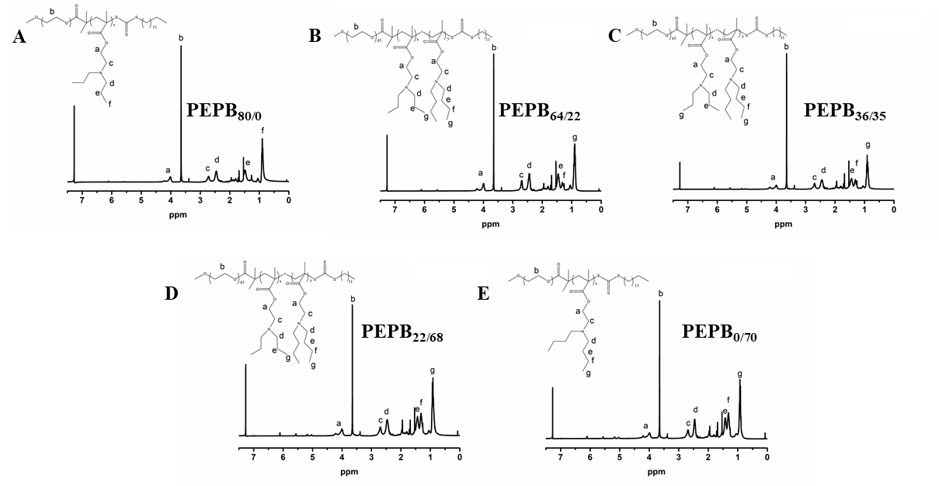
Figure S2. The ¹H NMR of PEPB_{80/0} (A), PEPB_{64/23} (B), PEPB_{36/35} (C), PEPB_{22/68} (D), PEPB_{0/100} (E).
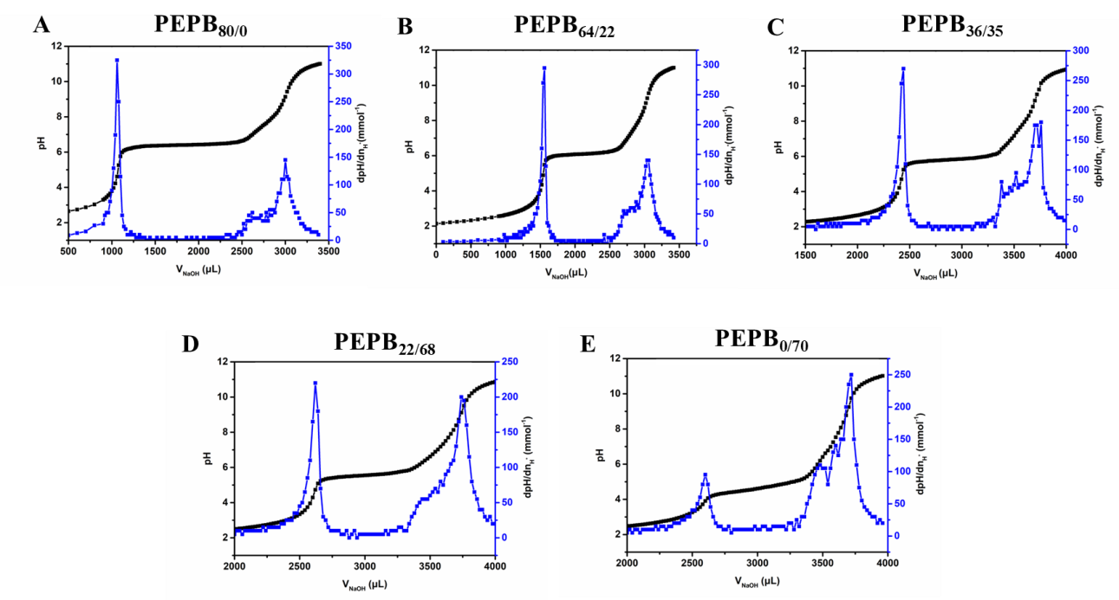
Figure S3. The titration curves of PEPB_{0/80} (A), PEPB_{64/22} (B), PEPB_{36/35} (C), PEPB_{22/68} (D), PEPB_{0/70} (E).
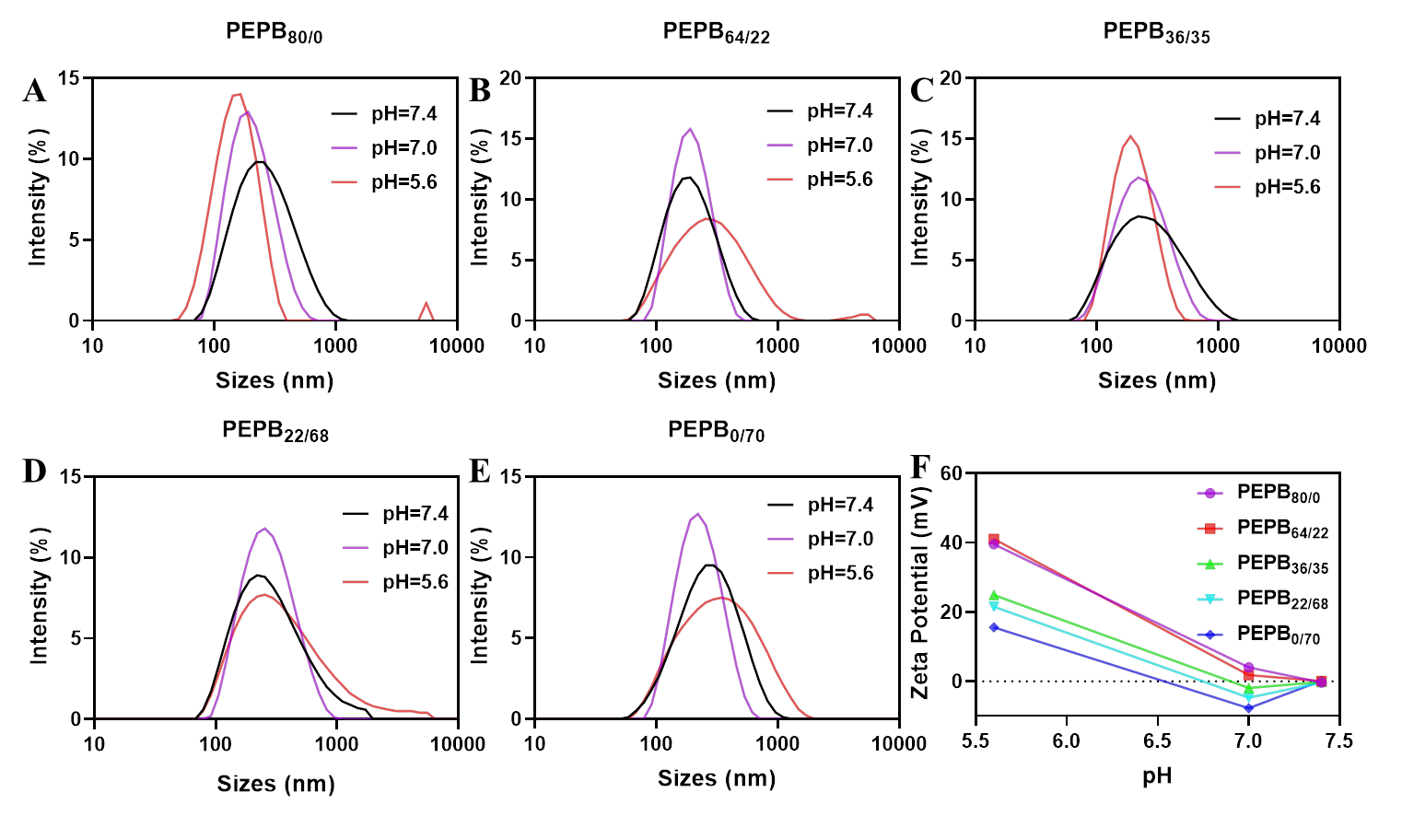
Figure S4. The pH-sensitive behaviors determination of PEPB_{x/y} NPs. (A-E) The sizes changes of PEPB_{x/y} NPs under different pH conditions. (F) Zeta potentials changes of PEPB_{x/y} NPs under different pH conditions.
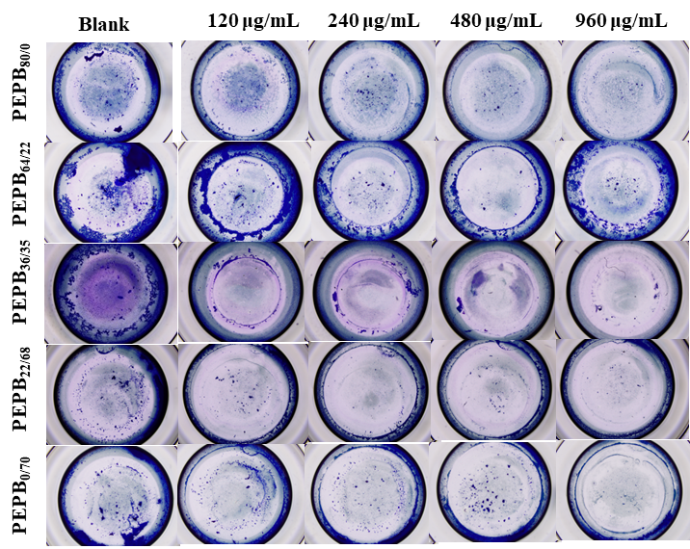
Figure S5. The biofilm elimination of MRSA under neutral environment with different concentration of PEPB_{x/y} NPs.

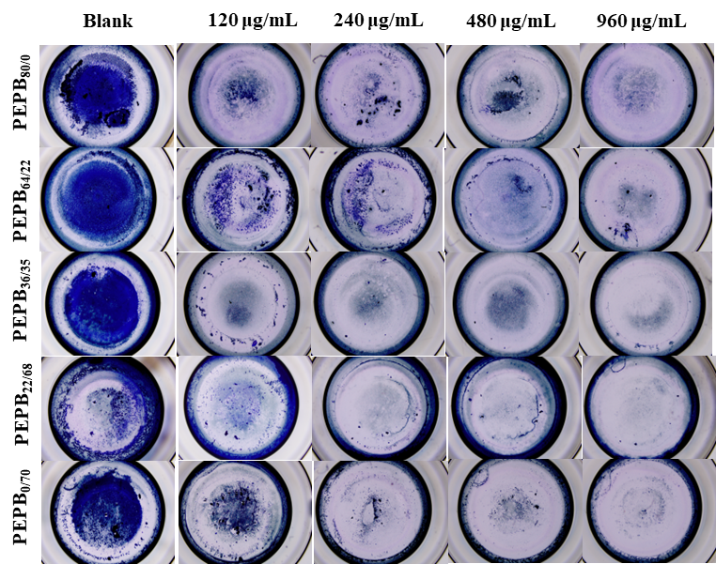
Figure S6. Biofilm elimination of MRSA in pH=5.6 medium with different concentration of PEPB_{x/y} NPs.
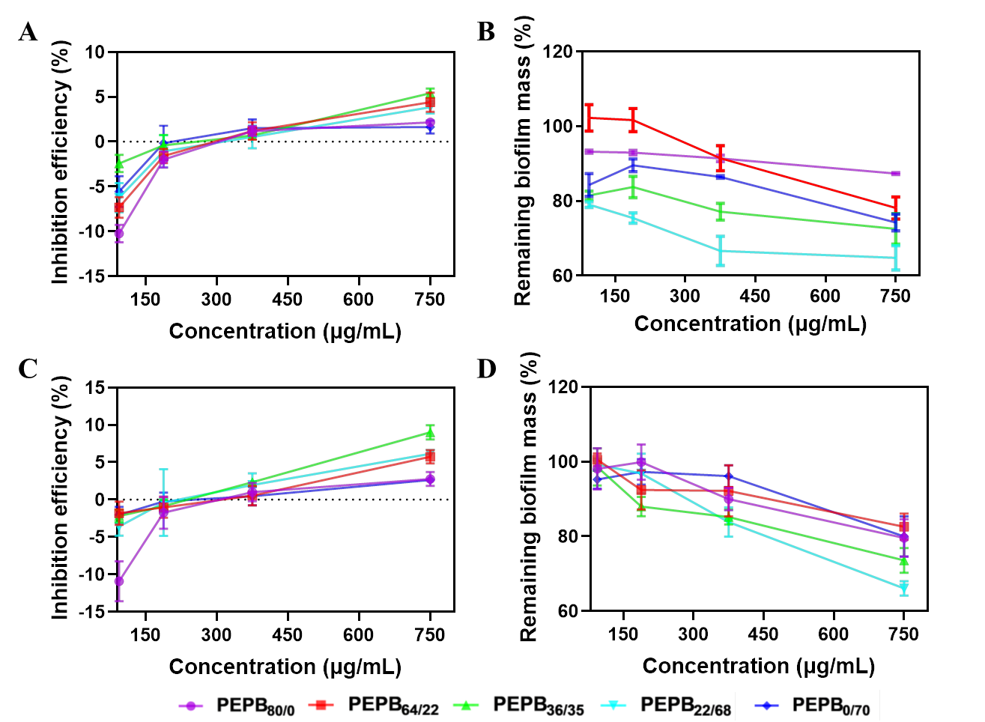
Figure S7. The P. aeruginosa inhibition and biofilm elimination by PEPB_{x/y} NPs. (A) and (B) the inhibition and biofilm elimanition of PEPB_{x/y} NPs under neutral environment. (C) and (D) the inhibition and biofilm elimination of PEPB_{x/y} NPs in pH=5.6 medium (Each bar represents Mean ± SEM of five experiments)
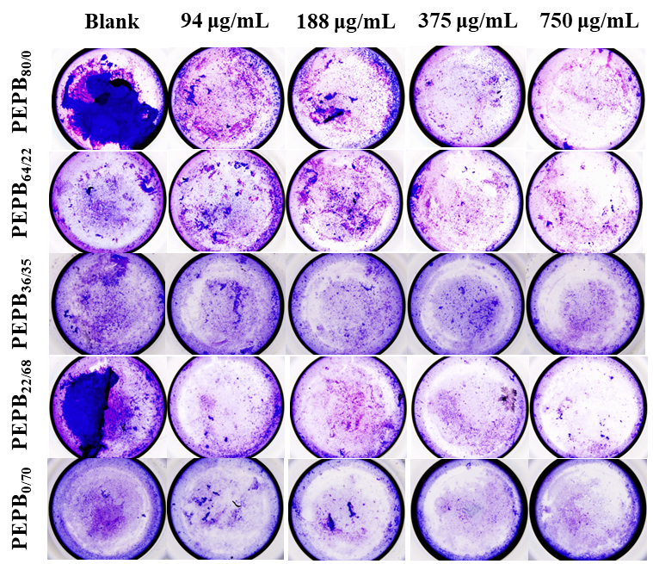
Figure S8. The biofilm elimination of P. Aeruginosa under neutral environment with different concentration of PEPB_{x/y} NPs.
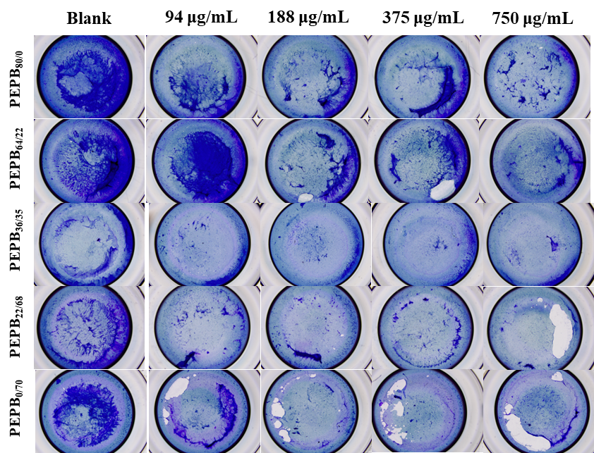
Figure S9. The biofilm elimination of P. Aeruginosa in pH 5.6 medium with different concentration of PEPB_{x/y} NPs.
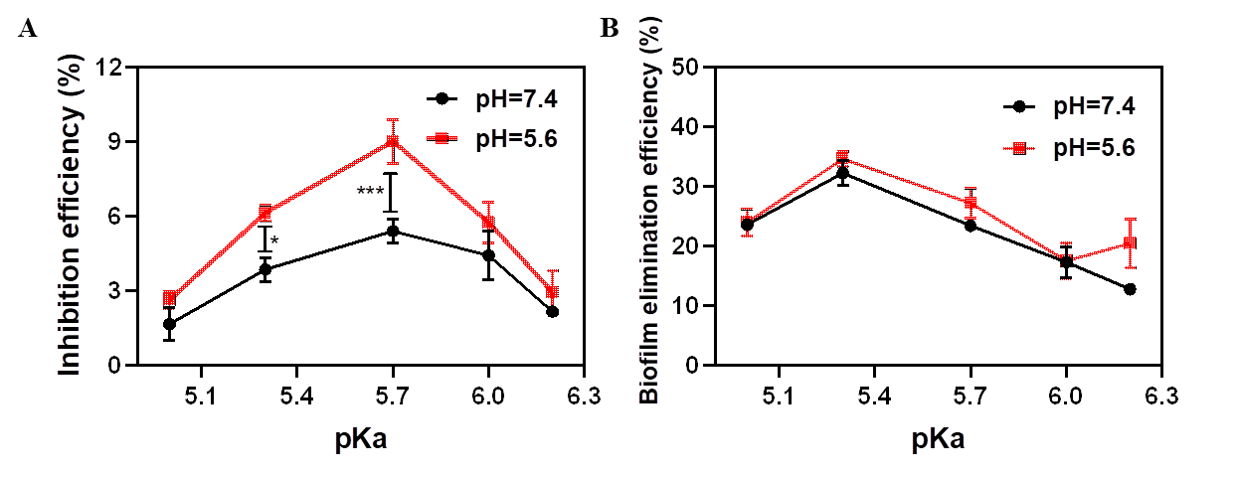
Figure S10. Plotting pKa values with antibacterial efficiency (A) and biofilm elimination (B) on P. Aeruginosa under different pH environment.
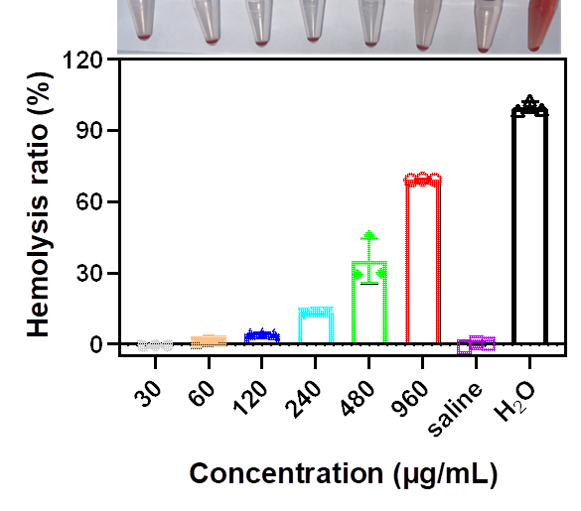
Figure S11. The hemolysis of PEPB_{80/0} NPs with different concentration (each bar represents Mean ± SEM of three experiments).
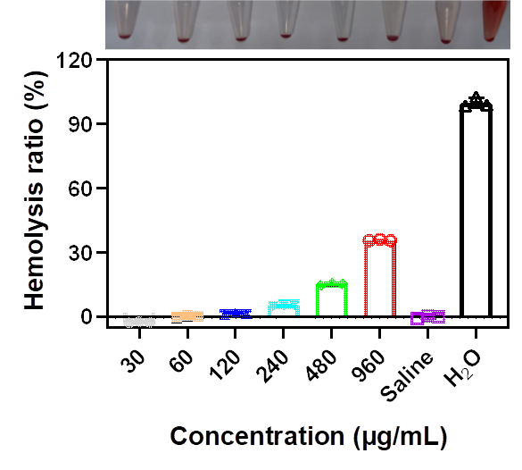
Figure S12. The hemolysis of PEPB_{64/22} NPs with different concentration (each bar represents Mean ± SEM of three experiments).
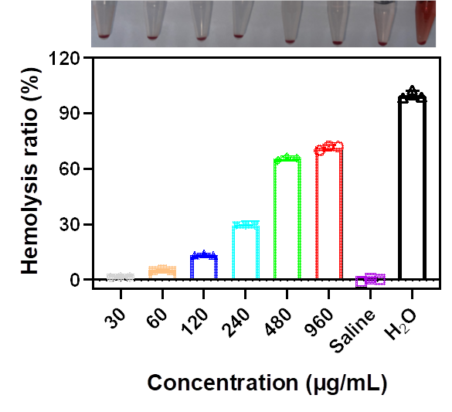
Figure S13. The hemolysis of PEPB_{22/68} NPs with different concentration (each bar represents Mean ± SEM of three experiments).
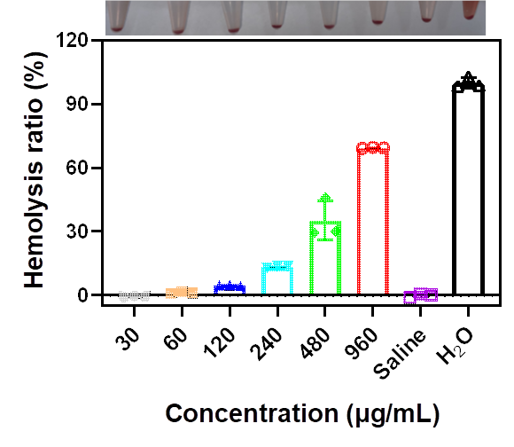
Figure S14. The hemolysis of PEPB_{0/70} NPs with different concentration (each bar represents Mean ± SEM of three experiments).
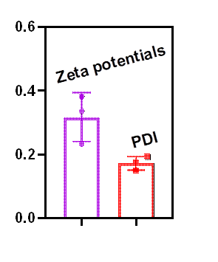
Figure S15. The zeta potential and PDI of PEPB_{36/35}@TCS NPs.
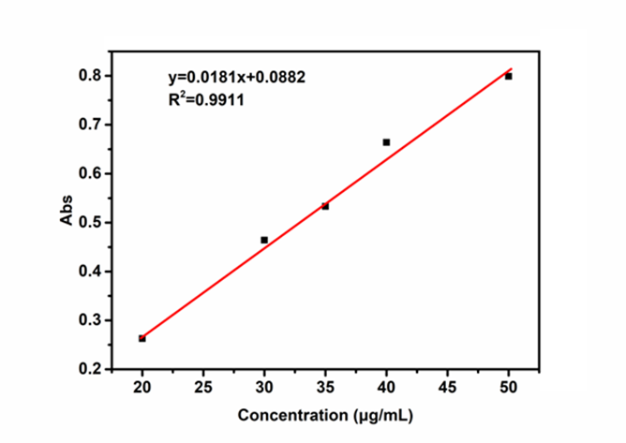
Figure S16. The standard curve of TCS determined by ultraviolet-visible spectrophotometer at 282 nm.

Table 1. The MIC of PEPB_{36/35}@TCS NPs under different pH environment.
 | MRSA | MRSA
 | pH=7.4 | pH=5.6
TCS | 0.125 µg/mL | 0.125 µg/mL
PEPB_{36/35}@TCS NPs | 0.25 µg/mL | 0.125 µg/mL

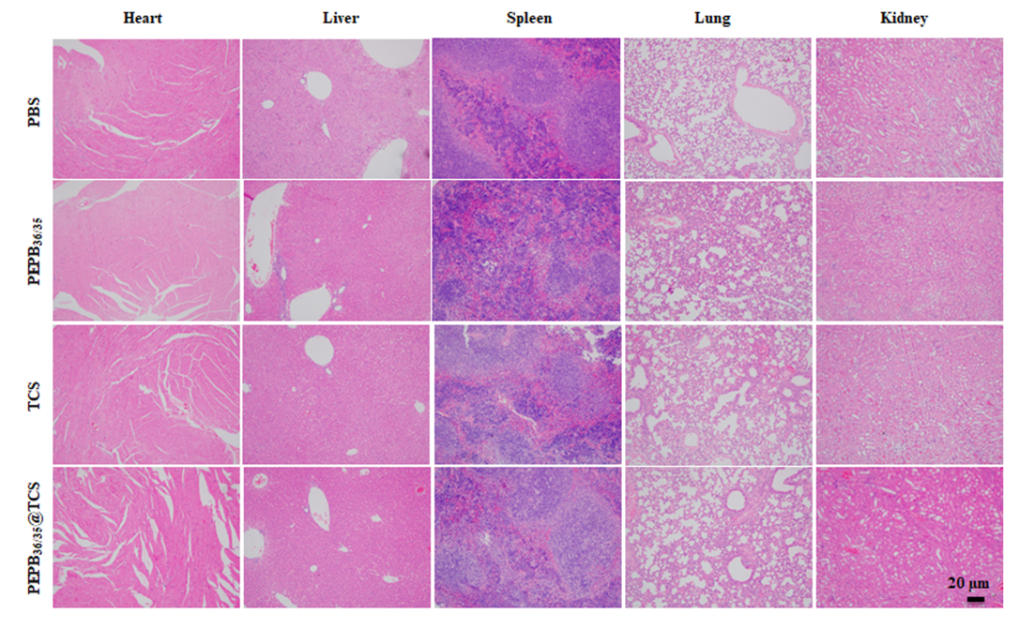
Figure S17. H&E staining of main organs.

