Table 1: Phenolic profile of boiled C. esculenta tuber (mg/g)[4] and standard inhibitors.
PubChem CID | Assigned ID | Name | Mean ± SD | 3D Structure
57363 | FIN | Finasteride | 2.75 ±0.11 | 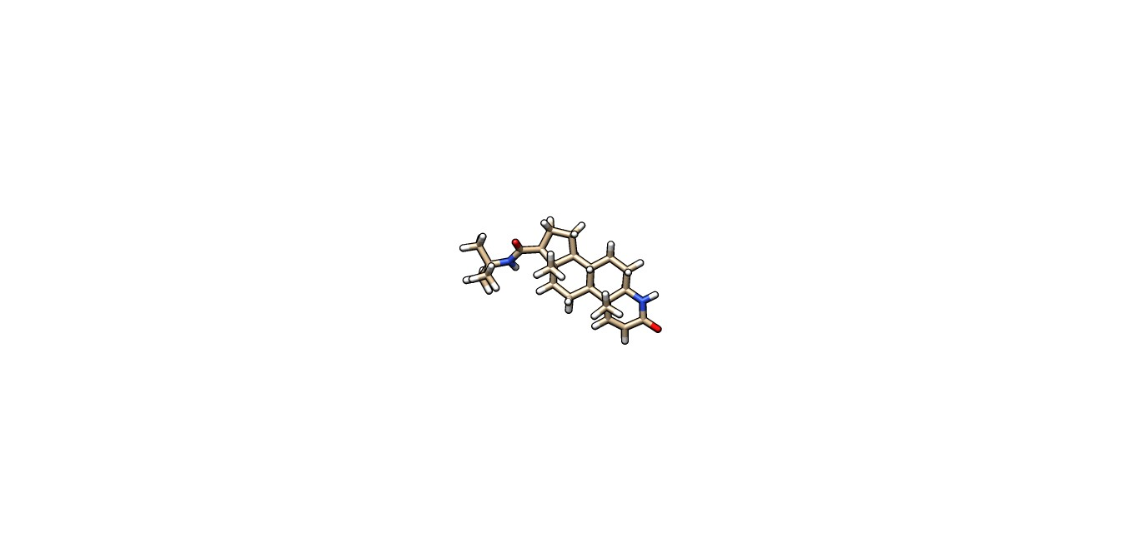
129211 | TIM | Tamsulosin | 0.86 ±0.00 | 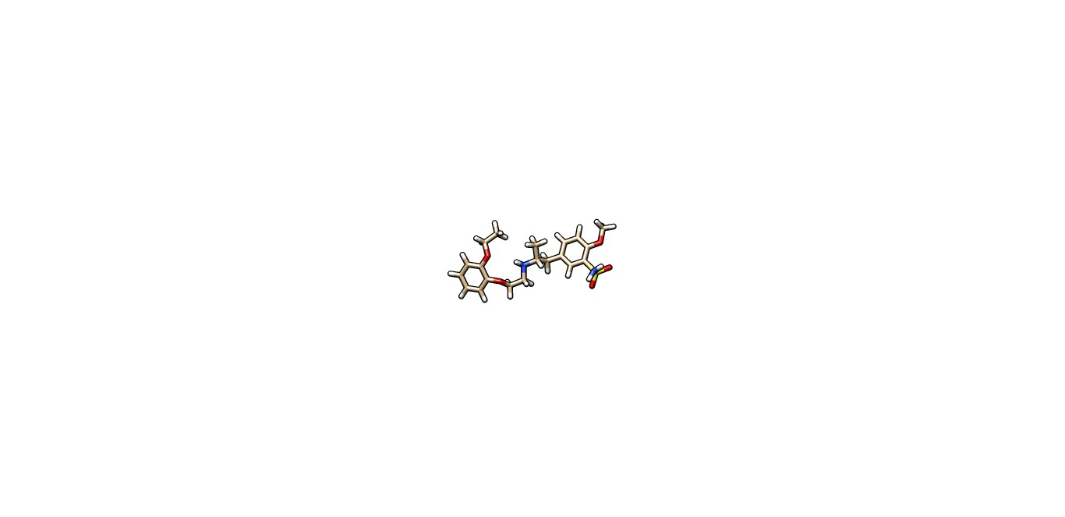
444539 | CyP 1 | Cinnamic acid | 0.09 ± 0.01 | 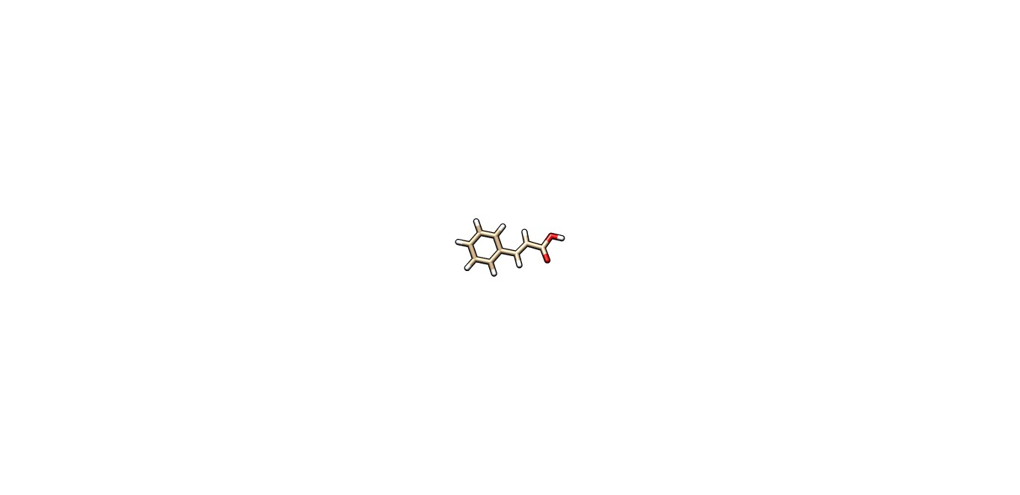
8468 | CyP 2 | Vanillic acid | 3.06 ± 0.00 | 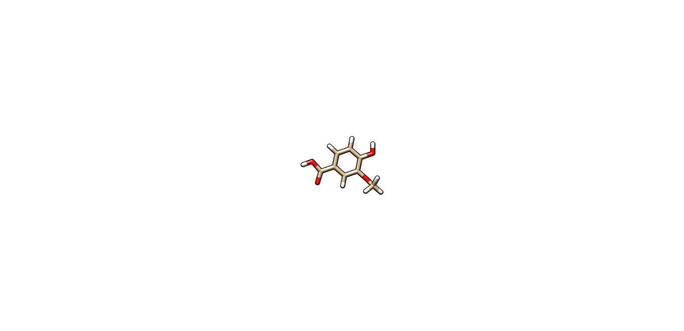
370 | CyP 3 | Gallic acid | 0.20 ±0.01 | 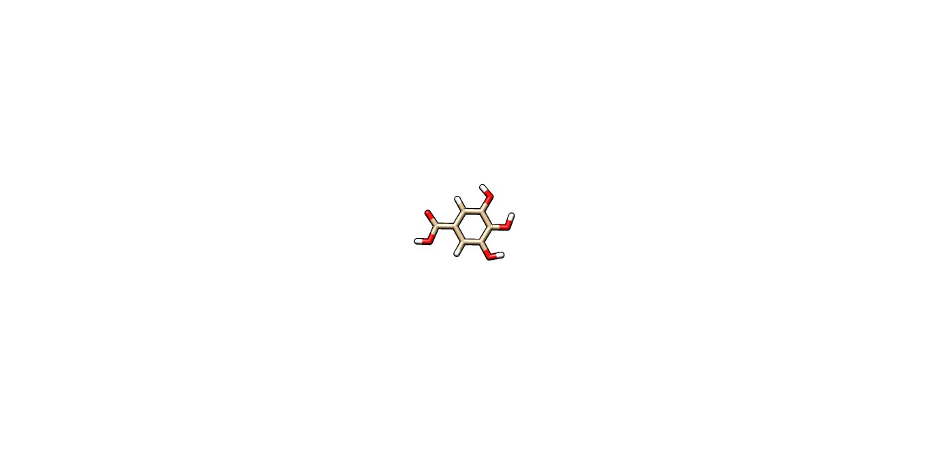
338 | CyP 4 | Salicyclic acid | 0.76 ±0.03 | 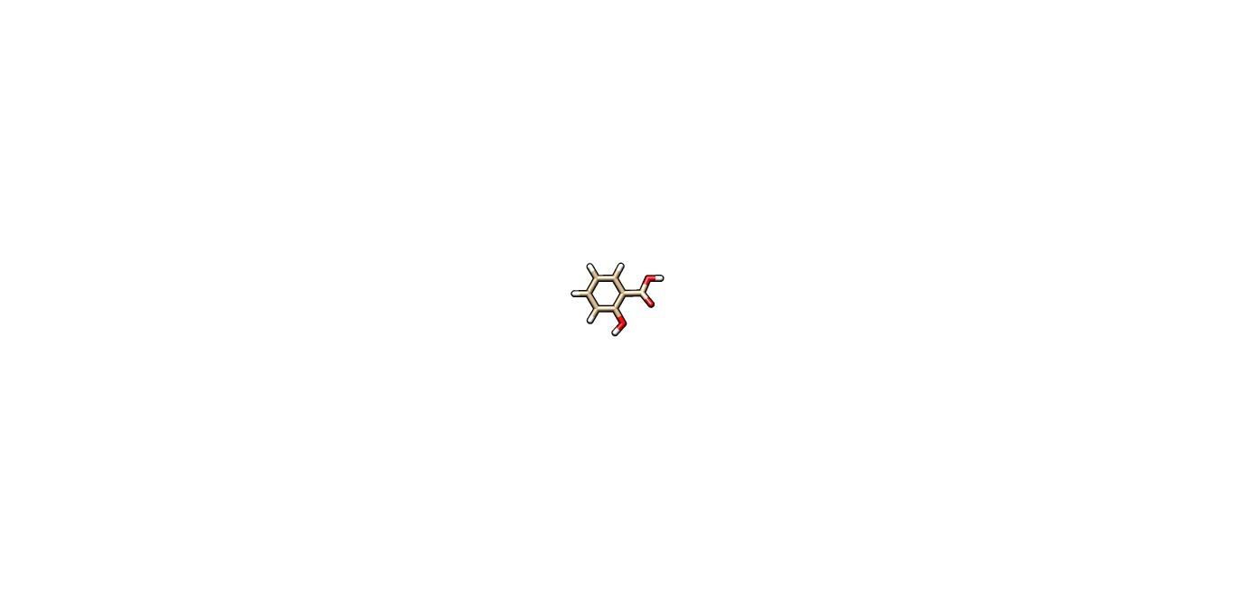
445858 | CyP 5 | Ferulic acid | 0.92 ±0.00 | 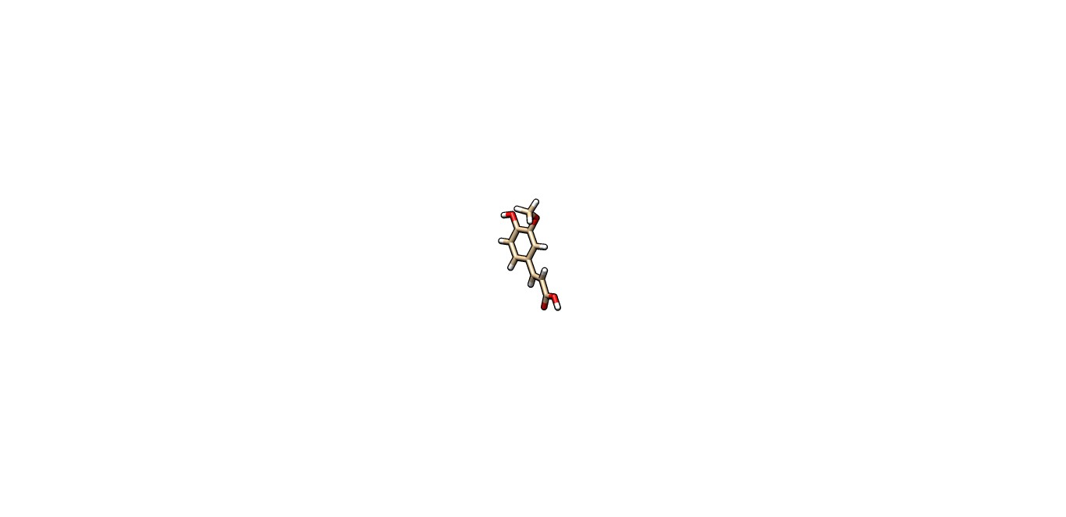
780 | CyP 6 | Homogentisic acid | 0.76 ±0.03 | 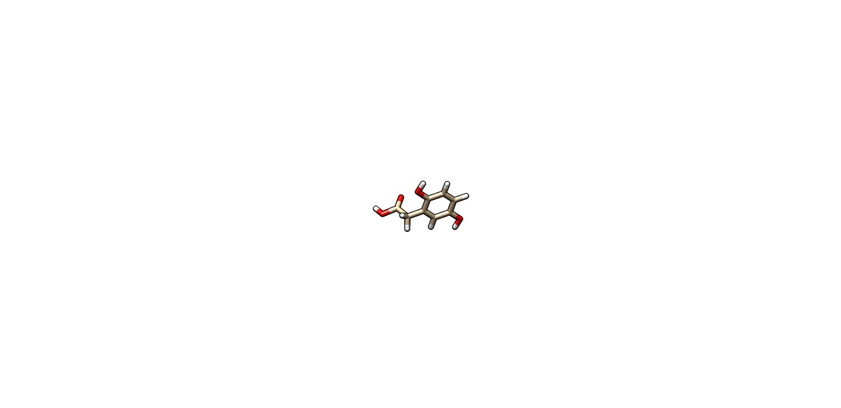
1057 | CyP7 | Pyrogallic | 0.29 ±0.05 | 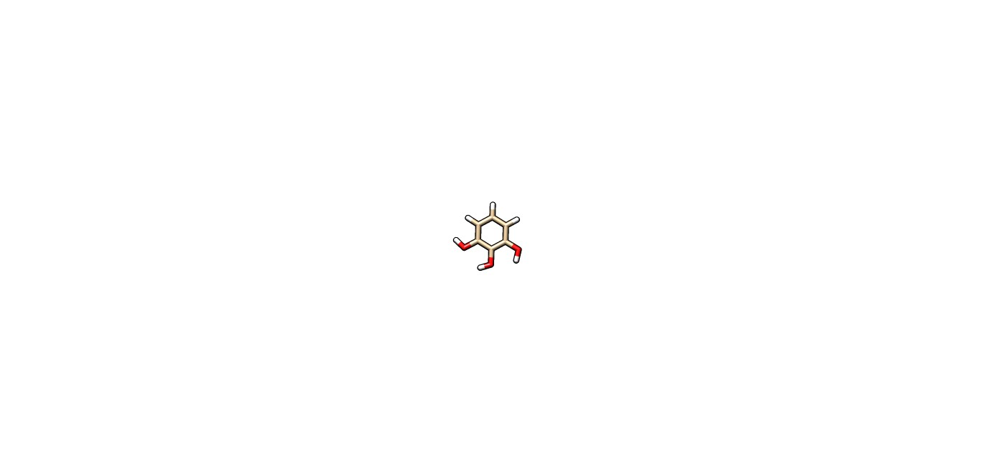
10742 | CyP8 | Syringic acid | 1.19 ±0.12 | 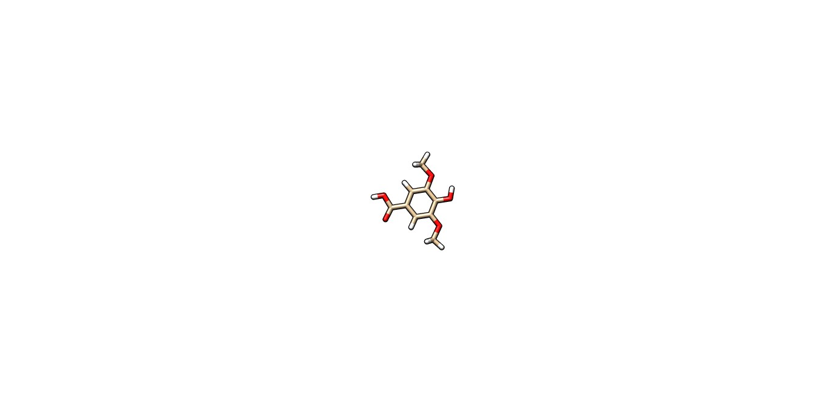
243 | CyP9 | Benzoic acid | 0.01 ±0.00 | 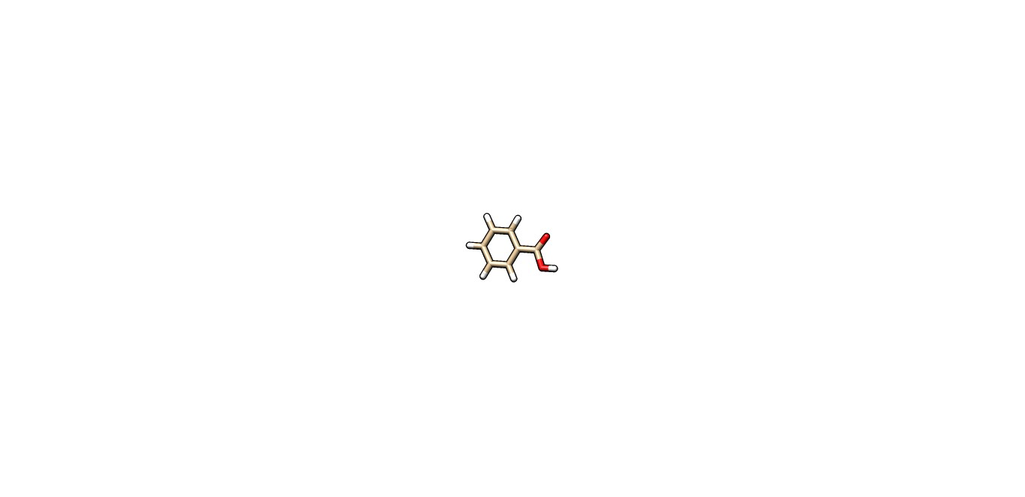
736186 | CyP10 | Isoferulic acid | 0.64 ±0.07 | 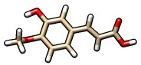
1292 | CyP11 | Mandelic acid | 2.05 ±0.01 | 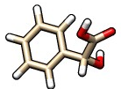
7240 | CyP12 | M-OH benzoic | 0.03 ±0.00 | 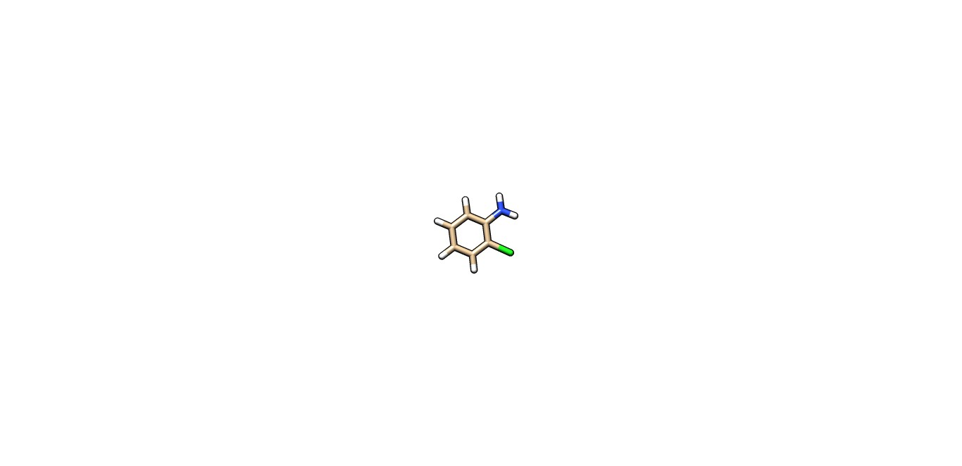
1738 | CyP13 | Homovanillic | 2.07 ±0.11 | 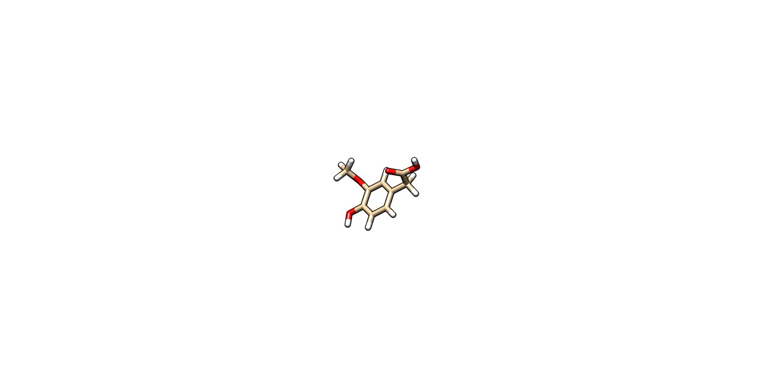
72 | CyP14 | Protocatechuic | 0.03 ±0.00 | 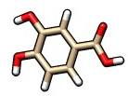
637542 | CyP15 | P-coumaric acid | 0.02 ±0.01 | 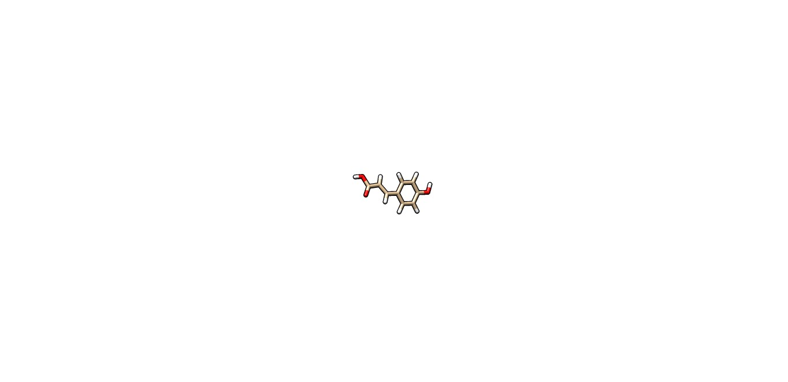
16129778 | CyP16 | Tannic acid | 0.01 ±0.00 | 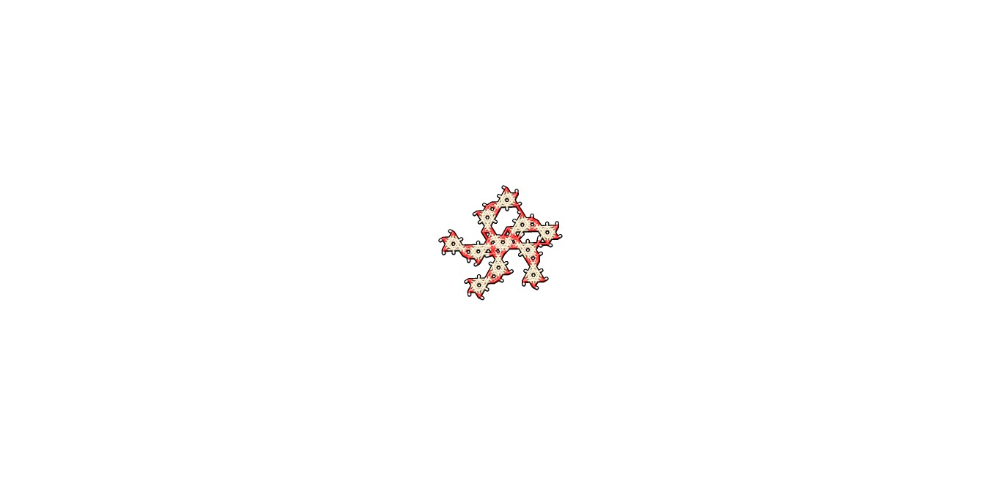
135 | CyP17 | p-hydroxybenzoic acid | 2.38±0.00 | 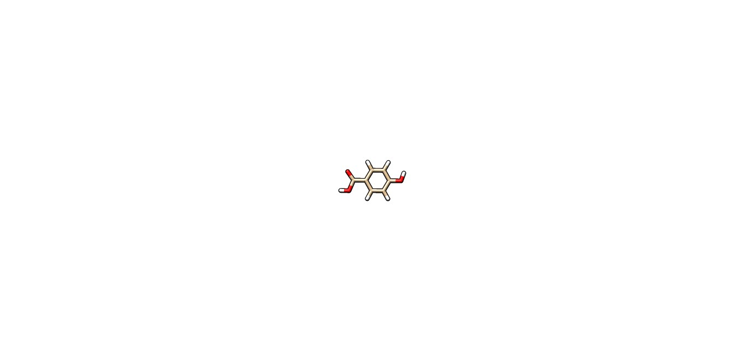
689043 | CyP18 | Caffeic acid | 0.20 ±0.07 | 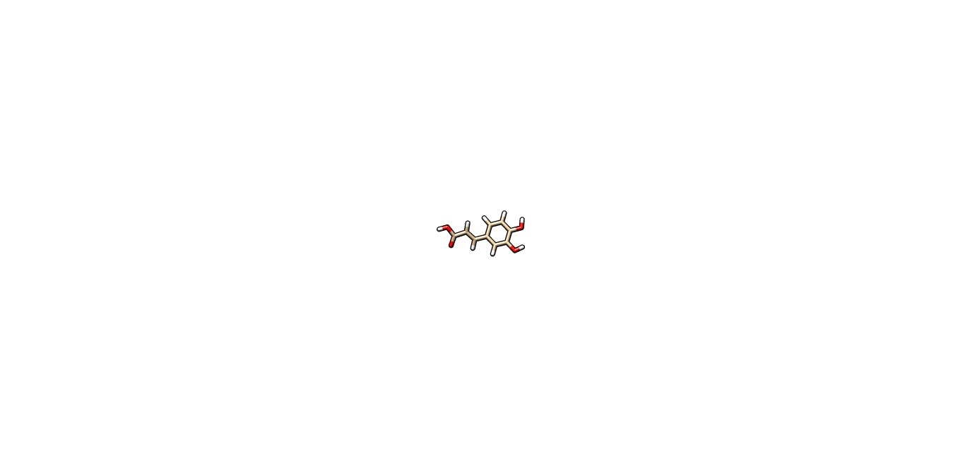
23724699 | CyP19 | Cyanidin coumaroyl | 0.03 ±0.01
9064 | CyP20 | Catechin | 0.14 ±0.00 | 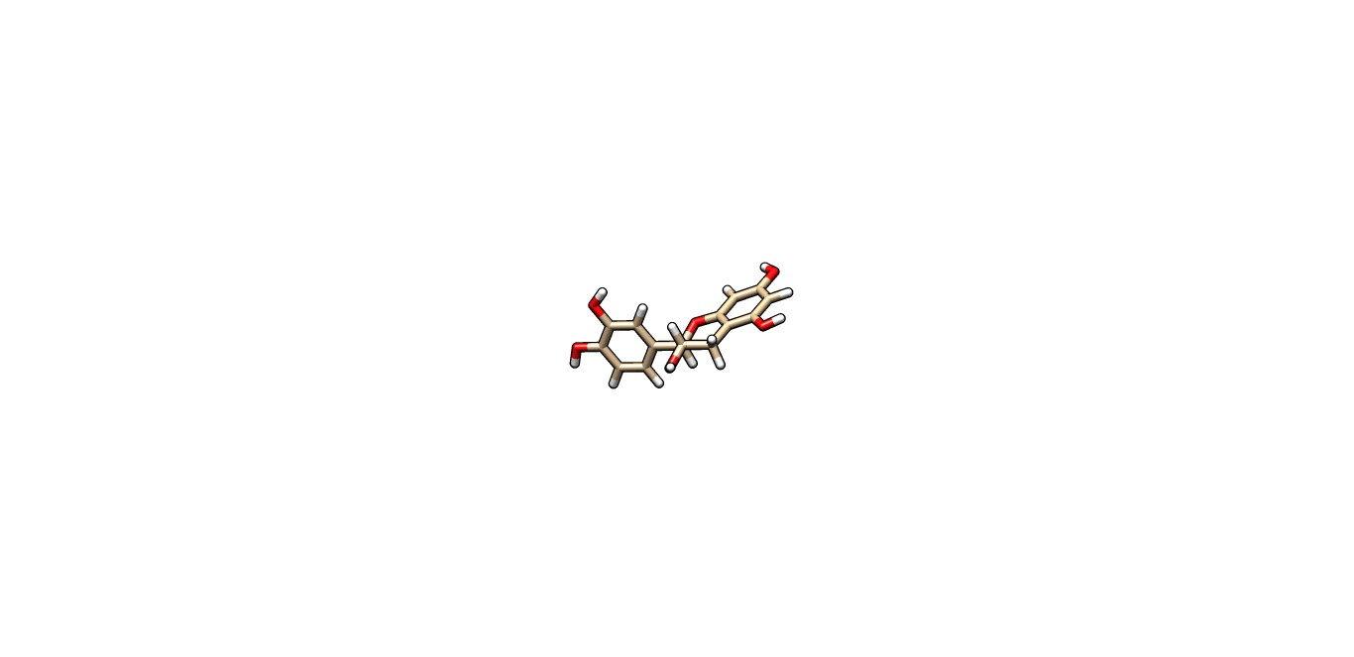
5281416 | CyP21 | Aesculetin | Mean ± SD | 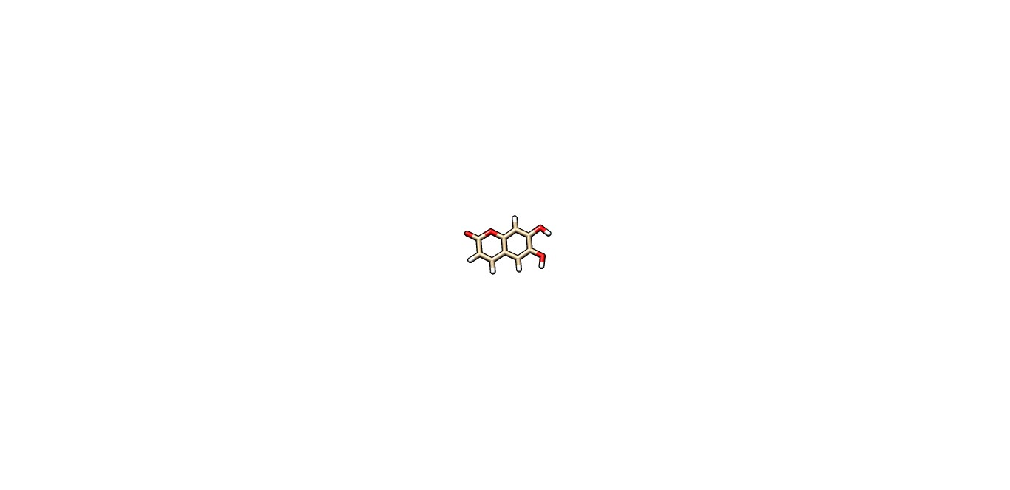
5317238 | CyP22 | Ethyl caffeate | 2.75 ±0.11 | 