SUPPLEMENTARY INFORMATION

Design, synthesis, and biological studies of the new cysteine-N-arylacetamide derivatives as potent urease inhibitor
Mohammad Nazari Montazerª, Mehdi Asadiª, Fatemeh Moradkhaniª, Zinat Bahrampour Omranyª, Mohammad Mahdavi^{b,} Massoud Amanlou^{a,c,}*
ª Department of Medicinal Chemistry, Faculty of Pharmacy, Tehran University of Medical Sciences, Tehran, Iran.
^{b} Endocrinology and Metabolism Research Center, Endocrinology and Metabolism Clinical Sciences Institute, Tehran University of Medical Sciences, Tehran, Iran.
^{c} Experimental Medicine Research Center, The Institute of Pharmaceutical Sciences (TIPS), Tehran University of Medical Sciences, Tehran, Iran.
*Email: amanlou@tums.ac.ir

Table of contents
The ¹H NMR spectra of the synthesized compounds (Figures S1-S12) ……………………..2
The ¹³C NMR spectra of the synthesized compounds (Figures S13-S24)……………………8
The Elemental analysis results of the synthesized compounds (Table S1)……….………….15

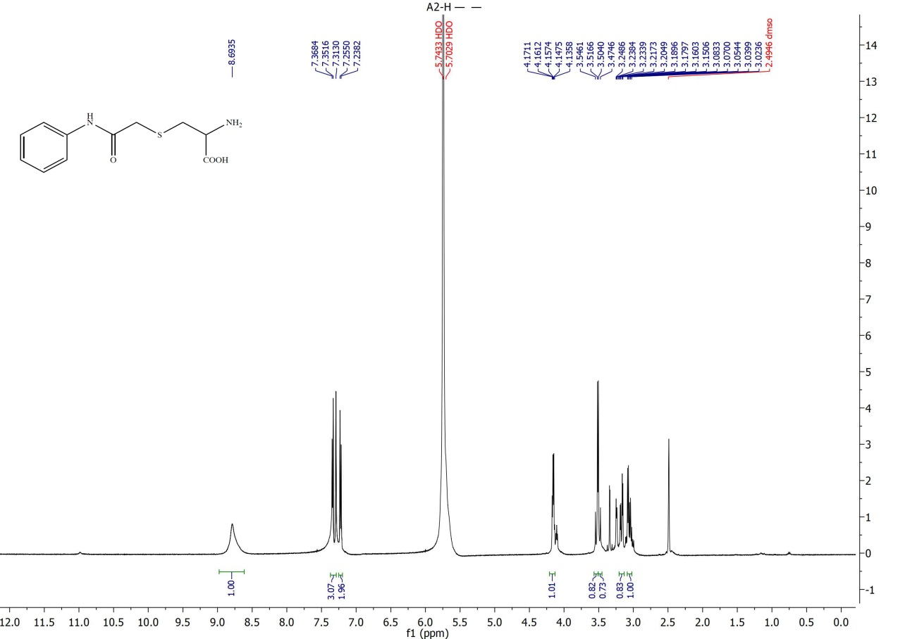
Figure S1. ¹H NMR spectrum in DMSO-d₆ of RS-(2-oxo-2-(phenylamino)ethyl)cysteine 5a
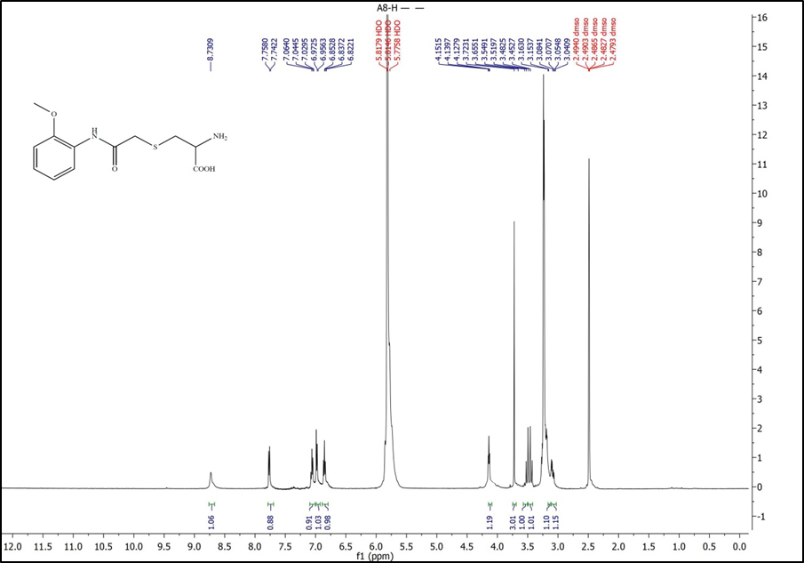
Figure S2. ¹H NMR spectrum in DMSO-d₆ of RS-(2-((2-methoxyphenyl)amino)-2-oxoethyl)cysteine 5b
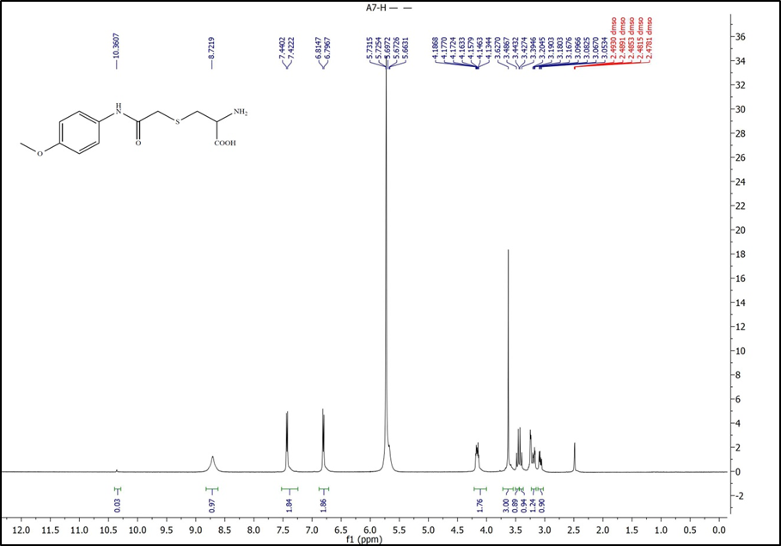
Figure S3. ¹H NMR spectrum in DMSO-d₆ of RS-(2-((4-methoxyphenyl)amino)-2-oxoethyl)cysteine 5c
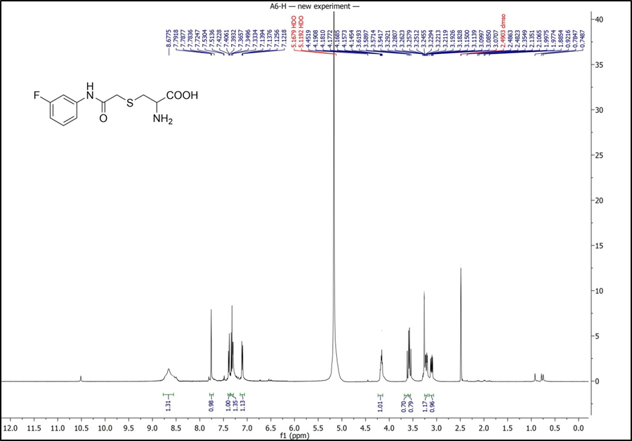
Figure S4. ¹H NMR spectrum in DMSO-d6 of RS-(2-((3-fluorophenyl)amino)-2-oxoethyl)cysteine 5d
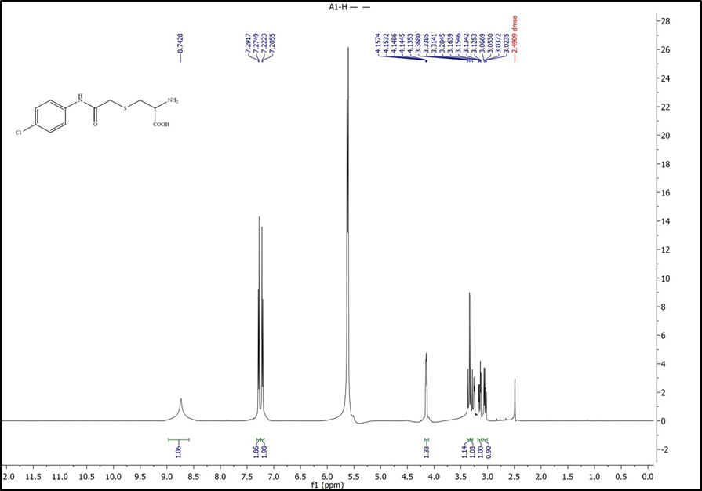
Figure S5. ¹H NMR spectrum in DMSO-d6 of RS-(2-((4-chlorophenyl)amino)-2-oxoethyl)cysteine 5e
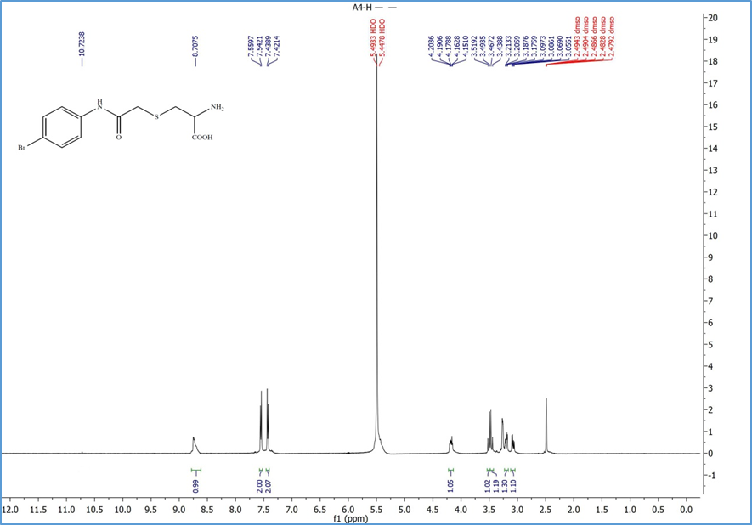
Figure S6. ¹H NMR spectrum in DMSO-d6 of RS-(2-((4-bromophenyl)amino)-2-oxoethyl)cysteine 5f
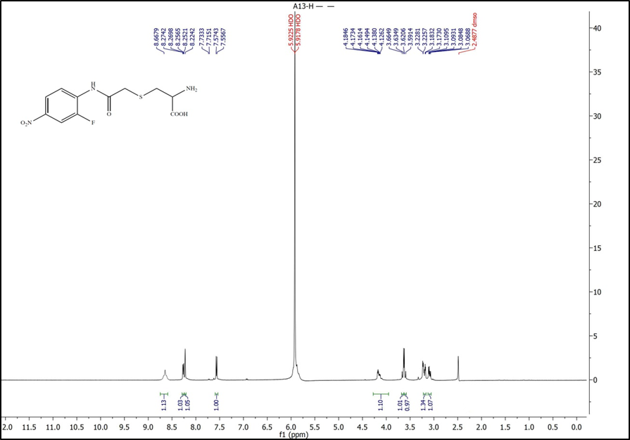
Figure S7. ¹H NMR spectrum in DMSO-d6 of RS-(2-((2-fluoro-4-nitrophenyl)amino)-2-oxoethyl)cysteine 5g
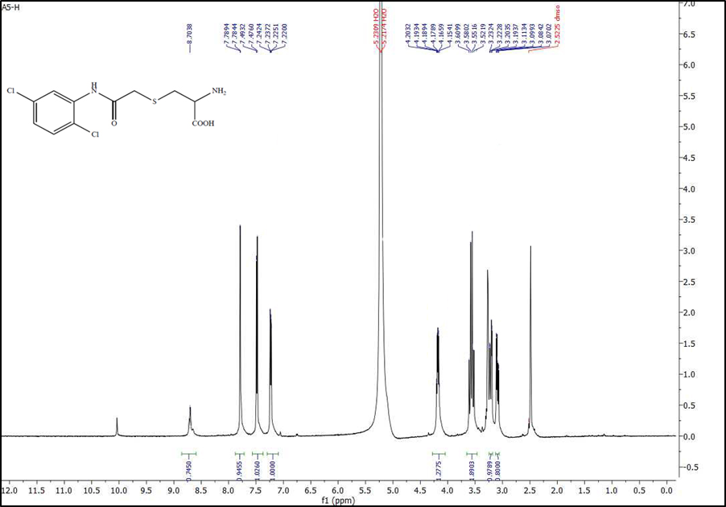
Figure S8. ¹H NMR spectrum in DMSO-d6 of RS-(2-((2,5-dichlorophenyl)amino)-2-oxoethyl)cysteine 5h
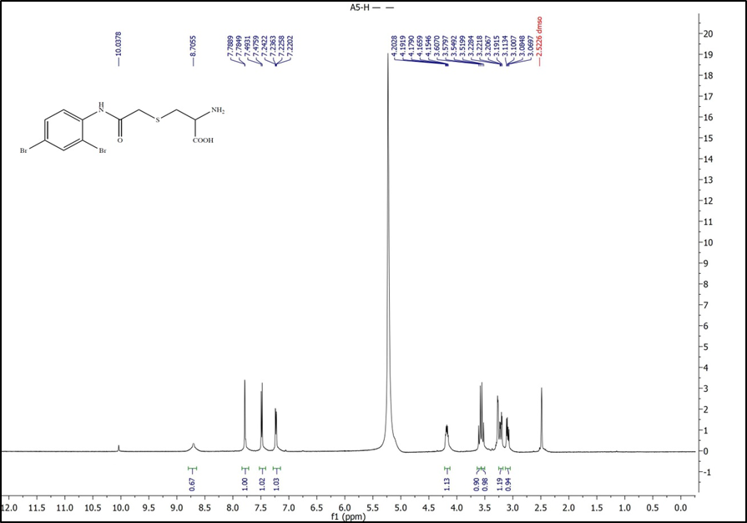
Figure S9. ¹H NMR spectrum in DMSO-d6 of RS-(2-((2,4-dibromophenyl)amino)-2-oxoethyl)cysteine 5i
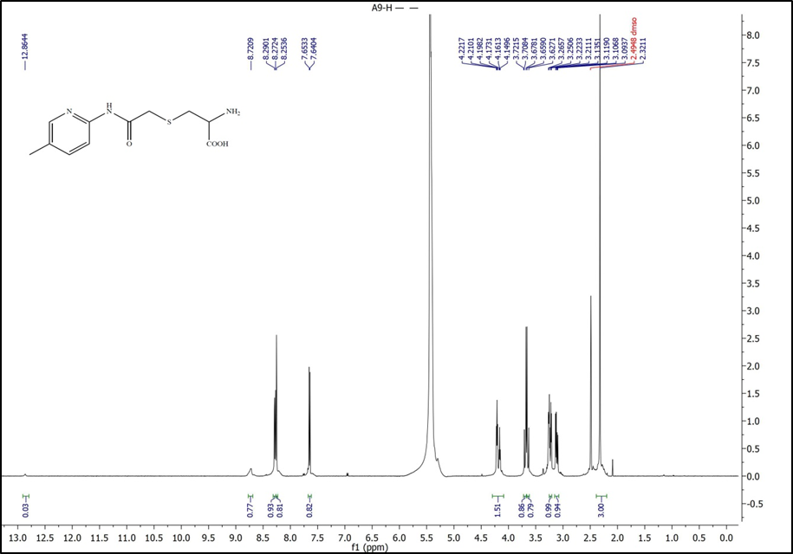
Figure S10. ¹H NMR spectrum in DMSO-d6 of RS-(2-((5-methylpyridin-2-yl)amino)-2-oxoethyl)cysteine 5j
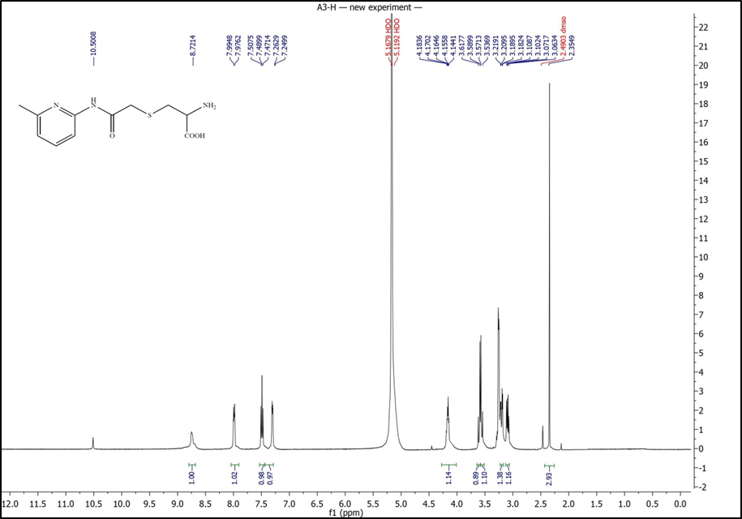
Figure S11. ¹H NMR spectrum in DMSO-d6 of RS-(2-((5-methylpyridin-2-yl)amino)-2-oxoethyl)cysteine 5k
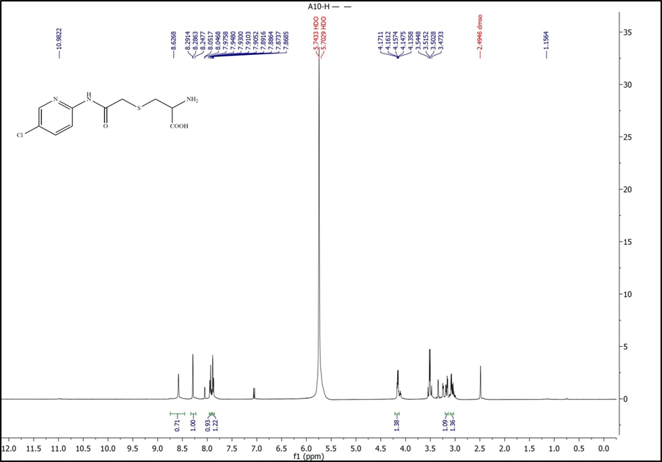
Figure S12. ¹H NMR spectrum in DMSO-d6 of RS-(2-((5-chloropyridin-2-yl)amino)-2-oxoethyl)cysteine 5l
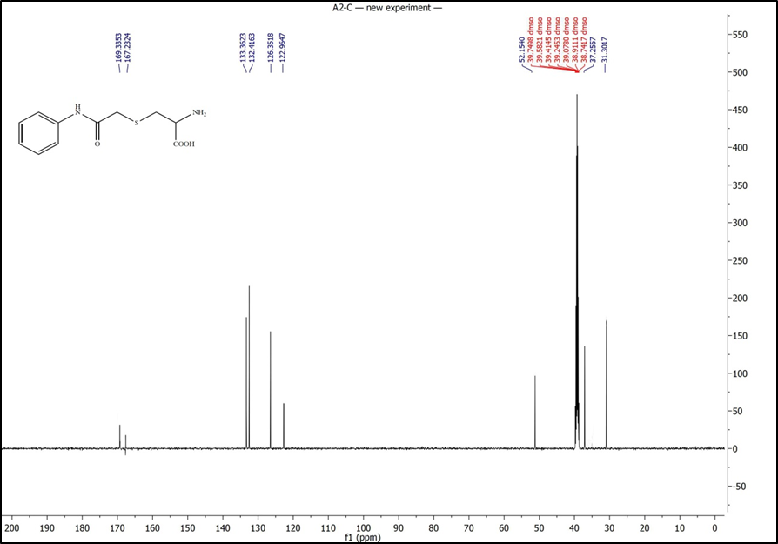
Figure S13. ¹³C NMR spectrum in DMSO-d₆ of RS-(2-oxo-2-(phenylamino)ethyl)cysteine 5a
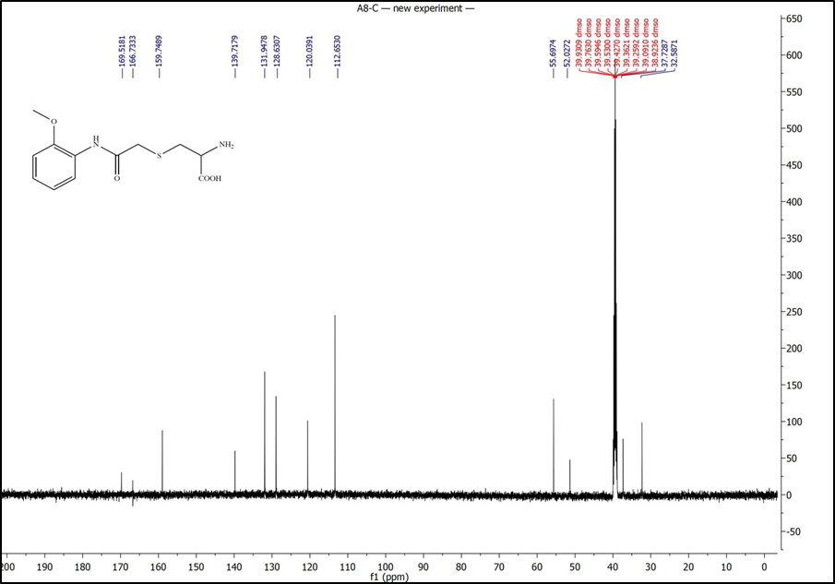
Figure S14. ¹³C NMR spectrum in DMSO-d₆ of RS-(2-((2-methoxyphenyl)amino)-2-oxoethyl)cysteine 5b
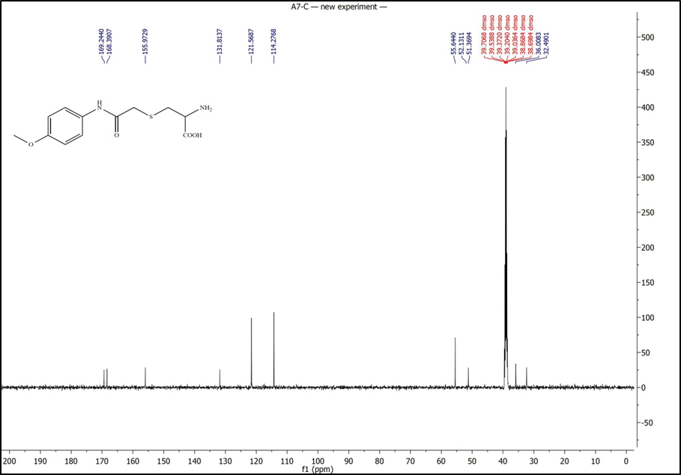
Figure S15. ¹³C NMR spectrum in DMSO-d₆ of RS-(2-((4-methoxyphenyl)amino)-2-oxoethyl)cysteine 5c
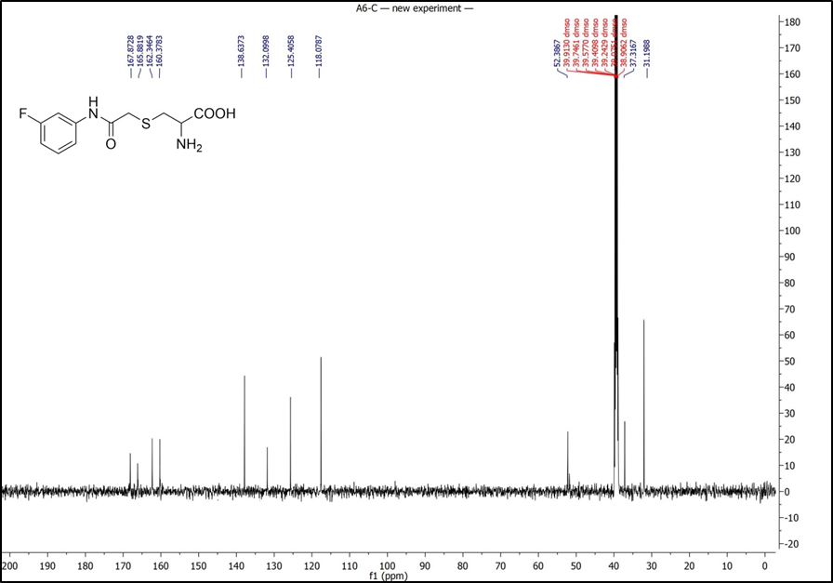
Figure S16. ¹³C NMR spectrum in DMSO-d6 of RS-(2-((3-fluorophenyl)amino)-2-oxoethyl)cysteine 5d
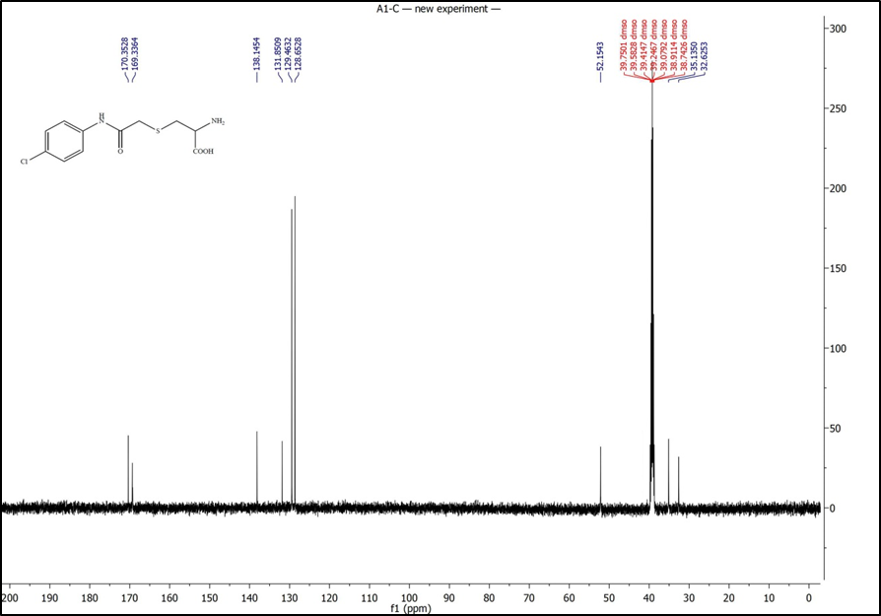
Figure S17. ¹³C NMR spectrum in DMSO-d6 of RS-(2-((4-chlorophenyl)amino)-2-oxoethyl)cysteine 5e
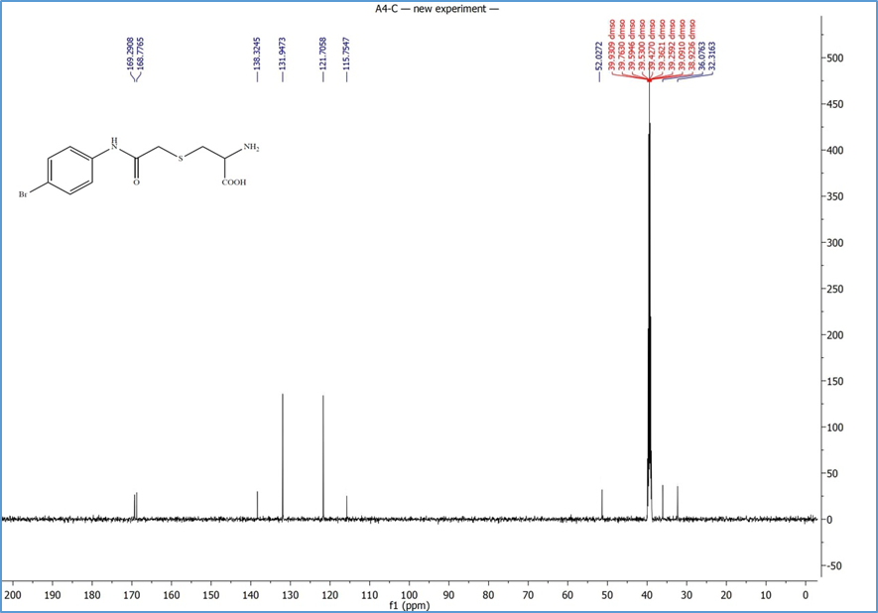
Figure S18. ¹³C NMR spectrum in DMSO-d6 of RS-(2-((4-bromophenyl)amino)-2-oxoethyl)cysteine 5f
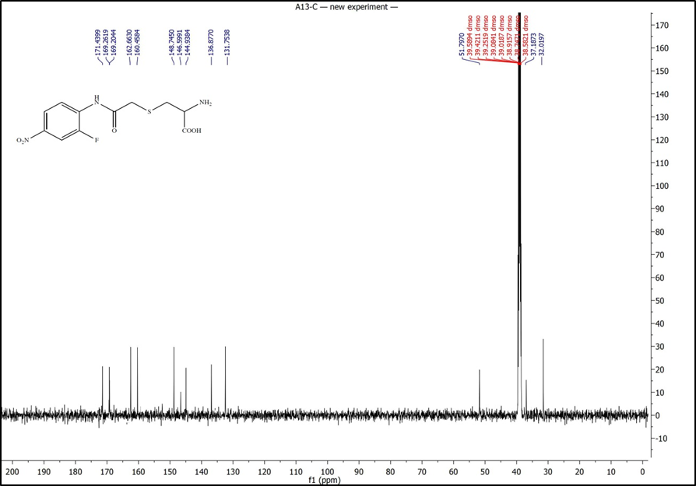
Figure S19. ¹³C NMR spectrum in DMSO-d6 of RS-(2-((2-fluoro-4-nitrophenyl)amino)-2-oxoethyl)cysteine 5g
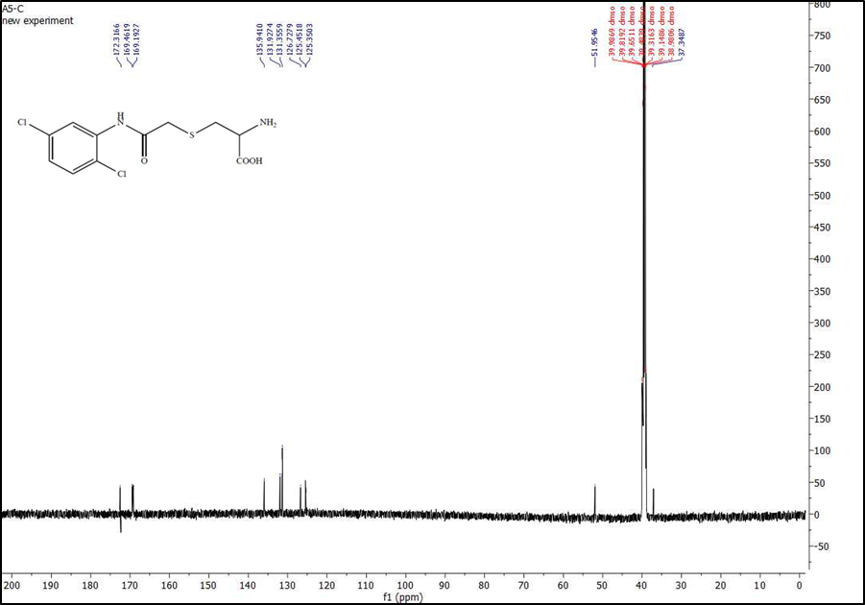
Figure S20. ¹³C NMR spectrum in DMSO-d6 of RS-(2-((2,5-dichlorophenyl)amino)-2-oxoethyl)cysteine 5h
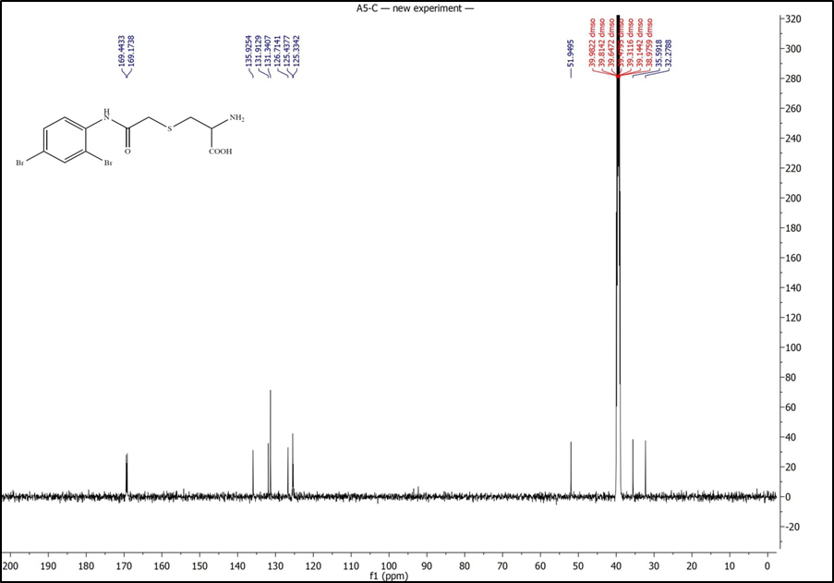
Figure S21. ¹³C NMR spectrum in DMSO-d6 of RS-(2-((2,4-dibromophenyl)amino)-2-oxoethyl)cysteine 5i
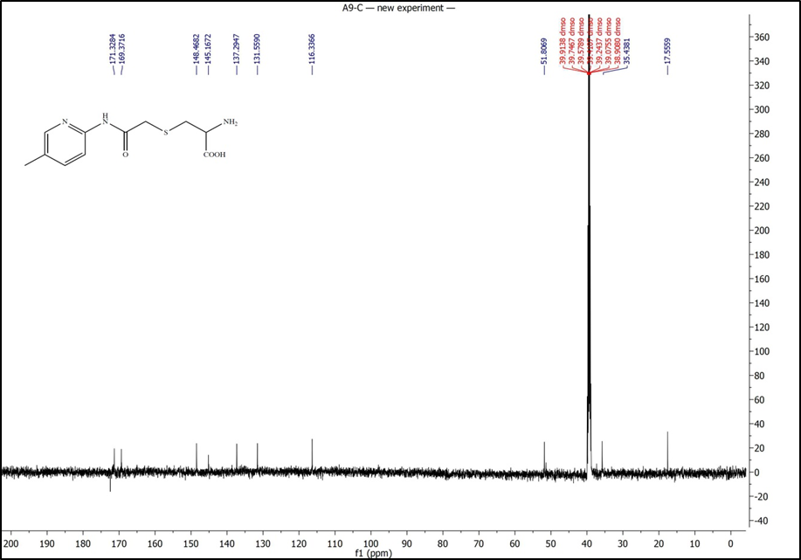
Figure S22. ¹³C NMR spectrum in DMSO-d6 of RS-(2-((5-methylpyridin-2-yl)amino)-2-oxoethyl)cysteine 5j
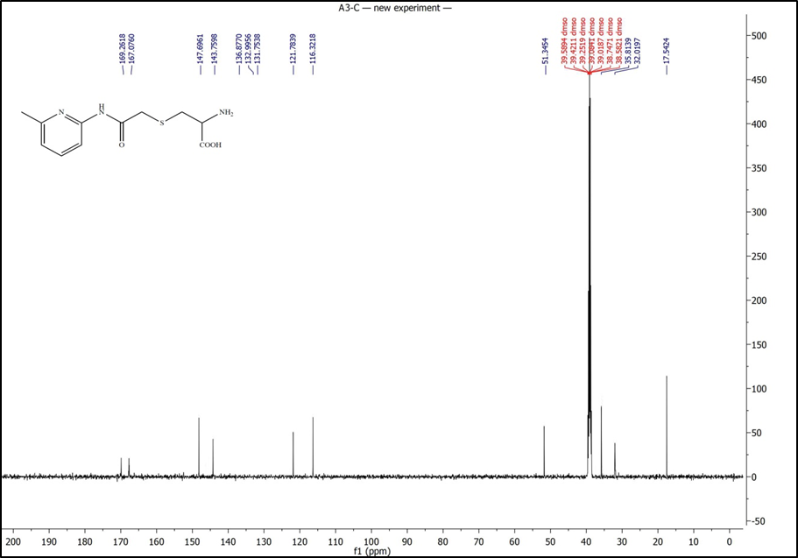
Figure S23. ¹³C NMR spectrum in DMSO-d6 of RS-(2-((5-methylpyridin-2-yl)amino)-2-oxoethyl)cysteine 5k
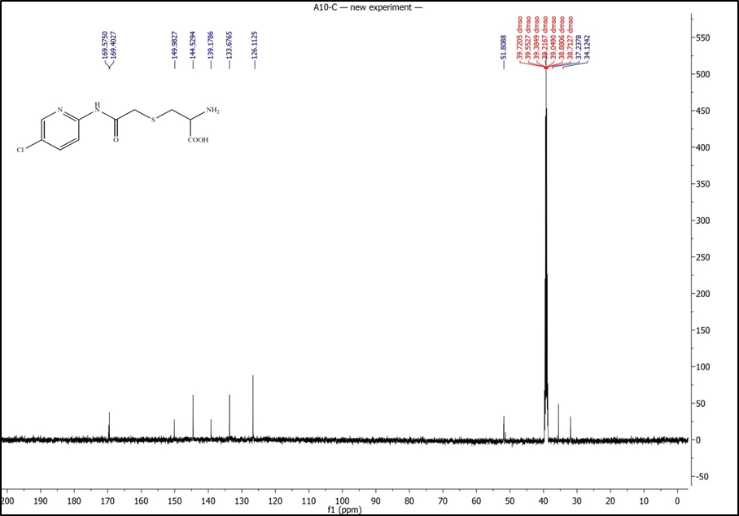
Figure S24. ¹³C NMR spectrum in DMSO-d6 of RS-(2-((5-chloropyridin-2-yl)amino)-2-oxoethyl)cysteine 5l
Elemental analysis results

Table 1. Elemental analysis results of compounds.
Compound | Formula | calculated [%] |  |  | Found [%]
Compound | Formula | C | H | N | C | H | N
5a | C₁₁H₁₄N₂O₃S | 51.95 | 5.55 | 11.02 | 52.06 | 5.31 | 11.14
5b | C₁₂H₁₆N₂O₄S | 50.69 | 5.67 | 9.85 | 50.23 | 5.41 | 9.99
5c | C₁₂H₁₆N₂O₄S | 50.69 | 5.67 | 9.85 | 51.01 | 5.69 | 9.42
5d | C₁₁H₁₃FN₂O₃S | 48.52 | 4.81 | 10.29 | 48.79 | 4.73 | 10.43
5e | C₁₁H₁₃ClN₂O₃S | 45.76 | 4.54 | 9.7 | 45.92 | 4.33 | 9.98
5f | C₁₁H₁₃BrN₂O₃S | 39.65 | 3.93 | 8.41 | 40.98 | 3.77 | 8.48
5g | C₁₁H₁₂FN₃O₅S | 41.64 | 3.81 | 13.24 | 41.93 | 3.99 | 13.69
5h | C₁₁H₁₂Cl₂N₂O₃S | 40.88 | 3.74 | 8.67 | 40.73 | 3.61 | 8.84
5i | C₁₁H₁₂Br₂N₂O₃S | 32.06 | 2.94 | 6.8 | 32.18 | 3.03 | 6.57
5j | C₁₁H₁₅N₃O₃S | 49.06 | 5.61 | 15.6 | 49.41 | 5.85 | 15.31
5k | C₁₁H₁₅N₃O₃S | 49.06 | 5.61 | 15.6 | 49.03 | 5.71 | 15.47
5l | C₁₀H₁₂ClN₃O₃S | 41.46 | 4.17 | 14.5 | 41.73 | 4.38 | 14.69

