SUPPLEMENTARY INFORMATION

XPAT® Proteins, Conditionally Activated T-Cell Engagers Engineered to Mitigate
On-Target, Off-Tumor Toxicity for Immunotherapy of Solid Tumors
Fiore Cattaruzza et al.
CONTENTS
Supplementary Fig. 1. Binding affinity of HER2-XPAT and its partially and fully unmasked metabolites to cynomolgus monkey HER2 and CD3.
Supplementary Fig. 2. Target-dependent T-cell activation with HER2-XPAT and unmasked HER2-TCE.
Supplementary Table 1. Summary of nomenclature for XPAT molecules evaluated in the nonclinical studies reported here.
Supplementary Table 2. Tumor types used for patient-derived cancer xenograft models in immunodeficient mice.
Materials and Methods.

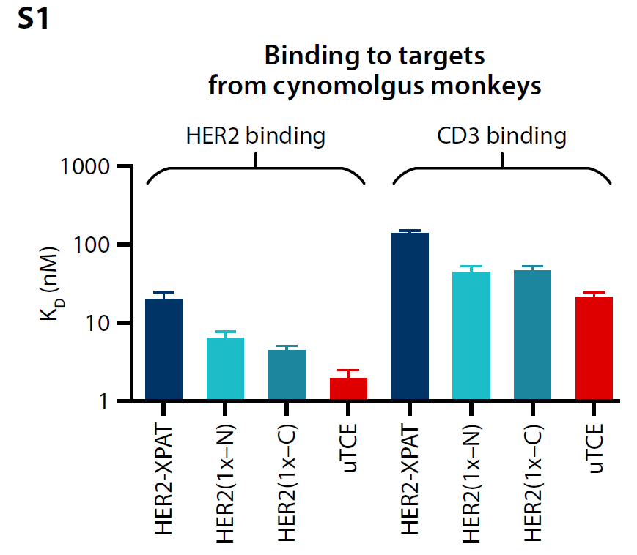
SUPPLEMENTARY FIGURES
Supplementary Fig. 1. Binding affinity of HER2-XPAT and its partially and fully unmasked metabolites to cynomolgus monkey HER2 and CD3.
Binding was assessed in vitro at 37°C by surface plasmon resonance. Data are K_{D} ± standard error (n=8−12). HER2, human epidermal growth factor receptor 2; uTCE, unmasked HER2 T-cell engager; XPAT proteins, TCEs fused to XTEN polypeptides.
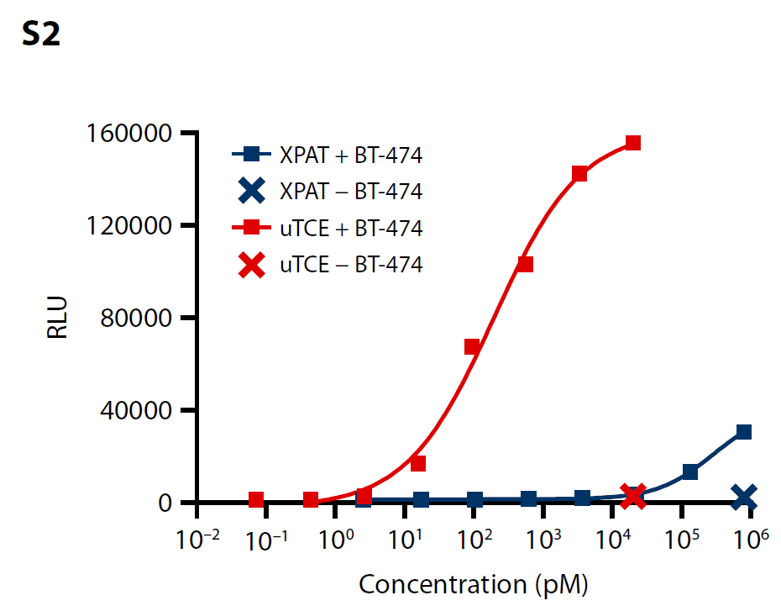
Supplementary Fig. 2. Target-dependent T-cell activation with HER2-XPAT and uTCE.
CD3⁺ Jurkat reporter T cells were incubated with or without BT-474 cells at a 5:1 effector−target ratio for 6 hours, followed by quantification of NFAT-induced luciferase activity.
HER2, human epidermal growth factor receptor 2; RLU, relative luminescence unit; uTCE, unmasked T-cell engager; XPAT proteins, TCE fused to XTEN polypeptides.

SUPPLEMENTARY TABLES
Supplementary Table 1. Summary of nomenclature for XPAT molecules evaluated in the nonclinical studies reported here.
Name | Description
HER2-XPAT
HER2-XPAT-prototype | Prototype engineered with the XTEN polypeptide masks on the N- and C-termini
HER2-XPAT | Clinical candidate engineered with optimized XTEN polypeptide masks on the N- and C-termini
EGFR-XPAT
EGFR-XPAT | Prototype engineered with XTEN polypeptide masks on the N- and C-termini
XPAT metabolites
XPAT(1x−C) | Singly masked XPAT protein: C-terminal XTEN mask remains intact  N-terminal XTEN mask cleaved off (anti-TAA scFv unmasked)
XPAT(1x−N) | Singly masked XPAT protein: N-terminal XTEN mask remains intact  C-terminal XTEN mask cleaved off (anti-CD3 scFv unmasked)
Unmasked XPAT (uTCE) | Fully active TCE, with both XTEN polypeptide masks cleaved off
Reference compounds
XPAT-NoClvSite | XPAT protein lacking the protease cleavage linker
XPAT-NoClvSite(1x−C) | XPAT protein lacking the protease cleavage sites; anti-TAA scFV unmasked
XPAT-NoClvSite(1x−N) | XPAT lacking the protease cleavage sites; anti-CD3 scFV unmasked
EGFR, endothelial growth factor receptor; HER2, human epidermal growth factor receptor 2; scFv, single-chain variable domain fragment; TAA, tumor-associated antigen; uTCE, unmasked T-cell engager; XPAT, TCE fused to XTEN polypeptides.
Supplementary Table 2. Tumor types used for patient-derived cancer xenograft models in immunodeficient mice.
Tumor number | Tumor type | XPAT tumor target
CTG-2543 | NSCLC | HER2
CTG-1569 | RCC | HER2
CTG-0828 | NSCLC | HER2
CTG-2432 | Breast | HER2
CTG-3303 | Breast | HER2
CTG-0835 | Colorectal | EpCAM
CTG-2647 | Endometrial | EpCAM
CTG-0936 | Gastric | EpCAM
CTG-0138 | Esophageal | EpCAM
CTG-1680 | NSCLC | EpCAM
EpCAM, human epithelial cell adhesion molecule; HER2, human epidermal growth factor receptor 2; NSCLC, non-small cell lung cancer; RCC, renal cell carcinoma.

SUPPLEMENTARY MATERIALS AND METHODS
Production of XPAT products in Escherichia coli
XTENylated T-cell engagers (XPATs) were expressed in Escherichia coli (E. coli), which was transformed with the expression vector and grown in fermentation. The culture broth was harvested by centrifugation, and the retained cells were mechanically lysed. Following lysis, the XPAT-containing soluble fraction was clarified, subsequently purified chromatographically, and then formulated.
XPATs and their derivatives were prepared as aqueous solutions and were stored frozen at ≤ −70°C and, after thawing, at temperatures between 2°C and 8°C.
Quantification of fluorophore-labeled XPAT metabolites generated in vivo in mice bearing patient-derived xenografts
Harvested mouse organs and tumor tissue were weighed, thawed, and homogenized using an approximate ratio of 1:5 tissue mass:volume homogenization buffer. Homogenization was performed in a Precellys Evolution with Cryolys, using CKMix lysing tubes (Bertin Corp) at 3×5800 revolutions per minute for 30 seconds with a 15-second pause. Insoluble material was cleared by centrifugation at 15,000 g for 10 minutes, and protein extracts were taken from the supernatant.
Clarified protein extracts were diluted 1:10 in radioimmunoprecipitation buffer (ThermoFisher Scientific), mixed with 4× Protein Sample Loading Buffer (LI-COR) to a final concentration of 1×, and run on NuPAGE 4%‒12% Bis-Tris protein gels in NuPAGE MES running buffer (ThermoFisher Scientific). A six-point standard curve was run on each gel containing XPAT(DyLight 800 [DyL800]) and XPAT(Alexa Fluor 680 [AF680]) using a five-fold dilution series from a concentration of 1,000 pM to 0.32 pM. Gels were directly scanned on a LI-COR Odyssey Imager using automatic image intensity.
Bands corresponding to the XPAT and its metabolites, XPAT(1x−C), XPAT(1x−N), and unmasked T-cell engager (uTCE) were quantified using a weighted linear regression, which used a weighting formula of 1/Y² against the concentration of the known full-length standards. To account for unmasking during processing, the XPAT(AF680)-labeled internal control was used to calculate a correction factor for the full-length XPAT and for each metabolite. The calculated concentrations were multiplied by the respective correction factors, and the lower limit of quantification was applied to the calculated concentrations after the correction factor. Relative percent unmasking was calculated using the concentrations of each metabolite as a percentage of total XPAT-derived material present in each organ. Averages for tissues with <14 samples below the limit of quantification (BLQ) were calculated by using the lower limit of quantification concentration for the BLQ samples. Thus, the actual average concentration may be even lower than shown in the graph. Tissues with averages calculated using some samples with BLQ readings are marked with an asterisk.

Quantitative Western blot method for quantification of HER2-XPAT metabolites in non-human primate plasma
The concentration of human epidermal growth factor receptor 2 (HER2)-XPAT singly cleaved metabolites, HER2-XPAT(1x−C) and HER2-XPAT(1x−N), in the plasma of non-human primates (NHPs) administered HER2-XPAT was measured using a quantitative Western blot method. A sample of 10 μL, standard (known concentrations of HER2-XPAT[1x−C] and HER2-XPAT[1x−N] diluted in plasma), or quality control in plasma was combined on ice with 20.0 μL of phosphate buffered saline with 2× concentration of protease inhibitors (HALT Protease Inhibitors, Pierce 78438). Ten μL of 4× NuPAGE LDS (Invitrogen NP0007) with 50 mM dithiothreitol was added to each diluted sample on ice and thoroughly mixed. For sodium dodecyl sulphate−polyacrylamide gel electrophoresis (SDS-PAGE), 5 μL of the final mixture was loaded to each lane of a 26-well NuPAGE 4%−12% Bis-Tris Midi protein gel (Invitrogen WG1403A). The gel was run at 200 V for 50 minutes. SDS-PAGE gels were incubated in NuPAGE Transfer Buffer (Invitrogen NP00061) prior to blotting onto nitrocellulose membranes using the Invitrogen iBlot 2 system (Invitrogen IB23001). The nitrocellulose membranes were thoroughly dried after blotting, then re-hydrated with Tris-buffered saline (TBS). The membrane was subsequently blocked using LI-COR Protein-Free Blocking Buffer (LI-COR 927-80001). A monoclonal mouse antibody recognizing the anti-HER2 scFv (aaHER2-M7) was conjugated to XPAT(DyL800) (XPAT tagged with the fluorescent dye DyL800) for detection of HER2-XPAT metabolites. The detection antibody was prepared in LI-COR Intercept T20 (TBS) antibody diluent (LI-COR, 927-650001) at 0.1 μg/mL. The blocked blots were briefly rinsed with TBS prior to incubating with 35 mL of the detection antibody at room temperature, rocking and protected from light. Blots were thoroughly washed with TBS containing 0.1% polysorbate 20 and rinsed with TBS prior to scanning on the LI-COR Odyssey CLx. ImageStudio Lite (LI-COR) was used to quantitate relative fluorescence signal for the HER2-XPAT(1x−C) and HER2-XPAT(1x−N) bands. Relative fluorescence signal for standards were processed in Softmax Pro using a four-parameter logistic standard curve regression with 1/Y² weighting to establish a dose-response curve. HER2-XPAT(1x−C) and HER2-XPAT(1x−N) concentrations for quality control and study samples were determined by interpolation to the dose-response curve. Samples with concentrations below the lowest standard point of 7.81 nM were reported as BLQ.

