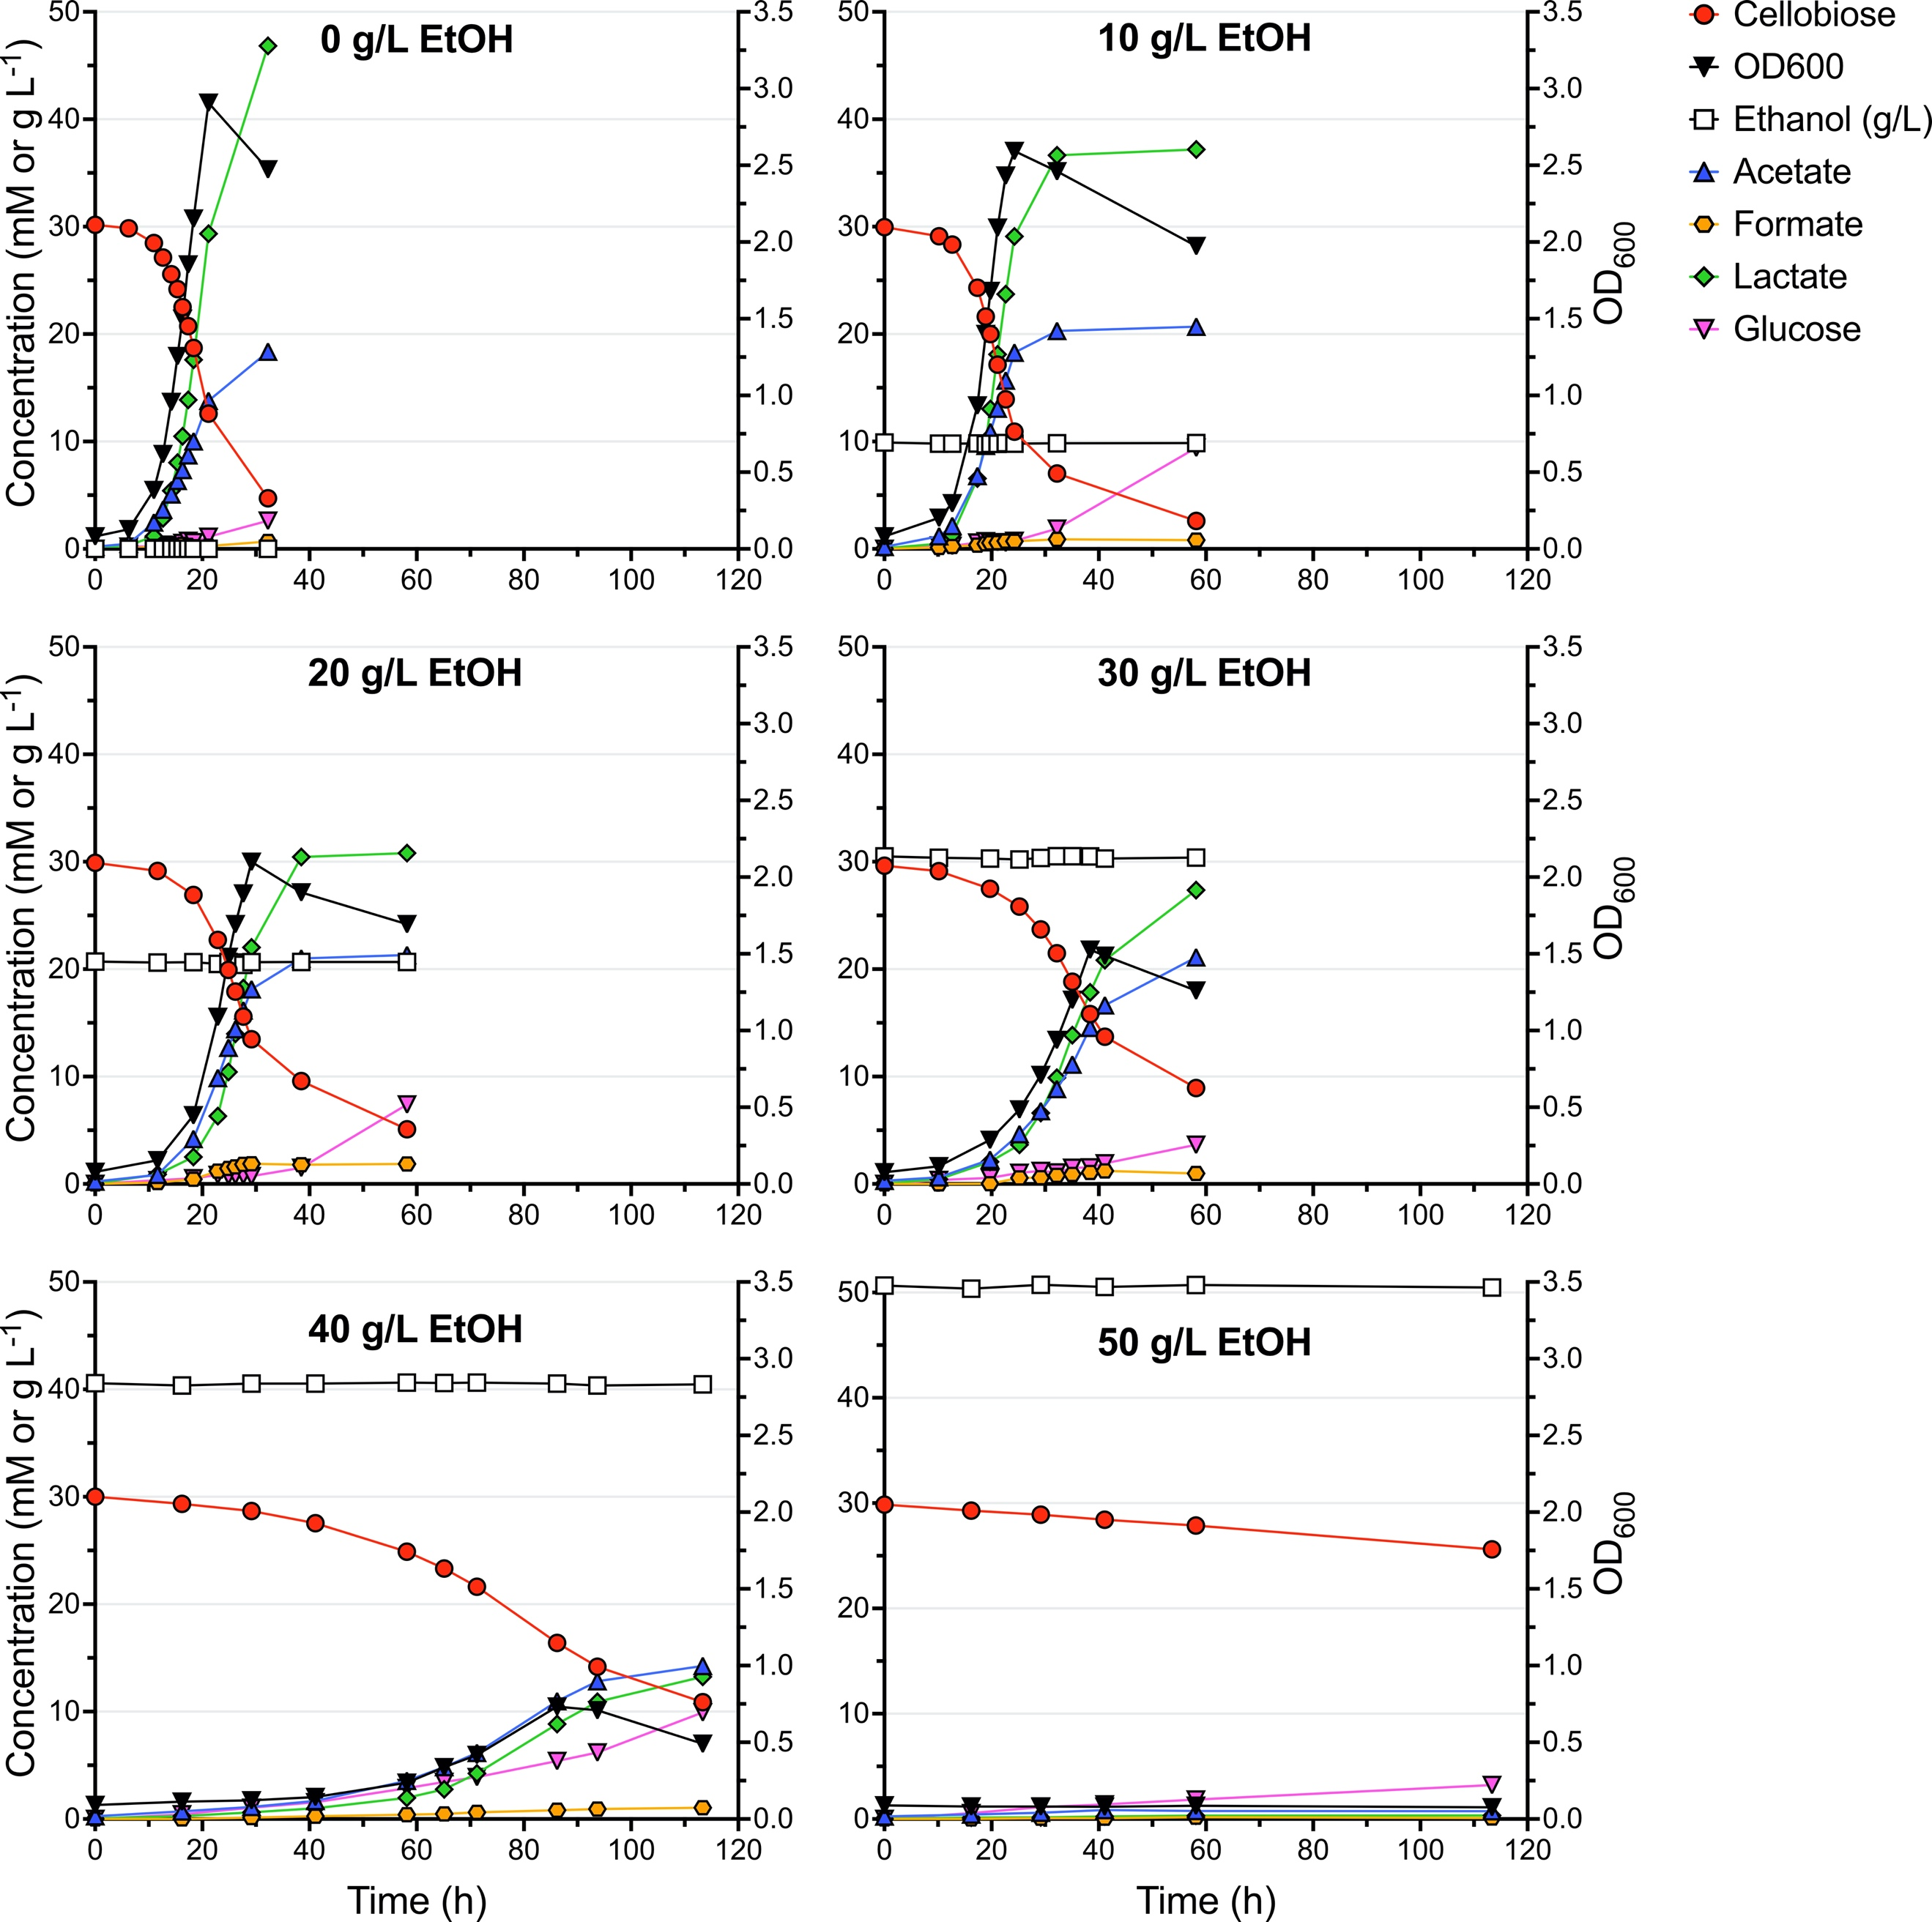
Fig. S4. Growth and product profiles of AVM062 (P_{clo1313_2638}::ldh* ∆adhE) at 55 °C in the presence of various added ethanol concentrations. Batch serum bottle cultures were grown on modified LC medium with 10 g L⁻¹ cellobiose. Data is shown for one representative experiment (n = 2).
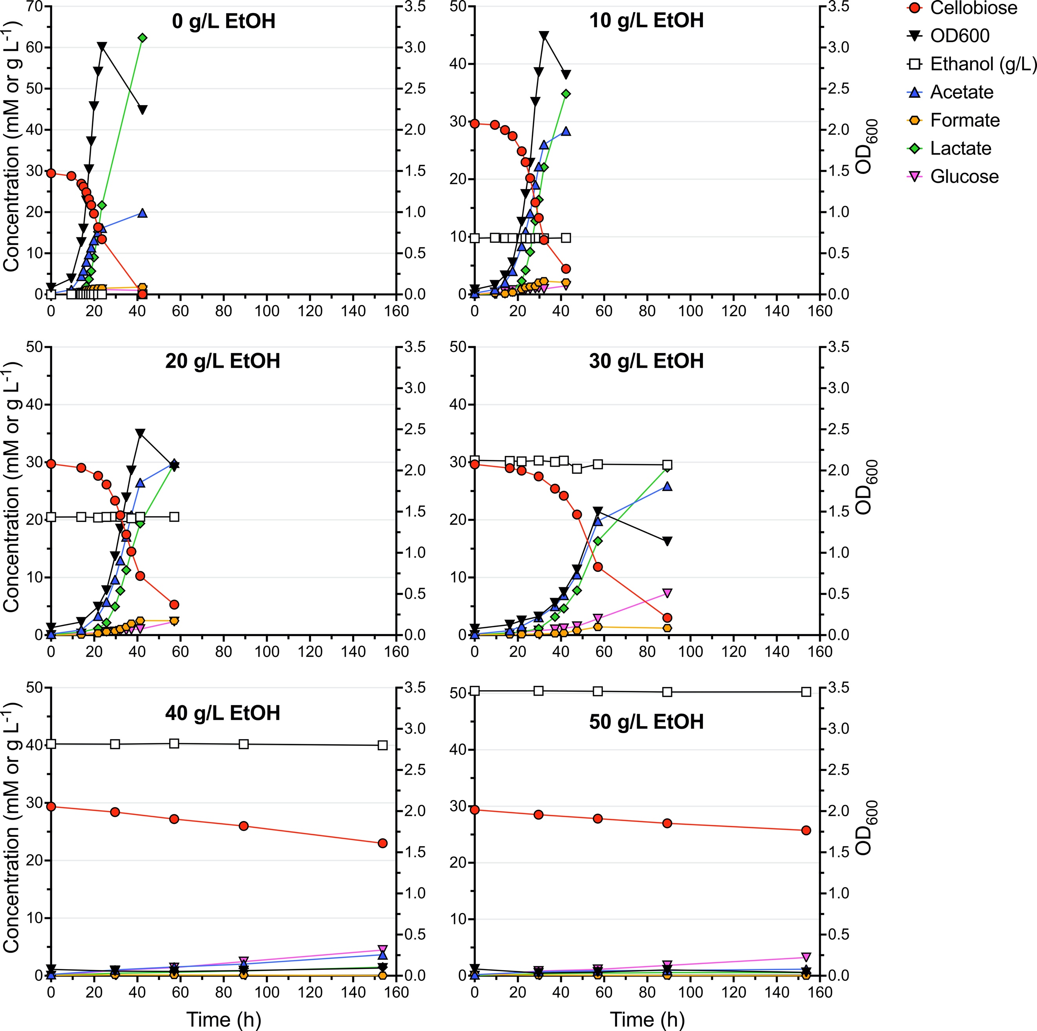
Fig. S5. Growth and product profiles of AVM062 (P_{clo1313_2638}::ldh* ∆adhE) at 50 °C in the presence of various added ethanol concentrations. Batch serum bottle cultures were grown on modified LC medium with 10 g L⁻¹ cellobiose. Data is shown for one representative experiment (n = 2).
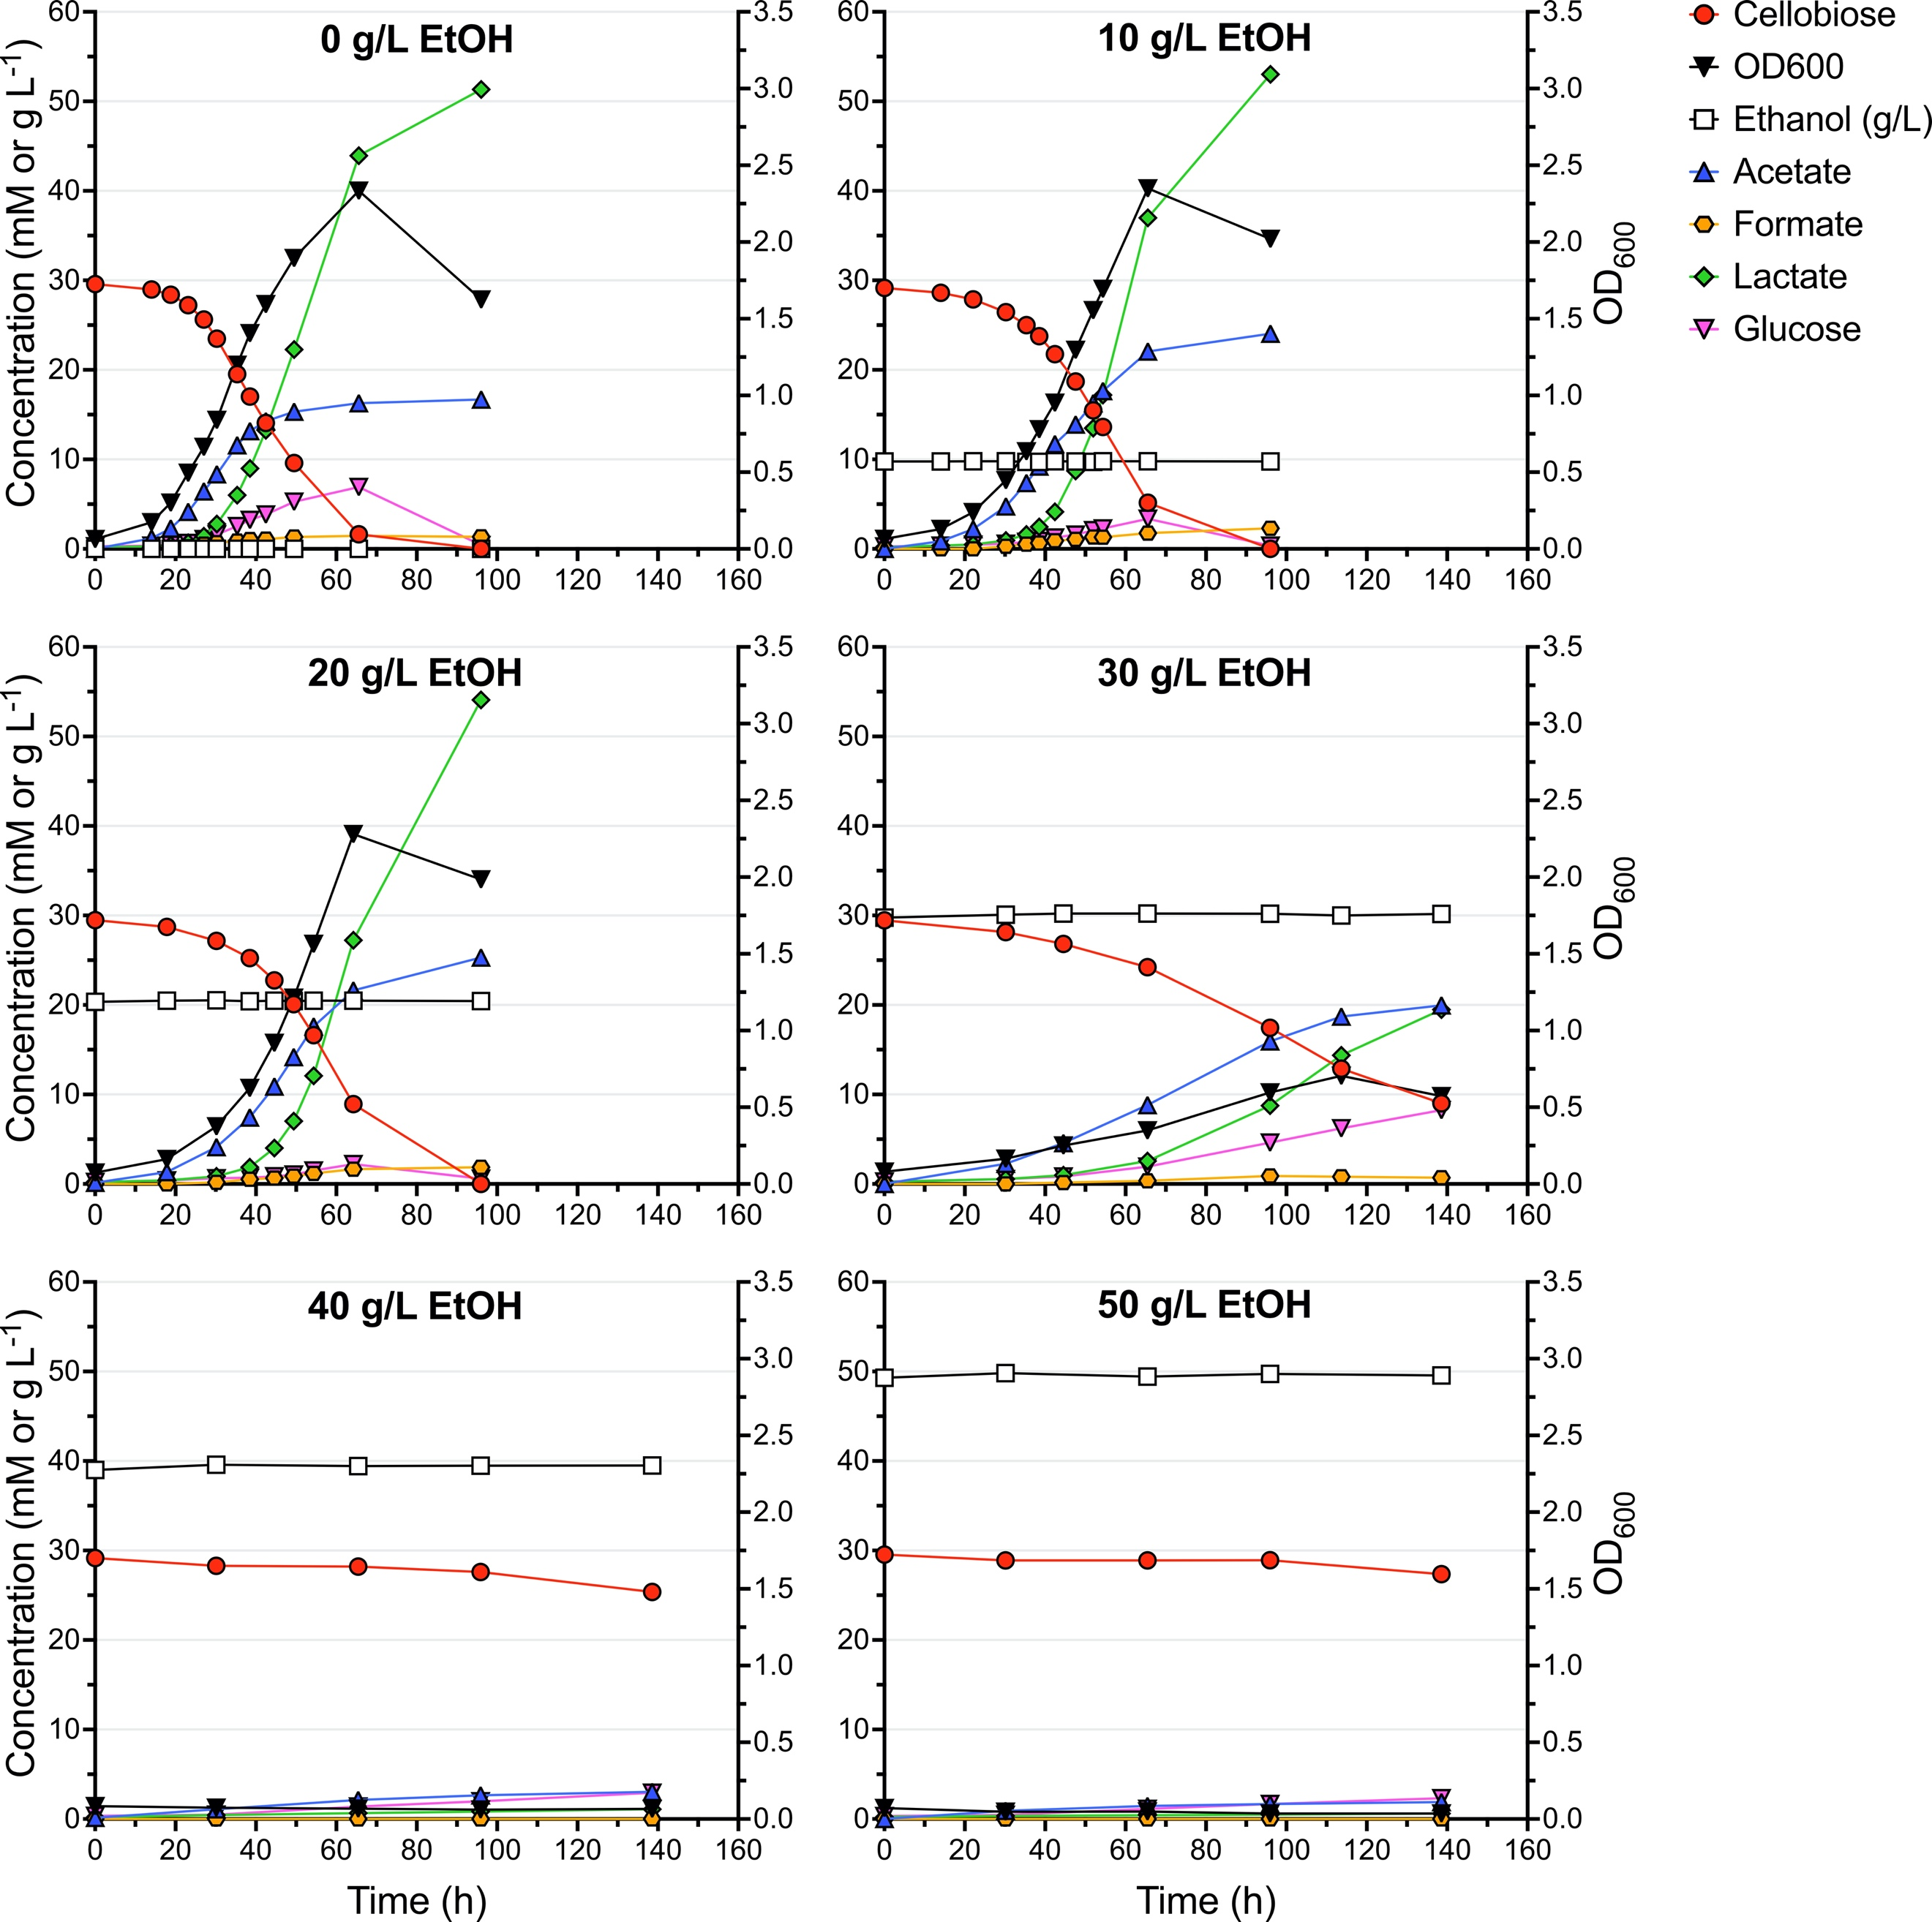
Fig. S6. Growth and product profiles of AVM062 (P_{clo1313_2638}::ldh* ∆adhE) at 45 °C in the presence of various added ethanol concentrations. Batch serum bottle cultures were grown on modified LC medium with 10 g L⁻¹ cellobiose. Data is shown for one representative experiment (n = 2).

