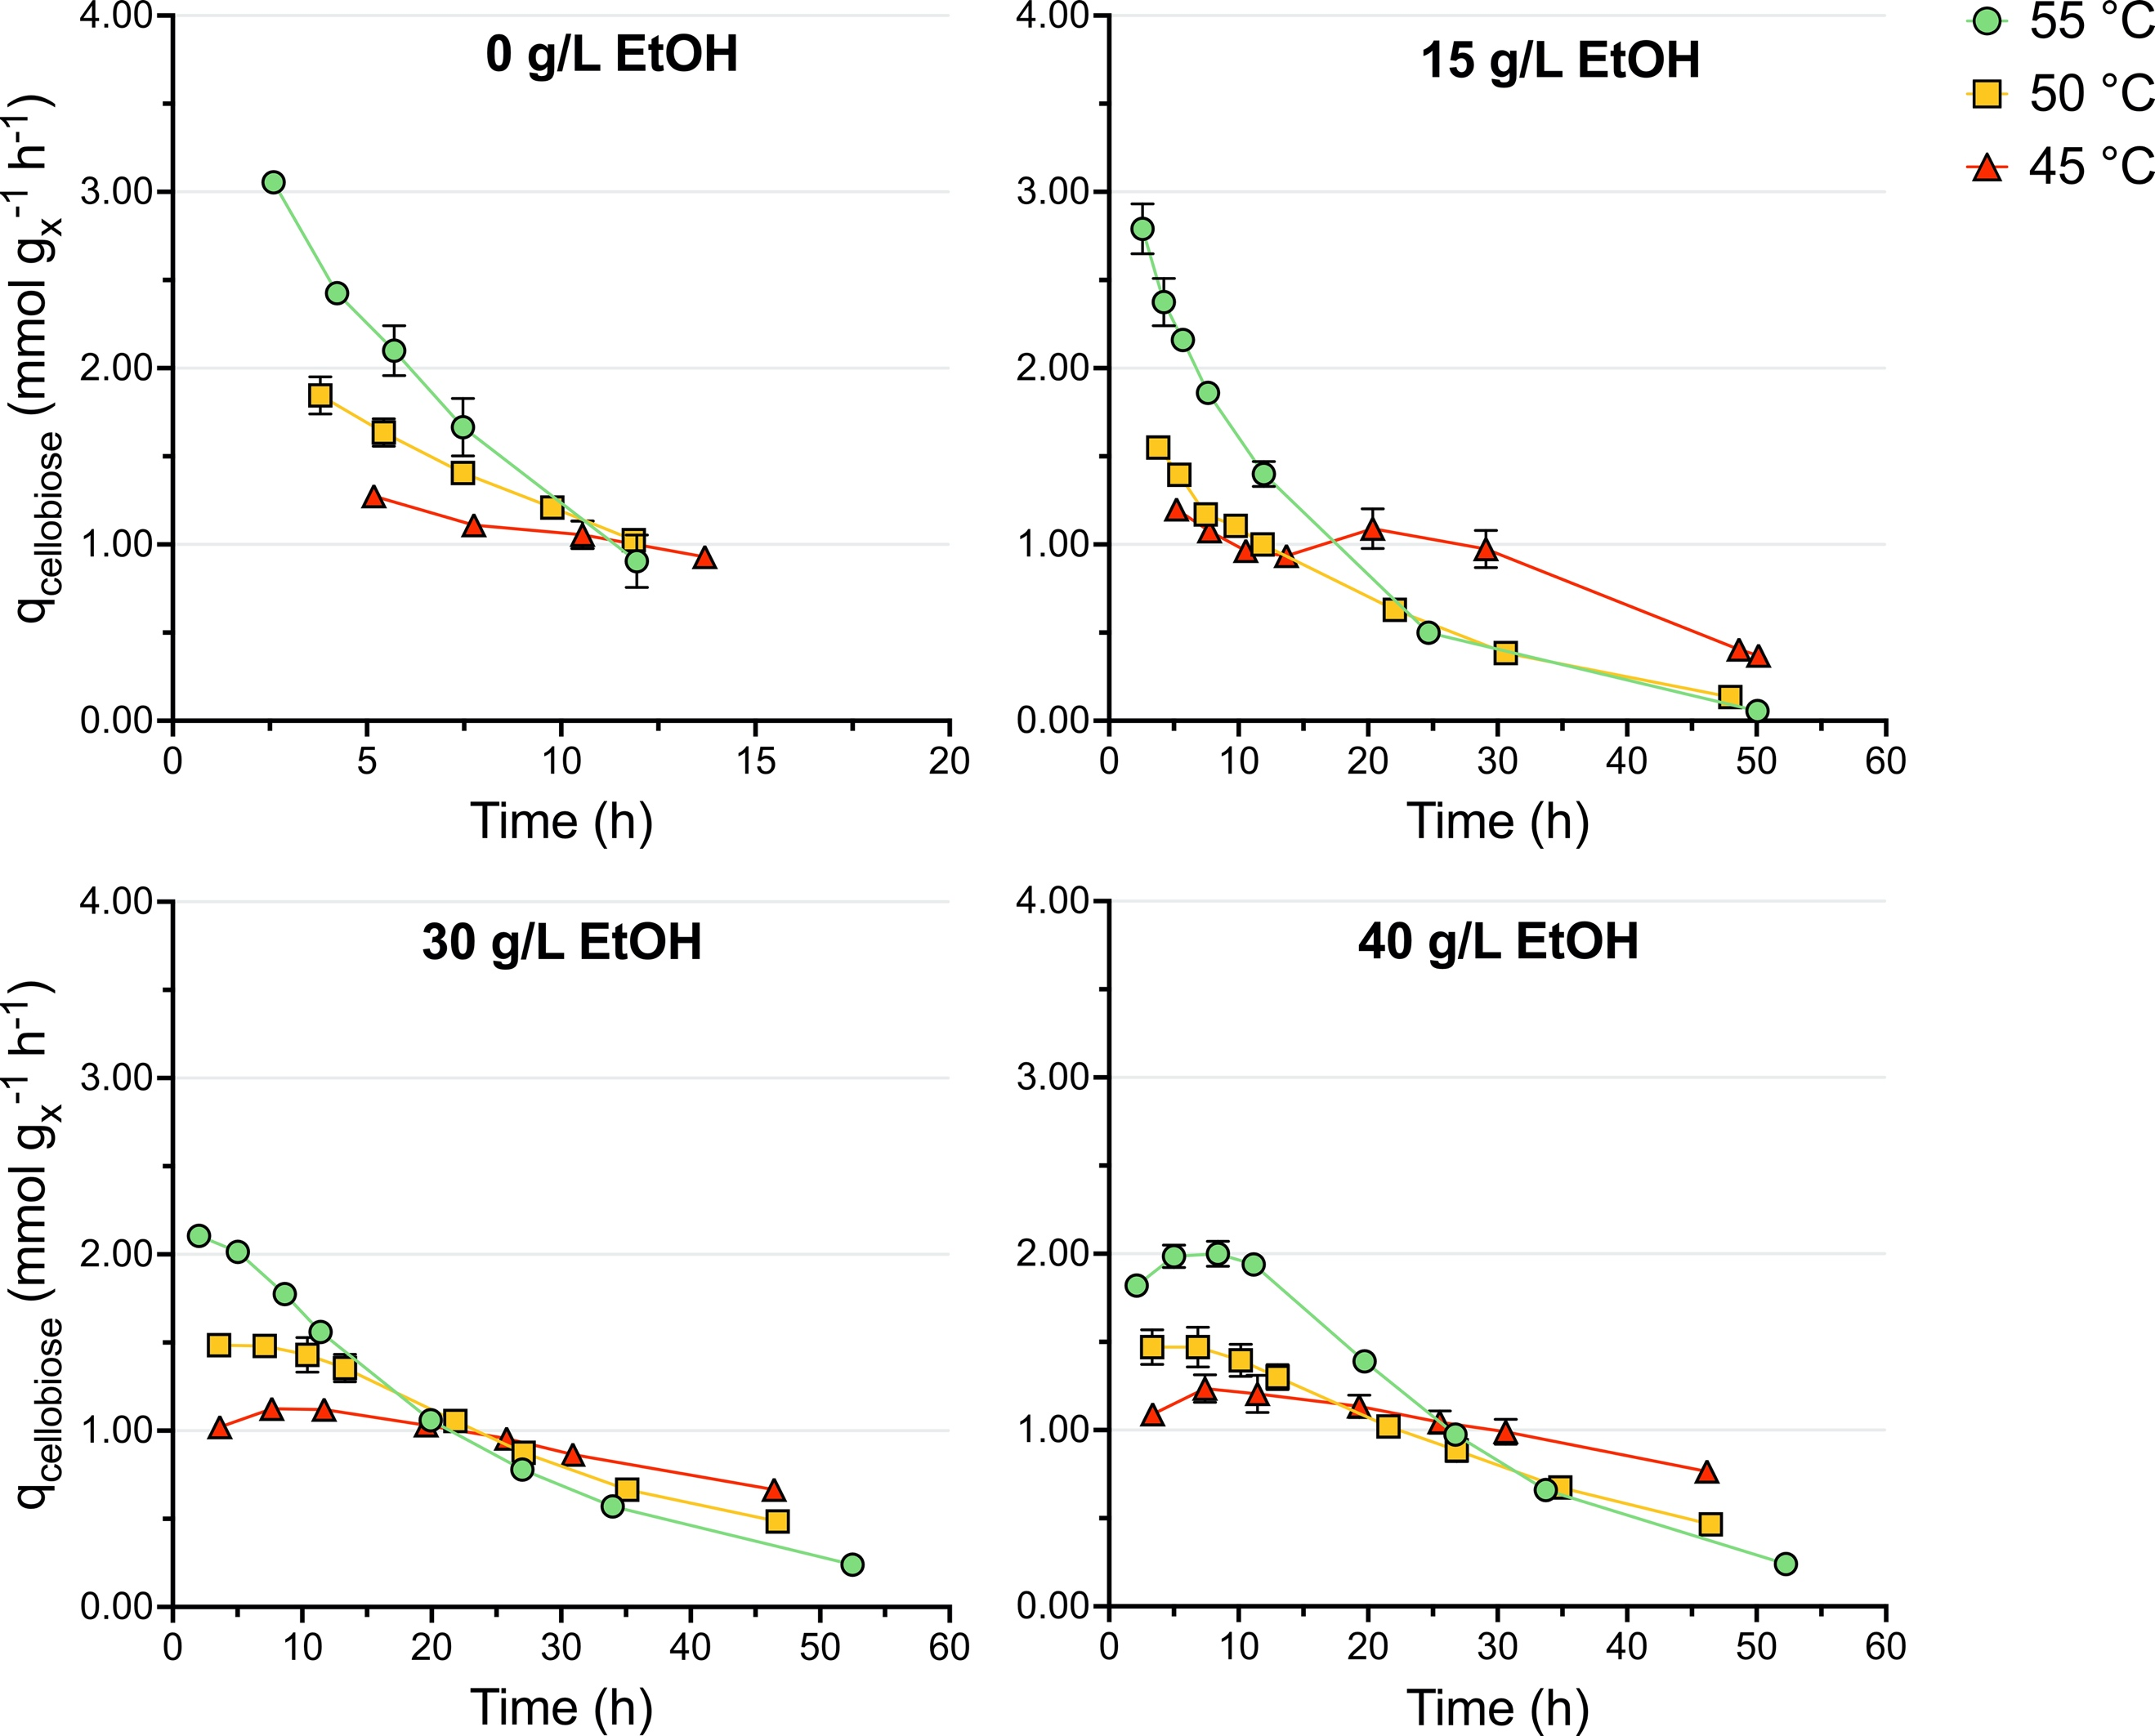
Fig. S10. Biomass-specific cellobiose consumption rate of DSM1313 as a function of time in the presence of 0, 15, 30, and 40 g L⁻¹ added ethanol during growth-arrest studies. Batch serum bottle cultures were grown on modified LC medium without Na₂SO₄ and with 0.01 g L⁻¹ cysteine and 10 g L⁻¹ cellobiose. Data is plotted from the moment growth was arrested until cellobiose became limiting (> 0.5 mM) (Additional file 7). Averages and mean deviations were obtained from independent biological duplicates. Absence of error bars indicates mean deviations were smaller than the symbol size.
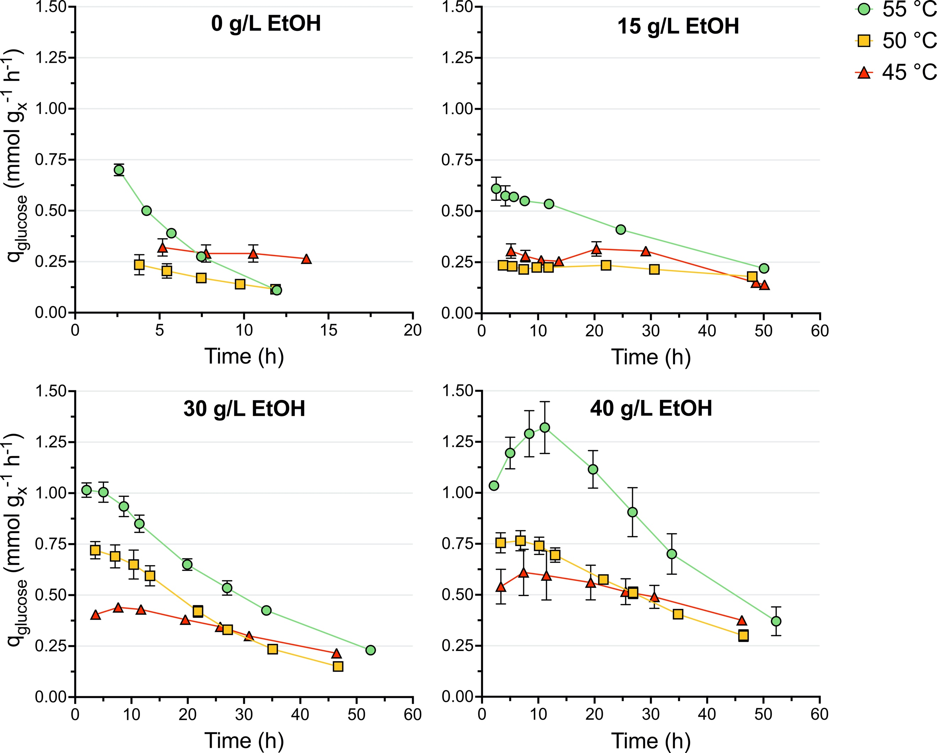
Fig. S11. Biomass-specific glucose production rate of DSM1313 as a function of time in the presence of 0, 15, 30, and 40 g L⁻¹ added ethanol during growth-arrest studies. Batch serum bottle cultures were grown on modified LC medium without Na₂SO₄ and with 0.01 g L⁻¹ cysteine and 10 g L⁻¹ cellobiose. Data is plotted from the moment growth was arrested until cellobiose became limiting (> 0.5 mM) (Additional file 7). Averages and mean deviations were obtained from independent biological duplicates. Absence of error bars indicates mean deviations were smaller than the symbol size.
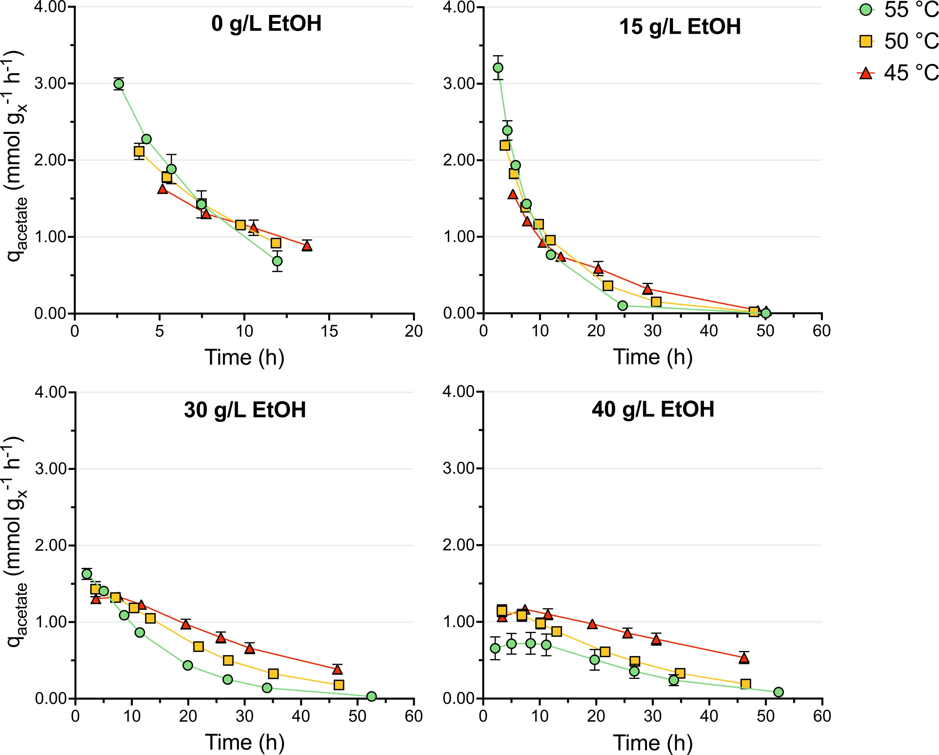
Fig. S12. Biomass-specific acetate production rate of DSM1313 as a function of time in the presence of 0, 15, 30, and 40 g L⁻¹ added ethanol during growth-arrest studies. Batch serum bottle cultures were grown on modified LC medium without Na₂SO₄ and with 0.01 g L⁻¹ cysteine and 10 g L⁻¹ cellobiose. Data is plotted from the moment growth was arrested until cellobiose became limiting (> 0.5 mM) (Additional file 7). Averages and mean deviations were obtained from independent biological duplicates. Absence of error bars indicates mean deviations were smaller than the symbol size.
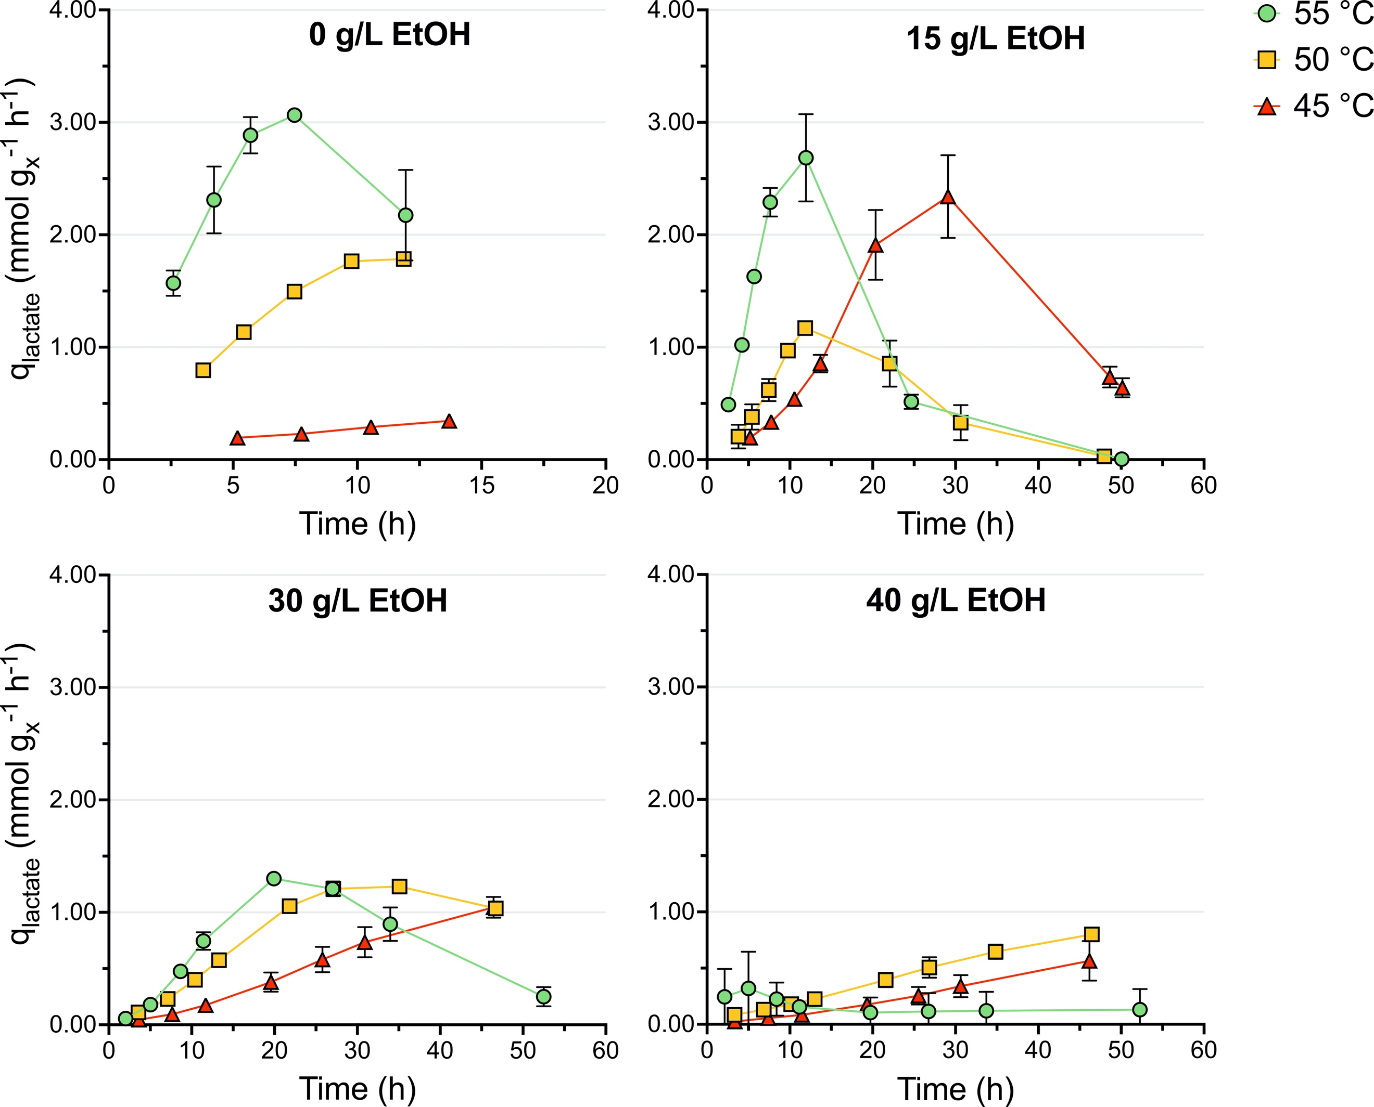
Fig. S13. Biomass-specific lactate production rate of DSM1313 as a function of time in the presence of 0, 15, 30, and 40 g L⁻¹ added ethanol during growth-arrest studies. Batch serum bottle cultures were grown on modified LC medium without Na₂SO₄ and with 0.01 g L⁻¹ cysteine and 10 g L⁻¹ cellobiose. Data is plotted from the moment growth was arrested until cellobiose became limiting (> 0.5 mM) (Additional file 7). Averages and mean deviations were obtained from independent biological duplicates. Absence of error bars indicates mean deviations were smaller than the symbol size.
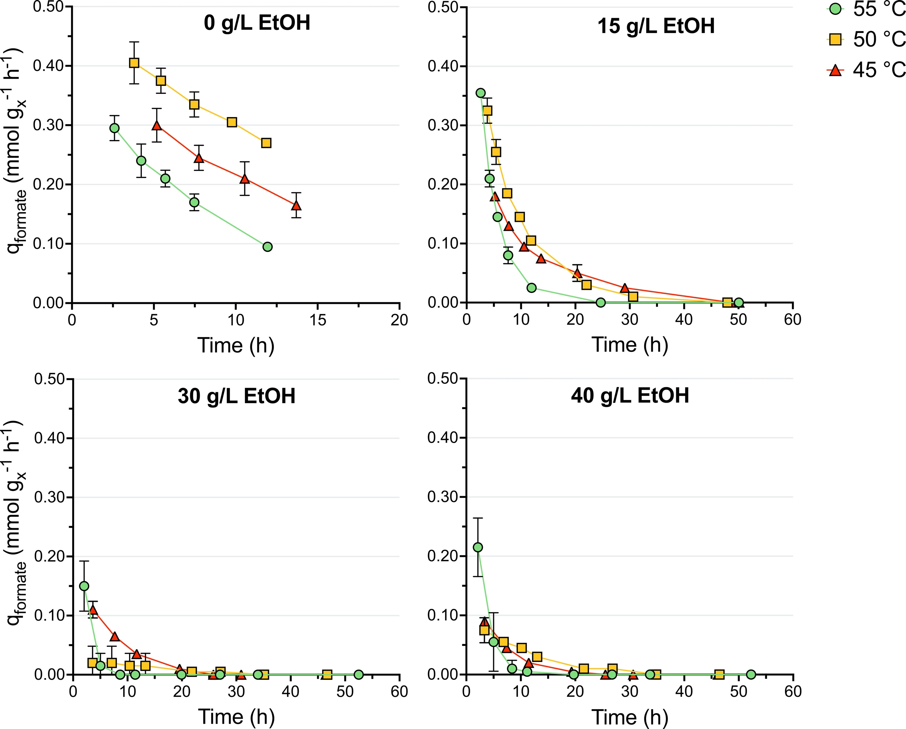
Fig. S14. Biomass-specific formate production rate of DSM1313 as a function of time in the presence of 0, 15, 30, and 40 g L⁻¹ added ethanol during growth-arrest studies. Batch serum bottle cultures were grown on modified LC medium without Na₂SO₄ and with 0.01 g L⁻¹ cysteine and 10 g L⁻¹ cellobiose. Data is plotted from the moment growth was arrested until cellobiose became limiting (> 0.5 mM) (Additional file 7). Averages and mean deviations were obtained from independent biological duplicates. Absence of error bars indicates mean deviations were smaller than the symbol size.

