a
b

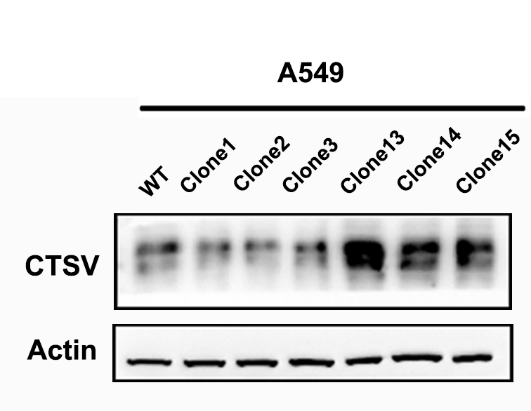
c

Figure S1 Metastatic lung cancer cell lines presented with high CTSV expression
(a) Migration assay of the 15 clones of A549 cells. (b) Relative CTSV mRNA expression of three most advanced metastatic property clones and three junior metastatic property clones. (c) Western Blot analysis of CTSV expression in A549 lung cancer cells. Two-tailed Student’s t-tests were used to analyze the data. *P < 0.05, **P < 0.01, ***P <0.001, ****P <0.0001.

