The Brachycephalic Paradox: The Relationship Between Attitudes, Personality, Knowledge of Health Problems, and Dog-Human Eye Contact
  - Zsófia Bognár^{1,2}*, Enikő Kubinyi^{1,2,3}
  - ¹ MTA-ELTE Lendület “Momentum” Companion Animal Research Group, Budapest, Hungary
² Department of Ethology, ELTE Eötvös Loránd University, Budapest, Hungary
³ ELTE NAP Canine Brain Research Group
  - *Corresponding author: bognarzsof@gmail.com

Supplementary
Table S1 – Respondents with controversial replies regarding their attitudes. In A) we list the brachycephalic breeds the respondent ever lived with. In B) the respondent’s most liked breeds and in C) the most disliked breeds or types are indicated. These respondents were assigned to the “Like” group in the analyses.
The ID of respondents with disambiguous replies | A) Lived together with an... | B) Like | C) Dislike
1 | Cavalier King Charles Spaniel | Cavalier King Charles Spaniel | Pug
2 | Cavalier King Charles Spaniel | No mention of flat-faced dogs | Pug
3 | English Bulldog | English Bulldog | Pekingese
4 | Griffon | Griffon | Boxer
5 | Pug | Pug | English Bulldog
6 | No mention of flat-faced dogs | Griffon | Bulldog (did not indicate the exact breed)
7 | Bulldog (did not indicate the exact breed) | No mention of flat-faced dogs | Brachycephalic dogs
8 | Cavalier King Charles Spaniel | No mention of flat-faced dogs | Flat-faced dogs
9 | Cavalier King Charles Spaniel | Cavalier King Charles Spaniel | Flat-faced dogs, e.g., Bulldogs (did not indicate the exact breeds)
10 | Pekingese | No mention of flat-faced dogs | Flat-faced dogs
11 | French Bulldog | No mention of flat-faced dogs | Flat-faced dogs, especially French Bulldogs
12 | Pug | No mention of flat-faced dogs | Pug, French Bulldog

Questionnaire items
Table S2 – Items of the Big Five Inventory (personality)
1  disagree  strongly | 2  disagree  a little | 3  neither agree  nor disagree | 4  agree  a little | 5  agree  strongly
I see myself as someone who...
1 | ........ is talkative | 23 | ........ tends to be lazy
2 | ........ tends to find fault with others | 24 | ........ is emotionally stable, not easily upset
3 | ........ does a thorough job | 25 | ........ is inventive
4 | ........ is depressed, blue | 26 | ........ has an assertive personality
5 | ........ is original, comes up with new ideas | 27 | ........ can be cold and aloof
6 | ........ is reserved | 28 | ........ perseveres until the task is finished
7 | ........ is helpful and unselfish with others | 29 | ........ can be moody
8 | ........ can be somewhat careless | 30 | ........ values artistic, aesthetic experiences
9 | ........ is relaxed, handles stress well | 31 | ........ is sometimes shy, inhibited
10 | ........ is curious about many different things | 32 | ........ is considerate and kind to almost everyone
11 | ........ is full of energy | 33 | ........ does things efficiently
12 | ........ starts quarrels with others | 34 | ........ remains calm in tense situations
13 | ........ is a reliable worker | 35 | ........ prefers work that is routine
14 | ........ can be tense | 36 | ........ is outgoing, sociable
15 | ........ is ingenious, a deep thinker | 37 | ........ is sometimes rude to others
16 | ........ generates a lot of enthusiasm | 38 | ........ makes plans and follows through with them
17 | ........ has a forgiving nature | 39 | ........ gets nervous easily
18 | ........ tends to be disorganized | 40 | ........ likes to reflect, play with ideas
19 | ........ worries a lot | 41 | ........ has few artistic interests
20 | ........ has an active imagination | 42 | ........ likes to cooperate with others
21 | ........ tends to be quiet | 43 | ........ is easily distracted
22 | ........ is generally trusting | 44 | ........ is sophisticated in art, music, or literature
- Reverse code reverse keyed items
The reversed items ® are: 2, 6, 8, 9, 12, 18, 21, 23, 24, 27, 31, 34, 35, 37, 41, 43
That is, for these items:
Replace a score of 5 with a score of 1
Replace a score of 4 with a score of 2
Replace a score of 2 with a score of 4
Replace a score of 1 with a score of 5
2. Take average of items within each scale
Extraversion items: 1, 6R, 11, 16, 21R, 26, 31R, 36
Agreeableness items: 2R, 7, 12R, 17, 22, 27R, 32, 37R, 42
Conscientiousness items: 3, 8R, 13, 18R, 23R, 28, 33, 38, 43R.
Neuroticism items: 4, 9R, 14, 19, 24R, 29, 34R, 39
Openness items: 5, 10, 15, 20, 25, 30, 35R, 40, 41R, 44

Table S3 – Items of the modified Interpersonal Reactivity Index (empathy toward dogs)
I often have tender, concerned feelings for dogs less fortunate than others. | D-EC
I sometimes find it difficult to see things from the dogs point to view. | D-PT—
Sometimes I don’t feel very sorry for dogs when they have problems or suffer. | D-EC—
I try to understand the reasons behind a dog’s undesired behaviour before making a decision. | D-PT
When I see a dog being treated badly, I feel protective towards it. | D-EC
I sometimes try to understand dogs better by imagining how things look from their perspective. | D-PT
Dogs’ misfortunes do not usually disturb me a great deal. | D-EC—
If I’m sure I’m right about how to handle a dog, I don’t waste time trying to think what might be causing the dogs behaviour. | D-PT—
When I see dogs being treated unfairly, I sometimes don’t feel very much pity for them. | D-EC—
I am often quite touched by things that I see happen. | D-EC
I believe that there are two sides to every question and try to look at them both. | D-PT
I would describe myself as a dog lover. | D-EC
When I am disappointed or angry because of how a dog behaves, I usually try to put myself in its place for a while. | D-PT
Before scolding a dog, I try to imagine how I would feel if I were in its place. | D-PT
D-EC, dog-directed emotional empathy (empathic concern); D-PT, dog-directed cognitive empathy (perspective taking); —,
reversed scoring. 5-point scale–(0 = does not describe me, 4 = describes me well).

Information on photo stimuli
Table S4 – Photo stimuli in order of presentation. How much the respondents liked the dog in the photo, which photo of the dog did they like more, and what was the respondents’ perception about the gaze direction of the dog. Calculation of the ‘difference score’: the percentage of ‘Yes’ answers for the Eye contact photo + the percentage of ‘No’ answers for the Look away photo. Higher scores mean greater perceived differences, that is the photos are more distinct.
Photos used as stimuli | In what proportion did the different groups (dislike brachycephalism, neutral towards it, like it) like the dog in the photo? | Which photo (eye contact/look away) did the different groups like more of the same dog? | Does the dog look at you? (different sample; N=20)
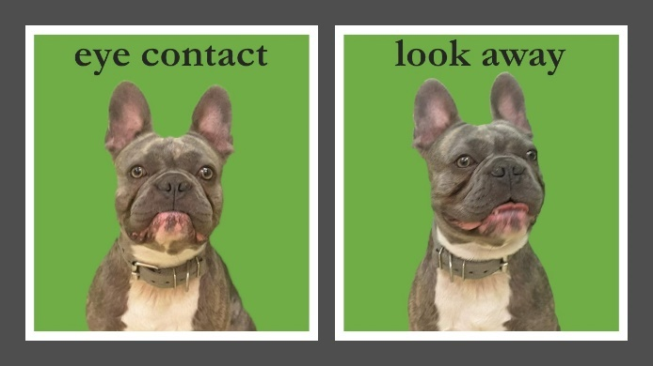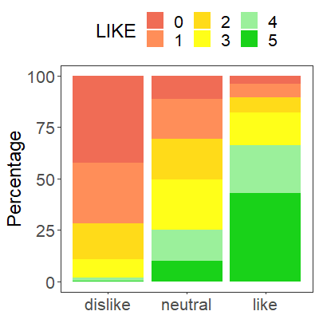 |  | 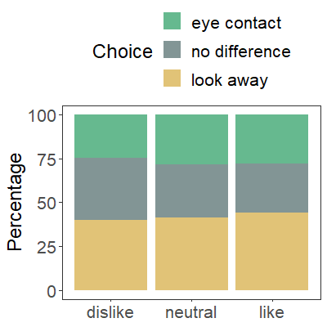 | - Eye contact photo  Yes: 85%; No: 15%  - Look away photo  Yes: 5%; No: 95%  ‘Difference score’: 90%
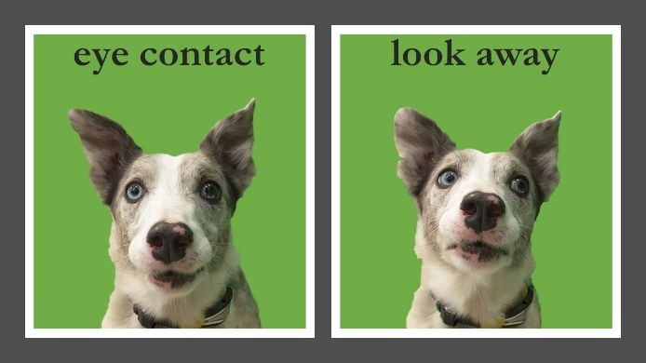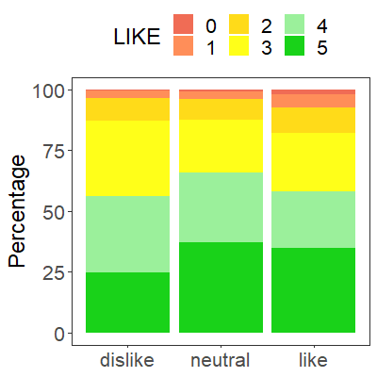 |  | 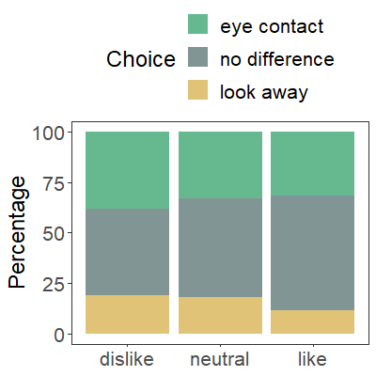 | - Eye contact photo  Yes: 80%; No: 20%  - Look away photo  Yes: 0%; No: 100%  ‘Difference score’: 90%
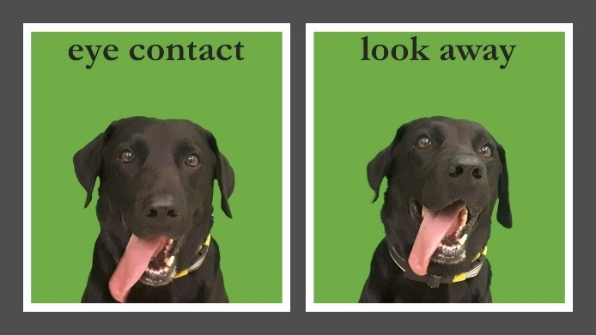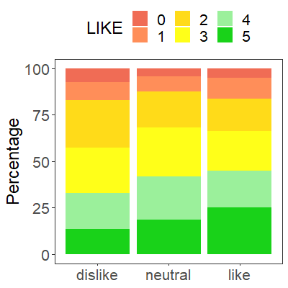 |  | 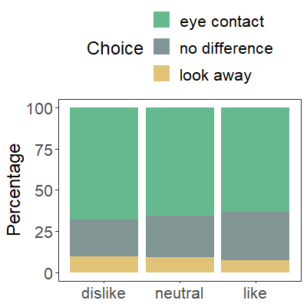 | - Eye contact photo  Yes: 95%; No: 5%  - Look away photo  Yes: 10%; No: 90%  ‘Difference score’: 92.5%
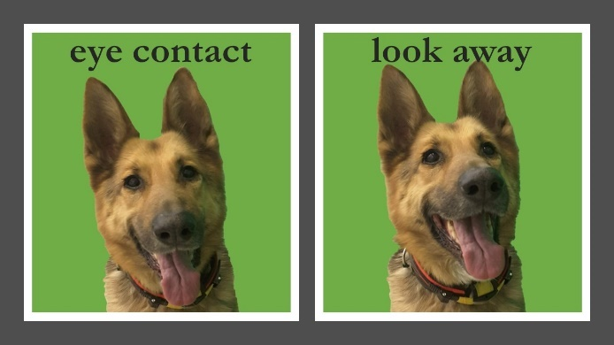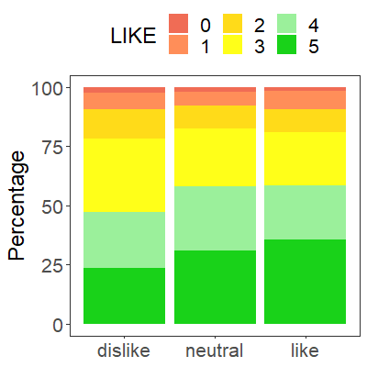 |  | 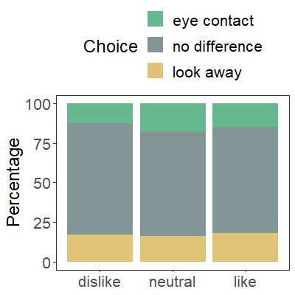 | - Eye contact photo  Yes: 95%; No: 5%  - Look away photo  Yes: 10%; No: 90%  ‘Difference score’: 92.5%
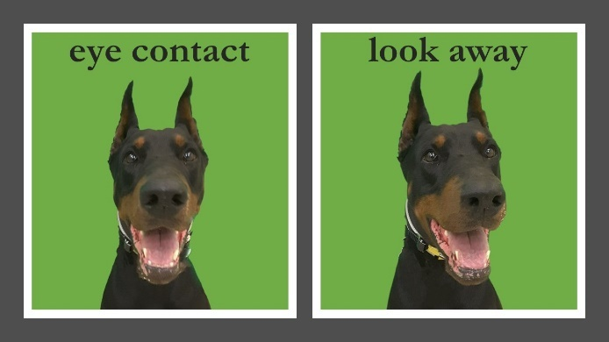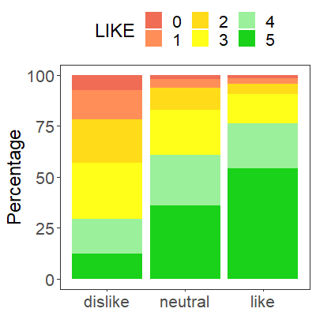 |  | 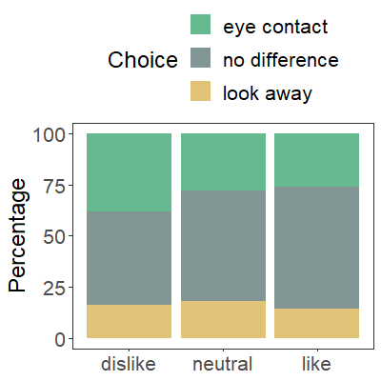 | - Eye contact photo  Yes: 80%; No: 20%  - Look away photo  Yes: 20%; No: 80%  ‘Difference score’: 80%
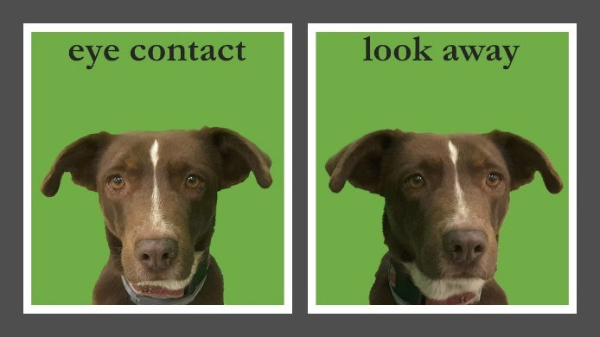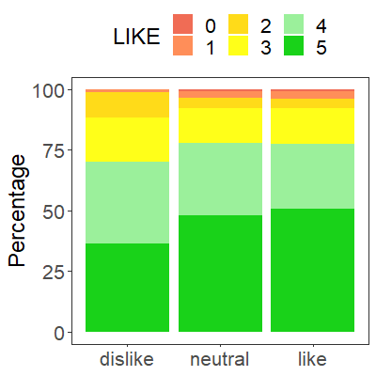 |  | 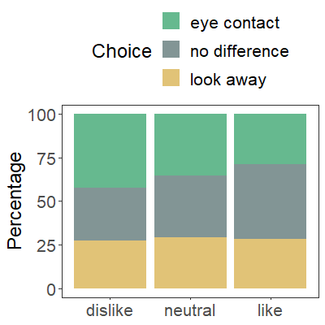 | - Eye contact photo  Yes: 60%; No: 40%  - Look away photo  Yes: 5%; No: 95%  ‘Difference score’: 77.5%
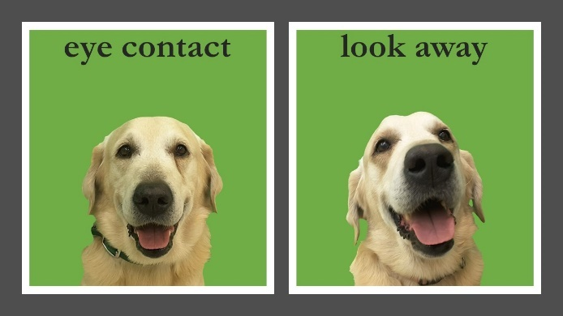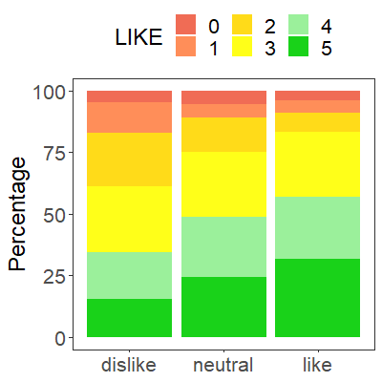 |  | 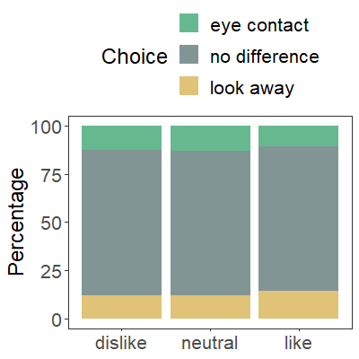 | - Eye contact photo  Yes: 95%; No: 5%  - Look away photo  Yes: 20%; No: 80%  ‘Difference score’: 87.5%
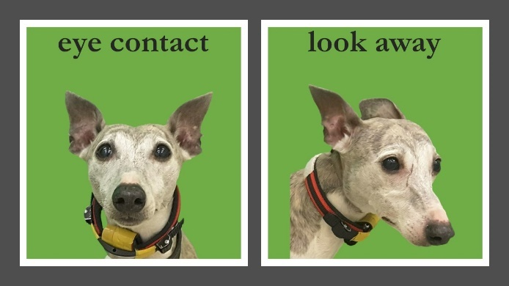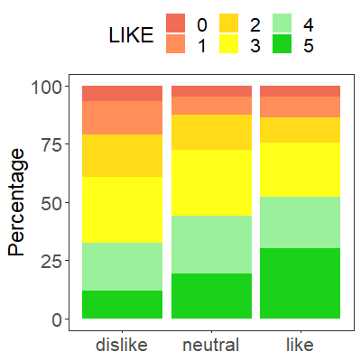 |  | 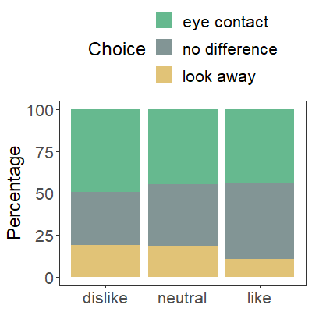 | - Eye contact photo  Yes: 75%; No: 25%  - Look away photo  Yes: 0%; No: 100%  ‘Difference score’: 87.5%
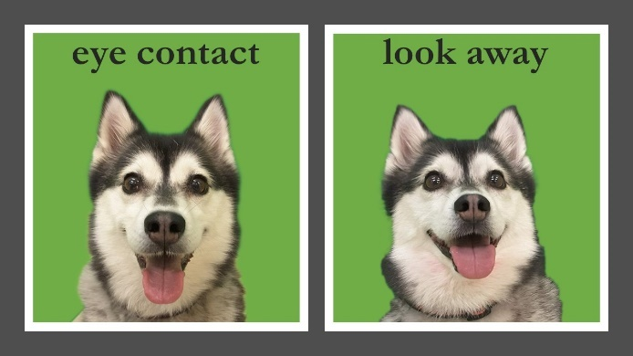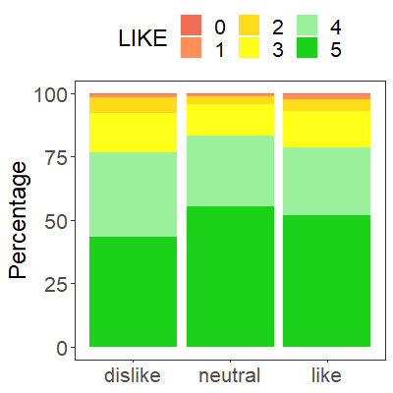 |  | 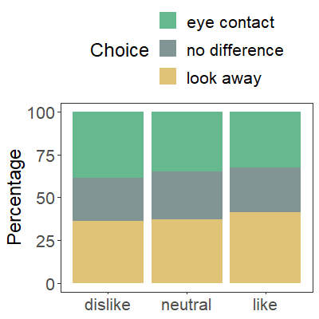 | - Eye contact photo  Yes: 100%; No: 0%  - Look away photo  Yes: 25%; No: 75%  ‘Difference score’: 87.5%
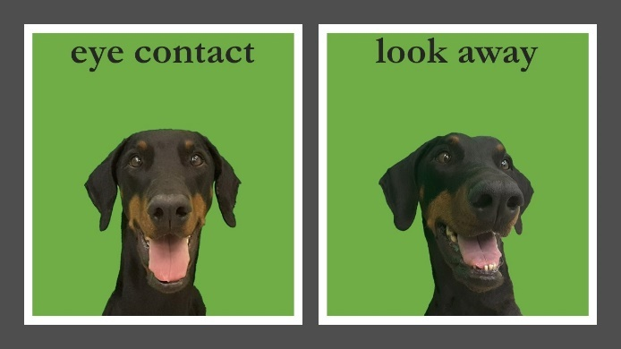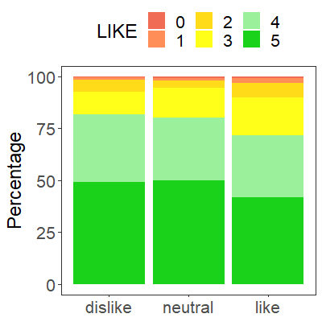 |  | 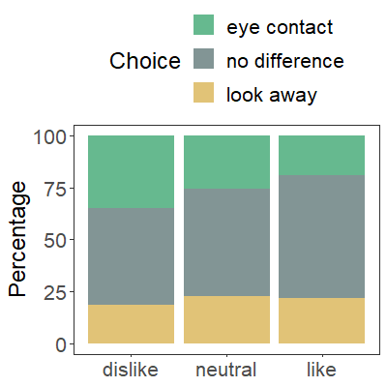 | - Eye contact photo  Yes: 100%; No: 0%  - Look away photo  Yes: 10%; No: 90%  ‘Difference score’: 95%
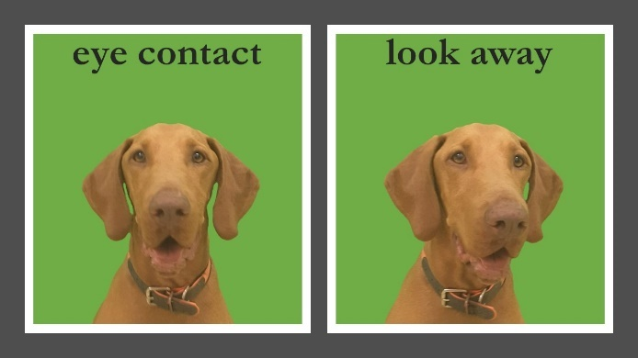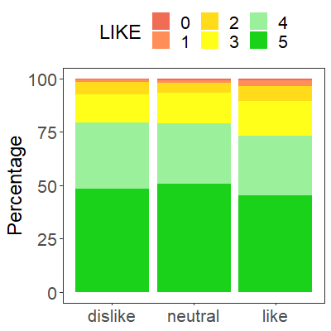 |  | 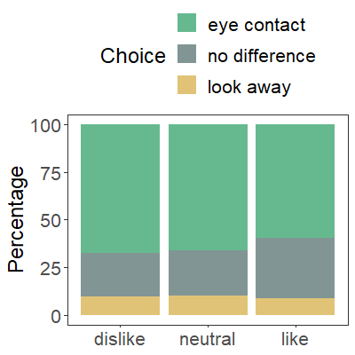 | - Eye contact photo  Yes: 80%; No: 20%  - Look away photo  Yes: 5%; No: 95%  ‘Difference score’: 87.5%
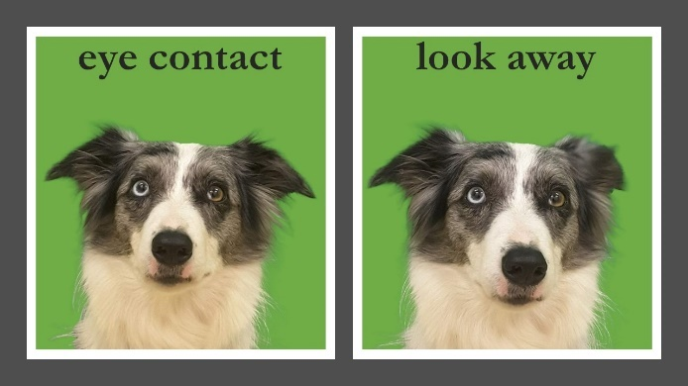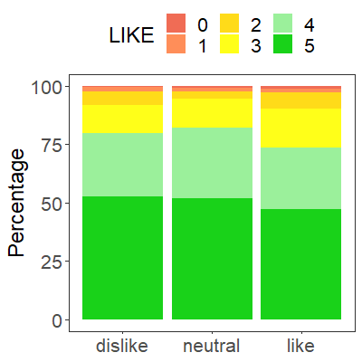 |  | 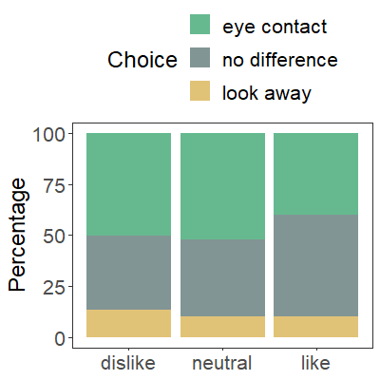 | - Eye contact photo  Yes: 40%; No: 60%  - Look away photo  Yes: 40%; No: 60%  ‘Difference score’: 50%
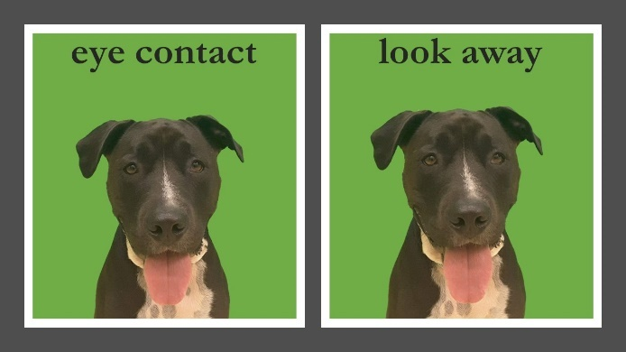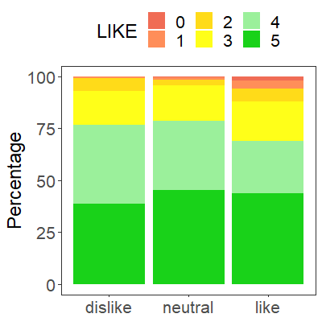 |  | 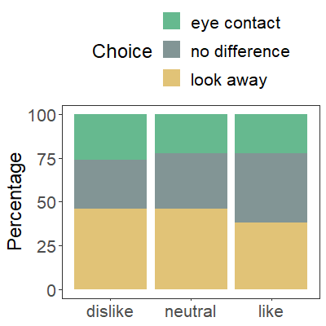 | - Eye contact photo  Yes: 85%; No: 15%  - Look away photo  Yes: 40%; No: 60%  ‘Difference score’: 72.5%
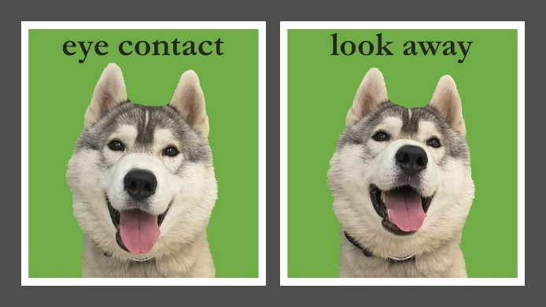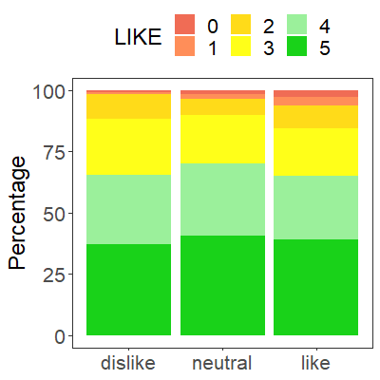 |  | 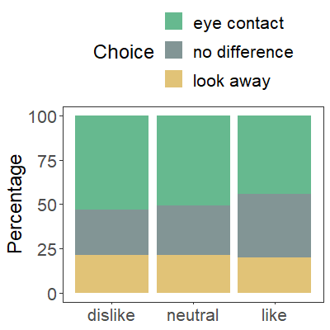 | - Eye contact photo  Yes: 95%; No: 5%  - Look away photo  Yes: 15%; No: 85%  ‘Difference score’: 90%
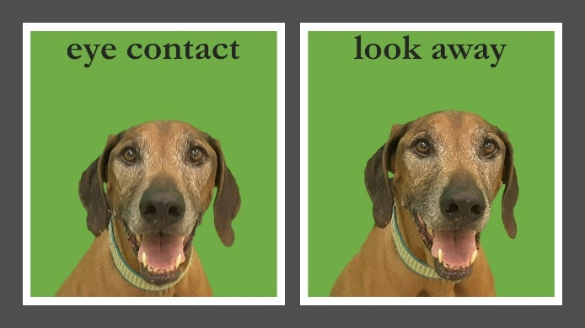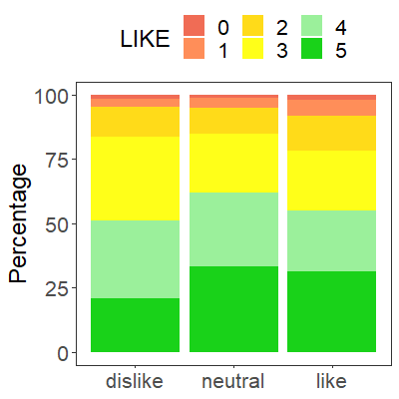 |  | 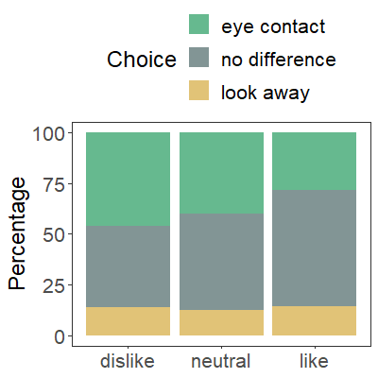 | - Eye contact photo  Yes: 95%; No: 5%  - Look away photo  Yes: 30%; No: 70%  ‘Difference score’: 82.5%
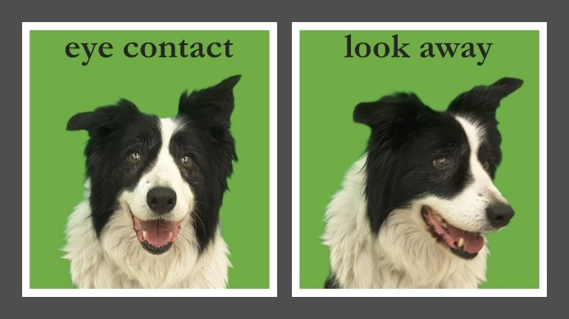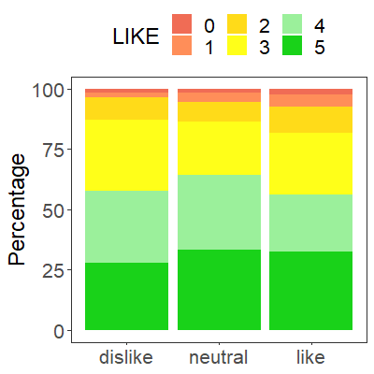 |  | 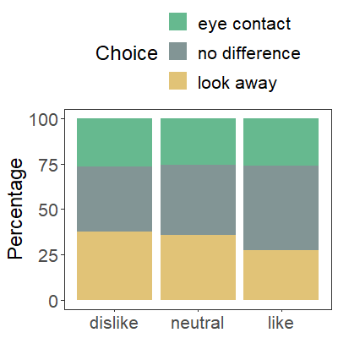 | - Eye contact photo  Yes: 40%; No: 60%  - Look away photo  Yes: 0%; No: 100%  ‘Difference score’: 70%
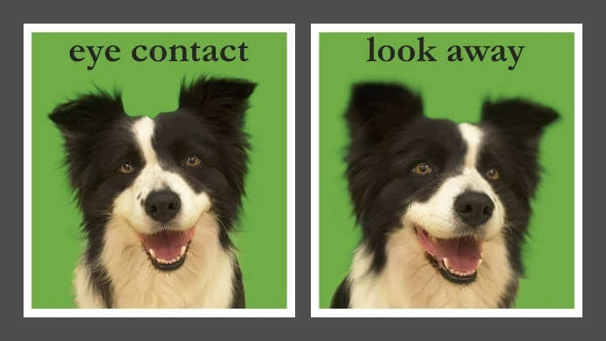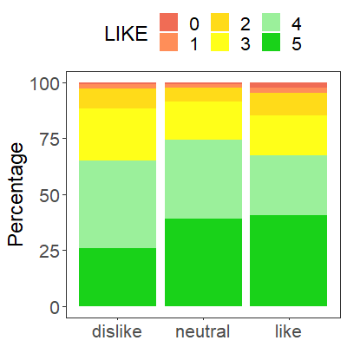 |  | 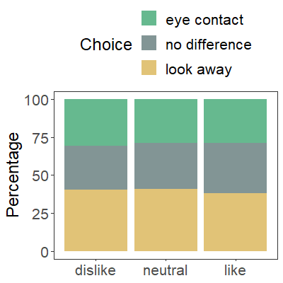 | - Eye contact photo  Yes: 80%; No: 20%  - Look away photo  Yes: 10%; No: 90%  ‘Difference score’: 85%
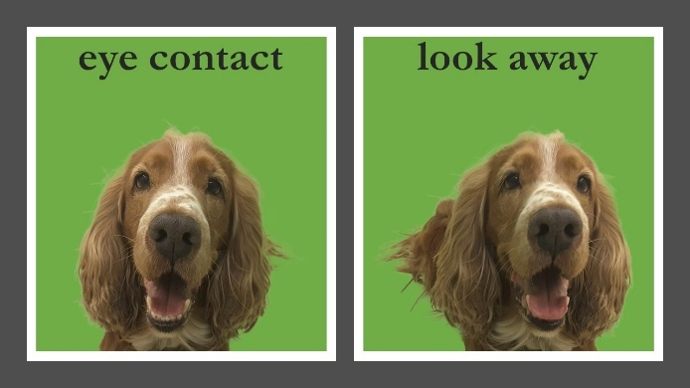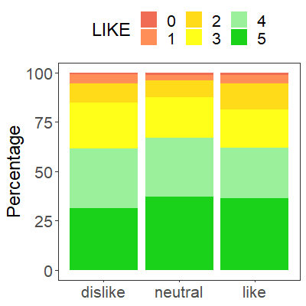 |  | 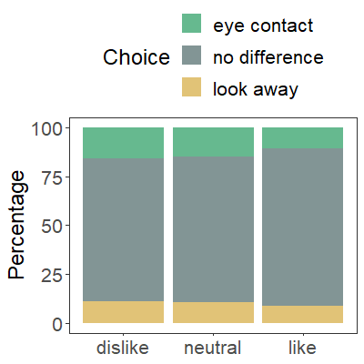 | - Eye contact photo  Yes: 90%; No: 10%  - Look away photo  Yes: 5%; No: 95%  ‘Difference score’: 92.5%
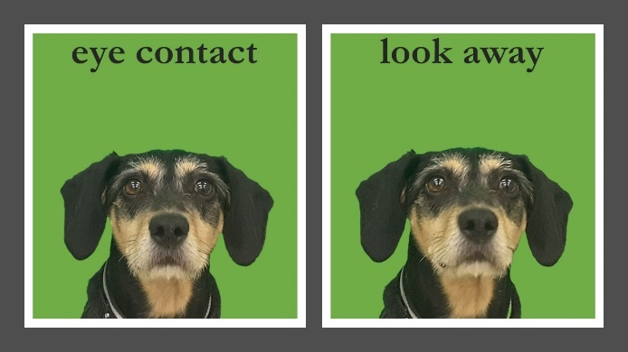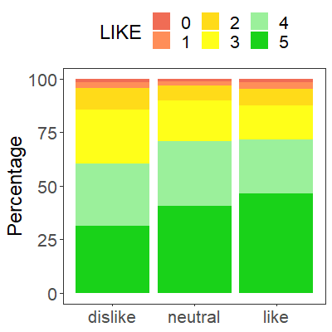 |  | 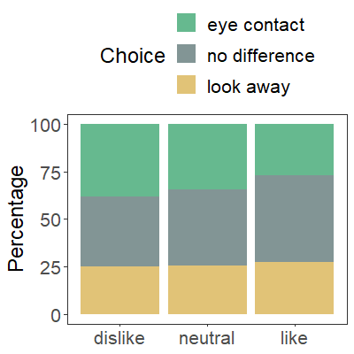 | - Eye contact photo  Yes: 60%; No: 40%  - Look away photo  Yes: 30%; No: 70%  ‘Difference score’: 65%
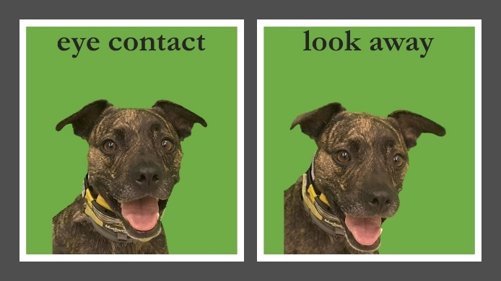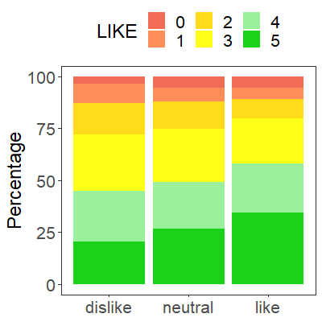 |  | 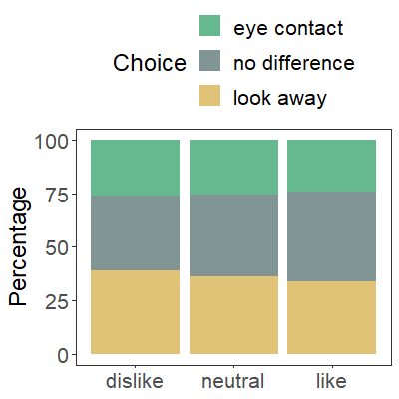 | - Eye contact photo  Yes: 80%; No: 20%  - Look away photo  Yes: 5%; No: 95%  ‘Difference score’: 87.5%
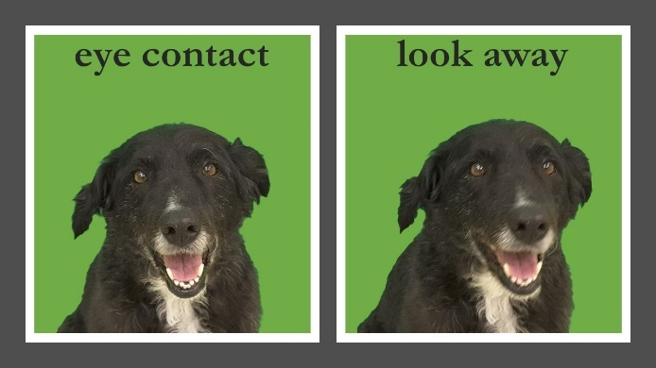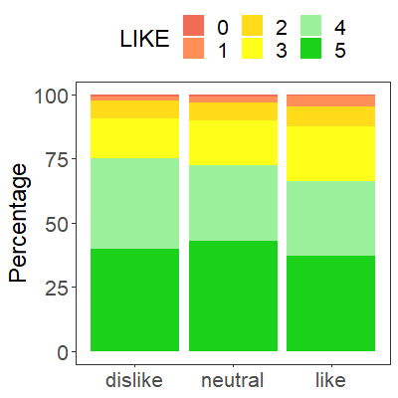 |  | 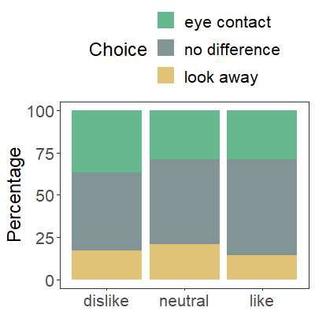 | - Eye contact photo  Yes: 95%; No: 5%  - Look away photo  Yes: 20%; No: 80%  ‘Difference score’: 87.5%
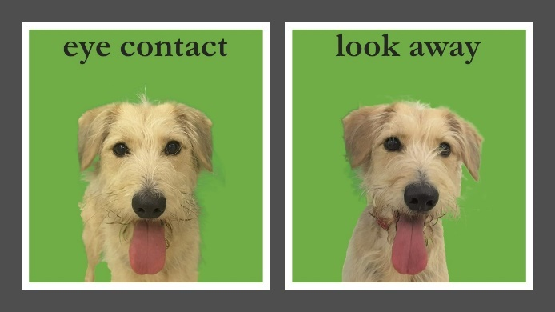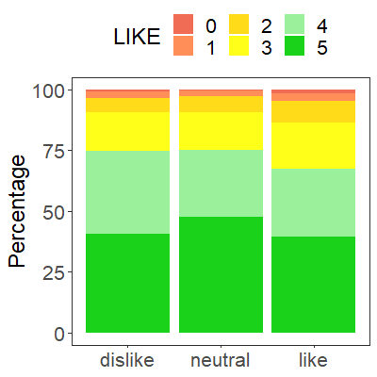 |  | 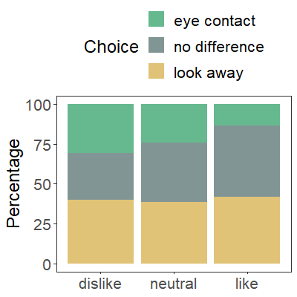 | - Eye contact photo  Yes: 100%; No: 0%  - Look away photo  Yes: 20%; No: 80%  ‘Difference score’: 90%
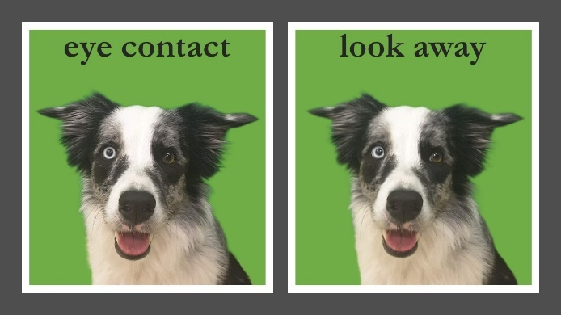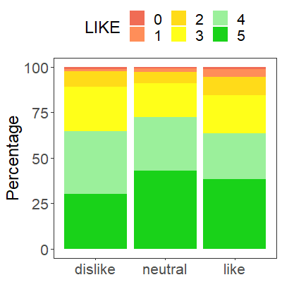 |  | 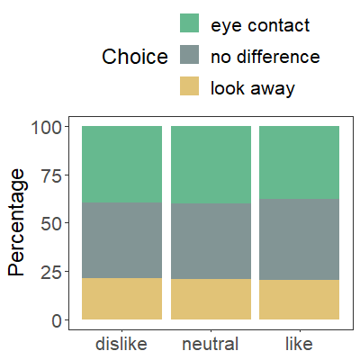 | - Eye contact photo  Yes: 85%; No: 15%  - Look away photo  Yes: 25%; No: 75%  ‘Difference score’: 80%
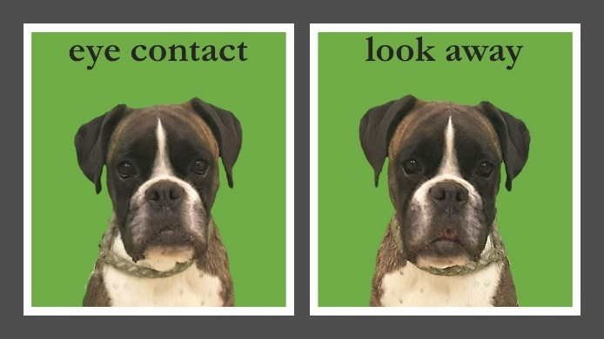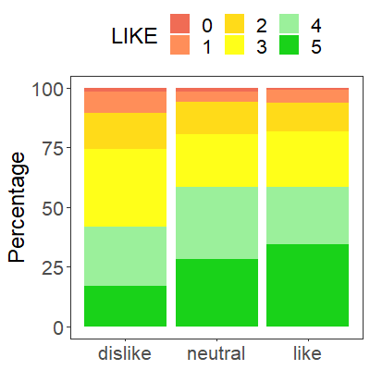 |  | 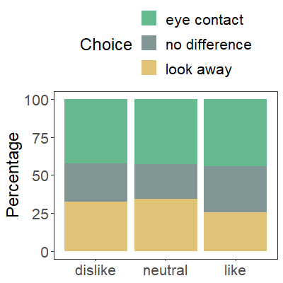 | - Eye contact photo  Yes: 90%; No: 10%  - Look away photo  Yes: 65%; No: 35%  ‘Difference score’: 62.5%
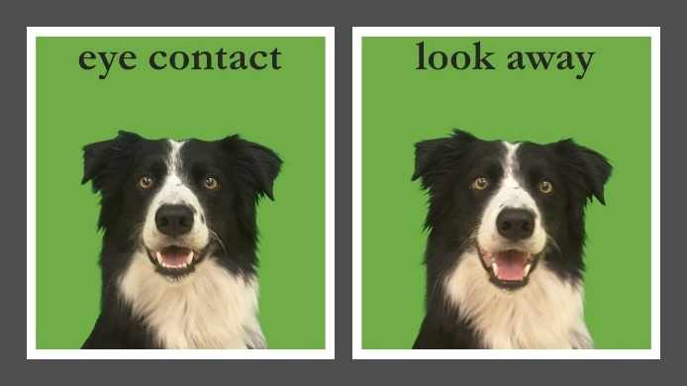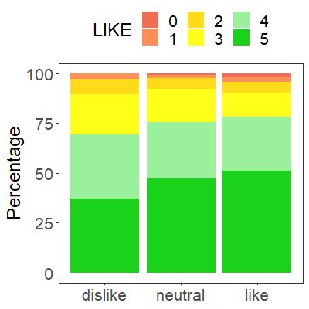 |  | 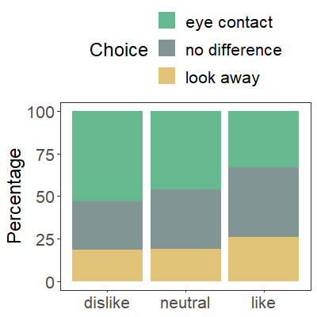 | - Eye contact photo  Yes: 50%; No: 50%  - Look away photo  Yes: 65%; No: 35%  ‘Difference score’: 42.5%

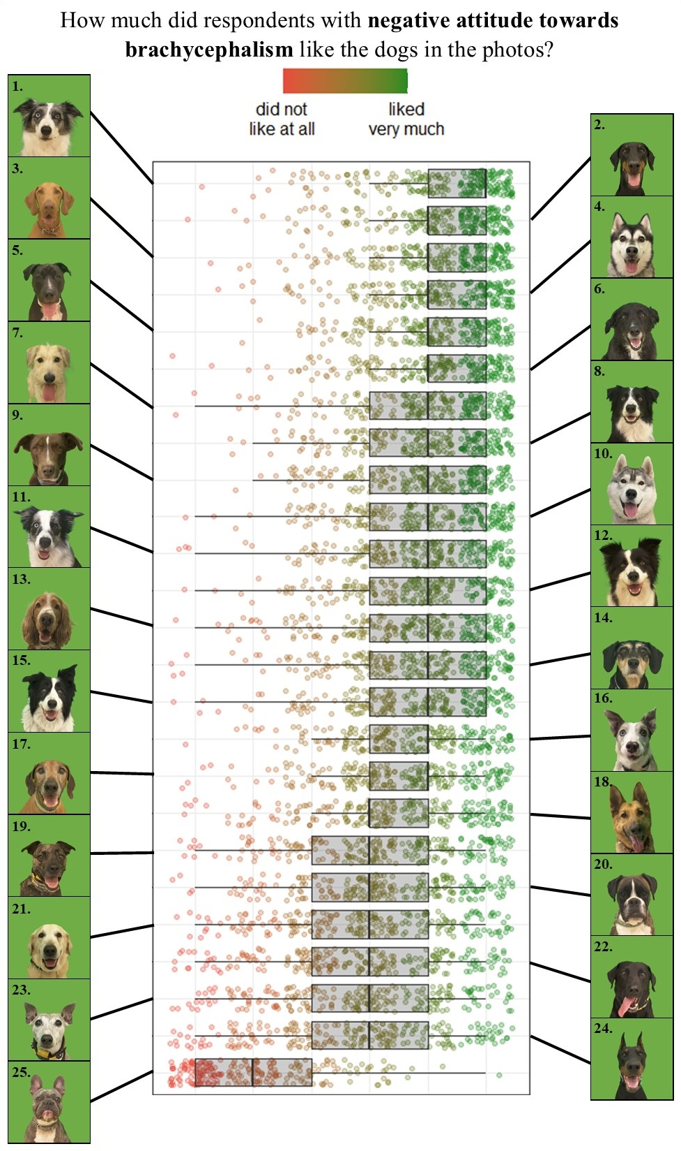
Figure S1 - The evaluation of respondents with negative attitude towards brachycephalism about how much did they like the dogs in the photo. At the top is the most liked picture, while on the bottom is the least liked one.
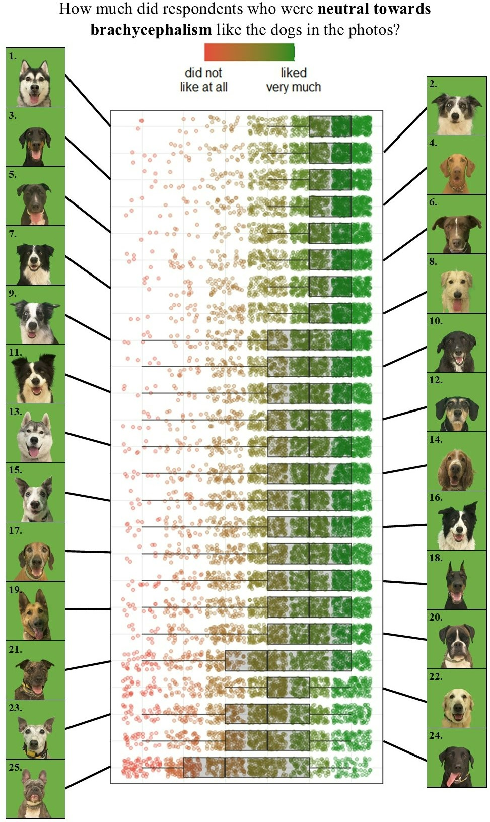
Figure S2 - The evaluation of respondents who were neutral towards brachycephalism about how much did they like the dogs in the photo. At the top is the most liked picture, while on the bottom is the least liked one.
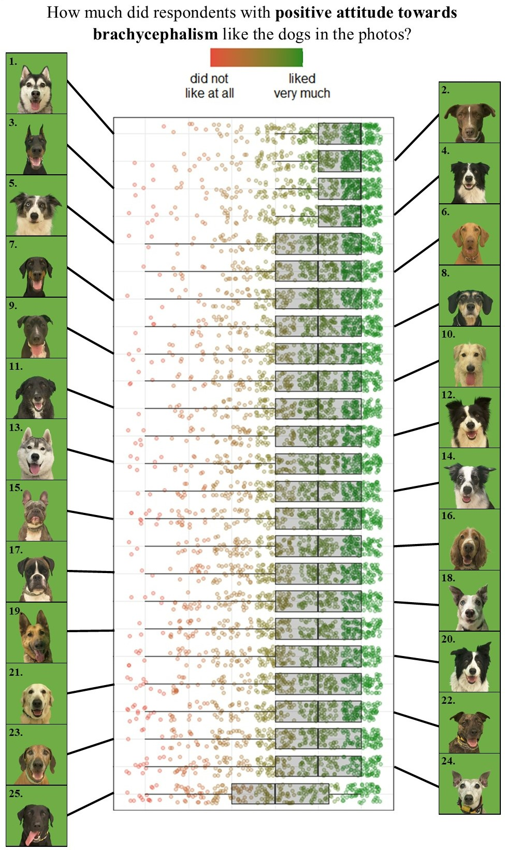
Figure S3 - The evaluation of respondents with positive attitude towards brachycephalism about how much did they like the dogs in the photo. At the top is the most liked picture, while on the bottom is the least liked one.

Model selections
Table S5 - Model selection of Multinomial Log-linear Models of the attitude towards brachycephalism
null model AIC: 2270 | Variables in the model
null model AIC: 2270 | 1 |  | 2 |  | 3 |  | 4 |  | 5 |  | 6 |  | 7 |  | 8 |  | 9 |  | 10 |  | 11
null model AIC: 2270 | AIC | p | AIC | p | AIC | p | AIC | p | AIC | p | AIC | p | AIC | p | AIC | p | AIC | p | AIC | p | AIC | p
Number of health problems  associated with brachycephalism | 2224 | < 0.001
Level of education | 2240 | < 0.001 | 2197 | < 0.001
Dog-related professional  expertise | 2254 | < 0.001 | 2205 | < 0.001 | 2178 | < 0.001
Respondents' age | 2243 | < 0.001 | 2205 | < 0.001 | 2179 | < 0.001 | 2158 | < 0.001
Respondents' residence | 2258 | < 0.001 | 2211 | < 0.001 | 2188 | 0.002 | 2167 | < 0.001 | 2147 | < 0.001
BFI - Agreeableness | 2260 | < 0.001 | 2214 | < 0.001 | 2186 | < 0.001 | 2167 | < 0.001 | 2148 | < 0.001 | 2137 | < 0.001
Respondents' sex | 2261 | 0.002 | 2215 | 0.002 | 2188 | 0.002 | 2168 | 0.001 | 2150 | 0.003 | 2140 | 0.003 | 2129 | 0.002
Dog-directed emotional  empathy | 2261 | 0.002 | 2217 | 0.005 | 2191 | 0.008 | 2170 | 0.003 | 2151 | 0.003 | 2139 | 0.002 | 2131 | 0.006 | 2121 | 0.002
BFI - Conscientiousness | 2262 | 0.003 | 2216 | 0.002 | 2189 | 0.002 | 2168 | 0.001 | 2150 | 0.003 | 2140 | 0.004 | 2134 | 0.035 | 2125 | 0.020 | 2119 | 0.049
Respondents' parental status | 2266 | 0.026 | 2220 | 0.026 | 2195 | 0.055 | 2177 | 0.100 | 2152 | 0.005 | 2145 | 0.035 | 2136 | 0.059 | 2128 | 0.076 | 2119 | 0.056 | 2117 | 0.057
Dog-directed cognitive empathy | 2272 | 0.525 | 2227 | 0.819 | 2201 | 0.975 | 2181 | 0.715 | 2162 | 0.673 | 2151 | 0.655 | 2141 | 0.769 | 2133 | 0.917 | 2123 | 0.373 | 2120 | 0.215 | 2118 | 0.221
BFI - Neuroticism | 2259 | < 0.001 | 2213 | < 0.001 | 2186 | < 0.001 | 2168 | < 0.001 | 2154 | 0.016 | 2143 | 0.017 | 2137 | 0.128 | 2130 | 0.251 | 2121 | 0.137 | 2121 | 0.359 | 2119 | 0.365
BFI - Openness | 2273 | 0.661 | 2227 | 0.729 | 2201 | 0.872 | 2182 | 0.966 | 2162 | 0.933 | 2151 | 0.996 | 2141 | 0.923 | 2133 | 0.934 | 2124 | 0.672 | 2122 | 0.525 | 2120 | 0.520
BFI - Extraversion | 2269 | 0.097 | 2223 | 0.109 | 2197 | 0.151 | 2178 | 0.126 | 2159 | 0.145 | 2147 | 0.119 | 2139 | 0.370 | 2131 | 0.366 | 2124 | 0.523 | 2122 | 0.619 | 2121 | 0.743

Table S6 - Detecting Multicollinearity with variance inflation factor (VIF) - Multinomial Log-linear Model of the attitude towards brachycephalism
Factor | VIF score
Number of health problems associated with brachycephalism | 1.03 - 1.08
Level of education | 1.02 - 1.04
Dog-related professional expertise | 1.05 - 1.13
Respondents' age | 1.49 - 1.64
Respondents' residence | 1.06 - 1.15
BFI - Agreeableness | 1.08 - 1.13
Respondents' sex | 1.10 - 1.15
Dog-directed emotional empathy | 1.11 - 1.18
BFI - Conscientiousness | 1.11 - 1.15
Respondents' parental status | 1.53 - 1.64

Table S7 - Model selection of Binomial Generalized Linear Mixed-Effects Models of the preference for eye contact against no preference
null model AIC: 20643 | Variables in the model
null model AIC: 20643 | 1 |  | 2 |  | 3 |  | 4 |  | 5 |  | 6
null model AIC: 20643 | AIC | p | AIC | p | AIC | p | AIC | p | AIC | p | AIC | p
How much did they like the dog in the photo overall? | 20351 | <0.001
Respondents' age | 20633 | <0.001 | 20341 | <0.001
Attitude towards brachycephalic dogs | 20637 | 0.005 | 20344 | 0.004 | 20331 | <0.001
Dog-directed cognitive empathy | 20639 | 0.010 | 20346 | 0.010 | 20335 | 0.006 | 20324 | 0.004
BFI - Extraversion | 20642 | 0.070 | 20349 | 0.072 | 20339 | 0.047 | 20328 | 0.029 | 20323 | 0.048
Respondents' sex | 20643 | 0.110 | 20350 | 0.120 | 20341 | 0.180 | 20330 | 0.110 | 20325 | 0.210 | 20323 | 0.200
Respondents' parental status | 20638 | 0.008 | 20347 | 0.020 | 20342 | 0.680 | 20333 | 1.000 | 20326 | 0.820 | 20325 | 1.000
Respondents' residence | 20647 | 0.370 | 20355 | 0.480 | 20345 | 0.500 | 20335 | 0.470 | 20329 | 0.560 | 20328 | 0.610
Level of education | 20642 | 0.063 | 20350 | 0.094 | 20340 | 0.085 | 20331 | 0.260 | 20325 | 0.170 | 20323 | 0.160
Dog-related professional expertise | 20641 | 0.041 | 20348 | 0.029 | 20338 | 0.045 | 20330 | 0.120 | 20326 | 0.250 | 20324 | 0.260
BFI - Agreeableness | 20645 | 0.400 | 20352 | 0.690 | 20342 | 0.490 | 20332 | 0.360 | 20326 | 0.610 | 20325 | 0.890
BFI - Conscientiousness | 20644 | 0.290 | 20351 | 0.280 | 20340 | 0.088 | 20329 | 0.055 | 20325 | 0.180 | 20324 | 0.320
BFI - Neuroticism | 20645 | 0.650 | 20353 | 0.790 | 20341 | 0.220 | 20331 | 0.190 | 20325 | 0.260 | 20324 | 0.470
BFI - Openness | 20644 | 0.170 | 20351 | 0.170 | 20341 | 0.160 | 20331 | 0.190 | 20326 | 0.440 | 20325 | 0.920
Dog-directed emotional empathy | 20645 | 0.740 | 20353 | 0.840 | 20342 | 0.520 | 20333 | 0.700 | 20323 | 0.077 | 20321 | 0.054

Table S8 - Detecting Multicollinearity with variance inflation factor (VIF) - Binomial Generalized Linear Mixed-Effects Model of the preference for eye contact against no preference
Factor | VIF score
How much did respondents like the dog in the photo? | 1.01
Age | 1.03
Attitude towards brachycephalism | 1.03
Dog-directed cognitive empathy | 1.01
Extraversion | 1.01

Table S9 - Model selection of Binomial Generalized Linear Mixed-Effects Models of the preference for look away against no preference
null model AIC: 17828 | Variables in the model
null model AIC: 17828 | 1 |  | 2 |  | 3
null model AIC: 17828 | AIC | p | AIC | p | AIC | p
How much did they like the dog in the photo overall? | 17607 | < 0.001
Respondents' age | 17822 | 0.006 | 17602 | 0.009
Attitude towards brachycephalic dogs | 17828 | 0.200 | 17607 | 0.170 | 17601 | 0.090
Respondents' sex | 17829 | 0.530 | 17608 | 0.560 | 17604 | 0.670
Respondents' parental status | 17827 | 0.077 | 17607 | 0.150 | 17604 | 0.930
Respondents' residence | 17833 | 0.540 | 17612 | 0.680 | 17608 | 0.720
Level of education | 17829 | 0.470 | 17608 | 0.620 | 17604 | 0.600
Dog-related professional expertise | 17830 | 0.450 | 17609 | 0.480 | 17605 | 0.560
BFI - Extraversion | 17828 | 0.140 | 17606 | 0.130 | 17601 | 0.096
BFI - Agreeableness | 17829 | 0.330 | 17608 | 0.530 | 17603 | 0.390
BFI - Conscientiousness | 17829 | 0.500 | 17608 | 0.430 | 17602 | 0.200
BFI - Neuroticism | 17829 | 0.610 | 17608 | 0.740 | 17603 | 0.290
BFI - Openness | 17828 | 0.200 | 17607 | 0.200 | 17602 | 0.180
Dog-directed emotional empathy | 17829 | 0.430 | 17607 | 0.200 | 17601 | 0.100
Dog-directed cognitive empathy | 17827 | 0.095 | 17606 | 0.089 | 17600 | 0.068

Table S10 - Detecting Multicollinearity with variance inflation factor (VIF) - Binomial Generalized Linear Mixed-Effects Model of the preference for look away against no preference
Factor | VIF score
How much did respondents like the dog in the photo? | 1.00
Age | 1.00
Table S11 - Model selection of Binomial Generalized Linear Mixed-Effects Models of the preference for eye contact against look away
null model AIC: 20472 | Variables in the model
null model AIC: 20472 | 1 |  | 2 |  | 3
null model AIC: 20472 | AIC | p | AIC | p | AIC | p
Dog-related professional expertise | 20464 | 0.003
Level of education | 20469 | 0.023 | 20460 | 0.021
Attitude towards brachycephalic dogs | 20472 | 0.140 | 20465 | 0.270 | 20463 | 0.470
Respondents' age | 20472 | 0.140 | 20464 | 0.180 | 20460 | 0.150
Respondents' sex | 20471 | 0.080 | 20464 | 0.130 | 20460 | 0.130
Respondents' parental status | 20472 | 0.250 | 20465 | 0.350 | 20462 | 0.420
Respondents' residence | 20477 | 0.610 | 20470 | 0.720 | 20466 | 0.600
BFI - Extraversion | 20474 | 0.900 | 20466 | 0.960 | 20462 | 0.870
BFI - Agreeableness | 20474 | 0.970 | 20466 | 0.920 | 20462 | 1.000
BFI - Conscientiousness | 20473 | 0.270 | 20465 | 0.280 | 20461 | 0.280
BFI - Neuroticism | 20474 | 0.650 | 20465 | 0.530 | 20462 | 0.580
BFI - Openness | 20474 | 0.740 | 20466 | 0.650 | 20462 | 0.600
Dog-directed emotional empathy | 20470 | 0.062 | 20463 | 0.090 | 20459 | 0.073
Dog-directed cognitive empathy | 20471 | 0.110 | 20464 | 0.200 | 20460 | 0.130
How much did they like the dog in the photo overall? | 20543 | 1.000 | 20474 | 1.000 | 20470 | 1.000

Table S12 - Detecting Multicollinearity with variance inflation factor (VIF) - Binomial Generalized Linear Mixed-Effects Model of the preference for eye contact against look away
Factor | VIF score
Dog-related professional experience | 1.00
Level of education | 1.00

Models’ results
Table S13 - Differences between those who are neutral to brachycephalism and those who dislike it
Groups compared | Factor | Levels compared |  | Est. | SE | Z value | Odds ratio | p-value
neutral vs.  dislike | Age | continuous variable |  | -0.015 | 0.008 | -1.78 | 0.99 [0.97-1.00] | 0.076
neutral vs.  dislike | Sex | man | woman | 0.792 | 0.274 | 2.89 | 2.21 [1.29-3.78] | 0.004
neutral vs.  dislike | Parental status | childless | parent | -0.102 | 0.205 | -0.50 | 0.90 [0.60-1.35] | 0.619
neutral vs.  dislike | Residence (spend most of the time here a week) | capital city | big city | -0.223 | 0.221 | -1.01 | 0.80 [0.52-1.23] | 0.312
neutral vs.  dislike | Residence (spend most of the time here a week) | capital city | small city | -0.050 | 0.227 | -0.22 | 0.95 [0.61-1.49] | 0.828
neutral vs.  dislike | Residence (spend most of the time here a week) | capital city | village | 0.149 | 0.249 | 0.60 | 1.16 [0.71-1.89] | 0.550
neutral vs.  dislike | Residence (spend most of the time here a week) | capital city | abroad | -0.029 | 0.410 | -0.07 | 0.97 [0.44-2.17] | 0.945
neutral vs.  dislike | Residence (spend most of the time here a week) | big city | small city | 0.174 | 0.270 | 0.64 | 1.19 [0.70-2.02] | 0.520
neutral vs.  dislike | Residence (spend most of the time here a week) | big city | village | 0.372 | 0.290 | 1.28 | 1.45 [0.82-2.56] | 0.200
neutral vs.  dislike | Residence (spend most of the time here a week) | big city | abroad | 0.195 | 0.437 | 0.45 | 1.22 [0.52-2.86] | 0.656
neutral vs.  dislike | Residence (spend most of the time here a week) | small city | village | 0.199 | 0.294 | 0.68 | 1.22 [0.69-2.17] | 0.499
neutral vs.  dislike | Residence (spend most of the time here a week) | small city | abroad | 0.021 | 0.439 | 0.05 | 1.02 [0.43-2.42] | 0.962
neutral vs.  dislike | Residence (spend most of the time here a week) | village | abroad | -0.051 | 0.452 | -0.13 | 0.84 [0.35-2.03] | 0.695
neutral vs.  dislike | Level of education | lower level of education | higher education | 0.637 | 0.203 | 3.13 | 1.89 [1.27-2.81] | 0.002
neutral vs.  dislike | Dog-related professional experience | no dog-related professional experience | have dog-related non-veterinary professional experience | 0.394 | 0.180 | 2.19 | 1.48 [1.04-2.11] | 0.029
neutral vs.  dislike | Dog-related professional experience | no dog-related professional experience | have dog-related veterinary professional experience | 0.952 | 0.435 | 2.19 | 2.59 [1.10-6.08] | 0.029
neutral vs.  dislike | Dog-related professional experience | has dog-related non-veterinary professional experience | have dog-related veterinary professional experience | 0.557 | 0.447 | 1.25 | 1.75 [0.73-4.19] | 0.213
neutral vs.  dislike | Number of health problems associated with brachycephalism (0-7) | continuous variable |  | 0.064 | 0.057 | 1.13 | 1.07 [0.95-1.19] | 0.260
neutral vs.  dislike | Agreeableness  (Big Five) | continuous variable |  | -0.404 | 0.141 | -2.86 | 0.67 [0.51-0.88] | 0.004
neutral vs.  dislike | Conscientiousness  (Big Five) | continuous variable |  | -0.316 | 0.131 | -2.42 | 0.73 [0.56-0.94] | 0.016
neutral vs.  dislike | Dog directed emotional empathy (modified Interpersonal Reactivity Index) | continuous variable |  | -0.856 | 0.279 | -3.07 | 0.42 [0.25-0.73] | 0.002

Table S14 - Differences between those who are neutral to brachycephalism and those who like it
Groups compared | Factor | Levels compared |  | Est. | SE | Z value | Odds ratio | p-value
neutral vs.  like | Age | continuous variable |  | -0.039 | 0.009 | -4.45 | 0.96 [0.95-0.98] | < 0.001
neutral vs.  like | Sex | man | woman | 0.789 | 0.285 | 2.77 | 2.20 [1.26-3.85] | 0.006
neutral vs.  like | Parental status | childless | parent | 0.437 | 0.203 | 2.15 | 1.55 [1.04-2.30] | 0.032
neutral vs.  like | Residence (spend most of the time here a week) | capital city | big city | 0.553 | 0.205 | 2.70 | 1.74 [1.16-2.60] | 0.007
neutral vs.  like | Residence (spend most of the time here a week) | capital city | small city | 0.553 | 0.219 | 2.53 | 1.74 [1.13-2.67] | 0.012
neutral vs.  like | Residence (spend most of the time here a week) | capital city | village | 0.914 | 0.245 | 3.73 | 2.49 [1.54-4.03] | < 0.001
neutral vs.  like | Residence (spend most of the time here a week) | capital city | abroad | 0.863 | 0.348 | 2.48 | 2.37 [1.20-4.68] | 0.013
neutral vs.  like | Residence (spend most of the time here a week) | big city | small city | 0.0005 | 0.233 | 0.002 | 1.00 [0.63-1.58] | 0.998
neutral vs.  like | Residence (spend most of the time here a week) | big city | village | 0.361 | 0.259 | 1.39 | 1.44 [0.86-2.39] | 0.164
neutral vs.  like | Residence (spend most of the time here a week) | big city | abroad | 0.310 | 0.358 | 0.87 | 1.36 [0.68-2.75] | 0.386
neutral vs.  like | Residence (spend most of the time here a week) | small city | village | 0.361 | 0.269 | 1.34 | 1.43 [0.85-2.43] | 0.181
neutral vs.  like | Residence (spend most of the time here a week) | small city | abroad | 0.310 | 0.365 | 0.85 | 1.36 [0.67-2.79] | 0.396
neutral vs.  like | Residence (spend most of the time here a week) | village | abroad | -0.051 | 0.383 | -0.13 | 0.95 [0.45-2.01] | 0.894
neutral vs.  like | Level of education | lower level of education | higher education | -0.480 | 0.164 | -2.93 | 0.62 [0.45-0.85] | 0.003
neutral vs.  like | Dog-related professional experience | no dog-related professional experience | have dog-related non-veterinary professional experience | -0.783 | 0.206 | -3.80 | 0.46 [0.31-0.69] | < 0.001
neutral vs.  like | Dog-related professional experience | no dog-related professional experience | have dog-related veterinary professional experience | -0.411 | 0.550 | -0.75 | 0.66 [0.23-1.95] | 0.455
neutral vs.  like | Dog-related professional experience | has dog-related non-veterinary professional experience | have dog-related veterinary professional experience | 0.372 | 0.573 | 0.65 | 1.45 [0.47-4.46] | 0.516
neutral vs.  like | Number of health problems associated with brachycephalism (0-7) | continuous variable |  | 0.384 | 0.062 | 6.23 | 1.47 [1.30-1.66] | < 0.001
neutral vs.  like | Agreeableness  (Big Five) | continuous variable |  | -0.001 | 0.137 | -0.01 | 1.00 [0.76-1.31] | 0.994
neutral vs.  like | Conscientiousness  (Big Five) | continuous variable |  | -0.036 | 0.129 | -0.28 | 0.97 [0.75-1.24] | 0.782
neutral vs.  like | Dog directed emotional empathy (modified Interpersonal Reactivity Index) | continuous variable |  | 0.127 | 0.300 | 0.42 | 1.14 [0.63-2.04] | 0.673

Table S15 - Differences between those who dislike brachycephalism and those who like it
Groups compared | Factor | Levels compared |  | Est. | SE | Z value | Odds ratio | p-value
dislike vs.  like | Age | continuous variable |  | -0.024 | 0.011 | -2.24 | 0.98 [0.96-1.00] | 0.025
dislike vs.  like | Sex | man | woman | -0.003 | 0.358 | -0.01 | 1.00 [0.49-2.01] | 0.994
dislike vs.  like | Parental status | childless | parent | 0.539 | 0.253 | 2.13 | 1.71 [1.04-2.81] | 0.033
dislike vs.  like | Residence (spend most of the time here a week) | capital city | big city | 0.776 | 0.262 | 2.96 | 2.17 [1.30-3.63] | 0.003
dislike vs.  like | Residence (spend most of the time here a week) | capital city | small city | 0.603 | 0.272 | 2.21 | 1.83 [1.07-3.12] | 0.027
dislike vs.  like | Residence (spend most of the time here a week) | capital city | village | 0.765 | 0.296 | 2.59 | 2.15 [1.20-3.84] | 0.010
dislike vs.  like | Residence (spend most of the time here a week) | capital city | abroad | 0.891 | 0.451 | 1.97 | 2.44 [1.01-5.91] | 0.048
dislike vs.  like | Residence (spend most of the time here a week) | big city | small city | -0.173 | 0.307 | -0.56 | 0.84 [0.46-1.53] | 0.572
dislike vs.  like | Residence (spend most of the time here a week) | big city | village | -0.011 | 0.329 | -0.03 | 0.99 [0.52-1.89] | 0.973
dislike vs.  like | Residence (spend most of the time here a week) | big city | abroad | 0.116 | 0.475 | 0.24 | 1.12 [0.44-2.85] | 0.808
dislike vs.  like | Residence (spend most of the time here a week) | small city | village | 0.162 | 0.336 | 0.48 | 1.17 [0.61-2.27] | 0.630
dislike vs.  like | Residence (spend most of the time here a week) | small city | abroad | 0.289 | 0.479 | 0.60 | 1.33 [0.52-3.39] | 0.547
dislike vs.  like | Residence (spend most of the time here a week) | village | abroad | 0.289 | 0.495 | 0.58 | 1.14 [0.43-2.01] | 0.560
dislike vs.  like | Level of education | lower level of education | higher education | -1.116 | 0.227 | -4.92 | 0.33 [0.21-0.51] | < 0.001
dislike vs.  like | Dog-related professional experience | no dog-related professional experience | have dog-related non-veterinary professional experience | -1.177 | 0.239 | -4.93 | 0.31 [0.19-0.49] | < 0.001
dislike vs.  like | Dog-related professional experience | no dog-related professional experience | have dog-related veterinary professional experience | -1.363 | 0.570 | -2.39 | 0.26 [0.08-0.78] | 0.017
dislike vs.  like | Dog-related professional experience | has dog-related non-veterinary professional experience | have dog-related veterinary professional experience | -0.185 | 0.593 | -0.31 | 0.83 [0.26-2.66] | 0.755
dislike vs.  like | Number of health problems associated with brachycephalism (0-7) | continuous variable |  | 0.320 | 0.074 | 4.31 | 1.38 [1.19-1.60] | < 0.001
dislike vs.  like | Agreeableness  (Big Five) | continuous variable |  | 0.403 | 0.168 | 2.39 | 1.50 [1.08-2.10] | 0.017
dislike vs.  like | Conscientiousness  (Big Five) | continuous variable |  | 0.280 | 0.158 | 1.77 | 1.32 [0.97-1.80] | 0.077
dislike vs.  like | Dog directed emotional empathy (modified Interpersonal Reactivity Index) | continuous variable |  | 0.982 | 0.349 | 2.81 | 2.70 [1.35-5.30] | 0.005

Table S16 - Factors in relationship with the choice between no difference and eye contact
Groups compared | Factor | Levels compared |  | Est. | SE | Z value | Odds ratio | p value
no difference vs. eye contact | Age | continuous variable |  | -0.024 | 0.01 | -4.12 | 0.57 [0.43-0.74] | < 0.001
no difference vs. eye contact | Extraversion (Big Five) | continuous variable |  | 0.183 | 0.092 | 1.98 | 1.32 [1.00-1.72] | 0.047
no difference vs. eye contact | Dog-directed cognitive empathy (modified Interpersonal Reactivity Index) | continuous variable |  | 0.606 | 0.221 | 2.75 | 1.46 [1.11-1.92] | 0.006
no difference vs. eye contact | Attitude towards brachycephalism | neutral | dislike | 0.141 | 0.179 | 0.78 | 1.15 [0.76- 1.75] | 0.712
no difference vs. eye contact | Attitude towards brachycephalism | neutral | like | -0.602 | 0.172 | -3.49 | 0.55 [0.37- 0.82] | 0.001
no difference vs. eye contact | Attitude towards brachycephalism | dislike | like | -0.743 | 0.211 | -3.52 | 0.48 [0.29- 0.78] | 0.001
no difference vs. eye contact | How much did the respondent like the dog in the photo? (5: the respondent liked it very much;  0: the respondent did not like the dog in the photo at all) | 5 | 4 | 0.362 | 0.056 | 6.46 | 1.44 [1.22-1.69] | < 0.001
no difference vs. eye contact |  | 5 | 3 | 0.115 | 0.064 | 1.80 | 1.12 [0.94-1.35] | 0.463
no difference vs. eye contact |  | 5 | 2 | -0.358 | 0.084 | -4.29 | 0.70 [0.55-0.89] | < 0.001
no difference vs. eye contact |  | 5 | 1 | -0.744 | 0.111 | -6.68 | 0.48 [0.35-0.65] | < 0.001
no difference vs. eye contact |  | 5 | 0 | -1.937 | 0.160 | -12.07 | 0.14 [0.09-0.23] | < 0.001
no difference vs. eye contact |  | 4 | 3 | -0.247 | 0.058 | -4.22 | 0.78 [0.66-0.92] | < 0.001
no difference vs. eye contact |  | 4 | 2 | -0.720 | 0.079 | -9.14 | 0.49 [0.39-0.61] | < 0.001
no difference vs. eye contact |  | 4 | 1 | -1.106 | 0.108 | -10.27 | 0.33 [0.24-0.45] | < 0.001
no difference vs. eye contact |  | 4 | 0 | -2.299 | 0.158 | -14.57 | 0.10 [0.06-0.16] | < 0.001
no difference vs. eye contact |  | 3 | 2 | -0.474 | 0.078 | -6.11 | 0.62 [0.50-0.78] | < 0.001
no difference vs. eye contact |  | 3 | 1 | -0.859 | 0.106 | -8.10 | 0.42 [0.31-0.57] | < 0.001
no difference vs. eye contact |  | 3 | 0 | -2.052 | 0.156 | -13.14 | 0.13 [0.08-0.20] | < 0.001
no difference vs. eye contact |  | 2 | 1 | -0.386 | 0.111 | -3.46 | 0.68 [0.50-0.93] | 0.007
no difference vs. eye contact |  | 2 | 0 | -1.578 | 0.159 | -9.92 | 0.21 [0.13-0.33] | < 0.001
no difference vs. eye contact |  | 1 | 0 | -1.193 | 0.167 | -7.13 | 0.30 [0.19-0.49] | < 0.001

Table S17 - Factors in relationship with the choice between the photos where the dog looked away and maintained eye contact
Groups compared | Factor | Levels compared |  | Est. | SE | Z value | Odds ratio | p-value
look away vs. eye contact | Level of education | lower level of education | higher education | 0.144 | 0.062 | 2.32 | 1.16 [1.02- 1.30] | 0.020
look away vs. eye contact | Dog-related professional experience | no dog-related professional experience | have dog-related non-veterinary professional experience | 0.134 | 0.065 | 2.05 | 1.14 [0.98- 1.33] | 0.101
look away vs. eye contact | Dog-related professional experience | no dog-related professional experience | have dog-related veterinary professional experience | 0.527 | 0.175 | 3.01 | 1.69 [1.12- 2.56] | 0.007
look away vs. eye contact | Dog-related professional experience | has dog-related non-veterinary professional experience | have dog-related veterinary professional experience | 0.394 | 0.181 | 2.17 | 1.48 [0.97- 2.27] | 0.077

Table S18 – Factors in relationship with the choice between no difference and preference of the photo where the dog looked away
Groups compared | Factor | Levels compared |  | Est. | SE | Z value | Odds ratio | p-value
no difference vs. look away | Age | continuous variable |  | -0.015 | 0.006 | -2.63 | 0.71 [0.55-0.92] | 0.009
no difference vs. look away | How much did the respondent like the dog in the photo? (5: the respondent liked it very much;  0: the respondent did not like the dog in the photo at all) | 5 | 4 | 0.330 | 0.060 | 5.48 | 1.39 [1.17-1.65] | < 0.001
no difference vs. look away |  | 5 | 3 | 0.154 | 0.069 | 2.25 | 1.17 [0.96-1.42] | 0.217
no difference vs. look away |  | 5 | 2 | -0.333 | 0.090 | -3.70 | 0.72 [0.55-0.93] | 0.003
no difference vs. look away |  | 5 | 1 | -0.695 | 0.120 | -5.77 | 0.50 [0.35-0.70] | < 0.001
no difference vs. look away |  | 5 | 0 | -1.709 | 0.164 | -10.45 | 0.18 [0.11-0.29] | < 0.001
no difference vs. look away |  | 4 | 3 | -0.176 | 0.063 | -2.80 | 0.84 [0.70-1.00] | 0.057
no difference vs. look away |  | 4 | 2 | -0.663 | 0.085 | -7.80 | 0.52 [0.40-0.66] | < 0.001
no difference vs. look away |  | 4 | 1 | -1.025 | 0.117 | -8.79 | 0.36 [0.26-0.50] | < 0.001
no difference vs. look away |  | 4 | 0 | -2.039 | 0.160 | -12.71 | 0.13 [0.08-0.21] | < 0.001
no difference vs. look away |  | 3 | 2 | -0.487 | 0.084 | -5.80 | 0.61 [0.48-0.78] | < 0.001
no difference vs. look away |  | 3 | 1 | -0.849 | 0.115 | -7.36 | 0.43 [0.31-0.59] | < 0.001
no difference vs. look away |  | 3 | 0 | -1.863 | 0.159 | -11.73 | 0.16 [0.10-0.24] | < 0.001
no difference vs. look away |  | 2 | 1 | -0.362 | 0.122 | -2.97 | 0.70 [0.49-0.99] | 0.035
no difference vs. look away |  | 2 | 0 | -1.376 | 0.162 | -8.47 | 0.25 [0.16-0.40] | < 0.001
no difference vs. look away |  | 1 | 0 | -1.014 | 0.172 | -5.88 | 0.36 [0.22-0.59] | < 0.001

