Supplementary Table 2: List of the 19 Phylostrata:

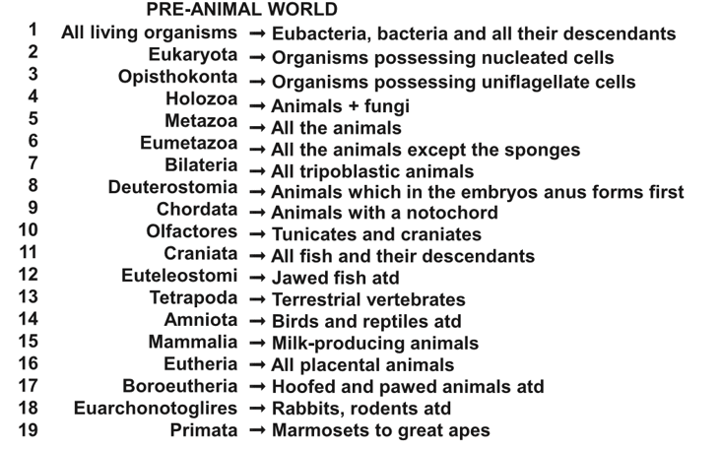
atd = and their descendants
List based on Domazets-Loso and Tautz (2010)¹⁴, as modified by Litman and Stein¹².

