Table S1: Different types of Active site pockets from the importin-11 represent with pocket ID, SeqID and AA.

SL | PocID | Chain | SeqID | AA | Atom
1 | 1 | A | 14 | LEU | CD1
2 | 1 | A | 18 | THR | O
3 | 1 | A | 21 | ASP | O
4 | 1 | A | 22 | THR | CA
5 | 1 | A | 23 | ALA | N
6 | 1 | A | 26 | LYS | O
7 | 1 | A | 27 | PRO | O
8 | 1 | A | 28 | ALA | O
9 | 1 | A | 29 | GLU | C
10 | 1 | A | 30 | GLU | O
11 | 1 | A | 32 | LEU | CD2
12 | 1 | A | 33 | LYS | CG
13 | 1 | A | 36 | GLU | OE2
14 | 1 | A | 41 | PHE | CZ
15 | 1 | A | 45 | LEU | CD2
16 | 1 | A | 48 | ILE | CD1
17 | 1 | A | 58 | VAL | O
18 | 1 | A | 61 | LEU | O
19 | 1 | A | 62 | ALA | N
20 | 1 | A | 64 | LEU | CB
21 | 1 | A | 65 | TYR | N
22 | 1 | A | 67 | LYS | O
23 | 1 | A | 68 | HIS | CA
24 | 1 | A | 69 | GLY | N
25 | 1 | A | 70 | ILE | O
26 | 1 | A | 71 | ASP | CA
27 | 1 | A | 72 | ARG | O
28 | 1 | A | 74 | TRP | CD1
29 | 1 | A | 75 | ARG | N
30 | 1 | A | 76 | ARG | CB
31 | 1 | A | 77 | VAL | CB
32 | 1 | A | 78 | ALA | CB
33 | 1 | A | 79 | PRO | CD
34 | 1 | A | 87 | LYS | NZ
35 | 1 | A | 111 | VAL | CA
36 | 1 | A | 112 | LEU | CA
37 | 1 | A | 114 | ALA | CB
38 | 1 | A | 115 | LYS | N
39 | 1 | A | 118 | ARG | O
40 | 1 | A | 119 | LEU | CA
41 | 1 | A | 120 | ASP | OD2
42 | 1 | A | 123 | ARG | CB
43 | 1 | A | 124 | GLN | CG
44 | 1 | A | 153 | HIS | CA
45 | 1 | A | 156 | LYS | O
46 | 1 | A | 157 | THR | CA
47 | 1 | A | 159 | ALA | C
48 | 1 | A | 160 | SER | CA
49 | 1 | A | 161 | LYS | O
50 | 1 | A | 162 | ARG | CA
51 | 1 | A | 163 | LEU | CD2
52 | 1 | A | 164 | ALA | CB
53 | 1 | A | 167 | ARG | CD
54 | 1 | A | 219 | ARG | NH2
55 | 1 | A | 220 | LYS | CA
56 | 1 | A | 223 | VAL | O
57 | 1 | A | 224 | ASN | OD1
58 | 1 | A | 225 | GLY | O
59 | 1 | A | 226 | PHE | C
60 | 1 | A | 227 | VAL | CA
61 | 1 | A | 228 | GLU | CG
62 | 1 | A | 275 | LYS | CA
63 | 1 | A | 278 | LEU | C
64 | 1 | A | 279 | ASP | N
65 | 1 | A | 284 | HIS | CA
66 | 1 | A | 285 | PRO | CD
67 | 1 | A | 286 | PHE | N
68 | 1 | A | 287 | SER | OG
69 | 1 | A | 307 | VAL | CG1
70 | 1 | A | 308 | GLY | O
71 | 1 | A | 309 | GLU | N
72 | 1 | A | 310 | GLY | C
73 | 1 | A | 311 | VAL | N
74 | 1 | A | 314 | GLU | C
75 | 1 | A | 315 | ARG | CA
76 | 1 | A | 318 | VAL | CG2
77 | 1 | A | 319 | GLN | CA
78 | 1 | A | 322 | ASN | O
79 | 1 | A | 325 | LYS | CB
80 | 1 | A | 326 | MET | O
81 | 1 | A | 328 | VAL | CG1
82 | 1 | A | 329 | LYS | CA
83 | 1 | A | 330 | ASN | OD1
84 | 1 | A | 332 | ALA | CB
85 | 1 | A | 333 | TYR | CD1
86 | 1 | A | 333 | TYR | CD2
87 | 1 | A | 335 | PRO | CA
88 | 1 | A | 336 | SER | O
89 | 1 | A | 337 | LYS | CA
90 | 1 | A | 345 | GLU | OE2
91 | 1 | A | 372 | HIS | CB
92 | 1 | A | 373 | TYR | O
93 | 1 | A | 374 | PHE | O
94 | 1 | A | 375 | LEU | CB
95 | 1 | A | 376 | LEU | CD2
96 | 1 | A | 377 | THR | CA
97 | 1 | A | 378 | GLU | OE2
98 | 1 | A | 379 | GLU | CB
99 | 1 | A | 380 | GLU | OE2
100 | 1 | A | 383 | MET | SD
101 | 1 | A | 384 | TRP | CZ2
102 | 1 | A | 391 | PHE | CZ
103 | 1 | A | 394 | GLU | CG
104 | 1 | A | 395 | GLU | O
105 | 1 | A | 396 | THR | CA
106 | 1 | A | 397 | GLY | O
107 | 1 | A | 398 | GLY | CA
108 | 1 | A | 399 | ASP | O
109 | 1 | A | 400 | SER | N
110 | 1 | A | 401 | TRP | CZ3
111 | 1 | A | 402 | LYS | N
112 | 1 | A | 403 | TYR | O
113 | 1 | A | 404 | SER | CA
114 | 1 | A | 405 | LEU | CD2
115 | 1 | A | 406 | ARG | N
116 | 1 | A | 407 | PRO | CD
117 | 1 | A | 410 | GLU | OE2
118 | 1 | A | 411 | VAL | CG1
119 | 1 | A | 414 | ILE | CD1
120 | 1 | A | 415 | ASP | CA
121 | 1 | A | 418 | HIS | CD2
122 | 1 | A | 419 | GLU | N
123 | 1 | A | 448 | LEU | CD1
124 | 1 | A | 451 | ASP | CB
125 | 1 | A | 455 | ASN | ND2
126 | 1 | A | 458 | GLY | O
127 | 1 | A | 459 | LEU | CA
128 | 1 | A | 461 | ALA | CB
129 | 1 | A | 491 | PRO | O
130 | 1 | A | 494 | ARG | CB
131 | 1 | A | 495 | ARG | CG
132 | 1 | A | 497 | ILE | CG2
133 | 1 | A | 498 | TRP | N
134 | 1 | A | 501 | GLY | O
135 | 1 | A | 502 | GLN | CA
136 | 1 | A | 504 | ILE | O
137 | 1 | A | 505 | SER | CA
138 | 1 | A | 513 | ARG | NH2
139 | 1 | A | 534 | GLU | CB
140 | 1 | A | 537 | THR | CG2
141 | 1 | A | 538 | THR | CA
142 | 1 | A | 540 | LYS | NZ
143 | 1 | A | 541 | LEU | CA
144 | 1 | A | 542 | THR | O
145 | 1 | A | 544 | ASP | CB
146 | 1 | A | 545 | ASP | O
147 | 1 | A | 546 | PHE | N
148 | 1 | A | 547 | GLU | C
149 | 1 | A | 548 | PHE | N
150 | 1 | A | 550 | THR | OG1
151 | 1 | A | 553 | PHE | CE1
152 | 1 | A | 575 | ASP | CA
153 | 1 | A | 576 | THR | CA
154 | 1 | A | 578 | MET | CB
155 | 1 | A | 579 | HIS | CE1
156 | 1 | A | 582 | HIS | CB
157 | 1 | A | 585 | SER | CB
158 | 1 | A | 586 | CYS | SG
159 | 1 | A | 589 | GLU | CG
160 | 1 | A | 590 | ARG | O
161 | 1 | A | 591 | VAL | CA
162 | 1 | A | 592 | ASN | N
163 | 1 | A | 593 | MET | CE
164 | 1 | A | 618 | MET | CA
165 | 1 | A | 621 | CYS | C
166 | 1 | A | 622 | ALA | N
167 | 1 | A | 625 | THR | OG1
168 | 1 | A | 628 | ILE | CD1
169 | 1 | A | 629 | HIS | CE1
170 | 1 | A | 629 | HIS | CD2
171 | 1 | A | 632 | GLN | O
172 | 1 | A | 633 | GLY | O
173 | 1 | A | 635 | GLY | CA
174 | 1 | A | 655 | VAL | O
175 | 1 | A | 656 | SER | O
176 | 1 | A | 657 | GLN | C
177 | 1 | A | 658 | PRO | N
178 | 1 | A | 660 | HIS | O
179 | 1 | A | 661 | VAL | CA
180 | 1 | A | 662 | TYR | O
181 | 1 | A | 663 | LEU | CA
182 | 1 | A | 664 | LEU | N
183 | 1 | A | 665 | GLU | OE2
184 | 1 | A | 666 | ASP | N
185 | 1 | A | 669 | GLU | O
186 | 1 | A | 672 | LEU | CD2
187 | 1 | A | 673 | VAL | CA
188 | 1 | A | 676 | GLU | OE2
189 | 1 | A | 677 | ASN | OD1
190 | 1 | A | 677 | ASN | ND2
191 | 1 | A | 695 | LEU | CD1
192 | 1 | A | 696 | LEU | O
193 | 1 | A | 698 | LEU | CG
194 | 1 | A | 699 | SER | OG
195 | 1 | A | 700 | SER | N
196 | 1 | A | 701 | GLU | O
197 | 1 | A | 702 | ASN | CA
198 | 1 | A | 703 | LEU | CD2
199 | 1 | A | 704 | ARG | N
200 | 1 | A | 705 | THR | OG1
201 | 1 | A | 708 | LYS | CD
202 | 1 | A | 733 | PHE | CE2
203 | 1 | A | 734 | CYS | O
204 | 1 | A | 735 | GLU | CA
205 | 1 | A | 736 | LEU | CD1
206 | 1 | A | 737 | LEU | N
207 | 1 | A | 738 | LYS | O
208 | 1 | A | 739 | GLU | CA
209 | 1 | A | 740 | ILE | O
210 | 1 | A | 741 | THR | N
211 | 1 | A | 742 | THR | OG1
212 | 1 | A | 744 | GLY | N
213 | 1 | A | 745 | GLN | NE2
214 | 1 | A | 772 | PRO | CB
215 | 1 | A | 773 | TYR | O
216 | 1 | A | 776 | LYS | CB
217 | 1 | A | 777 | GLY | CA
218 | 1 | A | 783 | ARG | CA
219 | 1 | A | 784 | TYR | OH
220 | 1 | A | 787 | VAL | CB
221 | 1 | A | 791 | TYR | CE2
222 | 1 | A | 906 | THR | O
223 | 1 | A | 907 | GLU | CA
224 | 1 | A | 908 | ASP | O
225 | 1 | A | 909 | GLU | O
226 | 1 | A | 910 | GLU | CA
227 | 1 | A | 911 | PRO | O
228 | 1 | A | 912 | PRO | CA
229 | 1 | A | 913 | THR | OG1
230 | 1 | A | 915 | GLN | CB

Table S2: List of Compounds, PubChem CID, Chemical Name, Molecular formula, molecular weight, docking score of the fifteen selected compounds with the highest binding affinity
SI No. | Pubchem ID | Chemical Name | Molecular Formula | Chemical structure | Molecular weight | Binding Affinity (Kcal/mol)
1 | CID 6432458 | Ergosta-5,22-dien-3.beta.-ol | C28H46O | 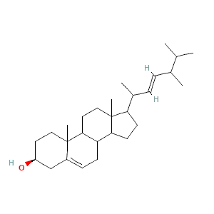 | 398.7 g/mol | -8.6
2 | CID605775 | Pentanedioic acid, (2,4-di-t-butylphenyl) mono-ester | C19H28O4 | 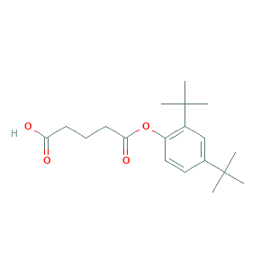 | 320.4 g/mol | -8.2
3 | CID 608814 | 2-Chloro-5-(methylthio)benzoic acid | C₈H₇ClO₂S | 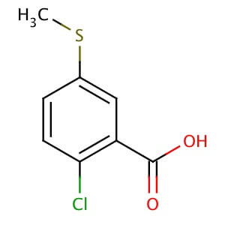 | 202.66 g/mol | -7.8
4 | CID 11955 | Benzoic hydrazide | C7H8N2O | 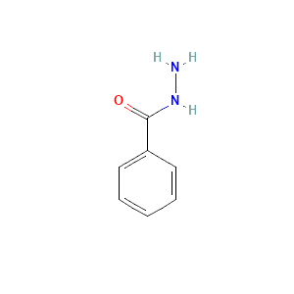 | 136.15 g/mol | -7.1
5 | CID 304 | Cholest-5-en-3-ol | C27H46O | 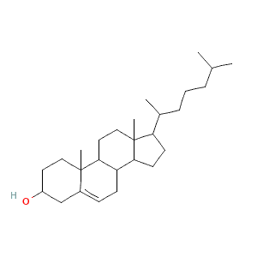 | 386.7 g/mol | -5.8
6 | CID 7690 | Benzeneacetic acid, α-methoxy-, (.+/-.)- | C9H10O3 | 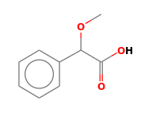 | 166.1 g/mol | -5.3
7 | CID 11005 | Tetradecanoic acid | C14H28O2 | 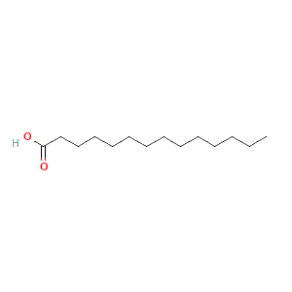 | 228.37 g/mol | -5.2
8 | CID 543842 | 3-n-Hexylthiolane, S,S-dioxide | C10H20O2S | 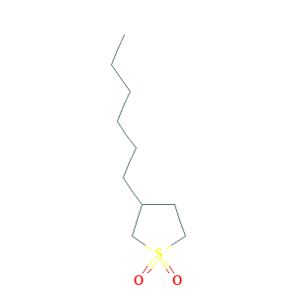 | 204.33 g/mol | -4.9
9 | CID 554101 | heptacosanoate, 25-methyl-methyl ester | C29H58O2 | 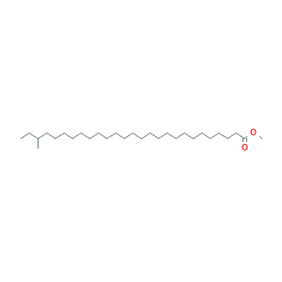 | 438.8 g/mol | -4.9
10 | CID 581770 | 3-Piperidinol, 1-ethyl-6-methyl- | C8H17NO | 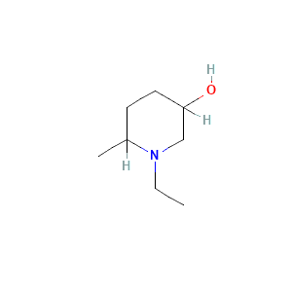 | 143.23 g/mol | -4.9
11 | CID 543691 | 3-n-Butylthiolane, S,S-dioxide | C8H16O2S | 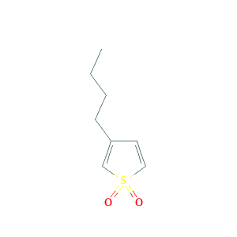 | 176.28g/mol | -4.7
12 | CID 82436 | 1-Tetracosene | C24H48 | 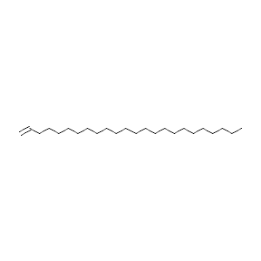 | 336.6 g/mol | -4.7
13 | CID 4065233 | Methyl 11-methyldodecanoate | C14H28O2 | 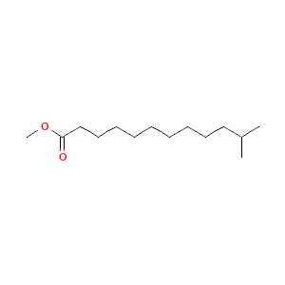 | 228.37 g/mol | -4.6
14 | CID 985 | palmitic acid | C16H32O2 | 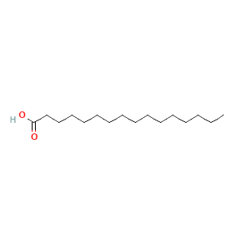 | 256.42 g/mol | -4.1
15 | CID 12406 | n-Pentacosane | C25H52 | 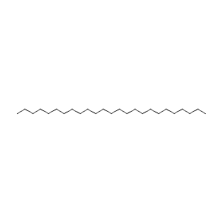 | 352.7 g/mol | -3.9
16 | CID 444899 | arachidonic acid | C₂₀H₃₂O₂ | 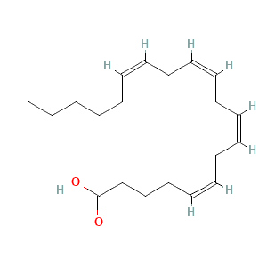 | 304.5 g/mol | -3.8
17 | CID1017 | 1,2-BENZENE DICARBOXYLIC ACID (Phthalic Acid) | C8H6O4 | 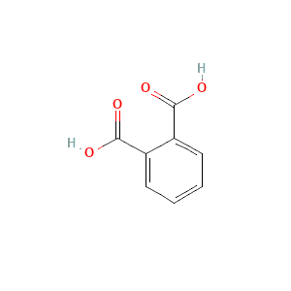 | 166.13 g/mol | -3.7
18 | CID3681 | Batilol | C21H44O3 | 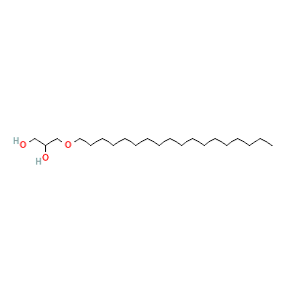 | 344.6 | -3.6
19 | CID 445639 | oleic acid | C18H34O2 | 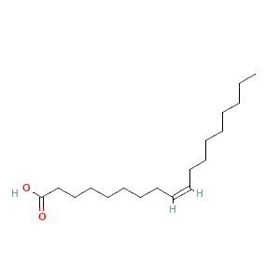 | 282.5 | -3.5

