Supplementary information for
The wider the gap between rich and poor
the higher the flood mortality

Sara Lindersson¹, Elena Raffetti^{1,2}, Maria Rusca³, Luigia Brandimarte⁴, Johanna Mård¹, and Giuliano Di Baldassarre¹
¹Centre of Natural Hazards and Disaster Science, Department of Earth Sciences, Uppsala University, Uppsala, Sweden
²Department of Public Health and Primary Care, University of Cambridge, Cambridge, UK
³Global Development Institute, The University of Manchester, Manchester, UK
⁴Department of Sustainable Development, Environmental Science and Engineering, KTH Royal Institute of Technology, Stockholm, Sweden

Supplementary information overview
The supplementary information contains relevant details of the analysis. This includes:
- Control variables estimation notes (incl. Table S1)
- Data sample overview (incl. Fig. S1 and Table S2-S4)
- Regression result tables (incl. Table S5-S6)
- Random effects (incl. Fig. S2)
- Residual analysis notes (incl. Fig. S3-S5)
- Spline regression notes (incl. Fig. S6)
- References

Control variables estimation notes
The outcome variable in our analysis is the number of fatalities per flood disaster as reported in the international disaster database EM-DAT (www.emdat.be). To control for the number of exposed people per flood, we only include records in EM-DAT that have been geocoded by the database GDIS¹.
Developers of the GDIS database have used the location text information in EM-DAT to connect each event with one or several administrative regions in GADM (www.gadm.org). GADM consists of different levels of administrative regions: Level 0 corresponds to national boundaries, Level 1 corresponds to state or province boundaries (or equivalent), Level 2 corresponds to county or district boundaries (or equivalent), while Level 3 corresponds to even smaller administrative regions. Disasters in EM-DAT have been georeferenced to regions in GADM on levels 1, 2 and/or 3 depending on their location description¹.
We then overlaid these flood-affected administrative regions with the Global Human Settlement (GHS) population maps² to estimate the number of potentially exposed people per disaster. This analysis was conducted using the cloud computation platform Google Earth Engine (GEE)³, on which the GHS maps were accessed via the GEE snippet “JRC/GHSL/P2016/POP_GPW_GLOBE_V1”. The GHS are offered as global seamless raster files at 9 arc-sec (~250 m) spatial resolution for the years 1990, 2000 and 2015. We derived yearly population estimates by linearly interpolating between the years 1990, 2000 and 2015. The years 2016, 2017 and 2018 were given the same population values as 2015. We also calculated the land area of each flood-affected region by subtracting the permanent water area from the total area, as given by the water mask derived from MODIS and SRTM the year 2015 (accessed via the GEE snippet "MODIS/006/MOD44W").
Disasters geocoded to Level 1-region(s) do not necessarily cover larger areas compared to disasters geocoded to Level 2- or 3-region(s). Rather, more specific location descriptions in EM-DAT will typically result in matches with higher administrative levels compared to more vague descriptions. Level 1-regions are typically five times larger than Level 2-regions, and eleven times larger than Level 3-regions (Table S1). The exposure estimate will thus also be considerably larger (around six and twelve times), which would bias the analysis. We therefore only included the flood disasters that had been geocoded to Level 2- and/or Level 3-region(s) in this study. We also excluded one disaster that was geocoded to one Level 2-region with no population according to the global population map, which we deemed to be unrealistic.
Supplementary Table 1 | Descriptive statistics of flood-affected regions by administrative level. Here we include all floods 1990-2018 in EM-DAT that have been geocoded by GDIS. The population estimate is here the average value across the 1990, 2000 and 2015 population grids by the Global Human Settlement Layer.
Flood-affected regions | Land area (km²) |  |  |  | Average population  1990-2018 (thousands)
n | Min | Max | Mean | SD | Min | Max | Mean | SD
Administrative Level 1
1919 | 2.3 | 4M | 8.4k | 0.15M | 1.2 | 205k | 760 | 11k
Administrative Level 2
3184 | 1.3 | 0.33M | 1.7k | 15k | 0.0 | 19k | 120 | 1.4k
Administrative Level 3
561 | 0.7 | 0.13M | 0.76k | 7.5k | 0.5 | 17k | 62 | 0.89k
Note. One disaster may be geocoded to multiple regions at varying levels.

Data sample overview
Supplementary Table 2 | Descriptive statistics per group of countries.
 | Min | Q1 | Median | Mean | Q3 | Max
Middle- and high-income countries. 537 floods in 65 countries.
51 in Africa, 165 in Americas, 124 in Asia, 169 in Europe and 28 in Oceania.
Fatalities | 0 | 0 | 2 | 15.1 | 10 | 900
Gini index (%) | 24.2 | 32.7 | 38.5 | 39.3 | 45.1 | 63.5
GDP/cap (1,000 US$) | 2.4 | 7.5 | 14.3 | 20.7 | 35.0 | 62.3
Potentially exposed | 555 | 119 k | 512 k | 1.5 M | 1.6 M | 32.3 M
Land area (km²) | 2.3 | 1.1 k | 3.8 k | 15.4 k | 13. k | 0.41 M
OECD member countries. 247 floods in 28 countries.
89 in Americas, 8 in Asia, 125 in Europe and 25 in Oceania.
Fatalities | 0 | 0 | 1 | 4.9 | 4 | 109
Gini index (%) | 24.2 | 31.0 | 33.1 | 34.8 | 37.4 | 54.3
GDP/cap (1,000 US$) | 7.6 | 26.0 | 35.8 | 33.9 | 43.0 | 62.3
Potentially exposed | 555 | 125 k | 557 k | 1.9 M | 2.2 M | 32.3 M
Land area (km²) | 2.3 | 1.4 k | 4.8 k | 19.6 k | 15.51 k | 0.41 M

Supplementary Table 3 | Descriptive statistics per country.
Country | Floods | Fatalities |  |  |  |  | Gini (%) | GDP/  cap (1,000 US$)
 | n | Sum | Min | Median | Mean | Max | Mean | Mean
OECD-member countries
Australia | 20 | 74 | 0 | 0 | 3.7 | 35 | 32.2 | 43.4
Austria | 1 | 0 | 0 | 0 | 0 | 0 | 28.0 | 45.6
Belgium | 7 | 4 | 0 | 0 | 0.6 | 2 | 26.2 | 38.6
Canada | 16 | 14 | 0 | 0 | 0.9 | 4 | 31.0 | 44.5
Chile | 10 | 163 | 0 | 4 | 16.3 | 109 | 49.2 | 13.7
Colombia | 15 | 148 | 0 | 2 | 9.9 | 56 | 50.7 | 11.3
Costa Rica | 7 | 23 | 0 | 2 | 3.3 | 9 | 45.0 | 12.8
Czechia | 2 | 8 | 1 | 4 | 4 | 7 | 25.3 | 31.3
France | 25 | 131 | 0 | 2 | 5.2 | 36 | 28.5 | 35.2
Germany | 3 | 3 | 0 | 0 | 1 | 3 | 26.8 | 36.0
Greece | 22 | 73 | 0 | 1 | 3.3 | 23 | 33.1 | 27.7
Hungary | 1 | 0 | 0 | 0 | 0 | 0 | 27.6 | 20.8
Italy | 16 | 89 | 0 | 2 | 5.6 | 35 | 33.3 | 36.7
Japan | 3 | 9 | 0 | 1 | 3 | 8 | 30.2 | 35.7
Lithuania | 1 | 4 | 4 | 4 | 4 | 4 | 33.6 | 22.5
Mexico | 5 | 68 | 3 | 4 | 13.6 | 37 | 47.2 | 14.4
New Zealand | 5 | 0 | 0 | 0 | 0 | 0 | 31.9 | 25.9
Norway | 1 | 0 | 0 | 0 | 0 | 0 | 24.8 | 45.8
Poland | 4 | 14 | 0 | 2.5 | 3.5 | 9 | 30.1 | 21.0
Portugal | 1 | 43 | 43 | 43 | 43 | 43 | 33.4 | 30.5
Slovakia | 5 | 61 | 1 | 2 | 12.2 | 54 | 25.4 | 19.8
Slovenia | 2 | 3 | 0 | 1.5 | 1.5 | 3 | 25.5 | 31.9
South Korea | 2 | 27 | 10 | 13.5 | 13.5 | 17 | 31.7 | 34.6
Spain | 12 | 41 | 0 | 1.5 | 3.4 | 10 | 32.1 | 31.5
Switzerland | 2 | 0 | 0 | 0 | 0 | 0 | 29.3 | 49.3
Turkey | 3 | 11 | 2 | 2 | 3.7 | 7 | 41.0 | 14.5
United Kingdom | 20 | 41 | 0 | 0 | 2.1 | 8 | 34.0 | 36.5
United States | 36 | 149 | 0 | 2 | 4.1 | 37 | 37.5 | 51.5
Not OECD-member countries
Albania | 1 | 0 | 0 | 0 | 0 | 0 | 39.1 | 9.1
Algeria | 2 | 1 | 0 | 0.5 | 0.5 | 1 | 36.0 | 12.2
Angola | 12 | 177 | 0 | 8.5 | 14.8 | 69 | 50.1 | 3.9
Argentina | 12 | 88 | 0 | 1.5 | 7.3 | 52 | 40.9 | 17.6
Azerbaijan | 6 | 16 | 0 | 0 | 2.7 | 11 | 30.8 | 4.2
Bolivia | 6 | 73 | 0 | 0 | 12.2 | 69 | 47.5 | 5.4
Bosnia & Herzegovina | 5 | 1 | 0 | 0 | 0.2 | 1 | 39.0 | 9.1
Botswana | 1 | 20 | 20 | 20 | 20 | 20 | 58.0 | 8.3
Brazil | 38 | 1,889 | 0 | 13 | 49.7 | 900 | 49.8 | 12.1
Bulgaria | 1 | 2 | 2 | 2 | 2 | 2 | 33.1 | 11.3
Cameroon | 6 | 71 | 3 | 9.5 | 11.8 | 30 | 44.9 | 2.8
China | 8 | 277 | 0 | 12 | 34.6 | 199 | 41.0 | 8.1
Croatia | 6 | 3 | 0 | 0 | 0.5 | 3 | 28.3 | 18.9
Ecuador | 3 | 2 | 0 | 0 | 0.7 | 2 | 45.0 | 9.0
Egypt | 1 | 4 | 4 | 4 | 4 | 4 | 41.3 | 5.4
Fiji | 3 | 26 | 4 | 10 | 8.7 | 12 | 40.3 | 7.9
Georgia | 4 | 1 | 0 | 0 | 0.3 | 1 | 37.9 | 6.1
Honduras | 2 | 10 | 5 | 5 | 5 | 5 | 50.0 | 3.5
Indonesia | 49 | 1,500 | 0 | 13 | 30.6 | 291 | 44.1 | 6.8
Iran | 10 | 449 | 1 | 7.5 | 44.9 | 370 | 40.8 | 11.4
Iraq | 2 | 20 | 0 | 10 | 10 | 20 | 32.5 | 7.2
Kazakhstan | 4 | 2 | 0 | 0 | 0.5 | 2 | 27.2 | 19.1
Malaysia | 5 | 32 | 0 | 4 | 6.4 | 13 | 41.9 | 17.1
Morocco | 18 | 1,094 | 0 | 13 | 60.8 | 730 | 41.2 | 5.4
Nicaragua | 3 | 0 | 0 | 0 | 0 | 0 | 45.2 | 4.0
Panama | 2 | 12 | 0 | 6 | 6 | 12 | 51.1 | 8.5
Peru | 8 | 106 | 1 | 14.5 | 13.3 | 22 | 49.6 | 7.4
Philippines | 22 | 194 | 0 | 0.5 | 8.8 | 98 | 42.1 | 5.3
Romania | 3 | 1 | 0 | 0 | 0.3 | 1 | 31.1 | 11.4
Russia | 19 | 427 | 0 | 0 | 22.5 | 172 | 35.5 | 17.5
Serbia | 5 | 5 | 0 | 0 | 1 | 4 | 33.9 | 14.4
South Africa | 11 | 264 | 0 | 4 | 24 | 207 | 62.3 | 10.6
Sri Lanka | 2 | 33 | 15 | 16.5 | 16.5 | 18 | 48.0 | 6.9
Thailand | 3 | 40 | 0 | 2 | 13.3 | 38 | 41.8 | 12.6
Ukraine | 4 | 29 | 2 | 4.5 | 7.3 | 18 | 27.9 | 8.2
Uzbekistan | 1 | 0 | 0 | 0 | 0 | 0 | 32.2 | 6.0
Venezuela | 2 | 26 | 0 | 13 | 13 | 26 | 41.9 | 8.1
Note. The OECD membership refers to the status in June 2022.

Supplementary Table 4 | Change in inequality and average living standards between 1990 and 2018. We proxy representative changes for the sample over the period with values close to the mean absolute changes (4 percentage points in the Gini and and 15,000 US$ in the per capita GDP), for which we quantified the effect on flood mortality.
 | Min | Q1 | Median | Mean | Q3 | Max
Middle- and high-income countries (n = 55)
Change Gini index (pp) | -8.2 | -3.3 | 2.1 | 0.78 | 4.0 | 11.8
Absolute change Gini index (pp) | 0.2 | 2.25 | 3.9 | 4.15 | 5.3 | 11.8
Change real GDP/cap (2017 US$) | -9,000 | 8,390 | 13,800 | 13,900 | 19,400 | 35,600
Absolute change real GDP/cap (2017 US$) | 347 | 8,590 | 13,800 | 14,218 | 19,400 | 35,600
OECD member countries (n = 28)
Change Gini index (pp) | -5.5 | 0.35 | 2.7 | 1.86 | 3.95 | 7.9
Absolute change Gini index (pp) | 0.7 | 2.25 | 3.3 | 3.34 | 4.13 | 7.9
Change real GDP/cap (2017 US$) | 6,000 | 15,100 | 18,800 | 18,900 | 23,000 | 35,600
Absolute change real GDP/cap (2017 US$) | 6,000 | 15,100 | 18,800 | 18,900 | 23,000 | 35,600
Note. In case of a missing value in 1990 or 2018, we used the available value closest in time within 1991-1994 or 2014-2018 to calculate the change over the period. The database was missing Gini values 1990-1994 for six countries: Angola, Cameroon, Albania, Bosnia & Herzegovina, Serbia and Iraq. The database was missing Gini values 2014-2018 for four countries: Azerbaijan, Algeria, Uzbekistan and Fiji. These ten countries were therefore not included when calculating these descriptive statistics of the change over the period.

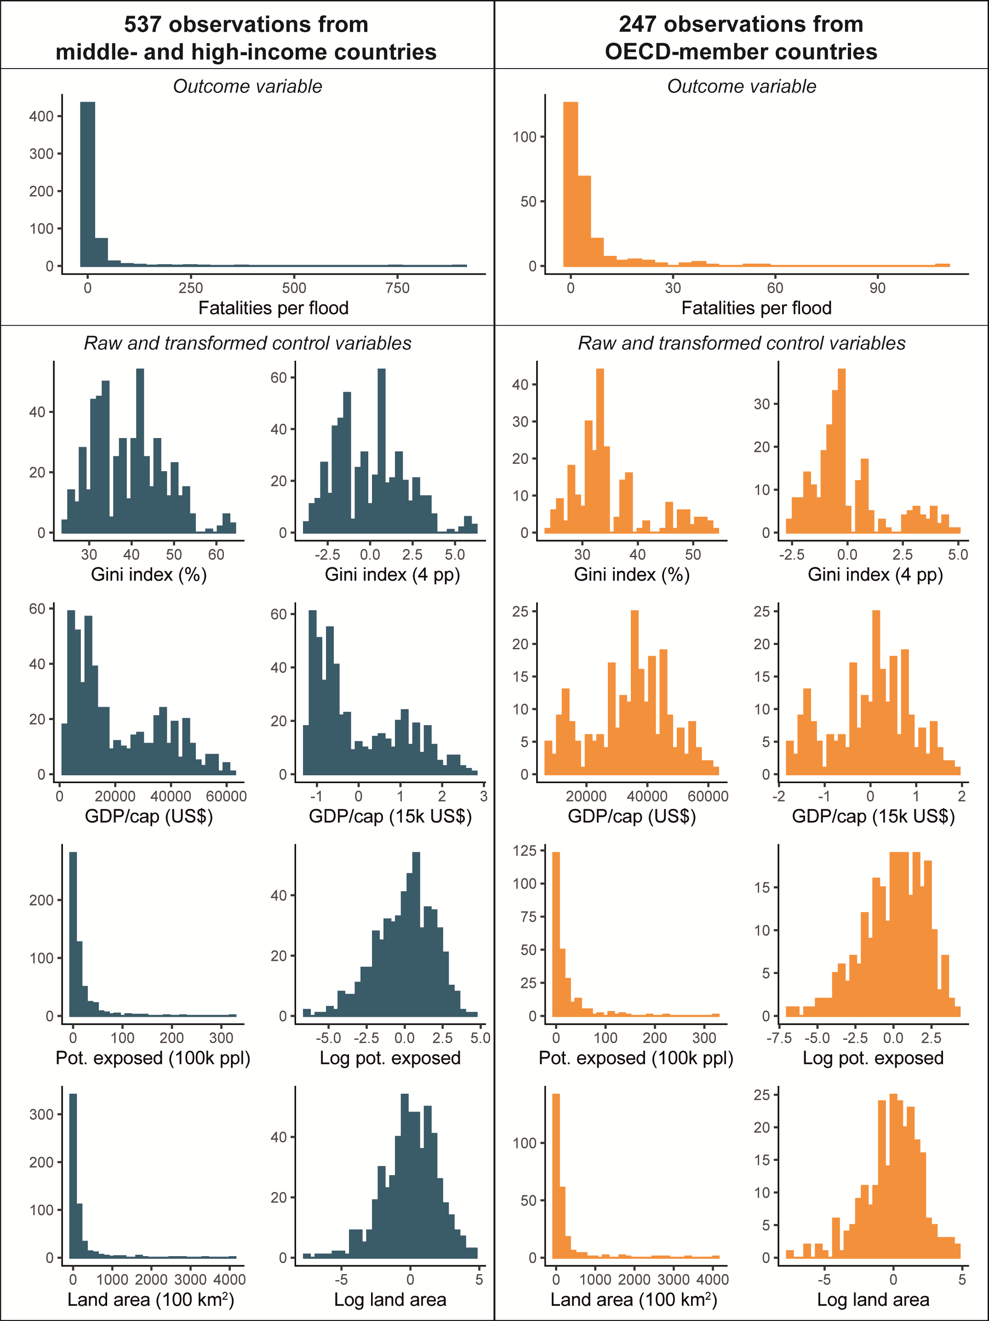
Supplementary Figure 1 | Histograms of the data sample.

Regression result tables
Supplementary Table 5 | Negative binomial mixed regression model results for middle- and high-income countries.
Random effects | (1) Full model |  | (2) No GINI |  | (3) No GDP |  | (4) No pot. exposure |  | (5) No land area |  | (6) No random effects
σ² | 1.45 |  | 1.45 |  | 1.44 |  | 1.46 |  | 1.45 |  | -
τ₀₀ | 0.52 |  | 0.64 |  | 0.64 |  | 0.55 |  | 0.52 |  | -
ICC | 0.26 |  | 0.31 |  | 0.31 |  | 0.27 |  | 0.26 |  | -
N | 65 |  | 65 |  | 65 |  | 65 |  | 65 |  | -
Fixed effects | Risk ratio  [95% CI] | p-value | Risk ratio  [95% CI] | p-value | Risk ratio  [95% CI] | p-value | Risk ratio  [95% CI] | p-value | Risk ratio  [95% CI] | p-value | Risk ratio  [95% CI] | p-value
4 pp GINI | 1.24  [1.07 – 1.45] | 0.004 | - | - | 1.35  [1.18 – 1.54] | <0.001 | 1.23  [1.05 – 1.43] | 0.009 | 1.24  [1.07 – 1.43] | 0.005 | 1.27  [1.14 – 1.41] | <0.001
15k$ GDP/cap | 0.71  [0.52 – 0.97] | 0.031 | 0.57  [0.43 – 0.76] | <0.001 | - | - | 0.71  [0.51 – 0.98] | 0.036 | 0.71  [0.52 – 0.97] | 0.031 | 0.62  [0.51 – 0.75] | <0.001
Log pot. exposed | 1.23  [1.09 – 1.39] | 0.001 | 1.22  [1.08 – 1.37] | 0.001 | 1.23  [1.09 – 1.39] | 0.001 | - | - | 1.21  [1.09 – 1.34] | <0.001 | 1.22  [1.09 – 1.37] | <0.001
Log land area | 0.97  [0.86 – 1.09] | 0.586 | 1.00  [0.88 – 1.12] | 0.948 | 0.97  [0.85 – 1.09] | 0.576 | 1.08  [0.97 – 1.19] | 0.170 | - | - | 0.97  [0.88 – 1.07] | 0.495
Observations | 537 |  | 537 |  | 537 |  | 537 |  | 537 |  | 537
AIC | 3205 |  | 3211 |  | 3207 |  | 3214 |  | 3203 |  | 3233
Log-Likelihood | -1596 |  | -1599 |  | -1598 |  | -1601 |  | -1596 |  | -1611
Deviance | 3191 |  | 3199 |  | 3195 |  | 3202 |  | 3191 |  | 3221
Alpha | 0.323 |  | 0.322 |  | 0.324 |  | 0.316 |  | 0.323 |  | 0.277
Note. The outcome variable in all models is fatalities per flood event, as reported in EM-DAT 1990-2018. Risk ratios are the multiplicative effects, derived from exponentiation of the model estimates. Models (1) – (5) include random intercepts at country level. σ² = residual variance. τ₀₀ = between-group variance. ICC = intra-class correlation coefficient. AIC = Akaike information criterion. pp = percentage points. Alpha = dispersion parameter. The models were fitted using maximum likelihood estimation with the R package “glmmTMB”⁴.

Supplementary Table 6 | Negative binomial mixed regression model results for OECD member countries.
Random effects | (1) Full model |  | (2) No GINI |  | (3) No GDP |  | (4) No pot. exposure |  | (5) No land area |  | (6) No random effects
σ² | 1.38 |  | 1.39 |  | 1.38 |  | 1.43 |  | 1.40 |  | -
τ₀₀ | 0.22 |  | 0.28 |  | 0.26 |  | 0.08 |  | 0.17 |  | -
ICC | 0.14 |  | 0.17 |  | 0.16 |  | 0.05 |  | 0.11 |  | -
N | 28 |  | 28 |  | 28 |  | 28 |  | 28 |  | -
Fixed effects | Risk ratio  [95% CI] | p-value | Risk ratio  [95% CI] | p-value | Risk ratio  [95% CI] | p-value | Risk ratio  [95% CI] | p-value | Risk ratio  [95% CI] | p-value | Risk ratio  [95% CI] | p-value
4 pp GINI | 1.22  [1.00 – 1.47] | 0.045 | - | - | 1.30  [1.09 – 1.56] | 0.004 | 1.17  [0.99 – 1.38] | 0.071 | 1.17  [0.98 – 1.40] | 0.086 | 1.17  [1.02 – 1.33] | 0.021
15k$ GDP/cap | 0.75  [0.51 – 1.09] | 0.132 | 0.62  [0.43 – 0.88] | 0.007 | - | - | 0.74  [0.53 – 1.03] | 0.070 | 0.71  [0.49 – 1.02] | 0.066 | 0.78  [0.60 - 1.02] | 0.068
Log pot. exposed | 1.24  [1.04 – 1.47] | 0.017 | 1.22  [1.03 – 1.46] | 0.024 | 1.25  [1.05 – 1.49] | 0.010 | - | - | 1.11  [0.97 – 1.27] | 0.131 | 1.17  [1.01 – 1.35] | 0.039
Log land area | 0.86  [0.73 – 1.01] | 0.065 | 0.88  [0.75 – 1.04] | 0.127 | 0.84  [0.71 – 0.99] | 0.034 | 0.97  [0.87 – 1.09] | 0.629 | - | - | 0.90  [0.79 – 1.02] | 0.093
Observations | 247 |  | 247 |  | 247 |  | 247 |  | 247 |  | 247
AIC | 1178 |  | 1180 |  | 1178 |  | 1182 |  | 1180 |  | 1178
Log-Likelihood | -582 |  | -584 |  | -583 |  | -585 |  | -584 |  | -583
Deviance | 1164 |  | 1168 |  | 1166 |  | 1170 |  | 1168 |  | 1166
Alpha | 0.365 |  | 0.36 |  | 0.363 |  | 0.341 |  | 0.354 |  | 0.339
Note. The outcome variable in all models is fatalities per flood event, as reported in EM-DAT 1990-2018. Risk ratios are the multiplicative effects, derived from exponentiation of the model estimates. Models (1) – (5) include random intercepts at country level. σ2 = residual variance. τ00 = between-group variance. ICC = intra-class correlation coefficient. AIC = Akaike information criterion. pp = percentage points. Alpha = dispersion parameter. The models were fitted using maximum likelihood estimation with the R package “glmmTMB”⁴.

Random effects
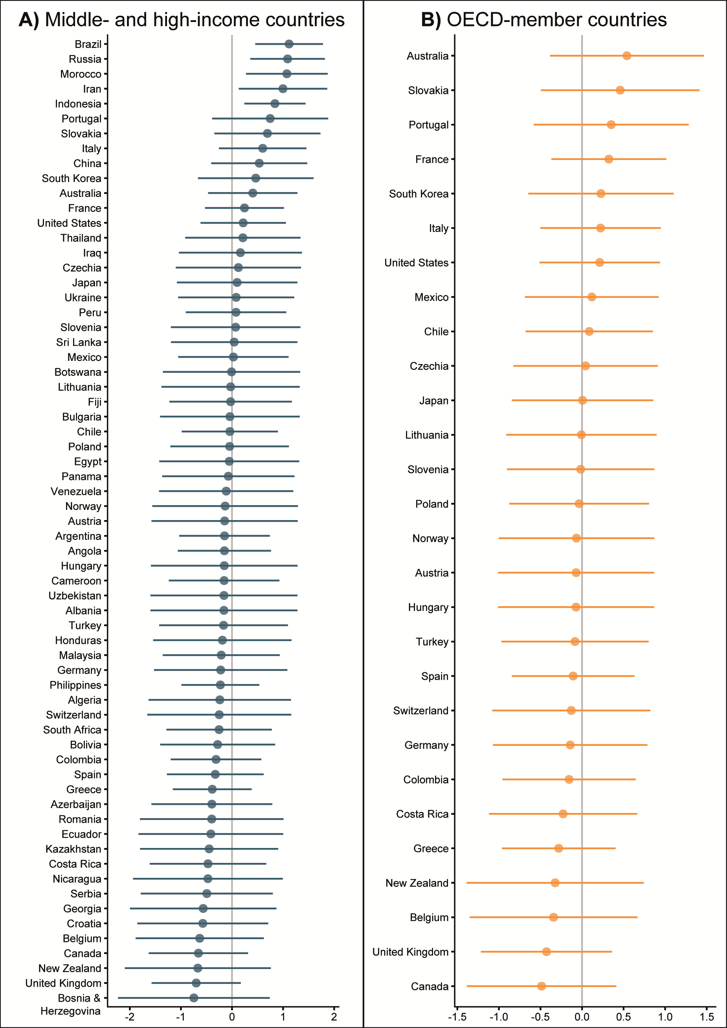
Supplementary Figure 2 | Random intercepts per country. The estimates are compared to the overall model estimate, being located at the zero on the x-axis. The confidence intervals show that most estimates are not significantly different from the estimation of the model, suggesting that the random effect might be redundant.

Residual analysis notes
We used the R package “DHARMa”⁵ to perform diagnostics in terms of residual analysis on the full model specification when including the 65 middle- and high-income countries (Fig. S3) and the 28 OECD member countries (Fig. S4). “DHARMa” generates standardized residuals for generalized linear mixed models, which can be read similarly as residuals from of a linear regression model. We used 1,000 iterations for each residual analysis.
The Kolmogorov-Smirnov (KS) test of the model results for the middle- and high-income countries indicates a significant deviation from the expected negative binomial distribution (Panel A in Fig. S3). The corresponding quantile-quantile plot does not exhibit a large deviation from the straight line, however. The outlier test did also indicate a significant deviation, which in the context of “DHARMa” means an observation outside of the simulation envelope⁵. We did not detect any significant problems when plotting the standardized residuals against model predictions (Panel B) or any of the covariate variables (Panel C). The residual plot in Panel B would typically exhibit a significant problem in the case of overdispersion of error, while the plots in Panel C control for heteroscedasticity.
We did not detect any significant problems in the OECD model (Fig. S4), in terms of deviation from the expected distribution, overdispersion of error, outliers or heteroscedasticity. We also compared the residual analysis of the full models with the models without the random effects (Fig. S5). When only including the OECD countries, the models with and without random effects performed similarly in the residual analysis. When including all observations from middle- and high-income countries, however, the model with the random effect yields less problematic residuals (Fig. S3) compared to the model without the random effect (Fig. S5). We therefore chose to include random intercepts per country in the full model specifications, even though Fig. S2 suggests that they might be redundant with the exception for five countries.
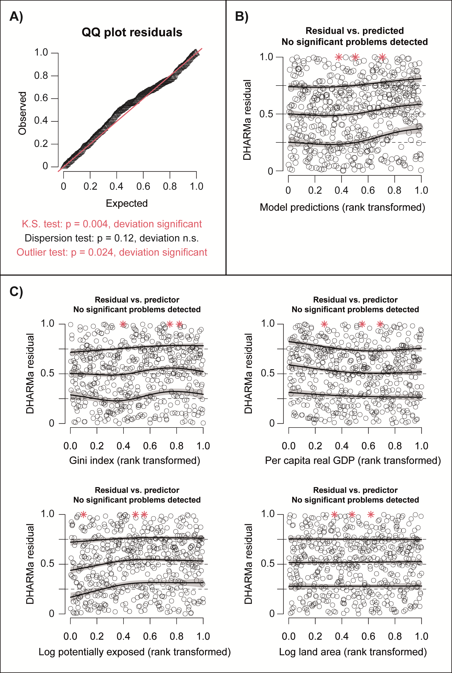
Supplementary Figure 3 | Residual analysis for the full model, using observations from middle- and high-income countries.

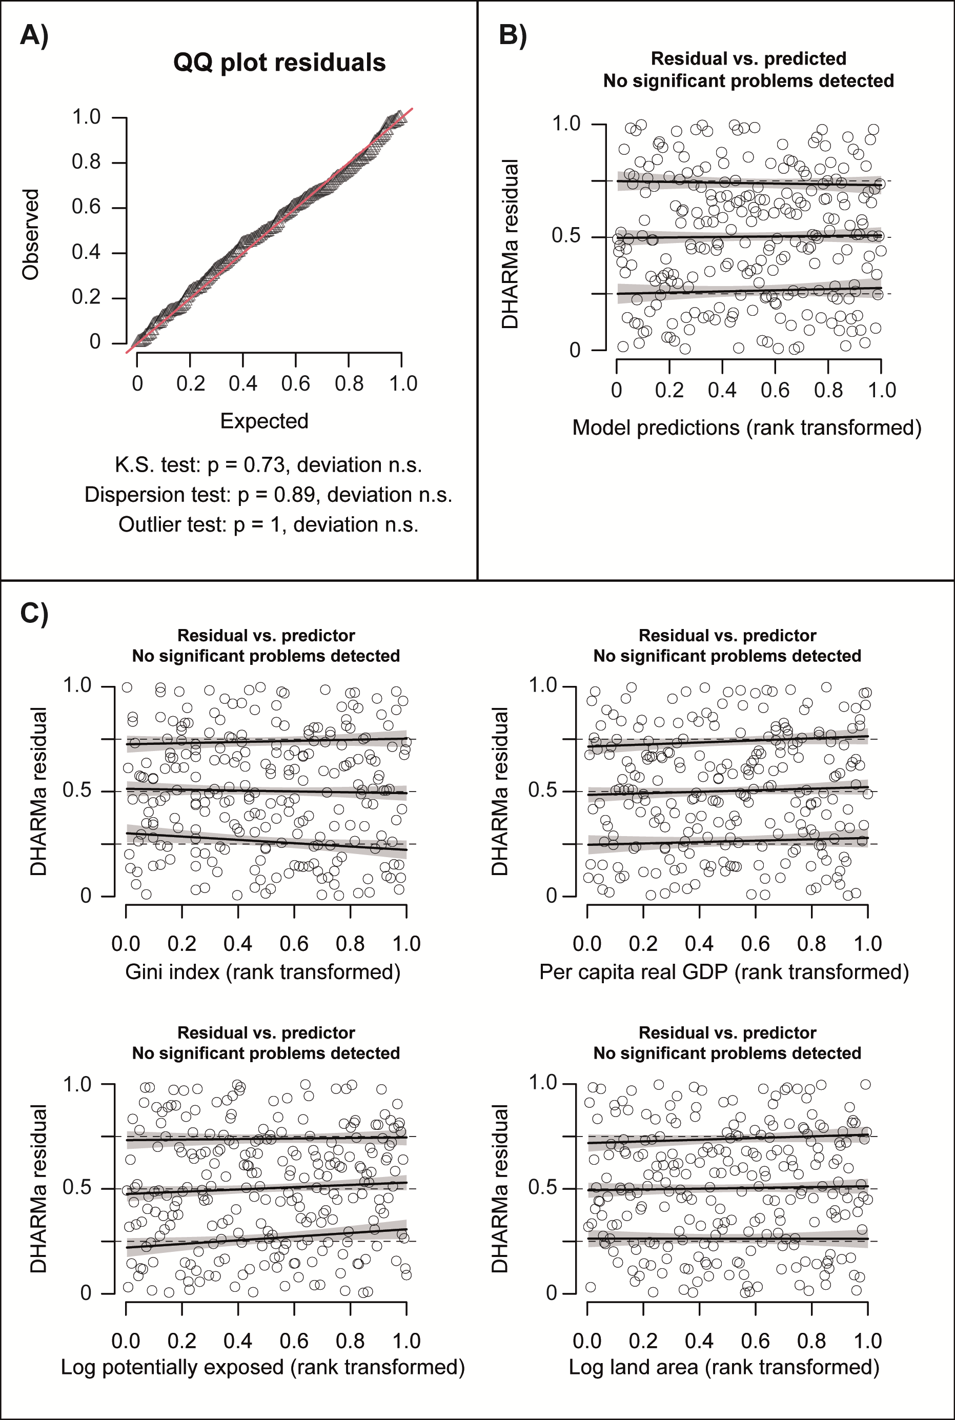
Supplementary Figure 4 | Residual analysis for the full model, using observations from OECD-member countries.

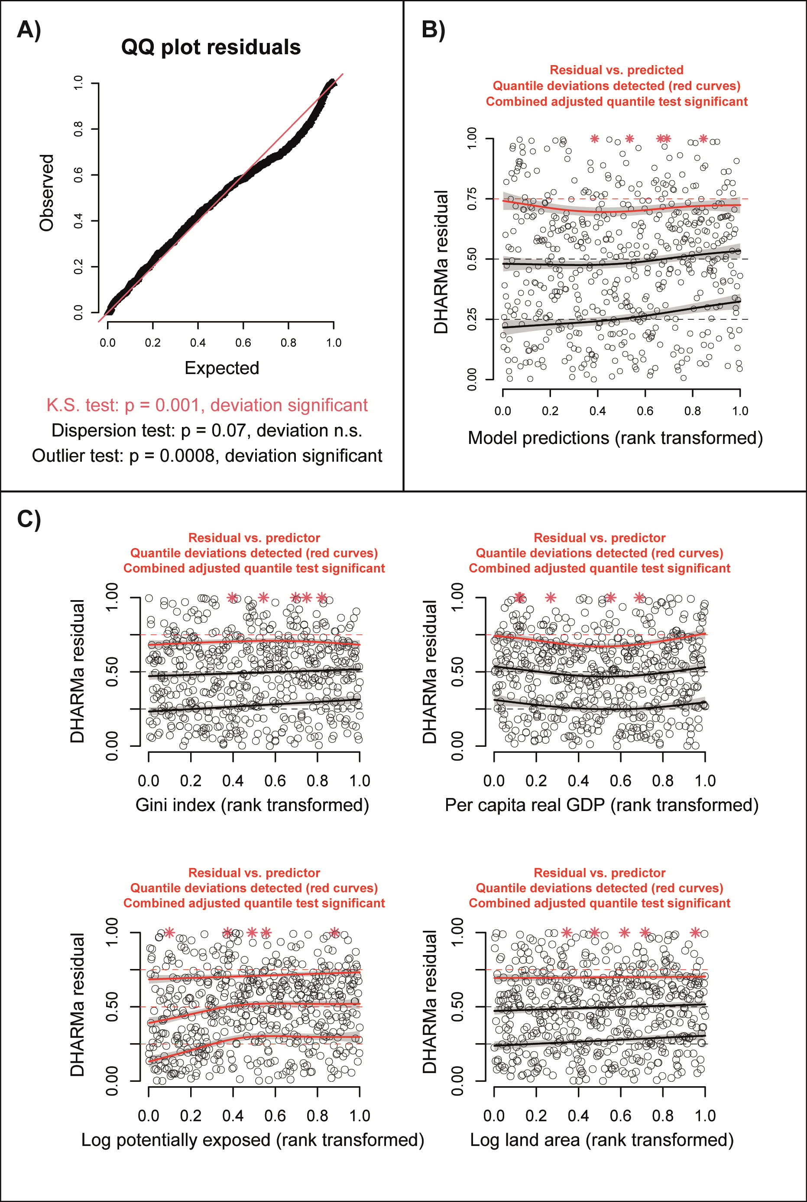
Supplementary Figure 5 | Residual analysis for the model without random effect, using observations from middle- and high-income countries.

Spline regression notes
A negative binomial regression model with a natural logarithmic link function assumes a linear relationship between a covariate and the outcome variable on the logarithmic scale. We conducted a spline regression analysis to evaluate the robustness of this linearity assumption (Fig. S6).
The model predictions in Panel A and Panel B come from the main model specification, while in the spline regression one (Panel C and Panel D) or two (Panel E and Panel E) covariates have been replaced with a natural cubic spline (ns) with three knots. We have cut the model predictions at the 5th and 95th percentiles of the distributions.
The linearity assumption holds well for the blue models, which includes all 65 middle- and high-income countries. The orange models, restricted to observations from OECD member countries, have less statistical power and the model predictions hence become more variable and more uncertain.

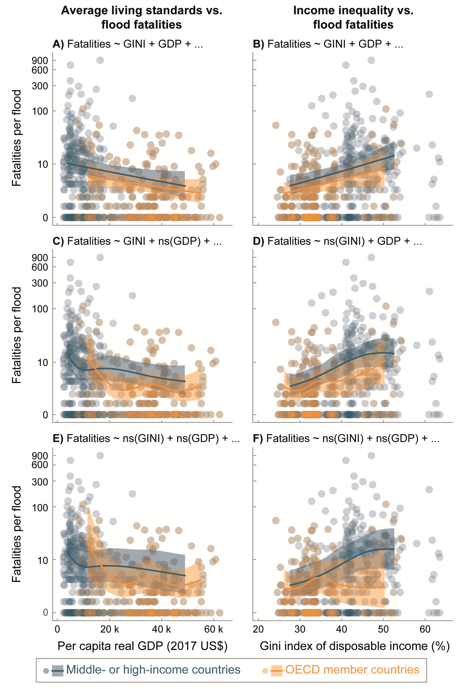
Supplementary Figure 6 | Model predictions with and without spline terms. Natural cubic splines (ns) with three knots replace the GDP predictor (Panel C), the Gini index predictor (Panel D) or both the GDP and Gini index predictors (Panel E and F).

References
1. Rosvold, E. L. & Buhaug, H. GDIS, a global dataset of geocoded disaster locations. Sci. Data 8, 61 (2021).
2. Freire, S., MacManus, K., Pesaresi, M., Doxsey-Whitfield, E. & Mills, J. Development of new open and free multi-temporal global population grids at 250 m resolution. in Agile (2016).
3. Gorelick, N. et al. Google Earth Engine: Planetary-scale geospatial analysis for everyone. Remote Sens. Environ. (2017) doi:10.1016/j.rse.2017.06.031.
4. Brooks, M. E. et al. glmmTMB Balances Speed and Flexibility Among Packages for Zero-inflated Generalized Linear Mixed Modeling. R J. 9, 378–400 (2017).
5. Hartig, F. DHARMa: Residual diagnostics for hierarchical (multi-level / mixed) regression models. R package version 0.4.5. (2022).

