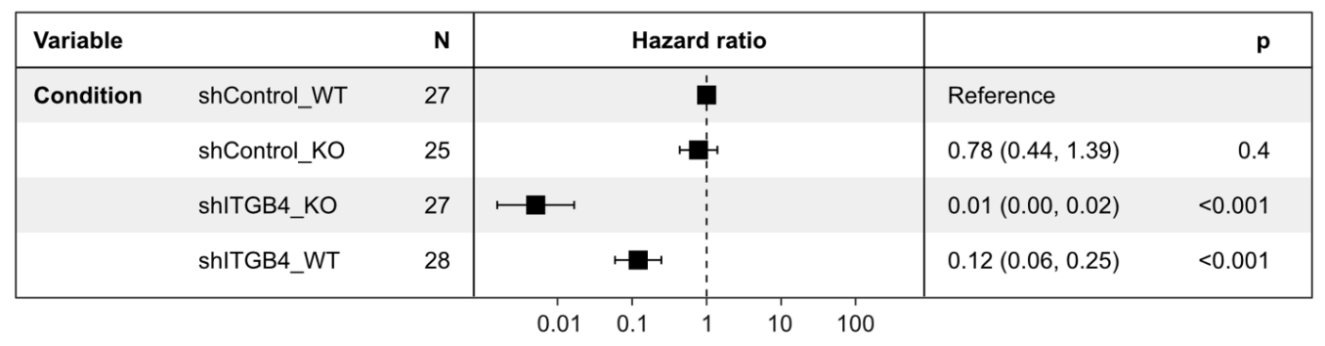
Suppl. Fig. S1: Cox proportional hazards regression model including cell line and KD condition as predictors to obtain cell line-adjusted effects of the ITGB4 knockdown condition on mouse survival (experiments shown in Fig. 1B and Fig. 2A-B). (Suppl. Fig. S1).

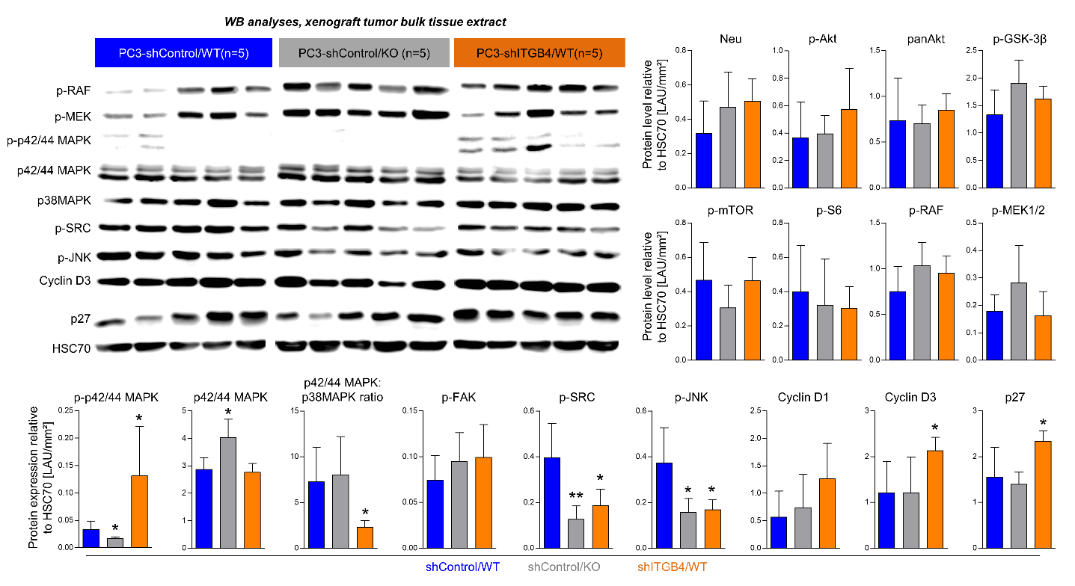
Suppl. Fig. S2: Western Blot analyses of PC-3 xenograft tumor samples. Exemplary Western Blot images and corresponding quantification of cell cycle- and survival-related protein levels relative to HSC70. Proteins were extracted from PC-3 xenograft tumors from the experiment shown in Fig. 1B. The combination group (shITGB4/KO) is missing since in this group only one mouse developed a xenograft tumor. Bar charts represent mean+SD of n=5. *p<0.05; **p<0.01.

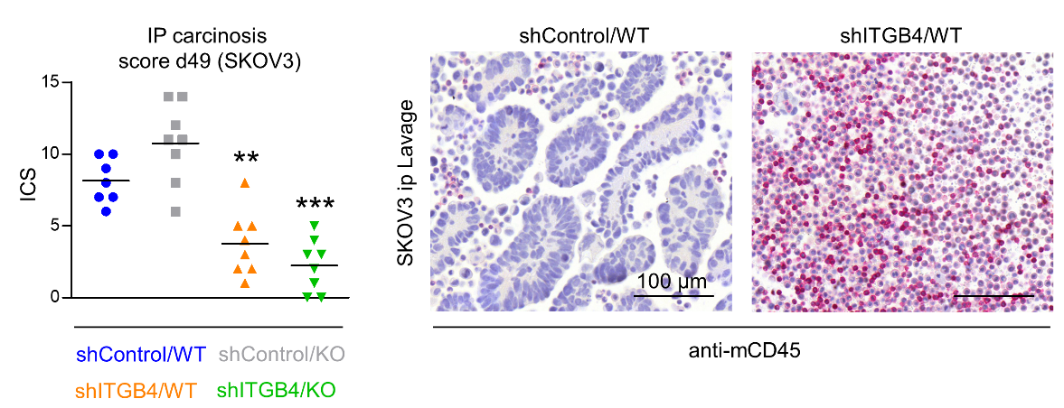
Suppl. Fig. S3: Additional SKOV3 intraperitoneal xenograft model. Intraperitoneal (IP) carcinosis score (ICS) on day 49 after injection of SKOV3 control vs. ITGB4 knockdown cells into E-/P-selectin wildtype vs. knockout rag2^{-/-} BALB/c mice. Representative anti-mCD45 immunostaining images of formalin-fixed, paraffin-embedded intraperitoneal lavage. Black lines in the scatter plot represent mean values. **p<0.01; ***p<0.001.

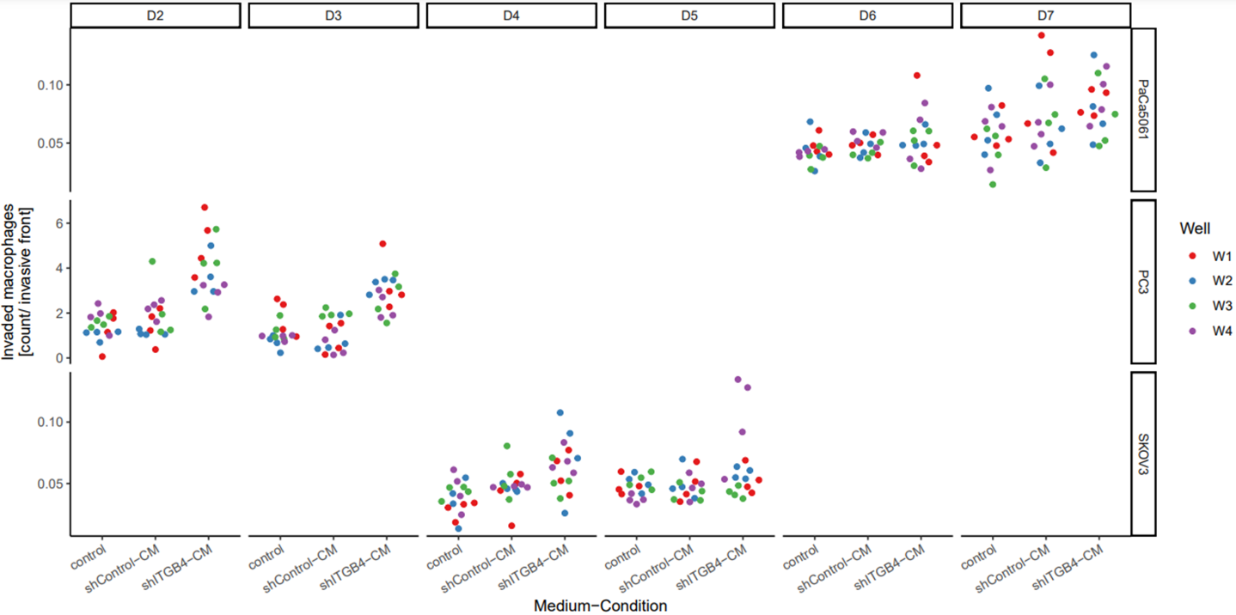
Suppl. Fig. S4: Attraction of human macrophages by ITGB4 knockdown tumor cell-conditioned media. Entire dataset of data shown in Fig. 4C including further donors.

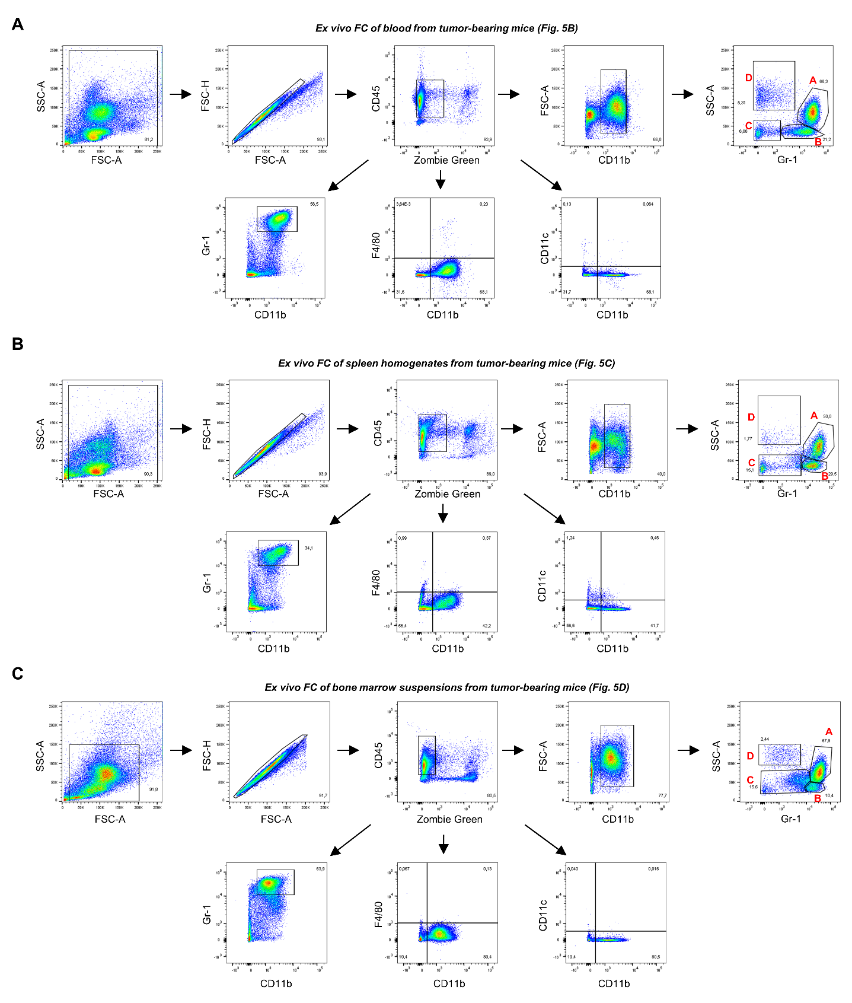
Suppl. Fig. S5: Representative density plots of ex vivo flow cytometric analyses of blood (A), spleen (B) and bone marrow (C) samples of s.c. tumor nodule-bearing mice (10 days after injection of PC-3 control vs. ITGB4 knockdown cells into E-/P-selectin wildtype vs. knockout mice, see Fig. 5 for differences between the groups). Note the populations assigned A-D in SSC-A/ Gr-1 plots (referring to Fig. 5).

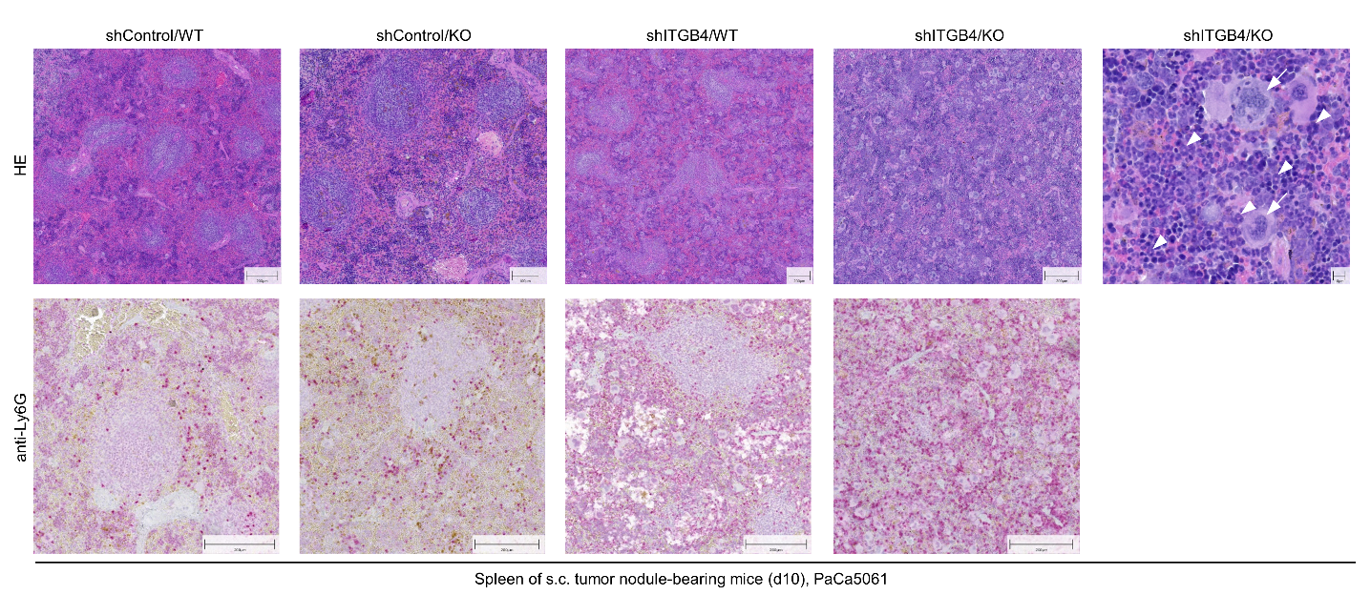
Suppl. Fig. S6: Validation of alterations in the spleen morphology ten days after s.c. injection of tumor cells. Representative photomicrographs of HE- and anti-Ly6G (Gr-1 epitope)-stained spleen samples on d10 after s. c. injection of PaCa5061 control vs. ITGB4 knockdown cells into E-/P-selectin wildtype vs. knockout mice. The arrows indicate megakaryocytes, arrowheads indicate immature granulocytes with ring-shaped nuclei.

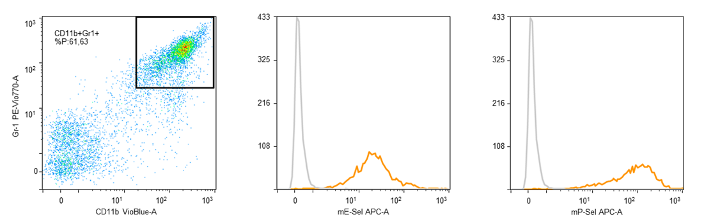
Suppl. Fig. S7: Static murine E- and P-selectin binding capacity of ITGB4 KD tumor-derived MDSCs. Flow cytometric analysis of CD11b⁺ Gr-1⁺ leukocytes isolated from s.c. PC-3 ITGB4 KD tumors regarding static binding of murine E- and P-selectin as indicated. Grey lines in histograms indicate unstained controls.

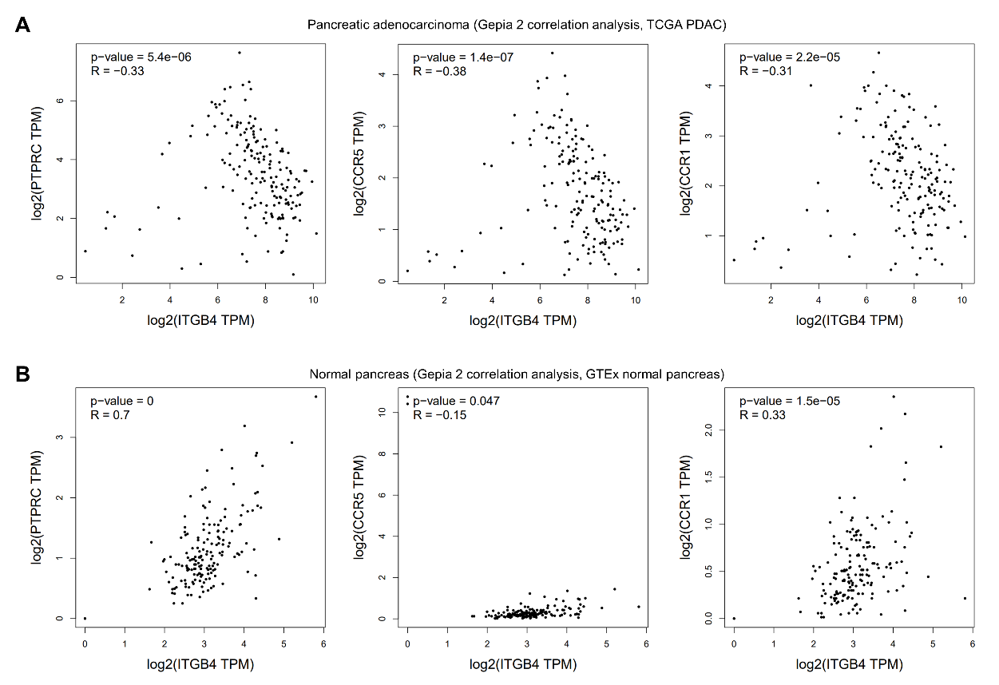
Suppl. Fig. S8: Validation of inverse correlation of ITGB4 and leukocyte markers in pancreatic cancer. Correlation of ITGB4 and CD45 (PTPRC gene), CCR5, or CCR1 in the human pancreatic ductal adenocarcinoma (PDAC) database of the cancer genome atlas (TCGA) (A) and normal human pancreas expression data of the Genotype-Tissue Expression (GTEx) portal (B) as determined by using the Gene Expression Profiling Interactive Analysis 2 (GEPIA2) online tool (http://gepia2.cancer-pku.cn). TPM = transcripts per million. R- and p-values were calculated based on Pearson correlation analysis.

Suppl. Table 1: Short IHC protocols relevant to the study (IHC-P).
 | Antigen retrieval | blocking | primary antibody | isotype control | secondary antibody
Integrin beta 4 (439-9B) | S1699 pH6,  2 x 4 min microwave | rabbit serum (Dako 68 g/l) 1:10 | abcam (0.5 mg/ml) 1:25 | rat IgG2b Antigenix America 1:10 | rabbit α rat (Dako) 1:200
Ki67 (M7240) | S1699 pH6, 16h 85°C water bath | goat serum  1:10 | Dako (35 mg/l)  1:32 | mouse IgG1 (Dako 100 mg/l) 1:91 | goat α mouse (Dako 0.77 g/l) 1:200 in TBS
Bim | S2367 pH9 (Tris/EDTA)  10 min 121°C steamer | NA | abcam (1 mg/ml) 1:100 | rabbit poly IgG abcam  1:20 | swine α rabbit (Dako 0.51 g/l) 1:200
pH2A.X [EP854(2)Y] | S1699 pH6 10 min 121°C steamer | NA | abcam  1:672 | rabbit immunoglobulin fraction Dako 1:266000 | swine α rabbit (Dako 0.51 g/l) 1:200
mCD45 (30-F11) | S1699 pH6,  2 x 4 min microwave | NA | BD Pharmingen (2.5 µg/ml)  1:25 | rat IgG2b BioLegend (1mg/ml) 1:200 | rabbit α rat  (Jackson Immono Research) 1:100
Ly6G | S2367 pH9 (Tris/EDTA)  10 min, 121°C steamer | NA | MyBioSource (360 µg/ml) 1:100 | rabbit poly IgG (5 mg/ml) abcam 1:1389 | goat α rabbit-Biotin (LS-Bio) 1:200 in TBS
mIntegrin beta 4 [EPR17517] | S2367 pH9 (Tris/EDTA) | NA | abcam  (1.11 mg/ml)  1:222 | rabbit mono IgG (1,68 mg/ml)  abcam 1:336 | goat α rabbit-Biotin (LS-Bio) 1:200 in TBS

