Additional file 5 Relevant domains, axial codes, statements, quotations and themes

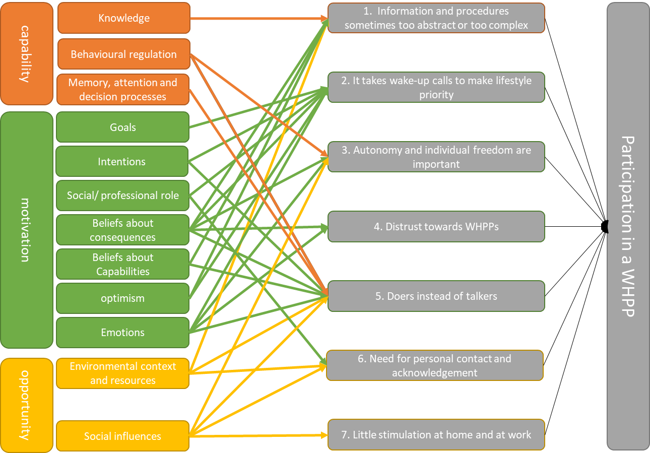

COM-B | TDF Domain (+ frequency count) | Axial code (+ frequency count) | Statement | Quotation (sometimes a second quotation was added when the code could point in 2 directions) | Theme
Capability (mental) | Knowledge (54) | Knowledge of existence WHPP (18) | I am not aware of WHPPs my employer offers | “I am hardly ever there. The only contact I have, is with the planning department. We get a monthly newsletter, but I didn’t see anything about health” (respondent 32, male, interstate truck driver, 58 years, no questionnaire, no coaching) | 1. Information and procedures sometimes too abstract or too complex
 |  | Knowledge of possibilities WHPP (9) | It is not clear to me what a WHPP would look like and what kind of topics I could work on | “It was not clearly stated on the phone that the WHPP would be via phone or you should go there and there, so to speak” (respondent 3, female, truck driver in training, 17 years, questionnaire, no coaching) | 1. Information and procedures sometimes too abstract or too complex
 |  | Knowledge of WHPP content (25) | I do not know what to expect from the WHPP | “yeah, they called me, you know, well, the coach is going to look with you in terms of food an things like that. She did tell me then, but it was not, you know, getting clearer, like oh that’s it, you know” (respondent 29, male, truck driver in training, 19 years, questionnaire, no coaching) | 1. Information and procedures sometimes too abstract or too complex
 |  | Knowing how to apply (6) | I do not know what steps to take when I want to participate in a WHPP | “It wasn’t clear to me, where to go to – well, I don’t want to participate, but yeah, maybe in the future” (respondent 29, male, truck driver in training, 19 years, questionnaire, no coaching) | 1. Information and procedures sometimes too abstract or too complex
Capability (mental) | Behavioural regulation (24) | Getting into action right away (7) | I do not overthink participation, I simply do it or I don’t | “I never thought about that, not so deeply. It was just spontaneous. I am going to do it” (respondent 29, male, crane operator, 54 years, questionnaire and coaching) | 5. Doers instead of talkers
 |  | Participation is own responsibility (17) | I should take the lead when it comes to participation in a WHPP | “No, I don’t want that, I’m not interested (…) I mean: if you have a number and it would bother me and I am able to call someone, well, yeah, that’s fine. Then I got a number that I can call (…) but I mean, then it’s up to me whether I call. And I’m not being called” (respondent 26, male, interstate truck driver, 55 years, questionnaire, no coaching)  “So the coach called me one day and said she wanted to see me, and I was like: just put some things for me in the e-mail’. But no, she really was like ‘no, I want to see you just once and then we’ll see how it goes from there, but I want to make an appointment. So she really insisted and, looking back, I think it was good she did” (respondent 25, male, interstate truck driver, 43 years, questionnaire and coaching) | 3. Autonomy and individual freedom are important
Capability (mental) | Memory, attention and decision processes (16) | Remembering – forgetting (16) | I need reminders to remember to fill out the questionnaire or apply for the WHPP | “we always have a briefing in the morning (..) This (the questionnaire) was mentioned a few times and then again referred to a few times: did you already do it? It costs nothing, just a bit of your time. I was the second or third time that I thought: o yeah, I haven’t done that yet” (respondent 18, female, courier, 41 years, questionnaire and coaching) | 5. Doers instead of talkers
Motivation (reflective) | Goals (26) | Having or setting a health goal (14) | I have a health/lifestyle goal that corresponds with the WHPP | “Well, to improve a part of yourself and yourself. You’re looking for something to find the right way through, a step further” (respondent 14, male, intrastate and interstate truck driver, 35 years, questionnaire and coaching) | 2. It takes wake-up calls to make lifestyle priority
 |  | Giving priority to health (12) | Health is not a priority for me, I have other things on my mind | “And when are we going to do that? Because we have very irregular jobs. Look, when I go away on Sunday and I come back on Saturday morning and my boss says you can go to the gym on my expense. Then I will look at him and probably look at him again and then I’ll say: see you on Monday, man!” (respondent 30, male, interstate truck driver, 61 years, no questionnaire, no coaching)  “When you get older, yeah, people around you fall ill. It makes you think about it (lifestyle)” (respondent 4, male, crane operator, 56 years, questionnaire, no coaching) | 2. It takes wake-up calls to make lifestyle priority
Motivation (reflective) | Intentions (58) | Feeling (no) urgency to change (26) | Healthy habits won’t make me feel better in the near future | “If I would have been heavier, or be sitting at home and not being physically active or live very unhealthy, then I would have looked at it (WHPP) differently. Then I would have participated, Because it would have been better for me, but now that wasn’t the case” (respondent 12, male, truck driver in training, 19 years, questionnaire, no coaching)  “yes, a burn-out, I never thought I would be in that position, and when you’re there, you want to get out of it as quickly as possible” (respondent 17, male, intrastate truck driver, 48 years, questionnaire and coaching) | 2. It takes wake-up calls to make lifestyle priority
 |  | Openness to change (15) | I am open to what a WHPP may bring me, which I think is necessary for participation | “you have to be open to change, you must be prepared to work on something and then it will be useful” (respondent 5, male, intrastate driver, 39 years, questionnaire and coaching) | 2. It takes wake-up calls to make lifestyle priority
 |  | Determined – doubt (7) | I am determined to participate in the WHPP | “It (lifestyle coaching) is the same as quitting smoking (..) The last attempt I thought: “well now, it’s done!” and then it’s done for me. So no, for me there was no – I thought: I’m starting it” (respondent 22, male, intrastate driver, 52 years, questionnaire and coaching)  “well, off course I had some kind of doubt (…) I don’t always believe that talking solves the problem. I am more a doer than a talker” (respondent 17, male, intrastate truck driver, 48 years, questionnaire and coaching) | 5. Doers instead of talkers
 |  | Already involved (with other professionals) in health/lifestyle activities (16) | I am already involved in lifestyle change activities outside work | “I was seeing a psychologist here in the village via the general practitioner. And that (WHPP and psychologist) came together and it brought me a lot, yeah” (respondent 16, male, intrastate truck driver and mover, 57 years, questionnaire and coaching) | 2. It takes wake-up calls to make lifestyle priority
Motivation (reflective) | Social/ professional role and identity (22) | Role of (grand)parent (8) | As a (grand) parent it is important to take care of my health | “and certainly for the kids. What’s in it for them when they have a fat daddy who is lazy as hell, instead of a fit daddy who can play with them, lives healthy and has a positive attitude towards life?” (respondent 19, male, intrastate truck driver, 39 years, questionnaire and coaching) | 2. It takes wake-up calls to make lifestyle priority
 |  | Professional role (9) | In my profession it is important to take care of your health | “Especially as a truck driver, it is very important. You sit all day. So it is important to be physically active and eat well” (respondent 3, female, truck driver in training, 17 years, questionnaire, no coaching) | 2. It takes wake-up calls to make lifestyle priority
 |  | Role of employee (2) | As an employee (in this company) it is important to invest in your own health | “You see, it’s an offer from the employer and he sticks his neck out for this, and I’m sure it will cost him something and yeah, I think you should participate then. Right? (…) It works back and forth a bit, you know (…) When they organise a party, I’m there as well, so to speak” (respondent 23, male, intrastate truck driver, 52 years, questionnaire, no coaching) | 6. Need for personal contact and acknowledgement
 |  | Role of partner (3) | Responsibility for my family keeps me from participating in a WHPP | “Lack of time. It’s not going to happen. Yeah, the family is on its own then (…) If something takes time, then I say: forget it” (respondent 24, male, intrastate truck driver, 35 years, questionnaire, no coaching) | 2. It takes wake-up calls to make lifestyle priority
Motivation (reflective) | Beliefs about consequences (133) | No expectations (16) | I don’t know what to expect from a WHPP, but it won’t hurt to try | “I just started it with an open mind. I did not have any experience with it. I thought: it won’t hurt to talk about it” (respondent 16, male, intrastate truck driver and mover, 57 years, questionnaire and coaching) | 1. Information and procedures sometimes too abstract or too complex
 |  | (insight in) health and lifestyle (50) | A WHPP may help me get insight in or improve my health and/or lifestyle | “after filling out all those questions, you get to know all kind of things – you know- how you’re lifestyle is. So for example, if something’s very wrong, then you know and you can change it” (respondent 3, female, truck driver in training, 17 years, questionnaire, no coaching) | 2. It takes wake-up calls to make lifestyle priority
 |  | Added value coach (27) | A lifestyle coach is not going to tell me anything new | “well, I know that I should eat more fruit. So yeah, I don’t need someone, not a dietician or I don’t know what. That, no, I’ll do it myself, you know. I’m trying to improve it” (respondent 4, male, crane operator, 56 years, questionnaire, no coaching) | 3. Autonomy and individual freedom are important
 |  | Expected benefits of talking (11) | Talking won’t solve my health problem(s) | “yeah, I had the idea a bit that it would all be a bit woo woo, you know? That we would fill in some colouring pages or search for a quiet spot in the woods. And that it would all turn out good (…) I find that a bit woo woo, so I thought: that’s not going to help” (respondent 27, male, interstate truck driver, 57 years, questionnaire and coaching) | 5. Doers instead of talkers
 |  | Giving up on individual freedom (21) | When you participate in a WHPP you have to give up on your freedom and I don’t want that | “Well, at first, you know, I had the idea ‘that’s someone who is going to tell me what I am not allowed to do anymore” (respondent 25, male, interstate truck driver, 43 years, questionnaire and coaching) | 3. Autonomy and individual freedom are important
 |  | Privacy concerns (15) | I am concerned that if I participate, my employer gets insight in my health status | “how anonymous is this all? You’re doing it on the company’s computer. I don’t think it’s all very anonymous” (respondent 12, male, intrastate truck driver, 61 years, questionnaire and coaching) | 4. Distrust towards WHPPs
 |  | Anticipated regret (3) | If I don’t participate in the WHPP, I may regret that in the future | “And then, I don’t know, when you end up in a hospital and you have to rehabilitate or whatever (…) yeah, maybe then you say: I wish had done that (participate in the WHPP) back then” (respondent 23, male, intrastate truck driver, 52 years, questionnaire, no coaching) | 2. It takes wake-up calls to make lifestyle priority
Motivation (reflective) | Belliefs about capabilities (6) | Concerns about ability to participate (3) | I do not have what it takes to participate in a WHPP | “sometimes it’s hard to open up to – so to speak – to…then I think…well, should I share all this with a stranger, some things, you know” (respondent 21, male, intrastate driver, 61 years, questionnaire and coaching) | 5. Doers instead of talkers
 |  | Giving answers (3) | It’s easy to answer questions about myself | “just giving answers to the questions. So, that’s not so hard” (respondent 2, male, intrastate truck driver, 43 years, questionnaire, no coaching) | 1. Information and procedures sometimes too abstract or too complex
Motivation (reflective) | Optimism (23) | Hope (9) | I have confidence the WHPP will do me good | “So I entered with a kind of hopeful ignorance, but with a confidence that it would turn out fine, a positive feeling” (respondent 5, male, intrastate truck driver, 39 years, questionnaire and coaching) | 1. Information and procedures sometimes too abstract or too complex
 |  | Risk perception (14) | I don’t think I’m at risk of becoming ill | “But if today or tomorrow…but I don’t feel that way and I don’t think anything will happen to me today or tomorrow” (respondent 23, male, intrastate driver, 52 years, questionnaire, no coaching) | 2. It takes wake-up calls to make lifestyle priority
Motivation (automative) | Emotions (39) | Enthusiasm (3) | I am looking forward to participation in the WHPP | “let’s start, I’m looking forward to it (the WHPP), yes” (respondent 15, male, intrastate driver, 52 years, questionnaire and coaching) | 5. Doers instead of talkers
 |  | Concern/fear about health or future (2) | Concerns about my health or future make it urgent for me to participate in the WHPP | “I took that health check and then it became clear that my cholesterol was way too high (…) That shocked me” (respondent 25, male, interstate driver, 43 years, questionnaire and coaching) | 2. It takes wake-up calls to make lifestyle priority
 |  | Curiosity (7) | The WHPP makes me curious about its content and possible results | “I was curious about what it all would entail, and I thought I will fill it out (the questionnaire) and then I’ll see what it all entails” (respondent 3, female, truck driver in training, 17 years, questionnaire, no coaching) | 5. Doers instead of talkers
 |  | Trust – distrust (15) | I do not trust my employer’s intention to offer me a WHPP | “They (the managers) sometimes act as if they’re interested in the person, but it’s pure self-interest” (respondent 21, male, intrastate truck driver, 61 years, questionnaire and coaching) | 4. Distrust towards WHPPs
 |  | Reactance (12) | I don’t let others influence my decision to participate. That’s up to me | “no, it’s your employer. It’s all good, but in life you’re on your own. It’s not up to them. That’s what I think” (respondent 14, intrastate and interstate truck driver, 35 years, questionnaire and coaching) | 3. Autonomy and individual freedom are important
Opportunity (physical) | Environmental context and resources (71) | Routing/ application (9) | The WHPP provider did not communicate clearly about the steps I had to take for participation | “I would be called indeed. But I never was. I sent them an e-mail later on ‘what’s happening?’ ‘yeah, we tried to call you’ But, I was not aware of that” (respondent 2, male, intrastate truck driver, 43 years, questionnaire, no coaching) | 1. Information and procedures sometimes too abstract or too complex
 |  | Time (20) | My working hours and time schedule are taken into account when planning the WHPP | “I am not going to take some time off to go to a dietician. And that nutrition consultant, well yeah, she made time to come this way on a Saturday” (respondent 10, male, interstate truck driver, 49 years, questionnaire and coaching) | 6. Need for personal contact and acknowledgement
 |  | Location (14) | I do not have to travel far to participate in the WHPP | “Then it was here, then there, but it was all in agreement, whatever suited us” (respondent 17, male, intrastate truck driver, 48 years, questionnaire and coaching) | 6. Need for personal contact and acknowledgement
 |  | Accessibility participation (29) | I do not have to arrange a lot myself to participate in a WHPP | “and then you don’t need to see your doctor or whatever. But you still can find out with this check, hey, maybe there’s something the matter” (respondent 2, male, intrastate truck driver, 43 years, questionnaire, no coaching) | 1. Information and procedures sometimes too abstract or too complex
 |  | Costs (9) | Costs for participation are acceptable to me | “My employer told me “the sector is paying me, so participation will cost you nothing” and I thought: ‘well why don’t I try it” (respondent 20, male, intrastate truck driver, 60 years, questionnaire and coaching) | 6. Need for personal contact and acknowledgement
 |  | User friendliness and attractiveness WHPP (6) | The WHPP is not attractive to me and it would cost me a lot of effort to participate | “and maybe a bit more practical. Because a whole afternoon in a theory class, that’s not for truck drivers, I think” (respondent 18, female, courier, 41 years, questionnaire and coaching) | 5. Doers instead of talkers
Opportunity (social) | Social influences (124) | Support from employer/ manager (35) | My employer/manager agrees with my participation in a WHPP but doesn’t stimulate me | “He (manager) didn’t support me, he knew I was participating, that man’s got more things on his mind. Real support, they informed me and that’s it” (respondent 15, male, intrastate truck driver, 52 years, questionnaire and coaching) | 7. Little stimulation at home and at work
 |  | Support from family (29) | My family agrees with my participation in a WHPP but doesn’t stimulate me | “But he (partner) is not the type that says: ‘hey, that’s the third time you’re walking to the fridge. Come on, let’s go for a walk outside. I don’t have that kind of support” (respondent 18, female, courier, 41 years, questionnaire and coaching) | 7. Little stimulation at home and at work
 |  | Social norm at work with regard to health and lifestyle (12) | At our company it is not really accepted to be concerned about your health and lifestyle | “yeah, I got laughed at on the road by co-workers. I was being called crazy for going for a walk in the evening. You’ve been working all day, aren’t you tired of working?” (respondent 31, male, interstate truck driver, 50 years, questionnaire and coaching) | 7. Little stimulation at home and at work
 |  | Social norm at work with regard to WHPPs (5) | At our company it is not really accepted to participate in a WHPP | “I don’t want that and I don’t need that (a WHPP). All that kind of nagging, you know. There’s always that bunch of negative ones (colleagues)” (respondent 26, male, interstate driver, 55 years, questionnaire, no coaching) | 7. Little stimulation at home and at work
 |  | Employing activities together (2) | Participation in a WHPP is easier when you do it together | “It works best, when you do it as a group, as colleagues. Nobody wants to be in the gym at 6 in the morning, but then you do it anyway” (respondent 18, female, courier, 41 years, questionnaire and coaching) | 5. Doers instead of talkers
 |  | Personal contact (7) | I appreciate personal contact and someone who listens to what I have to say | “it just created a relationship of trust instantly. I could just tell my story and I was being listened to. I found that very important” (respondent 16, male intrastate truck driver/mover, 57 years, questionnaire and coaching) | 6. Need for personal contact and acknowledgement
 |  | Talking at work about health and lifestyle (29) | In our company we do not talk a lot about health and lifestyle | “Actually, I didn’t talk about that (WHPP participation) with colleagues all that much” (respondent 18, female, courier, 41 years, questionnaire and coaching) | 7. Little stimulation at home and at work
 |  | Personal stories (8) | Reading or hearing about someone who went through the same thing as me, motivates me to participate | “At a certain point I thought…there’s a story (in a trucker magazine) of someone who’d gone through the same thing (burn-out). I thought: “that’s going to look a lot like me. Maybe I should fill out such a questionnaire” (respondent 27, male interstate truck driver, 57 years, questionnaire and coaching) | 7. Little stimulation at home and at work
 |  | Other’s opinions don’t matter (14) | What others think doesn’t affect my decision to participate or not | “well, all right, you listen to them (colleagues).Everyone has his own opinion and that’s ok. And yeah, then you still think: you choose for yourself and what is best for you” (respondent 16, male, intrastate truck driver/mover, 57 years, questionnaire and coaching) | 3. Autonomy and individual freedom are important

