Table S1 Primers used in this study.
Primers | Oligonucleotide sequence
Confirmation of mutations in coding region
TON_0597(549461)_F | 5'-ttcgtcacctactgggtgctct-3'
TON_0597(549461)_R | 5'-gccgagaaaaccgacctcat-3'
TON_0618_F | 5'-cttgttgctggtactctataagtgcc-3'
TON_0618_R | 5'-taaagaggatgctgtgttcgagatt-3'
TON_0820_F | 5'-aagcgtaatgagccctgttgg-3'
TON_0820_R | 5'-tacatgagccagcctcctgc-3'
TON_0865_F | 5'-atacgcggctgtgaggtgac-3'
TON_0865_R | 5'-gcagaggttcttaaccctgcat-3'
TON_0901_F | 5'-cgaactggccgatgacgtag-3'
TON_0901_R | 5'-catggcgacgtttctctcaga-3'
TON_0902_F | 5'-catggcgacgtttctctcaga-3'
TON_0902_R | 5'-ttcccattggcttcacctctt-3'
TON_1488_F | 5'-cttcagcaaccttggcaacc-3'
TON_1488_R | 5'-agaaggtaagtgccgagaaggc-3'
TON_1502_F | 5'-catatggatgctggacagcaga-3'
TON_1502_R | 5'-atcagccatgttaccaccgaata-3'
TON_1661_F | 5'-tccgtcagatccactttggc-3'
TON_1661_R | 5'-ggagaagcgatggactatggc-3'
TON_1698_F | 5'-ggtgggtgaatattatgacgtgg-3'
TON_1698_R | 5'-aatgaagagcaacacaagttgttcc-3'
TON_1779_F | 5'-aatggtcacgaaatacaccatcaa-3'
TON_1779_R | 5'-aacctgcaacgatgcagagg-3'
TON_1795_F | 5'-gcgaagtagatgttcttgactcca-3'
TON_1795_R | 5'-ccgaacgagctcgaggtctt-3'
TON_1797_F | 5'-gtatgagaaccgcctgtaagcc-3'
TON_1797_R | 5'-ttggctgtcctgatgacgtactc-3'
TON_1957_F | 5'-ttatccaagagcagtgcccc-3'
TON_1957_R | 5'-gacctccagggactgctcaa-3'
Confirmation of mutations in non-coding region
483252_F | 5'-gatcgccttcgcgacctcaa-3'
483252_R | 5'-tgatcctgggcatgttctcg-3'
994938_F | 5'-tggttccaccagagctttgc-3'
994938_R | 5'-acagggtgtggtcgtgacgta-3'

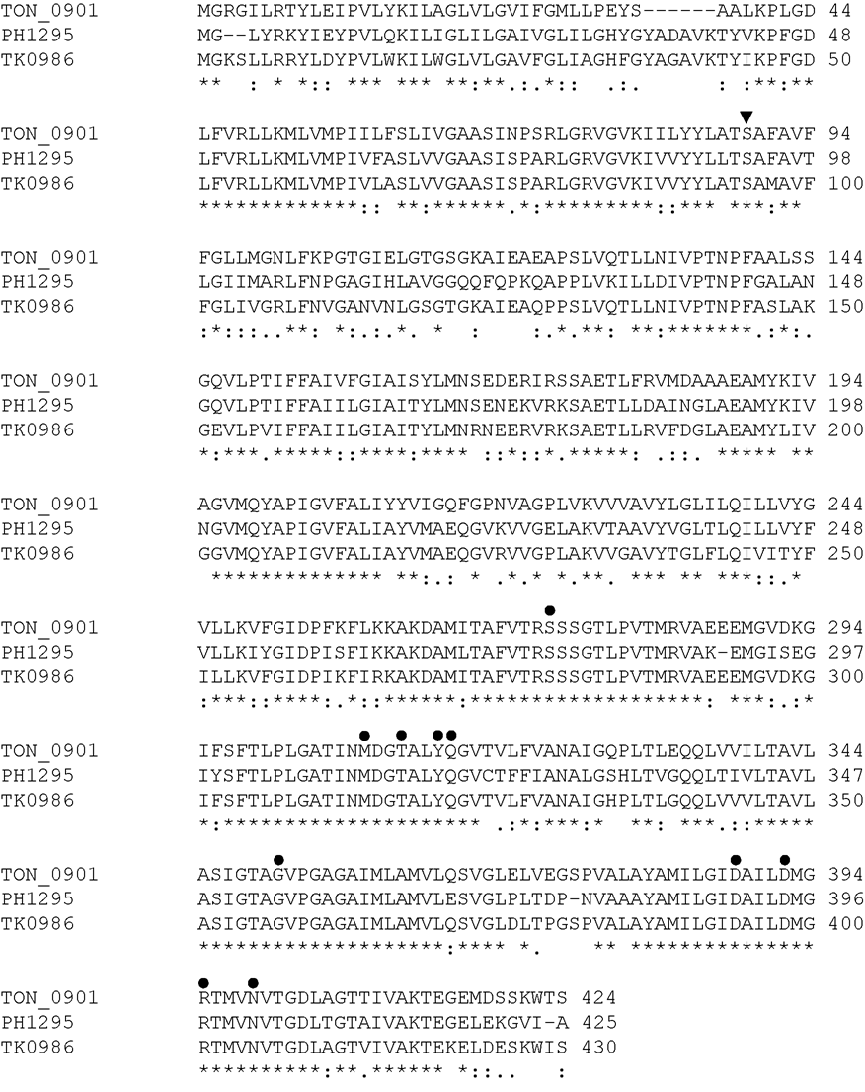
Fig. S1 Protein sequence alignment of the sodium-coupled aspartate transporter of T. onnurineus NA1 (TON_0901, GenBank accession number ACJ16389), P. horikoshii (PH1295, GenBank accession number BAA30399) and T. kodakarensis (TK0986, GenBank accession number BAD85175). Substrate binding residues identified in the P. horikoshii protein are indicated by filled circles. The inverted triangle represents the mutant residue (S89L) detected in glucose-adapted 100T cells. Identical residues, conserved substitutions, semi-substitutions and gaps are marked *, :, . and -, respectively.

