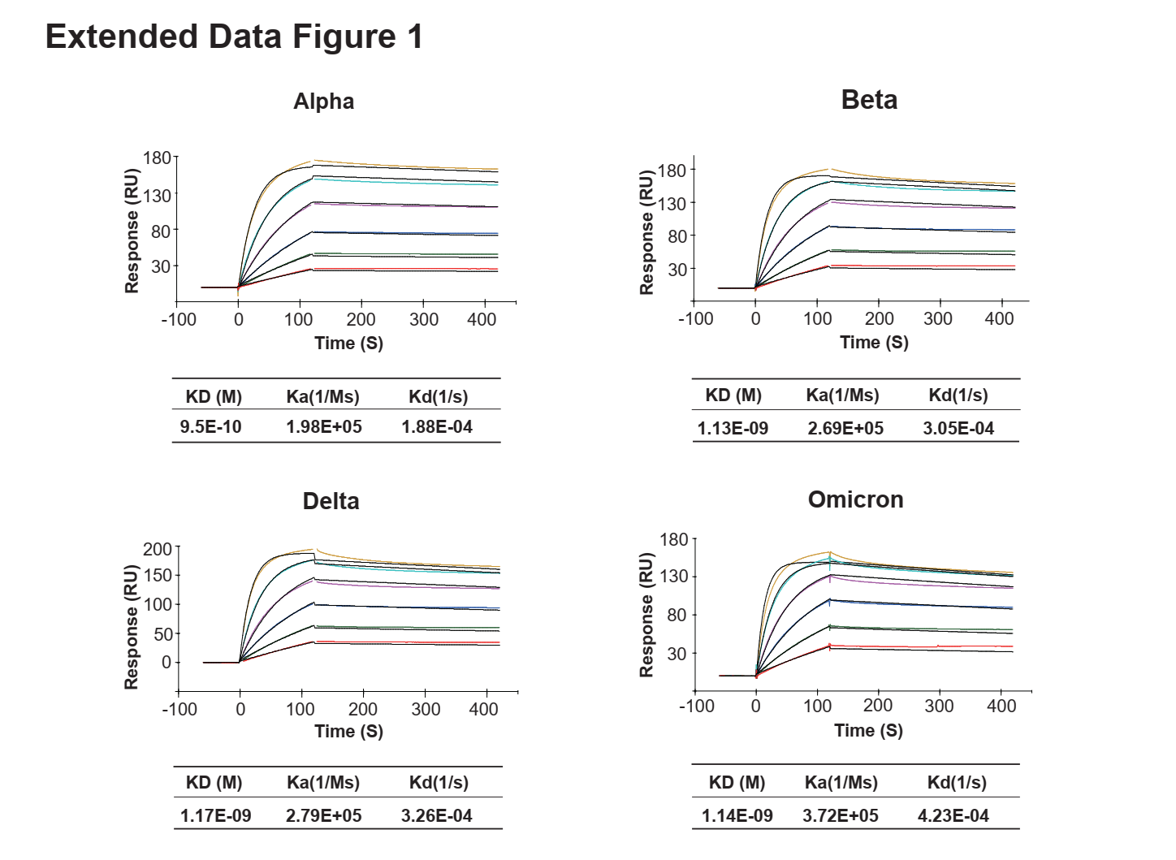
Extended Data Figure 1. Affinity and kinetics of the binding of HH-120 to SARS-CoV-2 S trimer proteins. The S trimer proteins of Alpha, Beta, Delta, and Omicron variants were analyzed for binding to HH-120 using a Biacore T200 instrument.

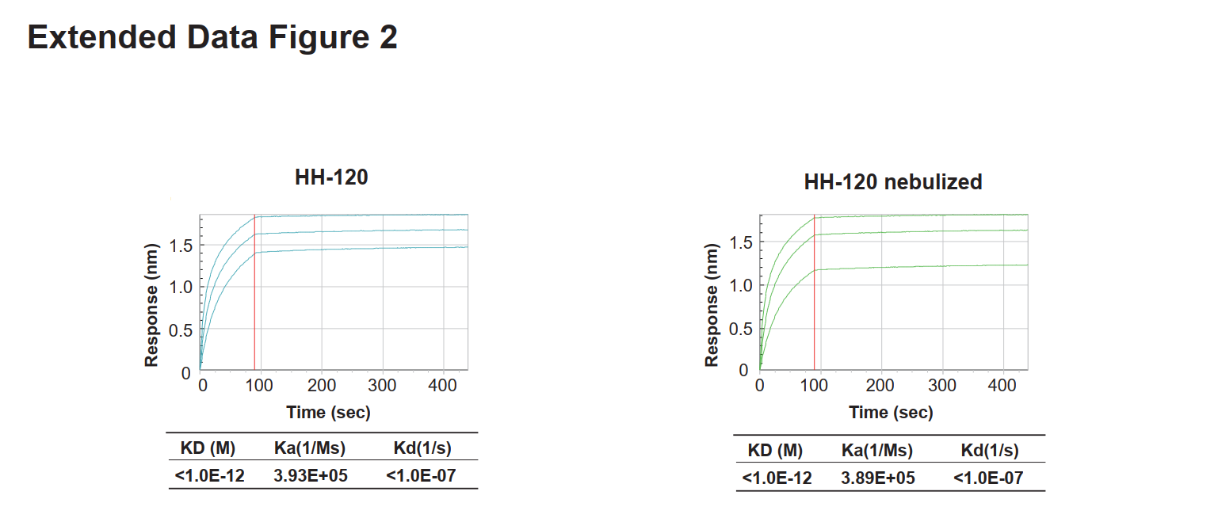
Extended Data Figure 2. Avidity and kinetics of the binding of HH-120 or nebulized HH-120 to SARS-CoV-2 RBD. The binding avidity and kinetics were measured using a Fortebio RED384 instrument.

