The effect of using treated domestic wastewater with different pH on workability, mechanical, and durability properties of self-compacting concrete

Shirin Keneshlo¹, Gholamreza Asadollahfardi¹*, Peyman Homami¹, Amir Masoud Salehi¹, Javad Akarbardoost² Mojtaba Tayebi Jeneli¹
¹ Civil Engineering Department, Faculty of Engineering, Kharazmi University, Tehran, Iran. fardi@khu.ac.ir
² Civil Engineering Department, Faculty of Engineering, Kharazmi University, Tehran, Iran.

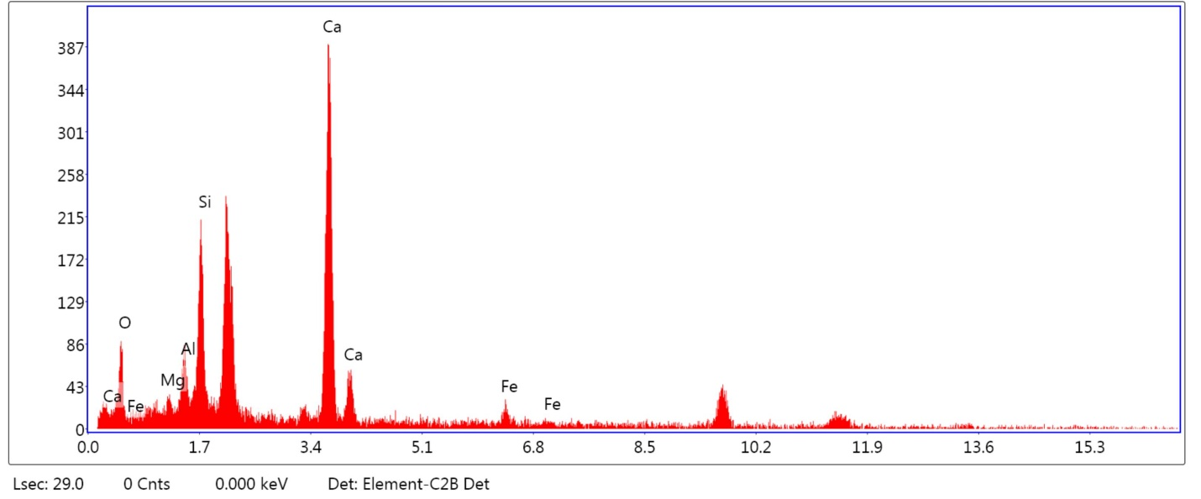

jij
ckk

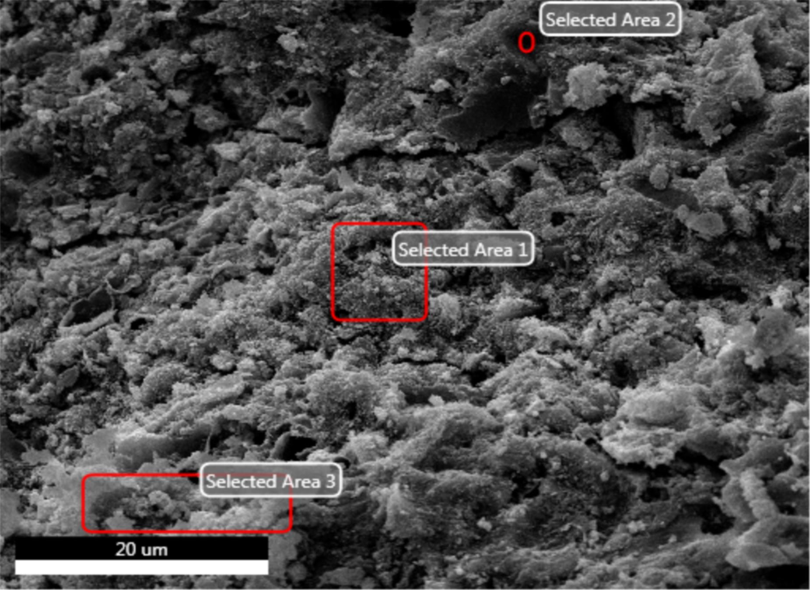
cELEMENT | WEIGHT% | ATOMIC%
OK | 38.57 | 57.94
MgK | 1.86 | 1.83
AlK | 5.34 | 4.76
SiK | 13.81 | 11.82
CaK | 36.88 | 22.12
FeK | 3.54 | 1.52
 | 100 | 100

CWW-400-5 area1 Ca/Si=1.87
Figure S1
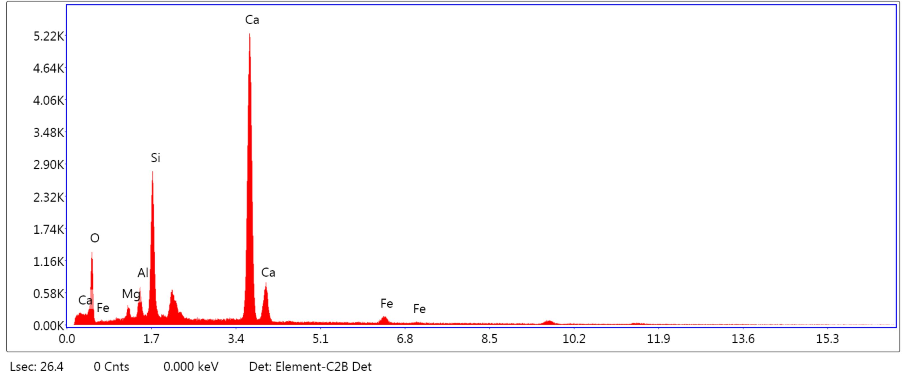
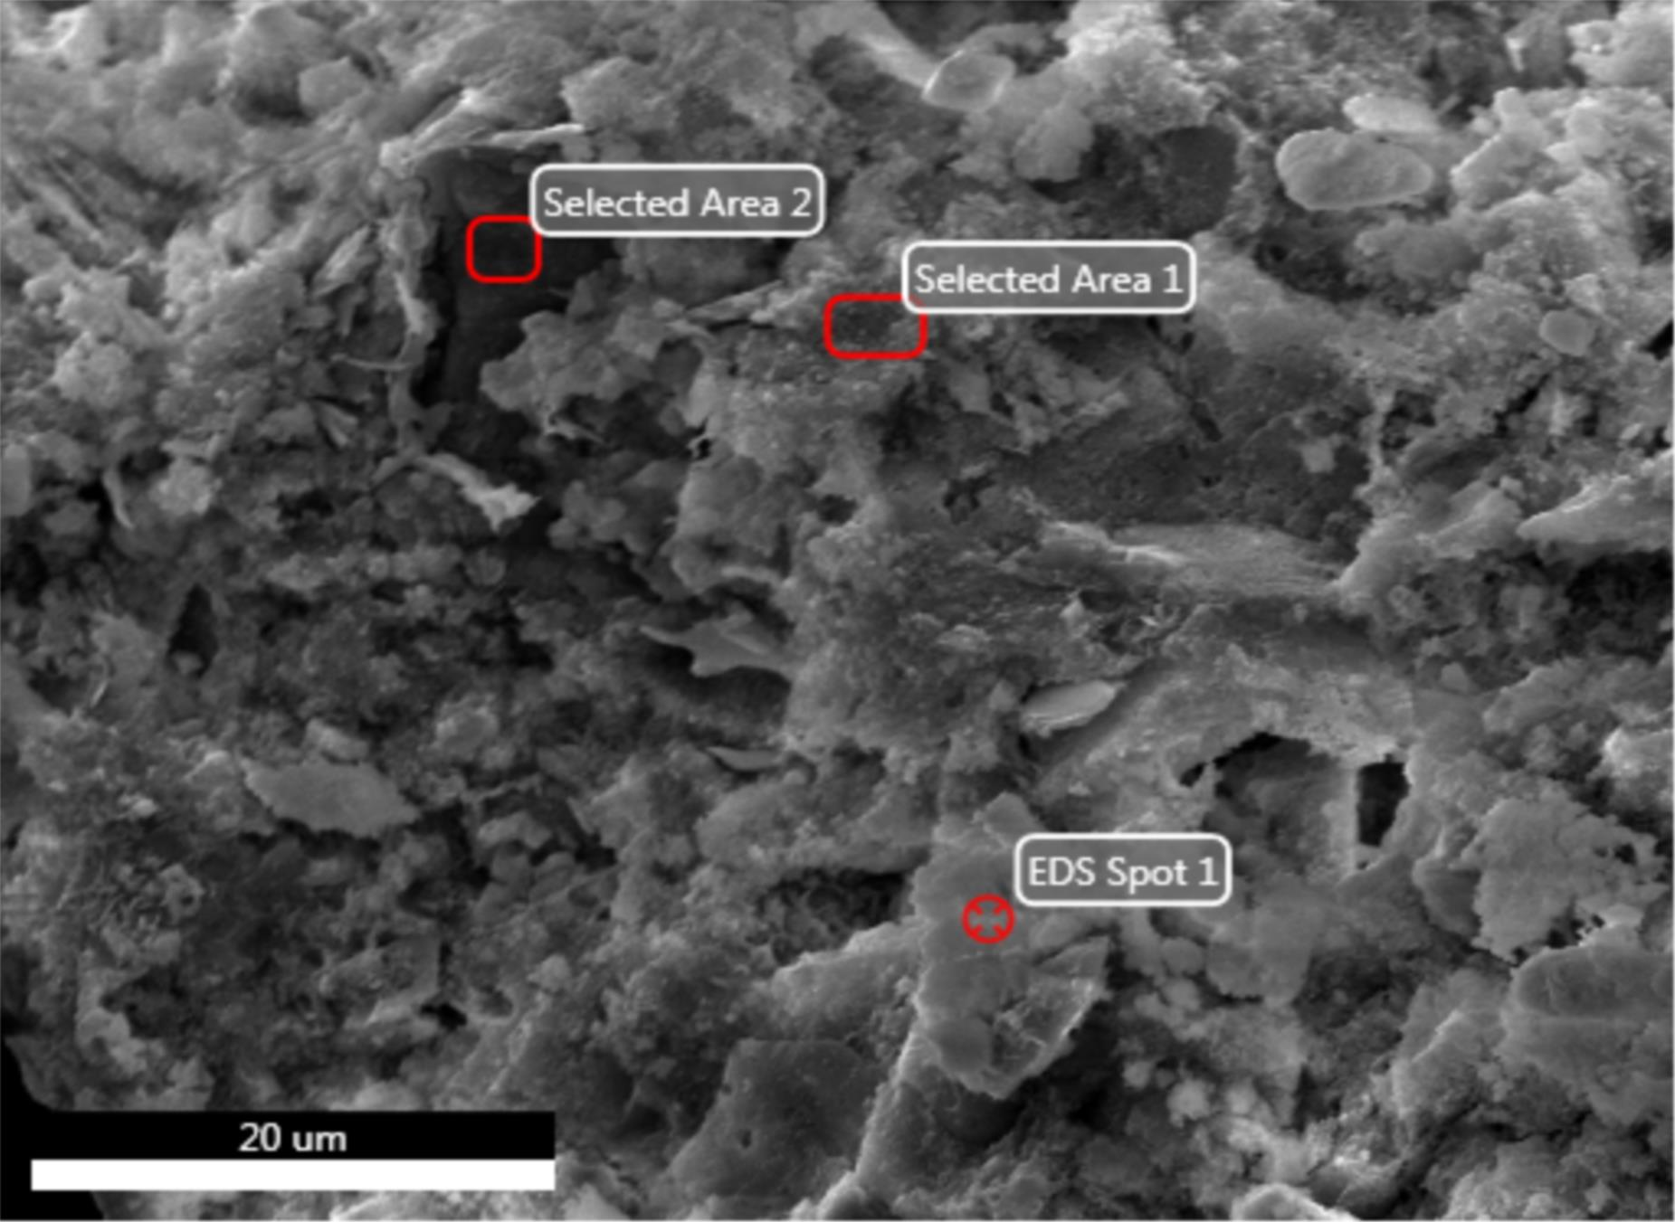
ELEMENT | WEIGHT% | ATOMIC%
OK | 41.11 | 55.32
MgK | 1.66 | 1.60
AlK | 2.70 | 2.36
SiK | 14.80 | 12.81
CaK | 38.39 | 22.55
FeK | 1.34 | 0.70
 | 100 | 100

CWW-400-7 area1 CA/SI=1.76
Figure S2
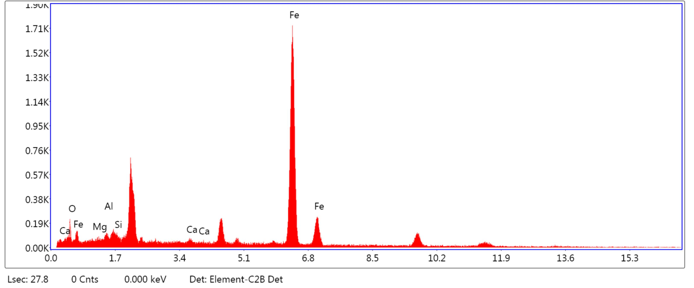
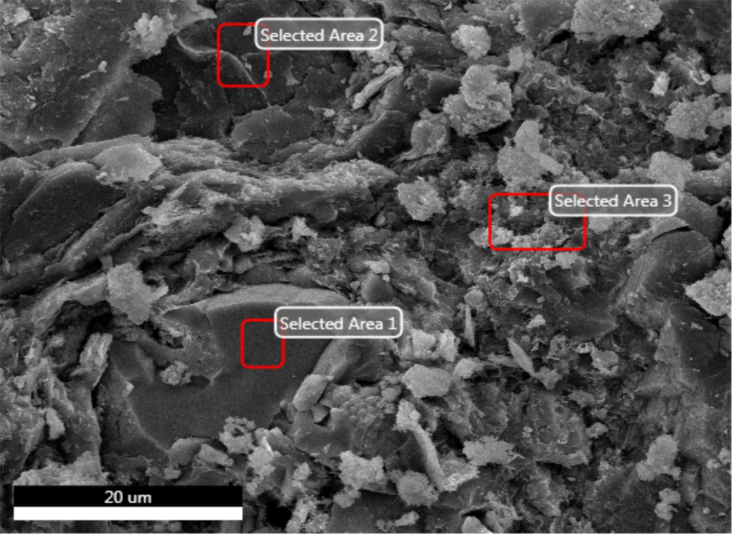
ELEMENT | WEIGHT% | ATOMIC%
OK | 25.24 | 57.89
MgK | 0.00 | 0.00
AlK | 4.91 | 4.76
SiK | 31.82 | 13.06
CaK | 35.02 | 22.87
FeK | 3.01 | 0.70
 | 100 | 100

CWW-400-9 area1 Ca/Si=1.75

Figure S3
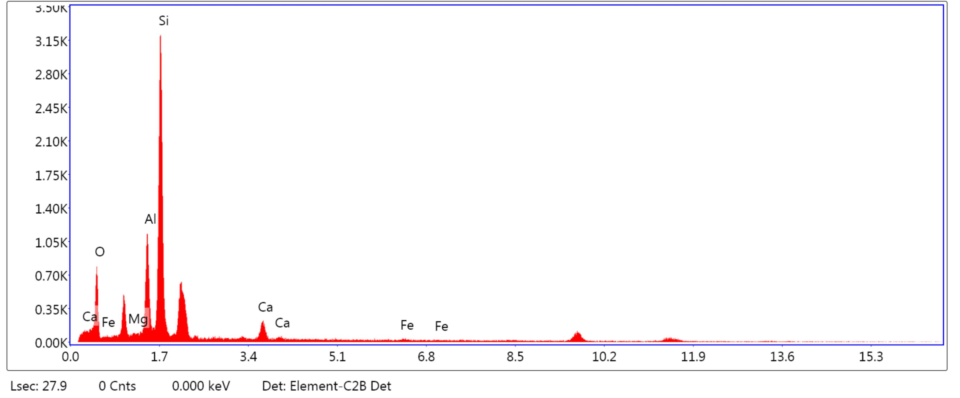
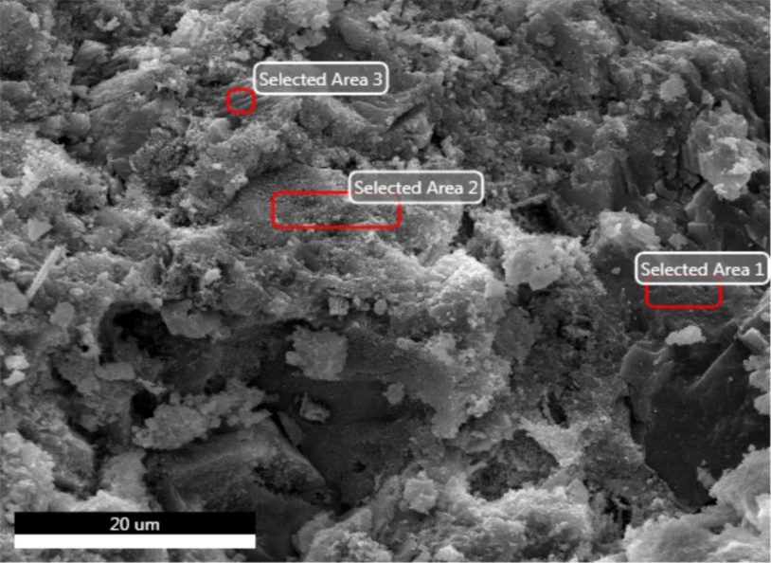

ELEMENT | WEIGHT% | ATOMIC%
OK | 42.41 | 61.36
MgK | 3.84 | 3.65
AlK | 6.36 | 5.45
SiK | 12.08 | 9.96
CaK | 30.30 | 17.00
FeK | 5.02 | 02.58
 | 100 | 100

CWW-440-5 area1 Ca/Si=1.7
Figure S4

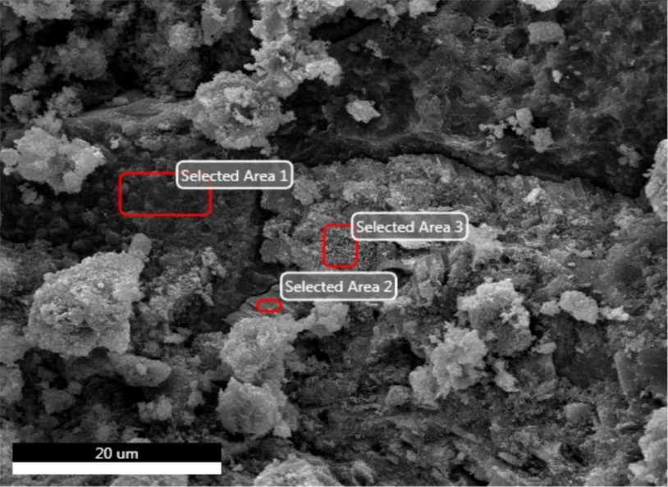
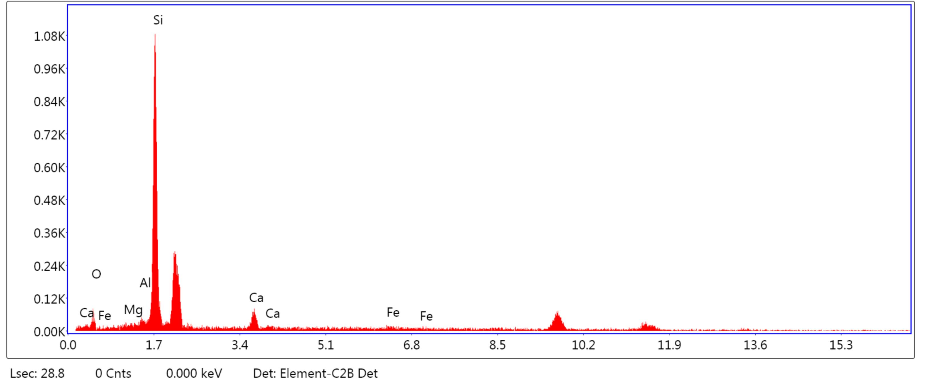

ELEMENT | WEIGHT% | ATOMIC%
OK | 36.67 | 52.72
MgK | 1.86 | 2.75
AlK | 1.67 | 2.51
SiK | 16.24 | 14.98
CaK | 41.98 | 23.5
FeK | 1.59 | 1.59
 | 100 | 100
CWW-440-7 area1 Ca/Si=1.57
Figure S5

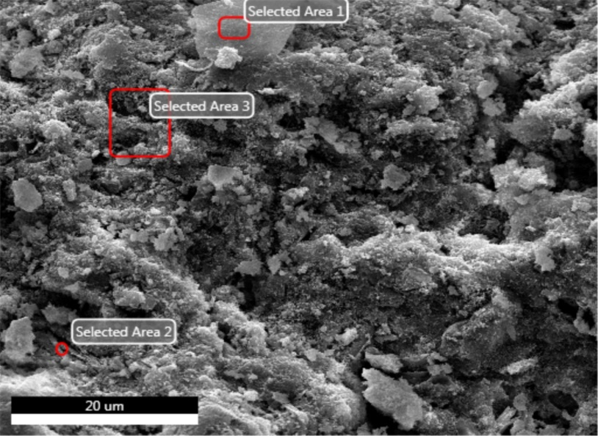
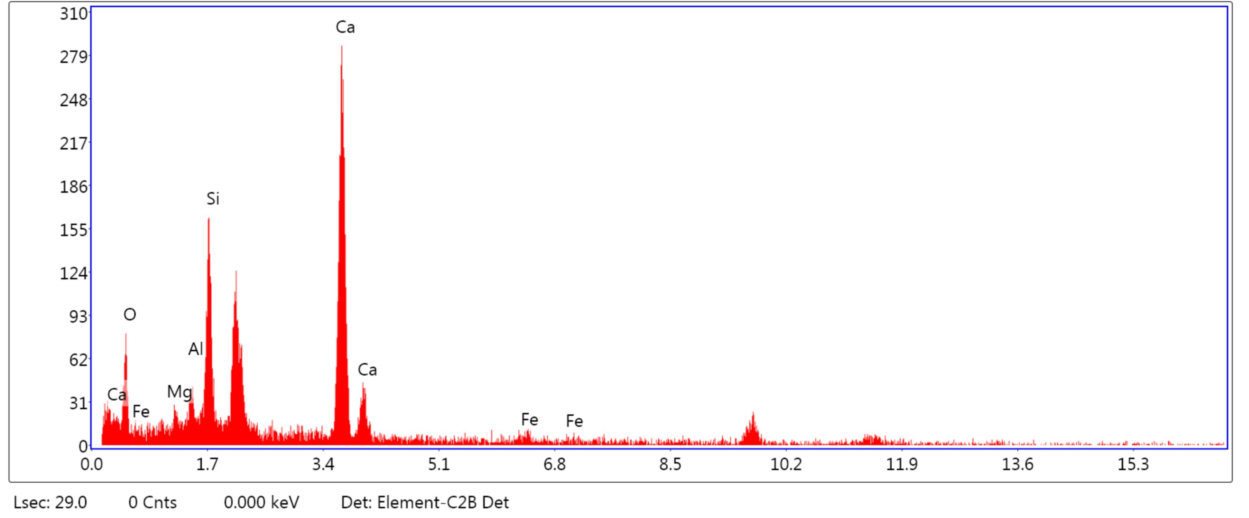

ELEMENT | WEIGHT% | ATOMIC%
OK | 37.99 | 55.32
MgK | 1.78 | 1.77
AlK | 4.06 | 6.06
SiK | 13.65 | 17.25
CaK | 39.23 | 23.97
FeK | 3.30 | 1.03
 | 100 | 100

CWW-440-9 area1 Ca/Si=1.39
Figure S6
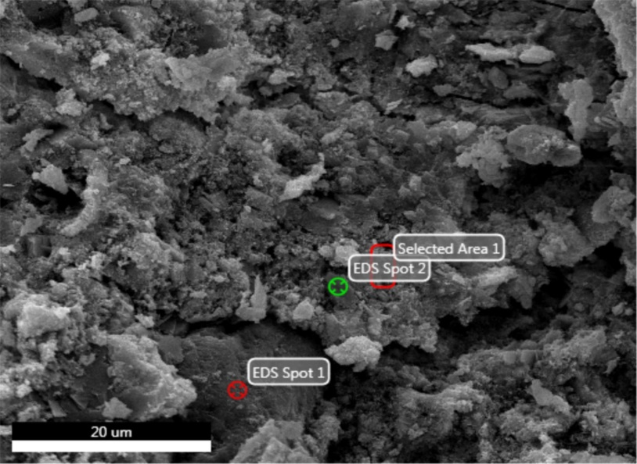
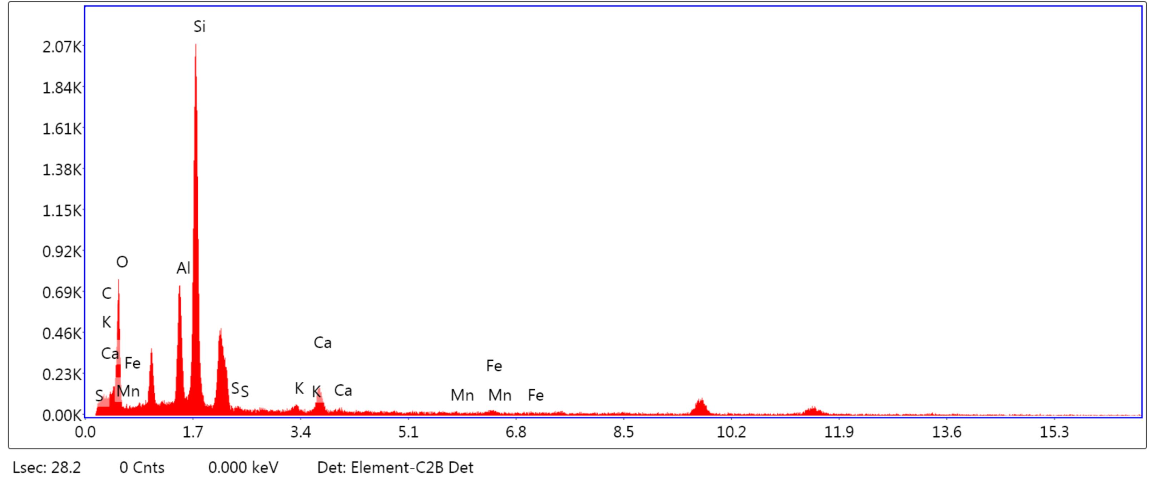

ELEMENT | WEIGHT% | ATOMIC%
CK | 0.02 | 0.01
OK | 36.39 | 45.41
AlK | 3.27 | 3.00
SiK | 10.26 | 16.5
SK | 8.34 | 6.43
KK | 0.53 | 0.33
CaK | 38.56 | 25.45
MnK | 0.63 | 0.26
FeK | 2.00 | 0.51
 | 100 | 100

CW-400 area1 Ca/Si=1.5
Figure S7

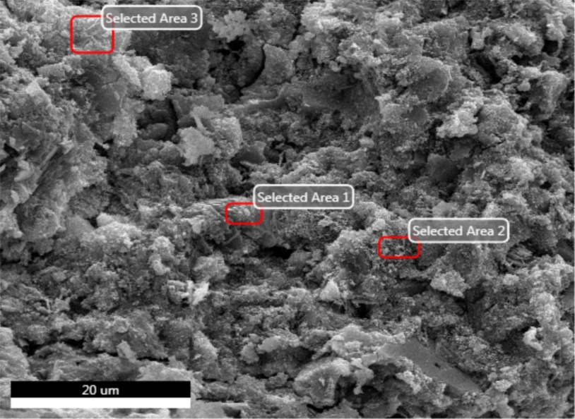
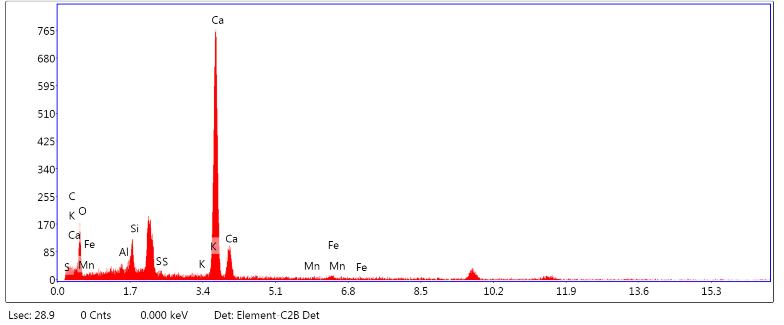

ELEMENT | WEIGHT% | ATOMIC%
CK | 0.05 | 0.09
OK | 37.79 | 55.86
AlK | 3.33 | 2.93
SiK | 14.09 | 15.09
SK | 3.18 | 6.05
KK | 0.51 | 0.31
CaK | 31.73 | 18.98
MnK | 0.88 | 0.166
FeK | 2.03 | 0.53
 | 100 | 100

CW-440 area1 Ca/Si=1.2
Figure S8

Dear Editor,
This is a resubmission of ESPR-D-22-13610.We checked all part of our manuscript according to the given software by your journal and removed or changed all copy past or similarities from our manuscript.
Regards,
Gholamreza Asadollahfardi

