Bace1 regulates expression of Clusterin in astrocytes for enhancing clearance of β-amyloid peptides
John Zhou, Neeraj Singh, James Galske, Jacob Hudobenko, Xiangyou Hu and Riqiang Yan*
Department of Neuroscience, UConn Health
263 Farmington Avenue, Farmington, USA CT 06030-3401

*Correspondence should be addressed to: Riqiang Yan, Ph.D., Department of Neuroscience, Room E4032, UConn Health, 263 Farmington Avenue, Farmington, CT USA 06030-3401
Tel: 860-679-3527, email: riyan@uchc.edu

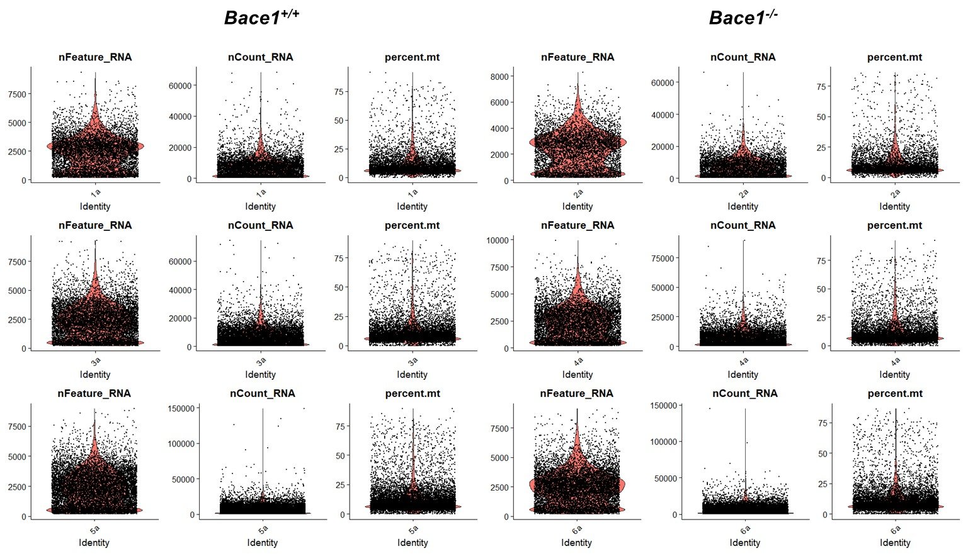

Bace1^{-/-}
Bace1^{+/+}

Supplemental Figure 1. Single cell RNAseq analysis of Bace1-null and wild type control astrocytes. (A) Quality control measure of Bace1^{-/-} and Bace1^{+/+} scRNAseq. Violin plots of data set quality control measurement for nFeature_RNA, nCount_RNA, and percent.mt generated from each ACSA2+-enriched sample. Samples 1a, 3a, 5a are from Bace1^{+/+} mice, while samples 2a, 4a, 6a are from
Bace1^{-/-}. Filtered cutoff points were set at GEMS containing >1,000 identified genes, <25,000 read counts, and <20% mitochondrial RNA. (B) UMAP dimension plot with cell type identified clusters from Bace1^{-/-} and Bace1^{+/+} scRNAseq. Visualization of UMAP defined clusters assigned to well-defined cell type markers.

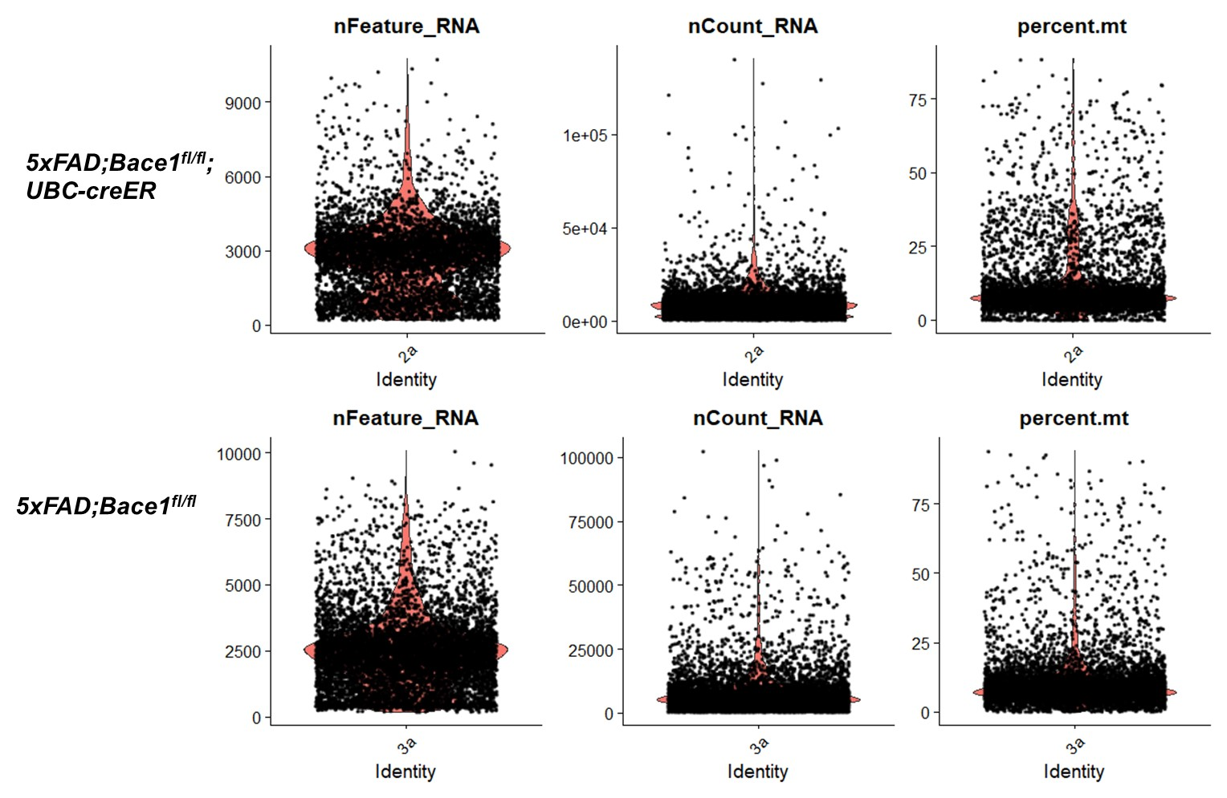
Supplemental Figure 2. Quality control measure of 5xFAD;Bace1^{fl/fl;UBC-creER} and 5xFAD;Bace1^{fl/fl}. Quality control measured for nFeature_RNA, nCount RNA, and percent.mt generated from pooled ACSA2+-enriched samples from 5xFAD;Bace1^{fl/fl;UBC-creER} (Sample 1A) and 5xFAD;Bace1^{fl/fl} (Sample 3a). Filtered cutoff points were set at GEMS containing >1,000 identified genes, <25,000 read counts, and <20% mitochondrial RNA.

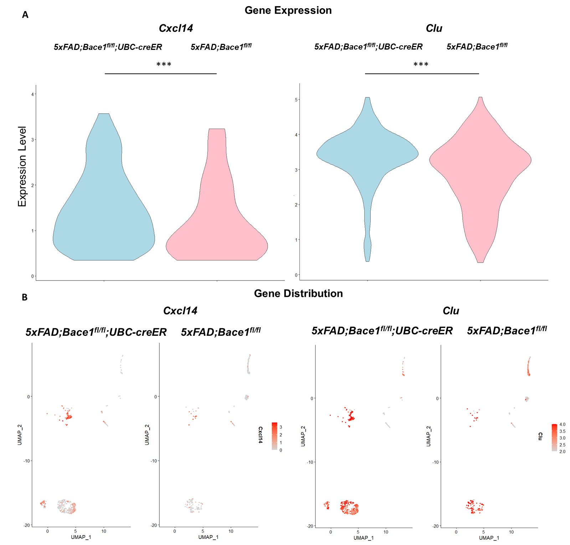

Supplemental Figure 3. Bace1 deficiency increases expression of Clu and Cxcl14 in 5xFAD reactive astrocytes. (A) The violin plot based on UMAP showed high expression of Clu and Cxcl14 (log2 fold change expression) in 5xFAD;Bace1^{fl/fl;UBC-Cre} compared 5xFAD;Bace1^{fl/fl} reactive astrocyte clusters. (B) Expression of Clu and Cxcl14 in reactive astrocytes on the UMAP showed clearly more upon Bace1 deletion.

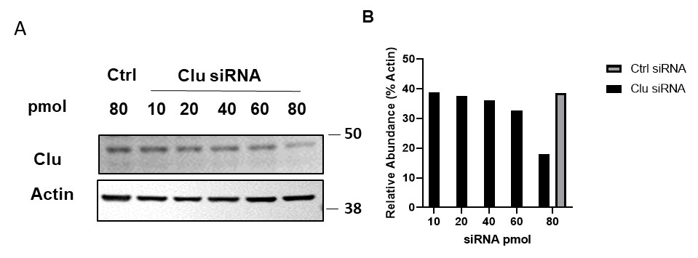
Supplemental Figure 4. Validation of siRNA Clu knockdown. (A) Western blot of WT-primary astrocytes treated with either 80, 40, 20, 10 pmol of Clu siRNA or 80 pmol of control scrambled siRNA. Images indicate major bands for CLU and actin proteins. (B) CLU band intensity normalized to actin. 80 pmol of Clu siRNA results in an approximately 50% decrease in CLU levels compared to control siRNA.

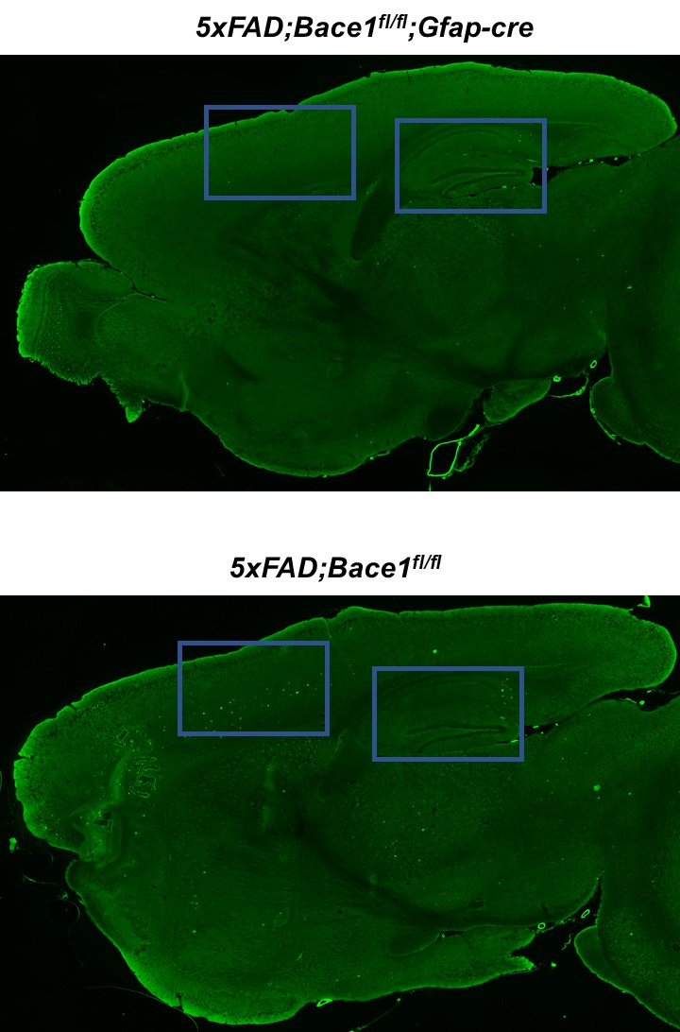
Supplemental Figure 5. Targeted astrocytic deletion of Bace1 increases Aβ clearance. Representative images from Thioflavin-S staining of amyloid plaques from fixed saggital brain sections of 5xFAD;Bace1^{fl/fl};Gfap-cre and 5xFAD;Bace1^{fl/fl}. Insets highlight hippocampal and cortical regions that are presented in Figure 9A.

Supplemental Table 1 List of differentially expressed genes of Bace1^{-/-} reactive astrocytes
Differentially expressed genes of Bace1^{-/-} compared to Bace1^{+/+} reactive astrocytes. Gene expression changes are expressed with log2(fold change) and -log10(p-value). P-value were calculated by Wilcoxon-ranked sum test.
Supplemental Table 2 List of differentially expressed genes of 5xFAD;Bace1^{fl/fl};UBC-creER reactive astrocytes
Differentially expressed genes of 5xFAD;Bace1^{fl/fl};UBC-creER compared to 5xFAD;Bace1^{fl/fl} reactive astrocytes. Gene expression changes are expressed with log2(fold change) and -log10(p-value). P-value were calculated by Wilcoxon-ranked sum test.

