Supplementary Information
Real-time reaction monitoring of Azide-Alkyne cycloadditions using benchtop NMR-based Signal Amplification by Reversible Exchange (SABRE)

Materials and Methods
Sample Preparation. Chemicals (1a–1c, 2a–2d, and 3a–3b), and deuterated solvents (methanol-d₄, CD₃OD, 99.8 atom %D, Eurisotop, and dimethyl sulfoxide-d₆, CD₃SOCD₃, 99.8 atom %D, Eurisotop) were also used in the form obtained. In the experiment, pre-catalysts ([Ir(IMes)(COD)Cl], [Ir(COD)(PCy₃)(py)]PF₆)] (2 mg, 3.1 × 10⁻³ mmol) and substrates (1a–1c, and 3a–3b, 3.1 × 10⁻² mmol) were dissolved in deuterated solvent (900 μL).
SABRE Catalyst Activation and calculation of Hyperpolarized Signal.
¹H NMR spectra used for the characterization of 1a–1c, 2a–2d, and 3a–3b was acquired on a Bruker Advance ӏӏӏ NMR spectrometer operating at a ¹H resonance frequency of 300 MHz and 60 MHz. The para-hydrogen generator was composed of a home-built instrument, in which hydrogen gas (Hanmi gas, >99.9 %, a mixture of the spin isomers ortho-hydrogen and para-hydrogen) was allowed to pass through a heat exchanger filled with a FeO(OH) catalyst (Sigma Aldrich).¹⁻³ This instrument was filled with liquid nitrogen in a Dewar flask generating ca. 50 % para-hydrogen. 1a–1c (3.1 × 10⁻² mmol) was added to a solution of pre-catalysts (3.1 × 10⁻³ mmol) in methanol-d₄ or MeOD:DMSO-d₆ = 2:1, individually. A continuous flow of para-hydrogen flowed into the reactants and catalyst mixture at a rate of 6 mL/min at 23 °C and 1 atm. In order to activate a mixture of the substrate and the catalyst, para-hydrogen was bubbled through the sample for 20 min in the NMR tube under the earth's magnetic field. Samples were injected rapidly into a 300-MHz NMR and 80-MHz spectrometer, in less than 5 sec, to measure the hyperpolarized signals. Measurements were taken in a multitude of magnetic fields (the earth’s magnetic field, 30 G, 50 G, 70 G, 90 G, 110 G, and 130 G) and signals of hyperpolarized hydrogen were regularly obtained. All NMR spectra were obtained for each magnetic field by bubbling for another 1 min and taking 1 scan. Detailed experimental processes were conducted in the same manner as mentioned in the references.¹⁻⁸
Click Reaction Monitoring using SABRE Hyperpolarization.
For SPAAC reaction monitoring, pre-catalysts (0.07 μmol), reactants (2a, 2c, 0.7 μmol) were dissolved in methanol-d₄ (900 μL). The reaction mixture was transferred to a 5-mm NMR tube and activated by para-hydrogen for 20 min, in a 90 G magnetic field. The bubbling process by para-hydrogen substituted the stirring of solution. After activation, an individual hyperpolarized spectrum was obtained by using the same hyperpolarized signal measurement procedure described above, using 300-MHz NMR, at 10-min intervals over 2 h. In the case of benchtop reaction monitoring via hyperpolarization, pre-catalysts (2 mg, 3.1 × 10⁻³ mmol) and reactants (2a, 2b, 2d, 3.1 × 10⁻² mmol) were dissolved in deuterated solvents (900 μL). The reaction monitoring process was conducted in the same manner as mentioned above, using 60-MHz NMR, at min intervals over 2 hours.

Figure S1 Structures of pre-catalysts.
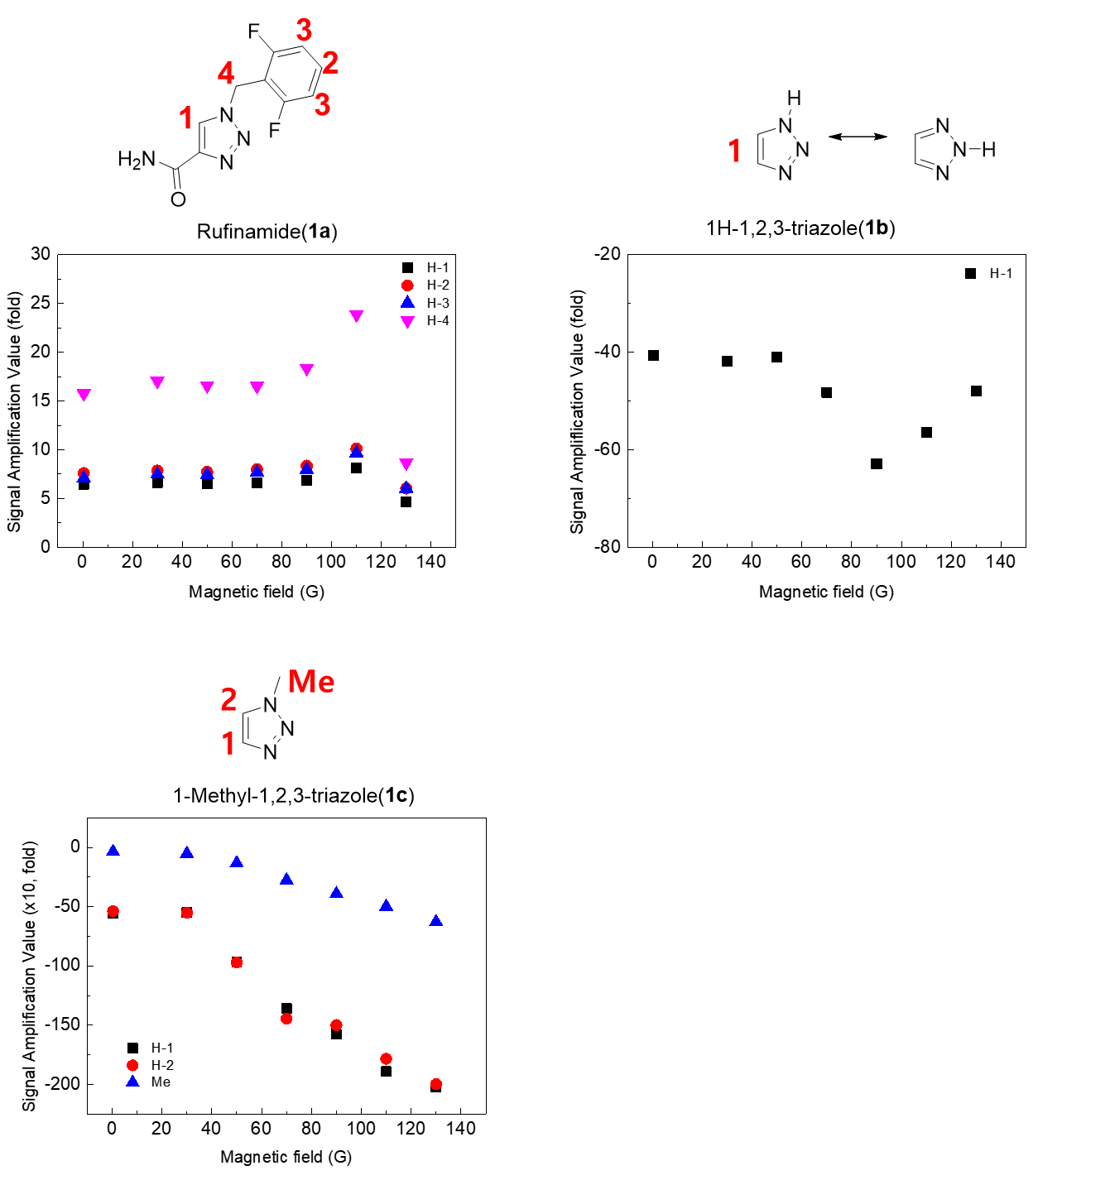
Figure S2 Signal amplification value of hyperpolarized 1a–c at various magnetic fields.
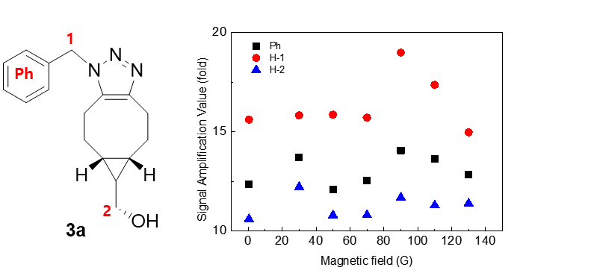
Figure S3 Signal amplification value of hyperpolarized 3a (0.7 μmol) at various magnetic fields
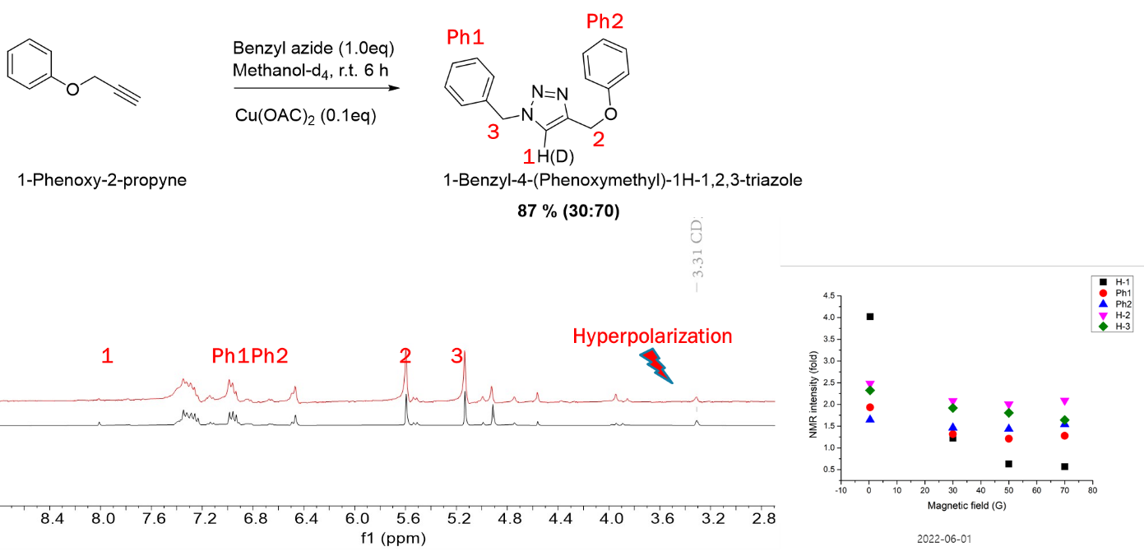
Figure S4 (a) Reaction scheme of 2a and 2d cycloaddition and 1H spectrum of 70 % deuterated 4a before (black spectrum) and after SABRE in the presence of earth’s field using IMes-Ir catalyst in methanol-d4 (red spectrum); signal amplification value of individual protons from hyperpolarized deuterated 4a in 300-MHz NMR.
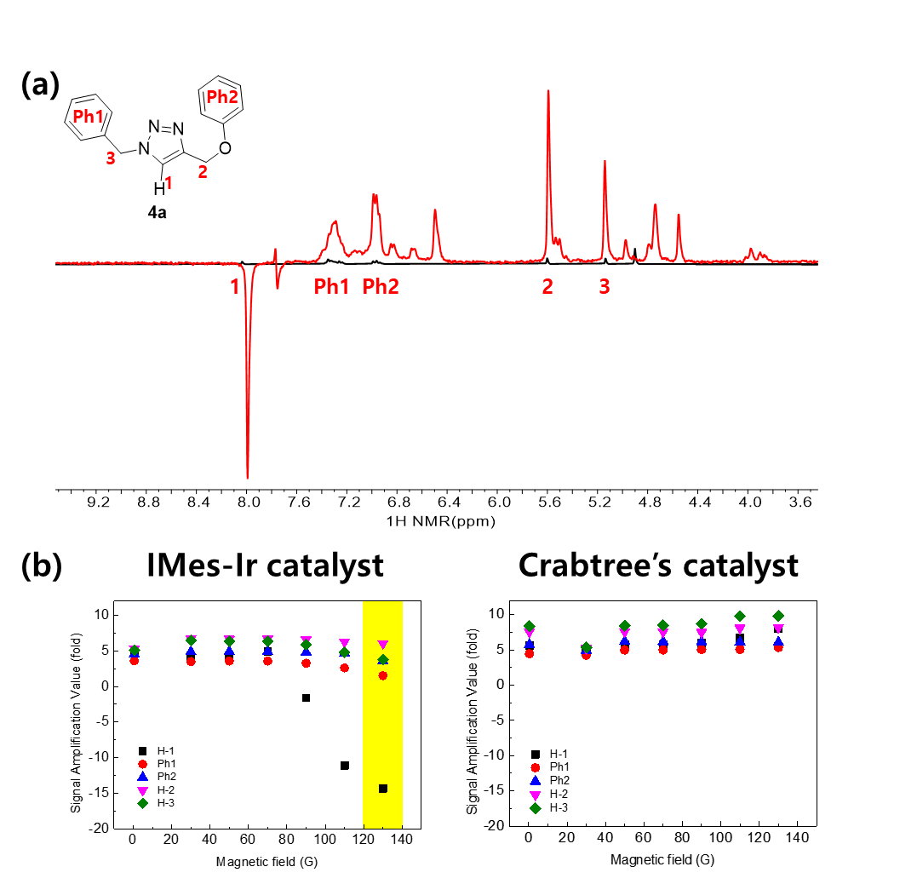
Figure S5 (a) 1H spectrum of 4a before (black spectrum) and after SABRE in the presence of 130G external magnetic field using IMes-Ir catalyst in methanol-d4 (red spectrum); (b) signal amplification value of individual protons from hyperpolarized 4a using IMes-Ir catalyst and Crabtree’s catalyst in 300-MHz NMR.

1. Chae, H., Min, S., Jeong, H. J., Namgoong, S. K., Oh, S., Kim, K. & Jeong, K. Organic Reaction Monitoring of a Glycine Derivative Using Signal Amplification by Reversible Exchange-Hyperpolarized Benchtop Nuclear Magnetic Resonance Spectroscopy. Anal. Chem. 92, 10902-10907 (2020).
2. Jeong, H. J., Min, S., Chae, H., Kim, S., Lee, G., Namgoong, S. K. & Jeong, K. Sci. Rep. 10, 1-13 (2020).
3. Jeong, H. J., Min, S. & Jeong, K. Analysis of 1-aminoisoquinoline using the signal amplification by reversible exchange hyperpolarization technique. Analyst 145, 6478-6484 (2020).
4. L. SJ, J. K, S. JH, L. HJ, M. S, C. H, N. SK and K. K, Sci. Rep. 9, 12422-12429 (2019).
5. Min, S., Chae, H., Jeong, H. J., Kim, K., Namgoong, S. K., & Jeong, K. Analyst 146 (2021).
6. Kim, S., Min, S., Chae, H., Jeong, H. J., Namgoong, S. K., Oh, S. & Jeong, K. Hyperpolarization of Nitrile Compounds Using Signal Amplification by Reversible Exchange. Molecules 25, 3347-3356 (2020).
7. Jeong, K., Min, S., Chae, H. & Namgoong, S. K. Monitoring of hydrogenation by benchtop NMR with parahydrogen-induced polarization. Magn. Reson. Chem. 57, 44-48 (2019).
8. Jeong, H. J., Min, S., Kim, S., Namgoong, S. K. & Jeong, K. Hyperpolarization study on remdesivir with its biological reaction monitoring via signal amplification by reversible exchange. RSC Adv. 12, 4377-4381 (2022).

1. H. Chae, S. Min, H. J. Jeong, S. K. Namgoong, S. Oh, K. Kim and K. Jeong, Analytical Chemistry, 2020, 92, 10902-10907.
2. H. J. Jeong, S. Min, H. Chae, S. Kim, G. Lee, S. K. Namgoong and K. Jeong, Scientific Reports, 2020, 10, 1-13.
3. H. J. Jeong, S. Min and K. Jeong, Analyst, 2020, 145, 6478-6484.
4. L. SJ, J. K, S. JH, L. HJ, M. S, C. H, N. SK and K. K, Scientific reports, 2019, 9, 12422-12429.
5. S. Min, H. Chae, H. J. Jeong, K. Kim, S. K. Namgoong and K. Jeong, Analyst, 2021, 146.
6. S. Kim, S. Min, H. Chae, H. J. Jeong, S. K. Namgoong, S. Oh and K. Jeong, Molecules, 2020, 25, 3347-3356.
7. J. K, M. S, C. H and N. SK, Magnetic resonance in chemistry : MRC, 2019, 57, 44-48.
8. H. J. Jeong, S. Min, S. Kim, S. K. Namgoong and K. Jeong, RSC Adv, 2022, 12, 4377-4381.

