Supplementary Information for:
Examining graph neural networks for inorganic crystalline structures: limitation of capturing periodicity
Sheng Gong¹, Tian Xie^{2,3}, Yang Shao-Horn^{1,4}, Rafael Gomez-Bombarelli¹, and Jeffrey C. Grossman^{1,*}

¹Department of Materials Science and Engineering, Massachusetts Institute of Technology, MA 02139, USA
²Computer Science and Artificial Intelligence Lab, Massachusetts Institute of Technology, MA 02139, USA
³Microsoft Research, Cambridge, United Kingdom CB1 2FB
⁴Department of Mechanical Engineering, Massachusetts Institute of Technology, MA 02139, USA

Contents
1. Limitation of average pooling on extensive properties. 2
2. Limitation of sum pooling on capturing periodicty. 4
3. Learning perfomance and artificial choice of lattice angles. 5
4. Structural Complexity 6
5. More discussions about U and C_{v} 7
6. Impact of hybridization with descriptors on the learned representations 7
7. Supplementary Tables 11

Limitation of average pooling on extensive properties.
Suggested by the limitation of average pooling on capturing primitive cell-level information, in this section, we show the limitation of average pooling on prediction of extensive properties. Extensive properties scale with number of atoms, such as total energy (E_{fin.}), (phonon) internal energy (U), (phonon) heat capacity (C_{v}) and magnetization (M). Despite their extensive nature, in many cases these extensive properties are normalized to intensive versions for data storage and evaluation¹⁻⁹, such as energy per atom and magnetization per unit formula. Since intensive properties cannot be learned by sum pooling because of their size invariance¹, for convenience, many GNNs, such as CGCNN and ALIGNN, only implement average pooling and learn the intensive versions of these extensive properties by average pooling in equation (4). Another way to learn extensive properties is illustrated in the bottom branch in Figure S1a, where extensive properties are first learned by machine learning models with sum pooling in equation (13), then normalized for evaluation.
Do the two approaches for learning extensive properties in Figure S1a have the same predictive power? Intuitively, they seem to be equivalent. However, as suggested in Figure 3c and 3h, we know that sum pooling is more powerful to distinguish graphs, and sum pooling can capture periodicity better. This insight suggests that sum pooling might be more powerful than average pooling for learning extensive properties. As shown in Figure S1b, we show the MAE/MAD scores of predictions of four extensive properties by CGCNN and ALIGNN with average pooling and sum pooling. We can see that, sum pooling outperforms average pooling for U, C_{v} and M, and has similar performance for E_{fin.}, which verifies our hypothesis that sum pooling might be more powerful than average pooling for learning extensive properties.
Currently, many GNNs designed for prediction of materials properties, such as CGCNN and ALIGNN, only implement size-invariant average pooling function, with the exception of MEGNet where users can easily switch between sum pooling and average pooling. Based on the results shown in this section, we argue that GNN models designed for prediction of materials properties should provide options of pooling functions for different properties, such as average pooling for intensive properties and sum pooling for extensive properties.

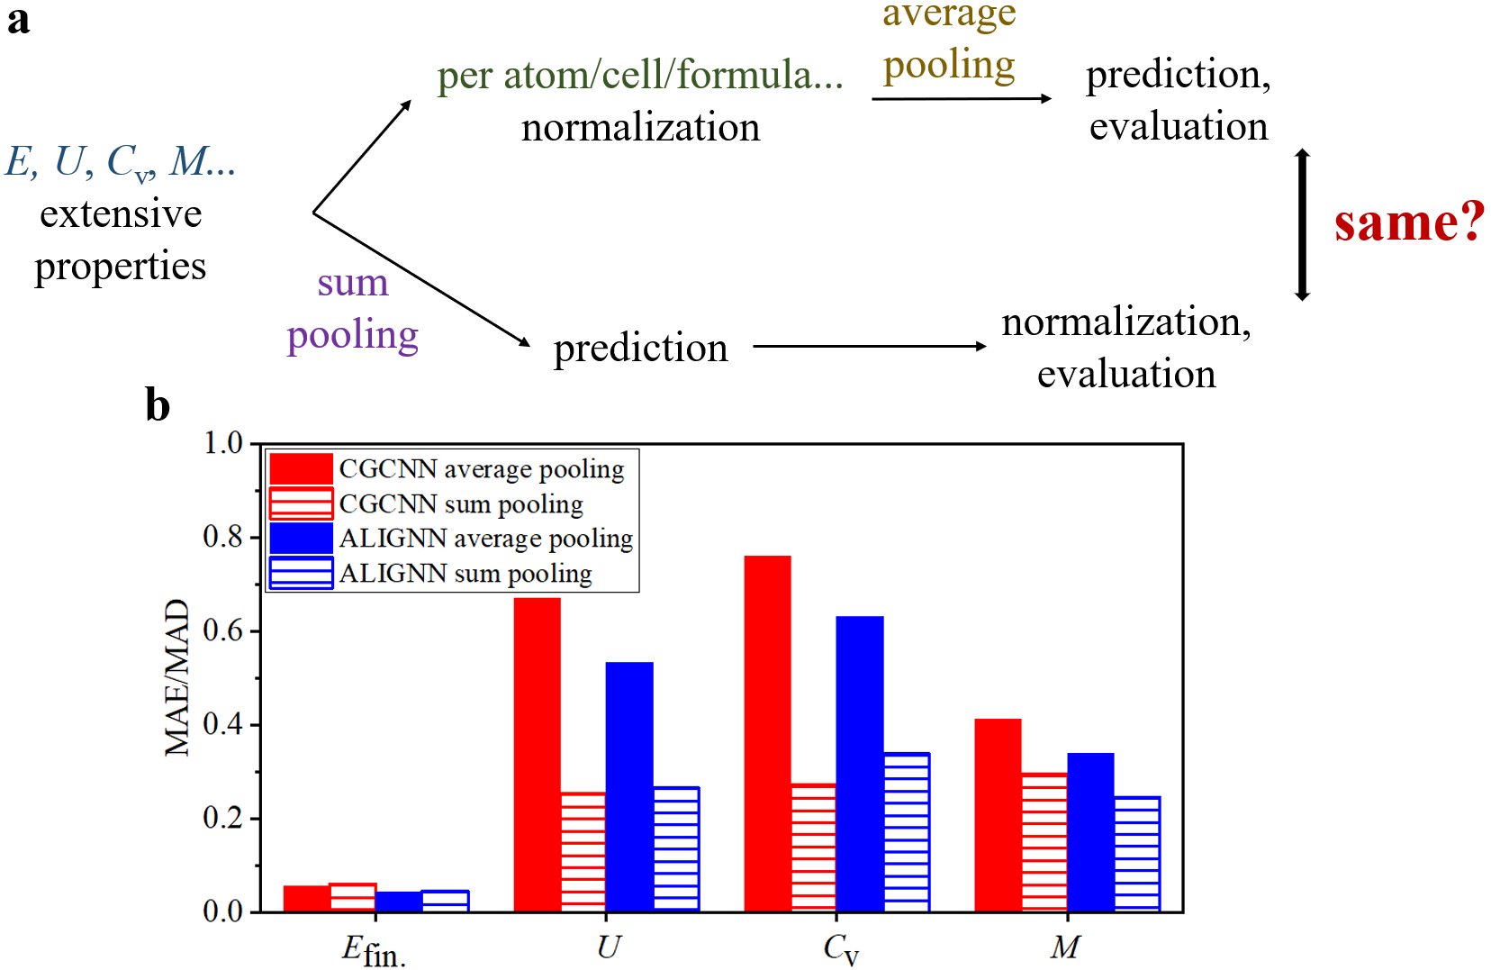
Figure S1. Average pooling and sum pooling for extensive properties. a Schematic of two approaches to learn, predict and evaluate prediction performance of extensive properties. b MAE/MAD of prediction of four extensive properties by CGCNN and ALIGNN with average pooling and sum pooling.

Limitation of sum pooling on capturing periodicty.
As mentioned in the main text, even if only primitive cells are input to the GNNs, sum pooling might also fail to capture periodicity in some cases, as periodicity does not always scale with number of atoms in the primitive cells. For example, in Figure 3d we show the case of 1D double chains. Compared with 1D single chains in Figure 3b and 3c, 1D double chains can have similar periodicity but twice number of atoms. In Figure S2, we show the R² scores of predictions of $a$ of the datasets with 1D single short chains, 1D single and double short chains, 1D single long chains, and 1D single and double long chains, from CGCNN with average pooling and sum pooling, respectively. For the datasets with only single chains, sum pooling outperforms average pooling significantly, while for the datasets with single and double chains, sum pooling can only have very limited improvement over average pooling, which shows the co-existence of single and double chains makes sum pooling harder to determine periodicity than the case with only single chains.

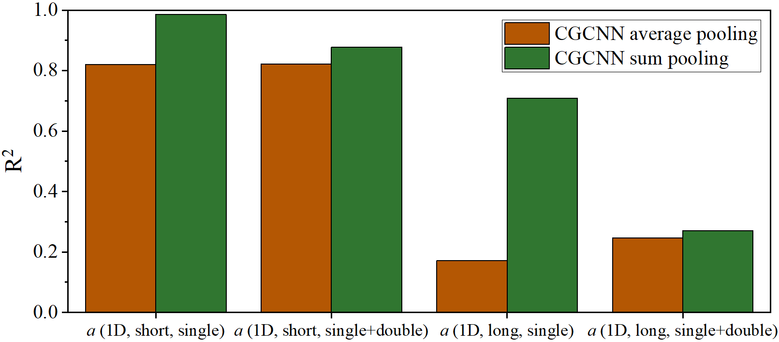
Figure S2. R² scores of predictions of $a$ of the datasets with 1D single short chains, 1D single and double short chains, 1D single long chains, and 1D single and double long chains, from CGCNN with average pooling and sum pooling, respectively.

Learning perfomance and artificial choice of lattice angles.
As mentioned in the main text, both CGCNN and ALIGNN cannot learn the lattice angles well. In Figure S3a, we show the prediction performance of CGCNN, CGCNN with more convolutions, CGCNN with larger limits of number of neighbors and neighboring cut-off radius, CGCNN with sum pooling and ALIGNN for three lattice angles. We can see that both CGCNN and ALIGNN cannot learn the three lattice angles well, and the modifications that improve learning performance of lattice lengths as in the main text do not improve that of lattice angles.
The artificial choice of lattice angles might cause the poor learning performance. As stated in the main text, we use the Niggli reduction to determine the unique Niggli-primitive cell for any given periodic structure¹⁰. In crystallography, we can use a set of six parameters to define a primitive cell: (a, b, c, $α$, $β$, $γ$), where the first three parameters are lengths of lattice vectors, and the later three parameters are angles between lattice vectors. In Niggli reduction, we require the lengths of lattice vectors to satisfy the following requirement:
$a+b+c= minimum$......(S1)
If the order of the three lengths are defined, as in the main text we define a the largest one and c the smallest one, then the set of (a, b, c) is unique for any given structure¹¹. However, the set of ($α$, $β$, $γ$) might not be unique even if (a, b, c) is unique. For example, in Figure S3b, we plot the structure of simple hexagonal structure. We can see that the three lengths of lattice vectors are unique and reflect the intrinsic characteristics of the structure, such as the three minimal distances between the smallest repeating units in three dimensions. For ($α$, $β$, $γ$), we know that two of them are 90º (angles between the vertical lattice vector and the two in-plane lattice vectors), but there are actually two choices of the third one: 60º and 120º, and two choices of ($α$, $β$, $γ$): (120º, 90º, 90º) and (90º, 90º, 60º). Although in Niggli reduction, (120º, 90º, 90º) is chosen as the lattice angles, this choice is artificial to the given structure. Therefore, machine learning algorithms might not be able to capture the artificially determined characteristics of crystal structures. Further studies are necessary to design more intrinsic description of relative orientation between the lattice vectors.

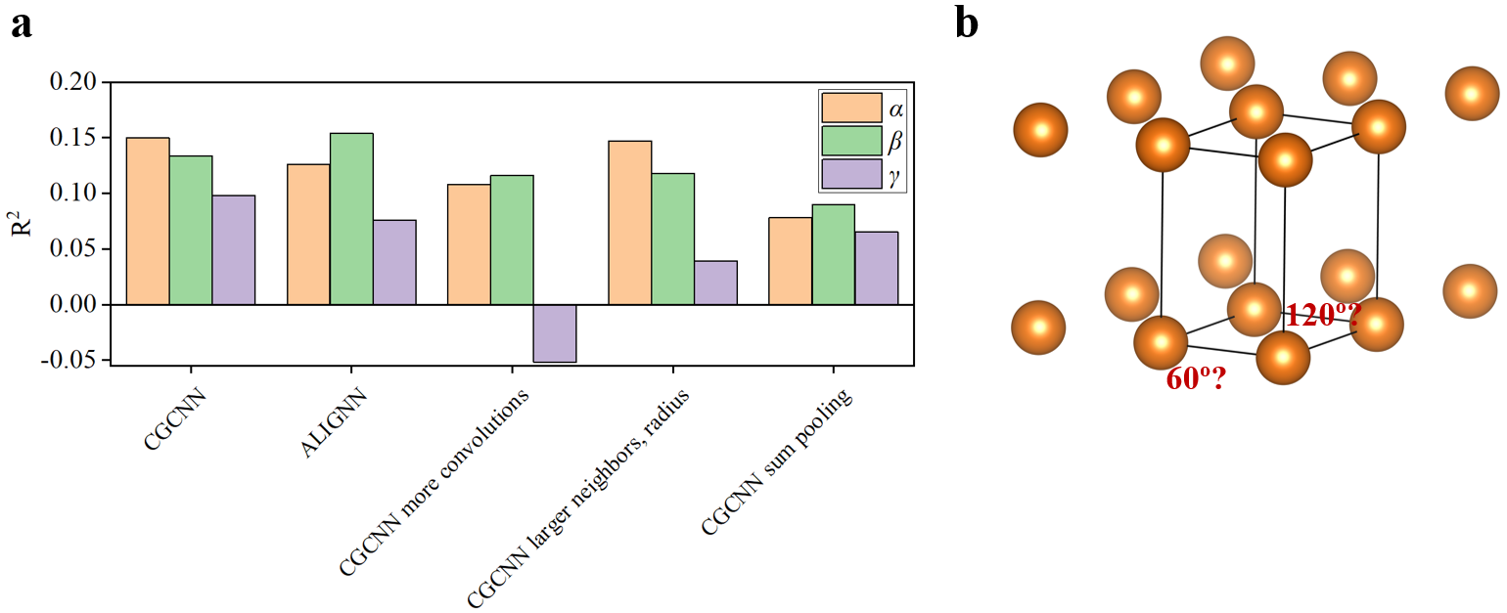
Figure S3. a R² scores of prediction of lattice angles from CGCNN, ALIGNN and variants of CGCNN. Alpha denotes the largest lattice angle, and gamma the smallest one. b Illustrations of ambiguity of choice of lattice angles by the example of simple hexagonal primitive cell.

Structural Complexity
Structural complexity is defined as below:
$S= -N\sum_{i=1}^{k}{\frac{m_{i}}{N}}\log_{2}\frac{m_{i}}{N}$......(S2),
where $N$ is the total number of atoms in the primitive cell, $k$ is the number of symmetrically inequivalent sites, $m_{i}$ is the number of sites classified in the i^{th} symmetrically inequivalent site. Structural complexity quantifies the complexity of sites distribution in a structure, as larger complexity, more different symmetrically inequivalent sites in the structure. Structural complexity per primitive cell is calculated as equation S2, and structural complexity per atom is calculated by equation S2 divided by the number of atoms in the primitive cell.

More discussions about U and C_{v}
Recently, Legrain et al.¹² reported machine learning of U by compositions of materials. The main difference between this work and Legrain et al.¹² is that, in Legrain et al.¹², only 292 materials are included in the dataset, while in this work about 1,500 materials are included in the datsets for U and C_{v}. On the other hand, Mat2Spec¹³ and E3NN¹⁴ are proposed to predict phonon density of states, and consequently, heat capacity. Unfortunately, we cannot easily compare our predictions and predictions from the two models mentioned above, as the C_{v} in this work is based on full phonon density of states, while Mat2Spec¹³ and E3NN¹⁴ are designed to predict filtered and truncated phonon density of states with 51 frequencies up to 1000 cm⁻¹. The reason for the success of E3NN for predicting C_{v} might be that E3NN employs equivariant representations¹⁴ with high local expressive power, and the reason for the success of Mat2Spec for predicting C_{v} might be the explicit exploitation of correlations of density of states between frequencies in phonon density of states.

Impact of hybridization with descriptors on the learned representations
As in equation (14) in the main text, since the descriptors participate in the optimization of deep representation learning, the inclusion of descriptors would affect the optimization of the learned representations. In other words, consider the gradient propagation in the optimization of the representation learning:
$\frac{∂L}{∂w_{pq}^{R}}= \frac{∂z_{q}^{R+1}}{∂w_{pq}^{R}}*\frac{∂L}{∂z_{q}^{R+1}}$ ...... (S3),
where $L$ is the loss function, $w_{pq}^{R}$ is the weight from the p^{th} unit of the representation layer ($\frac{1}{N_{a}}\sum_{i=1}^{N_{a}}{a_{i}^{n^{*}}}⊕descriptors$) in equation (14) to the q^{th} unit of the layer after the representation layer (first layer of FCN in equation (14)), and $z_{q}^{R+1}$ is the q^{th} unit of the layer after the representation layer. Therefore, after inclusion of descriptors, $z_{q}^{R+1}$ changes, and consequently $\frac{∂L}{∂w_{pq}^{R}}$ changes even if the p^{th} unit is from the part $\frac{1}{N_{a}}\sum_{i=1}^{N_{a}}{a_{i}^{n^{*}}}$, and all gradients before the representation layer change due to the chain rule of gradient propagation.
How does the change of gradient affect the learned representations? As an example, in Figure 4c, we show the feature importance spectrum of de-CGCNN for prediction of κ, from which we can see that the learned representations play the most important roles, and some descriptors contribute significantly such as mean and standard deviation of bond length, volume per atom and b. Except b, the other three important descriptors can be well learned by CGCNN as shown in Figure 2a. In order to understand this phenomenon, we investigate how well the learned representations from CGCNN correlate with descriptors before and after the hybridization with descriptors. In other words, we investigate the following correlation:
$Corr(\frac{1}{N_{a}}\sum_{i=1}^{N_{a}}{a_{i}^{n^{*}},} descriptors)$......(S4).
In Figure S4a, we show the correlation between the learned representations and each descriptor for learning κ, and we can see that the learned representations from de-CGCNN are less correlated with the descriptors than that from CGCNN. The weaker correlation after the inclusion of descriptors supports our hypothesis that hybridization with descriptors pushes the optimization of learned representations away from the already known information in the input human-designed descriptors.
As a comparison, we construct machine learning models based on learned representations from CGCNN and human-designed descriptors as below:
$Output=FCN(\frac{1}{N_{a}}\sum_{i=1}^{N_{a}}{a_{i}^{n^{*}}(already learned from CGCNN)}⊕descriptors)$ ...... (S5).
The main difference between equation (S5) (named as “CGCNN+descriptors”) and equation (14) (de-CGCNN) is that, descriptors participate in the optimization of learned representations in de-CGCNN, while descriptors do not in CGCNN+descriptors. In Figure S4b, we show the MAE/MAD ratio of machine learning models based only on descriptors, CGCNN, CGCNN+descriptors, and de-CGCNN. We can see that, for most properties, de-CGCNN has lower error than CGCNN+descriptors, which supports the proposed mechanism that participation of descriptors in the optimization of representations improves the performance of deep representation learning. For κ, U, C_{v}, and M, we observe that CGCNN+descriptors outperforms CGCNN, and such improvement mainly comes from the missing information in descriptors as discussed in the main text. For most remaining properties, CGCNN+descriptors has similar performance with CGCNN, which suggests that the improvement of de-CGCNN for these properties might come from the participation of descriptors in the optimization of representations.
Despite the observed improvement, intuitively, hybridization with descriptors in equation (14) and addition of descriptors in equation (S5) would have a negative impact on prediction performance due to the introduction of redundant information from these two modifications^{15, 16}. Such redundancy can be seen in Figure S4a, where learned representations from both CGCNN and de-CGCNN are correlated with human-designed descriptors in some degree. In Figure S4b, we observe that CGCNN+descriptors has higher error than the model based on only descriptors for U and C_{v}. Since the only difference between the two models is the presence of learned representations in CGCNN+descriptors, the increase of error associated with CGCNN+descriptors supports the proposed mechanism that redundant information can harm the predictive power of machine learning models^{15, 16}.

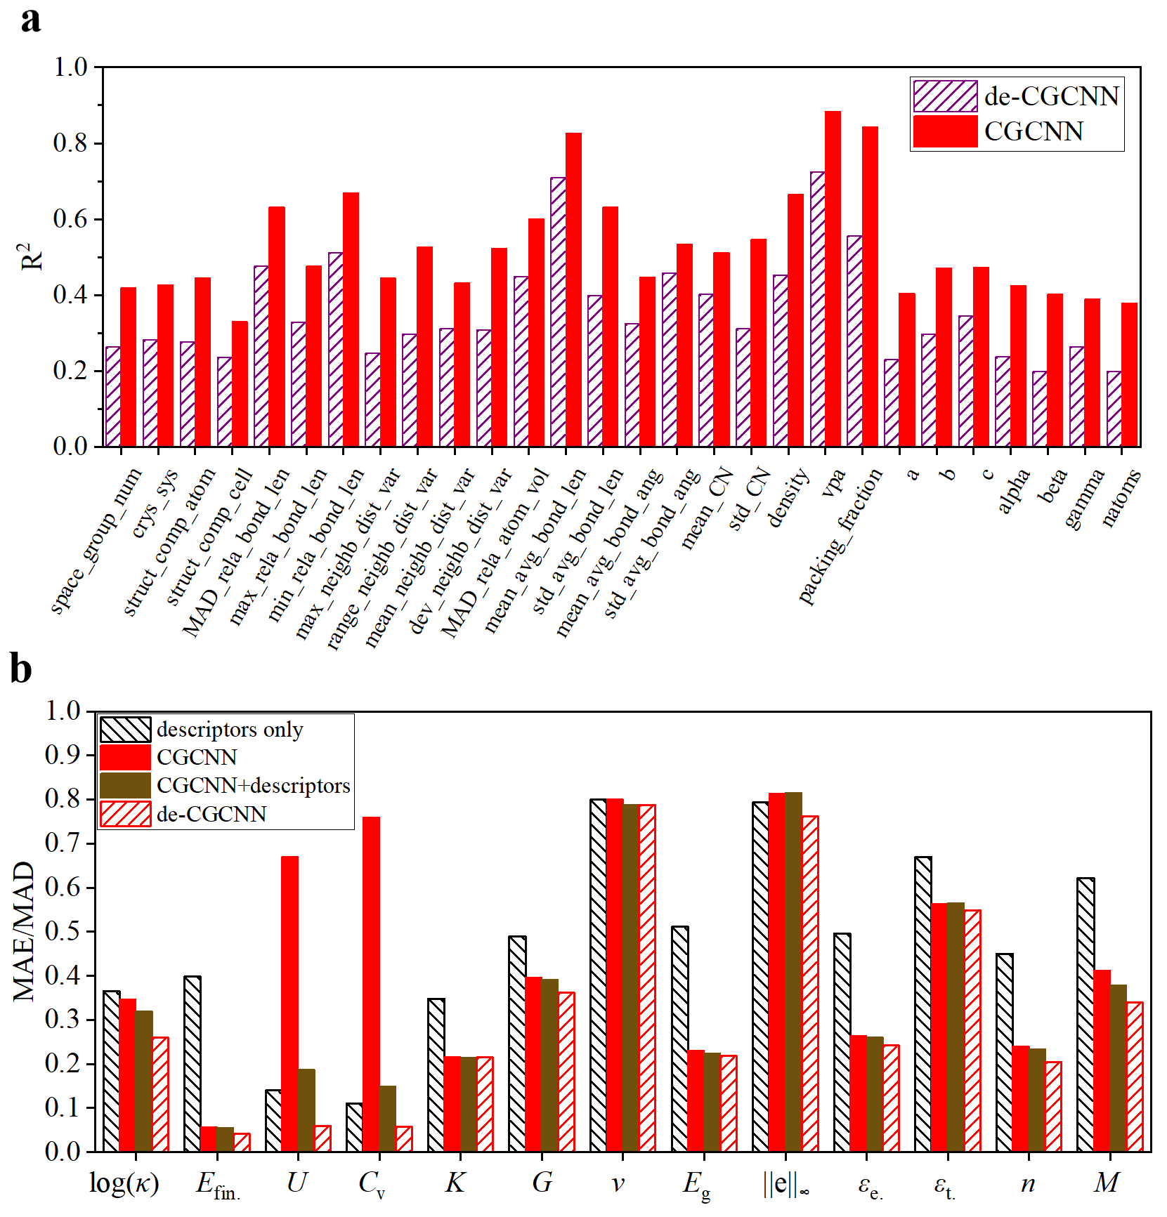
Figure S4. a R² scores of linear regressions between each descriptor and the learned representations from CGCNN and de-CGCNN. b MAE/MAD ratio of prediction of 13 materials properties from machine learning models based only on descriptors, CGCNN, machine learning models based on CGCNN-learned representations and descriptors, and de-CGCNN.

Supplementary Tables
Table S1. Ratio of materials (related to the 139,367 materials in the Materials Project V2021.03.22) with each property and prediction results of machine learning models for the lattice thermal conductivity in the TEDesignLab database and 12 properties in the Materials Project database.
 | Unit | Ratio of materials | MAD | MAE of descriptors + RF | MAE of CGCNN  +descriptors | MAE of de-CGCNN | MAE of CGCNN | MAE of ALIGNN | MAE of de-ALIGNN
log (κ) |  | 0.020 | 0.427 | 0.156 (0.365) | 0.137  (0.320) | 0.111 (0.260) | 0.148 (0.347) | 0.117 (0.276) | 0.106 (0.248)
E_{fin.} | eV/atom | 1.0 | 1.289 | 0.513 (0.398) | 0.071  (0.055) | 0.054 (0.042) | 0.073 (0.057) | 0.058 (0.045) | 0.068 (0.052)
U | KJ/mol-c | 0.011 | 25.70 | 3.602 (0.140) | 4.806  (0.187) | 1.540 (0.060) | 17.22 (0.670) | 13.73 (0.534) | 2.617 (0.101)
U | KJ/mol-atom | 0.011 | 5.106 |  |  |  | 3.047 (0.602) | 2.996  (0.587)
C_{v} | J/(mol-c*K) | 0.011 | 55.61 | 6.156 (0.111) | 8.286  (0.149) | 3.249 (0.058) | 42.19 (0.759) | 35.18 (0.632) | 4.952 (0.089)
C_{v} | J/(mol-atom*K) | 0.011 | 13.81 |  |  |  | 8.301  (0.601) | 8.374  (0.606)
K | GPa | 0.095 | 56.41 | 19.62 (0.348) | 12.15  (0.215) | 12.15 (0.215) | 12.26 (0.217) | 11.49 (0.204) | 11.61 (0.206)
G | GPa | 0.095 | 30.63 | 14.98 (0.489) | 12.01  (0.392) | 11.08 (0.362) | 12.17 (0.397) | 10.31 (0.337) | 9.988 (0.326)
v |  | 0.095 | 0.064 | 0.051 (0.800) | 0.050  (0.788) | 0.050 (0.788) | 0.084 (0.801) | 0.046 (0.716) | 0.045 (0.702)
E_{g} | eV | 1.0 | 1.258 | 0.643 (0.511) | 0.282  (0.224) | 0.274 (0.218) | 0.290 (0.231) | 0.247 (0.196) | 0.249 (0.198)
||e||∞ | C/m² | 0.024 | 0.555 | 0.440 (0.793) | 0.452  (0.815) | 0.423 (0.762) | 0.451 (0.813) | 0.442 (0.796) | 0.411 (0.742)
ε_{e.} |  | 0.052 | 2.819 | 1.399 (0.496) | 0.736  (0.261) | 0.683 (0.242) | 0.744 (0.264) | 0.602 (0.213) | 0.604 (0.214)
ε_{t.} |  | 0.052 | 9.055 | 6.064 (0.670) | 5.125  (0.566) | 4.971 (0.549) | 5.102 (0.563) | 4.507 (0.498) | 4.432 (0.489)
n |  | 0.052 | 0.590 | 0.266 (0.450) | 0.138  (0.234) | 0.121 (0.205) | 0.142 (0.240) | 0.116 (0.197) | 0.114 (0.194)
M | μB per formula | 1.0 | 3.134 | 1.950 (0.622) | 1.188  (0.379) | 1.065 (0.340) | 1.293 (0.412) | 1.062 (0.340) | 0.964 (0.308)

Table S2. Hyper-parameter search space for CGCNN, CGCNN with sum pooling, and de-CGCNN. Parameters not mentioned here are set to the default value as in the open source codes.
Name | Space
atom feature length | 32, 64
hidden feature length | 64, 128
number of hidden layers | 1, 2, 3
learning rate | 1e-3, 1e-2

Table S3. Hyper-parameter search space for ALIGNN, ALIGNN with sum pooling, and de-ALIGNN. Parameters not mentioned here are set to the default value as in the open source codes.
Name | Space
edge input feature length | 40, 80
hidden feature length | 64, 128, 256
triplet input feature length | 20, 40
learning rate | 1e-3, 1e-2

1. Xie, T.; Grossman, J. C., Crystal Graph Convolutional Neural Networks for an Accurate and Interpretable Prediction of Material Properties. Phys Rev Lett 2018, 120 (14), 145301.
2. Chen, C.; Ye, W.; Zuo, Y.; Zheng, C.; Ong, S. P., Graph Networks as a Universal Machine Learning Framework for Molecules and Crystals. Chem. Mater. 2019, 31 (9), 3564-3572.
3. Choudhary, K.; DeCost, B., Atomistic Line Graph Neural Network for improved materials property predictions. npj Comput. Mater. 2021, 7 (1).
4. Louis, S. Y.; Zhao, Y.; Nasiri, A.; Wang, X.; Song, Y.; Liu, F.; Hu, J., Graph convolutional neural networks with global attention for improved materials property prediction. Phys Chem Chem Phys 2020, 22 (32), 18141-18148.
5. Dunn, A.; Wang, Q.; Ganose, A.; Dopp, D.; Jain, A., Benchmarking materials property prediction methods: the Matbench test set and Automatminer reference algorithm. npj Comput. Mater. 2020, 6 (1), 138.
6. A. Jain*, S. P. O., G. Hautier, W. Chen, W.D. Richards, S. Dacek, S. Cholia, D. Gunter, D. Skinner, G. Ceder, K.A. Persson, The Materials Project: A materials genome approach to accelerating materials innovation. APL Mater. 2013, 1 (1), 011002.
7. Kirklin, S.; Saal, J. E.; Meredig, B.; Thompson, A.; Doak, J. W.; Aykol, M.; Rühl, S.; Wolverton, C., The Open Quantum Materials Database (OQMD): assessing the accuracy of DFT formation energies. npj Comput. Mater. 2015, 1 (1).
8. Curtarolo, S.; Setyawan, W.; Wang, S.; Xue, J.; Yang, K.; Taylor, R. H.; Nelson, L. J.; Hart, G. L. W.; Sanvito, S.; Buongiorno-Nardelli, M.; Mingo, N.; Levy, O., AFLOWLIB.ORG: A distributed materials properties repository from high-throughput ab initio calculations. Comput. Mater. Sci. 2012, 58, 227-235.
9. Choudhary, K.; Garrity, K. F.; Reid, A. C.; DeCost, B.; Biacchi, A. J.; Walker, A. R. H.; Trautt, Z.; Hattrick-Simpers, J.; Kusne, A. G.; Centrone, A. J. a. p. a., JARVIS: An Integrated Infrastructure for Data-driven Materials Design. arXiv:2007.01831 2020.
10. Grosse-Kunstleve, R. W.; Sauter, N. K.; Adams, P. D., Numerically stable algorithms for the computation of reduced unit cells. Acta Crystallogr. A 2004, 60 (Pt 1), 1-6.
11. WOLFF;, P. M. D.; GRUBER, B., Niggli Lattice Characters. Acta Cryst. 1991, A47, 29-36.
12. Legrain, F.; Carrete, J.; van Roekeghem, A.; Curtarolo, S.; Mingo, N., How Chemical Composition Alone Can Predict Vibrational Free Energies and Entropies of Solids. Chem. Mater. 2017, 29 (15), 6220-6227.
13. Kong, S.; Ricci, F.; Guevarra, D.; Neaton, J. B.; Gomes, C. P.; Gregoire, J. M., Density of states prediction for materials discovery via contrastive learning from probabilistic embeddings. Nat Commun 2022, 13 (1), 949.
14. Chen, Z.; Andrejevic, N.; Smidt, T.; Ding, Z.; Xu, Q.; Chi, Y. T.; Nguyen, Q. T.; Alatas, A.; Kong, J.; Li, M., Direct Prediction of Phonon Density of States With Euclidean Neural Networks. Adv. Sci. 2021, 8 (12), e2004214.
15. Ortiz-Jiménez;, G.; Modas;, A.; Moosavi-Dezfooli;, S.-M.; Frossard, P., Hold me tight! Influence of discriminative features on deep network boundaries. 34th Conference on Neural Information Processing Systems 2020.
16. Cai, J.; Luo, J.; Wang, S.; Yang, S., Feature selection in machine learning: A new perspective. Neurocomputing 2018, 300, 70-79.

