Supporting Information
Solution Printable Multifunctional Polymer-Based Composites for Smart Electromagnetic Interference Shielding with Tunable Frequency and On-Off Selectivities
Mina Seol^{1,†}, Uiseok Hwang^{1,†}, Junyoung Kim², Deokjoon Eom³, In-Kyung Park¹, Hyoungsub Kim³, Jonghwan Suhr⁴, and Jae-Do Nam^{1,2,*}
¹Department of Polymer Science and Engineering, Sungkyunkwan University, Suwon 16419, Republic of Korea
²Department of Energy Science, Sungkyunkwan University, Suwon 16419, Republic of Korea
³School of Advanced Materials Science and Engineering, Sungkyunkwan University, Suwon 16419, Republic of Korea
⁴School of Mechanical Engineering, Sungkyunkwan University, Suwon 16419, Republic of Korea

*Corresponding author: jdnam@skku.edu (Prof. J.-D. Nam)

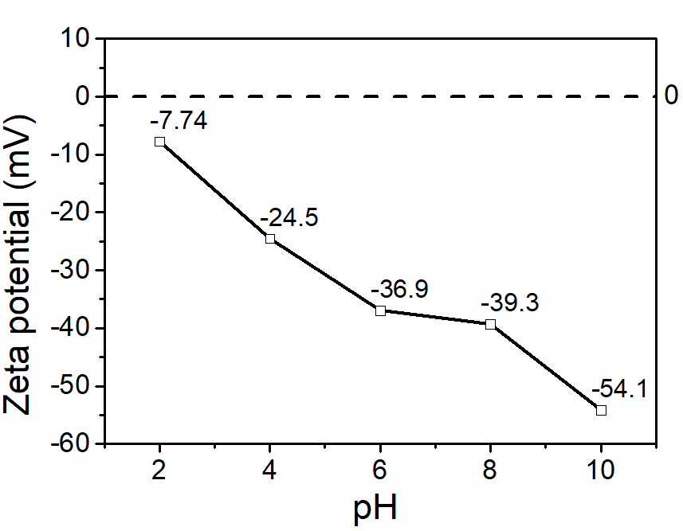
Fig. S1. Zeta potential curve of BN particle as a function of pH.

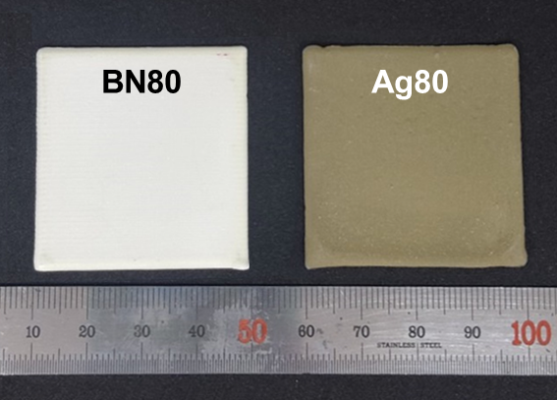
Fig. S2. Digital images of BN80 and Ag80 single-layered composites.

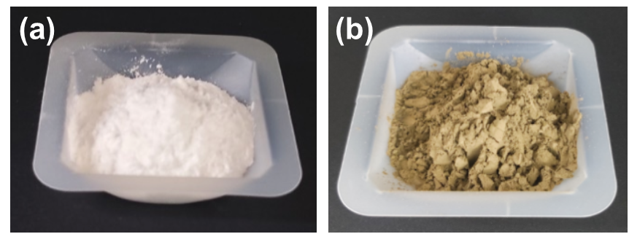
Fig. S3. Digital images of (a) BN and (b) Ag@BN powders.

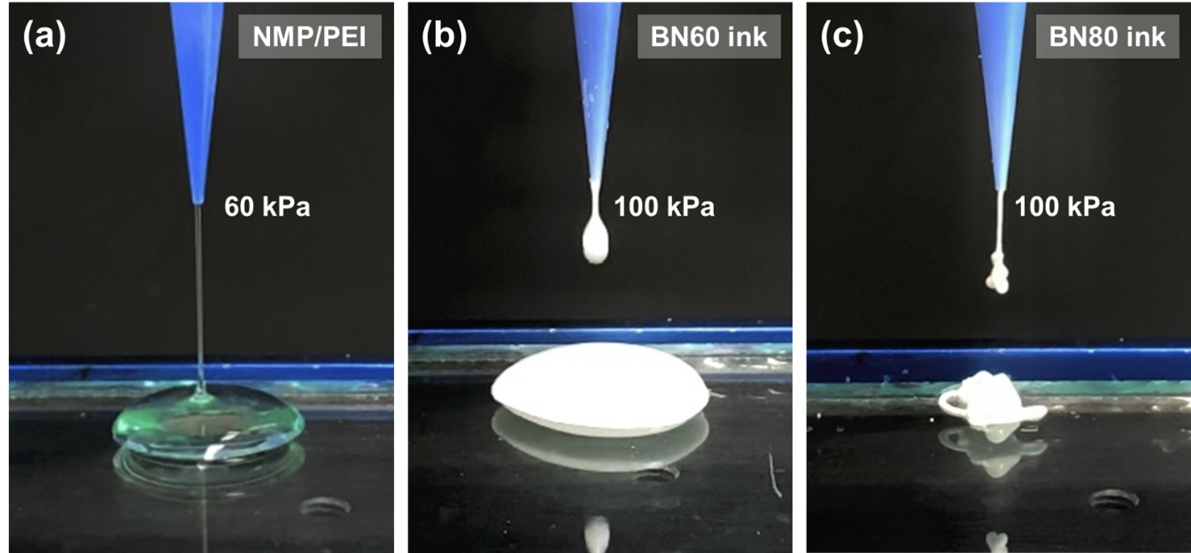
Fig. S4. Digital images of (a) NMP/PEI solution, (b) BN60 ink, and (c) BN80 ink printed under the pneumatic pressures of 60, 100, and 100 kPa, respectively.

Fig. S5. Contact angle image of NMP/PEI solution on glass substrate.

Table S1. Weight and volume compositions of various inks.
Inks | Weight fraction (wt.%) |  |  |  | Volume fraction (vol.%)
Inks | NMP | PEI | BN | Ag@BN | NMP | PEI | BN | Ag@BN
NMP/PEI solution | 85.0 | 15.0 | 0 | 0 | 87.5 | 12.5 | 0 | 0
BN60 ink | 64.6 | 11.4 | 24.0 | 0 | 73.6 | 10.5 | 15.8 | 0
BN70 ink | 57.0 | 10.1 | 32.9 | 0 | 67.7 | 9.7 | 22.6 | 0
BN80 ink | 46.2 | 8.1 | 45.7 | 0 | 58.3 | 8.3 | 33.4 | 0
Ag80 ink | 40.9 | 7.2 | 0 | 51.9 | 58.3 | 8.3 | 0 | 33.4

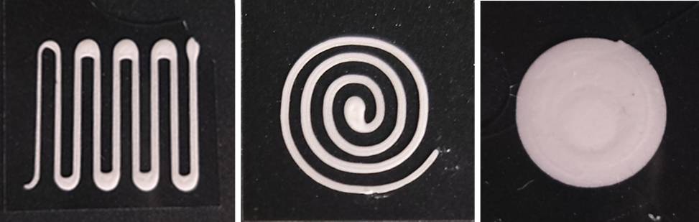
Fig. S6. Digital images of BN80 composites with various shapes, which were fabricated using a solution printing method, followed by thermal treatment.

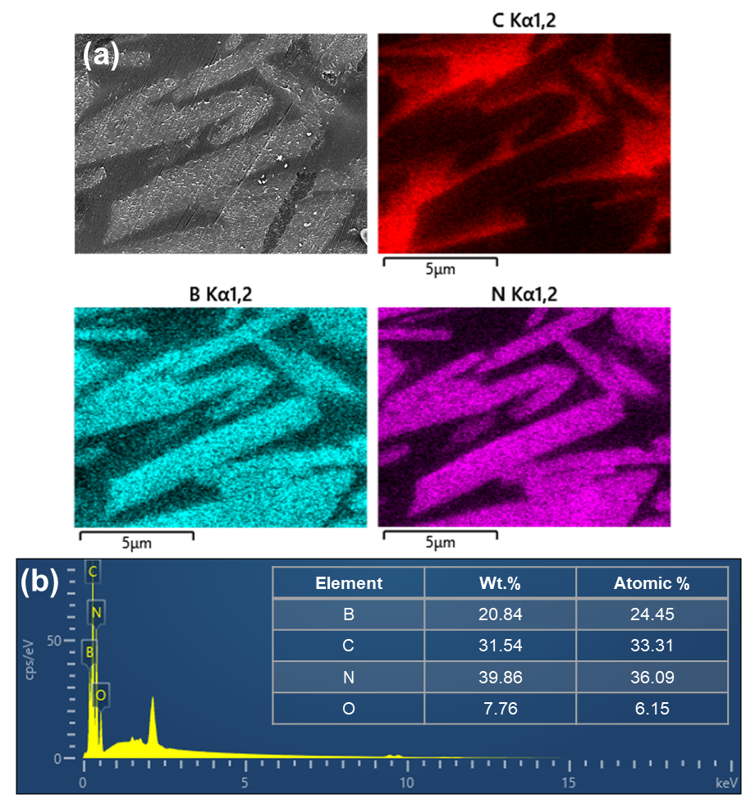
Fig. S7. (a) Cross-sectional FE-SEM image and corresponding EDS elemental C, B, and N mappings of BN80 composite. (b) EDS spectrum and elemental composition table of BN80 composite.

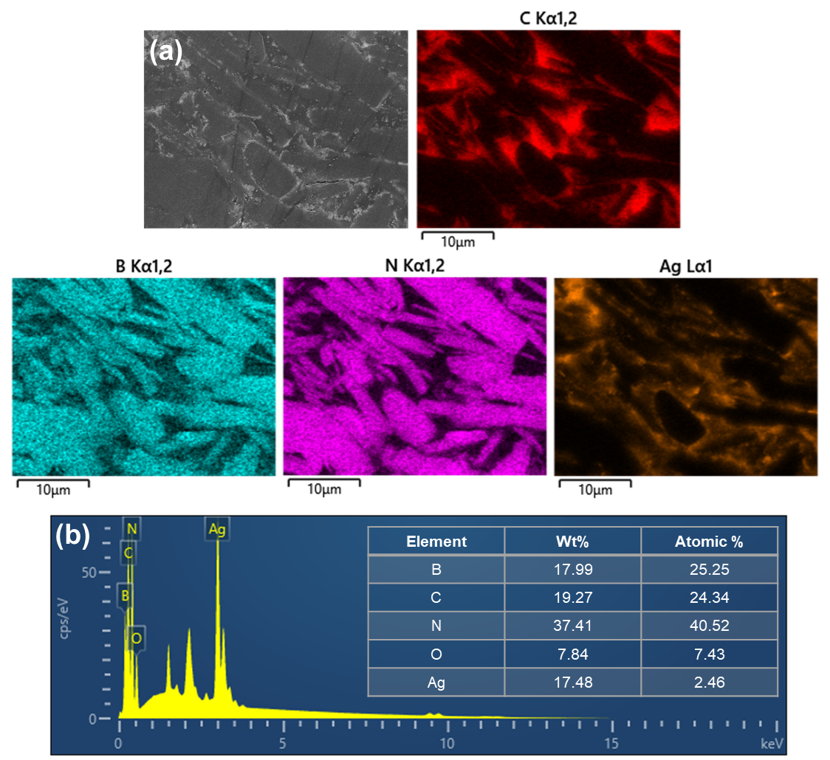
Fig. S8. (a) Cross-sectional FE-SEM image and corresponding EDS elemental C, B, N, and Ag mappings of Ag80 composite. (b) EDS spectrum and elemental composition table of Ag80 composite.

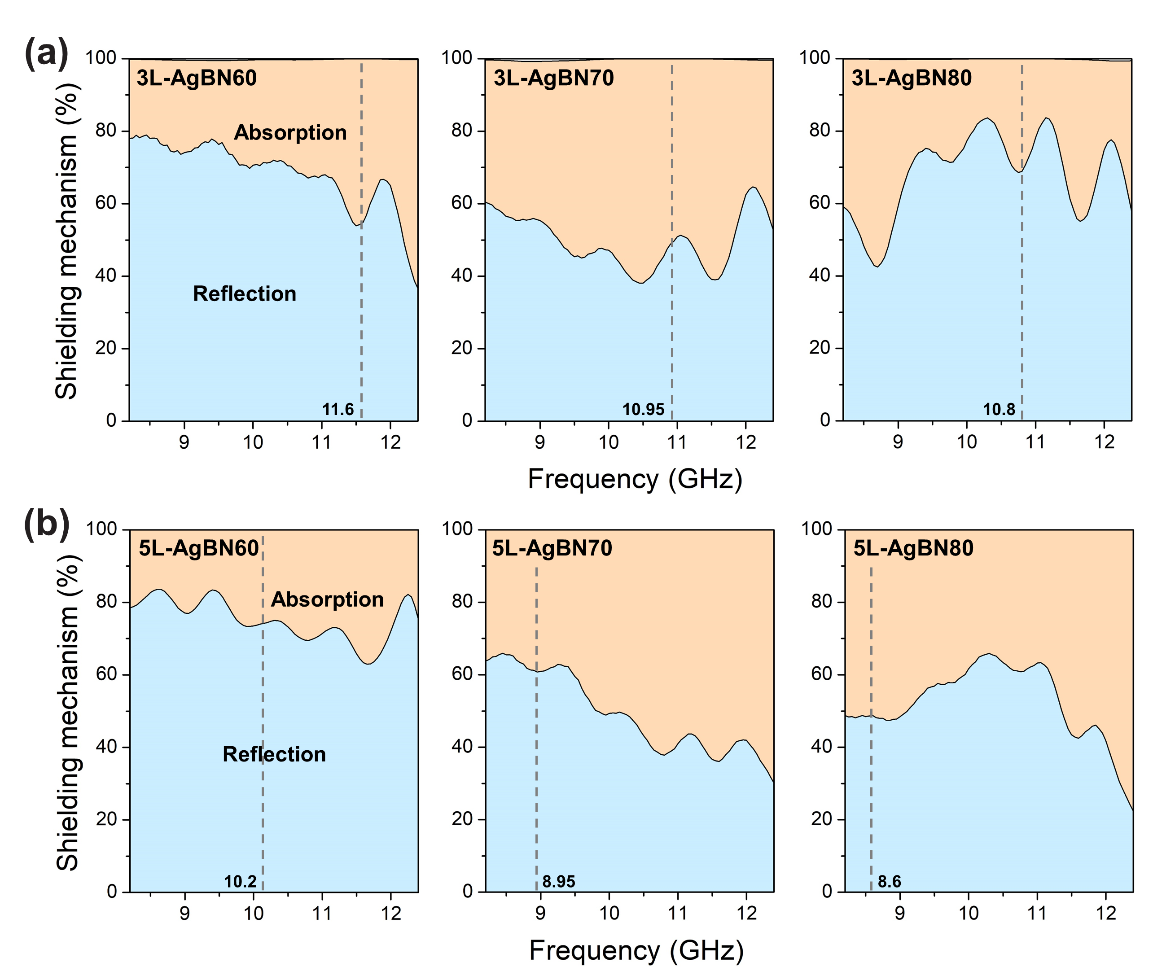
Fig. S9. Shielding mechanism of (a) 3L-AgBN00 and (b) 5L-AgBN00 composites as a function of frequency.

Table S2. Comparison of multifunctional polymer-based composites.
Filler | Matrix | EMI shielding (dB) | Thermal conductivity (λ⊥, W/m∙K) | Electrical insulation | Thickness  (mm) | Method | Ref.
BN, Ag@BN | PEI | 32–62 | 7.61 | 4.03 kV/mm | 2.3 | Solution printing, Pressing | This work
AlN, BN, MWCNT | PP | 27–30 | 3.051 | 3.25 kV/mm, 6.6 × 10¹³ Ω∙cm | 4 | Vacuum filtration, Pressing | [1]
BN, MWCNT | PVDF | 8–10 | 0.83 | 1.2 × 10¹³ Ω∙cm | 2 | Hot pressing | [2]
GO, BN | SEBS, PHDDT | 36–38 | < 6 | 1.52 kV/mm | 0.235 | Solution casting | [3]
MWCNT, Gt, SiC | HDPE | 11–38 | 2.05 | < 10⁹ Ω∙cm | 2 | Extrusion | [4]
BNF, BNNS | PDMS | 1–1.5 | 0.56 | 21.8 kV/mm | 2 | Vacuum-assisted infiltration | [5]
GNP, BN | Silicon rubber | 36–40 | 0.8 | 5.33 kV/mm, 10¹² Ω∙cm | 2 | Cold pressing | [6]
MXene, BN | PDMS | 33–36 | < 0.7 | 3.29 KV/mm, 2.9 × 10¹² Ω∙cm | 1.241 | Spin coating | [7]
GO/EG, Fe₃O₄ | PI | 33–36 | < 0.06 | / | 0.245 | Filtration, Pressing, Blade coating | [8]
BN: Hexagonal boron nitride; PEI: Poly(ether imide); AlN: Aluminum nitride; BN: boron nitride; MWCNT: Multi-walled carbon nanotube; PP: Polypropylene; PVDF: Poly(vinylidene fluoride); GO: Graphene oxide; SEBS: Styrene-ethylene/butylene-styrene; PHDDT: Poly(hydroxybenzate-co-DOPO-benzenediol dihydrodiphenyl ether terephthalate); Gt: Graphite; SiC: Silicon carbide; HDPE: High density polyethylene; BNF: Boron nitride foam; BNNS: Boron nitride nanosheet; PDMS: Poly(dimethylsiloxane); GNP: Graphene nanoplatelet; EG: Expanded graphite.

Supporting references
1. Y. Zhang, B. Tang, Y. Liu, R. Feng, S. Song, C. Xiong, L. Dong. Dual-direction high thermal conductivity polymer composites with outstanding electrical insulation and electromagnetic shielding performance. Polym. Compos. 41(4), 1673–1682 (2020). https://doi.org/https://doi.org/10.1002/pc.25488
2. P. Zhang, X. Ding, Y. Wang, Y. Gong, K. Zheng, L. Chen, X. Tian, X. Zhang. Segregated double network enabled effective electromagnetic shielding composites with extraordinary electrical insulation and thermal conductivity. Compos. A. Appl. Sci. Manuf. 117, 56–64 (2019). https://doi.org/https://doi.org/10.1016/j.compositesa.2018.11.007
3. X. Zhang, X. Zhang, M. Yang, S. Yang, H. Wu, S. Guo, Y. Wang. Ordered multilayer film of (graphene oxide/polymer and boron nitride/polymer) nanocomposites: An ideal EMI shielding material with excellent electrical insulation and high thermal conductivity. Compos. Sci. Technol. 136, 104–110 (2016). https://doi.org/https://doi.org/10.1016/j.compscitech.2016.10.008
4. X. Zhang, J. Zhang, L. Xia, J. Wang, C. Li, F. Xu, X. Zhang, H. Wu, S. Guo. Achieving high-efficiency and robust 3D thermally conductive while electrically insulating hybrid filler network with high orientation and ordered distribution. Chem. Eng. J. 334, 247–256 (2018). https://doi.org/https://doi.org/10.1016/j.cej.2017.10.037
5. H. Fang, S.-L. Bai, C. P. Wong. Thermal, mechanical and dielectric properties of flexible BN foam and BN nanosheets reinforced polymer composites for electronic packaging application. Compos. A Appl. Sci. Manuf. 100, 71–80 (2017). https://doi.org/https://doi.org/10.1016/j.compositesa.2017.04.018
6. C.-P. Feng, S.-S. Wan, W.-C. Wu, L. Bai, R.-Y. Bao, Z.-Y. Liu, M.-B. Yang, J. Chen, W. Yang. Electrically insulating, layer structured SiR/GNPs/BN thermal management materials with enhanced thermal conductivity and breakdown voltage. Compos. Sci Technol. 167, 456–462 (2018). https://doi.org/https://doi.org/10.1016/j.compscitech.2018.08.039
7. H. Liu, R. Fu, X. Su, B. Wu, H. Wang, Y. Xu, X. Liu. Electrical insulating MXene/PDMS/BN composite with enhanced thermal conductivity for electromagnetic shielding application. Compos. Commun. 23, 100593 (2021). https://doi.org/https://doi.org/10.1016/j.coco.2020.100593
8. Y. Guo, H. Qiu, K. Ruan, Y. Zhang, J. Gu. Hierarchically multifunctional polyimide composite films with strongly enhanced thermal conductivity. Nano-Micro Lett. 14(1), 26 (2021). https://doi.org/10.1007/s40820-021-00767-4

