Supplementary Material
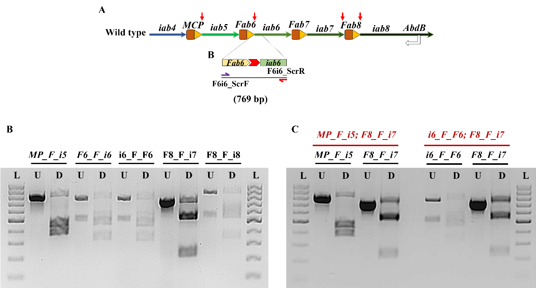
Supplemental Figure S1: Molecular validation of FRT knock-ins at various regions within the bithorax complex: (A) Representation of wild type locus exemplifying validation of FRT at Fab6-iab6 locus. (B) Molecular validation of FRT at single locus. The genomic DNA of the transgenes is amplified with specific primers designed for the locus. Half of the amplicon is digested with Xba-I as a separate reaction and are run on the gel next to each other (U – undigested, D – digested; see text for details). (C) Molecular validation of double-FRT lines. The genomic DNA was amplified for multiple loci of interest and digested with Xba-I. The undigested and digested products are analysed in 1.5% agarose gel via electrophoresis.
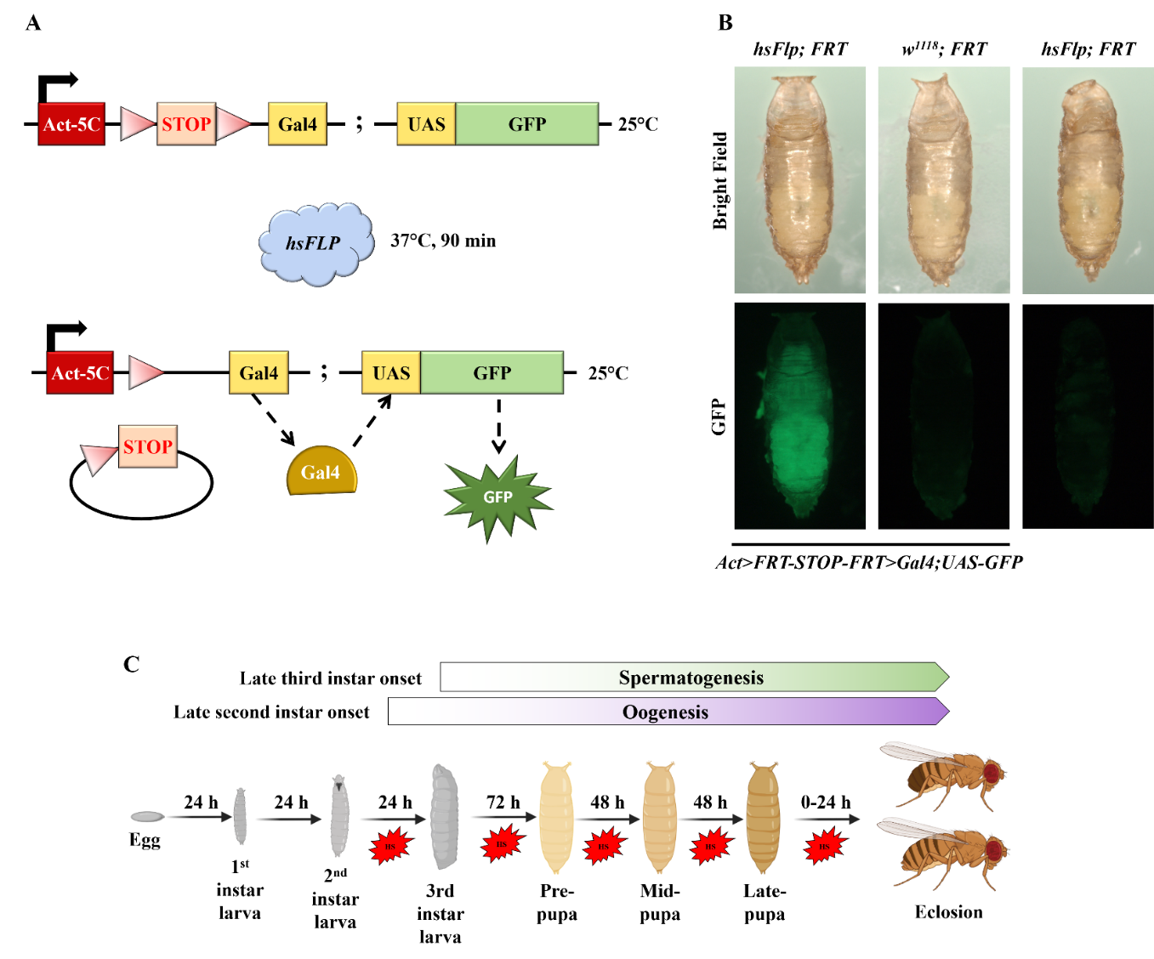
Supplemental Figure S2: Validation of FLP activity: (A) Representation of transgene used for validating activity of Flp. (B) All the flies involved in validating FLP activity are given heat shock at 37°C for 90 mins. Flies expressing functional flippase fluoresce green only when they have the hsFlp and Act-Gal4 module along with UAS-GFP. For flies with w¹¹¹⁸ and flies lacking Act5C-FRT.Gal4, no GFP is observed. (C) Strategy for providing heat shock to G1 animals from the late second instar stage. See text for details. Image created with biorender.
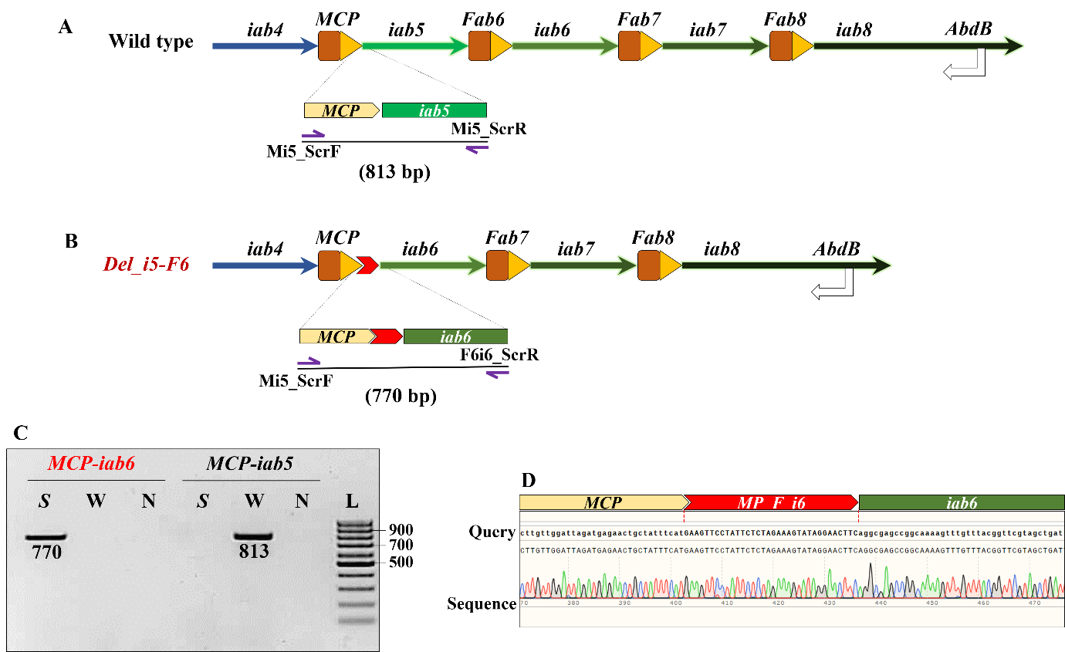
Supplemental Figure S3: Molecular validation of the deletion of iab5 through Fab6: (A) A representation of wild-type Abd-B locus. The MCP-iab5 region was selected as the control locus for PCR-based molecular validation. (B) After deletion, the region spanning iab5 and Fab6 was lost. However, due to FRT based recombination, the sites for recombination were specific. Therefore, the forward primer to screen FRT at MCP-iab5 locus (Mi5_ScrF) was repurposed with the reverse primer to screen FRT insertion between Fab6 and iab6 (F6i6_ScrR). (C) 1.5% agarose gel with 1μg/ml EtBr shows amplification of specific products upon PCR. See text for details. The genomic DNA from the deletion mutant, S, amplifies the recombined locus but fails to amplify the endogenous MCP-iab5 locus as opposed to a wild-type CS fly, W. N is no template control. (D) Confirmation of deletion locus by sequencing. The region was sequenced using multiple primers.
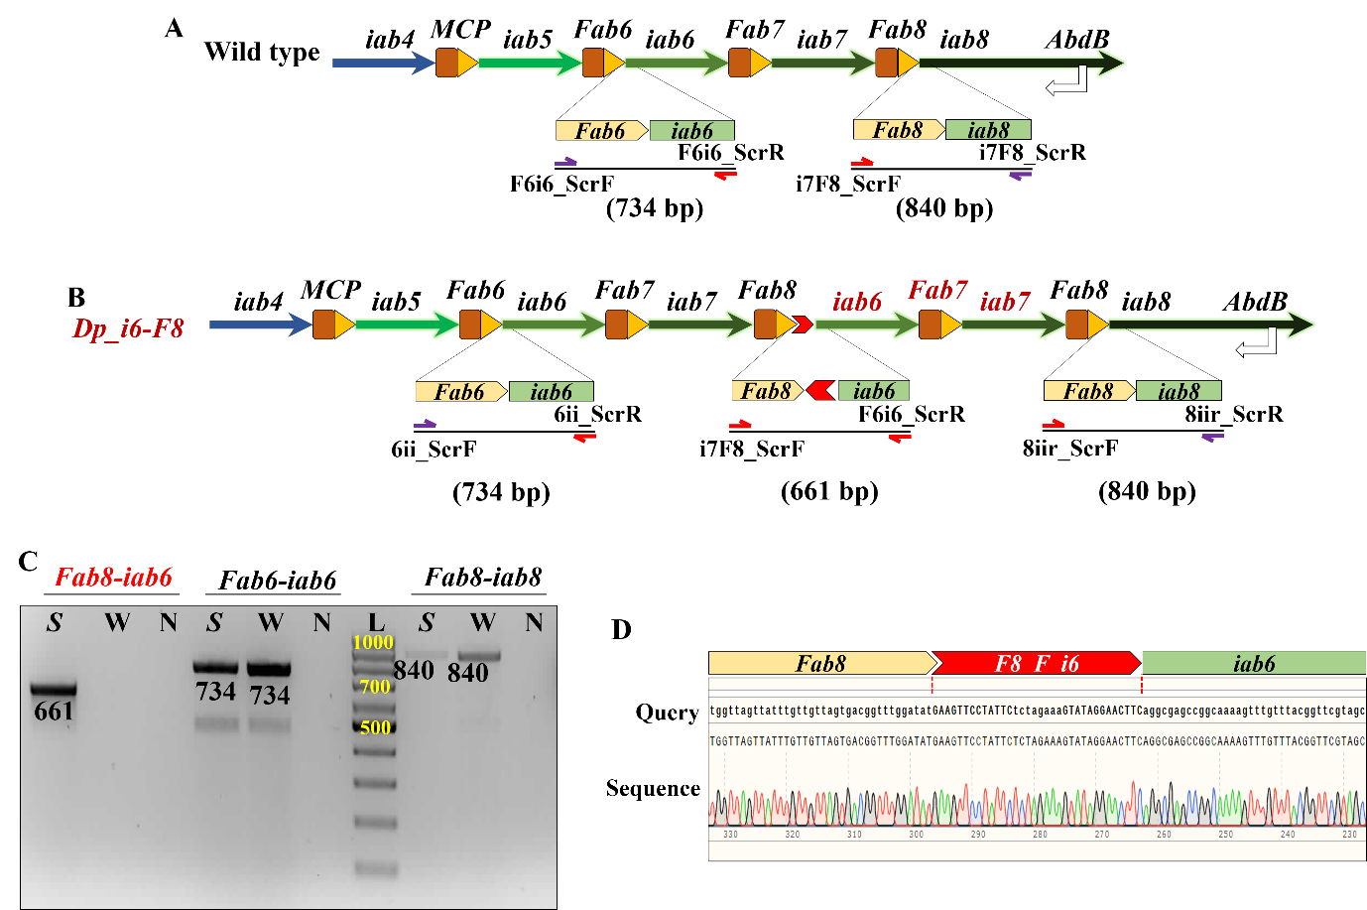
Supplemental Figure S4: Molecular validation of the duplication of iab6 through Fab8: (A) A representation of wild-type Abd-B locus. The regions used as a PCR control is also depicted (outset from Fab6-iab6 and Fab8-iab8). (B) After duplication, the region spanning iab6 through iab8 is duplicated and juxtaposed next to the proximal Fab8. The forward primer to screen FRT at Fab8-iab8 locus (F8i8_ScrF) was repurposed with the reverse primer to screen FRT insertion between Fab6 and iab6 (F6i6_ScrR). Only a fly with the desired duplication can amplify the genomic DNA with mentioned primers, thereby indicating the recombination event. (C) 1.5% agarose gel with 1μg/ml EtBr shows amplification of specific products upon PCR. The genomic DNA from the duplication mutant, S, amplifies the recombined locus, which is not amplified by the genomic DNA of a CS fly, W. The Fab6-iab6 and Fab8-iab8 loci amplify in the mutant and the CS fly, indicating a duplication event. N is no template control. (D) Confirmation of duplication locus by sequencing.
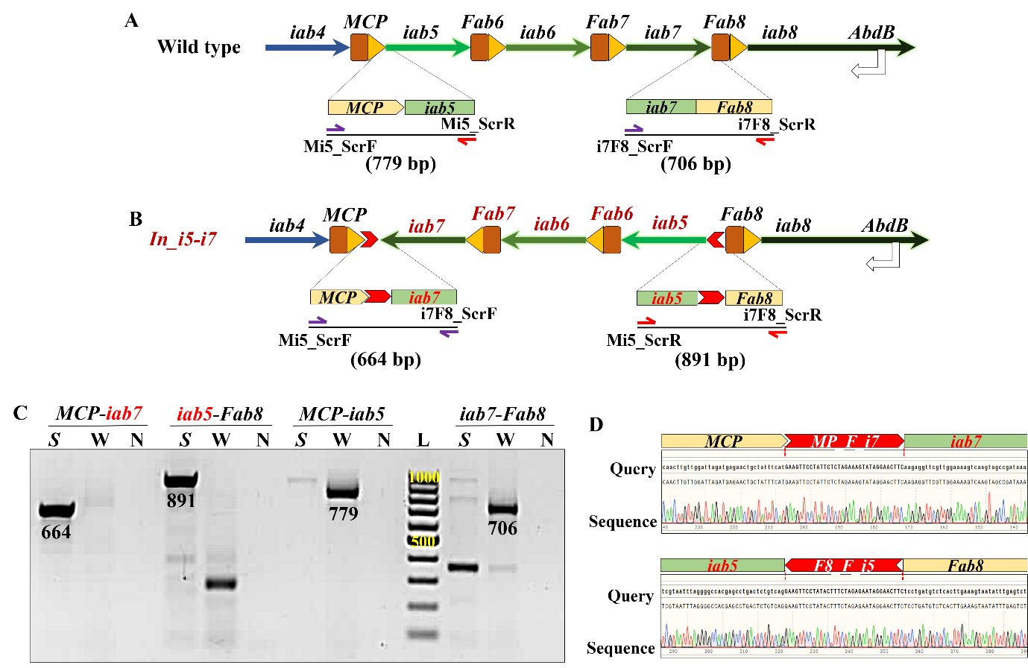
Supplemental Figure S5: Molecular validation of the inversion of iab5 through iab7: (A) A representation of wild-type Abd-B locus. The regions used as a PCR control is also depicted (outset from MCP-iab5 and iab7-Fab8). (B) After inversion, the region spanning iab5 through iab7 is inverted. Due to FRT based recombination, the sites for recombination are specific as indicated in outsets representing the loci amplified from the In_i5-i7 flies (MCP-iab7 and iab5-Fab8). The forward primer to screen FRT at MCP-iab5 locus (Mi5_ScrF) was repurposed with the forward primer to screen FRT insertion between iab7 and Fab8 (i7F8_ScrF) to screen MCP-iab7. A second locus of recombination (iab5-Fab8) was amplified by repurposing the reverse primers for screening the MCP-iab5 (Mi5_ScrR) and iab7-Fab8 (i7F8_ScrR) loci in the wild-type flies. Only a fly with the desired inversion can amplify the genomic DNA with mentioned primers. (C) 1.5% agarose gel with 1μg/ml EtBr shows amplification of specific products upon PCR. See text for details. The genomic DNA from the inversion mutant, S, amplifies the recombined locus, which is not amplified by the genomic DNA of a CS fly, W. N is no template control. On the contrary, the MCP-iab5 and iab7-Fab8 loci amplify in the CS fly, W, but not in the inversion mutant, S. (D) Confirmation of inversion by Sanger sequencing.
S. No. | Name | Genotype | Site of insertion of FRT or regions affected upon recombination*
1 | MP_F_i5 | Abd-B^{[MCP-KI{FRT}-iab5]} | 16,872,061
2 | F6_F_i6 | Abd-B^{[Fab6-KI{FRT}-iab6]} | 16,887,207
3 | i6_F_F6 | Abd-B^{[iab6-KI{FRT}-Fab6]} | 16,887,207
4 | F8_F_i7 | Abd-B^{[Fab8-KI{FRT}-iab7]} | 16,918,581
5 | F8_F_i8 | Abd-B^{[Fab8-KI{FRT}-iab8]} | 16,921,983
6 | i6_F_F6, F8_F_i7 | Abd-B[iab6-KI{FRT}-Fab6, Fab8-KI{FRT}-iab7] | i6_F_F6 at 16,887,207  F8_F_i7 at 16,918,581
7 | MP_F_i5, F8_F_i7 | Abd-B[MCP-KI{FRT}-iab5, Fab8-KI{FRT}-iab7] | i6_F_F6 at 16,887,207  F8_F_i7 at 16,918,581
8 | Del_i5-F6 | Abd-B^{[Del(iab5-Fab6)]} | 16,872,062..16,887,207
9 | Del_i6-i7 | Abd-B^{[Del(iab6-iab7)]} | 16,887,208..16,918,581
10 | Dp_i6-i7 | Abd-B^{[Dp(iab6-iab7)]} | 16,887,208..16,918,581
11 | Dp_i6_F8 | Abd-B^{[Dp(iab6-Fab8)]} | 16,887,208..16,921,983
12 | Inv_i5-i7 | Abd-B^{[Inv(iab5-iab7)]} | 16,872,062.. 16,918,581
* All coordinates are mentioned as per the latest Drosophila melanogaster genome assembly coordinates R6.0
Supplemental Table S1: List of transgenic lines and FRT mediated recombinants generated in the study: The FRT sequences are inserted in Drosophila genome between MCP-iab5, Fab6-iab6, iab7-Fab8, and Fab8-iab8. The nomenclature is displayed with respect to the orientation of FRT sequence. For example, line MP_F_i5 has FRT inserted between MCP and iab5 with the direction of FRT towards iab5. The table also lists different mutations generated as a result of Flp-FRT mediated recombination.
S. No. | Name | Purpose
1 | pMP_F_i4 | Donor to insert FRT between MCP and iab4 towards iab4
2 | pMP_F_i5 | Donor to insert FRT between MCP and iab5 towards iab5
3 | pi5_F_MP | Donor to insert FRT between iab5 and MCP towards MCP
4 | pF6_F_i6 | Donor to insert FRT between Fab6 and iab6 towards iab6
5 | pi6_F_F6 | Donor to insert FRT between iab6 and Fab6 towards Fab6
6 | pF7_F_i6 | Donor to insert FRT between Fab7 and iab6 towards iab6
7 | pF7_F_i7 | Donor to insert FRT between Fab7 and iab7 towards iab7
8 | pF8_F_i7 | Donor to insert FRT between Fab8 and iab7 towards iab7
9 | pF8_F_i8 | Donor to insert FRT between Fab8 and iab8 towards iab8
10 | pi8_F_F8 | Donor to insert FRT between iab8 and Fab8 towards Fab8

Supplemental Table S2: List of donor constructs generated in pBSKS(-) for targeting FRT via CRISPR/Cas9: The FRT sequences were cloned in different orientations with required homology arms in pBSKS(-) vector backbone. See methods for details.
S. No. | Name | Purpose
1 | pi4-MP_C | Guide to target region between iab4 and MCP
2 | pMP-i5_C | Guide to target region between MCP and iab5
3 | pi5-F6_C | Guide to target region between iab5and Fab6
4 | pF6-i6_C | Guide to target region between Fab6 and iab6
5 | pi6-F7_C | Guide to target region between iab6 and Fab7
6 | pF7-i7_C | Guide to target region between Fab7 and iab7
7 | pi7-F8_C | Guide to target region between iab7 and Fab8
8 | pF8-i8_C | Guide to target region between Fab8 and iab8

Supplemental Table S3: List of guide RNA expressing constructs generated in pCFD3 vector for targeting FRT: Different guides were selected and cloned in pCFD3 vector. See methods for details.
S. No. | Name | Sequence (5’ → 3’) | Purpose
1 | pbsksEcoRV_LH_i4MP | Ctgcaggaattcgatgcttactgggtaaagcggat | Amplify left homology arm with left half of the FRT for the Gibson® assembly cloning of pMP_F_i4
2 | i4MP_LH_LFRT | ttctctagaaagtataggaacttcacagcatttcaggtgccacgc
3 | i4MP_RH_RFRT | atactttctagagaataggaacttctaaaagccagctgcagactt | Amplify right homology arm with right half of the FRT for the Gibson® assembly cloning of pMP_F_i4
4 | RH_i4MP_pbsksEcoRV | atcgataagcttgatccgcattaaatattgcatgc
5 | pbsksEcoRV_LH_MPi5 | ctgcaggaattcgatatacagcttccggcagcgac | Amplify left homology arm with left half of the FRT for the Gibson® assembly cloning of pMP_F_i5
6 | MPi5_LH_LFRT | atactttctagagaataggaacttctgaaatagcagttctcatc
7 | MPi5_RH_RFRT | ttctctagaaagtataggaacttcactgacagagtcaggctcgtg | Amplify right homology arm with right half of the FRT for the Gibson® assembly cloning of pMP_F_i5
8 | RH_MPi5_pbsksEcoRV | atcgataagcttgatagccactgataaattaccag
9 | i5MP_LH_LFRT | ttctctagaaagtataggaacttcatgaaatagcagttctcatct | Can be repurposed with Primer# 5 and 8 respectively for cloning pi5_F_MP
10 | i5MP_RH_RFRT | atactttctagagaataggaacttcctgacagagtcaggctcgtg
11 | pbsksEcoRV_LH_F6i6 | ctgcaggaattcgatcaaataaaccagcgctgcaa | Amplify left homology arm with left half of the FRT for the Gibson® assembly cloning of pF6_F_i6
12 | F6i6_LH_LFRT | atactttctagagaataggaacttccgctggaagtgggcggtggg
13 | F6i6_RH_RFRT | ttctctagaaagtataggaacttcaggcgagccggcaaaagtttg | Amplify right homology arm with right half of the FRT for the Gibson® assembly cloning of pF6_F_i6
14 | RH_F6i6_pbsksEcoRV | atcgataagcttgattgtgttatttggcgaaacag
15 | i6F6_LH_LFRT | ttctctagaaagtataggaacttcacgctggaagtgggcggtggg | Can be repurposed with Primer# 11 and 14 respectively for cloning pi6_F_F6
16 | i6F6_RH_RFRT | atactttctagagaataggaacttcggcgagccggcaaaagtttg
17 | pbsksEcoRV_LH_i6F7 | ctgcaggaattcgataggcgacgctttgtcataaa | Amplify left homology arm with left half of the FRT for the Gibson® assembly cloning of pF7_F_i6
18 | i6F7_LH_LFRT | ttctctagaaagtataggaacttcagagaaattacttttctgtga
19 | i6F7_RH_RFRT | atactttctagagaataggaacttccaactcgtgaaggtcgtgca | Amplify right homology arm with right half of the FRT for the Gibson® assembly cloning of pF7_F_i6
20 | RH_i6F7_pbsksEcoRV | atcgataagcttgattgagcgacattctacctcgc
21 | pbsksEcoRV_LH_F7i7 | ctgcaggaattcgatcaccgcaaaatccaattgga | Amplify left homology arm with left half of the FRT for the Gibson® assembly cloning of pF6_F_i6
22 | F7i7_LH_LFRT | atactttctagagaataggaacttcggtctacaaaggtctattta
23 | F7i7_RH_RFRT | ttctctagaaagtataggaacttcatcttaccgaacccaataatt | Amplify right homology arm with right half of the FRT for the Gibson® assembly cloning of pF6_F_i6
24 | RH_F7i7_pbsksEcoRV | atcgataagcttgattttagcagcggaacggtagt
25 | pbsksEcoRV_LH_i7F8 | ctgcaggaattcgatcatgccgccattcggcgatt | Amplify left homology arm with left half of the FRT for the Gibson® assembly cloning of pF8_F_i7
26 | i7F8_LH_LFRT | ttctctagaaagtataggaacttcaagaggttcgttggaaaagtc
27 | i7F8_RH_RFRT | atactttctagagaataggaacttctcctgatgtctcacttgaaa | Amplify right homology arm with right half of the FRT for the Gibson® assembly cloning of pF8_F_i7
28 | RH_i7F8_pbsksEcoRV | atcgataagcttgatactcttgttatcaaagcaga
29 | pbsksEcoRV_LH_F8i8 | ctgcaggaattcgatgcaacatgtggcattaatta | Amplify left homology arm with left half of the FRT for the Gibson® assembly cloning of pF8_F_i8
30 | F8i8_LH_LFRT | atactttctagagaataggaacttccacggtgctttggatgcgga
31 | F8i8_RH_RFRT | ttctctagaaagtataggaacttcacacggtgctttggatgcgga | Amplify right homology arm with right half of the FRT for the Gibson® assembly cloning of pF8_F_i8
32 | RH_F8i8_pbsksEcoRV | atcgataagcttgatacggcctttgtcttcggtgg
33 | i8F8_LH_LFRT | ttctctagaaagtataggaacttcaatatccaaaccgtcactaac | Can be repurposed with Primer# 29 and 32 respectively for cloning pi8_F_F8
34 | i8F8_RH_RFRT | atactttctagagaataggaacttcatatccaaaccgtcactaac

Supplemental Table S4: List of oligos for cloning donor constructs with FRTs in pBSKS: The oligos were used for amplifying different homology arms with a particular orientation of FRT sequence. See methods for details.

S. No. | Name | Sequence | Target region for Cas9 mediated DSB
1 | i4MP_Cr_s | gtcggctggcttttacagcatttc | Between iab4 and MCP
2 | i4MP_Cr_as | aaacgaaatgctgtaaaagccagc | Between iab4 and MCP
3 | MPi5_Cr_s | gtcggctatttcactgacagagtc | Between MCP and iab5
4 | MPi5_Cr_as | aaacgactctgtcagtgaaatagc | Between MCP and iab5
5 | F6i6_Cr_s | gtcggccggctcgcccgctggaag | Between Fab6 and iab6
6 | F6i6_Cr_as | aaaccttccagcgggcgagccggc | Between Fab6 and iab6
7 | i6F7_Cr_s | gtcggtaatttctccaactcgtga | Between iab6 and Fab7
8 | i6F7_Cr_as | aaactcacgagttggagaaattac | Between iab6 and Fab7
9 | F7i7_Cr_s | gtcggttcggtaagaggtctacaa | Between Fab7 and iab7
10 | F7i7_Cr_as | aaacttgtagacctcttaccgaac | Between Fab7 and iab7
11 | i7F8_Cr_s | gtcggacatcaggaagaggttcgt | Between iab7 and Fab8
12 | i7F8_Cr_as | aaacacgaacctcttcctgatgtc | Between iab7 and Fab8
13 | F8i8_Cr_s | gtcggtttggatatcacggtgctt | Between Fab8 and iab8
14 | F8i8_Cr_as | aaacaagcaccgtgatatccaaac | Between Fab8 and iab8

Supplemental Table S5: List of oligos for cloning sgRNA expressing element in pCFD3: The primers were annealed and ligated in the pCFD3 vector to yield sgRNA expressing constructs. See methods for details.
S. No. | Name | Sequence | Molecular validation of the transgenic line
1 | Mi5_ScrF | ccaccgcacttttctgttcg | MP_F_i5 and i5_F_MP
2 | Mi5_ScrR | tcagccagttccaaggttcc | MP_F_i5 and i5_F_MP
3 | F6i6_ScrF | tgtggctgctacgtgagttt | F6P_F_i6 and i6_F_F6P
4 | F6i6_ScrR | ttacttaaacgggccagcgt | F6P_F_i6 and i6_F_F6P
5 | i7F7_ScrF | ttgcatatcttcgcagggct | F7B_F_i6
6 | i7F7_ScrR | ttccattcccgattgccgtt | F7B_F_i6
7 | F7i7_ScrF | acggcattttgttgggcatt | F7P_F_i7
8 | F7i7_ScrR | gcaagggaattgtgtggacg | F7P_F_i7
9 | i7F8_ScrF | gcatcatggcctcggttttc | F8B_F_i7
10 | i7F8_ScrR | atgtgtttgtgctggttggc | F8B_F_i7
11 | F8i8_ScrF | tcttggccgcattttgcatc | F8P_F_i8 and i8_F_F8P
12 | F8i8_ScrR | gaacggaaaccgcctcaaag | F8P_F_i8 and i8_F_F8P

Supplemental Table S6: List of oligos for screening FRT insertion at genomic DNA in transgenes: Different primers were designed eccentric to the FRT site to yield products of different lengths upon Xba-I mediated restriction digestion. These primers were used to screen the insertion of FRT as well as were repurposed to screen Flp-FRT mediated recombination events.

S. No. | Name | Genotype | Comments
1 | nos-Cas9 | y^{[1]} M{w^{[+mC]}=nos-Cas9.P}ZH-2A w[*] | BDSC# 54591. The fly produces Cas9 protein driven by nanos promoter expressing in pole cells of the embryo which form the germinal epithelium of the adult flies
2 | T3/T6B | w^{[118]}; + ; TM3Sb/TM6BTb | Third chromosome balancer
3 | TG | Transgene of interest
4 | Bal1 | Any one type of balancer: TM3Sb or TM6BTb

Supplemental Table S7: Nomenclature of flies used for obtaining transgenes: The flies and genetic crosses mentioned below were utilized to obtain knock-in transgenic flies for FRT.
Generation |  | Fly 1 | Fly 2 | Comments
G0 | Genotype | nos-Cas9 | T3/T6B | Desired constructs are injected in the embryos of Fly1
G0 | Phenotype | Yellow body, red eyes | Stubble, tubby, humeral bristles, ebony | Desired constructs are injected in the embryos of Fly1
G1 | Genotype | TG/Bal | TG/T6B | After 3 days of setting up single-fly crosses, flies are confirmed via PCR
G1 | Phenotype | Any of the balancer phenotype | Stubble, tubby, humeral bristles, ebony
G2 | Genotype | TG/Bal1 | TG/Bal1 | These crosses are set only for the confirmed G1 lines
G2 | Phenotype | Flies with same balancer are crossed |  | These crosses are set only for the confirmed G1 lines
G3 | Genotype | TG/TG | TG/TG | These flies are maintained as stocks
G3 | Phenotype | Normal body |  | These flies are maintained as stocks

Supplemental Table S8: Genetic crosses for obtaining transgenic FRT knock-in flies
S. No. | Name | Genotype | Comments
1 | hsFlp; MP_F_i5 | P{ry[+t7.2]=hsFLP}1, y[1] w[1118]; MP_F_i5 | FRT inserted between MCP-PRE and iab5 with the orientation of FRT towards iab5 in hsFlp background
2 | hsFlp; F6_F_i6 | P{ry[+t7.2]=hsFLP}1, y[1] w[1118]; F6_F_i6 | FRT inserted between Fab6 and iab6 with the orientation of FRT towards iab6 in hsFlp background
3 | T3/T6B | w¹¹¹⁸; + ; TM3Sb/TM6BTb | Third chromosome balancer
4 | #; Del or Dup*i5_F6/Bal1 | #; +; Del or Dupi5_F6/Bal1 | # - X chromosome could be P{ry[+t7.2]=hsFLP}1, y[1] w[1118] or w[1118] depending on the parent and is immaterial to the cross  Del* or Dup* – Deletion or Duplication, to be validated molecularly

Supplemental Table S9: Nomenclature of flies used for FLP mediated recombination to obtain the deletion or duplication mutants: If the two FRTs are in a trans-heterozygous position in the same orientation, the resultant recombination would lead to the generation of a chromosome with deletion while the other with duplication of the region that they flank. Therefore, we utilized the mentioned flies to obtain the desired manipulation. A case for Deletion/Duplication of iab5-Fab6 is exampled in the table.

Generation |  | Fly line 1 | Fly line 2 | Comments
G0 | Genotype | hsFlp; MP_F_i5 | hsFlp; F6_F_i6
G0 | Phenotype | Yellow body, white eyes | Yellow body, white eyes
G1 Larvae | Genotype | hsFlp; MP_F_i5/F6_F_i6 |  | The transheterozygous larvae were given heat shock at 37ºC from late 2nd instar onwards to late pupal stages
G1 (adults eclosed) | Genotype | hsFlp; MP_F_i5/F6_F_i6 | T3/T6B | Fly line 1 is eclosing after heat shock.
G1 (adults eclosed) | Phenotype | White eyes | White eyes, stubble bristles, humeral bristles, tubby, ebony body | Fly line 1 is eclosing after heat shock.
G2^ | Genotype | #; Del or Dup*i5_F6/Bal1 | T3/T6B | # - genotype on X chromosome is immaterial  * - The chromosome could be a deletion, duplication or similar to any of G0 flies.  ^Pools of 10 flies each are set-up and screened after 3-4 days via PCR.  Positive pools are propagated via single-fly crosses
G2^ | Phenotype | Any one balancer phenotype T3 or T6; might also have a homeotic phenotype | White eyes, stubble bristles, humeral bristles, tubby, ebony body
G3 | Genotype | #; Del or Dup*i5_F6/Bal1 | T3/T6B | # and * same as above.  Single fly crosses are set from the pool that was positive for a transgene
G3 | Phenotype | Any one balancer phenotype T3 or T6; might also have a homeotic phenotype | White eyes, stubble bristles, humeral bristles, tubby, ebony body
G4 | Genotype | #; Del or Dup*i5_F6/Bal1 | #; Del or Dup*/Bal1 | * These are the confirmed deletion or duplication lines via PCR from G3 single fly cross
G4 | Phenotype | Any one balancer phenotype T3 or T6; might also have a homeotic phenotype | Any one balancer phenotype T3 or T6; might also have a homeotic phenotype
G5 | Genotype | #; Del or Dup*i5_F6/Del or Dup*i5_F6 | #; Del or Dup*i5_F6/Del or Dup*i5_F6 | *Stock of confirmed deletion or duplication line
G5 | Phenotype | White eyes, putative homeotic transformation |  | *Stock of confirmed deletion or duplication line

Supplemental Table S10: Genetic crosses to obtain a deletion or a duplication mutant: If the two FRTs are in a trans-heterozygous position in the same orientation, the resultant recombination would lead to the generation of a chromosome with deletion while the other with duplication of the region that they flank. A case for Deletion/Duplication of iab5-Fab6 is exampled in the table. Deletions and duplications of other regions were generated in a similar manner. These regions include the deletion or duplication of iab6-iab7 obtained from i6_F_F6, F8_F_i7 double FRT flies, and, deletion or duplication of iab6-Fab8 obtained from F6_F_i6 and F8_F_i8.
S. No. | Name | Genotype | Comments
1 | hsFlp; MP_F_i5, F8_F_i7 | P{ry[+t7.2]=hsFLP}1, y[1] w[1118]; MP_F_i5, F8_F_i7 | FRT1 inserted between MCP-PRE and iab5 with the orientation of FRT towards iab5 while the FRT2 is inserted between Fab8-Boundary and iab7 with the orientation towards iab7 in hsFlp background. Thus, the two FRTs face each otheron the same chromosome.
3 | T3/T6B | w118; + ; TM3Sb/TM6BTb | Third chromosome balancer
4 | #; In*i5_i7/Bal1 | #; +; In_i5-i7/Bal1 | # - X chromosome could be P{ry[+t7.2]=hsFLP}1, y[1] w[1118] or w[1118] depending on the parent and is immaterial to the cross  In* – Inversion to be screened molecularly

Supplemental Table S11: Nomenclature of flies used for generating FLP mediated inversion of iab5-iab7: Inversions are obtained when the two FRTs are in the opposite orientation and in -cis. Therefore, we utilized the listed flies to obtain the desired manipulation.
Generation |  | Fly line 1 | Fly line 2 | Comments
G0 | Genotype | hsFlp; MP_F_i5, F8_F_i7 | T3/T6B
G0 | Phenotype | Yellow body, white eyes | Yellow body, white eyes
G1 Larvae | Genotype | hsFlp; MP_F_i5, F8_F_i7/ Bal1 | T3/T6B | The heterozgous larvae were given heat shock at 37oC from late 2nd instar onwards to late pupal stages
G1 (adults eclosed) | Genotype | hsFLP; MP_F_i5, F8_F_i7/Bal1 | T3/T6B | Fly line 1 is eclosing after heat shock.
G1 (adults eclosed) | Phenotype | Stubble bristles, white eyes | White eyes, stubble bristles, humeral bristles, tubby, ebony body | Fly line 1 is eclosing after heat shock.
G2 | Genotype | #; In*i5_i7/Bal1 | T3/T6B | # - genotype on X chromosome is immaterial, * - The chromsome is a potential inversion of the desired region or can be similar to the G0 fly. Pools of 10 flies each are set-up and screened after 3-4 days via PCR
G2 | Phenotype | Any one balancer phenotype T3 or T6; might also have a homeotic phenotype | White eyes, stubble bristles, humeral bristles, tubby, ebony body
G3 | Genotype | #; In*i5_i7/Bal1 | T3/T6B | # and * same as above. Single fly crosses are set from the pool that was positive for a transgene
G3 | Phenotype | Any one balancer phenotype T3 or T6; might also have a homeotic phenotype | White eyes, stubble bristles, humeral bristles, tubby, ebony body
G4 | Genotype | #; In*i5_i7/Bal1 | #; In*i5_i7/Bal1 | * These are the confirmed inversion lines via PCR for G3 single fly cross
G4 | Phenotype | Any one balancer phenotype T3 or T6; might also have a homeotic phenotype | Any one balancer phenotype T3 or T6; might also have a homeotic phenotype
G5 | Genotype | #; In-i5_i7/Bal1 | #; In-i5_i7/Bal1 | Stock of confirmed inversion line
G5 | Phenotype | White eyes, putative homeotic transformation |  | Stock of confirmed inversion line

Supplemental Table S12: Genetic crosses to obtain a mutant with an inversion of iab5-iab7

