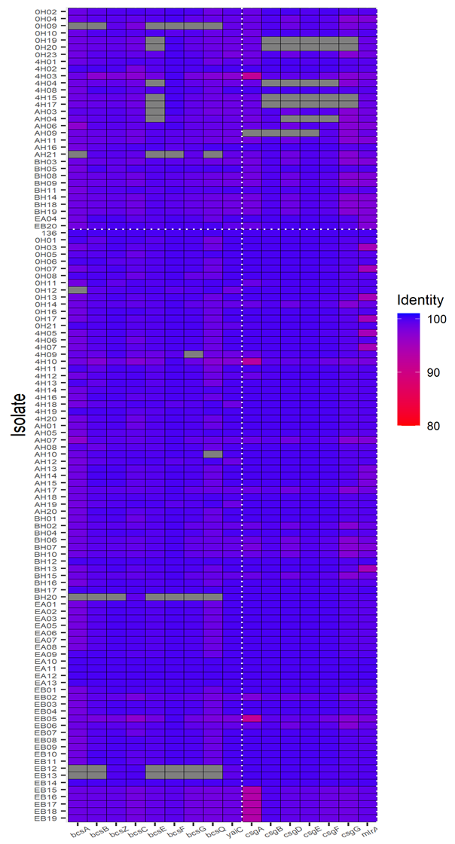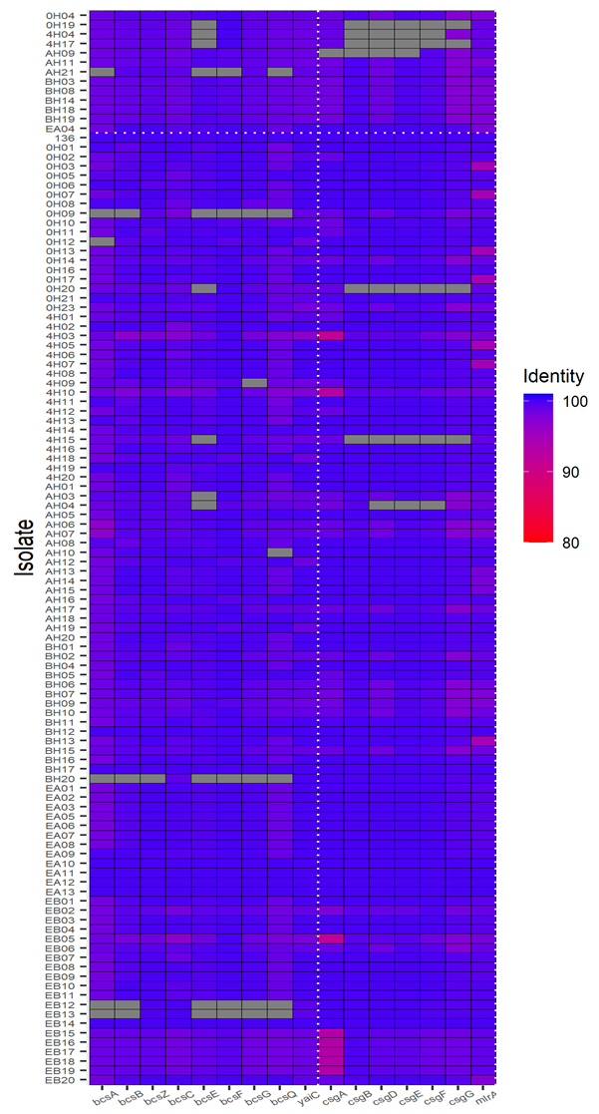
B
A
Figure S1. The presence and extent of similarity of genes involved in cellulose and curli production in E. coli genomes (n=114). The data in Figure 6 were replotted for a better visualization of the relationship of cellulose and curli genes and their respective phenotype. The vertical line separates the genes involved in cellulose (left) and curli (right). A horizontal dotted line separates the negative (top) and positive (bottom) phenotypic trait for cellulose (A) and curli (B). The identities between relevant genes in each isolate and in strain 136 are shown in color from red to blue. The grids filled with gray indicate the isolate has 0 or more than one copy of the corresponding gene and hence identity level is not shown.

