Supplementary Material

2D materials-based photo-memristors with tunable non-volatile responsivities for neuromorphic vision processing

Xiao Fu^{a,b,c#}, Tangxin Li ^{b,c #}, Bin Cai^{d#}, Jinshui Miao^{a,b,c *}, Gennady Panin^{e}, Jinjin Wang ^{b,c}, Xiaoyong Jiang ^{b,c}, Hangyu Xu ^{b,c}, Yi Dong ^{b,c}, Bo Song^{d*}, Fansheng Chen ^{b,c}, Xiaoshuang Chen ^{b,c}, Wei Lu ^{b,c}, Weida Hu^{a,b,c *}

ªSchool of Physics and Optoelectronic Engineering, Hangzhou Institute for Advanced Study, University of Chinese Academy of Sciences, Hangzhou, China.
^{b}State Key Laboratory of Infrared Physics, Shanghai Institute of Technical Physics, Chinese Academy of Sciences, Shanghai, China.
^{c}University of Chinese Academy of Sciences, Beijing, China.
^{d}Institute of Intelligent Machines, HFIPS, Chinese Academy of Sciences, Hefei, China
^{e}Institute of Microelectronics Technology and High-Purity Materials, Russian Academy of Sciences, Chernogolovka, Moscow distr., Russia.

*Corresponding authors
E-mail: Weida Hu: wdhu@mail.sitp.ac.cn; Jinshui Miao: jsmiao@mail.sitp.ac.cn and Bo Song: songbo@iim.ac.cn.
#These authors contributed equally to the work.

Table of contents

Section A: Materials Preparation and Device Fabrication
Section B: Materials Characterization
Section C: Current-Voltage Measurements
Section D: Raman characterization
Section E: Implementation of stateful logical operations with photo-memristors
Section F: Emulation of a retinomorphic vision sensor and logical operations with photo-memristors

Section A: Materials Preparation and Device Fabrication
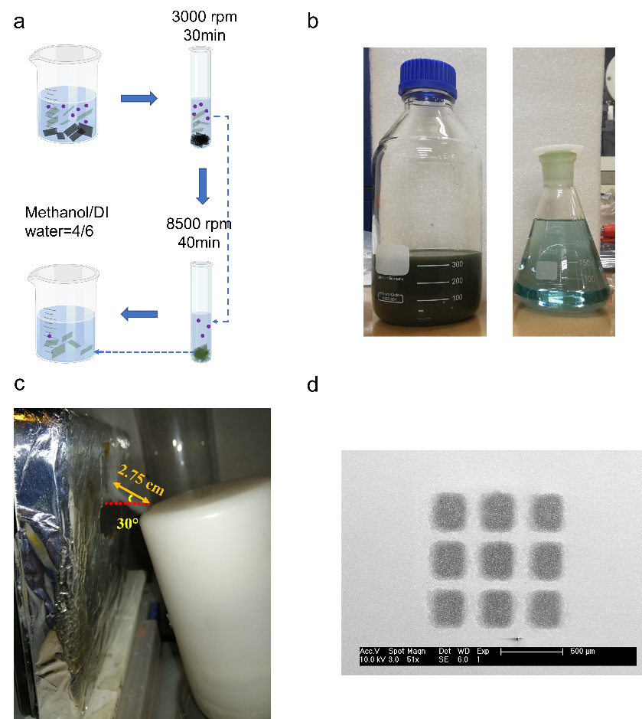
Figure S1. (a) Schematic representation of the experimental LPE MoS₂ process and MoS₂ ink preparation. (b) Photo of exfoliated NS (left) and QDs (right). (c) Photo of ultrasonic deposition process. (d) SEM image of deposited arrays.

Figure S1a shows the experimental LPE process, then, MoS_{2-x}O_{x} thin film was deposited at 210°C for 90 min in ambient air by using the ultrasonic deposition method as shown in Figure S1c. A thin MoS_{(2-x)}O_{x} film with a thickness of about 200 nm in contact with two lateral GO_{y} was formed through a mask with a given geometry. For such a device, the channel length is 10 µm, the contact area of SC₁ and SC₂ are 3.5×1.4 mm² and 3.5×0.4 mm², respectively. We note that such deposition method can be used to fabricate MoS_{2-x}O_{x} arrays for further applications such as retinomorphic vision sensors in ESI Section E.

Section B: Materials Characterization
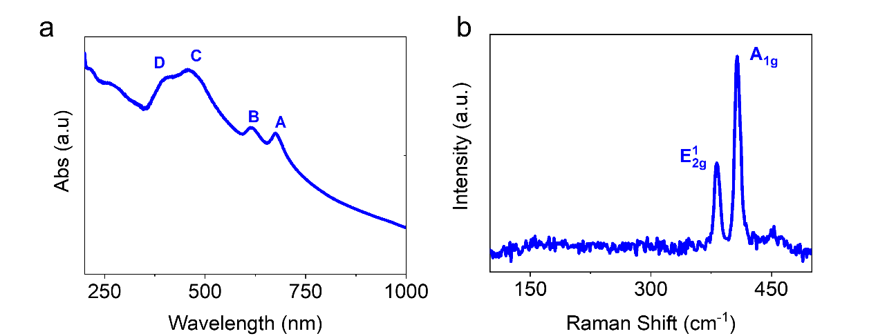

Figure S2. (a) UV-Visible spectra of MoS₂ NSs. (b) Raman Spectra of LPE MoS₂ NSs.

Figure S2a shows the absorption spectra of MoS₂ sample, the peaks at 413, 457, 613 and 675 nm are the characteristic absorption peaks of exfoliated MoS₂ nanosheets obtained from liquid phase exfoliation. Supplementary Figure S2b shows a typical Raman spectrum of exfoliated MoS₂, which exhibits two characteristic peaks, A_{1g} and E_{2g}, corresponding to the out-of-plane and in-plane vibration modes of 2H-MoS₂ layers, respectively.

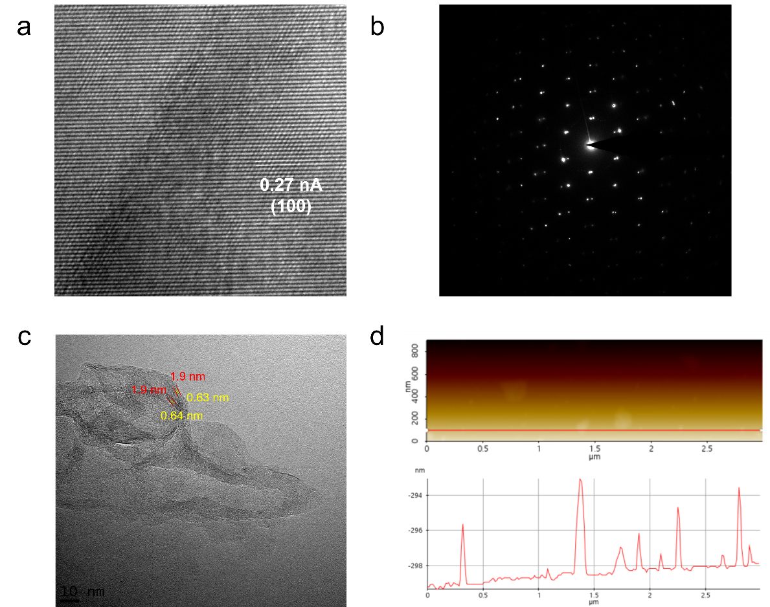
Figure S3. (a) HRTEM image of exfoliated MoS₂ NS. (b) SEAD image of twist exfoliated MoS₂ NS. (c) HRTEM image of MoS₂ NSs. (d) AFM analysis of MoS₂ NS.

The MoS₂ mixed with QDs can be obtained after 3000 rpm centrifugation process as shown in Figure S1. Figure S3a show the HRTEM image of twist MoS₂ NSs with the corresponding MoS₂ lattice spacing, and the Figure S3b shows the corresponding SEAD image, the hexagonal structure indicates the formation of high quality of MoS₂ NS. Figure S3c shows a typical view of the edges of MoS₂ nanosheets with clear lattice fringes. The thickness of MoS₂ is 1.9 nm and a uniform interlayer spacing of ~0.63 nm was clearly observed, which indicates the formation of 3-4 layers of MoS₂. AFM analysis of a MoS₂ nanosheet shows the thickness of MoS₂ nanosheets is about 2-5 nm.

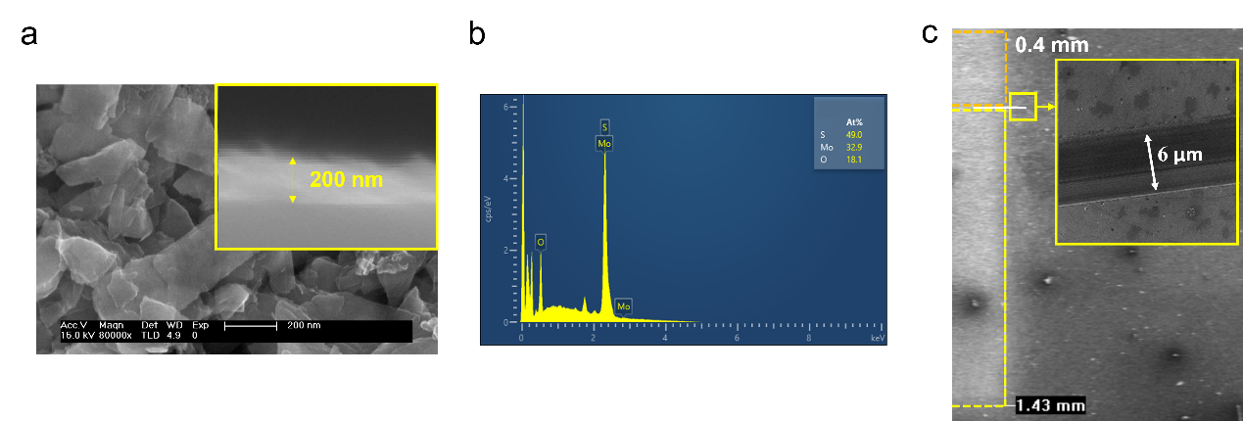
Figure S4. (a) SEM image of deposited MoS_{(2-x)}O_{x} NSs. The inset shows the SEM image of the cross-section of the MoS_{(2-x)}O_{x} thin film obtained on GO_{y}/SiO₂. (b) Analysis of the deposited thin film by the method of energy dispersive X-ray spectroscopy (EDS). (c) The SEM image of the edge of G/M/G device, the channel distance is about 6 um and the contact area ratio is 1.43:0.4.

The deposition of the MoS₂ film in the surrounding ambient atmosphere leads to the oxidation of the structure, as a result of which a thin MoS_{(2-x)}O_{x} film with a thickness of about 200 nm, in contact with two lateral GO_{y}, was formed through a mask with a given asymmetric geometry (x≈0.27). A pulse of -4V for 8s is applied under illumination to initiate the device.

Section C: Current-Voltage Measurements
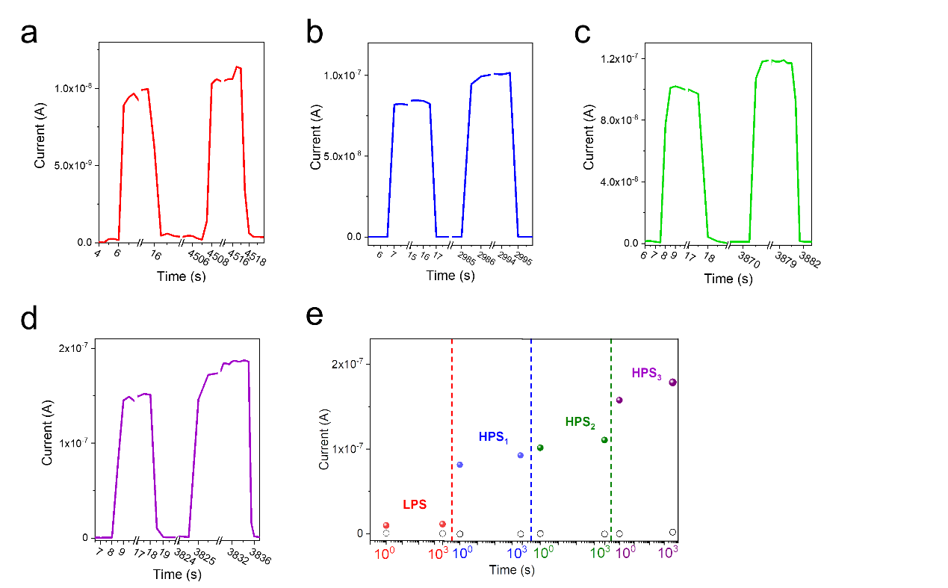
Figure S5. (a-d) Photocurrent response of device to light pulses of 10s duration for LPS, HPS₁, HPS₂ and HPS₃, respectively. (e) Retention times of multilevel photoresponse states at 0 bias, the symbols represent: current without illumination-black square; photocurrent at LPS, HPS₁, HPS₂, HPS₃-red, blue, green, purple sphere, respectively.

Figure S5 shows the photocurrent retention of photo-memristor, during the measurement, the photo-memristor is illuminated with a 10 s pulse of light from solar simulator (power density, 56 mW/cm²), during the retention time, the light was turn on. The retention time for LPS and HPS states are all more than 3×10³ seconds at room temperature.

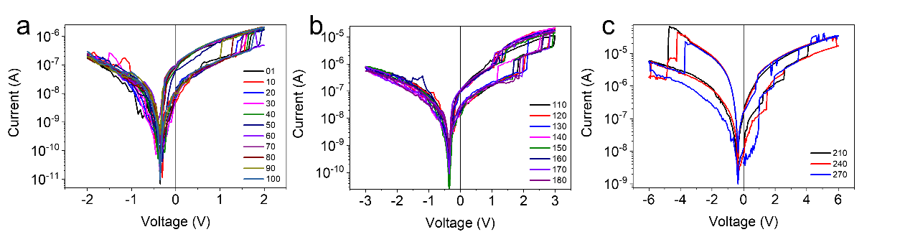
Figure S6. I-V characteristics of the GO_{y}/MoS_{(2-x)}O_{x}/GO_{y} device in the light for hundreds of sweeps of various bias voltages, which represent hundreads experimental switching loops for various photoresponse state, indicates a high degree of repeatability of photoresponse state switching.
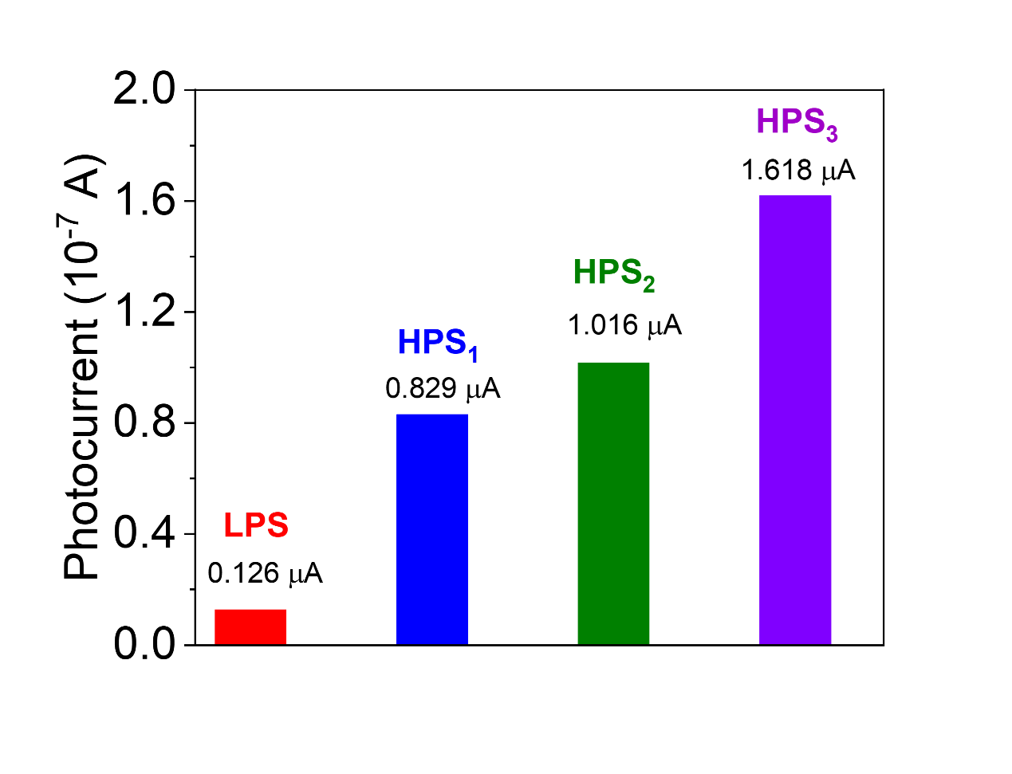

Figure S7. Photocurrent readout at 0V for various photoresponse states, the photocurrent calculate average of hundreds switching loops at various photoresponse states.

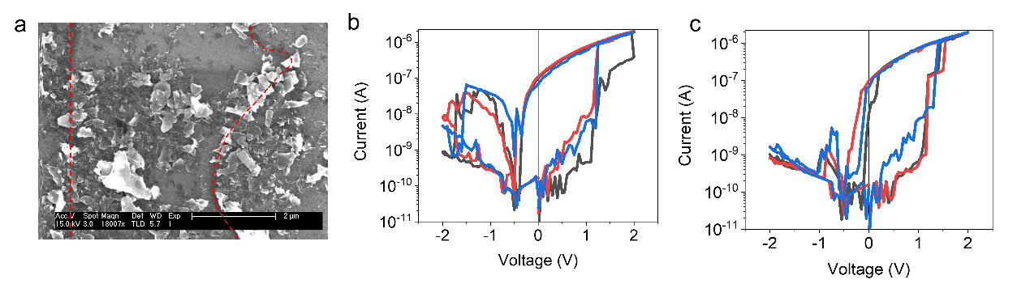
Figure S8. (a) SEM image of a specific GO_{y}/MoS_{(2-x)}O_{x}/GO_{y} structure for Raman characterization, the channel length is 2 µm. (b-c) I-V characteristic of specific GO_{y}/MoS_{(2-x)}O_{x}/GO_{y} photo-memristors.

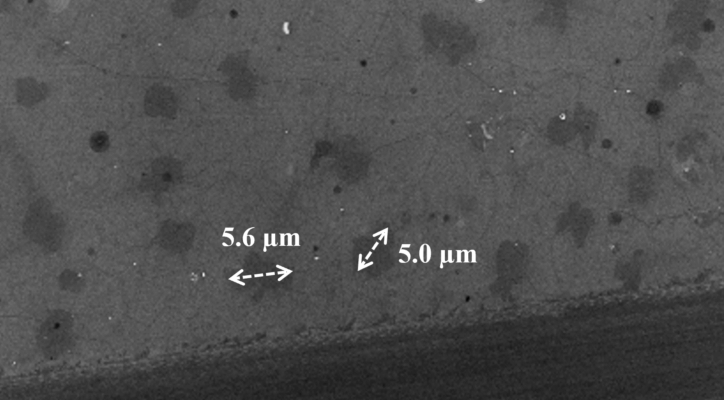
Section D: Raman characterization

Figure S9. SEM image of pristine CVD graphene electrode.

The CVD graphene was grow on Cu foil (99.999%), the preliminar annealed at 1060 °C under a hydrogen flow of 300 sccm and an Ar flow of 2000 sccm at a pressure of <10⁻⁴ Torr for 1-2h in the growth chamber. Then the graphene was grown by CVD at 1020 °C from a mixture of CH₄ (40 sccm flow) and H₂ (10 sccm). Finally, the sample was cooled to room temperature under a temperature regime.¹ Figure S9 shows the SEM image of defective structure, a specific structures distributed ober the surface with a mean density of about $3×{10}^{6}$ cm⁻² was found.

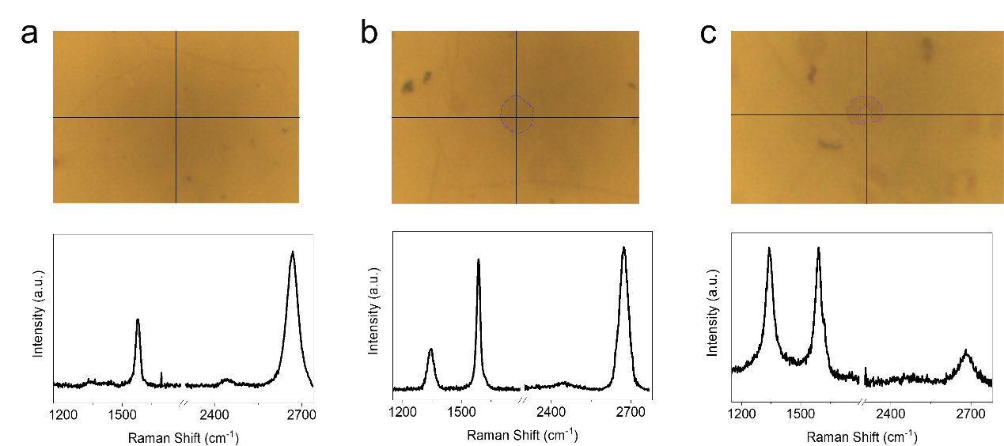
Figure S10. Optical images and Raman spectrum of a graphene film (a), a multilayer island (b) and annulus (c).

Figure S10 show the corresponding Raman characteristics for a graphene film, a multilayer island and annulus, respectively, it was found that the main difference of various structure being the rise of I_{D}/I_{G}, the decrease of I_{2D}/I_{G}, indicates the degradation of graphene quality and the formation of very defective multilayer graphene structure for oxidation and reduction.

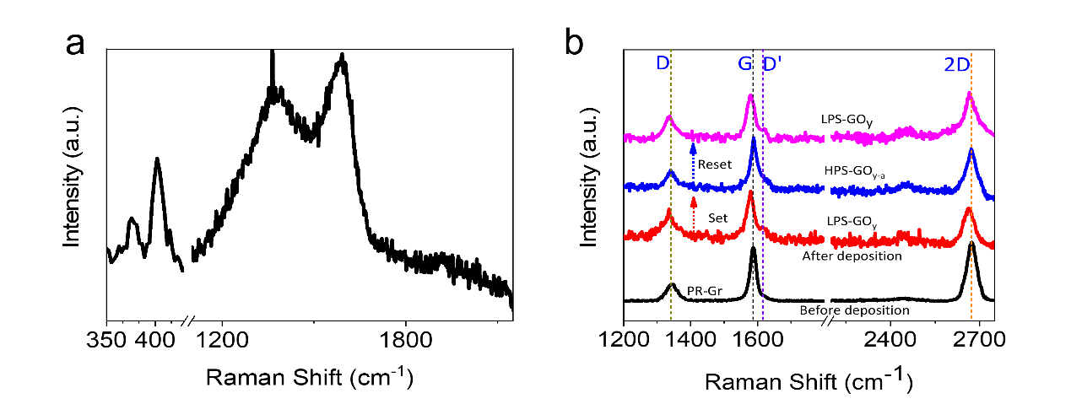
Figure S11. (a) Raman spectra of G/M/G with residual organic contamination. (b) Black curve: Raman spectra of CVD graphene before oxidation; The red, blue, and pink curves show the Raman spectrum of the specific point of SC₂ at various photoresponse states.

Due to the inevitable carbon contamination during evaporation process, it’s difficult to estimate the feature of graphene from Raman spectrum when thick enough MoS_{2-x}O_{x} film was deposited. Therefore, Raman characterization was carried out on a specific point on atomic thin G/M/G structure for various states. Note that the Raman results of pristine graphene calculated the average of more than 10 points as shown in Figure S11b (black curve).

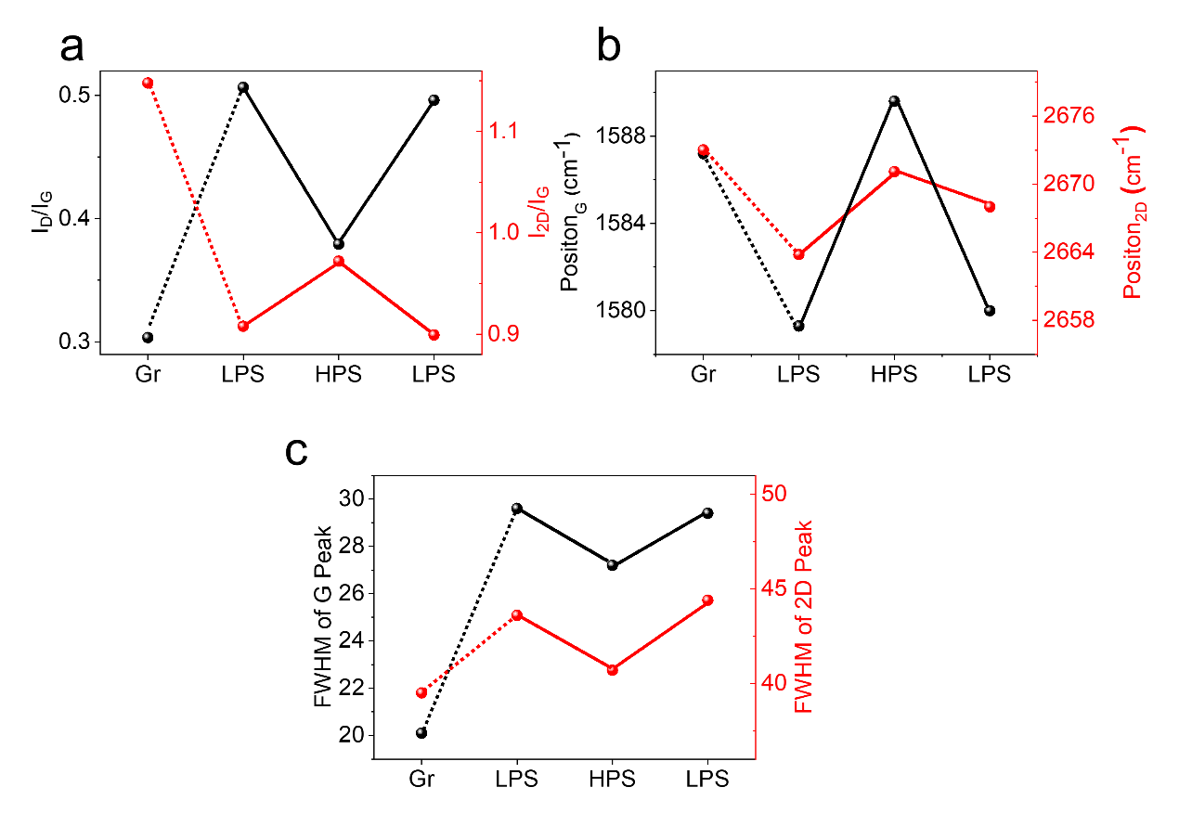
Figure S12. Correlation changes in the states of the pristine graphene and the states of the photoresponse of the device for: (a) Raman intensity ratios for G- and 2D-modes; (b) Shifts of the G and 2D modes; (c) Full width at half maximum (FWHM) of the G peak and 2D peak.

The pristine graphene shows a D/G and 2D/G intensity ratio of around 0.3 and 1.2. With the increment of degree of lattice disorder after oxidation, the ratio of the defect-induced D band and the graphite-originated G band (I_{D}/I_{G}) rise from 0.3 to 0.5, while the 2D/G intensity ratio decreases from 1.2 to 0.9. When the device switches from LPS to HPS, the ratio of I_{D}/I_{G} decreases from 0.5 to 0.4, the ratio of I_{2D}/I_{G} increases from 0.9 to 1.0; the peak position of G band and 2D band shows a slight red shift and a decrease in the FWHM of G mode and 2D mode can be observed as shown in Figure S11b-c, corresponding to a reduction process of GO_{y} according to previous reports^{2,3}. After the Reset process, the ratio of I_{D}/I_{G} increases up to 0.5, the ratio of I_{2D}/I_{G} decreases to 0.9; a slightly blue shift and broadening of the G band and the 2D band can be observed, which indicates the oxidation process²⁻⁴.

Section E: Implementation of stateful logical operations with photo-memristors
Like the devices connected as shown in the inset of Figure S13d, here we connect several devices as schematic shown in Figure 4, to demonstrate the stateful logic computation, when we read the photoresponse states of each device, we disconnect the device from the logic operation unit, and read the photoresponse of each device.

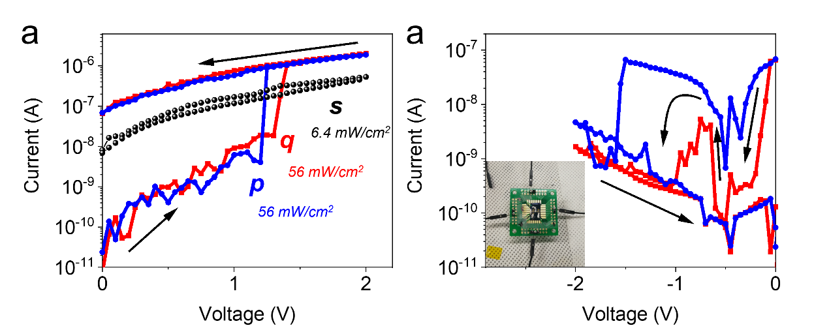
Figure S13. (a) The I-V curve of devices s, p and q under illumination with different light intensities. (b) Hysteresis reset curve of the photo-memristors (p and q) in the light, the inset shows photograph of two devices.

To implement the IMP operation, the device s is set to HPS, and during the measurements the device s is illuminated at the light intensity of 6.4 mW cm⁻², the corresponding I-V is shown in S13a. Those three photo-memristors are connected as schematic shown in Figure 3a. The light intensity is set to be 56 mW cm⁻² for p and q, and 6.4 cm⁻² for s, as shown in Figure S13a, the resistance of device s is one order higher than that of the device in HPS illuminated with a light intensity of 6.4 mW cm⁻², and its two orders lower than that of the device in LPS illuminated with a light intensity of 6.4 mW cm⁻². As the FALSE operation always switch the device in LPS (logic value: 0), we simply applied a negative voltage pulse of -2.5V for 6s on both p and q device under illumination as shown in Figure 3. the photoresponse states can be read by light stimuli, the results and corresponding truth table are shown in Figure 3d. Note that the device can hardly show negative photoresponse even a -2.5 V pulse is applied on a LRS device, which may be due to the asymmetric contact geometry.

Section F: Emulation of a retinomorphic vision sensor
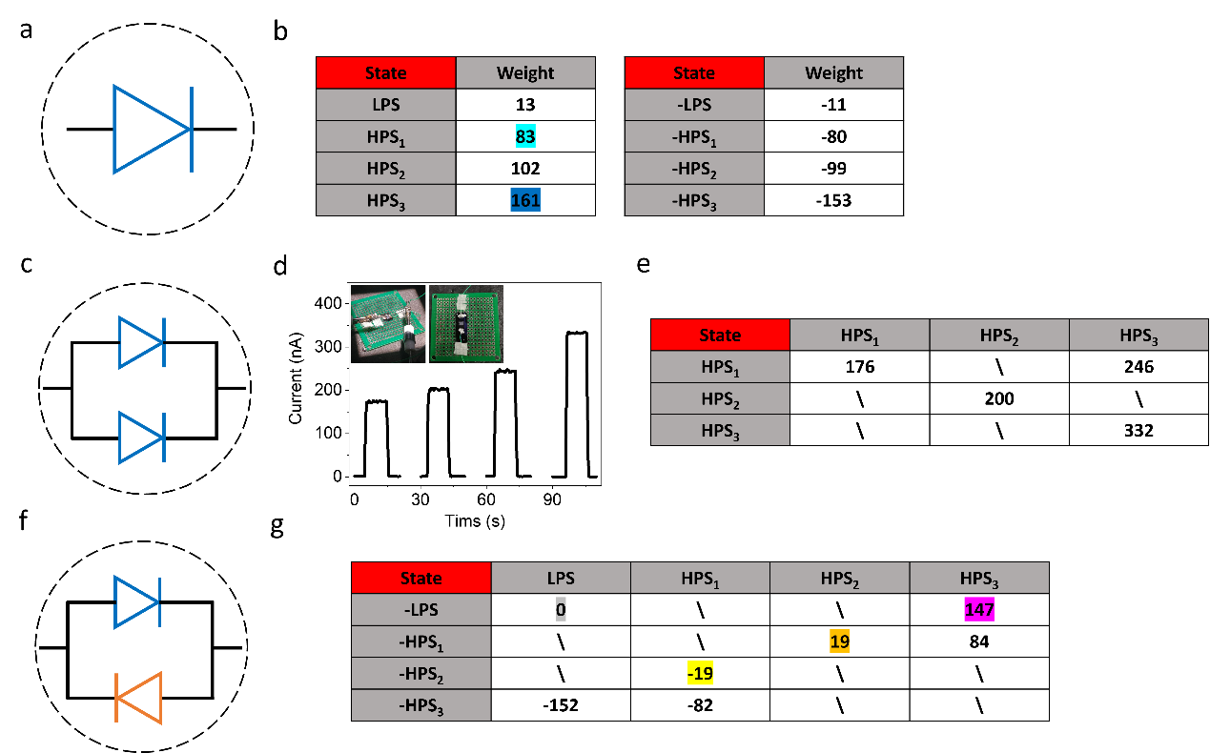

Figure S14. (a) Schematic representation of single photo-memristor cell for various photoresponse state. (b) The photocurrent (power density, 56 mW/cm⁻²) for LPS, HPS₁, HPS₂, HPS₃ reading at 0V and its opposite polarity, the unit in the Table is nA. (c) Schematic representation of photo-memristors connected in parallel with the same direction for various photoresponse states. (d-e) The photocurrent response of devices in (c) to light pulses (power density, 56 mW cm⁻²) of 10s duration for HPS₁ & HPS₁, HPS₁ & HPS₃, HPS₂ & HPS₂ and HPS₃ & HPS₃, respectively. The inset of Figure S13d show the two devices collected with wire bonding. The unit in the Table is nA. (f) Schematic representation of photo-memristors connected in parallel with the opposite direction for various photoresponse states. (g) The short-circuit current of devices in (f) to light pulses (power density, 56 mW/cm⁻²) of 10s duration. The unit in the Table is nA.

As the short-circuit photocurrent can hardly increases with higher voltage stimuli, the multi-photoresponse states can be realized by varying the different states and polarities of the photo-memristors. By setting the photoresponse state of each photo-memristor with different polarities, the output photocurrents of -11, -80, -99, -153 nA can be obtained by changing the polarity of photo-memristor as shown in Figure S14 (a) and (b). By connecting two devices in parallel, we are able to obtain short-circuit current of 176, 200, 246, 332 nA when the polarities of two devices are same, when the polarities of two devices are opposite the circuit current are -152, -82, -19, 0, 19, 84, 147 nA as shown in Figure 4b and Figure S14g. We note that we only remain the photoresponse states which generate distinguishable circuit current.

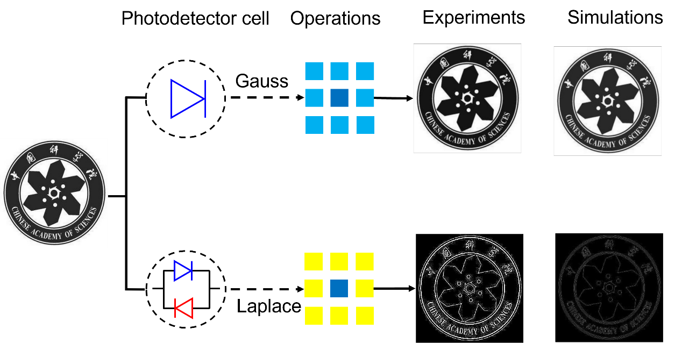

Figure S15. Demonstration of image pre-processing with photo-memristor array.

The operation of Gaussian blur is emulated by a $3×3$ photo-memristor arrays with the individual device write to specific photoresponse state, in which each cell contains a single photo-memristor as shown in Figure S15. The Experiment results emulated from the photoresponse states matrix of $\left[\begin{matrix}83 & 83 & 83 \\ 83 & 161 & 83 \\ 83 & 83 & 83\end{matrix}\right]$ with our photo-memristor, while the simulated blurred image calculated with matrix of $\left[\begin{matrix}1 & 1 & 1 \\ 1 & 2 & 1 \\ 1 & 1 & 1\end{matrix}\right]$. The operation of Laplacian operator is emulated by a $3×3$ photo-memristor arrays with two photo-memristors write to specific photoresponse state. The Experiment results emulated from the photoresponse states matrix of $\left[\begin{matrix}-19 & -19 & -19 \\ -19 & 147 & -19 \\ -19 & -19 & -19\end{matrix}\right]$ with our photo-memristors set, while the simulated blurred image calculated with matrix of $\left[\begin{matrix}-1 & -1 & -1 \\ -1 & 8 & -1 \\ -1 & -1 & -1\end{matrix}\right]$.

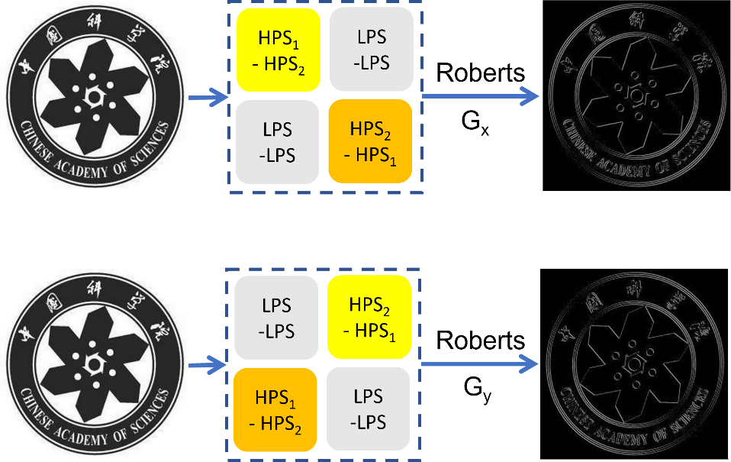

Figure S16. Demonstration of image pre-processing of Roberts operator with photo-memristors array.
The operation of image preprocessing of Roberts operator is emulated by a $2×2$ photo-memristor arrays with the individual device write to specific photoresponse state, in which each cell contains 2 photo-memristors as shown in Figure S16.

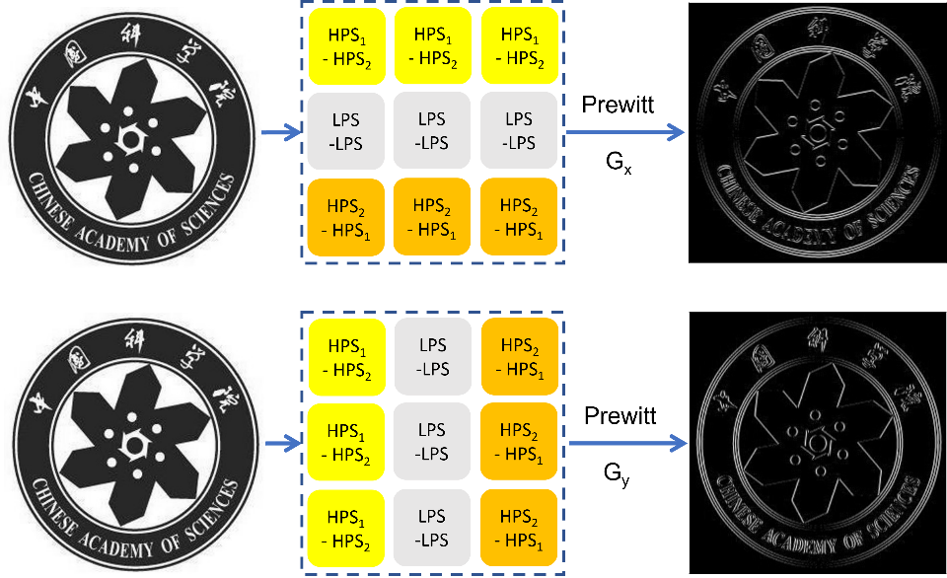

Figure S17. Demonstration of image pre-processing of Prewitt operator with photo-memristors array.

The operation of image preprocessing of Prewitt operator is emulated by a $3×3$ photo-memristor arrays with the individual device write to specific photoresponse state, in which each cell contains 2 photo-memristors as shown in Figure S17.

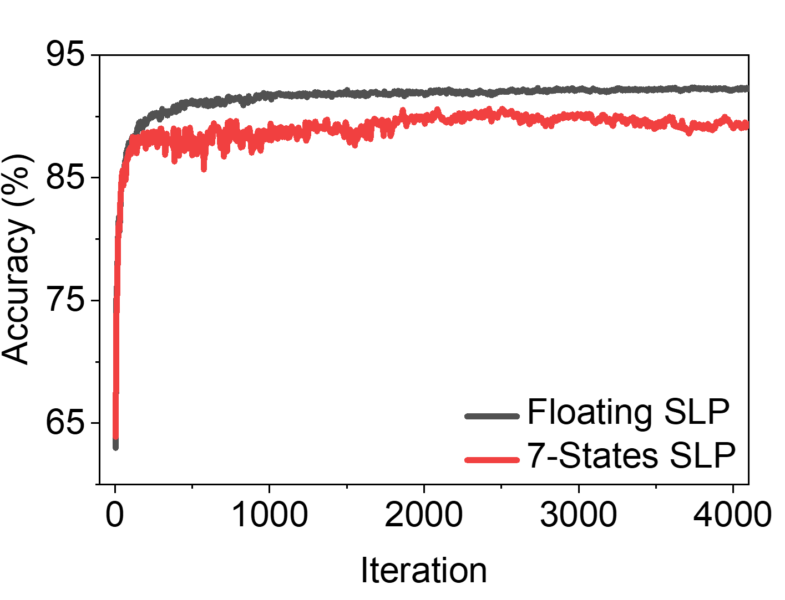

Figure S18. Accuracy of the SLP classifier during training with floating-point weight and discrepant 7-level photoresponse state.

Such SLP classifier also allows classifying MNIST data set into 10 classes when 10 photo-memristors can be integrated in one cell. For such a neural network, it is implemented in Pytorch on an NVIDIA TITAN XP GPU. The SLP is trained offline with 60000 images of the training set with batchsize 64 and 4000 iterations, delivering the final output probability that classify the input image to 10 classes on the testing set (10000 images) with 92.02% accuracy (Figure S18). The weights in the FC are discretized to accommodate the 7-levels photoresponse states. After discretization, the accuracy is about 90.03% which is 2% lower than the pristine SLP

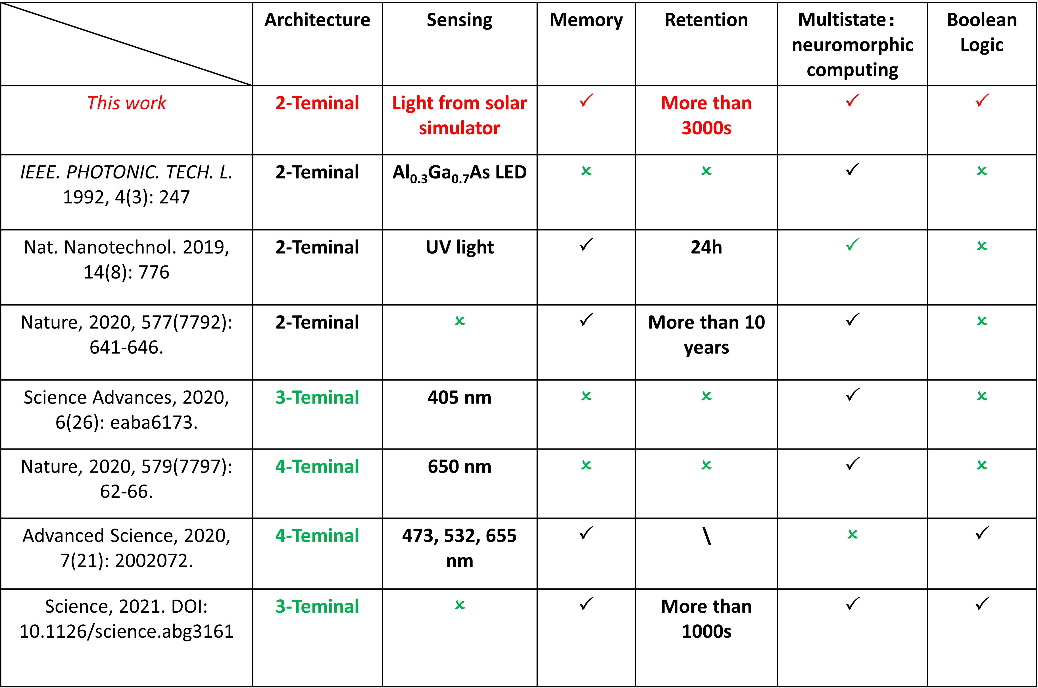
Table S1. Typical parameters of neuromorphic computing devices.
We have demonstrated experimentally a memphotoresponsitive switching device with simple two-terminal architecture, in which photoexcited carriers and ion migration are coupled under photoexcitation and bias voltage (Supplementary Table S1). These results are an example of a pinched current-voltage characteristic hysteresis beyond zero under illumination. The theory of the photo-memristor and experimentally obtained characteristics of this new device require further study and establishment. Photo-memristors in integrated circuits artificial neural networks have enormous potential for significantly expanding the functionality of optoelectronic systems, if the theory of photo-memristor is well established, and the dynamical nature of such optoelectronic devices is comprehensively studied and effectively used. Imperative applications include ultra-dense in-memory sensing and computing systems, as well as photoinduced learning networks.

References:
¹ Kapitanova, O. O. et al., Laterally Selective Oxidation of Large-Scale Graphene with Atomic Oxygen. The Journal of Physical Chemistry C 121 27915 (2017).
² Mulyana, Y., Uenuma, M., Ishikawa, Y. & Uraoka, Y., Reversible Oxidation of Graphene Through Ultraviolet/Ozone Treatment and Its Nonthermal Reduction through Ultraviolet Irradiation. The Journal of Physical Chemistry C 118 27372 (2014).
³ Kwon, S. et al., Reversible oxidation states of single layer graphene tuned by electrostatic potential. SURF SCI 612 37 (2013).
⁴ Kapitanova, O. O., Panin, G. N., Cho, H. D., Baranov, A. N. & Kang, T. W., Formation of self-assembled nanoscale graphene/graphene oxide photomemristive heterojunctions using photocatalytic oxidation. NANOTECHNOLOGY 28 204005 (2017).

