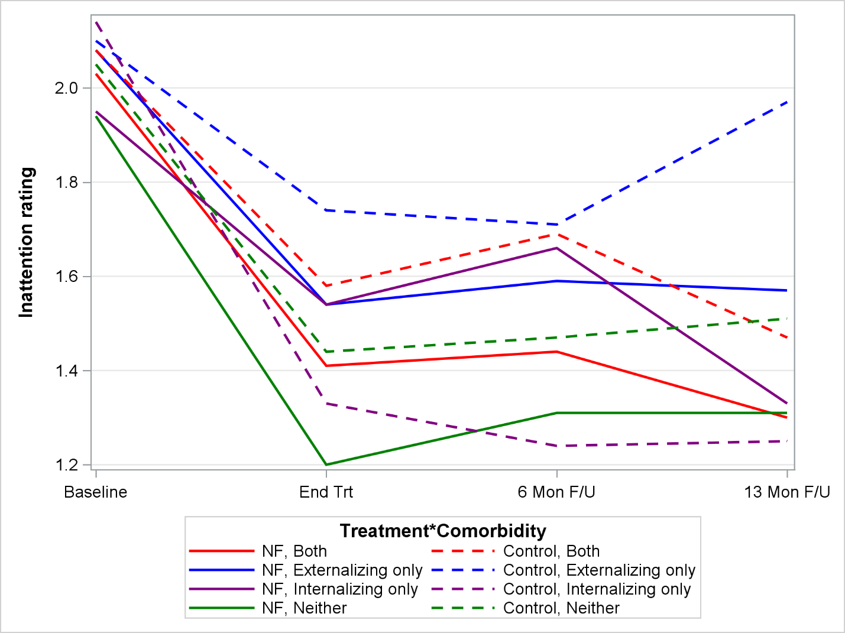
NF, Both
NF, ODD only
NF, Anxiety only
NF, Neither
Neigther

Control, Both
Control, ODD only
Control, Anxiety only
Control, Neither
Neigther

Appendix. Change in composite parent- and teacher-rated inattention mean item score by comorbid disorder type. Notes. NF = Neurofeedback treatment group. ODD = Oppositional Defiant Disorder. Control = Control treatment group. Both = both ODD and anxiety. TRT = Treatment. F/U = Follow-up. Youth with ODD who received NF (solid blue line) improved from baseline to TRT end, and maintained improvements through 13-month F/U. In contrast, control youth with ODD (dotted blue line) initially got better (placebo effect) but symptoms returned by 13-month F/U. Youth without comorbidities who received NF (solid green line) appeared to have the steepest decline from baseline to TRT end, which was upheld through 13-month F/U. Control youth with anxiety comorbidities (dotted purple line) also had a sharp decline in inattentive symptoms that were maintained over the 13-month F/U while those who received NF did significantly worse than the controls at treatment end. There is clinically-meaningful, but not statistically-significant “recovery” of youth with anxiety between TRT end and 13-month F/U (solid purple line).

